# HANDS-ON 1 :

import React from "react";

import "./App.css";

function App() {

const flag = true; // set true or false for your required output

const players = [

{ name: "Jack", score: 50 },

{ name: "Michael", score: 70 },

{ name: "John", score: 40 },

{ name: "Ann", score: 61 },

{ name: "Elisabeth", score: 61 },

{ name: "Sachin", score: 95 },

{ name: "Dhoni", score: 100 },

{ name: "Virat", score: 84 },

{ name: "Jadeja", score: 64 },

{ name: "Raina", score: 75 },

{ name: "Rohit", score: 80 }

];

const IndianTeam = ["Sachin1", "Dhoni2", "Virat3", "Rohit4", "Yuvaraj5", "Raina6"];

const T20players = ["First Player", "Third Player", "Fifth Player"];

const RanjiTrophyPlayers = ["Second Player", "Fourth Player", "Sixth Player"];

const IndianPlayers = [...T20players, ...RanjiTrophyPlayers];

if (flag === true) {

// Flag = true: list of players + players with score <= 70

const playersBelow70 = players.filter(item => item.score <= 70);

return (

<div className="App">

<h1>List of Players</h1>

<ul>

{players.map((item, index) => (

<li key={index}>

Mr. {item.name} {item.score}

</li>

))}

</ul>

<hr />

<h1>List of Players having Scores Less than 70</h1>

<ul>

{playersBelow70.map((item, index) => (

<li key={index}>

Mr. {item.name} {item.score}

</li>

))}

</ul>

</div>

);

} else {

// Flag = false: odd, even, merged Indian players

const [first, , third, , fifth] = IndianTeam;

const [, second, , fourth, , sixth] = IndianTeam;

return (

<div>

<h1>Odd Players</h1>

<ul>

<li>First : {first}</li>

<li>Third : {third}</li>

<li>Fifth : {fifth}</li>

</ul>

<hr />

<h1>Even Players</h1>

<ul>

<li>Second : {second}</li>

<li>Fourth : {fourth}</li>

<li>Sixth : {sixth}</li>

</ul>

<hr />

<h1>List of Indian Players Merged:</h1>

<ul>

{IndianPlayers.map((player, index) => (

<li key={index}>Mr. {player}</li>

))}

</ul>

</div>

);

}

}

export default App;

**Output:**

When Flag=true

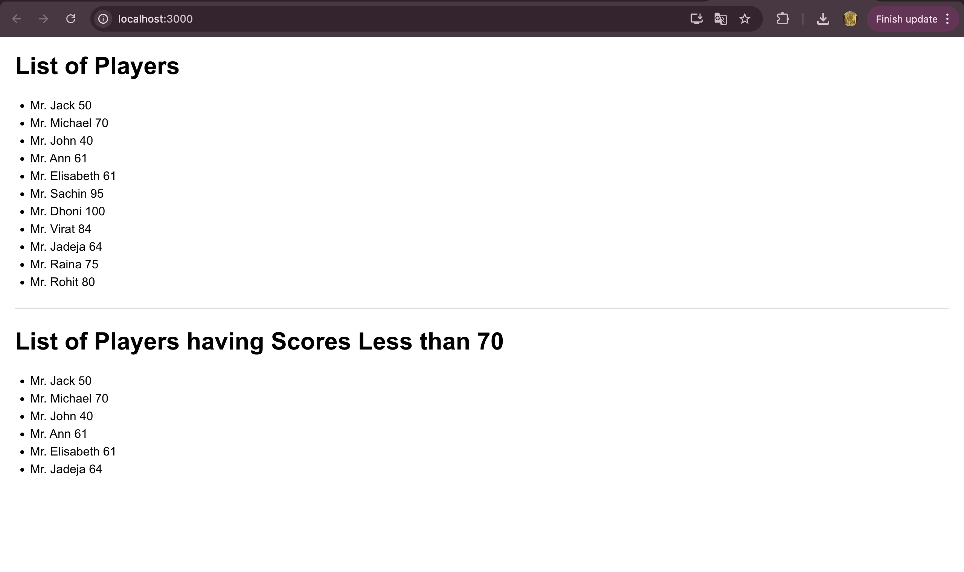

When Flag=false

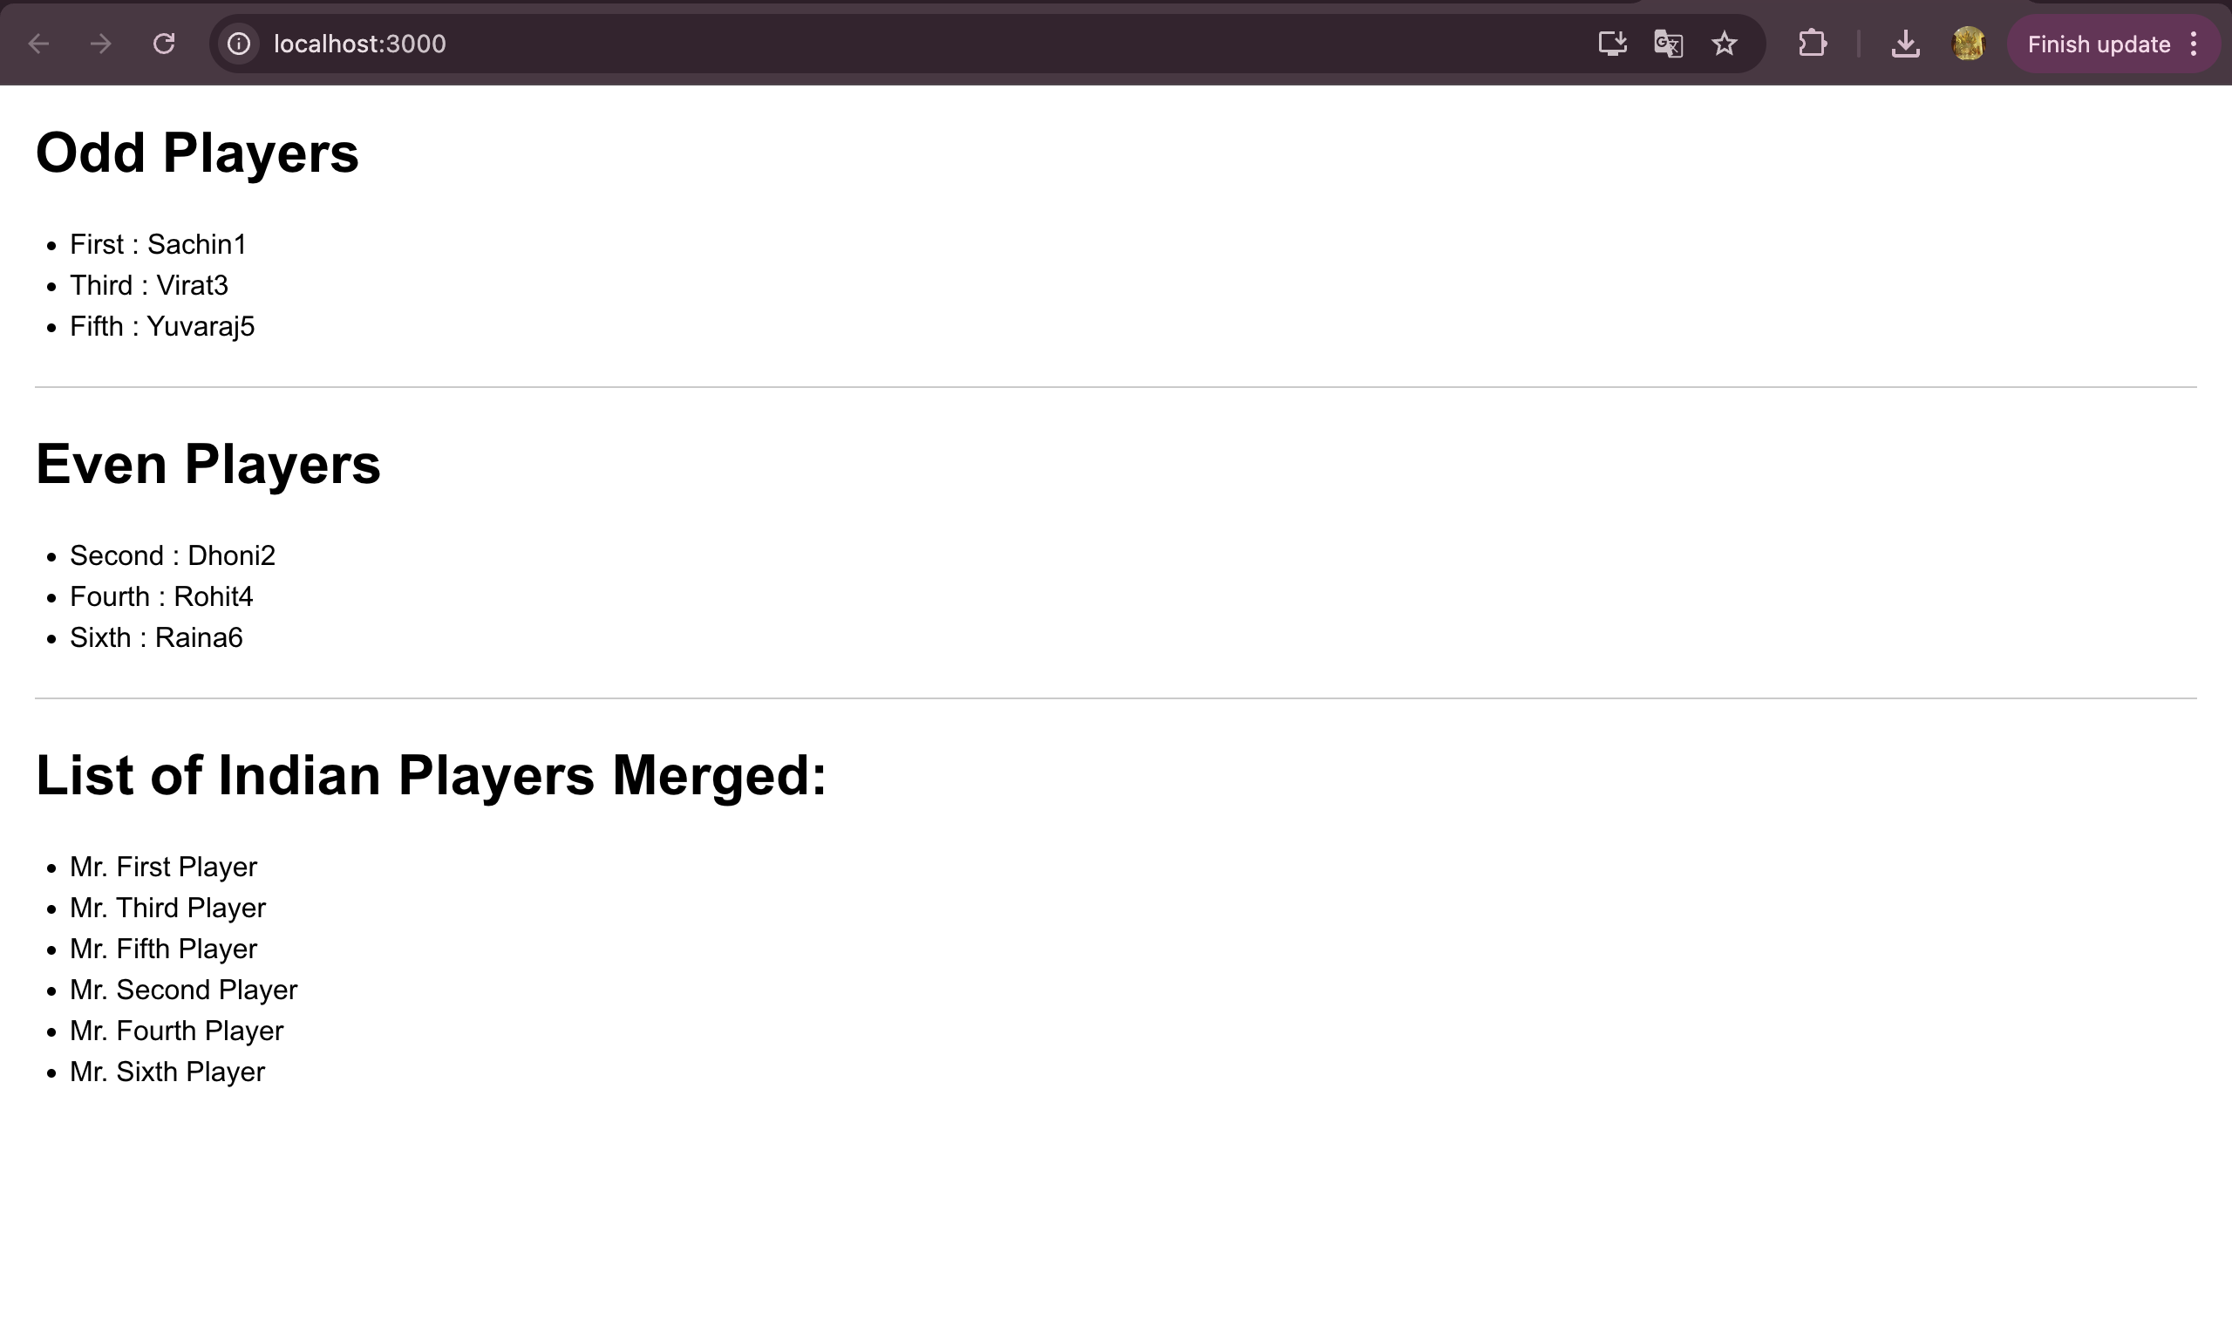

# HANDS-ON 2 :

import React from "react";

import "./App.css";

const heading = "Office Space";

const officeImage = (

<img

src="/office.webp" // Make sure your image is in public folder or update path accordingly

width="25%"

height="25%"

alt="Office Space"

/>

);

const ItemName = { Name: "DBS", Rent: 50000, Address: "Chennai" };

const officeList = [

{ Name: "DBS", Rent: 50000, Address: "Chennai" },

{ Name: "WeWork", Rent: 70000, Address: "Bangalore" },

];

const officeItems = officeList.map((office, index) => {

const colorStyle = {

color: office.Rent <= 60000 ? "red" : "green",

};

return (

<div key={index} style={{ marginBottom: "20px" }}>

<h2>Name: {office.Name}</h2>

<h3 style={colorStyle}>Rent: Rs. {office.Rent}</h3>

<h3>Address: {office.Address}</h3>

</div>

);

});

function App() {

return (

<div style={{ marginLeft: "50px", marginTop: "30px" }}>

<h1>{heading} , at Affordable Range</h1>

{officeImage}

<h2 style={{ marginTop: "20px" }}>Name: {ItemName.Name}</h2>

<h3 style={{ color: ItemName.Rent <= 60000 ? "red" : "green" }}>

Rent: Rs. {ItemName.Rent}

</h3>

<h3>Address: {ItemName.Address}</h3>

<h2 style={{ marginTop: "40px", marginBottom: "20px" }}>Available Office Spaces:</h2>

{officeItems}

</div>

);

}

export default App;

body {

font-family: Arial, sans-serif;

}

h1 {

font-weight: bold;

}

h2, h3 {

margin: 5px 0;

}

**Output**

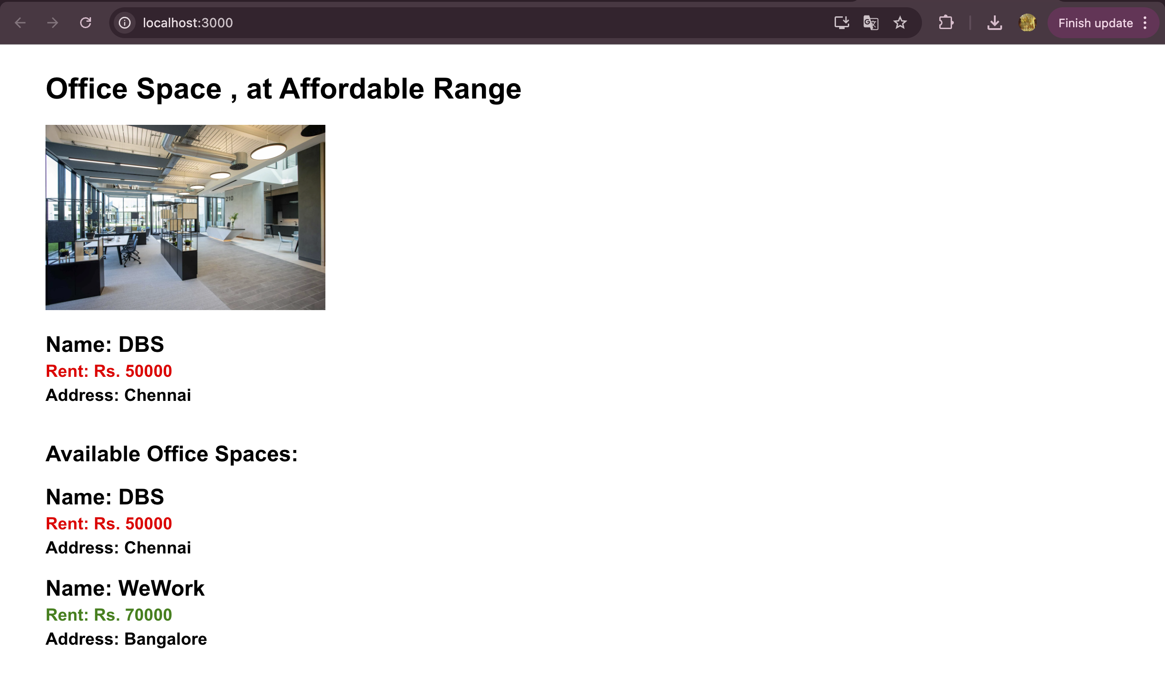

# HANDS-ON 3 :

import React, { useState } from "react";

import CurrencyConvertor from "./CurrencyConvertor";

function App() {

const [count, setCount] = useState(5);

const increment = () => {

setCount(prev => prev + 1);

sayHello();

};

const decrement = () => {

setCount(prev => prev - 1);

};

const sayHello = () => {

alert("Hello! Member!");

};

const sayWelcome = (msg) => {

alert(msg);

};

const handleClick = () => {

alert("I was clicked");

};

return (

<div style={{ margin: "40px 0 20px 0" }}>

<div style={{ paddingBottom: "15px"}}>{count}</div>

<button onClick={increment}>Increment</button><br/>

<button onClick={decrement}>Decrement</button><br/>

<button onClick={() => sayWelcome("welcome")}>Say welcome</button><br/>

<button onClick={handleClick}>Click on me</button><br/>

<CurrencyConvertor />

</div>

);

}

export default App;

import React, { useState } from "react";

function CurrencyConvertor() {

const [amount, setAmount] = useState("");

const [converted, setConverted] = useState("");

const handleSubmit = (e) => {

e.preventDefault();

const euro = (amount / 90).toFixed(2);

setConverted(euro);

alert(`Converted amount in Euro: €${euro}`);

};

return (

<div>

<h2 style={{ color: "green" }}>Currency Convertor!!!</h2>

<form onSubmit={handleSubmit}>

<div style={{ display: "flex", alignItems: "center", marginBottom: "10px" }}>

<label style={{ width: "100px" }}>Amount:</label>

<input

type="text"

value={amount}

onChange={(e) => setAmount(e.target.value)}

/>

</div>

<div style={{ display: "flex", alignItems: "center", marginBottom: "10px" }}>

<label style={{ width: "100px" }}>Currency:</label>

<input value="Euro" readOnly />

</div>

<button type="submit">Submit</button>

</form>

{converted && (

<h3>Converted Amount: €{converted}</h3>

)}

</div>

);

}

export default CurrencyConvertor;

**Output**

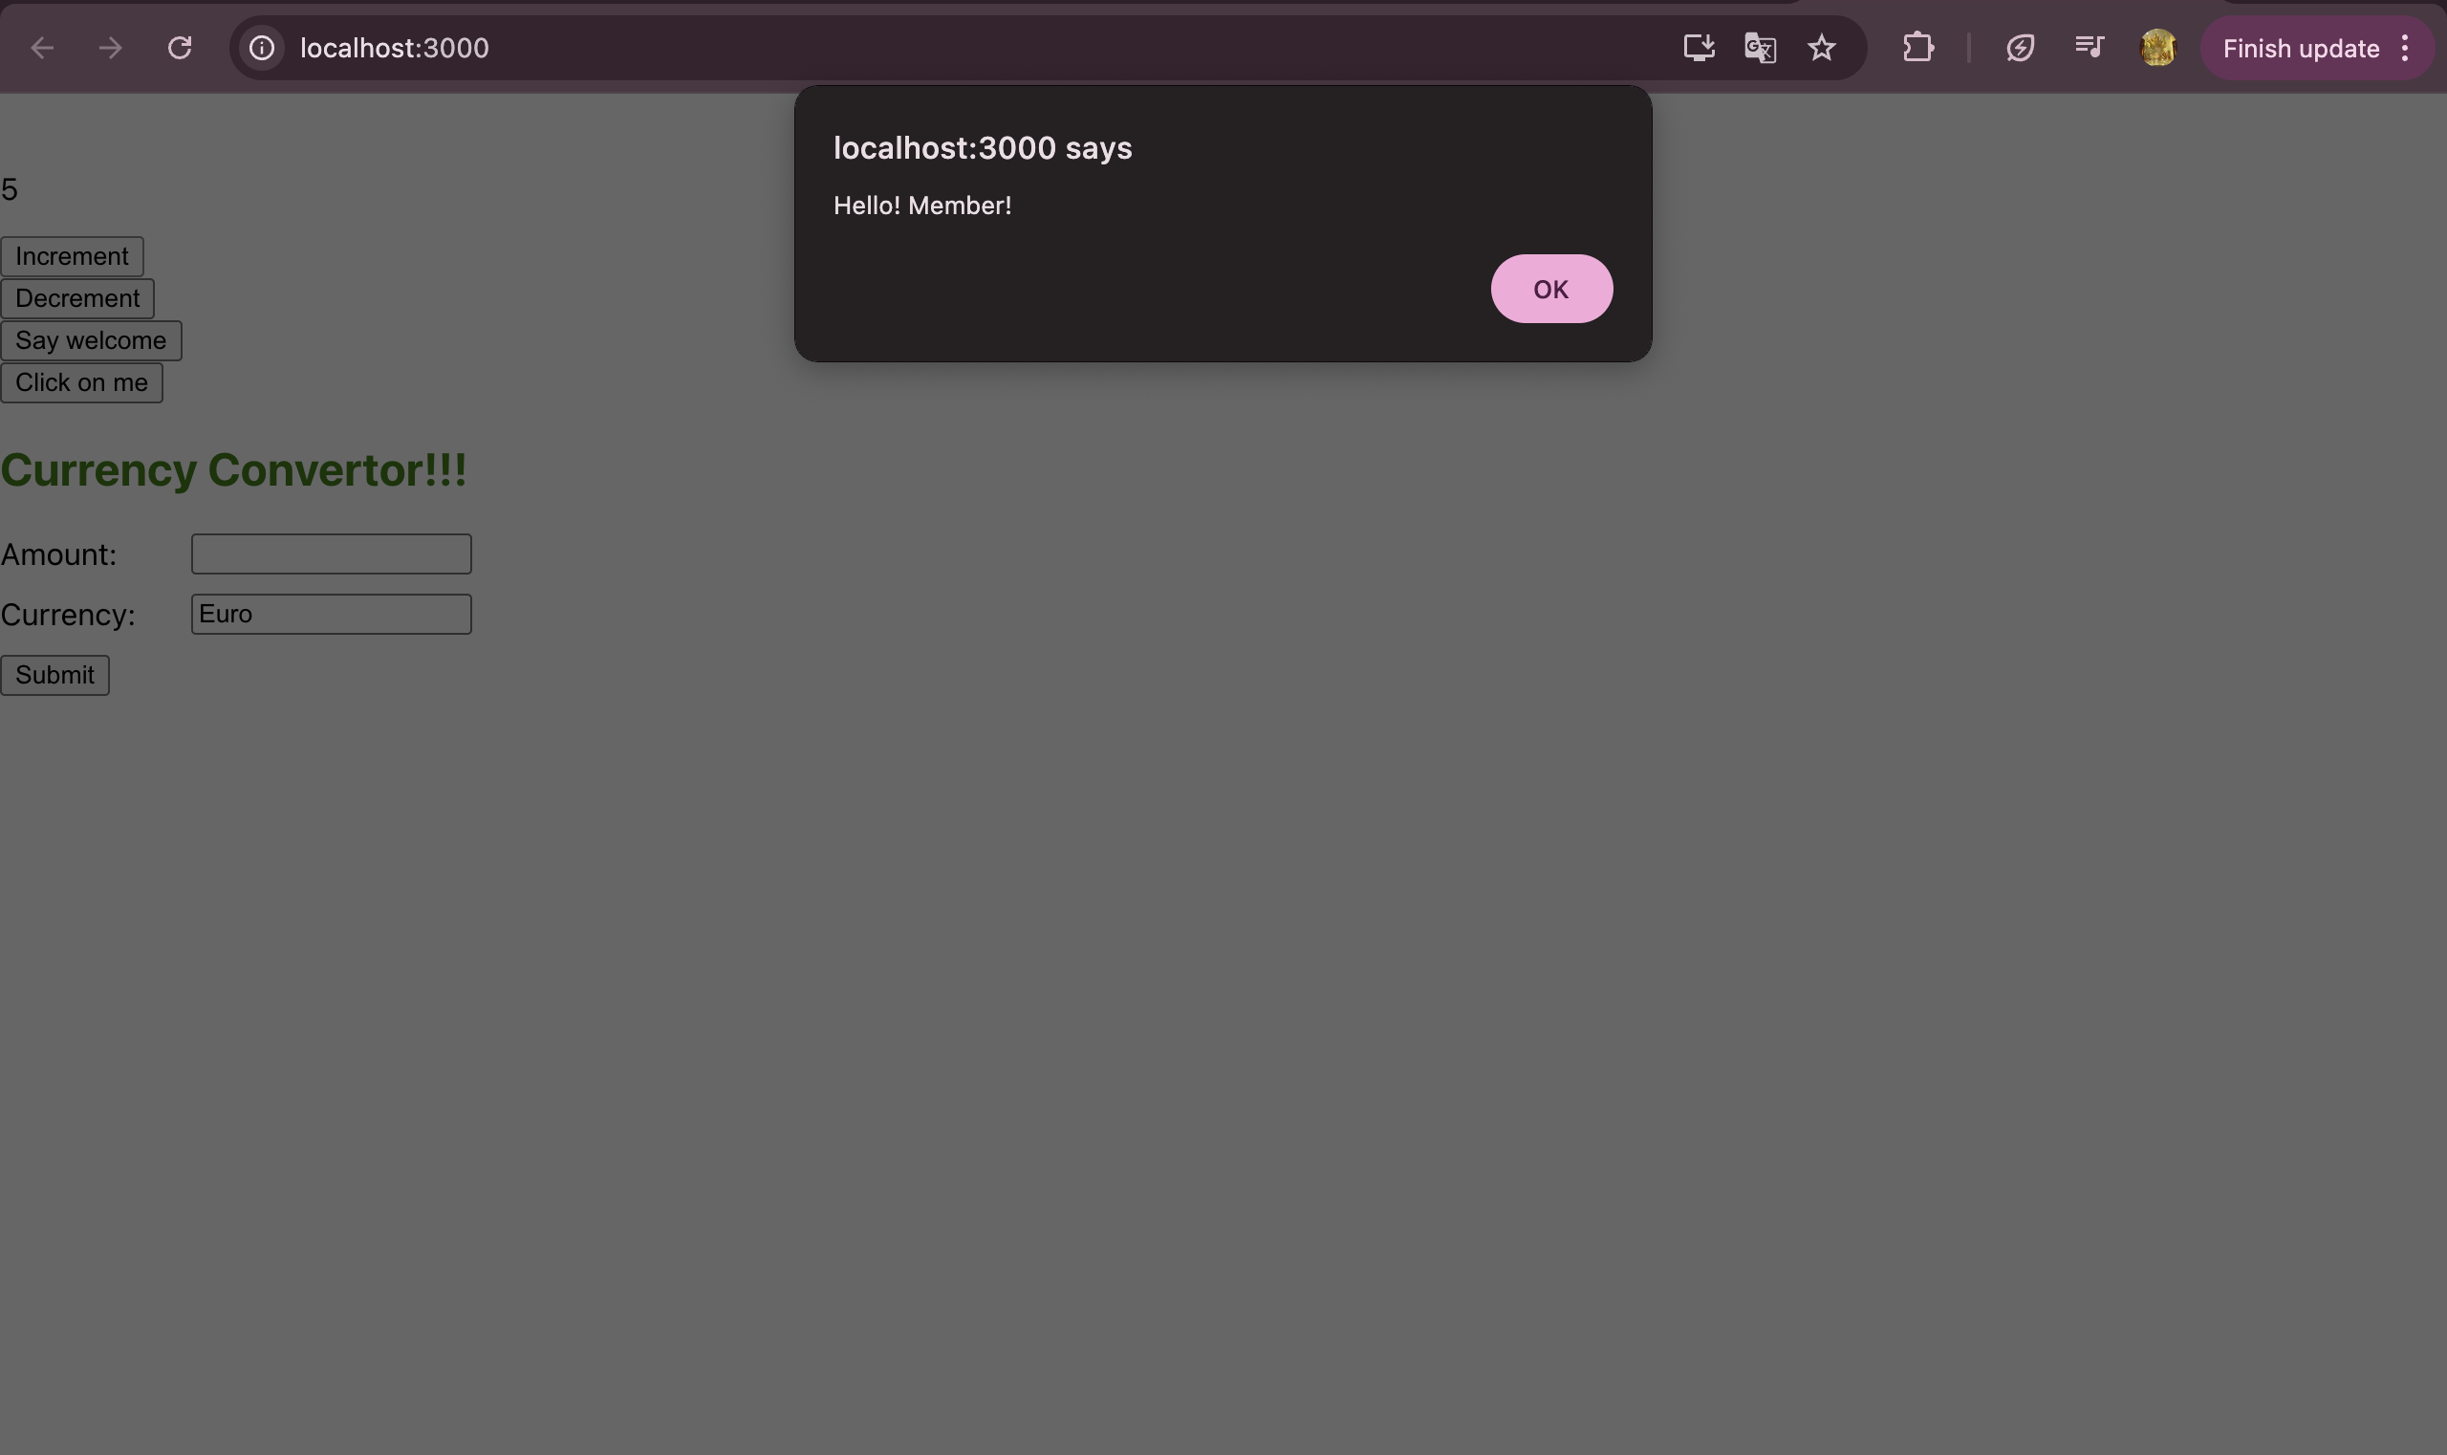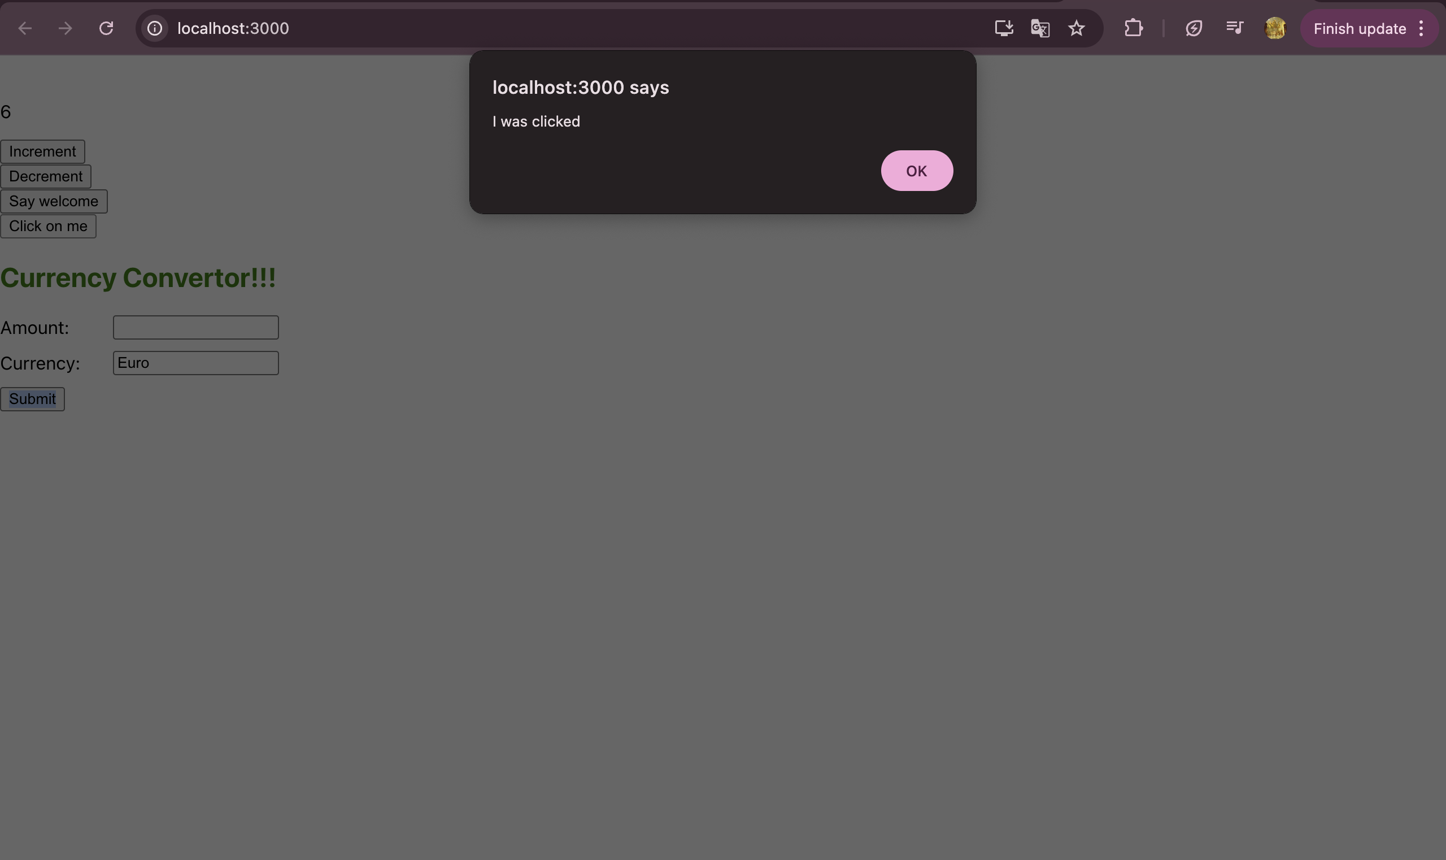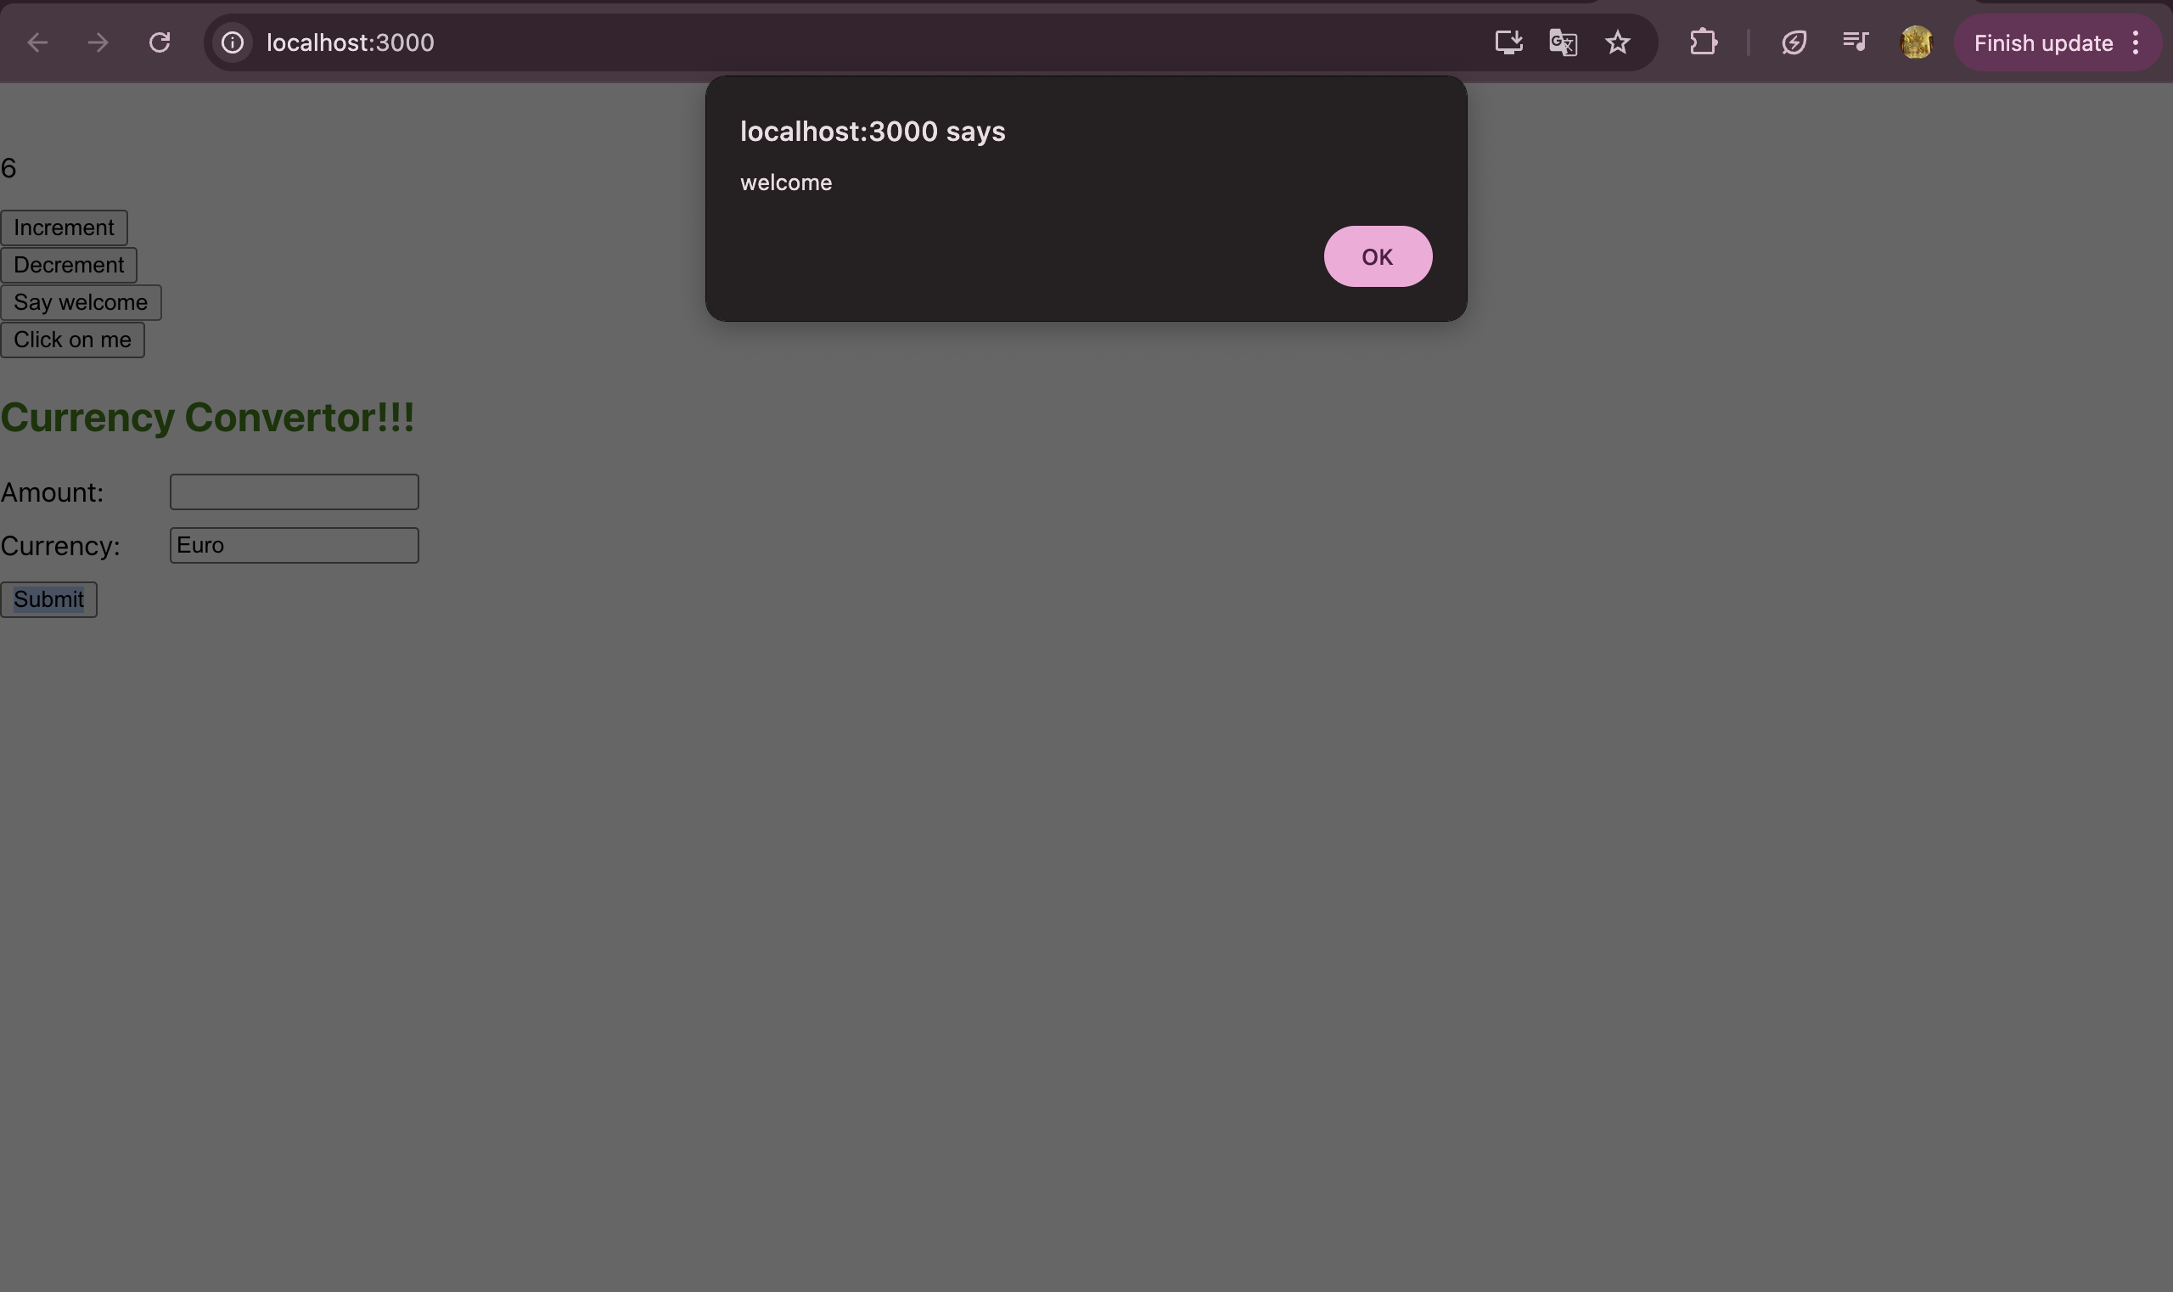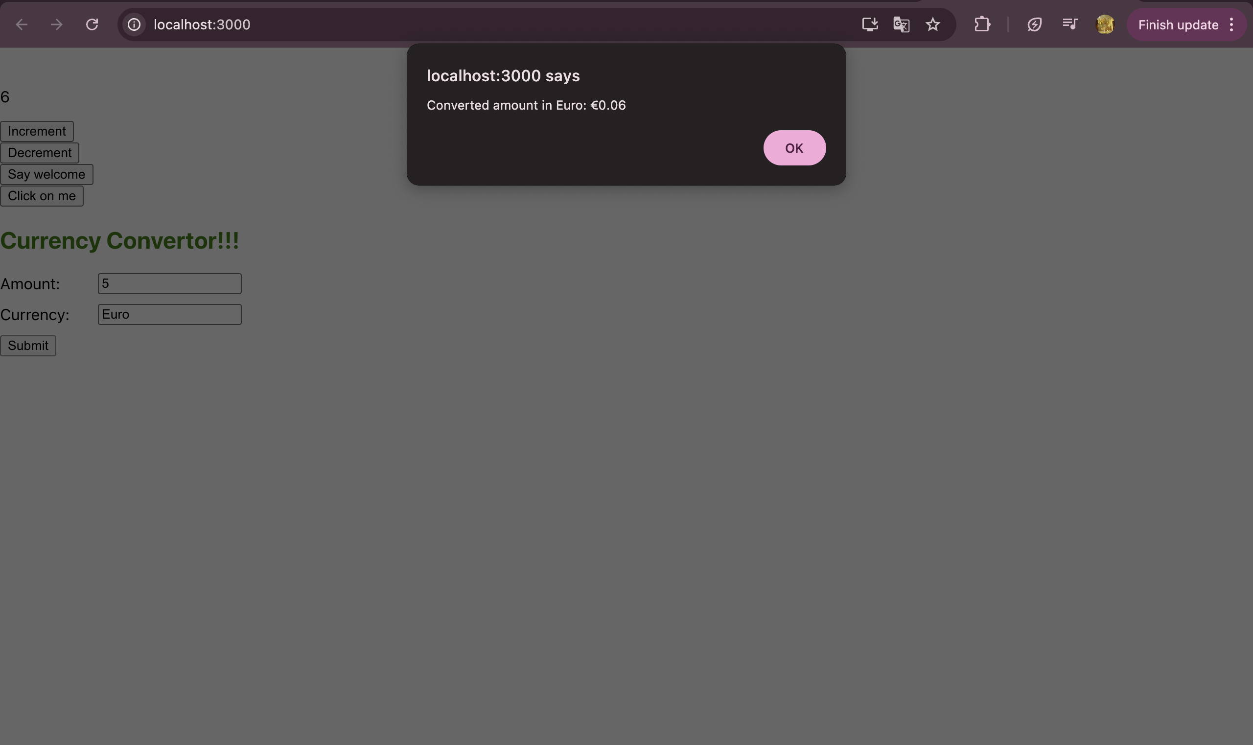

# HANDS-ON 4 :

import './App.css';

import React from "react";

function LoginButton(props) {

return (

<button onClick={props.onClick}>

Login

</button>

);

}

function LogoutButton(props) {

return (

<button onClick={props.onClick}>

Logout

</button>

);

}

function UserGreeting() {

return <h1>Welcome back</h1>;

}

function GuestGreeting() {

return <h1>Please sign up.</h1>;

}

function Greeting(props) {

const isLoggedIn = props.isLoggedIn;

if (isLoggedIn) {

return <UserGreeting />;

}

return <GuestGreeting />;

}

class App extends React.Component {

constructor(props) {

super(props);

this.handleLoginClick = this.handleLoginClick.bind(this);

this.handleLogoutClick = this.handleLogoutClick.bind(this);

this.state = { isLoggedIn: false };

}

handleLoginClick() {

this.setState({ isLoggedIn: true });

}

handleLogoutClick() {

this.setState({ isLoggedIn: false });

}

render() {

const isLoggedIn = this.state.isLoggedIn;

let button;

if (isLoggedIn) {

button = <LogoutButton onClick={this.handleLogoutClick} />;

} else {

button = <LoginButton onClick={this.handleLoginClick} />;

}

return (

<div className="App">

<Greeting isLoggedIn={isLoggedIn} />

{button}

</div>

);

}

}

export default App;

**Output**

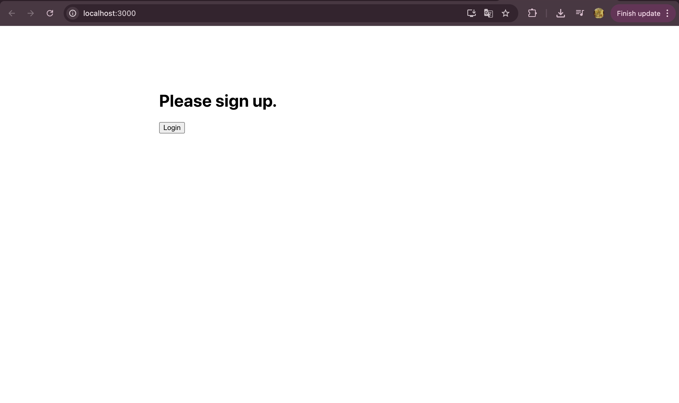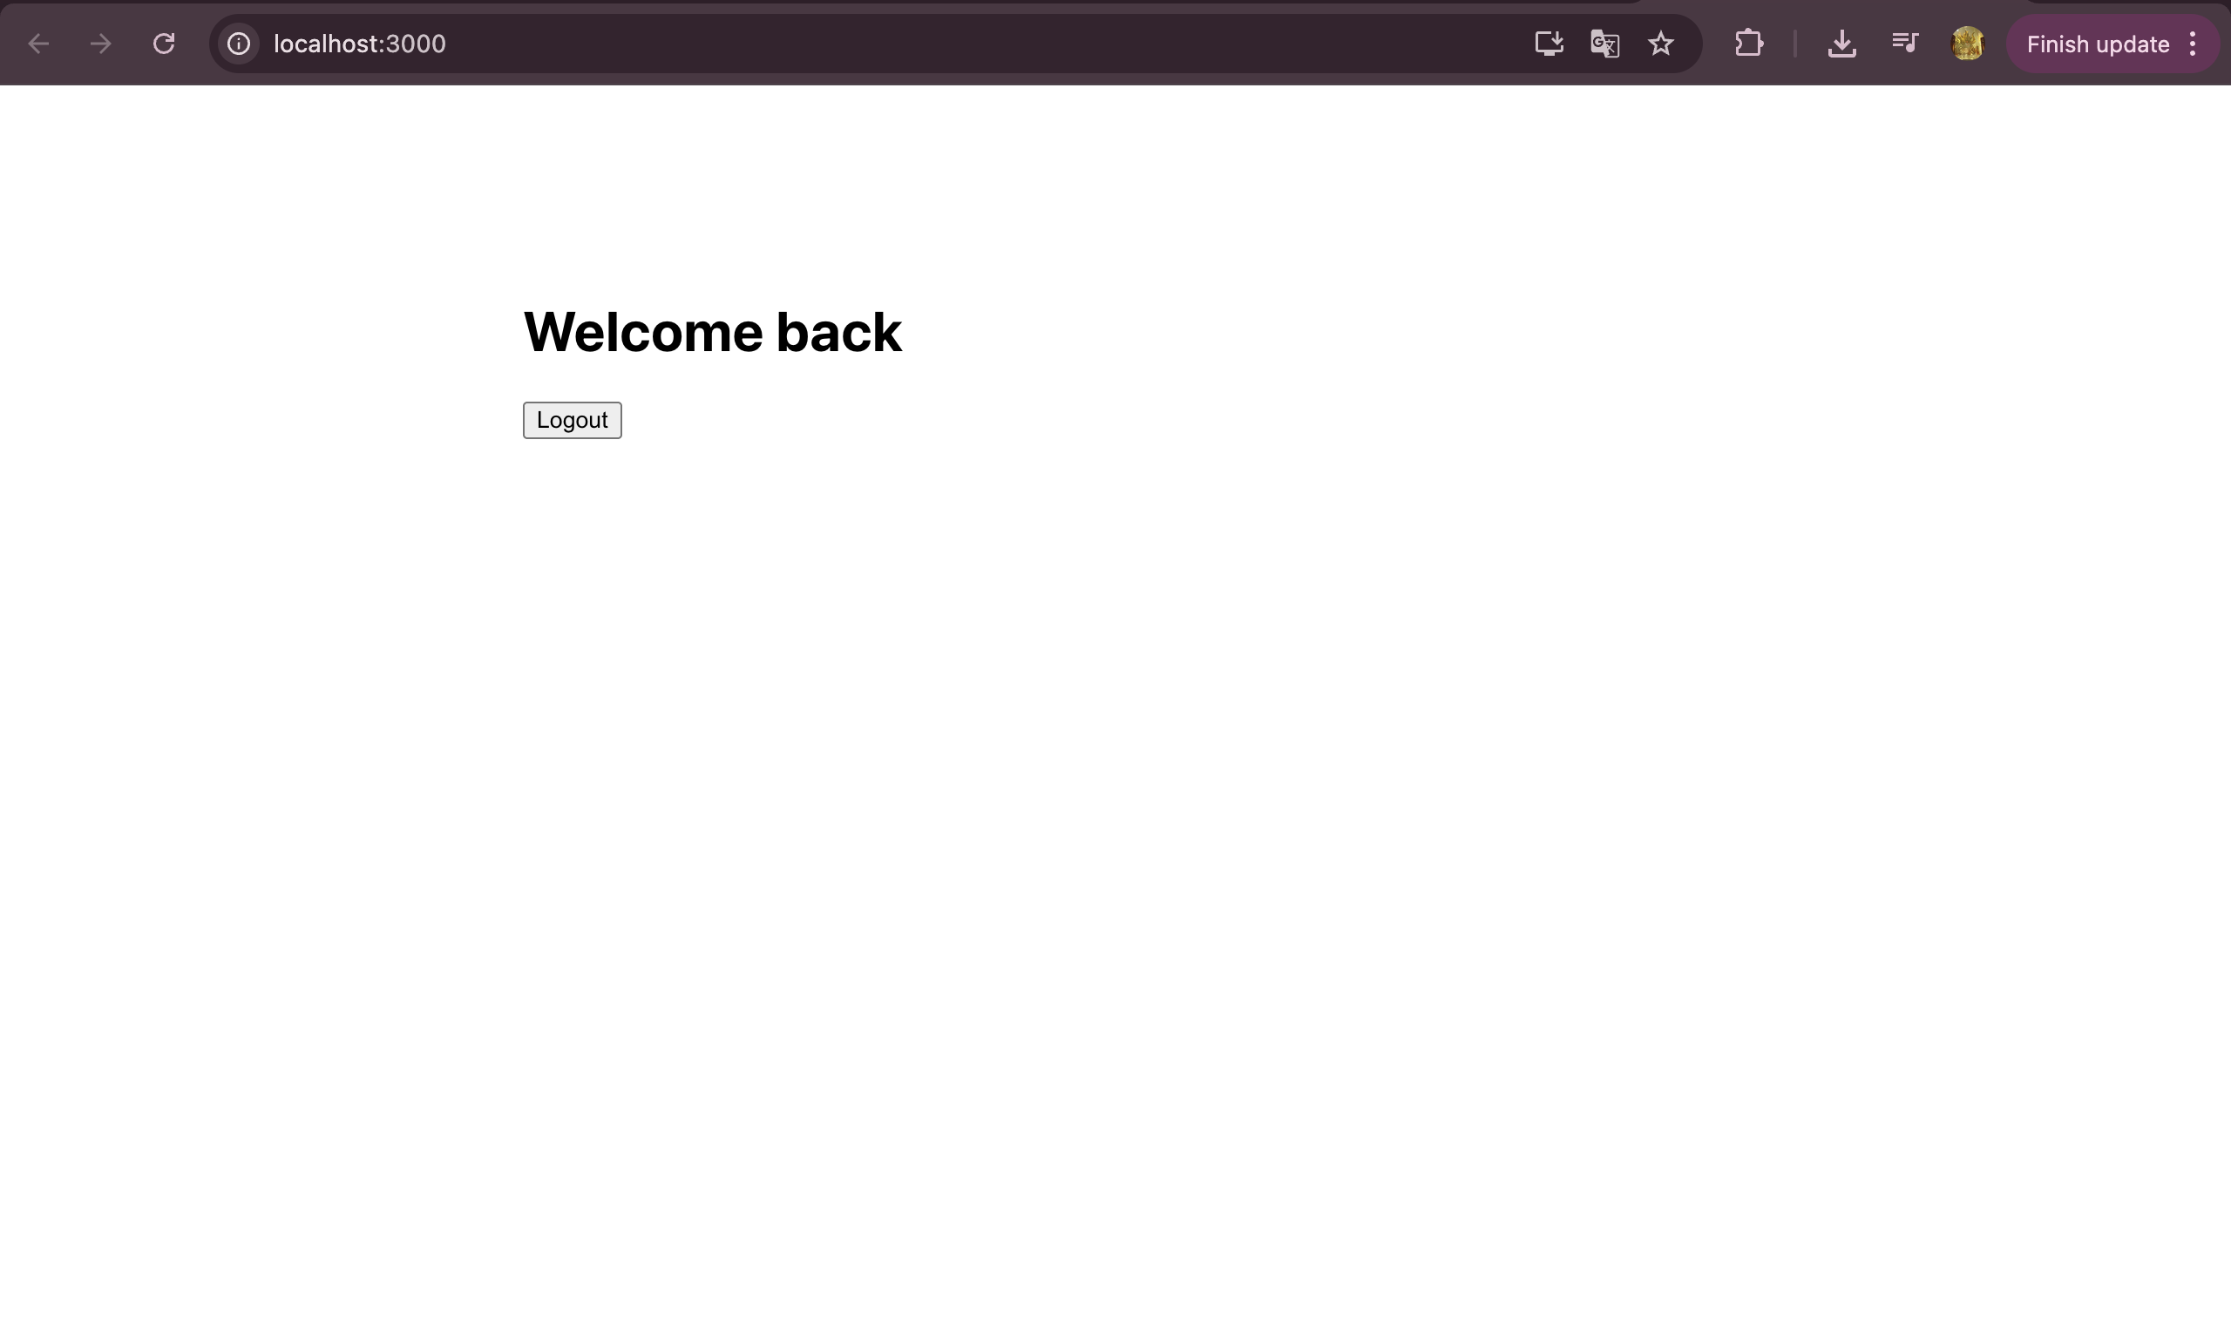

# HANDS-ON 5 :

import React from "react";

const blogs = [

{

title: "React Learning",

author: "Stephen Biz",

content: "Welcome to learning React!",

},

{

title: "Installation",

author: "Schewzdenier",

content: "You can install React from npm.",

},

];

function BlogDetails() {

return (

<div>

{blogs.map((blog, index) => (

<div

key={index}

>

<h1 style={{ fontWeight: 'bold'}}>{blog.title}</h1>

{blog.author && (

<div style={{ fontWeight: 'bold', marginBottom: '20px' }}>

{blog.author}

</div>

)}

<div>{blog.content}</div>

</div>

))}

</div>

);

}

export default BlogDetails;

import React from "react";

export const books = [

{ id: 101, bname: "Master React", price: 670 },

{ id: 102, bname: "Deep Dive into Angular 11", price: 800 },

{ id: 103, bname: "Mongo Essentials", price: 450 },

];

function BookDetails() {

if (books.length === 0) {

return <p><b>No Books Available</b></p>;

}

return (

<div style={{ paddingLeft: '30px' }}>

<ul style={{ listStyleType: 'none', padding: 0 }}>

{books.map((book) => (

<li

key={book.id}

style={{ padding: '10px', marginBottom: '5px' }}

>

<div style={{ fontWeight: 'bold', marginBottom: '5px' }}>

{book.bname}

</div>

<div style={{ fontWeight: 'bold', paddingTop: '20px' }}>{book.price}</div>

</li>

))}

</ul>

</div>

);

}

export default BookDetails;

import React from "react";

const courses = [

{ cname: "Angular", cdate: "4/5/2021" },

{ cname: "React", cdate: "6/3/2021" }, // corrected typo in year

];

function CourseDetails() {

return (

<>

{courses.length > 0 ? (

<div style={{ listStyle: "none"}}>

{courses.map((course, index) => (

<li

key={index}

>

<h1 style={{ fontWeight: "bold", paddingBottom: "5px" }}>

{course.cname}

</h1>

<div style={{ fontWeight: "bold" }}>{course.cdate}</div>

</li>

))}

</div>

) : (

<p style={{ fontWeight: "bold" }}>No Courses Available</p>

)}

</>

);

}

export default CourseDetails;

// App.js

import React from "react";

import BookDetails from "./BookDetails";

import BlogDetails from "./BlogDetails";

import CourseDetails from "./CourseDetails";

import "./App.css";

function App() {

return (

<div>

<div style={{ display: "flex", justifyContent: "space-evenly", padding: "40px" }}>

<div className="mystyle1">

<h1>Course Details</h1>

<CourseDetails />

</div>

<div className="st2">

<h1>Book Details</h1>

<BookDetails />

</div>

<div className="v1">

<h1>Blog Details</h1>

<BlogDetails />

</div>

</div>

</div>

);

}

export default App;

/* App.css */

.mystyle1, .st2, .v1 {

padding-left: 30px;

font-family: Arial, sans-serif;

}

.st2,.v1{

border-left: 4px solid green;

}

