# HANDS-ON 1 :

srijitpal@SRIJITs-MacBook-Pro ~ % git --version

git version 2.49.0

srijitpal@SRIJITs-MacBook-Pro ~ % git config --global --list

filter.lfs.clean=git-lfs clean -- %f

filter.lfs.smudge=git-lfs smudge -- %f

filter.lfs.process=git-lfs filter-process

filter.lfs.required=true

user.name=SrijitPal-Dev

user.email=151395008+SrijitPal-Dev@users.noreply.github.com

srijitpal@SRIJITs-MacBook-Pro ~ % git config --global user.name "SrijitPal-Dev"

git config --global user.email "srijit.activities@gmail.com"

srijitpal@SRIJITs-MacBook-Pro ~ % git config --global --list

filter.lfs.clean=git-lfs clean -- %f

filter.lfs.smudge=git-lfs smudge -- %f

filter.lfs.process=git-lfs filter-process

filter.lfs.required=true

user.name=SrijitPal-Dev

user.email=srijit.activities@gmail.com

srijitpal@SRIJITs-MacBook-Pro ~ % git config --global core.editor "code --wait"

srijitpal@SRIJITs-MacBook-Pro ~ % mkdir GitDemo

cd GitDemo

git init

hint: Using 'master' as the name for the initial branch. This default branch name

hint: is subject to change. To configure the initial branch name to use in all

hint: of your new repositories, which will suppress this warning, call:

hint:

hint: git config --global init.defaultBranch <name>

hint:

hint: Names commonly chosen instead of 'master' are 'main', 'trunk' and

hint: 'development'. The just-created branch can be renamed via this command:

hint:

hint: git branch -m <name>

Initialized empty Git repository in /Users/srijitpal/GitDemo/.git/

srijitpal@SRIJITs-MacBook-Pro GitDemo % echo "Welcome to the version control" > welcome.txt

srijitpal@SRIJITs-MacBook-Pro GitDemo % cat welcome.txt

ls -al

Welcome to the version control

total 8

drwxr-xr-x 4 srijitpal staff 128 4 Aug 10:36 .

drwxr-x---+ 64 srijitpal staff 2048 4 Aug 10:36 ..

drwxr-xr-x 9 srijitpal staff 288 4 Aug 10:36 .git

-rw-r--r-- 1 srijitpal staff 31 4 Aug 10:36 welcome.txt

srijitpal@SRIJITs-MacBook-Pro GitDemo % git status

git add welcome.txt

On branch master

No commits yet

Untracked files:

(use "git add <file>..." to include in what will be committed)

welcome.txt

nothing added to commit but untracked files present (use "git add" to track)

srijitpal@SRIJITs-MacBook-Pro GitDemo % git commit -m "Initial commit: add welcome.txt"

git status

[master (root-commit) efb8de0] Initial commit: add welcome.txt

1 file changed, 1 insertion(+)

create mode 100644 welcome.txt

On branch master

nothing to commit, working tree clean

srijitpal@SRIJITs-MacBook-Pro GitDemo % git branch -M master

srijitpal@SRIJITs-MacBook-Pro GitDemo % git push -u origin master

srijitpal@SRIJITs-MacBook-Pro GitDemo % git remote add origin https://gitlab.com/srijit.activities-group/GitDemo.git

srijitpal@SRIJITs-MacBook-Pro GitDemo % git push -u origin master

Username for 'https://gitlab.com': srijit.activities

Password for 'https://srijit.activities@gitlab.com':

Enumerating objects: 3, done.

Counting objects: 100% (3/3), done.

Writing objects: 100% (3/3), 270 bytes | 270.00 KiB/s, done.

Total 3 (delta 0), reused 0 (delta 0), pack-reused 0 (from 0)

remote:

remote: To create a merge request for master, visit:

remote: https://gitlab.com/srijit.activities-group/GitDemo/-/merge_requests/new?merge_request%5Bsource_branch%5D=master

remote:

To https://gitlab.com/srijit.activities-group/GitDemo.git

* [new branch] master -> master

branch 'master' set up to track ‘origin/master'.

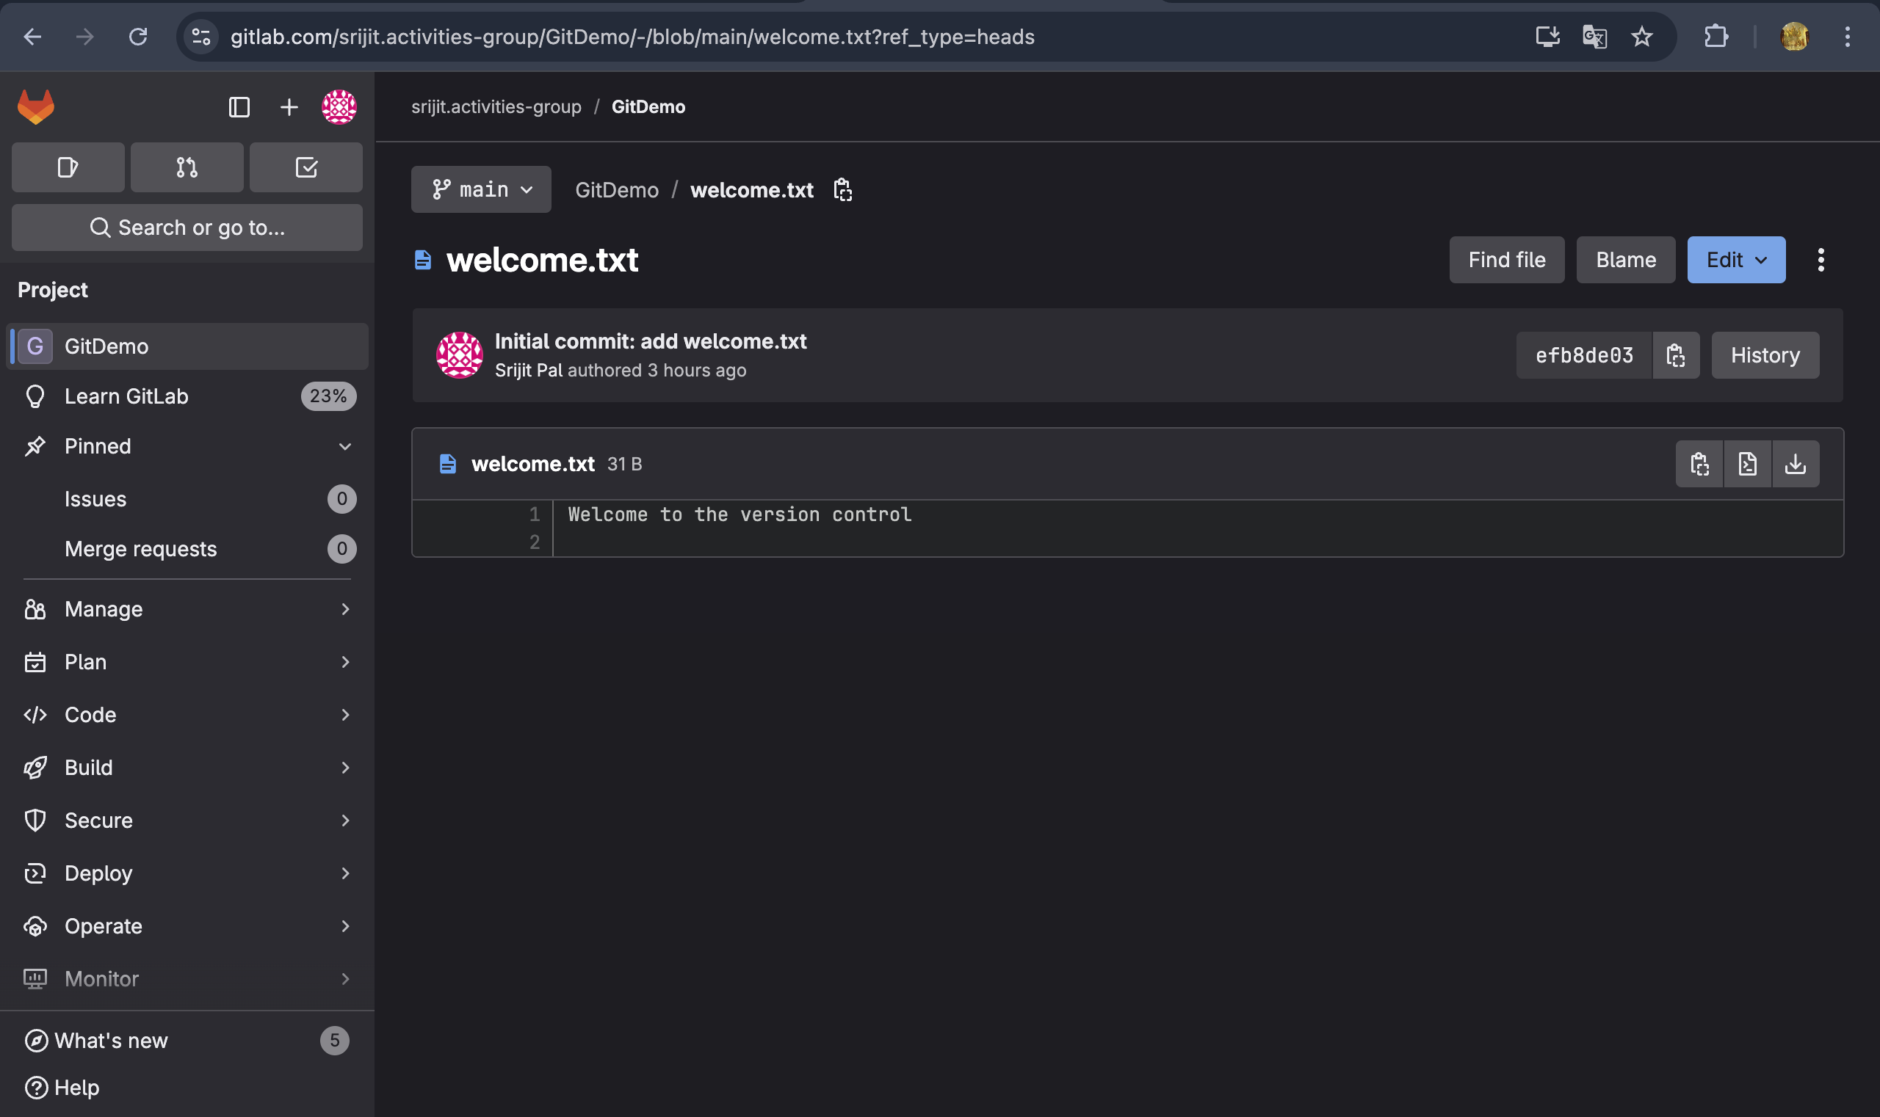

# HANDS-ON 2 :

srijitpal@SRIJITs-MacBook-Pro GitDemo % touch test.log

srijitpal@SRIJITs-MacBook-Pro GitDemo % mkdir log

srijitpal@SRIJITs-MacBook-Pro GitDemo % touch log/debug.txt

srijitpal@SRIJITs-MacBook-Pro GitDemo % touch .gitignore

srijitpal@SRIJITs-MacBook-Pro GitDemo % nano .gitignore

srijitpal@SRIJITs-MacBook-Pro GitDemo % git status

On branch master

Your branch is up to date with 'origin/master'.

Untracked files:

(use "git add <file>..." to include in what will be committed)

.gitignore

nothing added to commit but untracked files present (use "git add" to track)

srijitpal@SRIJITs-MacBook-Pro GitDemo % git add .gitignore

git commit -m "Add .gitignore to exclude log files and folder"

git push

[master 27ac7f8] Add .gitignore to exclude log files and folder

1 file changed, 3 insertions(+)

create mode 100644 .gitignore

Enumerating objects: 4, done.

Counting objects: 100% (4/4), done.

Delta compression using up to 8 threads

Compressing objects: 100% (2/2), done.

Writing objects: 100% (3/3), 324 bytes | 324.00 KiB/s, done.

Total 3 (delta 0), reused 0 (delta 0), pack-reused 0 (from 0)

remote:

remote: To create a merge request for master, visit:

remote: https://gitlab.com/srijit.activities-group/GitDemo/-/merge_requests/new?merge_request%5Bsource_branch%5D=master

remote:

To https://gitlab.com/srijit.activities-group/GitDemo.git

* [new branch] master -> master

srijitpal@SRIJITs-MacBook-Pro GitDemo % git status

On branch master

Your branch is up to date with 'origin/master'.

nothing to commit, working tree clean

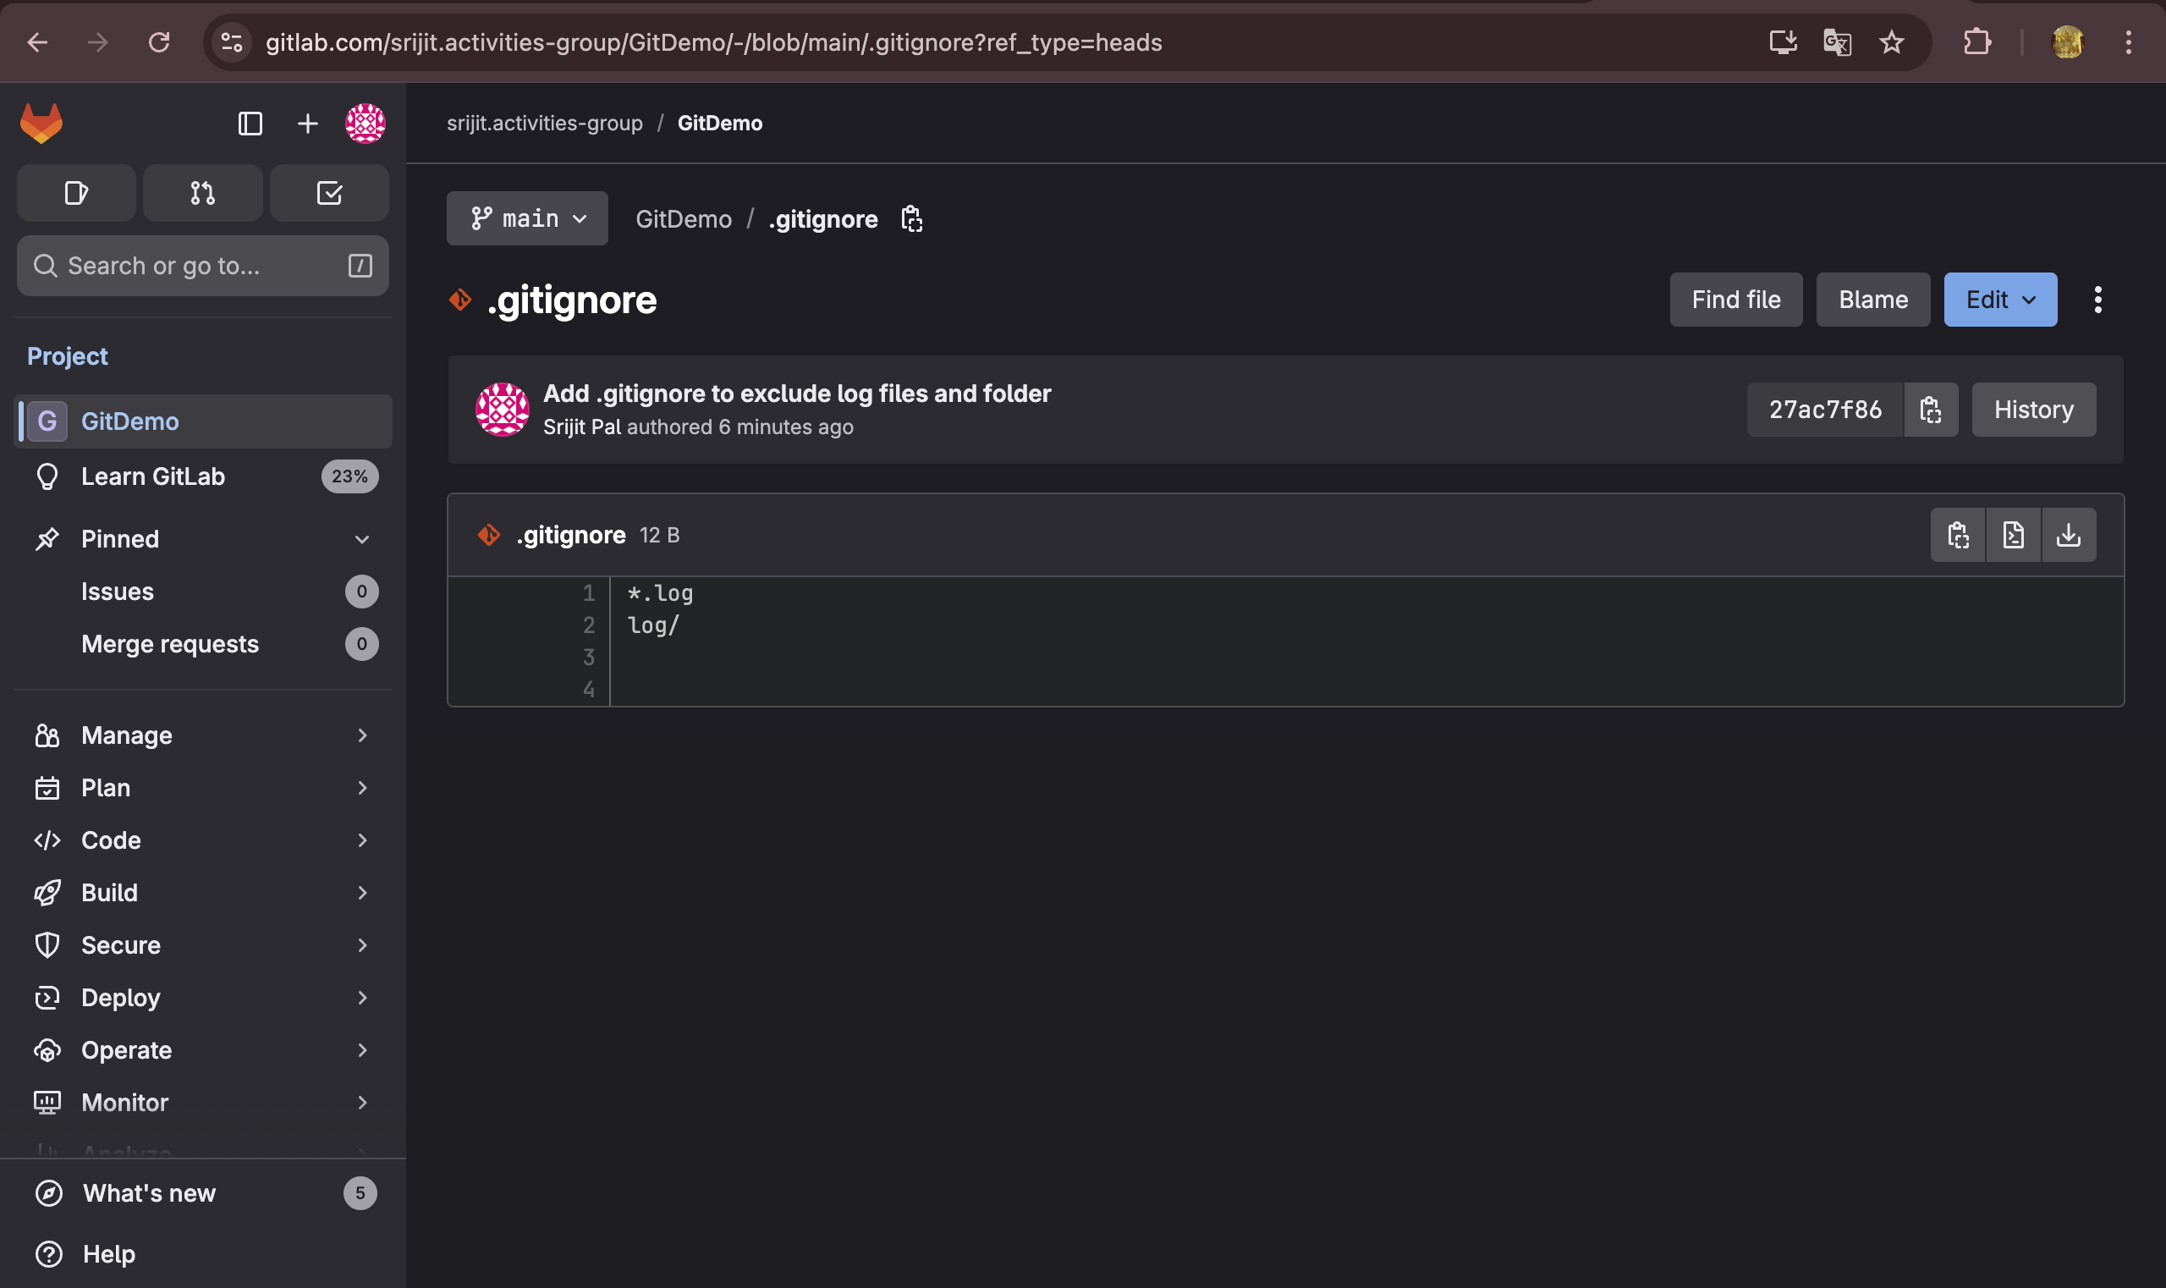

# HANDS-ON 3 :

**Branching**

srijitpal@SRIJITs-MacBook-Pro GitDemo % git branch GitNewBranch

srijitpal@SRIJITs-MacBook-Pro GitDemo % git branch -a

GitNewBranch

* master

remotes/origin/HEAD -> origin/main

remotes/origin/main

remotes/origin/master

srijitpal@SRIJITs-MacBook-Pro GitDemo % git checkout GitNewBranch

Switched to branch 'GitNewBranch'

srijitpal@SRIJITs-MacBook-Pro GitDemo % echo "This is a file on the new branch" > branchfile.txt

mkdir newfolder

echo "Inside new folder" > newfolder/info.txt

mkdir: newfolder: File exists

srijitpal@SRIJITs-MacBook-Pro GitDemo % git add .

git commit -m "Added new files in GitNewBranch"

On branch GitNewBranch

nothing to commit, working tree clean

srijitpal@SRIJITs-MacBook-Pro GitDemo % git status

On branch GitNewBranch

nothing to commit, working tree clean

**Merging**  
  
srijitpal@SRIJITs-MacBook-Pro GitDemo % git checkout master

Switched to branch ‘master'

srijitpal@SRIJITs-MacBook-Pro GitDemo % git difftool GitNewBranch

qt.pointer.dispatch: skipping QEventPoint(id=1 ts=0 pos=0,0 scn=404.819,386.753 gbl=404.819,386.753 Released ellipse=(1x1 ∡ 0) vel=0,0 press=-404.819,-386.753 last=-404.819,-386.753 Δ 404.819,386.753) : no target window

^C

srijitpal@SRIJITs-MacBook-Pro GitDemo % git merge GitNewBranch

Updating 1aa35cf..c969f54

Fast-forward

branchfile.txt | 2 ++

1 file changed, 2 insertions(+)

srijitpal@SRIJITs-MacBook-Pro GitDemo % git log --oneline --graph --decorate

* c969f54 (**HEAD** -> **master**, **GitNewBranch**) Added new files in GitNewBranch

* 1aa35cf Added new files in GitNewBranch

* 27ac7f8 (**origin/master**) Add .gitignore to exclude log files and folder

* efb8de0 Initial commit: add welcome.txt

srijitpal@SRIJITs-MacBook-Pro GitDemo % git branch -d GitNewBranch

Deleted branch GitNewBranch (was c969f54).

srijitpal@SRIJITs-MacBook-Pro GitDemo % git status

On branch master

Your branch is up to date with 'origin/master'.

nothing to commit, working tree clean

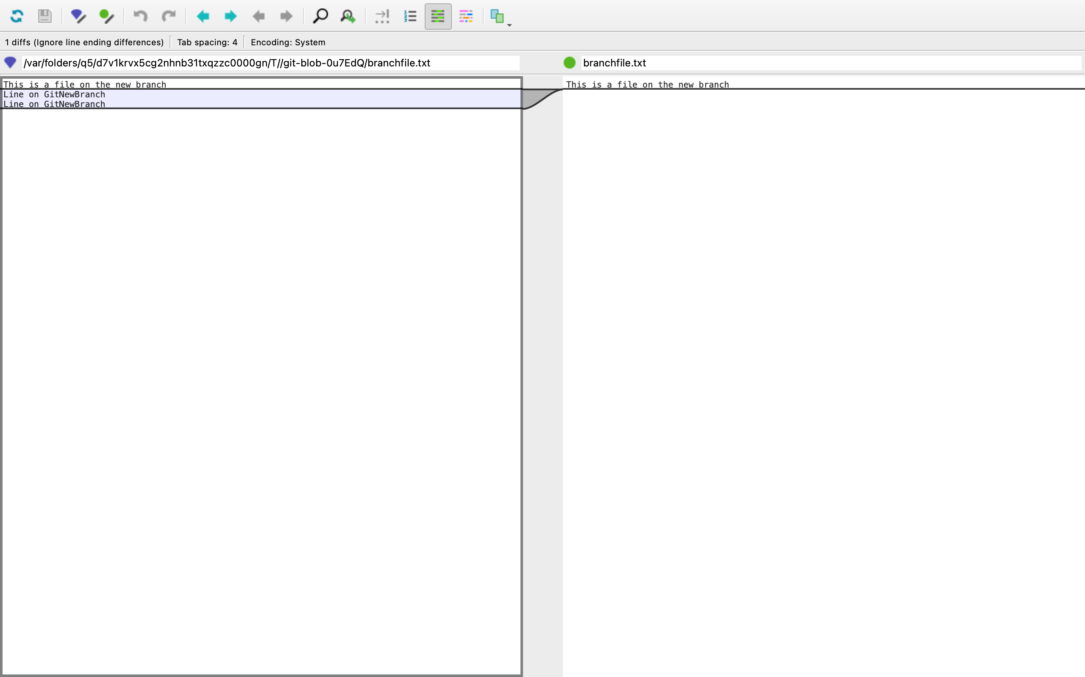

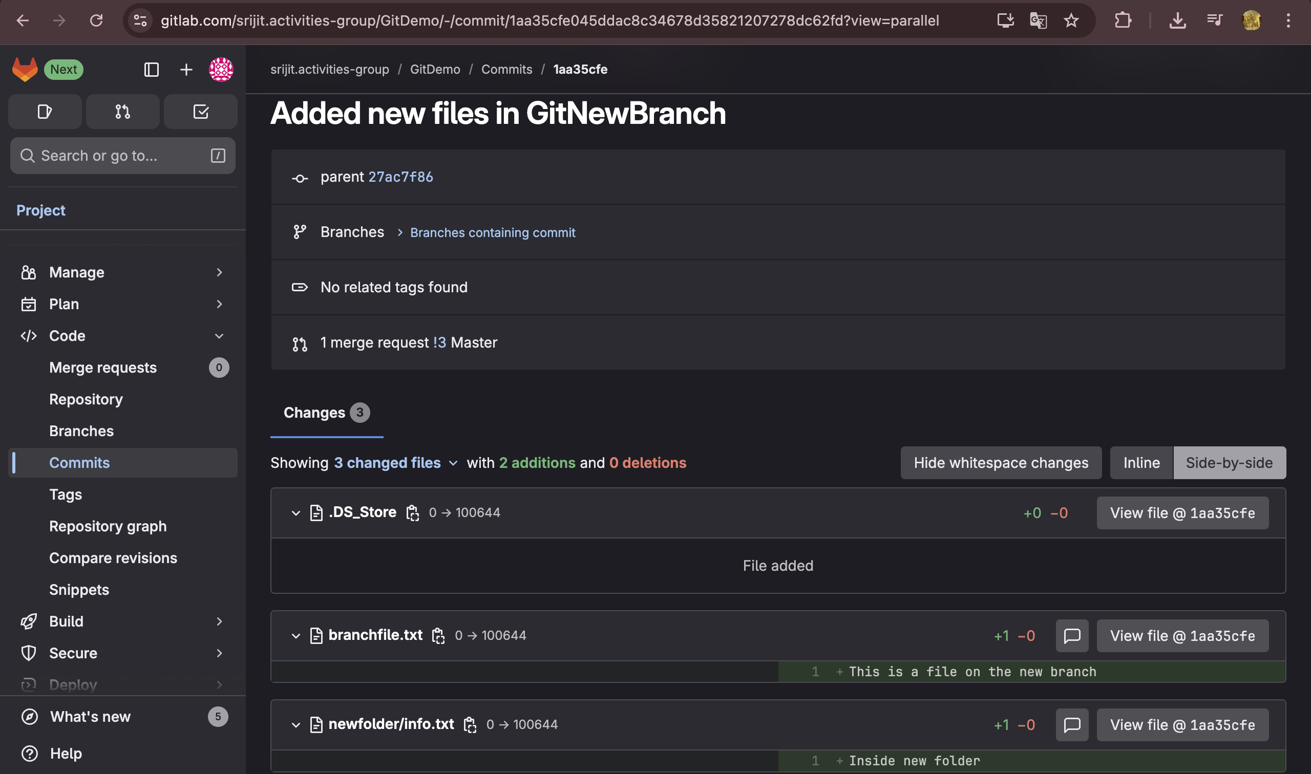

# HANDS-ON 4 :

srijitpal@SRIJITs-MacBook-Pro GitDemo % git checkout master

Already on 'master'

Your branch is up to date with 'origin/master'.

srijitpal@SRIJITs-MacBook-Pro GitDemo % git status

On branch master

Your branch is up to date with 'origin/master'.

nothing to commit, working tree clean

srijitpal@SRIJITs-MacBook-Pro GitDemo % git checkout -b GitWork

Switched to a new branch 'GitWork'

srijitpal@SRIJITs-MacBook-Pro GitDemo % echo "<note><to>User</to></note>" > hello.xml

srijitpal@SRIJITs-MacBook-Pro GitDemo % echo "<from>GitWork Branch</from>" >> hello.xml

srijitpal@SRIJITs-MacBook-Pro GitDemo % git status

git add hello.xml

git commit -m "Added hello.xml in GitWork branch"

On branch GitWork

Untracked files:

(use "git add <file>..." to include in what will be committed)

hello.xml

nothing added to commit but untracked files present (use "git add" to track)

[GitWork 0a24f2d] Added hello.xml in GitWork branch

1 file changed, 2 insertions(+)

create mode 100644 hello.xml

srijitpal@SRIJITs-MacBook-Pro GitDemo % git checkout master

Switched to branch 'master'

Your branch is up to date with 'origin/master'.

srijitpal@SRIJITs-MacBook-Pro GitDemo % echo "<note><to>MasterUser</to><body>Master content</body></note>" > hello.xml

git add hello.xml

git commit -m "Added hello.xml in master with different content"

[master d1c053b] Added hello.xml in master with different content

1 file changed, 1 insertion(+)

create mode 100644 hello.xml

srijitpal@SRIJITs-MacBook-Pro GitDemo % git log --oneline --graph --decorate --all

* d1c053b (**HEAD** -> **master**) Added hello.xml in master with different content

| * 0a24f2d (**GitWork**) Added hello.xml in GitWork branch

|/

* a1a1d49 (**origin/master**) Update .gitignore to ignore temporary files

* c969f54 Added new files in GitNewBranch

* 1aa35cf Added new files in GitNewBranch

* 27ac7f8 Add .gitignore to exclude log files and folder

| * c9e8a88 (**origin/main**, **origin/HEAD**) Merge branch 'master' into 'main'

| |\

| |/

|/|

* | efb8de0 Initial commit: add welcome.txt

/

* 4711e6a Initial commit

srijitpal@SRIJITs-MacBook-Pro GitDemo % git difftool GitWork

qt.pointer.dispatch: skipping QEventPoint(id=1 ts=0 pos=0,0 scn=417.924,389.595 gbl=417.924,389.595 Released ellipse=(1x1 ∡ 0) vel=0,0 press=-417.924,-389.595 last=-417.924,-389.595 Δ 417.924,389.595) : no target window

qt.pointer.dispatch: skipping QEventPoint(id=1 ts=0 pos=0,0 scn=611.884,279.01 gbl=611.884,279.01 Released ellipse=(1x1 ∡ 0) vel=0,0 press=-611.884,-279.01 last=-611.884,-279.01 Δ 611.884,279.01) : no target window

^C

srijitpal@SRIJITs-MacBook-Pro GitDemo % git difftool -t p4merge GitWork

qt.pointer.dispatch: skipping QEventPoint(id=1 ts=0 pos=0,0 scn=295.785,271.338 gbl=295.785,271.338 Released ellipse=(1x1 ∡ 0) vel=0,0 press=-295.785,-271.338 last=-295.785,-271.338 Δ 295.785,271.338) : no target window

^C

srijitpal@SRIJITs-MacBook-Pro GitDemo % git merge GitWork

Auto-merging hello.xml

CONFLICT (add/add): Merge conflict in hello.xml

Automatic merge failed; fix conflicts and then commit the result.

srijitpal@SRIJITs-MacBook-Pro GitDemo % git mergetool

This message is displayed because 'merge.tool' is not configured.

See 'git mergetool --tool-help' or 'git help config' for more details.

'git mergetool' will now attempt to use one of the following tools:

tortoisemerge emerge vimdiff nvimdiff

Merging:

hello.xml

Normal merge conflict for 'hello.xml':

{local}: created file

{remote}: created file

Hit return to start merge resolution tool (vimdiff):

3 files to edit

srijitpal@SRIJITs-MacBook-Pro GitDemo % git add hello.xml

git commit -m "Resolved conflict between GitWork and master"

[master 932749e] Resolved conflict between GitWork and master

srijitpal@SRIJITs-MacBook-Pro GitDemo % git status

On branch master

Your branch is ahead of 'origin/master' by 3 commits.

(use "git push" to publish your local commits)

Untracked files:

(use "git add <file>..." to include in what will be committed)

hello.xml.orig

nothing added to commit but untracked files present (use "git add" to track)

srijitpal@SRIJITs-MacBook-Pro GitDemo % echo "*.orig" >> .gitignore

git add .gitignore

git commit -m "Ignore backup files from merge tools"

[master 4425e5d] Ignore backup files from merge tools

1 file changed, 1 insertion(+)

srijitpal@SRIJITs-MacBook-Pro GitDemo % git branch

GitWork

* master

srijitpal@SRIJITs-MacBook-Pro GitDemo % git branch -d GitWork

Deleted branch GitWork (was 0a24f2d).

srijitpal@SRIJITs-MacBook-Pro GitDemo % git log --oneline --graph --decorate

* 4425e5d (**HEAD** -> **master**) Ignore backup files from merge tools

* 932749e Resolved conflict between GitWork and master

|\

| * 0a24f2d Added hello.xml in GitWork branch

* | d1c053b Added hello.xml in master with different content

|/

* a1a1d49 (**origin/master**) Update .gitignore to ignore temporary files

* c969f54 Added new files in GitNewBranch

* 1aa35cf Added new files in GitNewBranch

* 27ac7f8 Add .gitignore to exclude log files and folder

* efb8de0 Initial commit: add welcome.txt

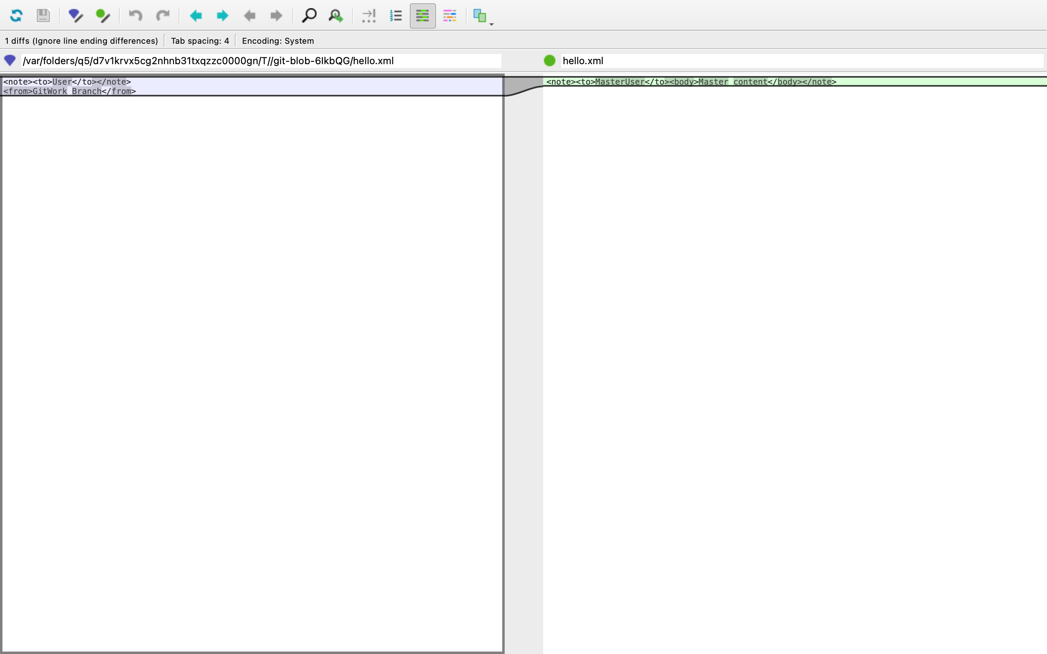

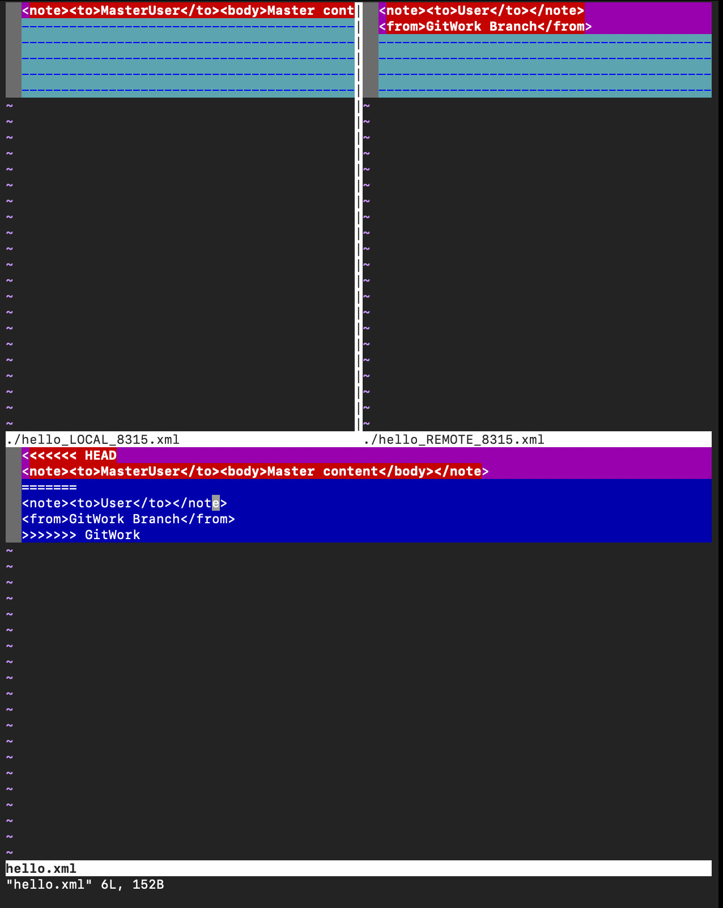

# HANDS-ON 5 :

srijitpal@SRIJITs-MacBook-Pro GitDemo % git checkout master

Already on 'master'

Your branch is up to date with 'origin/master'.

srijitpal@SRIJITs-MacBook-Pro GitDemo % git status

On branch master

Your branch is up to date with 'origin/master'.

nothing to commit, working tree clean

srijitpal@SRIJITs-MacBook-Pro GitDemo % git branch -a

* master

remotes/origin/HEAD -> origin/main

remotes/origin/main

remotes/origin/master

srijitpal@SRIJITs-MacBook-Pro GitDemo % git pull origin master

From https://gitlab.com/srijit.activities-group/GitDemo

* branch master -> FETCH_HEAD

Already up to date.

srijitpal@SRIJITs-MacBook-Pro GitDemo % git push origin master

Enumerating objects: 30, done.

Counting objects: 100% (30/30), done.

Delta compression using up to 8 threads

Compressing objects: 100% (19/19), done.

Writing objects: 100% (30/30), 2.86 KiB | 2.86 MiB/s, done.

Total 30 (delta 8), reused 22 (delta 5), pack-reused 0 (from 0)

remote:

remote: To create a merge request for master, visit:

remote: https://gitlab.com/srijit.activities-group/GitDemo/-/merge_requests/new?merge_request%5Bsource_branch%5D=master

remote:

To https://gitlab.com/srijit.activities-group/GitDemo.git

* [new branch] master -> master

srijitpal@SRIJITs-MacBook-Pro GitDemo % git add .gitignore

git commit -m "Update .gitignore to ignore .log files and log folder (HOL_002)"

git push origin master

On branch master

Your branch is up to date with 'origin/master'.

nothing to commit, working tree clean

Everything up-to-date