Curriculum Vitae

Name : Srijita Kundu 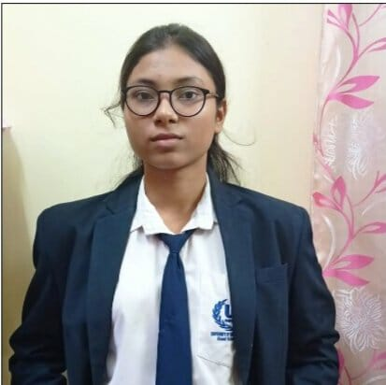

Address : 13/1/2 Nather Bagan Street, Kolkata-700005

Mobile No : 7439260701

E-mail : [srijitakundu66@gmail.com](mailto:srijitakundu66@gmail.com)

Academic Qualifications:

|  |  |  |  |  |  |  |
| --- | --- | --- | --- | --- | --- | --- |
| Degree/  Certificate | Degree | Discipline | Institute | Board/  University | Year of passing | Agreegate  % / CGPA |
| Graduation | B.Tech | CSE | University of  Engineering & Management,  Kolkata | University of  Engineering & Management,  Kolkata | 2026 | 9.02( Upto 2ND Semester)  7.83(Upto 4th Semester) |
| 12th | Higher  Secondary | Science | Taki House Govt. Sponsored  Girls’ High School | WBCHSE | 2022 | 80.8 |
| 10th | Secondary | General | Ramakrishna Sarada Mission  Sister Nivedita  Girls’ School | WBBSE | 2020 | 88.57 |

Trainings / Projects Undertaken:

|  |  |  |
| --- | --- | --- |
| Name of Institute/  Organization | Project Title | Duration |
| University Of Engineering &Management | STUDENT_PORTAL | 7 DAYS |

Minor Projects Completed:

1. Designing &Implementation of Job Portal and connecting the frontend with backend.
2. Making Signup & Login Portal using react & connect with MongoDB compass & displaying backend data into page.
3. Making calculator using Html, CSS &JavaScript.
4. E-commerce Project
5. Making Food App

Major Projects Completed:

Additional qualification/achievements/Certifications:

* DSA Workshops Attended
* Got Certificate of Appreciation in University EVENT MANAGEMENT

Subjects of Interest:

* Data Structures and Algorithms
* Database Management
* Web Development
* Operating System
* Photography
* Reading
* Computer Skills

Skills:

* Programming
* Project Management
* Web Designing
* Prototyping
* Front-End Web Development
* Communication skills
* Analytical thinking
* Problem solving
* Teamwork
* Circuit Design
* Active Learning
* Organizational Skills
* Patience

**Cours**e:

* Html, CSS and JavaScript course
* Data analysis and algorithm

Programming Language Proficiency:

* C
* Java Basics
* Python Basics

Hobbies:

* Reading books
* Listening music
* Art crafting

Family Details:

|  |  |  |
| --- | --- | --- |
| Details | Name | Occupation |
| Father | Tarun Kumar Kundu | Business |
| Mother | Anjana Kundu | Home maker |

Personal Details:

Date of Birth: 11-08-2004

Gender: Female

Languages Known: Bengali ,English , Hindi

Date: 25.09.2023