Design Document: Customer Churn Prediction
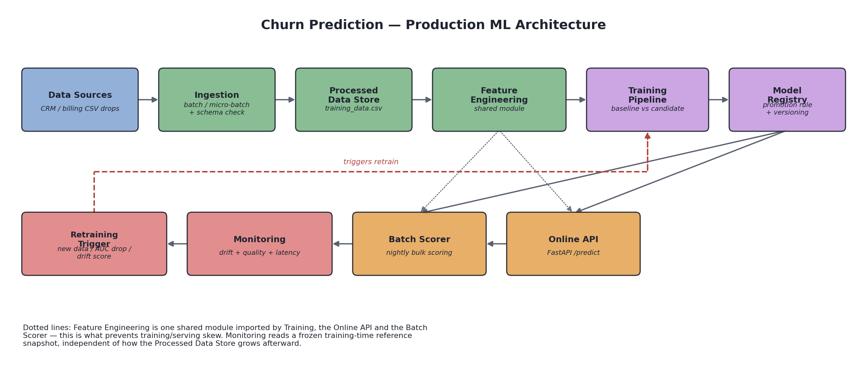
Figure 1: System architecture

1. Problem Definition and Metrics
Use case. Binary classification: given a telecom customer's account attributes, predict whether they will churn (Churn = Yes/No). A churn score feeds two downstream consumers: a retention team's daily outreach list (batch) and a CRM widget an agent can query mid-call (online).
Dataset. IBM Telco Customer Churn, 7,043 customers, 21 raw columns (demographics, subscribed services, contract/billing terms, tenure, charges, and the Churn label). Positive rate (churn) is ~26.5% — moderately imbalanced, which drives the metric choice below. One known data quirk: 11 customers with tenure == 0 have a blank TotalCharges string (they haven't been billed yet); this is handled explicitly in src/features.py rather than silently coerced to NaN.
Metrics. ROC AUC is the primary model-selection metric because it is threshold-independent and robust to the ~3:1 class imbalance — accuracy alone can look good on a model that just leans toward predicting "No churn." Precision, recall, and F1 are reported alongside AUC because they map to the actual business trade-off: every predicted churner triggers a retention offer with a real cost (recall too high → wasted incentives on customers who weren't leaving; recall too low → preventable churn missed). This project reports all four and lets a configurable promotion rule (Section 3) act on AUC, but a real deployment would tune the decision threshold against the retention team's cost-per-offer, not just use 0.5.

2. Data and Feature Design
Six engineered features, implemented once in src/features.py::build_features and imported unchanged by training, the online API, and the batch scorer (the training/serving-skew mitigation — see below):
- num_services — count of subscribed add-ons + internet (aggregation).
- tenure_bucket — new / established / loyal, a coarse lifecycle-stage encoding of tenure.
- avg_monthly_spend_ratio — lifetime average spend (TotalCharges / (tenure+1)) vs. current MonthlyCharges; a ratio well below 1 flags a recent price increase or promo rolling off, a known churn precursor.
- contract_risk_score — a domain-informed composite of contract length, payment method, and paperless billing, each independently correlated with churn.
- is_high_value_customer — MonthlyCharges above the 75th percentile of the training set.
- has_internet_no_security — interaction flag: has internet service but neither OnlineSecurity nor TechSupport.
Online vs. offline. In this dataset every raw input is available at request time (it's a point-in-time account snapshot, not an event stream), so features 1, 2, 4, and 6 are computed online, directly from the request payload, with zero external lookups. Feature 5 is the interesting case: its threshold is a statistic of the training population, not of any single request, so it cannot be recomputed per-request without risking a different cutoff at serving time than at training time (and a meaningless cutoff for a single-row batch). It is fit once in fit_feature_thresholds on the training split, persisted to models/feature_thresholds.json, and loaded by model_loader.py alongside the model — a minimal "feature store" in spirit: one small JSON file instead of a training/serving copy of the same computation. In a system with true time-windowed aggregates (e.g., "logins in the last 30 days"), this is exactly the pattern that would generalize: an offline job writes aggregates to a feature table, and serving does a lookup instead of a live recomputation.
Training/serving skew mitigation. The core guardrail here is structural, not procedural: build_features is one function, imported by train.py, serving/app.py, and scripts/batch_score.py. There is no second implementation to drift out of sync. tests/test_features.py includes a direct regression test for this: it featurizes one row as part of a full batch (training path) and again as a lone single-row frame (online-serving path) and asserts the two outputs are byte-for-byte identical.
Data pipeline step. src/data_ingestion.py is the repeatable micro-batch ingestion piece: it scans data/incoming/ for CSV files not yet recorded in data/ingestion_log.jsonl, validates each against the required-column schema in configs/config.yaml, appends valid files to data/processed/training_data.csv, and logs {timestamp, source_file, rows_ingested, cumulative_rows} per file. It is idempotent (safe to re-run on a schedule) and rejects files with missing columns outright rather than silently dropping fields. scripts/simulate_batches.py is a one-time fixture generator (not part of the repeatable pipeline) that splits the raw dataset into a historical seed and 5 simulated daily arrivals, with one day's MonthlyCharges and contract mix deliberately shifted to give the monitoring step (Section 5) something real to catch.

3. Model Choice and Offline Evaluation
Two models share an identical preprocessing pipeline (StandardScaler on numeric features, OneHotEncoder on categoricals) so the comparison isolates model choice, not feature handling:
- Baseline: LogisticRegression — fast, interpretable, a reasonable floor for a tabular problem this size.
- Candidate: RandomForestClassifier (300 trees, max depth 8) — can capture non-linear interactions (e.g., contract type × tenure) the baseline cannot.
Split: 70% train / 15% val / 15% test, stratified on Churn, fit on the pre-drift training snapshot (6,480 rows — see Section 4 on why day_04/ day_05 were excluded from this snapshot). Validation results:
Metric | Baseline (LogisticRegression) | Candidate (RandomForest)
Accuracy | 0.778 | 0.783
ROC AUC | 0.839 | 0.836
Precision | 0.604 | 0.614
Recall | 0.502 | 0.517
F1 | 0.548 | 0.561

Promotion rule (configs/config.yaml: promotion): promote the candidate only if its AUC clears an absolute floor (0.75) and it does not regress vs. the baseline by more than 0.01 AUC. Here the candidate's AUC is 0.0032 below the baseline's — within the allowed regression margin — and it clears the floor, and it wins on every other metric (precision, recall, F1, accuracy), so train.py promotes it. The decision and full reasoning are written to artifacts/eval/comparison_report.md and models/registry.json every run, not just printed — this is what a promotion gate in CI would read. On the held-out test set the promoted model scores AUC 0.822, accuracy 0.786 — close enough to validation to suggest limited overfitting from the RandomForest's depth constraint.

4. Serving and Inference Pattern
Chosen pattern: hybrid (online API + batch scorer), both reusing the same model_loader.py (reads models/registry.json for "which model is currently in production") and the same features.py.
- Online (src/serving/app.py, FastAPI): POST /predict takes raw customer fields and returns {churn_probability, churn_prediction, model_version}; GET /health reports liveness and the loaded model version. Justification (M2 framing): a CRM agent mid-call, or an automated retention workflow reacting to a support-ticket event, is a human/system waiting on the answer — this needs low, predictable latency, not high throughput on any single request.
- Batch (scripts/batch_score.py): scores an entire CSV in one process, no HTTP overhead. Justification: nightly scoring of the full customer base for a retention-outreach list has no one waiting on any individual row — throughput matters, not per-row latency.
Measured performance (artifacts/eval/): the online endpoint averaged 9.35ms latency (p50 9.19ms, p95 10.54ms, max 14.2ms) over 200 sequential local requests, zero errors. Batch scoring processed all 7,043 rows in 0.137s (~51,500 rows/sec) — expected, since it pays feature engineering and inference cost once per batch instead of once per HTTP round trip. This asymmetry is the quantitative version of the pattern-choice argument above: batch is roughly 500x more row-throughput-efficient, at the cost of not being real-time.
Containerization (bonus): a minimal Dockerfile (python:3.11-slim, copies src/, models/, configs/, runs uvicorn) is included but not build-verified in this environment (no Docker daemon available here).

5. Data Pipeline, Monitoring, and Retraining
Monitoring plan.
- Infra metrics: request latency (avg/p95, measured above) and error rate — in production, a dashboard for the on-call engineer, alerting if p95 latency exceeds an SLO or error rate exceeds a small threshold.
- Data/feature metrics: null rates and out-of-range values (tenure, MonthlyCharges) on every incoming batch; mean/std drift on 6 numeric features and category-share drift on Contract, compared against a reference frozen at training time — a dashboard for the ML/data engineering team, alerting on any single flagged feature so a schema or upstream-pipeline change is caught before it reaches the model.
- Model/business metrics: AUC computed periodically against freshly labeled feedback (customers whose actual churn/no-churn outcome is now known) — a dashboard for the ML team and product stakeholders, alerting when it drops meaningfully below the last-validated baseline.
Drift/quality check (src/monitoring.py, all three implemented and runnable, not just described): check_schema (required columns present), check_data_quality (null rates, out-of-range values), and check_drift. The drift check compares a recent batch against models/train_feature_stats.json (the exact training-time reference, frozen independent of how training_data.csv grows afterward) using a one-sample z-test per numeric feature — (recent_mean − ref_mean) / (ref_std / √n_recent) — rather than a flat percent-of-mean threshold. This matters in practice: an early version of this check used a flat 10% relative-mean-shift threshold and it false-positived on a clean 281-row batch purely from sampling noise; the z-test correctly accounts for batch size (a given mean shift is less surprising on a small sample) and made the false positive disappear while still catching the real drift. Verified against two real files: day_04 (deliberately shifted MonthlyCharges +25% and contract mix) correctly flags 4 numeric features (MonthlyCharges z=6.72, avg_monthly_spend_ratio z=−19.56, contract_risk_score z=3.43, is_high_value_customer z=7.19) and the Contract category (17.1pp share shift); day_05 (untouched) is checked as a negative control and correctly reports no issues.
Retraining trigger (should_retrain in src/monitoring.py, a real function, not pseudocode — the pseudocode form below is for readability):
retrain if ANY of:
new_days_of_data >= 3 # enough fresh data has accumulated
baseline_auc - recent_labeled_auc >= 0.03 # measured perf has degraded
drift_score >= 2 # 2+ features/categories flagged
Run against day_04 with a simulated recent-feedback AUC of 0.79 (vs. the production test AUC of 0.822), all three signals fire independently: 4 days of new data, a 0.032 AUC drop, and a drift score of 5. Run against clean day_05, none fire. Any single signal is sufficient by design — data volume, measured performance, and distributional drift each catch failure modes the others miss (drift can precede a measurable AUC drop; an AUC drop can happen with no detectable feature drift, e.g. a change in customer behavior).
Incident scenario. Suppose the upstream billing system reworks its export and silently drops the Contract column (a real "schema evolved without telling anyone" failure). check_schema on the next ingested batch immediately flags missing_columns: ['Contract'] and the pipeline skips the drift check for that batch rather than crashing deep inside feature engineering or silently imputing a wrong default — this was verified directly by dropping the column from a real batch file and confirming SCHEMA ALERT fires and no drift/retrain computation proceeds on bad data. Response: (1) freeze ingestion of new batches from that source, (2) roll the production pointer in models/registry.json back to the previously known-good model version if the current one is already degrading (no retrain needed if the previous model still meets the promotion bar), (3) fix the upstream export or add a backward-compatible default, (4) backfill/re-ingest the affected batches once the schema is restored, (5) retrain once enough corrected data has accumulated.

6. Trade-offs, Limitations, and Future Work
- Static snapshot, not a real event stream. Telco churn is a point-in-time dataset; "online vs. offline feature" is somewhat academic here since nothing requires a real feature store. The design (frozen reference stats, shared feature module, JSON-persisted thresholds) is deliberately the pattern that would generalize to a system with true time-windowed aggregates, but it is not stress-tested against one here.
- Simple registry, no rollback tooling. models/registry.json is a single JSON file with no history beyond "current baseline/candidate," and no automated rollback command — Section 5's incident response describes rolling back manually. A real system would want versioned history and a one-command rollback.
- Drift check is univariate. Each feature is checked independently; it would miss a drift that only shows up in a combination of features (e.g., a multivariate distribution shift with unchanged marginals). A more mature version would add a multivariate check (e.g., population stability index on model score itself, or a classifier-based drift detector).
- No real labeled feedback loop. recent_labeled_auc in the retraining trigger is supplied manually via a CLI flag in this project; production would need an actual feedback pipeline joining predictions to eventual outcomes, with its own latency (churn labels only become known after the fact, often weeks later).
- Threshold left at 0.5. The API and evaluation both use the default 0.5 cutoff; a production deployment should pick the operating threshold from the retention team's real cost-per-outreach vs. cost-per-missed-churn, which this project does not have.
- Future work: a real model registry (MLflow or similar) instead of one JSON file; a proper feature store for any future time-windowed features; canary/shadow deployment of the candidate before full promotion instead of an offline-only promotion gate; SHAP-based explanations surfaced alongside each prediction for the retention team.

