***PERSONALIZE GREETING CARD GENERATOR***

**Abstract**

Our ground breaking project, the "Personalize Greetings Card Generator," is a delightful fusion of creativity and technology aimed at revolutionizing the art of heartfelt expression. The project leverages a pre-trained text-to-image generation model obtained from the Hugging Face website, setting the stage for a unique and personalized greeting card creation experience.

The journey begins with the careful selection and validation of the pre-trained model to ensure its seamless integration into our system. After confirming its functionality, we proceeded to implement the model in our codebase, where we established a robust interface for user interaction.

Key to the project's success is the creation of an Excel database that serves as the repository for employee preferences and details. This database allows us to store valuable information about each employee, capturing their likes and preferences. The stored data becomes the foundation for generating personalized greetings cards.

Our user-friendly interface prompts the user to input specific details, such as the employee ID and the desired number of images for greetings card creation. Once the input is provided, the code dynamically retrieves the relevant information from the Excel sheet, constructing a prompt for the greetings card generation process.

The magic unfolds as the model takes the generated prompt and creates unique and personalized greetings cards, reflecting the individuality of each recipient. Whether it's a colleague's birthday or a special occasion, our AI-powered Greetings Card Generator transforms routine expressions into memorable and heartfelt moments.

In summary, our documentation provides a comprehensive overview of the entire project journey – from model selection and validation to database implementation and user interface development. The Greetings Card Generator stands as a testament to the seamless integration of AI technology into the realm of creative expression, enhancing the way we convey sentiments and celebrate meaningful occasions.

**INTRODUCTION:-**

Personalized Greeting Card Generator is a delightful fusion of creativity and technology that aims to revolutionize the art of heartfelt expressions. This innovative project is designed to redefine the traditional greeting card experience by seamlessly blending personalization with user-friendly technology. Harnessing the power of advanced algorithms, our generator enables users to craft unique and emotionally resonant messages tailored to individual preferences. From birthdays to special occasions, this project empowers users to transcend generic sentiments, infusing each card with a personalized touch that truly speaks from the heart. Embracing the charm of customization, our Greeting Card Generator promises a novel and memorable way to celebrate and connect, fostering genuine connections in a digital age. Welcome to a world where heartfelt sentiments meet cutting-edge technology, inviting everyone to share the joy of personalized expressions.

**LIBRARIES USED FOR THIS PROJECT:-**

We have used some python libraries to complete the project , the libraries and what the libraries does in our project is given below….

* torch: PyTorch library, commonly used for deep learning tasks. In this case, it seems to be utilized for the Stable Diffusion XL model.
* Diffusers.:- Diffusers is the go-to library for state-of-the-art pre-trained diffusion models for generating images, audio, and even 3D structures.
* PIL (Python Imaging Library): Used for image processing tasks. It's employed for opening, manipulating, and saving images.
* pandas: A powerful data manipulation library used to read data from an Excel file into a Data-Frame.
* OS: The Python os module provides a way to interact with the operating system. It's used here to create directories and handle file operations.
* time: The time module is used for generating a timestamp that's appended to the generated image filenames.
* rembg (Remove Background): A library for removing the background from images. It seems to be applied to a personal photo in the project.
* numpy: A library for numerical operations. In this case, it's used to convert images to arrays for processing.
* gradio: A library , used for generating a interface for the user to give input and take output.

**Methodology:**

1. User Input: Gather user information, such as recipient's name, occasion, preferences, and personal photo. Input can be collected through a user interface or retrieved from a database.
2. Data Extraction: Extract additional information from a database or external source. This may include details like favourite colour, favourite season, types of places like to visit(mountain , sea beach , etc) hobbies, or any other personalized data.
3. Model Initialization: Initialize a pre-trained model that generates personalized greeting card designs. In this case, it appears to be the Stable Diffusion XL model.
4. Image Generation: Use the model to generate a base image for the greeting card based on the user's preferences and occasion details.
5. Image Customization: Overlay the user's personal photo onto the generated base image. Use background removal techniques (e.g., rembg) to ensure a clean integration of the personal photo.
6. Text Addition: Add personalized text to the image, including a greeting message, recipient's name, and any other relevant information.
7. Font and Style Selection: Utilize a specified font and style to ensure a visually appealing and cohesive design.
8. Image Saving: Save the personalized greeting card image to a designated directory, ensuring a unique filename (possibly with a timestamp).

# Model Details

1**:- Model Description:**

* Developed by: Segmind
* Developers: Yatharth Gupta and Vishnu Jaddipal.
* Model type: Diffusion-based text-to-image generative model
* License: Apache 2.0
* Distilled From stabilityai/stable-diffusion-xl-base-1.0

**Key Features**

* **Text-to-Image Generation:** The model excels at generating images from text prompts, enabling a wide range of creative applications.
* **Distilled for Speed:** Designed for efficiency, this model offers a 60% speedup, making it a practical choice for real-time applications and scenarios where rapid image generation is essential.
* **Diverse Training Data:** Trained on diverse datasets, the model can handle a variety of textual prompts and generate corresponding images effectively.
* **Knowledge Distillation:** By distilling knowledge from multiple expert models, the Segmind Stable Diffusion Model combines their strengths and minimizes their limitations, resulting in improved performance.

**Model Architecture:**

The SSD-1B Model is a 1.3B Parameter Model which has several layers removed from the Base SDXL Model.

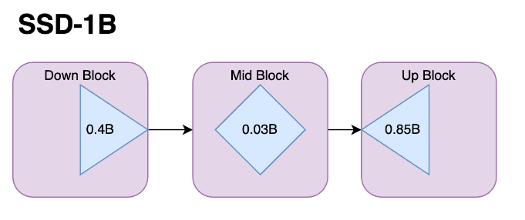

**WORKFLOW:**

1. User Input:

The process begins when a user interacts with the Gradio interface. The interface prompts the user to input an employee ID and specify the number of personalized greeting cards they want to generate. Not more than 6 images

1. Excel Data Extraction:

The process begins with extracting information from an Excel spreadsheet. It extracts information according to NGS that we put in gradio. This spreadsheet likely contains data about individuals, including attributes like their name, birthday, preferences (season, colour, food, travel, flower, music , activity ), and paths to their personal photos.

1. Prompt Construction:

Once the relevant information is extracted by Unique NGS from the Excel sheet, the code constructs a personalized message for each individual based on their attributes. This message serves as a prompt for generating the greeting card. And According to the prompt greetings card will generate.

1. Background Image Generation:

A Stable Diffusion XL Pipeline is initialized using a pre-trained model. This pipeline is responsible for generating images based on textual prompts provided to it. Using a pre-trained stablediffusionXL model (segmind/Segmind-Vega) that is taken form hugging face , the code generates an image based on the constructed prompt. The diffusion model is a deep learning model capable of generating high-quality images conditioned on textual prompts. It also specifies the device to be used for computation. In this case, the device is set to "cpu" for local machine.

1. Function Definition:-

‘add_text_to_image’: A function that adds text to an image using PIL's ImageDraw module.

‘extract_info_from_excel’: This function reads data from an Excel file located at a specific path . It searches for a specific employee ID (target ID) in the Excel file.

If the ID is found: It extracts various attributes associated with the ID from the Excel row (e.g., name, season, travel, colour, etc.). If the ID is not found then it shows error.

1. Personalization:

After generating the base image, the code personalizes it further by: Adding the individual's personal photo onto the generated image. This personal photo is retrieved from the provided path in the Excel spreadsheet . Adding additional text elements such as the individual's name and birthday onto the image.

1. Image Saving:

Once personalized, the generated greeting card images are saved to a specified directory with unique filenames using timestamp and files are not replaced. This ensures that each card is uniquely identifiable and can be retrieved later.

1. Output to Gradio Interface:

The function returns the constructed prompt and a list of generated images to the Gradio interface. The prompt may include details about the employee's preferences and characteristics. The interface displays the generated images in a gallery format, allowing users to preview and download them.



**User Input**



**Excel Data**

**Extraction**



**Prompt**

**Construction**



**Personalization**



**Function**

**Defini**

**tion**



**Background**

**Image**

**Generation**



**Output**

**in Gradio**

**Interface**



**Image Saving**

Workflow of the project

**OUTPUT:**

The output images are……

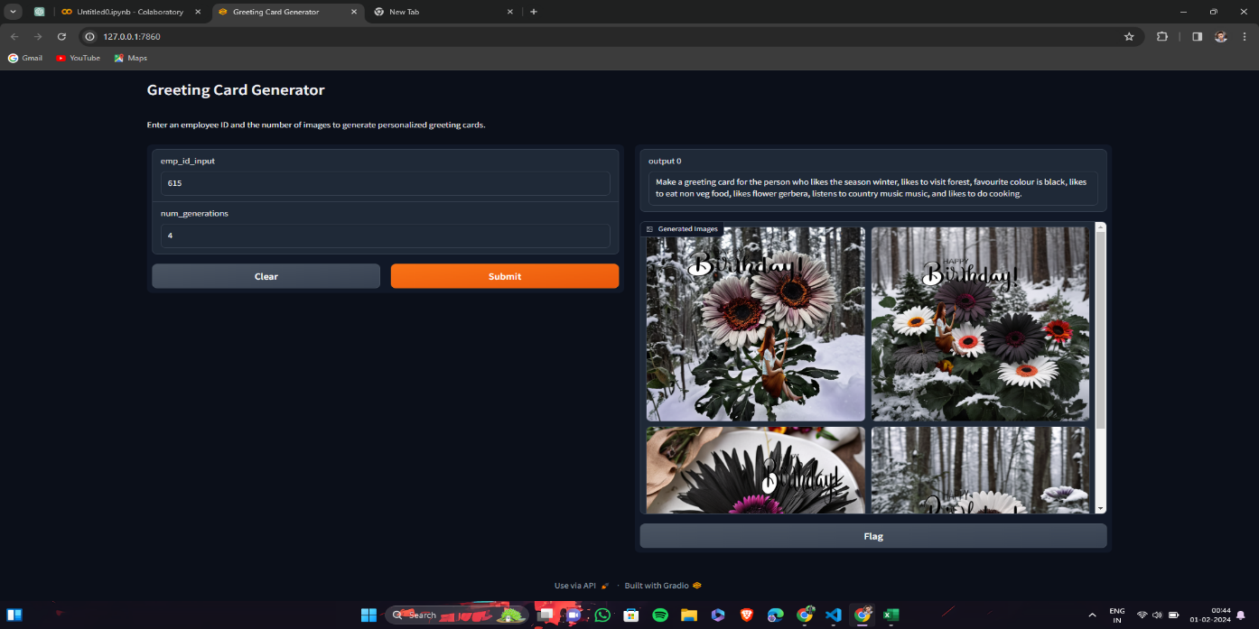

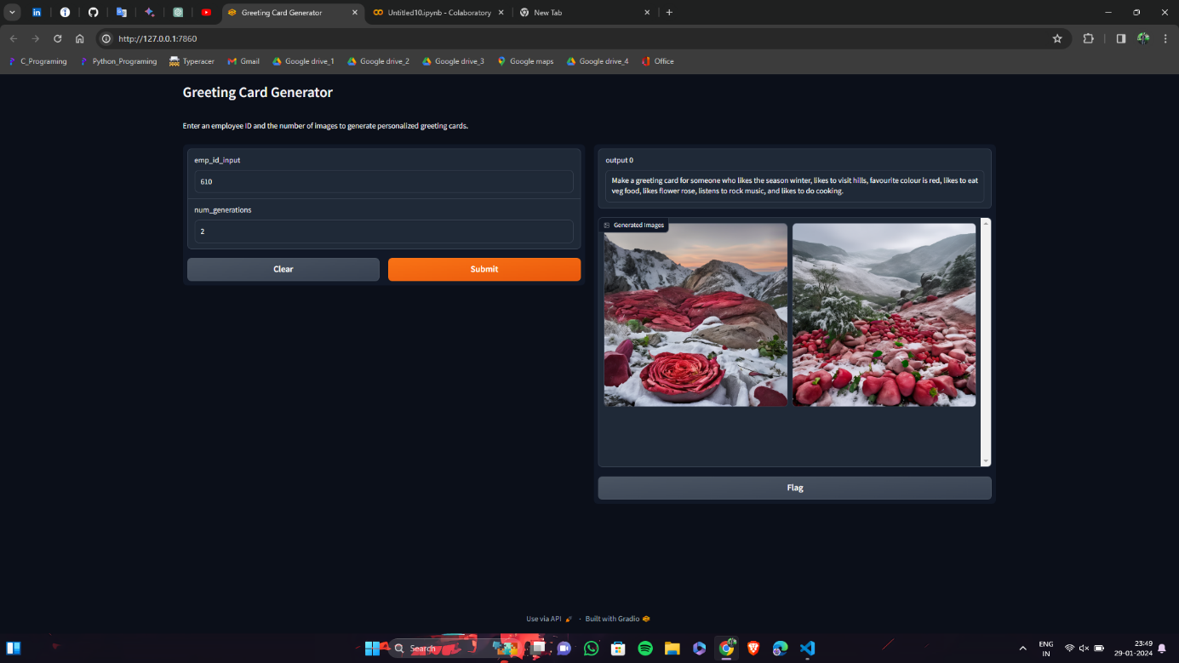

**Limitations:**

* + **Dependency on Pretrained Model:**

The success of the project heavily relies on the Stable Diffusion XL model pretrained on the " segmind/Segmind-Vega " dataset. Any limitations or biases present in the pretrained model may affect the quality and diversity of generated images.

* + **Fixed Template Structure:**

The project follows a predefined template for overlaying images and boxes. This fixed structure might not be suitable for all scenarios or user preferences, limiting the adaptability of the generated greeting cards.

* + **Limited Customization Options:**

The current interface allows users to input an employee ID and the number of images to generate. However, there are limited options for users to customize the greeting card further, such as selecting specific prompts or adjusting the layout.

* + **Assumption of Existing Employee ID:**

The project assumes that the entered employee ID exists in the loaded dataset. If an invalid or non-existent ID is provided, the user receives an error message. Adding functionality for ID validation or handling non-existent IDs could improve user experience.

* + **Potential Image Quality Issues:**

The resizing and overlaying process may result in image quality loss, especially if the original images have different resolutions. The project does not currently address potential artifacts or blurriness that may occur during image processing.

**Advantages:**

* + **Automated Greeting Card Generation:**

The project automates the process of generating personalized greeting cards, saving time and effort for users who want to create multiple cards based on employee preferences.

* + **User-Friendly Interface:**

The Gradio interface provides a simple and interactive platform for users to input parameters and view generated results. This makes the project accessible to users with varying technical backgrounds.

* + **Integration of Multiple Libraries:**

The project effectively integrates popular libraries such as PIL, Matplotlib, PyTorch, Pandas, and Gradio. This enables a comprehensive solution for image processing, visualization, and user interface development.

* + **Dynamic Prompt Generation:**

The prompts used for image generation are dynamically retrieved from the dataset, allowing for a personalized touch in the generated greeting cards based on individual preferences.

**References:**

* **Gradio Documentation:**

<https://www.gradio.app/docs/interfaceStable>

* **Stable Diffusion XL Model:**

<https://huggingface.co/segmind/Segmind-Vega>

* **PIL (Pillow) Documentation:**

<https://buildmedia.readthedocs.org/media/pdf/pillow-radarhere/open_files/pillowradarhere.pdf>

* **PyTorch Documentation:**

<https://pytorch.org/docs/stable/notes/cuda.html>

* **rembg-greenscreen documentation**

<https://github.com/danielgatis/rembg>