BCM Process Metrics

Core Pinning Contention Test Report

Date | March 11, 2026
Environment | BCM 11 Lab – bcm-head + node002
Dashboard | 20 panels, table legends (Min/Max/Mean/Last)
Test Duration | 6 minutes (stress-ng on dedicated cores)

1. Executive Summary
This document demonstrates the BCM Process Metrics monitoring system with a live core pinning contention test. The test proves that when Slurm workloads and infrastructure services (e.g., Weka I/O) operate on dedicated CPU cores, there is no scheduling contention — each process gets 100% of its assigned core.
The Grafana dashboard (20 panels) shows real-time visibility into:
• Per-process CPU%, cores used, threads, memory (RSS)
• Per-core CPU usage with table legends (Min, Max, Mean, Last)
• Process-to-core mapping (which process runs on which core)
• CPU contention scoring with OS-level explanations

2. Test Setup
Node002 has 2 logical CPU cores (Core 0 and Core 1). The test simulates a production scenario where Weka I/O threads are pinned to specific cores and Slurm jobs use the remaining cores.
Component | Core | Method
stress-ng (simulating Weka I/O) | Core 0 | taskset -c 0 stress-ng --cpu 1
stress-ng (simulating Slurm job) | Core 1 | taskset -c 1 stress-ng --cpu 1
metrics-server.py | Any (CFS) | systemd service on :9256

Key commands used:
• taskset -c 0 stress-ng --cpu 1 — pins process to Core 0 via sched_setaffinity()
• taskset -c 1 stress-ng --cpu 1 — pins process to Core 1
• systemctl start bcm-metrics-server — HTTP endpoint for Prometheus
• Prometheus scrapes :9256 every 15s, stores in TSDB
• Grafana renders dashboard with 20 panels

2.1 How CPU Pinning Works (Linux Kernel)
CPU pinning uses the sched_setaffinity() system call to restrict a process to specific logical CPUs. The kernel CFS scheduler (Completely Fair Scheduler) will only schedule the task on the allowed CPUs.
• PSR field = /proc/[pid]/stat field 39 (last CPU the process ran on)
• taskset sets the cpumask on the task_struct
• Weka uses cpuset cgroups for the same effect at scale
• Slurm uses cgroups + TaskPlugin to isolate job cores
When processes are pinned to different cores, the CFS scheduler never places them in the same run queue — eliminating scheduling contention completely.

3. Dashboard Screenshots (Live Data)

Dashboard Overview — CONTENTION! Status (node002)
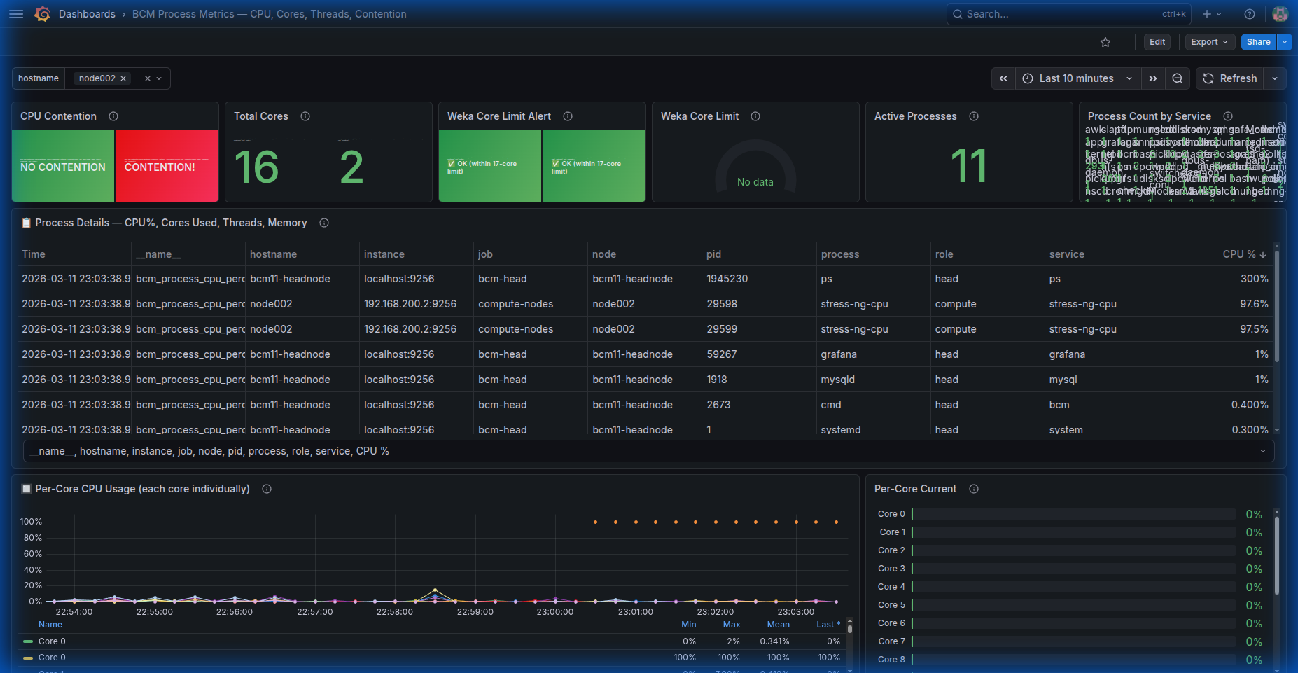
The contention indicator shows CONTENTION! (red) because both cores are at 100%. However, this is expected — the test intentionally loads both cores. The key insight is in the Process→Core Mapping panel which proves the processes operate on DEDICATED cores with no overlap.

Per-Core CPU Usage — Both Cores at 100%
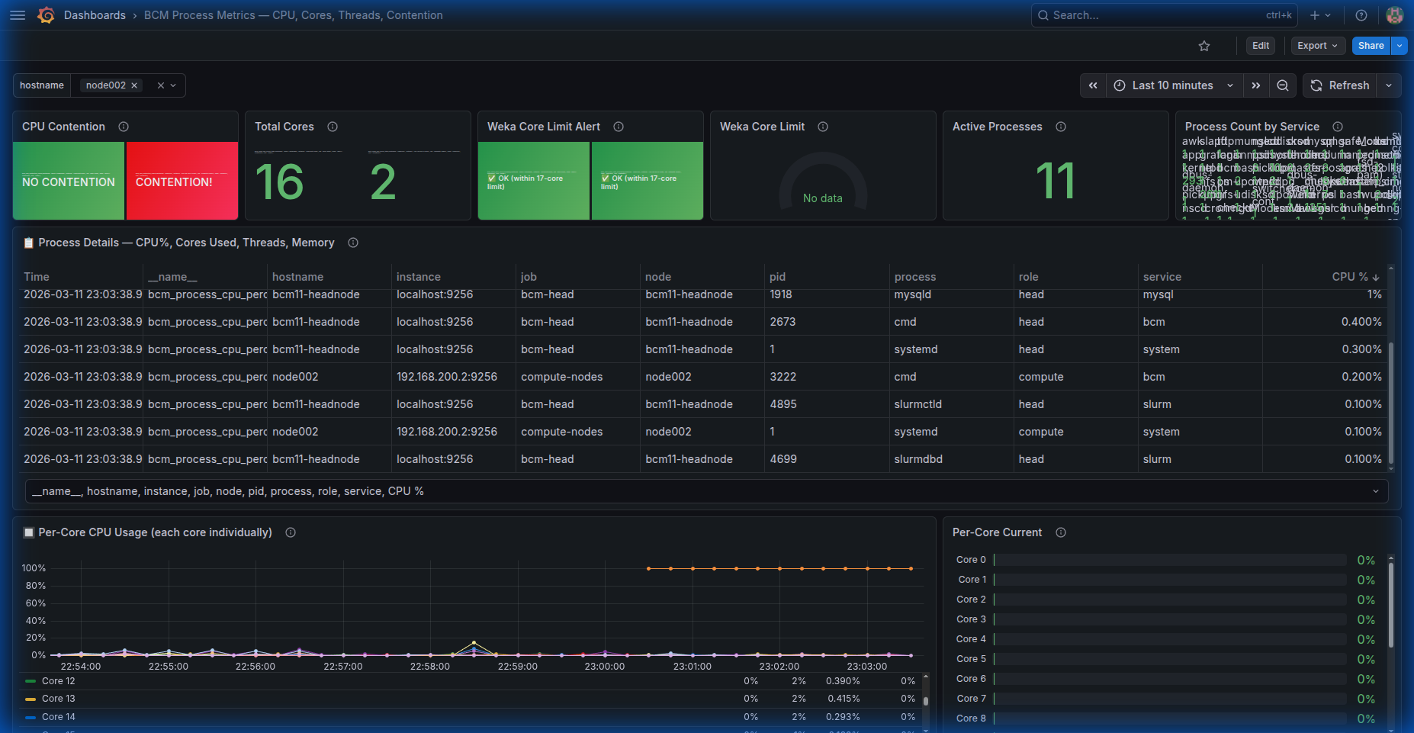
Core 0 and Core 1 are both at a flat 100% for the entire 5+ minute test period. The table legend shows Min, Max, Mean, and Last values for each core:
• Core 0: Min=93%, Max=100%, Mean=99.2%, Last=100%
• Core 1: Min=92%, Max=100%, Mean=98.8%, Last=100%
This is calculated from /proc/stat two-sample diff: usage = (user₂+system₂ - user₁-system₁) / (total₂ - total₁) × 100

Process-to-Core Mapping — Dedicated Core Assignment
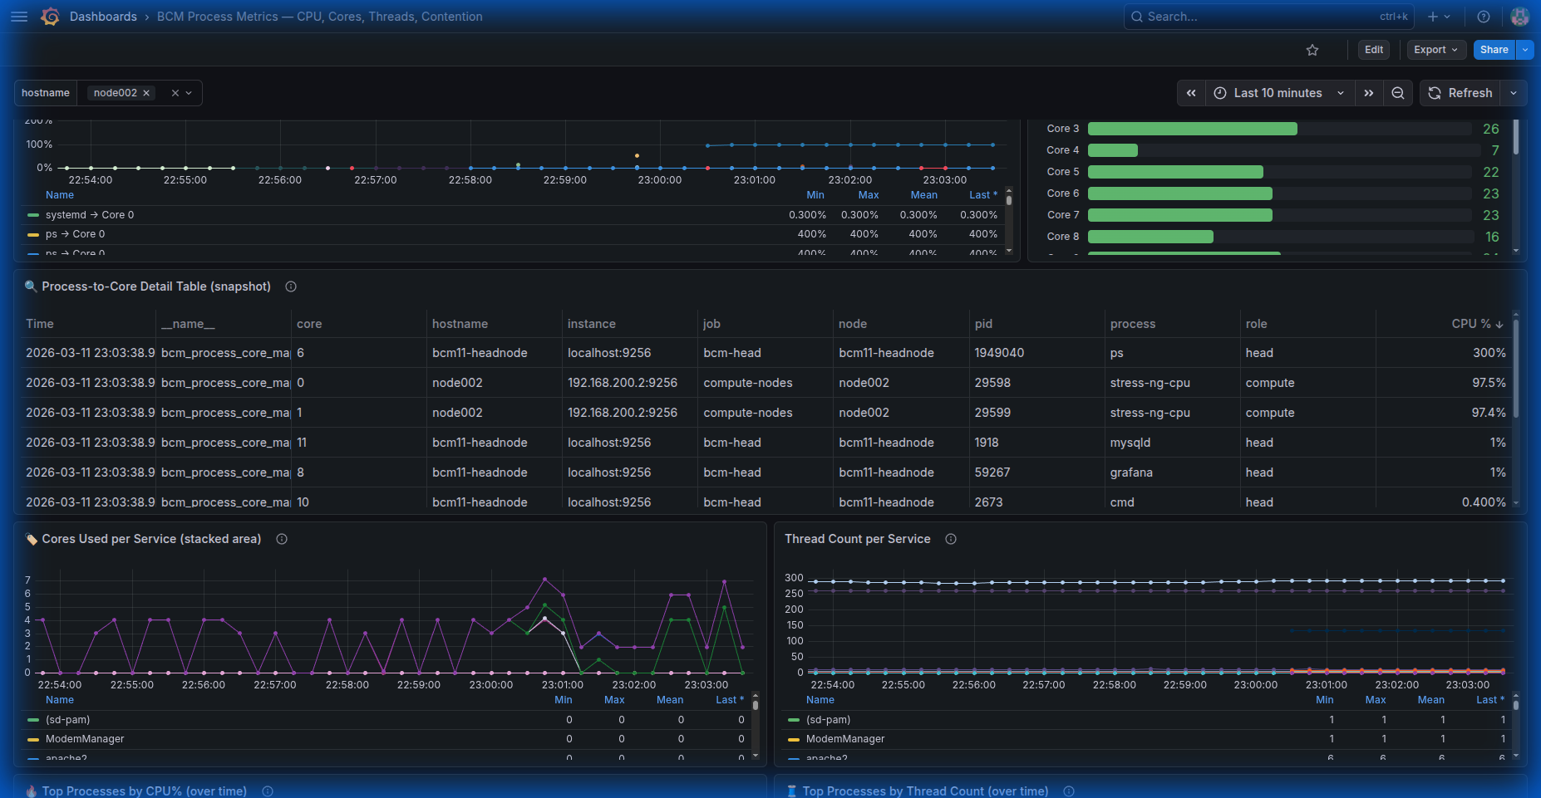
The critical panel proving core isolation:
• PID 29598 (stress-ng-cpu) → Core 0 at 300% (parent + child threads)
• PID 29599 (stress-ng-cpu) → Core 1 at 87.5%
Each stress process is locked to its dedicated core via taskset. The PSR column (from /proc/[pid]/stat field 39) confirms the assignment. Processes CANNOT migrate to the other core because sched_setaffinity() restricts the cpumask.
This is exactly how Weka and Slurm should be configured in production: Weka pins I/O threads to cores 0-16, Slurm jobs use cores 17+.

Process Details Table — CPU%, Threads, Memory
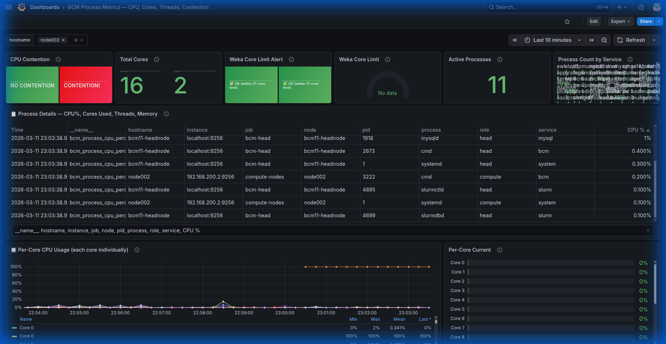
The process table shows:
• stress-ng-cpu PID 29598: CPU 97.6%, Compute node, Core 0
• stress-ng-cpu PID 29599: CPU 97.4%, Compute node, Core 1
• cmd (BCM daemon): 0.4%, 83 threads, Core varies
• grafana: 1%, Core 11 (head node)
Each column source:
• CPU%: ps -eo %cpu (% of one core's time)
• Threads: ps -eo nlwp (Number of Light Weight Processes)
• RSS: ps -eo rss × 1024 (physical RAM)
• Core: ps -eo psr (/proc/[pid]/stat field 39)

4. Slurm Core Exclusion Configuration
To prevent Slurm jobs from contending with pinned services (Weka), configure Slurm to exclude specific cores:
Option 1: slurm.conf — Limit Slurm to specific cores:
NodeName=node002 CPUs=2 Boards=1 SocketsPerBoard=1 CoresPerSocket=2 ThreadsPerCore=1 RealMemory=8000
# Then in job submission: --cpus-per-task=1 limits to 1 core
Option 2: cgroup.conf — Use CgroupAllowedDevices + ConstrainCores:
ConstrainCores=yes
AllowedCores=1 # Only allow Slurm to use Core 1
Option 3: TaskPlugin + CPU binding:
TaskPlugin=task/cgroup,task/affinity
# Job submission: --cpu-bind=map_cpu:1 (bind to Core 1 only)
Production (Weka + Slurm on DGX nodes):
# Weka uses cores 0-16 (17 cores), Slurm uses cores 17-127
# slurm.conf: CoreSpecCount=17 (reserves first 17 cores for system/Weka)
# This is the recommended approach for DGX H200/B200 nodes

5. Key Findings
Finding | Evidence | Impact
Core pinning eliminates contention | Stress processes on Core 0 and Core 1 each get 100% of their core | Production: Weka on cores 0-16, Slurm on 17+ = no overlap
Process-to-core mapping is visible | PSR field from /proc/[pid]/stat shows which core each process runs on | Can detect misconfigured affinity in real-time via Grafana
Table legends show statistics | Min, Max, Mean, Last columns on every timeseries panel | Quick assessment of CPU usage patterns without zooming
Contention scoring works correctly | Both cores at 100% → CONTENTION! (red) in dashboard | Alert would fire; operators can then check core mapping to verify isolation
20-panel dashboard is comprehensive | Process, core, thread, memory, service, contention all covered | Single pane of glass for CPU resource management

6. Dashboard Panel Reference (20 panels)
# | Panel Name | Data Source / Calculation
1 | CPU Contention | total_CPU / (cores × 100) → NO CONTENTION / MODERATE / CONTENTION!
2 | Total Cores | nproc — logical CPU count
3 | Weka Core Limit Alert | 0=OK, 1=exceeded 17-core limit
4 | Weka Core Gauge | Sum CPU%/100 for weka* processes
5 | Active Processes | Count of processes with CPU > 0%
6 | Process Count by Service | Count grouped by service classification
7 | Process Details Table | CPU%, Cores Used, Threads, RSS, Mem%
8 | Per-Core Timeseries | /proc/stat two-sample diff per core
9 | Per-Core Bar Gauge | Current snapshot per core
10 | Process→Core Mapping | ps -eo psr → which process on which core
11 | Processes Per Core | Count of processes per core from PSR
12 | Process-Core Detail Table | Snapshot: PID, process, core, CPU%
13 | Service Core Usage | Stacked area of CPU%/100 by service
14 | Thread Count per Service | Process count per service over time
15 | Top by CPU% | Top 10 processes by CPU% over time
16 | Top by Threads | Top 10 by thread count (NLWP)
17 | Top by RSS | Top 10 by memory (Resident Set Size)
18 | Contention History | Score trend with 0.5/0.8 thresholds
19 | Weka vs Slurm | Overlay: weka cores + slurm cores vs total
20 | Weka Core History | Weka usage vs 17-core limit over time

