Healthy Fleet Maintenance
& Tenant-Safe Node Lifecycle
Architecture Design Document
━━━━━━━━━━━━━━━━━━━━━━━━━━━━━━━━━━━━━━━━━━━━━━━━━━━━━━━━━━━━━━━━━━━━━━━━━━━━━━━━
Classification | Internal — Engineering
Version | 3.0
Date | February 19, 2026
Author | Distinguished Engineer, AI Compute Platform
Status | Final
Review Board | Compute Platform · K8s · OE · Storage · Network · DC Infra

Table of Contents
1. Executive Summary
2. Pillar 1 — Healthy Fleet Maintenance (Phase 1)
3. Pillar 2 — Automated Node Lifecycle & Certification (Phase 2)
4. Pillar 3 — Automated Image Pipeline (Phase 2)
5. Pillar 4 — Tenant Reassignment
6. Node Certification SOP ("Good Host" Standard)
7. NPD as a Platform — Multi-Team Model
8. Node Lifecycle with NPD Detection & Enforcement
9. Scope Definition
10. End-to-End Test Plan
11. Deployment, Observability & Operations
12. Enterprise Promises & Customer Impact
Appendix A: Glossary

1. Executive Summary
This document defines the Healthy Fleet Maintenance & Tenant-Safe Node Lifecycle platform feature for the AI Compute Platform. It establishes a deterministic, automated state transition model for GPU compute nodes, ensuring every node meets a codified certification standard before serving production tenants.
The platform operates across four pillars, phased for execution:
- Phase 1 — Healthy Fleet Maintenance: Establish 99.5% availability SLA with a dedicated L1 reliability squad & process — runbooks, daily triage, RMA & vendor SLA tracking, executive dashboards & reporting. Incident 5337 learnings integrated. Already operational.
- Phase 2 — Automated Node Lifecycle & Certification: Automate node lifecycle using NPD + controllers for detection and enforcement. Merge certification pipeline (BCM burn-in, DCGM L4, NCCL, HPL) into the lifecycle state machine.
- Phase 2 — Automated Image Pipeline: Deprecate BCM image cloning. Build Packer-based image pipeline with GitOps CD, cross-AZ replication, and self-service layers for Storage, K8s, and other teams.
- Tenant Reassignment: Fixed state transition: Internal Tenant A → Certified → Production Tenant X → reimage + wipe + recertify. Every tenant move traverses the full certification pipeline.
Design is tenant-first: unhealthy nodes never serve production tenants. Self-heal is out of scope for Phase 1.
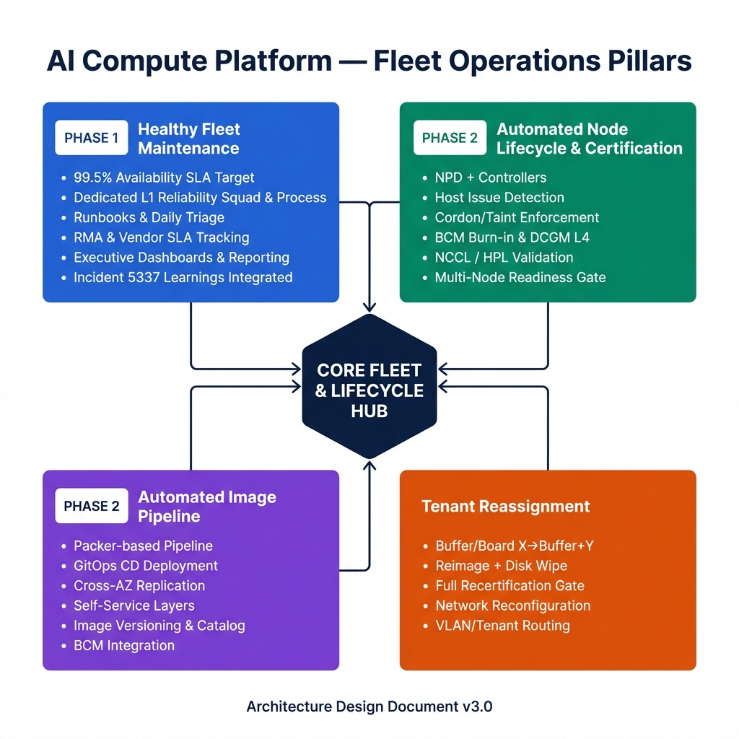
Figure 1: AI Compute Platform — Four-Pillar Fleet Operations Overview

2. Pillar 1 — Healthy Fleet Maintenance (Phase 1)
This pillar is already operational. A dedicated 99.5% SLA squad has been established to maintain fleet health through people-driven processes, runbooks, and daily operational rigor.

2.1 SLA Definition & Critical Path
The 99.5% availability target is measured at the node-level: a node is "available" when it passes all Good Host certification checks and is actively serving a production tenant without blocking signals.
SLA Component | Scope | Critical Path
GPU Health | All 8 GPUs healthy, ECC clean, no critical XIDs | DCGM metrics, XID monitoring, ECC counters
InfiniBand | All IB ports active, NDR 400G, error counters under threshold | ibstat, perfquery, link flap detection
NVLink / NVSwitch | All NVLink5 links active, zero CRC/replay errors | nvidia-smi nvlink, nvbandwidth
Node Readiness | K8s node Ready, kubelet/runtime stable | Node conditions, kubelet health
Storage | NVMe SMART healthy, Weka/VAST probes passing | NVMe smart-log, storage operator
Tenant Network | VLAN/routing applied, node routing agent healthy | Node routing agent, connectivity checks
GPU Operators | GPU operator + network operator pods running | Operator pod status, CRD health

2.2 Operational Squad & Processes
Item | Details
Squad | Dedicated L1 99.5% SLA squad — established and operational
Runbooks | Runbooks for every critical path component: GPU, IB, NVLink, OS, disk, K8s node, operator
Daily Triage | Daily fleet health triage with status review, owner assignment, ETA tracking
Observability | Grafana dashboards per critical path component; alerting pipeline operational
Executive Dashboards | Automated daily executive summary / business dashboards emitted
GPU Reliability | Q4 GPU reliability tasks completed (XID patterns, ECC trends, RMA rates)
RMA Workflow | Evidence capture → ticket routing → vendor SLA tracking → post-RMA recertification gate
Vendor SLAs | NVIDIA RMA SLAs documented and tracked; DC Infra swap SLAs committed
Capacity Return | Clean SOP: ensure failed node capacity returned to fleet in under 24 hours

2.3 Incident 5337 Integration
Multi-node distributed training failure learnings are integrated into Phase 1 operations:
- Stricter IB readiness thresholds for multi-node workloads; link flap detection tightened
- Correlation across node sets: job failure → suspect node identification → quarantine repeat offenders
- Certification includes multi-node smoke checks (NCCL cross-node + sample distributed job)
- Bus bandwidth AND algorithm bandwidth must both scale — validated via nccl-tests and HPL multi-node
- Repeat offender tracking: nodes with >2 quarantine events in 7 days flagged for RMA triage

3. Pillar 2 — Automated Node Lifecycle & Certification (Phase 2)
This pillar merges automated node lifecycle management with the node certification pipeline. NPD and custom controllers detect host-level degradation and enforce tenant safety. The certification pipeline (BCM burn-in, DCGM L4, NCCL, HPL) is integrated into the lifecycle state machine.

3.1 Layered Component View (Our Ownership Boundary)
The Compute Platform team owns through the Kubernetes boundary. K8s, Storage, and RMA are coordination dependencies.
Layer | Components | Ownership
Hardware | GPU (B200), HCA/NIC (IB NDR 400G), NVMe, BMC, NVLink5/NVSwitch, CPU/Memory | Compute Platform
Host OS | Kernel, drivers, filesystem, time sync, container runtime | Compute Platform
NVIDIA Stack | BCM, DCGM/DCGMI, gpu_burn, nccl-tests, nvbandwidth, HPL | Compute Platform
GPU / Network Operators | GPU operator, network operator, IB SR-IOV / VFs, Multus | Compute Platform
Tenant Network | Node routing agent, VLAN/tenant routing, IB fabric integration | Compute Platform + Network
Kubernetes | Kubelet, CNI (Tigera/Calico), node readiness, scheduling | K8s Team (coordinate)
Storage | Weka/VAST probes, NVMe health, storage operator | Storage Team (coordinate)
RMA / DC Infra | Physical swap, shipping, vendor coordination | DC Infra (coordinate)

3.2 Detection & Enforcement Model
NPD detectors feed host signals into a standardized framework. On any blocking signal, the node is quarantined (cordon + taint NoSchedule). Self-heal is explicitly out of scope for Phase 1.
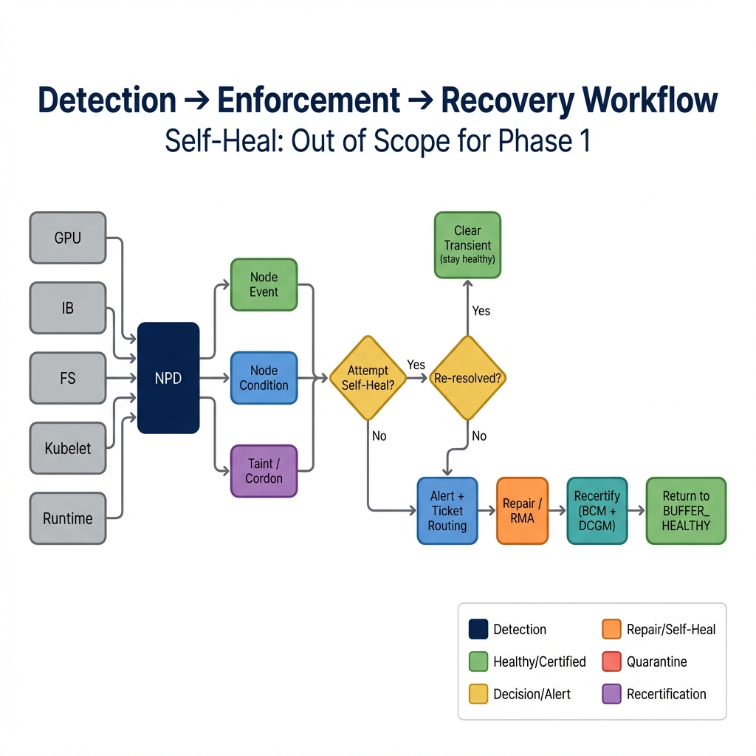
Figure 2: Detection → Enforcement → Recovery Workflow (Self-Heal: Out of Scope)

3.3 Lifecycle State Machine
The lifecycle has 8 states with deterministic transitions. The certification pipeline (burn-in → DCGM L4 → NCCL → HPL) is embedded in the state machine. Every node must pass through INTERNAL_TENANT_A for certification before entering production.
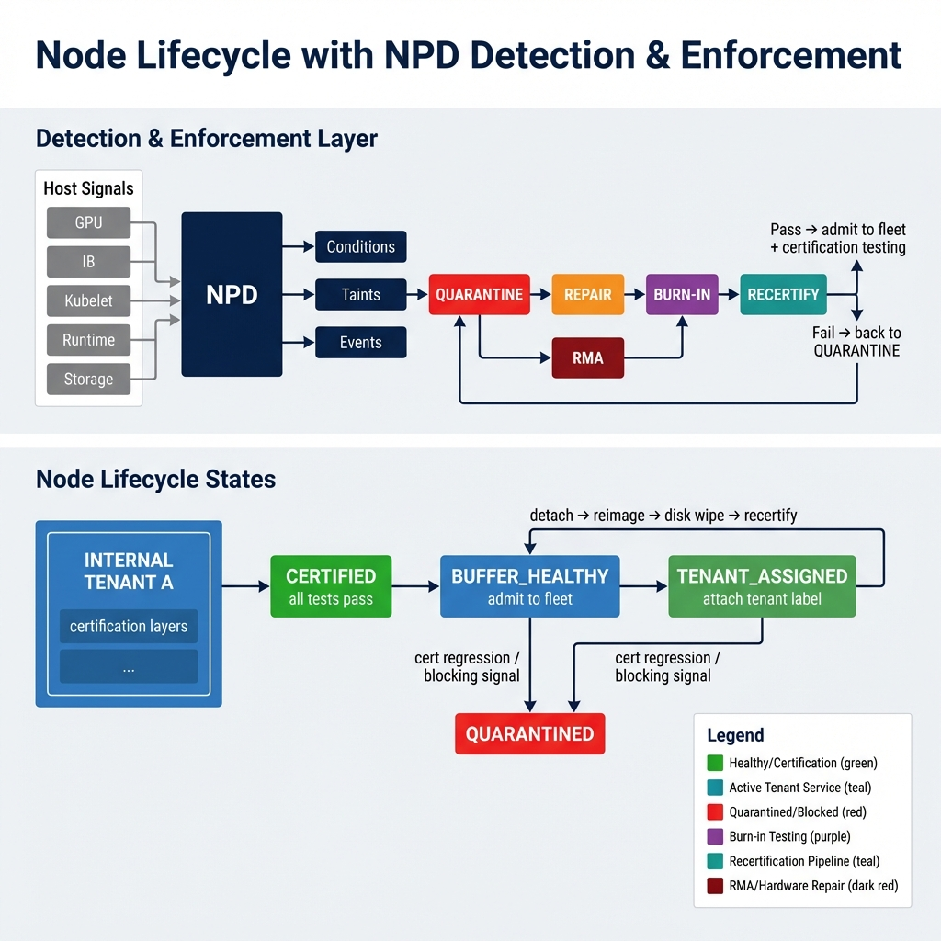
Figure 3: Node Lifecycle with NPD Detection & Enforcement (8 States)
State | Description | Entry | Exit
INTERNAL_TENANT_A | Certification testing environment | New node / detach+wipe / certified | All tests pass → CERTIFIED
CERTIFIED | All certification layers passed | Recertification pass | Admit to fleet → BUFFER_HEALTHY
BUFFER_HEALTHY | Certified, available for assignment | Certified + admitted | Tenant attach OR blocking signal
TENANT_ASSIGNED | Serving production tenant | Attach tenant label | Detach+wipe OR blocking signal
QUARANTINED | Blocked; removed from scheduling | Blocking signal from any state | → REPAIR or → RMA
REPAIR | Software/config fix underway | Triage: SW/config issue | Fix complete → BURN_IN
RMA | Hardware replacement in progress | Hardware fault confirmed | Replaced → BURN_IN
BURN_IN | BCM burn-in (6–24h) | Post-repair or post-RMA | Pass → RECERTIFY; Fail → QUARANTINED

4. Pillar 3 — Automated Image Pipeline (Phase 2)
BCM's current image cloning model does not support reproducible, cross-environment image replication. This pillar replaces it with a Packer-based, GitOps-driven image pipeline.

4.1 Current State & Problem
- BCM uses image cloning (golden image → clone to nodes) with no version control or audit trail
- No mechanism to replicate images from one AZ/region to another consistently
- Other teams (Storage, K8s) cannot self-serve their layer configuration into the base image
- Re-imaging after tenant transitions requires manual intervention

4.2 Target Architecture
Component | Details
Packer Pipeline | Packer templates with NVIDIA support; builds DGX OS base image with all drivers, DCGM, NCCL, operators
GitOps CD | Git repository as source of truth; CI/CD pipeline triggers image builds on merge; tagged releases
Cross-AZ Replication | Built images replicated from primary AZ to all target AZs/regions automatically
Self-Service Layers | Storage team adds Weka/VAST agents; K8s team adds kubelet/CNI config; each layer has tests
Image Versioning | Semantic versioning; rollback support; image catalog with metadata
BCM Integration | BCM provisions nodes using Packer-built images; image ID tracked in BCM node record

4.3 Layer Contributions
Layer | Owner | Contributes to Image
Base OS + Drivers | Compute Platform | Kernel, NVIDIA drivers, CUDA, container runtime, BCM agent
DCGM + Diagnostics | Compute Platform | DCGM, DCGMI, gpu_burn, nccl-tests, nvbandwidth
GPU / Network Operators | Compute Platform | Operator manifests, IB SR-IOV config, Multus
Storage Agents | Storage Team | Weka client, VAST agent, mount configuration
K8s Components | K8s Team | Kubelet config, CNI (Tigera/Calico), node labels/annotations
Monitoring | OE Team | Log/metric agents, NPD config, alert rules

5. Pillar 4 — Tenant Reassignment
Every node movement between tenants follows a fixed, mandatory state transition pipeline. There are no spare buffer nodes — all idle nodes live in Internal Tenant A for continuous certification testing. There is NO direct path from Internal Tenant A to Production Tenant X. Every assignment traverses the full un-assign → disk wipe → reimage → re-certify → assign pipeline.

5.1 Reassignment Lifecycle
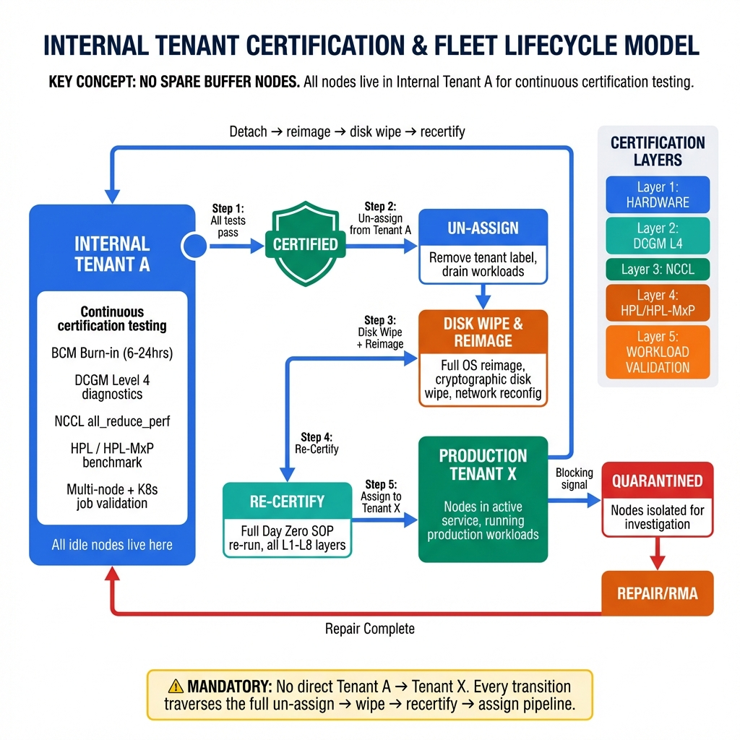
Figure 4: Internal Tenant Certification & Fleet Lifecycle Model (Mandatory 5-Step Pipeline)
The mandatory transition is: Internal Tenant A → Certified → Un-assign → Disk Wipe & Reimage → Re-Certify (full Day Zero SOP) → Assign to Production Tenant X. No shortcuts are permitted. The return path follows the same discipline: Tenant X → Detach → Reimage → Disk Wipe → Recertify → Internal Tenant A.

5.2 Mandatory Reassignment Steps
Step | Action | Validation
1. Certify in Tenant A | Node passes all L1–L8 certification layers in Internal Tenant A | All tests pass → CERTIFIED status
2. Un-assign | Remove Internal Tenant A label, drain workloads | No tenant pods running on node
3. Disk Wipe & Reimage | Full OS reimage + cryptographic wipe of all local storage + network reconfig | Image hash matches catalog; wipe log verified; IB ports active
4. Re-Certify | Full Day Zero SOP re-run (all L1–L8 layers) | All certification layers pass again
5. Assign to Tenant X | Attach production tenant label; apply tenant network config | Tenant routing validated; scheduling enabled

5.3 Internal Tenant A — Daily Certification
Nodes in Internal Tenant A run daily certification tests including multi-node sample jobs. This serves as both continuous validation and the certification gate for tenant assignment. Tests validate bus bandwidth and algorithm bandwidth scaling per Incident 5337 retrospective.
- Daily burn-in cycles with gpu_burn at various precisions (FP64/FP32/TF32/FP8)
- NCCL all_reduce_perf across node sets — bus BW must meet ≥1530 GB/s (85% of NVLink5 1.8 TB/s)
- Multi-node sample job: validates cross-node IB communication, NCCL collective scaling
- K8s dummy job: validates pod scheduling, GPU device plugin, operator health

6. Node Certification SOP ("Good Host" Standard)
Aligned with SOP-GPU-CERT-001 v1.1 for NVIDIA B200 GPU nodes. A node must pass ALL certification layers before being flagged CERTIFIED and eligible for production tenant assignment.

6.1 Day Zero — Certification Layers
Layer | Test | Tool / Command | B200 Pass Criteria
L1: Pre-Flight | GPU discovery (8× B200) | nvidia-smi -L | 8 GPUs detected
L1: Pre-Flight | Driver / CUDA version | nvidia-smi | Matches BCM baseline
L1: Pre-Flight | DCGM agent running | systemctl status nvidia-dcgm | Active/Running
L1: Pre-Flight | NVSwitch discovery | dcgmi discovery -l | All NVSwitches detected
L1: Pre-Flight | ECC enabled (all GPUs) | nvidia-smi -q -d ECC | ON — all GPUs
L1: Pre-Flight | Firmware versions | nvfwupd show_version | Matches fleet baseline
L1: Pre-Flight | System health | sudo nvsm show health | Healthy
L1: Pre-Flight | InfiniBand ports (NDR 400G) | ibstat | All ports Active
L1: Pre-Flight | PCIe link width/speed | lspci -vvv | Gen5 x16, no downgrade
L2: GPU Burn-In | Sustained GPU stress (100% util) | gpu_burn -tc 21600 | Zero XID, zero DBE, 6–24h
L2: GPU Burn-In | Temperature monitoring | nvidia-smi dmon | ≤70°C sustained (liquid-cooled)
L2: GPU Burn-In | Power monitoring | nvidia-smi dmon | ≤1000W TDP per GPU
L3: DCGM L4 | All plugins: HW, SM stress, memtest, EUD | dcgmi diag -r 4 | ALL plugins PASS (~90 min)
L3: DCGM L4 | NVLink5 bandwidth | Integration plugin | BW ≥90% of 1.8 TB/s
L3: DCGM L4 | HBM3e memtest (192 GB/GPU) | Memtest plugin | Zero memory errors
L4: NCCL | All-Reduce (intra-node 8 GPUs) | all_reduce_perf -g 8 | BusBW ≥1530 GB/s
L4: NCCL | All-Gather, Reduce-Scatter, Broadcast | nccl-tests suite | BusBW ≥1530 GB/s
L4: NCCL | Multi-node cross-node all-reduce | mpirun + all_reduce_perf | ≥85% per-port IB line rate
L5: HPL | FP64 peak FLOPS | HPL (NGC container) | ≥70% theoretical peak
L5: HPL | Mixed-precision (HPL-MxP) | HPL-MxP (NGC) | ≥70% theoretical peak
L6: NVLink/NVSwitch | NVLink status + errors | nvidia-smi nvlink --status/-e | All active, zero CRC/replay
L6: NVLink/NVSwitch | Device-to-device bandwidth | nvbandwidth | D2D ≥90% of 1.8 TB/s
L6: IB Network | IB port status | ibstat | Active, NDR 400 Gb/s
L6: IB Network | RDMA write bandwidth | ib_write_bw | ≥90% line rate
L6: IB Network | GPUDirect RDMA | Multi-node NCCL | ≥85% per-port line rate
L7: Storage | NVMe SMART health | nvme smart-log /dev/nvme* | Spare ≥80%, zero media errors
L7: Storage | NVMe throughput | fio (seq + random) | Meets drive spec
L7: System | System memory | memtester | Zero errors
L7: System | CPU stress | stress-ng --cpu $(nproc) | Zero failures, no MCEs
L7: System | BMC sensors + PSU | ipmitool sensor/sdr list | All in range, all OK
L8: Workload | Sample distributed training job | mpirun + training script | Completes, no errors
L8: Workload | Cross-node connectivity | IB health + NCCL scaling | Bus BW + algo BW scale
L8: Workload | Pod scheduling + GPU allocation | kubectl + sample workload | Job completes, GPUs visible

Day Zero Gate: Node admitted ONLY if ALL layers (L1–L8) pass. Output: certification record → node marked CERTIFIED.

6.2 Day Two — Continuous Monitoring
Metric | Source | B200 Healthy | Severity
GPU Temp | DCGM_FI_DEV_GPU_TEMP | ≤70°C (liquid) | P2 if exceeded
HBM Temp | DCGM_FI_DEV_MEMORY_TEMP | ≤95°C | P2 if exceeded
Power Draw | DCGM_FI_DEV_POWER_USAGE | ≤1000W | P2 if exceeded
ECC SBE | DCGM_FI_DEV_ECC_SBE_VOL_TOTAL | 0 | P2 — investigate 4h
ECC DBE | DCGM_FI_DEV_ECC_DBE_VOL_TOTAL | Must be 0 | P1 — immediate quarantine
Retired Pages (DBE) | DCGM_FI_DEV_RETIRED_DBE | Must be 0 | P1 — immediate quarantine
Row Remap Failure | DCGM_FI_DEV_ROW_REMAP_FAILURE | Must be 0 | P1 — immediate quarantine
XID Errors | DCGM_FI_DEV_XID_ERRORS | 0 | P1 for critical XIDs (48/63/64/79/94/95)
NVLink CRC | DCGM_FI_DEV_NVLINK_CRC_* | 0 | P2 — investigate
PCIe Replay | DCGM_FI_DEV_PCIE_REPLAY_COUNTER | 0 per 24h | P3 — weekly review
IB Errors | perfquery | 0 per 24h | P2 — investigate
NVMe Spare | smartctl | ≥50% | P3 if <80%; P2 if <50%

6.3 Periodic Re-Validation
Frequency | Test | Duration
Weekly | dcgmi diag -r 1 (quick health) | ~2 min
Monthly | dcgmi diag -r 3 (medium diagnostic) | ~15 min
Quarterly | dcgmi diag -r 4 + NCCL collectives + NVLink | ~100 min
Annually | Full burn-in + HPL + 24h soak (same as Day Zero) | ~8 hrs

7. NPD as a Platform — Multi-Team Contribution Model
NPD is the common substrate for node health detection. Five teams contribute domain-specific detectors under a single framework with standardized outputs.
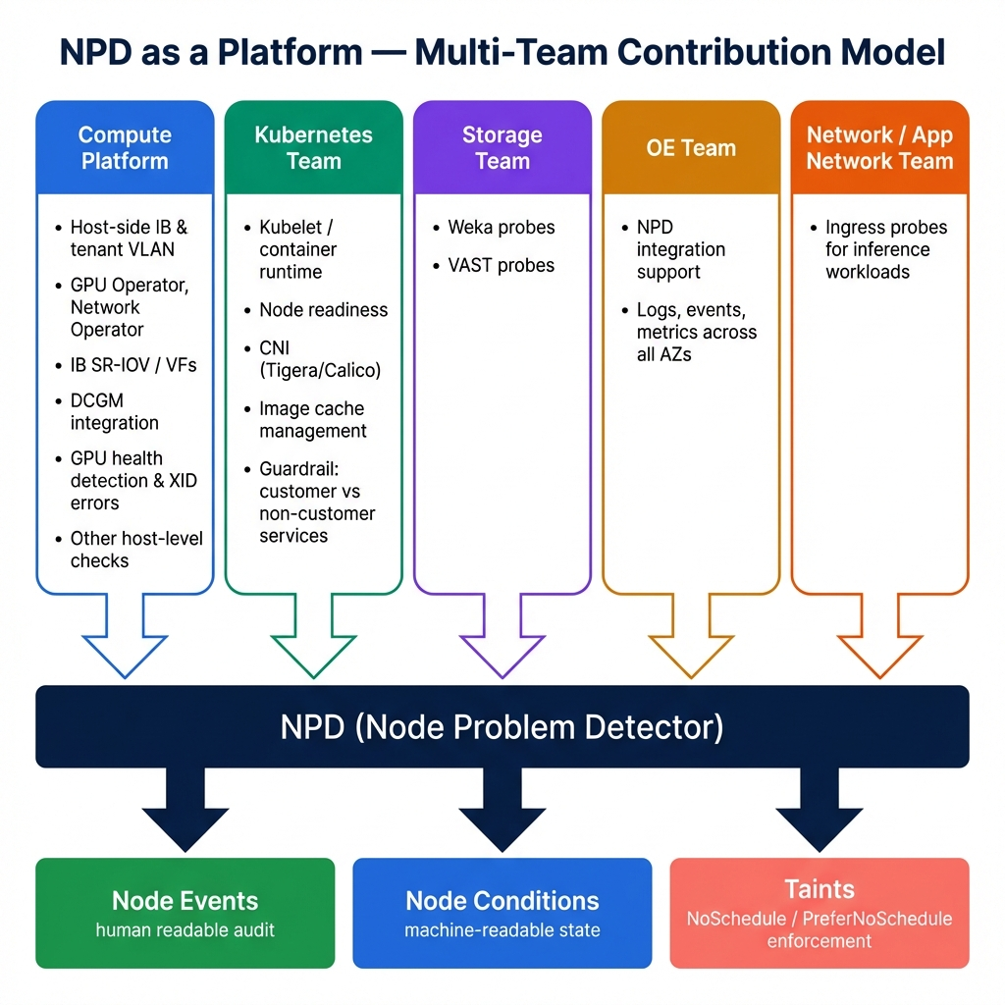
Figure 5: NPD as a Platform — Multi-Team Contribution Model
Team | Owns / Contributes to NPD | Specific Ask
Compute Platform | Host-side IB & tenant VLAN; GPU/Network Operators; IB SR-IOV/VFs; DCGM integration; GPU health & XID detection; host-level checks | Owns NPD framework, detector development, certification pipeline, state machine controller
Kubernetes | Kubelet/runtime; node readiness; CNI (Tigera/Calico); image cache management; guardrail: customer vs non-customer services | CNI health probes, node readiness signal fidelity, taint/toleration policy enforcement, K8s layer guardrails
Storage | Weka probes; VAST probes | Storage health probe integration into NPD; R/W latency signals; capacity alerts
OE | NPD integration support; logs, events, metrics across all AZs | Log/metric pipeline reliability; NPD deployment across all AZs; monitoring infra
Network / App Network | Ingress probes for inference workloads | Ingress health signals; endpoint readiness probes; latency thresholds for inference

8. Scope Definition
Category | In Scope | Out of Scope
People / Process | L1 squad, runbooks, daily triage, escalation, exec dashboards | Tenant application ops
Host Certification | BCM burn-in, DCGM L4, NCCL, HPL, ECC, NVLink, IB, storage checks | Tenant workload tests beyond host gating
Node Lifecycle | 8-state machine, cordon/taint, deterministic reassignment | Auto-reboot/reimage without gate
Self-Heal | Out of scope for Phase 1 | Automated self-remediation (future)
Image Pipeline | Packer build, GitOps CD, cross-AZ replication, self-serve layers | BCM image cloning (deprecated)
Our Boundary | Hardware through GPU/Network operators and tenant networking | K8s scheduling policy, storage backend ops
K8s (Coordinate) | Node readiness signals, CNI health, taint enforcement | K8s control plane, scheduler logic
Storage (Coordinate) | Weka/VAST probes, NVMe health integration | Storage backend operations
RMA (Coordinate) | Evidence capture, ticket routing, recertification gate | Physical swap (DC Infra + vendor)

9. End-to-End Test Plan
Test Layer | What We Validate | Where
Certification (D0) | All L1–L9 SOP layers pass | Internal Tenant A
Continuous (D2) | DCGM metrics, IB health, NVMe, operators healthy | All nodes, always
Multi-Node | NCCL cross-node, bus BW + algo BW scaling, sample job | Internal Tenant A node sets
Enforcement | Taint/cordon on blocking signal; scheduling blocked | Continuous (NPD)
Recovery | Repair → burn-in → recertify → CERTIFIED → fleet | Post-fix pipeline
Reassignment | Reimage + wipe + full recertification + network reconfig | Every tenant transition
Image Pipeline | Packer build reproducible; image replicates across AZs | CI/CD pipeline

Acceptance Criteria
- AC-1: Node cannot enter TENANT_ASSIGNED unless all L1–L9 certification layers pass.
- AC-2: Blocking signal → quarantine (cordon+taint) within detection-to-quarantine SLO.
- AC-3: No return-to-fleet without full recertification (burn-in + DCGM L4 + NCCL + HPL).
- AC-4: Tenant reassignment always follows: reimage → disk wipe → recertification → network reconfig.
- AC-5: Bus BW ≥1530 GB/s and algo BW must scale for distributed workload eligibility.
- AC-6: Packer-built images replicate to all target AZs before any deployment.

10. Deployment, Observability & Operations

10.1 Staged Rollout
Stage | Action | Risk
1 | Deploy NPD baseline + dashboards (observe only) | No enforcement
2 | Enable enforcement in Internal Tenant A only | Limited blast radius
3 | Enforce certification gating for production tenant attachment | Tenant-impacting; rollback plan
4 | Enable automated reassignment + image pipeline | Full automation; max monitoring

10.2 Dashboards & Alerts
Dashboards:
- Fleet by state: Internal Tenant A, CERTIFIED, BUFFER_HEALTHY, TENANT_ASSIGNED, QUARANTINED, BURN_IN, RMA
- Detection-to-quarantine latency (P50/P95/P99) · Quarantine-to-recovery latency · Certification pass/fail rate
- NCCL/HPL benchmark trends · Repeat offender tracking · Daily automated executive summary
Alerts:
- Blocking taint/cordon applied · Certification failure · Multi-node failure correlation spike
- Vendor SLA breach risk · Image pipeline build failure · Cross-AZ replication failure

10.3 L1 Daily Report
Item | Content
Unhealthy Nodes | Hostname, fault category, owner, ETA
Returned to Fleet | Nodes returned in last 24h, cause summary
Escalated (RMA) | Evidence status, vendor ticket #, SLA tracking
Certification Pipeline | Throughput, pass/fail rate, average time-to-certify
Fleet Health | Total fleet, % TENANT_ASSIGNED, % in certification, % quarantined

11. Enterprise Promises & Customer Impact
# | Promise | Delivered By
1 | Tenant Safety by Default | NPD + taint enforcement; unhealthy nodes never serve production tenants
2 | Predictable Availability (99.5%) | Dedicated SLA squad, runbooks, <24h capacity return, automated exec dashboards
3 | Deterministic Lifecycle | 8-state machine; all transitions follow secure, clean, auditable path
4 | Certified Hosts Only | L1–L9 certification SOP; DCGM L4, NCCL bus/algo BW, HPL benchmarks
5 | Reproducible Images | Packer pipeline, GitOps CD, cross-AZ replication, self-serve layers
6 | Platform Extensibility | NPD as shared platform; 5 teams contribute detectors independently

Customer Impact
Positive:
- Fewer tenant-visible failures; higher multi-node job success rate (5337 mitigation)
- Cleaner tenant isolation (reimage + wipe); consistent image across AZs
- Layer-by-layer certification ensures bus BW and algo BW scale before production exposure
Tradeoffs:
- Stricter gating may temporarily reduce capacity; quarantine-first (no self-heal) increases repair dependency in Phase 1

Appendix A: Glossary
Term | Definition
BCM | NVIDIA Base Command Manager — cluster management and bare-metal provisioning
DCGM / DCGMI | NVIDIA Data Center GPU Manager / CLI Interface — GPU diagnostics and monitoring
ECC / DBE / SBE | Error Correcting Code / Double-Bit Error / Single-Bit Error — memory error categories
gpu_burn | GPU stress testing tool — sustained matrix multiply at 100% utilization
HPL / HPL-MxP | High Performance Linpack — FP64 and mixed-precision benchmark for GPU compute
IB / NDR | InfiniBand / Next Data Rate (400 Gb/s) — high-performance networking fabric
NCCL | NVIDIA Collective Communications Library — GPU-to-GPU collective operations
NPD | Node Problem Detector — Kubernetes DaemonSet for node health monitoring
NVLink5 | NVIDIA GPU interconnect — 1.8 TB/s per GPU bidirectional (B200)
Packer | HashiCorp tool for building automated machine images from configuration
RMA | Return Merchandise Authorization — hardware replacement process with vendor
SR-IOV / VF | Single Root I/O Virtualization / Virtual Function — hardware network virtualization
XID | NVIDIA GPU error identifier code — categorizes GPU fault types

