|  |  |  |  |  |
| --- | --- | --- | --- | --- |
|  | INTERNATIONAL TELECOMMUNICATION UNION  **TELECOMMUNICATION** **STANDARDIZATION SECTOR**  STUDY PERIOD 2022-2024 | | **Focus Group on AI Native Networks** | |
| **AINN-I-xx** | |
| **Original: English** | |
| **Question(s):** | | N/A | Virtual, TBD 2024 | |
| **INPUT DOCUMENT** | | | | |
| **Source:** | | *SSN College of Engineering, Chennai* | | |
| **Title:** | | Dynamic Beamforming Optimization Using Genetic Algorithm for Mobile Devices, Fleets, and Drones in Multi-Antenna Systems | | |
| **Contact:** | | Srikanth S,  Syed Azim,  Prasanna Karthikeyan G | | E-mail:  [srikanth2110893@ssn.edu.in](mailto:srikanth2110893@ssn.edu.in),  [syed2110753@ssn.edu.in](mailto:syed2110753@ssn.edu.in),  [prasanna2110778@ssn.edu.in](mailto:Prasanna2110778@ssn.edu.in) |

|  |  |
| --- | --- |
| **Abstract:** | This document presents a solution for dynamic beamforming in multi-antenna systems using a genetic algorithm, applicable not only to mobile devices but also to fleets and drones that require continuous monitoring. Conventional static or slowly adaptive beamforming mechanisms become inefficient when devices, fleets, or drones are in motion. This proposal addresses this issue by using historical antenna weight values and signal strength data to predict optimal weight adjustments in real time. A genetic algorithm explores a search space of potential weights, applying mutation and crossover techniques to maintain strong connectivity despite the uncertain movement of devices. This approach is designed to enhance wireless network performance in highly dynamic environments, such as transportation fleets, drone operations, and mobile communication systems. |

## Use case introduction:

In modern wireless systems, maintaining optimal beamforming is challenging when devices, vehicles, or aerial systems (such as drones) are moving. For example, in fleets or drone monitoring operations, real-time beamforming is crucial for maintaining uninterrupted connectivity. The proposed system dynamically adjusts antenna weight values to ensure consistent and strong signal strength, even as the monitored entities are in motion. By using a genetic algorithm, the system adapts to changes without relying on exact positional data, making it suitable for a variety of real-time, dynamic applications.

**Phase 1:**  
A device, fleet vehicle, or drone connects to the multi-antenna system. Initial antenna weight values are assigned, and signal strength is measured.

**Phase 2**:  
The connected entity (device, fleet, or drone) begins to move. The system detects a change in signal strength, indicating the need for dynamic weight adjustment.

**Phase 3**:  
The genetic algorithm is triggered. It initializes a population of weight values near the previous set, and signal strength is used to evaluate the fitness of each individual.

**Phase 4:**  
The algorithm applies mutation and crossover to iteratively search for better weight values, continuously optimizing beamforming as the entity moves.

**Phase 5:**  
Optimal weight values are found, signal strength is maximized, and the system maintains connectivity. Historical weight values are stored for future predictions.

**Phase 6:**  
If the entity moves again, the system uses the learned weight values to predict the next optimal beamforming configuration, repeating the process as needed.

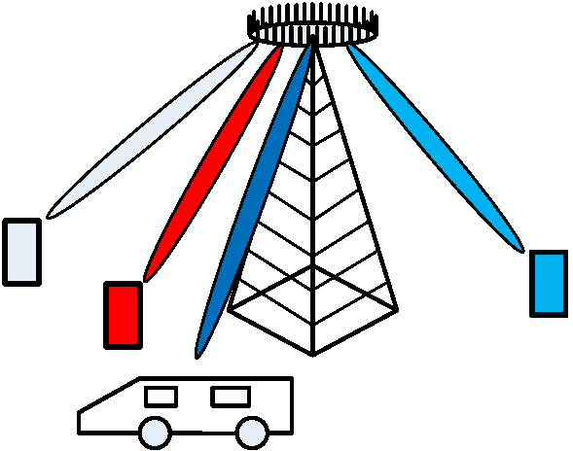

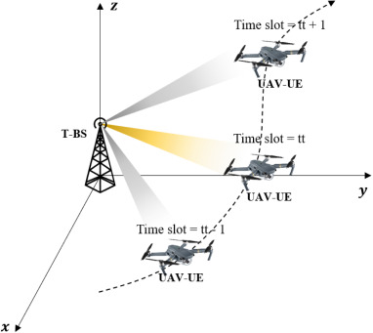

Dynamic Beam forming for Drones

**Use Case Requirements:**

* **Problem**: Current static beamforming methods struggle to maintain optimal connectivity in environments with moving devices, fleets, or drones.
* **Proposed Solution**: Use a genetic algorithm to dynamically adjust antenna weights based on historical weight values and signal strength data.
* **ML Concept**: Apply a genetic algorithm to optimize weight values in real time, ensuring connectivity for moving devices, fleets, and drones.

**Pipeline design (Genetic Algorithm Design)**

* **Initial Step**: When movement is detected (in devices, fleets, or drones), initialize a population of antenna weight values near the previous configuration.
* **Fitness Evaluation**: Signal strength serves as the fitness function to rank the effectiveness of each weight configuration.
* **Genetic Operations**: Crossover and Mutation are performed iteratively to explore better configurations.
* **Convergence**: The algorithm quickly identifies the optimal weight values to maintain signal strength.

**Dataset Used:**

**Time-Varying Ackley Function**

**Reasons for Using Ackley function as fitness function and model for drone antenna beamforming**

1. **Global Minima and Antenna Orientation**: The global minima of the Ackley function can be likened to optimal antenna orientations. Just as the Ackley function seeks to minimize energy, an optimal polarization map indicates the best configuration for signal reception or transmission.
2. **Movement in Space**: As the Ackley function dynamically changes with respect to time, it can represent a drone moving through various environmental conditions. The changing surface might reflect varying signal strengths, obstacles, or atmospheric effects affecting the antenna's performance.
3. **Complex Landscape**: Both the Ackley function and the antenna map involve navigating complex landscapes. The Ackley function's rugged terrain represents challenges like interference or multipath propagation that a drone might encounter as it moves.
4. **Optimization**: The goal in both scenarios is optimization. For the Ackley function, it's finding the minimum, while for the drone, it's about finding the best antenna configuration for given conditions, possibly adapting in real-time as the environment changes.

**Relation to Standards**

**5G and Beyond**

The **3GPP 5G NR (New Radio) standards** define the use of **massive MIMO** and **hybrid beamforming** for improving spectral efficiency and handling high data rates. The use of genetic algorithms and adaptive beamforming falls within the goals of **5G** for dynamic resource management and efficient beam steering in mobile environments.

##### IEEE 802.11ad and IEEE 802.11ay

##### These standards for millimeter-wave (mmWave) wireless communication define the beamforming protocols for 60 GHz WPAN (Wireless Personal Area Networks). The beam codebook-based beamforming used in this system aligns with the beam steering techniques specified in these standards, ensuring compatibility with multi-Gbps data rates and low-latency communication.

##### mmWave and WPAN Protocols

The use of dynamic beamforming in the **60 GHz WPANs**, as outlined by **Junyi Wang et al.**, corresponds to the need for efficient beam management in short-range, high-throughput wireless networks. The system’s ability to dynamically track moving devices aligns with the requirements for **multi-Gbps connectivity** in **millimeter-wave** environments.

**Code submission**

Github link: <https://github.com/Srikanth-Drklrd/MIMO_Genetic_Algorithm.git>

Contains:

* Input Document
* Code Implementations in Jupyter notebook (.ipynb )
* Result in Jupyter notebook (.ipynb )

### References

1. Junyi Wang et al., "Beam codebook-based beamforming protocol for multi-Gbps millimeter-wave WPAN systems," IEEE Journal on Selected Areas in Communications, vol. 27, no. 8, pp. 1390-1399, Oct. 2009, doi: 10.1109/JSAC.2009.091009.
2. Hu, Z., & Hsu, H. T. (2019). Efficient Adaptive Subarrays in Millimeter-Wave MIMO Systems with Hybrid RF/Baseband Precoding Combining Design. IEEE Transactions on Vehicular Technology, 68(2), 1713-1726, doi: 10.1109/TVT.2018.2887367.
3. IEEE Standard 802.11ad-2012, “Wireless LAN Medium Access Control (MAC) and Physical Layer (PHY) Specifications—Amendment 3: Enhancements for Very High Throughput in the 60 GHz Band.”
4. Qu, C., Peng, X., & Zeng, Q. (2024). Learning search algorithm: framework and comprehensive performance for solving optimization problems. *Artificial Intelligence Review*, *57*(6), 139.

**Appendix A:**

#### 1. Concept Explanation

This appendix outlines the core concepts and methods used for dynamic beamforming in tracking moving devices, focusing on hybrid beamforming, genetic algorithms, and real-time feedback mechanisms.

##### 2. Hybrid Beamforming

Hybrid beamforming combines analog and digital beamforming to achieve high-performance beam steering while reducing hardware complexity. In the context of moving devices, hybrid beamforming dynamically adjusts subarrays and RF chains to maintain connectivity, balancing between power efficiency and high throughput. The system adapts to changes in device positions by leveraging both phase shifting (analog) and digital signal processing.

##### 3. Genetic Algorithm for Beamforming Optimization

A genetic algorithm (GA) is employed to dynamically optimize the antenna weights in response to device movement. The GA adapts by initializing a population of weight values based on prior configurations (historical signal strength), and through iterative selection, crossover, and mutation, finds the optimal beamforming pattern. This enables real-time adaptability without requiring exact device location data.

##### 4. Beam Codebook and Adaptive Search

The system uses a pre-defined **beam codebook**, which simplifies the search space for beamforming directions. The genetic algorithm operates within this codebook to rapidly find the most efficient beam patterns. The use of adaptive search techniques helps optimize connectivity as the device moves.

**5. Beam Tracking**

Real-time feedback through beam tracking algorithms (e.g., Kalman Filters) ensures that the system continuously adjusts the beam direction as the device moves. This is particularly important in mmWave communications, where beam directionality is crucial to overcoming path loss and maintaining high signal strength.

**Appendix B:**

**Genetic Algorithm Overview:**

In this section, we explain the Genetic Algorithm (GA) implemented in the Python notebook for dynamic beamforming in multi-antenna systems.

**1. Initialization:**

The GA starts by initializing a population of potential solutions (antenna weight values). These solutions are initialized near the previous optimal weight configuration to ensure the search starts from a reasonable point in the solution space. If the previous optimal weight configuration is unavailable, then the search begins at a random pooint.

**2. Fitness Function:**

The fitness of each solution is evaluated based on the signal strength obtained from the antenna configuration. Higher signal strength results in higher fitness scores. This metric ensures that the algorithm is always optimizing toward the best connectivity for mobile devices, fleets, and drones.

Here we use, the dynamic time-varying Ackley function to effectively model the challenges faced by a drone's antenna system as it navigates through different spatial and temporal conditions. The dynamic Ackley function is often used in optimization problems due to its complex landscape, which includes multiple local minima and a single global minimum. When considering its movement in the x, y, and z directions over time, you can think of it as a three-dimensional surface that changes dynamically, creating a rich landscape that can simulate various conditions.

**3. Selection:**

Selection involves choosing the fittest individuals from the current population for reproduction. In our implementation, individuals with better fitness (stronger signal strength) have a higher probability of being selected.

**4. Crossover (Recombination):**

Crossover is applied to the selected individuals to produce the next generation. In this step, portions of the antenna weight values from two parent solutions are combined to create a new solution. This encourages the exploration of new configurations while regaining the properties of the parent.

**5. Mutation:**

Mutation introduces small random changes to individual solutions. This step is crucial for maintaining diversity within the population and avoiding premature convergence on suboptimal solutions. Since vehicle motion can be abrupt and random, introducing some amount of randomness in the search process could prove to be beneficial.

**6. Adaptive Learning:**

As the GA operates, it learns from the historical weight values and signals strengths, enabling it to predict the next optimal weight configurations when the device, fleet, or drone moves again.

**7. Error function:**

The Euclidean distance between the estimated genetic algorithm and the actual point of maximum signal strength is used as an error function.

_________________

**1st feedback from mentor sessions:**

Here are the notes and suggestions:

model the ant pattern when the drone is in motion

- ⁠signal strength prediction at the highest

- ⁠beam forming is assigned based on the inference.

- ⁠direction is based on the inference

- ⁠input is the signal strength

- ⁠drone is moving and find the sig strength at various locations.

- ⁠based on the inferred location, apply the beam forming direction.

- ⁠comment-1: closed loop needs to be called out.

- comment-2: studying existing mechanisms for beam optimization: e.g. ⁠<https://www.youtube.com/watch?v=fJ5OomvILRc> , [https://www.deepsense6g.net](https://www.deepsense6g.net/)

*Thank you,*

**P. Prudhvi Krishna,**

*Junior Project Officer*

***ML Workshop Intern***

[*prudhvi.pavuluri@itu.int*](mailto:prudhvi.pavuluri@itu.int)