|  |  |  |  |  |
| --- | --- | --- | --- | --- |
|  | INTERNATIONAL TELECOMMUNICATION UNION  **TELECOMMUNICATION** **STANDARDIZATION SECTOR**  STUDY PERIOD 2022-2024 | | **Focus Group on AI Native Networks** | |
| **AINN-I-xx** | |
| **Original: English** | |
| **Question(s):** | | N/A | Virtual, TBD 2024 | |
| **INPUT DOCUMENT** | | | | |
| **Source:** | | *SSNCE-ECE* | | |
| **Title:** | | Dynamic Beamforming Optimization Using Genetic Algorithm for Mobile Devices, Fleets, and Drones in Multi-Antenna Systems | | |
| **Contact:** | | Srikanth S,  Syed Azim,  Prasanna Karthikeyan G | | E-mail:  [srikanth2110893@ssn.edu.in](mailto:srikanth2110893@ssn.edu.in),  [syed2110753@ssn.edu.in](mailto:syed2110753@ssn.edu.in),  [prasanna2110778@ssn.edu.in](mailto:Prasanna2110778@ssn.edu.in) |

|  |  |
| --- | --- |
| **Abstract:** | This document presents a solution for dynamic beamforming in multi-antenna systems using a genetic algorithm, applicable not only to mobile devices but also to fleets and drones that require continuous monitoring. Conventional static or slowly adaptive beamforming mechanisms become inefficient when devices, fleets, or drones are in motion. This proposal addresses this issue by using historical antenna weight values and signal strength data to predict optimal weight adjustments in real time. A genetic algorithm explores a search space of potential weights, applying mutation and crossover techniques to maintain strong connectivity despite the movement of devices. This approach is designed to enhance wireless network performance in highly dynamic environments, such as transportation fleets, drone operations, and mobile communication systems*.* |

## Use case introduction:

In modern wireless systems, maintaining optimal beamforming is challenging when devices, vehicles, or aerial systems (such as drones) are moving. For example, in fleets or drone monitoring operations, real-time beamforming is crucial for maintaining uninterrupted connectivity. The proposed system dynamically adjusts antenna weight values to ensure consistent and strong signal strength, even as the monitored entities are in motion. By using a genetic algorithm, the system adapts to changes without relying on exact positional data, making it suitable for a variety of real-time, dynamic applications.

* **Phase 1:**  
  A device, fleet vehicle, or drone connects to the multi-antenna system. Initial antenna weight values are assigned, and signal strength is measured.
* **Phase 2**:  
  The connected entity (device, fleet, or drone) begins to move. The system detects a change in signal strength, indicating the need for dynamic weight adjustment.
* **Phase 3**:  
  The genetic algorithm is triggered. It initializes a population of weight values near the previous set, and signal strength is used to evaluate the fitness of each individual.
* **Phase 4**:  
  The algorithm applies mutation and crossover to iteratively search for better weight values, continuously optimizing beamforming as the entity moves.
* **Phase 5**:  
  Optimal weight values are found, signal strength is maximized, and the system maintains connectivity. Historical weight values are stored for future predictions.
* **Phase 6**:  
  If the entity moves again, the system uses the learned weight values to predict the next optimal beamforming configuration, repeating the process as needed.

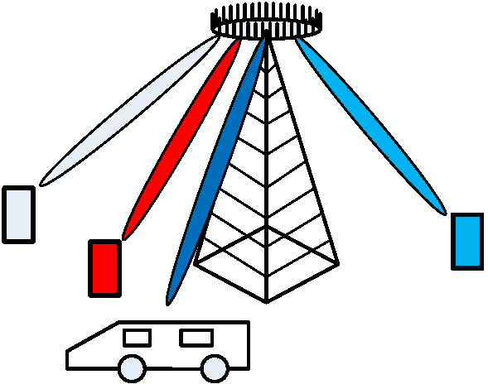

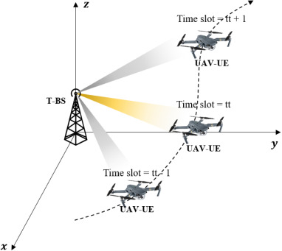

**Use Case Requirements:**

* **Problem**: Current static beamforming methods struggle to maintain optimal connectivity in environments with moving devices, fleets, or drones.
* **Proposed Solution**: Use a genetic algorithm to dynamically adjust antenna weights based on historical weight values and signal strength data.
* **ML Concept**: Apply a genetic algorithm to optimize weight values in real time, ensuring connectivity for moving devices, fleets, and drones.

**Pipeline design (Genetic Algorithm Design)**

* **Initial Step**: When movement is detected (in devices, fleets, or drones), initialize a population of antenna weight values near the previous configuration.
* **Fitness Evaluation**: Signal strength serves as the fitness function to rank the effectiveness of each weight configuration.
* **Genetic Operations**: Crossover and Mutation are performed iteratively to explore better configurations.
* **Convergence**: The algorithm quickly identifies the optimal weight values to maintain signal strength.

**Relation to Standards**

* **5G/6G and Beyond**: The approach aligns with future telecommunications standards focusing on dynamic beamforming and multi-antenna systems.
* **Application to Fleets and Drones**: Extends the existing use cases of MIMO systems to fleet management and drone operations, where maintaining strong connectivity is crucial.

Clause-6: Code submission details

Clause-7: Self-Testing results

_________________