# Laboratory 5a

Title of the Laboratory Exercise: Java database programming

1. Introduction and Purpose of Experiment

The SQL includes commands to define view on the data. A view contains rows and columns, just like a real table. Java uses JDBC (Java Database Connectivity) to connect to databases. JDBC allows to connect to a wide-range of databases such as Oracle, MySQL, etc. By doing this lab, students will be able to implement views in SQL and connect the developed database with the application.

1. Aim and Objectives

Aim

* To design and implement views on the data using SQL commands
* To connect to the relational database in Java

Objectives

At the end of this lab, the student will be able to

* Design and execute views using SQL commands
* Perform database programming in Java

1. Experimental Procedure
   * 1. Analyse the problem statement
     2. Execute the built-in functions in SQL
     3. Design and execute the view statements in SQL
     4. Test the executed commands
     5. Document the Results
     6. Analyse and discuss the outcomes of your experiment
2. Questions
   1. Create a table MANGER with attributes such as Name, Id, Department, Address, and Salary. Write SQL statements for the following expressions.
3. Create a view ‘MANAGER_VIEW’ to display the details such as name and department of each manager
4. Display the name of the manager from MANAGER_VIEW whose department is ‘Information Technology’
5. Drop the views generated
6. Presentation of Results

**Code**

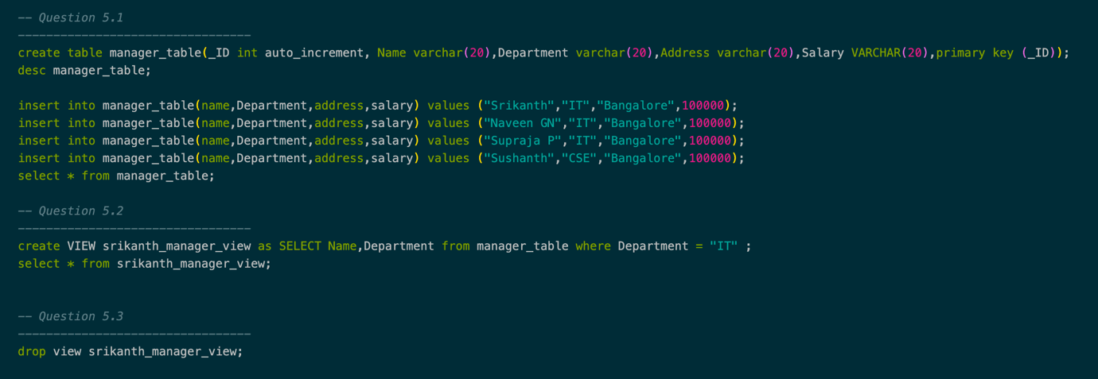

Figure SQL Queries for given problem statement

**Results**

**Question 1.1)**

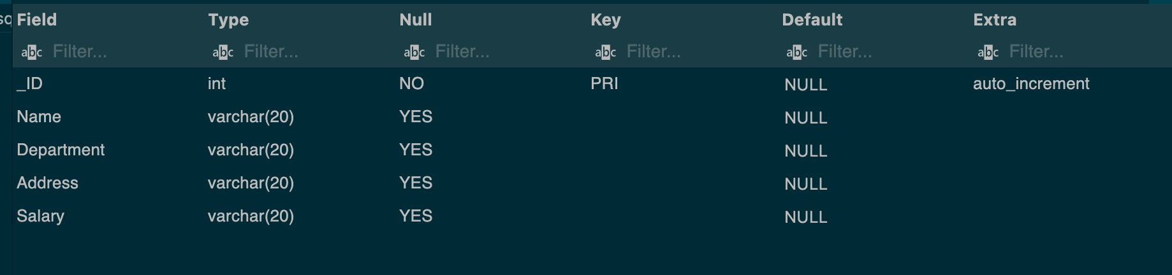

Figure Metadata for table “Manager table”

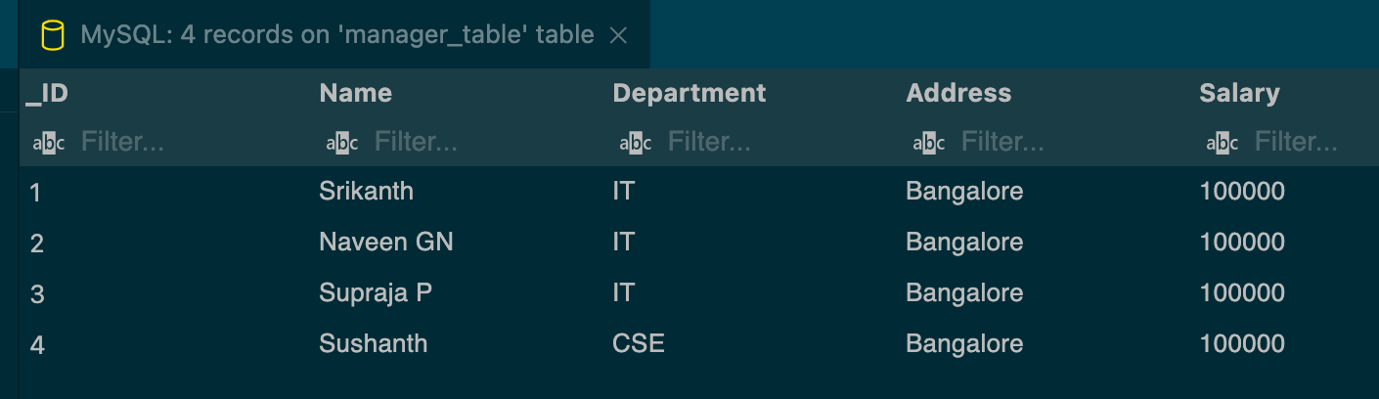

Figure Data displayed from table "Manager table"

**Question 1.2 )**

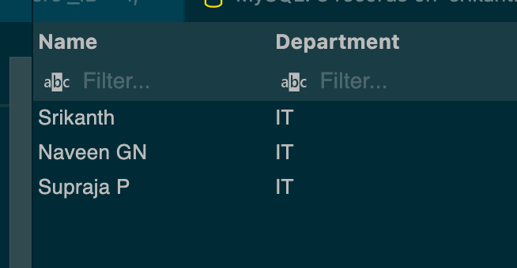

Figure View table for srikanth_view_manager

**Question 1.3)**



Figure View table dropped

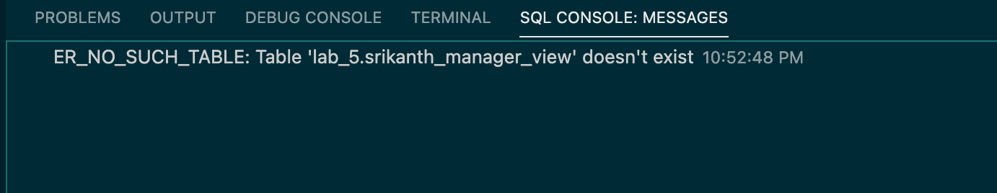

Figure Verification that view table was dropped

1. **Analysis and Discussions**

A view in SQL is a virtual table based on the result-set of an SQL statement it contains rows and

columns, just like a real table. The fields in a view are fields from one or more real tables in the

database. A view can be created by selecting fields from one or more tables present in the database. A View can either have all the rows of a table or specific rows based on certain condition.

JDBC offers a programming-level interface that handles the mechanics of Java applications

communicating with a database or RDBMS. The JDBC API supports communication between the

Java application and the JDBC manager.

1. **Conclusions**

A data can be presented in the form of virtual table called views, they can be created, displayed and dropped just like any other table by making SQL queries. A view of table was created, displayed and dropped in Srikanth_view_manager. We can use JDBC driver to make SQL queries. JDBC provides an interface to make SQL queries in java program.

1. **Comments**

**1. Limitations of Experiments**

One of the limitations on views is that it’s only creates the appearance of a table, not a real table, the query processor must translate queries against the view into queries against the underlying source tables.

**2. Learning happened**

To design and execute views using SQL commands