# Laboratory 8

Title of the Laboratory Exercise: Stored Procedure in MySQL

1. Introduction and Purpose of Experiment

A stored Procedure is a procedure stored in a database which can be called by the database engine and connected programming languages. A stored procedure is invoked using the CALL statement. A procedure has a name, a parameter list, and SQL statement(s). The parameters make the stored procedure more flexible and useful. In MySQL, a parameter has one of three modes: IN, OUT, or INOUT. By doing this lab, students will be able to implement MySQL stored procedure.

1. Aim and Objectives

Aim

* To implement MySQL stored procedure

Objectives

At the end of this lab, the student will be able to

* Design SQL procedures for the given problem statement
* Implement the procedures in MySQL

1. Experimental Procedure
   * 1. Analyse the problem statement
     2. Create the table and its attributes with essential properties
     3. Design the procedures in MySQL
     4. Implement the procedures in MySQL
     5. Test the implemented procedures
     6. Document the Results
     7. Analyse and discuss the outcomes of your experiment
2. Questions
   1. Design and implement a procedure which accepts one INOUT parameter (count) and one IN parameter (inc). Inside the stored procedure, increase the counter (count) by the value of the inc parameter.
   2. Create a table OFFICES in OFFICEDB with attributes such as OfficeCode, OfficeName, OfficePhone, City, and Country.
      1. Write a ‘GetPhoneNo’ procedure in MySQL to take the name of an office and display the phone number of that office.
      2. Write a ‘GetOffice’ procedure in MySQL to take the name of a particular country and display the number of offices located in that Country.
3. Presentation of Results

**Creating a Table**

**Query**

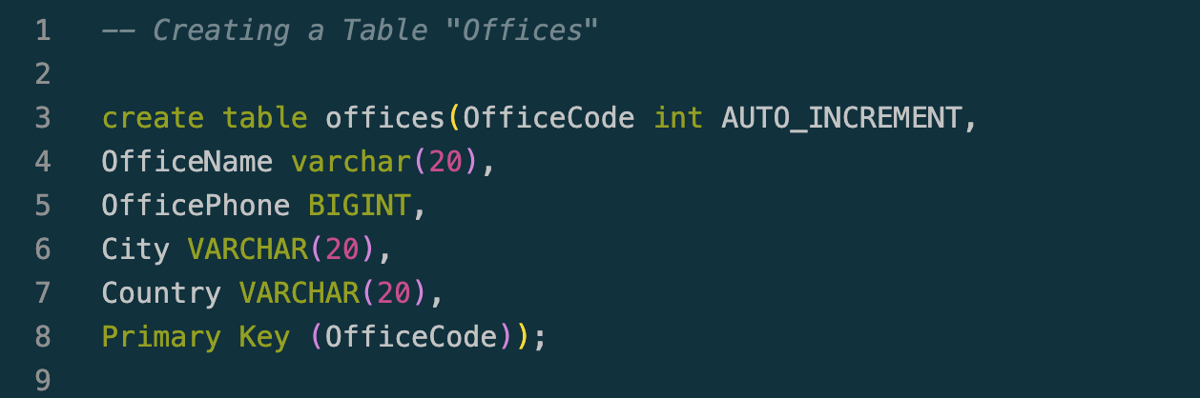

Figure 1 MySQL Queries to create "offices" table.

**Result**

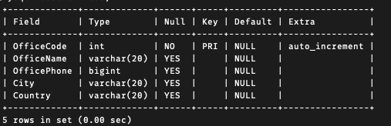

Figure 2 MySQL Metadata for "offices" table.

**Inserting Data**

**Query**

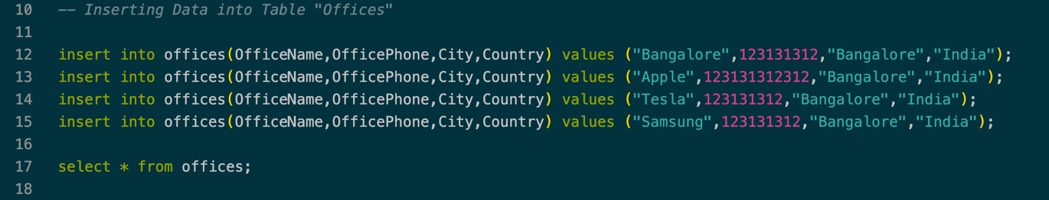

Figure 3 MySQL Queries to insert data into "offices" table.

**Result**

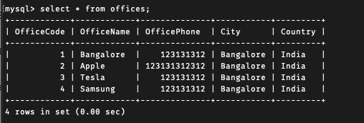

Figure 4 MySQL Data inside "office" table.

**Question A**

**Query**

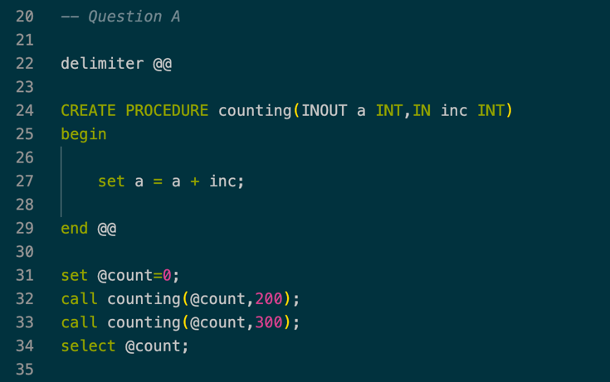

Figure 5 MySQL Queries for given problem statement using procedure.(Question 1)

**Result**

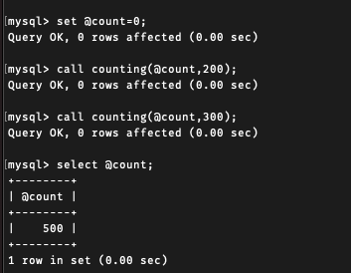

Figure 6 MySQL result for the given problem statement using procedure.(Question 1)

**Question B (i)**

**Query**

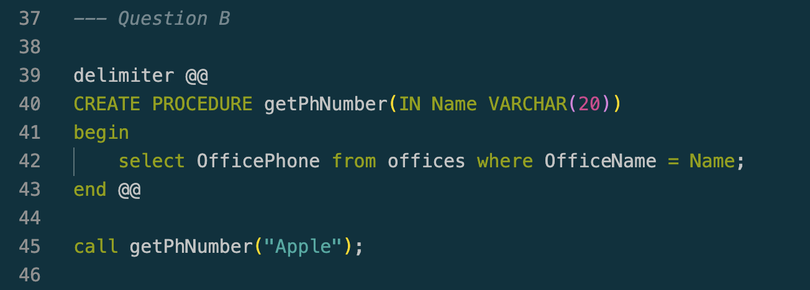

Figure 7 Figure 5 MySQL Queries for given problem statement using procedure.(Question 2)

**Result**

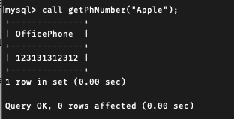

Figure 8 MySQL result for the given problem statement using procedure.(Question 2)

**Question B (ii)**

**Query**

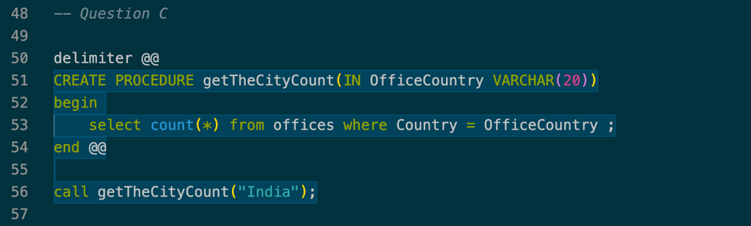

Figure 9 Figure 5 MySQL Queries for given problem statement using procedure.(Question 3)

**Result**

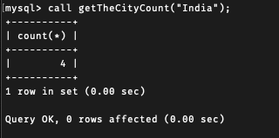

Figure 10 MySQL result for the given problem statement using procedure.(Question 3)

1. **Conclusions**

A stored procedure is a prepared SQL code that you can save, so the code can be reused over and over again. So if you have an SQL query that you write over and over again, save it as a stored procedure, and then just call it to execute it. You can also pass parameters to a stored procedure, so that the stored procedure can act based on the parameter value(s) that is passed**.**

These Procedures can be used with parameters also as we saw in Question B.

1. **Comments**

**1. Limitations of Experiments**

Sometimes using these procedures can be complicated as they not be that easy to debug.

**2. Limitations of Results**

Using procedure can help reduce writing queries again and again

**3. Learning happened**

Learned using procedures in MySQL and executing the queries.