Technical Design Document
AI Changelog & Release Notes Generator — Architecture, Diagrams & Build Steps
Owner: Srikanth Pusapati · Version 1.0 · July 31, 2026

1. Design Principles
- Deterministic shell, probabilistic core. Everything around the LLM call (collection, classification rules, rendering, git operations) is plain deterministic code. The LLM does exactly one job: rewrite grouped facts into audience-appropriate prose, returning JSON that is schema-validated.
- Human in the loop. Output lands as a PR or draft release, never an unreviewed publish.
- Metadata only. Commit messages, PR titles/bodies and labels go to the LLM — never source diffs by default.
- Portable core. The generator is a plain Python package; CLI, GitHub Action, and future SaaS are thin adapters around it.

2. High-Level Architecture (Component View)
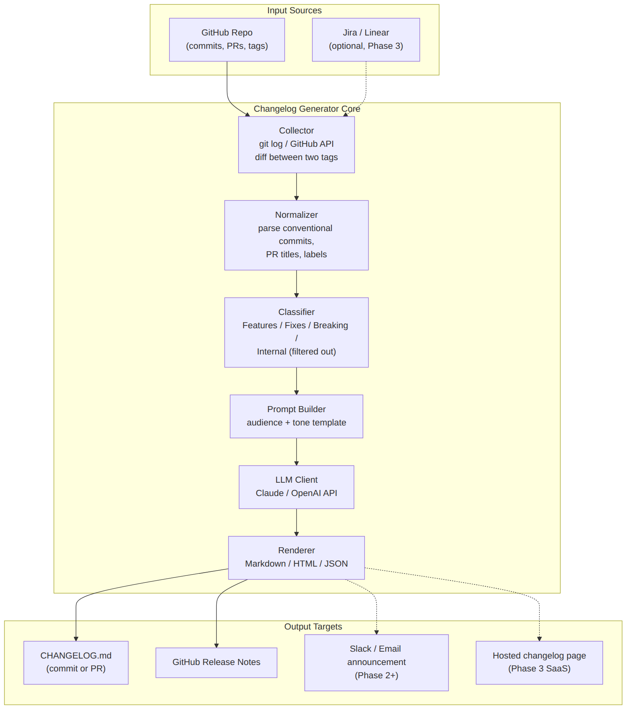
Figure 1 — Component diagram: sources → pipeline → outputs. Dashed edges are later phases.

Component responsibilities
Component | Responsibility | Implementation
Collector | Fetch commits and merged PRs between two refs (tags, SHAs, or dates) | git CLI via subprocess + GitHub REST API (requests); paginate; cache to JSON
Normalizer | Unify commits/PRs into one ChangeItem model; parse Conventional Commit prefixes, PR labels, linked issues | Pure Python, dataclasses; unit-testable
Classifier | Bucket into Features / Improvements / Fixes / Breaking; drop noise (chore, ci, deps, test) | Rules first (prefix/label maps); LLM assist only for unlabeled leftovers
Prompt Builder | Assemble system + user prompt: grouped changes, tone, audience, product context, few-shot examples | Jinja2 templates versioned in-repo
LLM Client | One API call per release; JSON-schema-constrained output; 1 retry on validation failure | Anthropic/OpenAI SDK behind a small interface
Renderer | Markdown (Keep-a-Changelog), GitHub Release body, JSON | Jinja2 templates; idempotent
Output Adapters | Write file, open PR, publish release; later Slack/email/pages | GitHub API; Action uses GITHUB_TOKEN

3. Generation Flow (Sequence View)
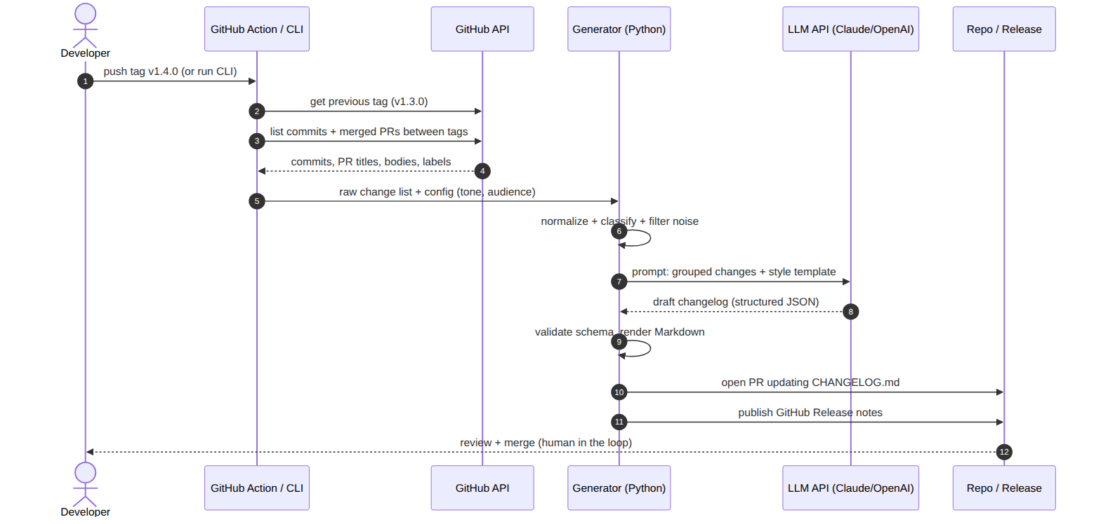
Figure 2 — Sequence: tag push → collect → classify → LLM → validated render → PR for human review.
Key detail: steps 6–9 form the reliability loop. The generator validates the LLM's JSON against a schema; on failure it retries once with the validation error appended; on second failure it falls back to a rule-based render of the grouped changes so the pipeline never blocks a release.

4. Deployment Evolution
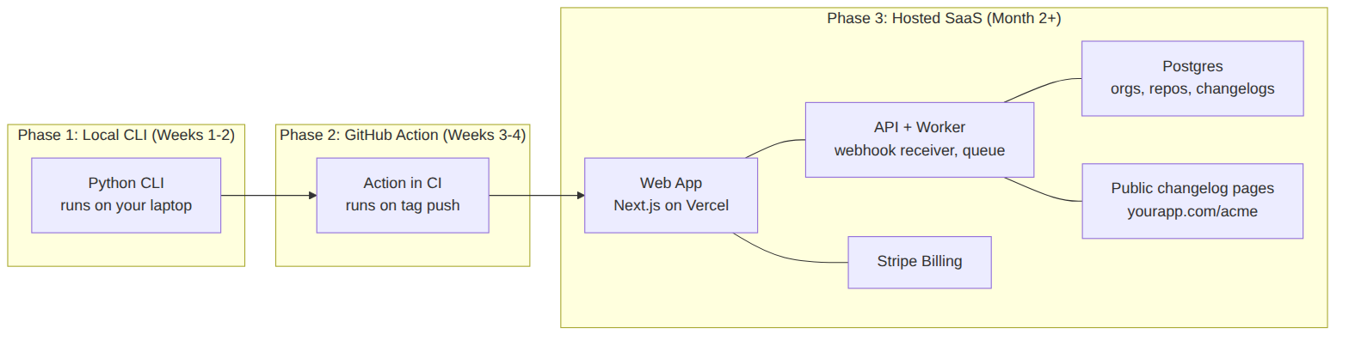
Figure 3 — Same core package deployed three ways as the project matures.

5. Tech Stack
Layer | Choice | Why
Language | Python 3.12 | Your daily driver; fastest path; rich SDKs
CLI framework | Typer + Rich | Clean CLI with near-zero boilerplate
LLM | Claude (Haiku/Sonnet tier) or GPT mini-tier, behind an interface | Cheap per release; easy to swap; bring-your-own-key mode later
Prompting | Jinja2 templates + JSON schema outputs | Versionable, testable prompts; no silent format drift
Validation | Pydantic v2 | Schema for ChangeItem and LLM response
GitHub integration | REST API via requests; Action = composite action running the CLI | No framework needed at this scale
Packaging | uv + pyproject.toml; publish to PyPI | pipx install changelog-gen
Phase-3 SaaS | Next.js on Vercel + Postgres (Neon/Supabase) + Stripe | Solo-friendly, near-zero ops

6. Data Model & LLM Contract

6.1 ChangeItem (internal model)
class ChangeItem(BaseModel):
id: str # sha or PR number
source: Literal['commit', 'pr']
title: str # commit subject or PR title
body: str | None # PR body (truncated)
labels: list[str] # PR labels
kind: Literal['feature','improvement','fix','breaking','internal']
refs: list[str] # linked issues '#123'

6.2 LLM response schema (enforced)
{
"version": "v1.4.0",
"headline": "one-sentence release summary",
"sections": [
{ "name": "Features",
"entries": [ { "text": "customer-facing sentence",
"source_ids": ["#482", "a1b2c3"] } ] }
]
}
Every generated entry must cite the source_ids it was derived from — this makes review trivial (the PR diff links prose back to commits) and is your anti-hallucination guard: entries with unknown ids are rejected in validation.

6.3 Prompt design (summary)
- System prompt: role (“you write customer-facing release notes”), tone/audience from config, hard rules (no invented features, one sentence per entry, cite source_ids, skip internal jargon).
- User prompt: product one-liner from config, grouped ChangeItems as compact JSON, 2 few-shot examples of good entries (bad commit → good entry).
- One call per release, not per change — cheaper and lets the model dedupe related commits into one entry.

7. Exact Build Steps — Phase 1 CLI
Repository layout to create (this is the folder pushed to GitHub as ChangeLogScriptGenerator):
ChangeLogScriptGenerator/
├─ pyproject.toml
├─ README.md
├─ .changelog.yml # example config
├─ action.yml # Phase 2: composite GitHub Action
├─ src/changelog_gen/
│ ├─ __init__.py
│ ├─ cli.py # Typer entrypoint
│ ├─ collect.py # git + GitHub API
│ ├─ models.py # ChangeItem, LLMResponse (Pydantic)
│ ├─ classify.py # rules-first bucketing
│ ├─ llm.py # provider interface + retry/validate
│ ├─ prompts/release.j2 # versioned prompt template
│ └─ render.py # markdown / release templates
├─ tests/
└─ docs/ # BRD, this design doc, diagrams
- Bootstrap (1 evening). uv init, add typer, rich, pydantic, requests, jinja2, pyyaml, anthropic. Wire `changelog-gen --help`. Commit, push to GitHub.
- Collector (1 evening). `git log prev_tag..new_tag --pretty` via subprocess for commits; GitHub API `/repos/{o}/{r}/pulls?state=closed` filtered to merged-in-range for PRs. Auto-detect previous tag with `git describe --tags --abbrev=0 <tag>^`. Dump raw JSON — verify on a real repo before going further.
- Normalize + classify (1 evening). Map conventional prefixes and PR labels to kinds; drop internal kinds; leftovers default to 'improvement'. Unit-test with messy real-world messages.
- LLM call (1–2 evenings). Jinja2 prompt → one API call → parse JSON → Pydantic validate (including source_ids exist) → retry once with error feedback → rule-based fallback. This module is where you learn structured outputs properly.
- Render + ship (1 evening). Markdown and Release templates; `changelog-gen generate --from v1.3.0 --to v1.4.0 --style friendly`. Run on your repos and 2 friends' repos; iterate on the prompt with real output.
- Phase 2 — Action (1 weekend). action.yml (composite): checkout with fetch-depth 0, setup Python, pip install your package, run generate, then peter-evans/create-pull-request to open the changelog PR. Trigger: push tags 'v*'. Secrets: ANTHROPIC_API_KEY; GITHUB_TOKEN is built in.

Example .changelog.yml
product: "Acme API — payments infrastructure for indie SaaS"
tone: friendly # professional | friendly | technical
audience: customers # customers | developers | internal
sections: [Features, Improvements, Bug Fixes, Breaking Changes]
ignore:
- "chore(*"
- "ci:*"
- "bump *"
breaking_labels: [breaking, breaking-change]
llm:
provider: anthropic
model: claude-haiku # cheap tier is plenty for this task

8. Testing & Quality
- Unit tests: normalizer and classifier on a corpus of ugly real commit messages (collect these from day one — they become your eval set).
- Golden tests: 3 frozen releases with recorded LLM responses (VCR-style) so refactors don't silently change output.
- Prompt evals: a 10-case eval file (input changes → expected qualities checklist: no hallucinated features, correct bucketing, cites sources). Run manually per prompt change in Phase 1; automate with an LLM grader in Phase 2. This is deliberately your on-ramp to LLM evals as a skill.

9. Cost & Operations
- Typical release (≤50 changes) ≈ 3–5K input tokens, ~1K output → well under $0.05 on a cheap-tier model.
- Phase 1–2 has zero infrastructure to operate: it runs in the user's CI with their key. All ops burden is deferred until the SaaS is justified by demand.

