ReadMe:

export the files into a location which the matlab can acess.

practise 1 has all the .m files needed.

Example executions:

Execute/Run: assignFun(100,2)

Get the graph as the result. Were X is 100, a is 2

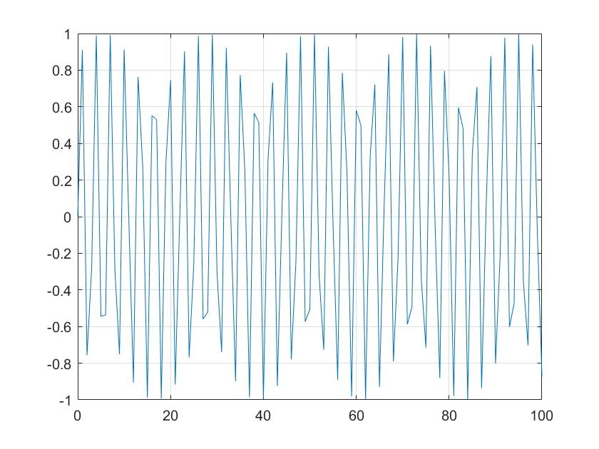

Execute/Run: practice1incrScript.m

get the results for various values of x0 i.e. x0=100, x0=50 etc.

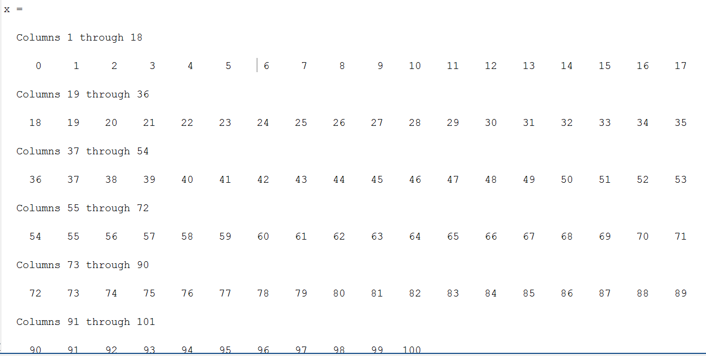

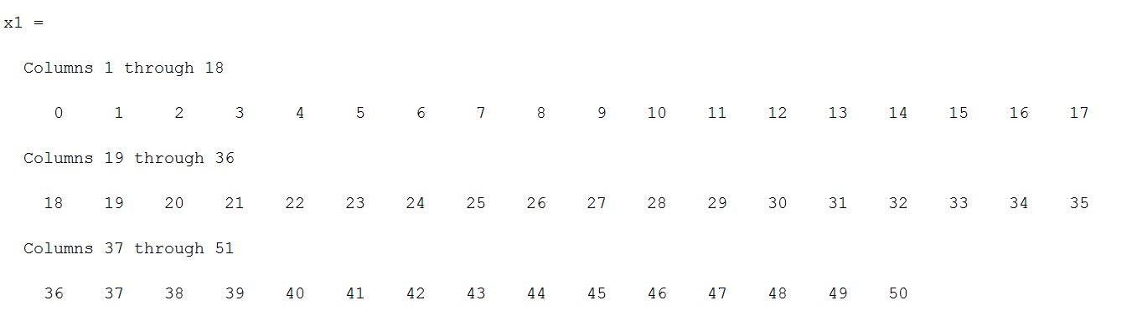

Execute/Run: practice1FindSinScript.m

we get the results for dot product of sin(x).sin(2x) and sin(x).sin(5x)

for different values of x the results change

**when x is 0-100**

d1x =

0.0071

d2x =

0.2933

**When X is 0-50**

d1x1 =

-0.0410

d2x1 =

-1.5261

For practice 2:

Sample execution: execute the script scriptLoadImage.m

output: 3 different channels of the image uploaded will be displayed.

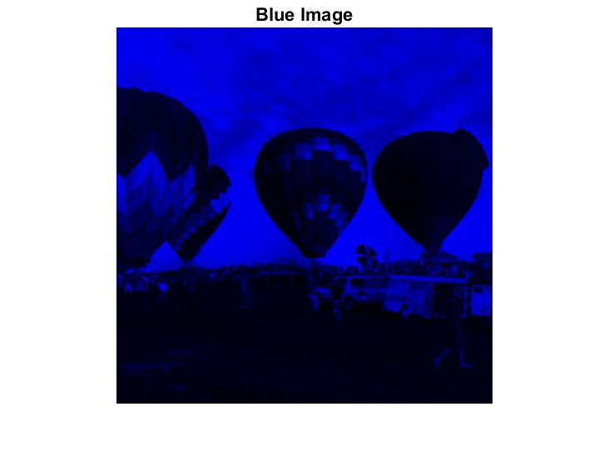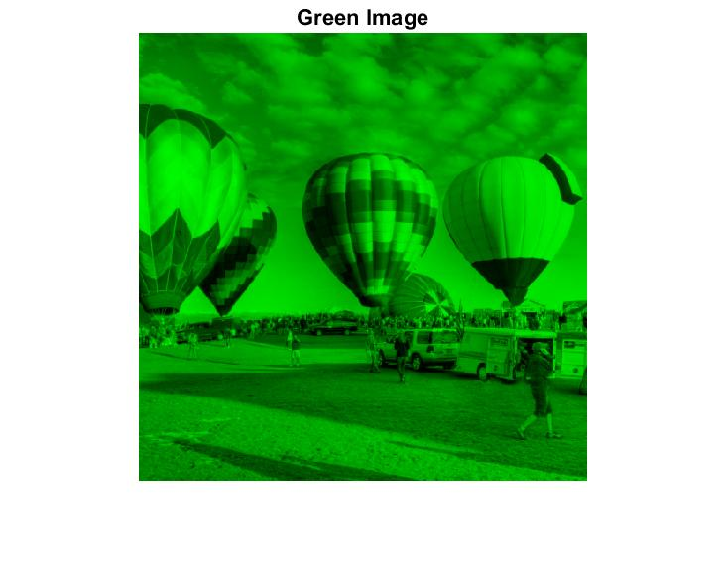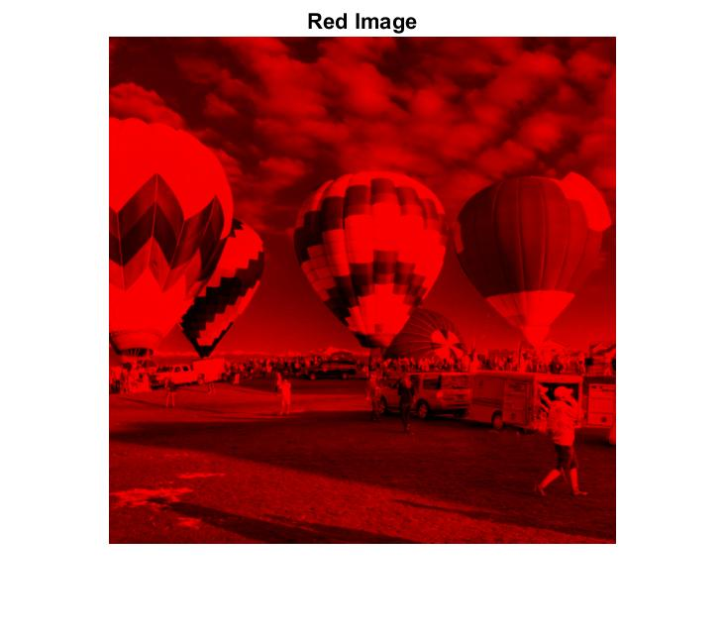

%the size of the image variable

sz =

512 512 3

%memory allocation for the image variable

Name Size Bytes Class Attributes

image 512x512x3 786432 uint8

Also, can see the reduced image

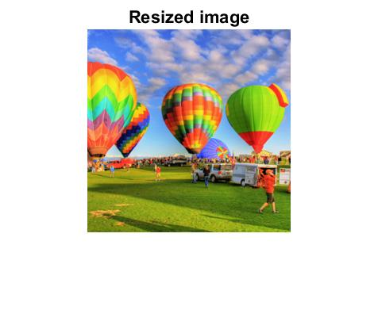

Can also view the switched image.

