

REAL TIME VIOLENCE

ALERT SYSTEM

**Guide:**

**Ms. Jayalekshmi J**

**Co-guide: Ms. Dhanya L.K**

**Presented by:**

**Ben Sam Sabu S8 CS2 17**

**C J Peter S8 CS2 18**

**Govind B Chandran S8 CS2 22**

**Mannu Thomas S8 CS2 35**

# PROBLEM STATEMENT

**CCTV Surveillance is used to a greater extent but still it lacks the feature of automatic violence detection.**

**Manual monitoring is not a feasible task and the time taken to respond to the situation is also crucial.**

**A Real-time violence alert system is proposed.**



**METHODOLOGY**

**Data**

**Training**

**Dataset**

**Testing**

**Dataset**

**MobileNet v2**

**Model**

**Testing Video**

**Image frames**

# METHODOLOGY

**A dataset having 1000 videos each of violence category and non-violence category was chosen**

**A model was trained using MobileNetV2 using the dataset**

**Real-time video footage is given as input**

**Output is obtained as image frames**

# MOBILENET V2

**Convolutional neural network that is 53 layers deep**

**Provides real-time classification capabilities under computing constraints in devices like smartphones.**

**Utilizes an inverted residual structure where the input and output of the residual blocks are thin bottleneck layers.**

**Uses lightweight convolutions to filter features in the expansion layer.**

# MOBILENET V2 ARCHITECTURE

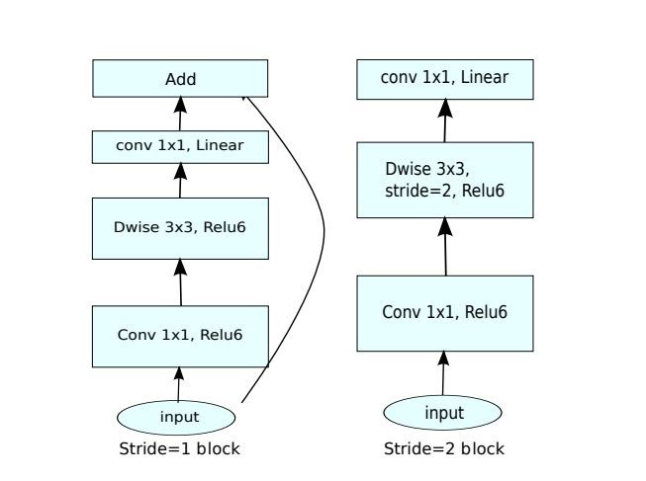

## OPERATING ENVIRONMENT

**PYTHON**

**The language used.**

**GOOGLE COLABORATORY**

**Environment for running python and similiar Machine**

**Learning and Deep Learning projects**

**Able to use Google's GPU and TPU**

## RESULTS

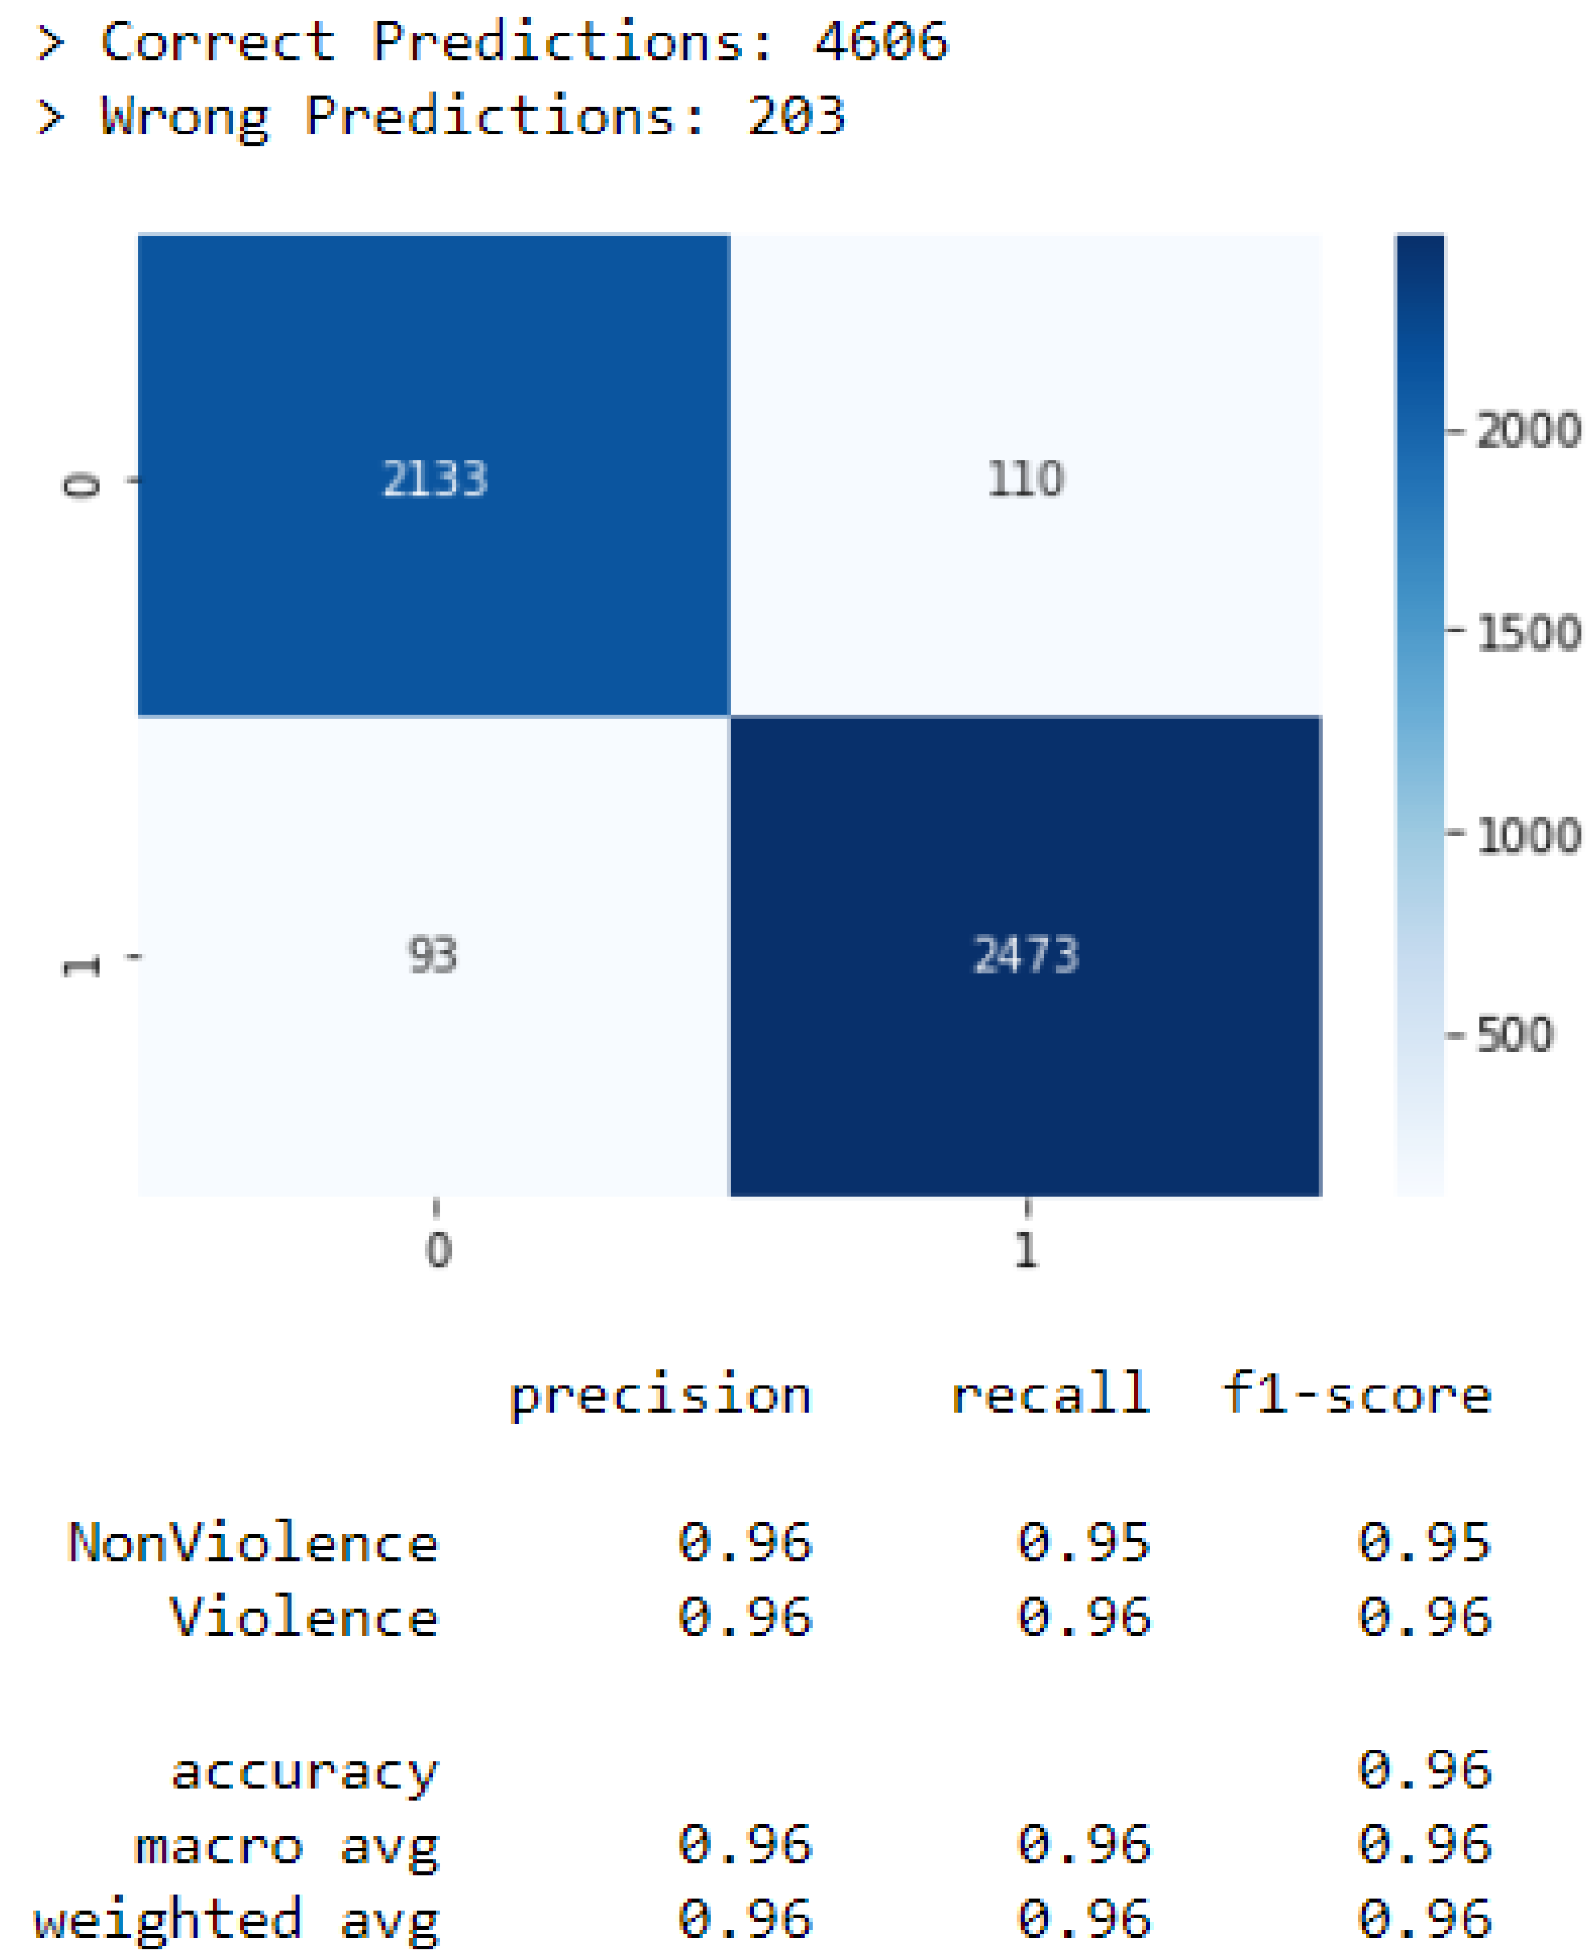

**Nov**AREA AND TOPIC RESEARCH

**ACTION PLAN**Status : Completed

**Dec**LITERATURE REVIEW AND DATASET COLLECTION

Status : Completed

-------------------Implementation phase starts-------------------

DESIGN & IMPLEMENTATION

**Jan-Mar**Status : Completed

NOVELTY IMPLEMENTATION

**Apr**status : To be completed

FINAL TESTING, PAPER

**May**PUBLICATION

Status : To be completed

## REFERENCES

1. **Mi Young Lee, Ijaz Ul Haq, Seungmin Rho, Sung Wook Baik, and Samee Ullah Khan Cover the**

**Violence: A Novel Deep-Learning-Based Approach Towards Violence-Detection in Movies, MDPI Article Received: 3 October 2019; Accepted: 7 November 2019; Published: 18 November 2019**

1. **M. -S. Kang, R. -H. Park and H. -M. Park, "Efficient Spatio-Temporal Modeling Methods for RealTime Violence Recognition," in IEEE Access, vol. 9, pp. 76270-76285, 2021, doi:**

**10.1109/ACCESS.2021.3083273, Date of Publication: 25 May 2021.**

1. **Zhou P, Ding Q, Luo H, Hou X (2018) Violence detection in surveillance video using lowlevelfeatures. PLoS ONE 13(10): e0203668. https://doi.org/10.1371/journal.pone.0203668, Published:**

**October 3, 2018**

**[4]https://towardsdatascience.com/review-mobilenetv2-light-weight-model-image-classification8febb490e61c**

# THANK YOU