class TwitterApp

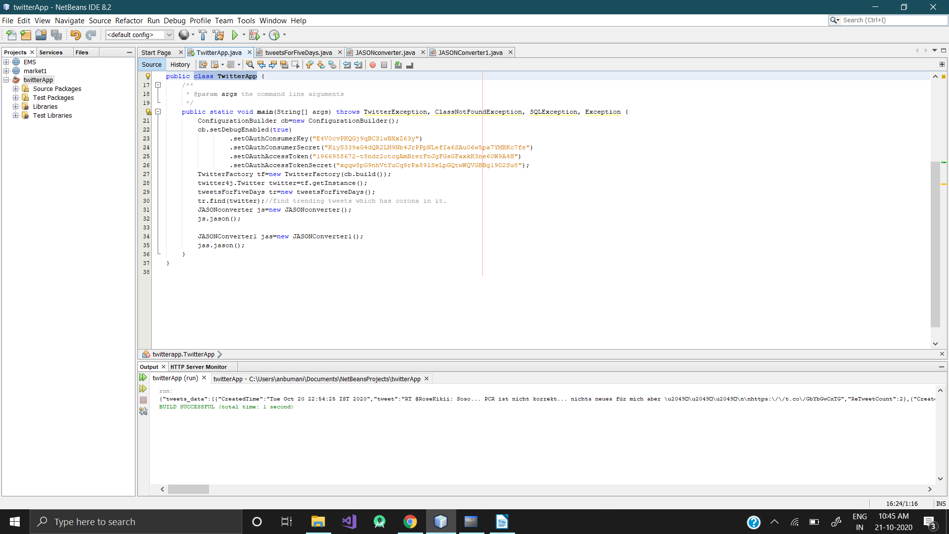

class tweetsForFiveDays

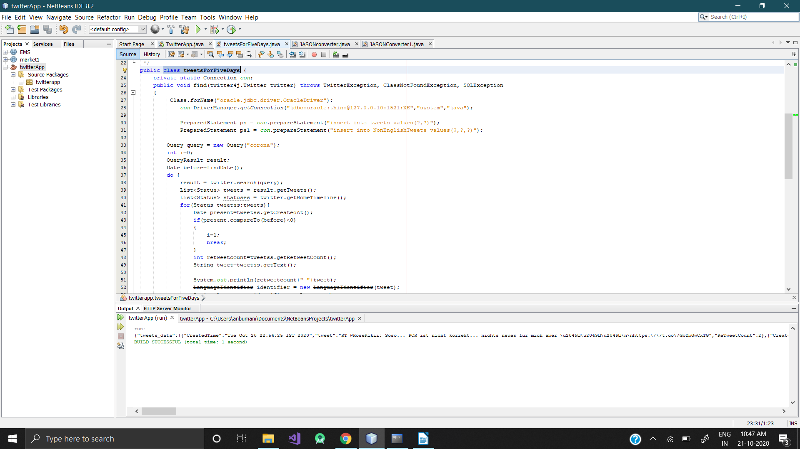

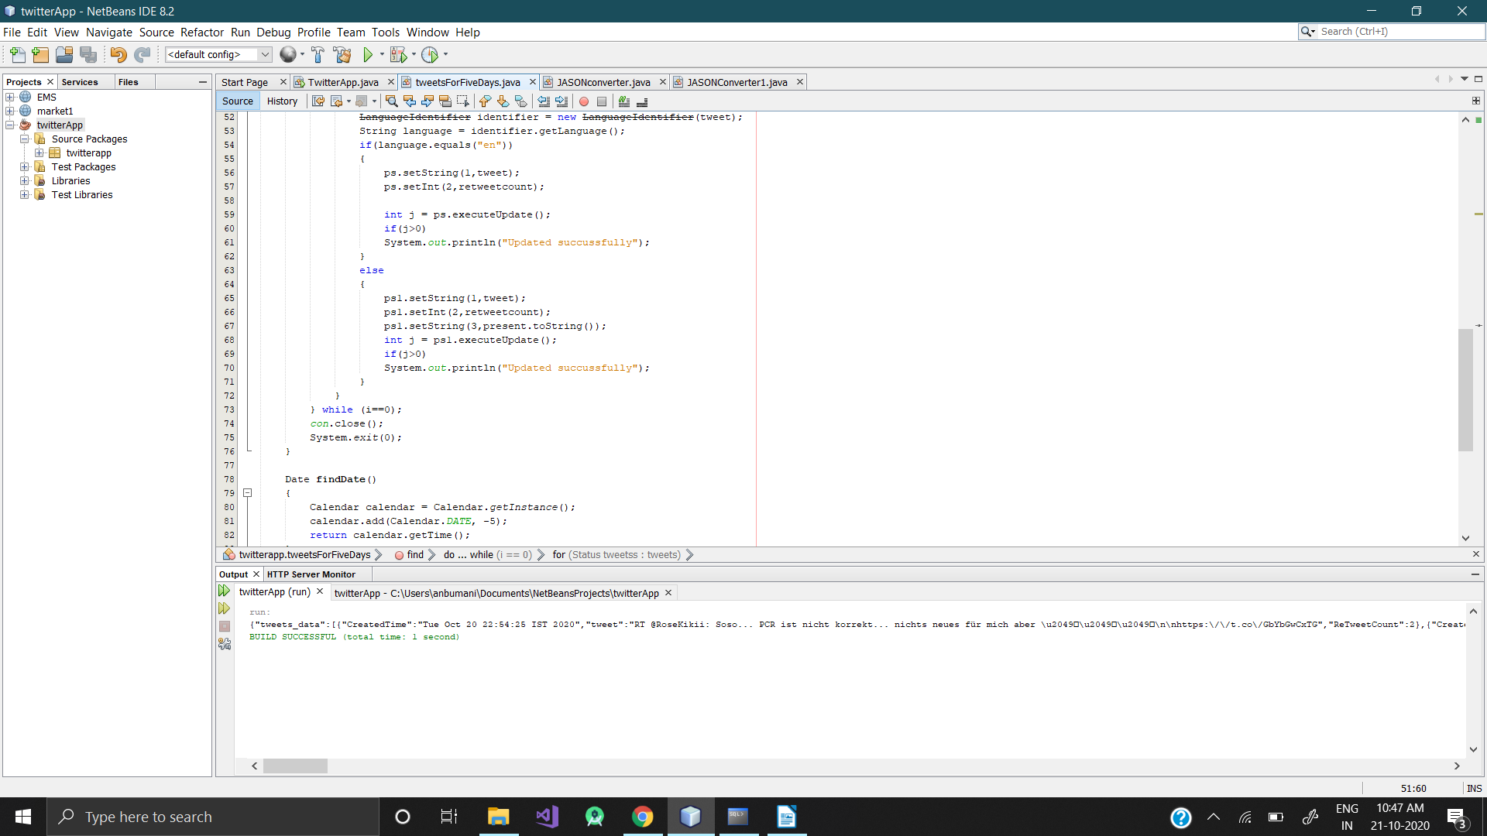

class JASONconverter

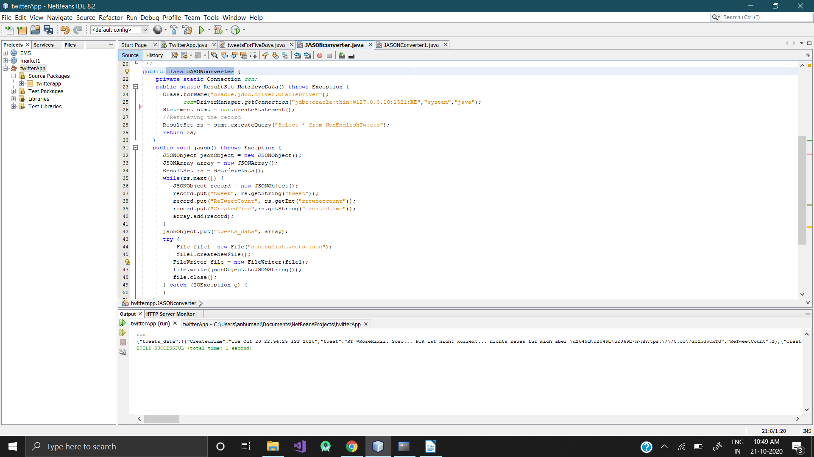
JASONConverter1

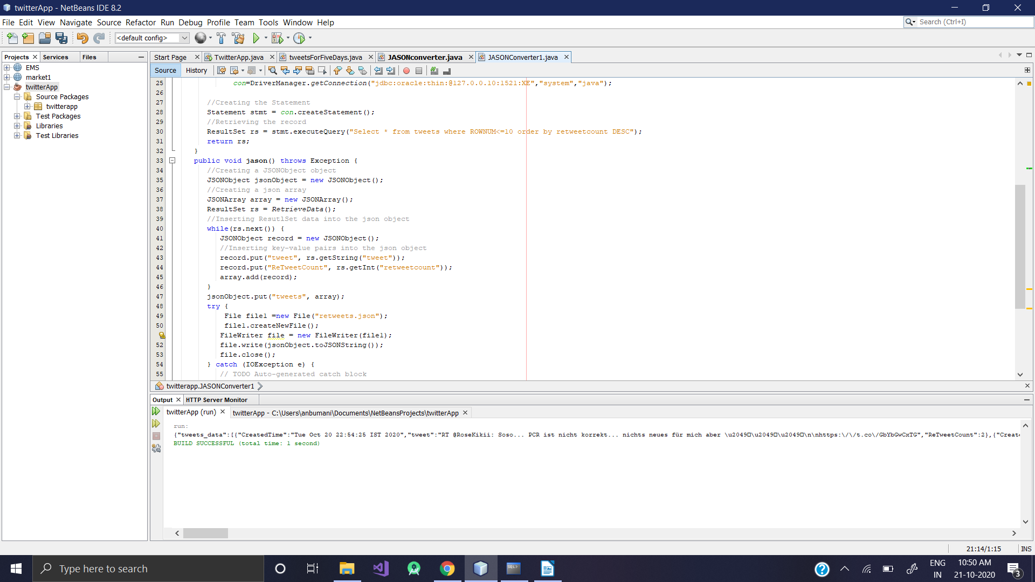

retweet jason file

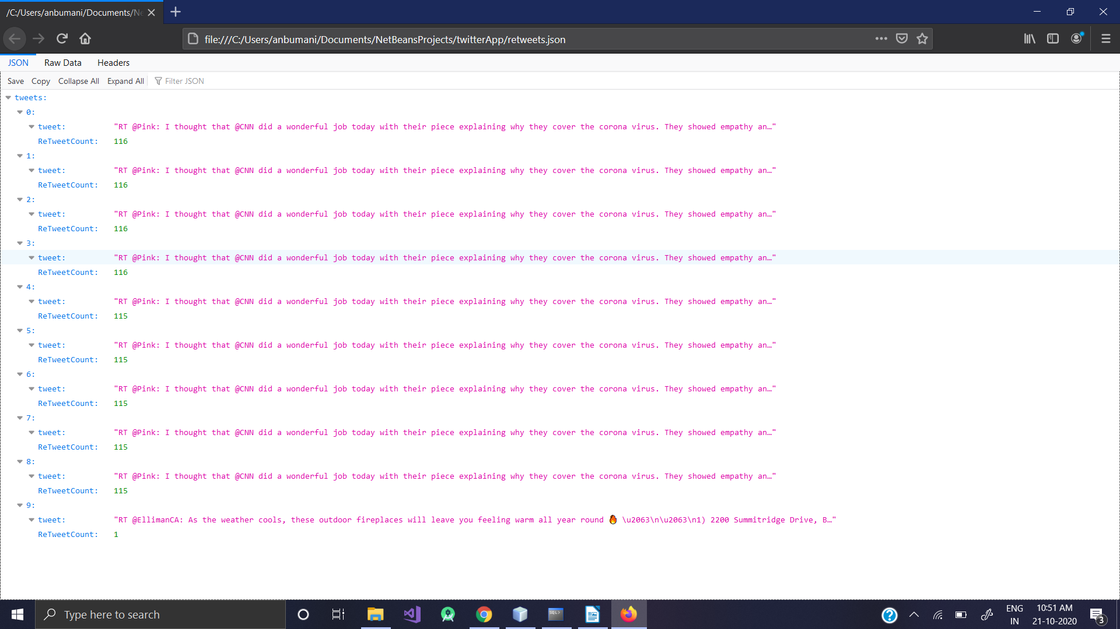
NonEnglishTweets jason file

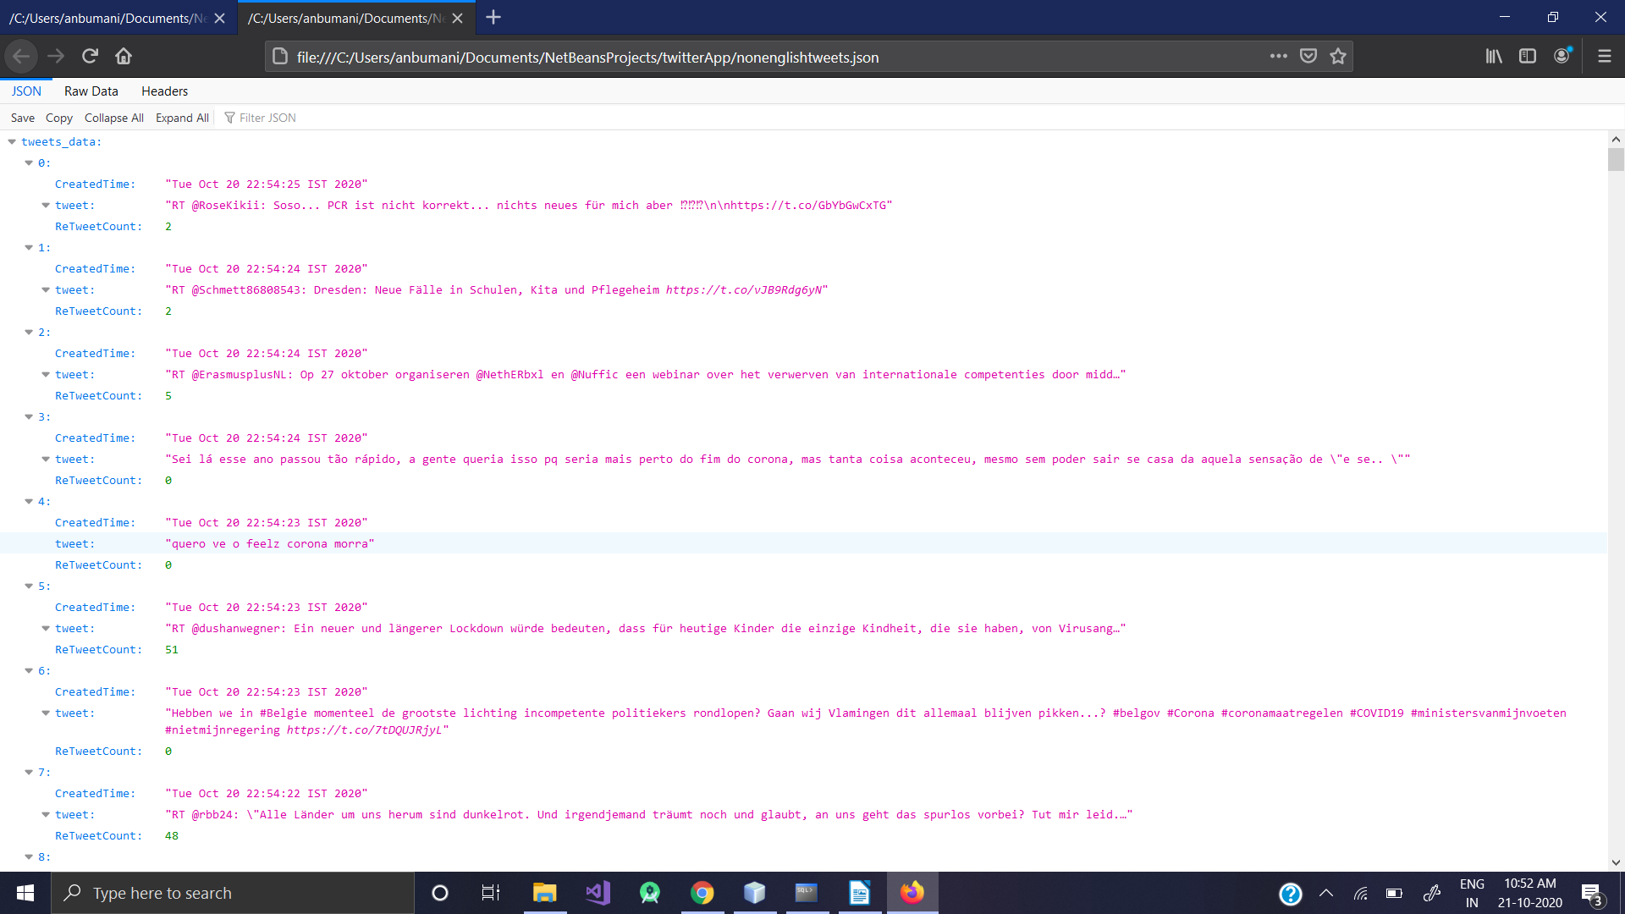

Database

Creating tables

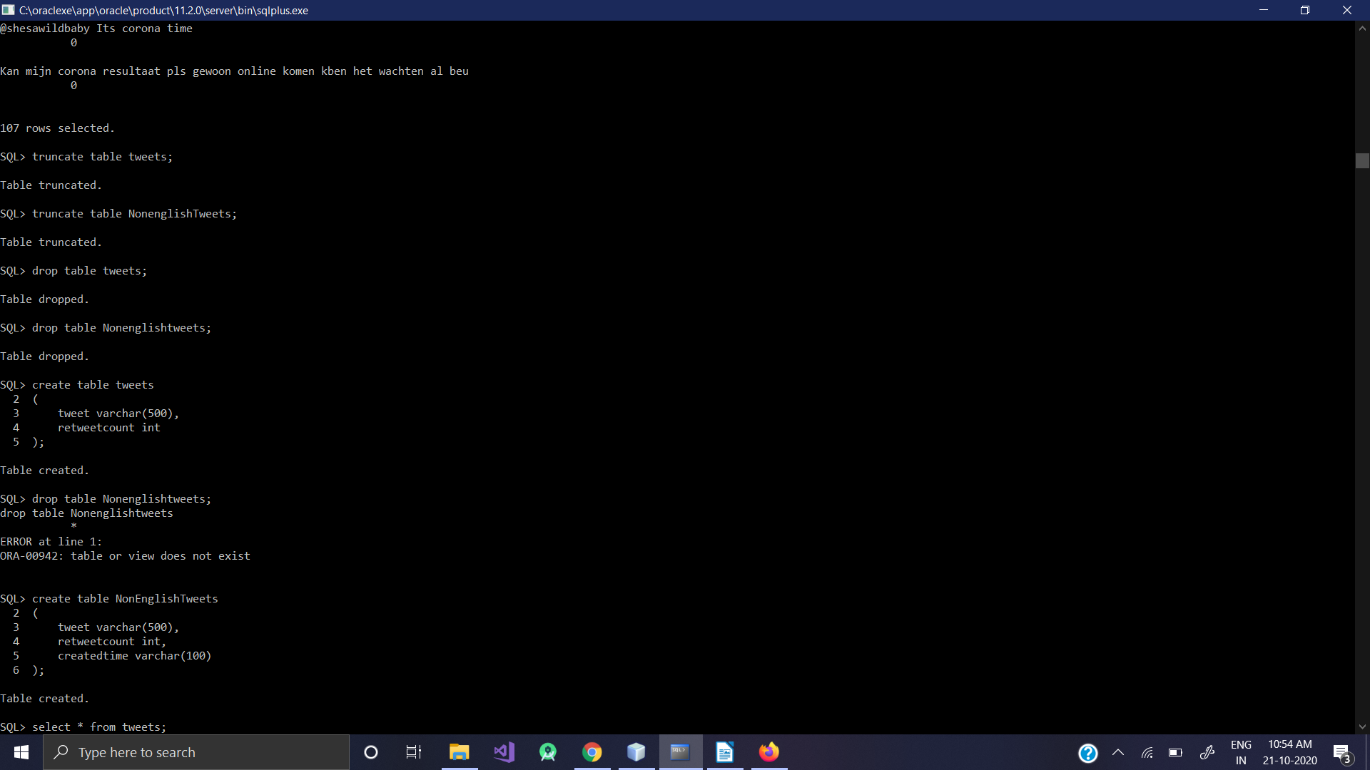
create table NonEnglishTweets
(
tweet varchar(500),
retweetcount int,
createdtime varchar(100)
);

create table tweets
(
tweet varchar(500),
retweetcount int
);

