Project Report - BT3041 Term Project
  - Molecular Subtypes of Breast Cancer: Analysis of TCGA-BRCA Gene Expression Data
Team members: Naveen, Srikant, Piyush Kuldeep (BS23B037), Vimal, Madhavan
Code files: Jupyter notebooks 01–09

1. Introduction & Research Question(s)

1.1 Background
Breast cancer is the most common cancer in women and is not a single disease. Based on gene expression, breast tumours are divided into five intrinsic (PAM50) subtypes: Luminal A (LumA), Luminal B (LumB), HER2-enriched (Her2), Basal-like and Normal-like. These subtypes differ in prognosis and treatment, but they often overlap, and clinical receptor tests (ER, PR, HER2) only approximate them.
In this project, RNA-seq gene expression data from the TCGA breast cancer (TCGA-BRCA) cohort was analysed using statistics and machine-learning methods to study how the subtypes differ, how well they can be predicted, and how they relate to patient outcome.

1.2 Dataset Description
Dataset details:
- Project: TCGA-BRCA (The Cancer Genome Atlas, breast invasive carcinoma)
- Source: NCI Genomic Data Commons (GDC) portal
- Data type: RNA-seq gene expression, raw counts (STAR – Counts, GENCODE v36)
- Organism: Homo sapiens; tissue: primary breast tumour
Dataset characteristics:
- 1,231 samples × 60,660 genes (1,111 primary tumour, 113 normal tissue, 7 metastatic)
- PAM50 subtype labels for 1,099 tumour samples
- Clinical data (age, tumour stage, ER, PR, HER2 status) from UCSC Xena
- Survival data (overall survival time and status) from cBioPortal PanCanAtlas
Each sample is named by its TCGA barcode, which encodes the patient and the sample type. Example: TCGA-A1-A0SD-01A (patient A1-A0SD, primary tumour "01", vial "A").

1.3 Research Question(s)
The major research questions were:
- Do PCA, UMAP and clustering reveal groups that match the known PAM50 subtypes?
- Which genes and pathways differ significantly between the subtypes?
- Can machine-learning models predict the subtype from gene expression, and which genes are most important?
- Are the subtypes and key gene-expression features associated with age, tumour stage and survival?

2. Data Acquisition & Preprocessing

2.1 Data Source
The gene expression files were downloaded from the GDC portal using a manifest file and the gdc-client tool (1,231 files, one per sample). Clinical and survival tables were downloaded from UCSC Xena and cBioPortal. All files were loaded into Python using pandas. The final matrix contained:
- rows → genes
- columns → samples

2.2 Data Cleaning & Preprocessing

(a) Merging the Count Files
The raw count column ("unstranded") of each file was merged into one matrix, and four quality-control rows (N_unmapped, N_multimapping, etc.) were removed.

(b) Sample Selection
Only primary tumour samples with a PAM50 label were kept. When a patient had more than one sample, only one was kept (vial A preferred), so that no patient appears twice. This gave 1,083 patients: LumA 562, LumB 209, Basal 190, Her2 82, Normal-like 40. All patients were female.

(c) Merging Clinical and Survival Data
Clinical and survival data were matched to each sample using the TCGA barcode. Tumour stages were grouped into Stage I–IV. Expression, clinical and survival data were collected separately, so only gene expression was used for feature selection and classification.

(d) Gene Filtering
Only protein-coding genes were kept, and genes with low expression were removed (CPM ≥ 1 in at least 40 samples, the size of the smallest subtype). This reduced 60,660 genes to 15,959 genes.

(e) Normalization and Log Transformation
Samples had very different sequencing depths (19–111 million reads), so counts were converted to counts per million (CPM) and log-transformed: log2(CPM + 1). Raw counts were kept separately for differential expression with DESeq2.

(f) Standardization
Before PCA and machine learning, expression values were standardized using StandardScaler so that genes with a large range do not dominate.

3. Methods and Codes

3.1 Exploratory Data Analysis
Bar plots, box plots and violin plots were used to study subtype balance, age, stage and receptor status. Kruskal–Wallis (age) and chi-square tests (stage, ER, PR, HER2) were used to check differences between subtypes. A heatmap of the 50 most variable genes and a gene correlation heatmap were also made.

3.2 PCA and UMAP
PCA was done on the 2,000 most variable genes (highly variable genes, HVG) to reduce dimensionality, and samples were coloured by subtype. UMAP was applied on the first 30 PCs (n_neighbors = 30, min_dist = 0.3). To check for batch effects, we measured how much of each PC was explained by subtype compared with sequencing plate, hospital and library size.

3.3 K-Means and Hierarchical Clustering
K-means and hierarchical clustering (Ward linkage) were applied on the first 30 PCs for k = 2 to 10. The elbow plot, silhouette score and Adjusted Rand Index (ARI, agreement with PAM50) were used to choose k.

3.4 Differential Expression (Hypothesis Testing)
Null hypothesis (H0): the expression of a gene does not differ between subtypes. A Kruskal–Wallis test was done for every gene, and p-values were corrected for multiple testing using the Benjamini–Hochberg (BH) FDR method. Each subtype was then compared with LumA using PyDESeq2. A gene was called significant if the adjusted p-value < 0.05 and the fold change was at least 2 (|log2FC| > 1).

3.5 Pathway Enrichment
Significant genes were tested against the 50 MSigDB Hallmark pathways using over-representation analysis (ORA, Fisher's exact test) and gene set enrichment analysis (GSEA, 1,000 permutations) with the gseapy module.

3.6 Classification
The data was split into 80% training and 20% test sets (stratified). Five models were trained: Logistic Regression, SVM, Random Forest, XGBoost and LightGBM. Feature selection (SelectKBest, ANOVA F-test, 500 genes) and scaling were done inside 5-fold cross-validation to avoid data leakage. Class weights were balanced because the subtypes are imbalanced, and models were compared using accuracy, balanced accuracy and macro-F1.

3.7 Survival and Regression Analysis
Kaplan–Meier curves with log-rank tests compared survival between subtypes and stages. A Cox regression model tested whether subtype affects survival after adjusting for stage and age. Linear regression tested whether a proliferation score (average of 11 PAM50 proliferation genes) and ESR1 expression change with age and stage.

4. Results & Interpretations

4.1 Clinical Exploratory Analysis
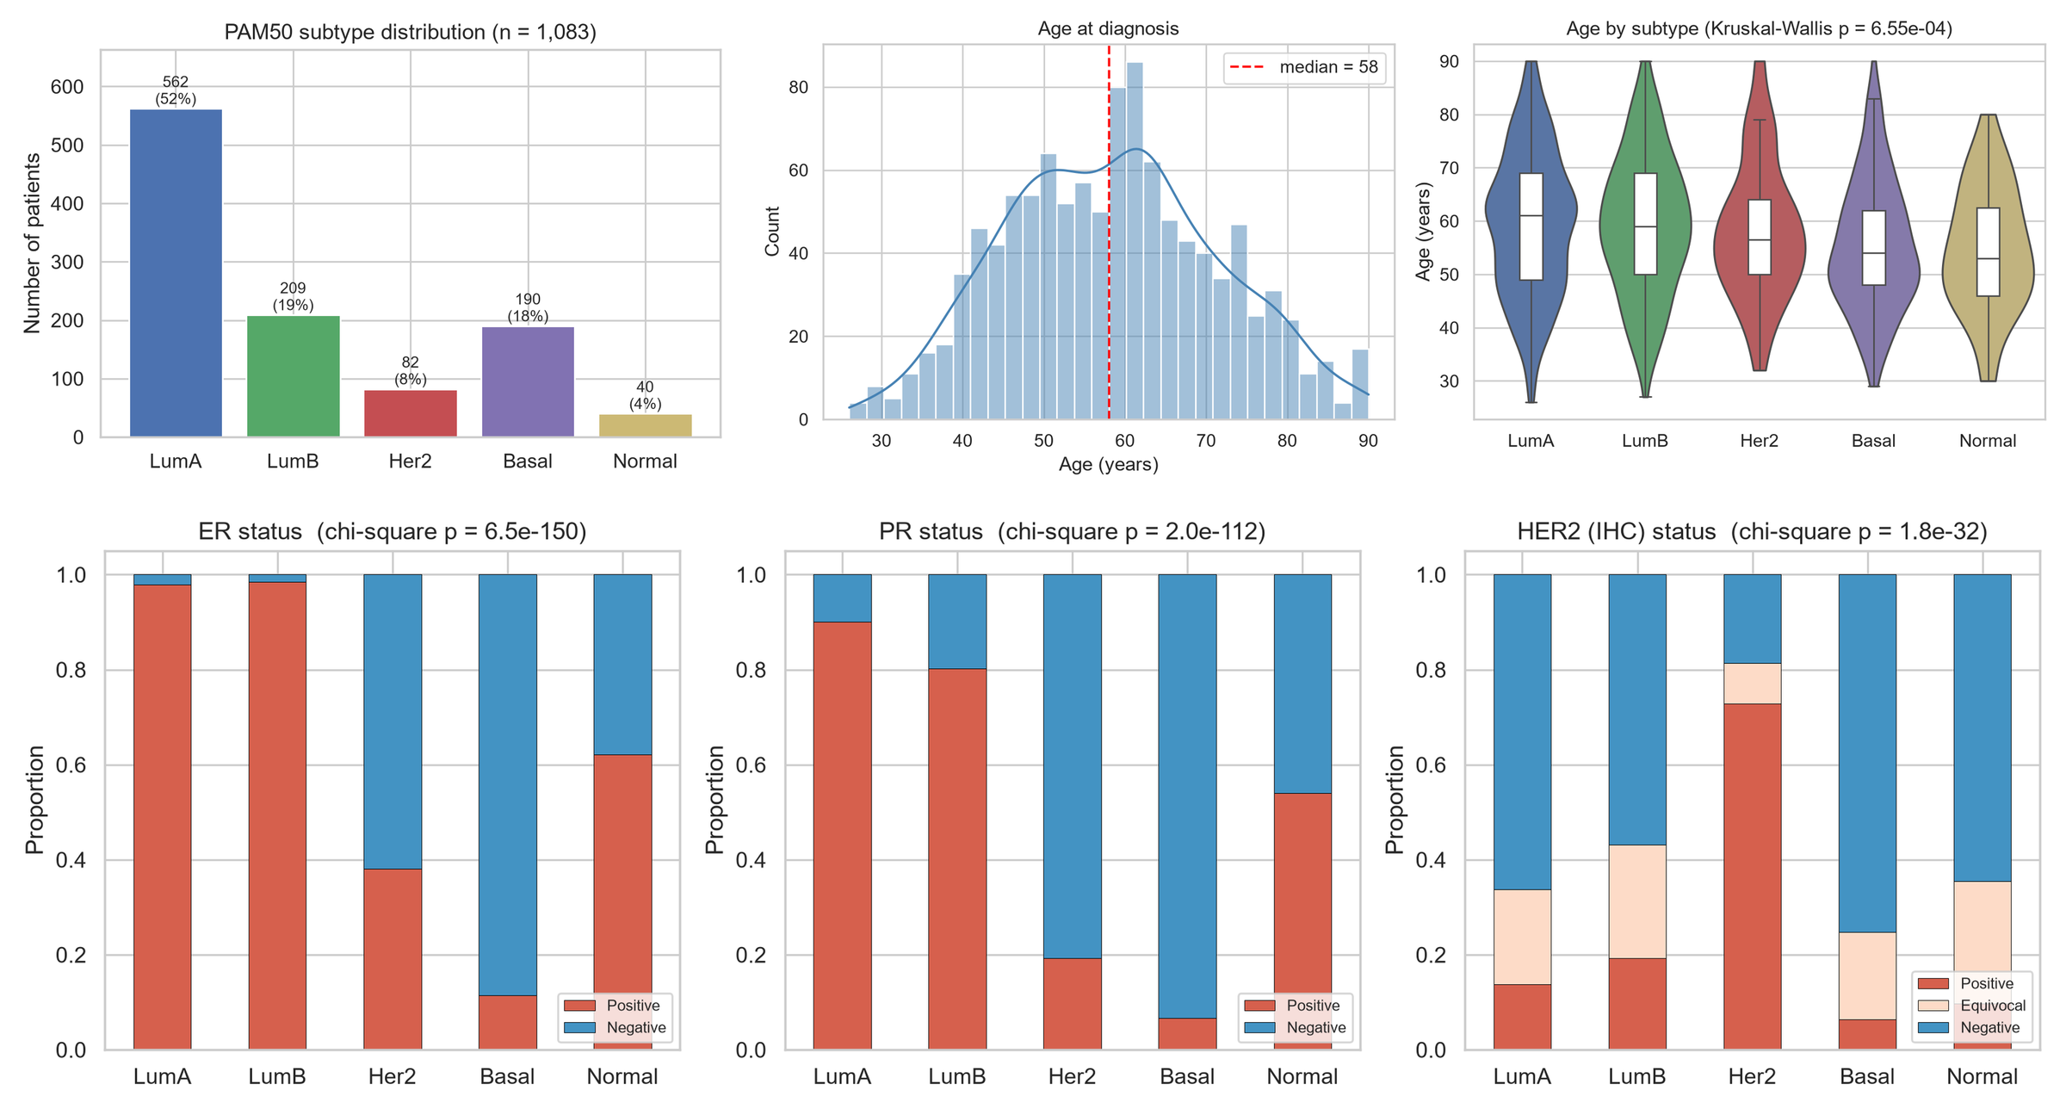
Figure 1: Subtype distribution, age at diagnosis and receptor status (ER, PR, HER2) by subtype.
- The classes were imbalanced: LumA was 52% of patients and Normal-like only 4%.
- Receptor status matched the subtypes well: LumA and LumB were ~98% ER-positive, Basal tumours were mostly triple-negative, and 73% of Her2 tumours were HER2-positive (chi-square p < 10⁻³⁰).
- However, 27% of Her2-enriched tumours were not HER2-positive by IHC, showing that receptor tests only approximate the molecular subtype.
- Basal and Her2 patients were younger (median age 54–56 vs 61 for LumA; p = 0.0007).

4.2 PCA and UMAP
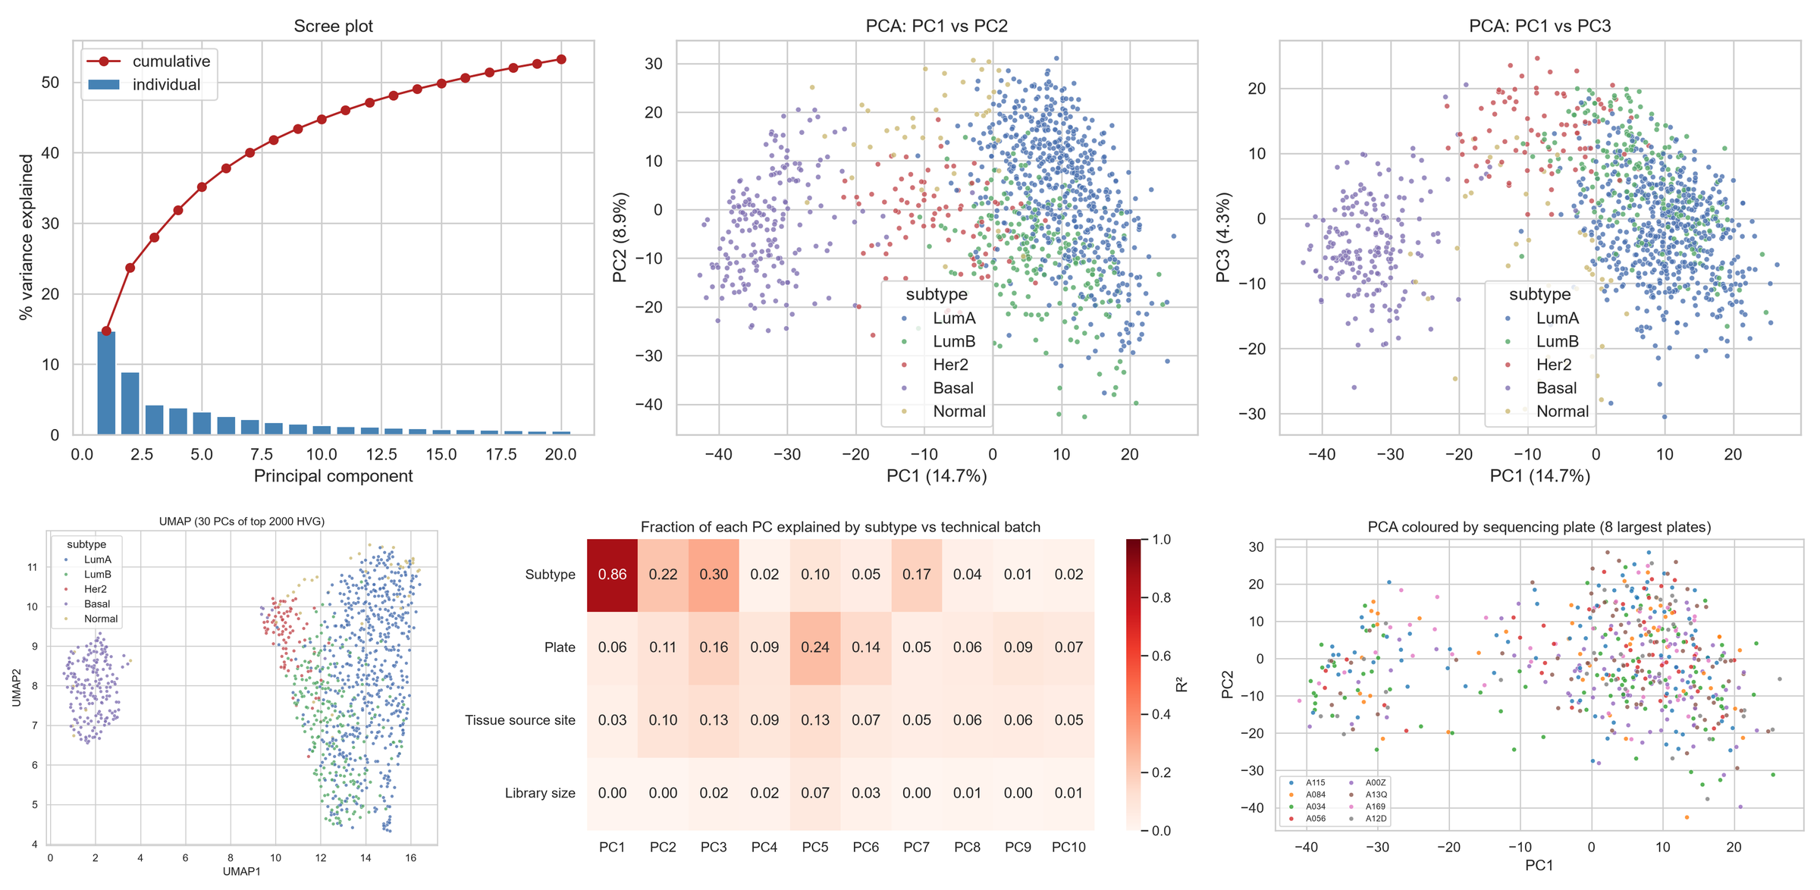
Figure 2: PCA and UMAP of the top 2,000 genes coloured by subtype, and batch-effect check.
PC1 explained 14.7% and PC2 8.9% of the variance. PC1 separated luminal tumours (high ESR1, FOXA1, GATA3) from Basal tumours (high FOXC1). Basal tumours formed a clearly separate group in both PCA and UMAP, Her2 tumours were at the edge of the luminal group, and LumA and LumB overlapped strongly. Subtype explained 86% of PC1, while sequencing plate explained only 6%, so there was no major batch effect.

4.3 K-Means and Hierarchical Clustering
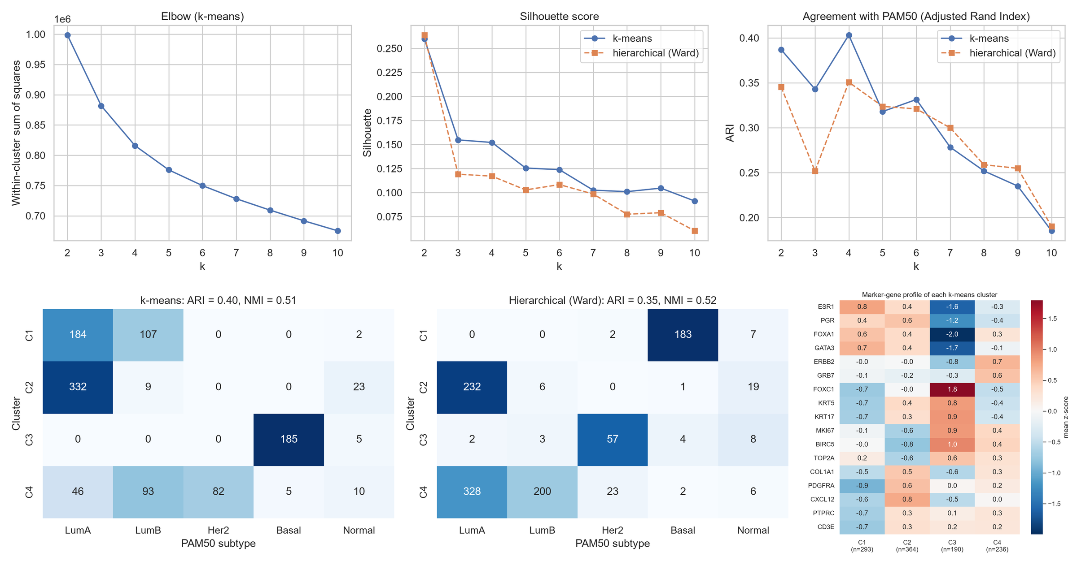
Figure 3: Choosing k (elbow, silhouette, ARI), clusters compared with PAM50 (k = 4), and marker genes of each cluster.
There was no sharp elbow and the silhouette scores were low (0.10–0.26), so the samples do not form clearly separated clusters. The best agreement with PAM50 was at k = 4 (ARI = 0.40):
- Cluster 3: 185 of 190 Basal tumours (97% pure).
- Cluster 4: all 82 Her2 tumours with 93 LumB tumours (high ERBB2 and proliferation genes).
- Clusters 1 and 2: luminal tumours, split by the amount of stroma in the sample rather than into LumA and LumB.
Hierarchical clustering gave similar results (ARI = 0.35). Basal and Her2 match known biology, but LumA and LumB form a continuum.

4.4 Differential Expression
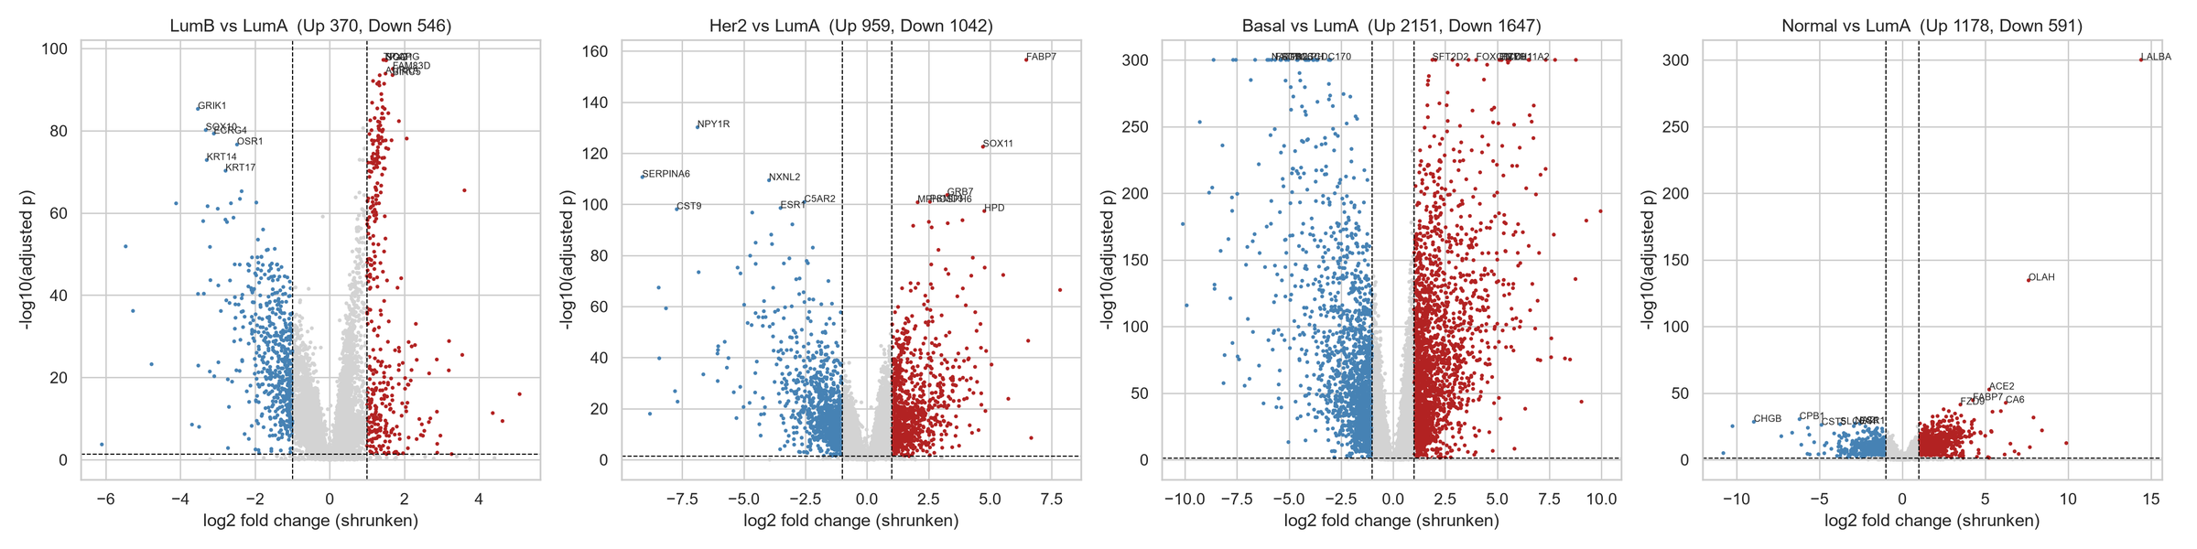
Figure 4: Volcano plots of each subtype compared with LumA (red = up, blue = down).
The Kruskal–Wallis test rejected H0 for 97% of genes after FDR correction. Because almost all genes were significant with 1,083 patients, a 2-fold change cut-off was also used. Compared with LumA:
- LumB: 916 genes (up: cell-cycle genes TPX2, AURKA, BIRC5).
- Her2: 2,001 genes (up: ERBB2, GRB7, PSMD3 – genes next to each other on chromosome 17q12, showing DNA amplification).
- Basal: 3,798 genes (luminal genes TFF1, AGR3, MLPH, PGR switched off; FOXC1 up).
- Normal-like: 1,769 genes (up: normal breast genes LALBA, CA6).

4.5 Pathway Enrichment
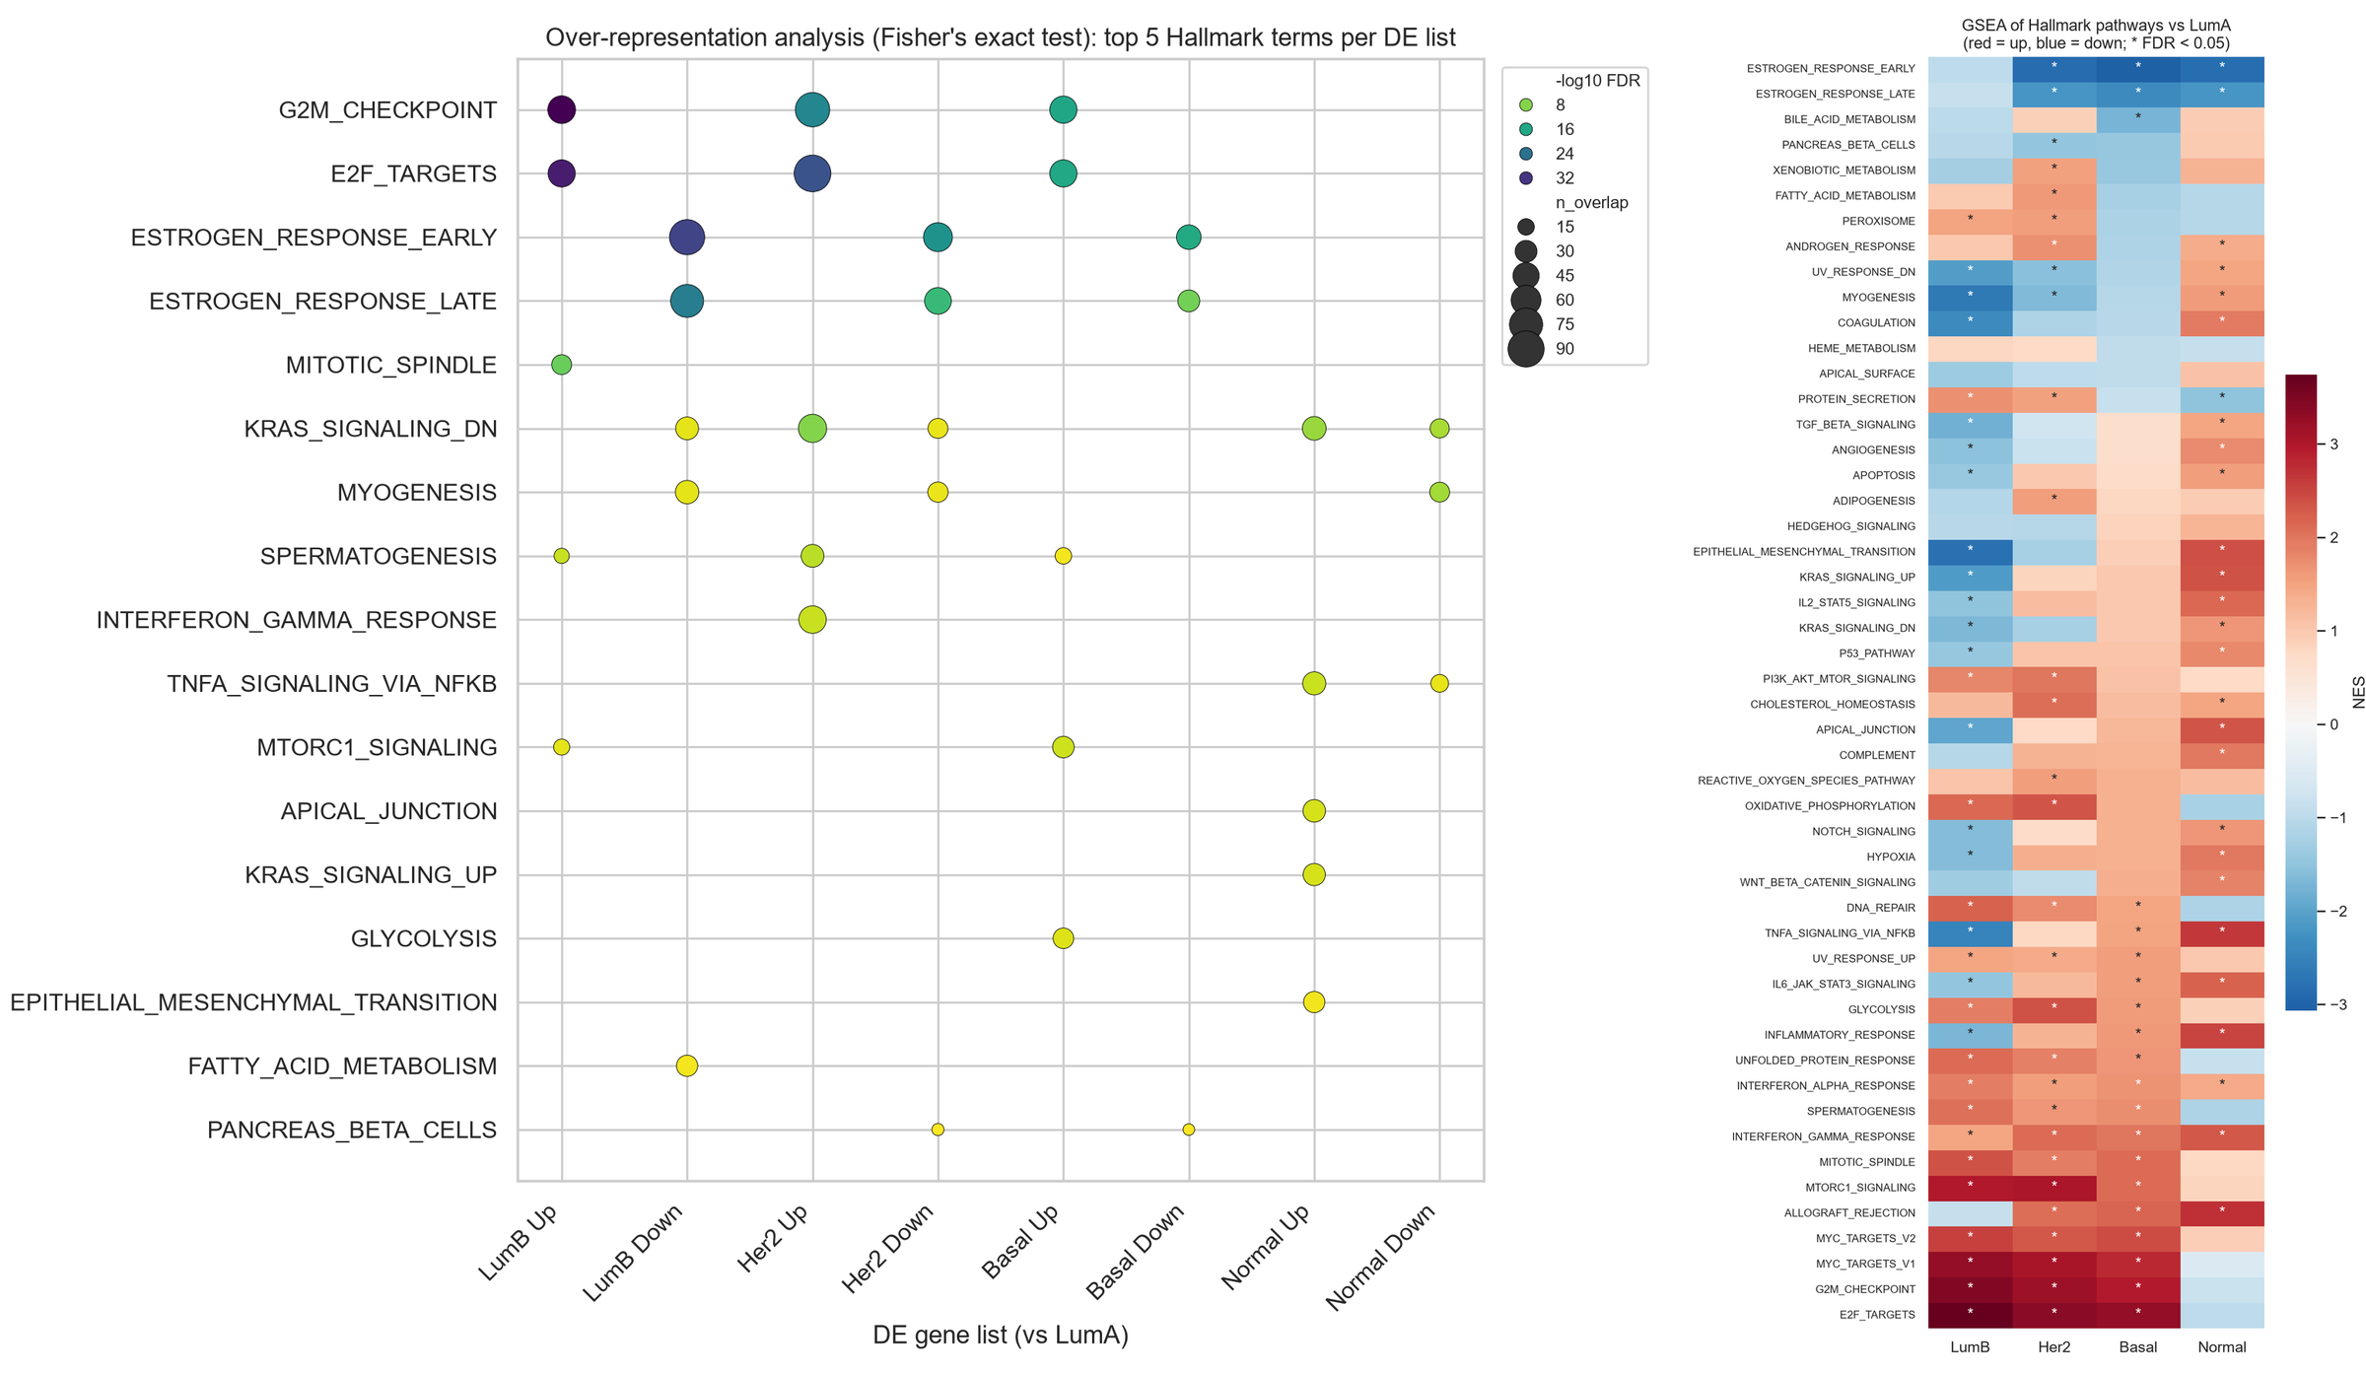
Figure 5: ORA dot plot and GSEA scores (NES) of Hallmark pathways for each subtype vs LumA (* FDR < 0.05).
Both ORA and GSEA gave the same main results:
- Proliferation pathways (E2F targets, G2M checkpoint, MYC targets) were increased in LumB, Her2 and Basal (NES 3.3–3.7).
- Estrogen response pathways were decreased in Her2, Basal and Normal-like (NES ≈ −3), but not in LumB.
- Basal tumours showed immune activation, and Normal-like tumours showed stromal and inflammatory pathways.

4.6 Classification
Model | Accuracy | Balanced accuracy | Macro-F1
Logistic Regression | 0.922 | 0.929 | 0.900
XGBoost | 0.908 | 0.856 | 0.873
LightGBM | 0.917 | 0.846 | 0.871
SVM (linear) | 0.899 | 0.879 | 0.861
Random Forest | 0.866 | 0.812 | 0.835

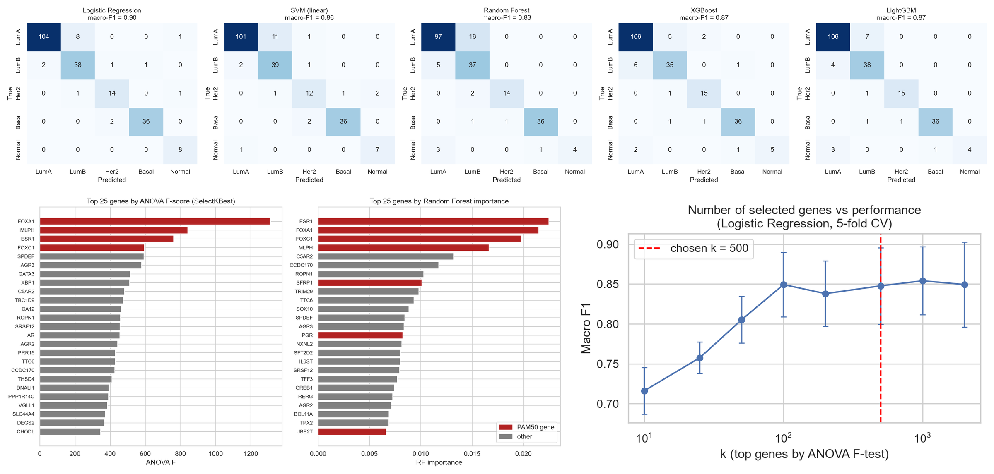
Figure 6: Confusion matrices on the test set (n = 217), most important genes (red = PAM50 gene), and performance vs number of genes.
Logistic Regression was the best model (92.2% accuracy, macro-F1 0.90) and correctly classified all 8 Normal-like test samples. Most errors were between LumA and LumB, while Basal was almost perfect (36/38). About 100 genes were enough for good performance. 33 of the 49 PAM50 genes in our data were among the 500 selected genes (only 1.5 expected by chance; p = 1.7 × 10⁻³⁸), so the model rediscovered the published PAM50 genes.

4.7 Survival and Regression Analysis
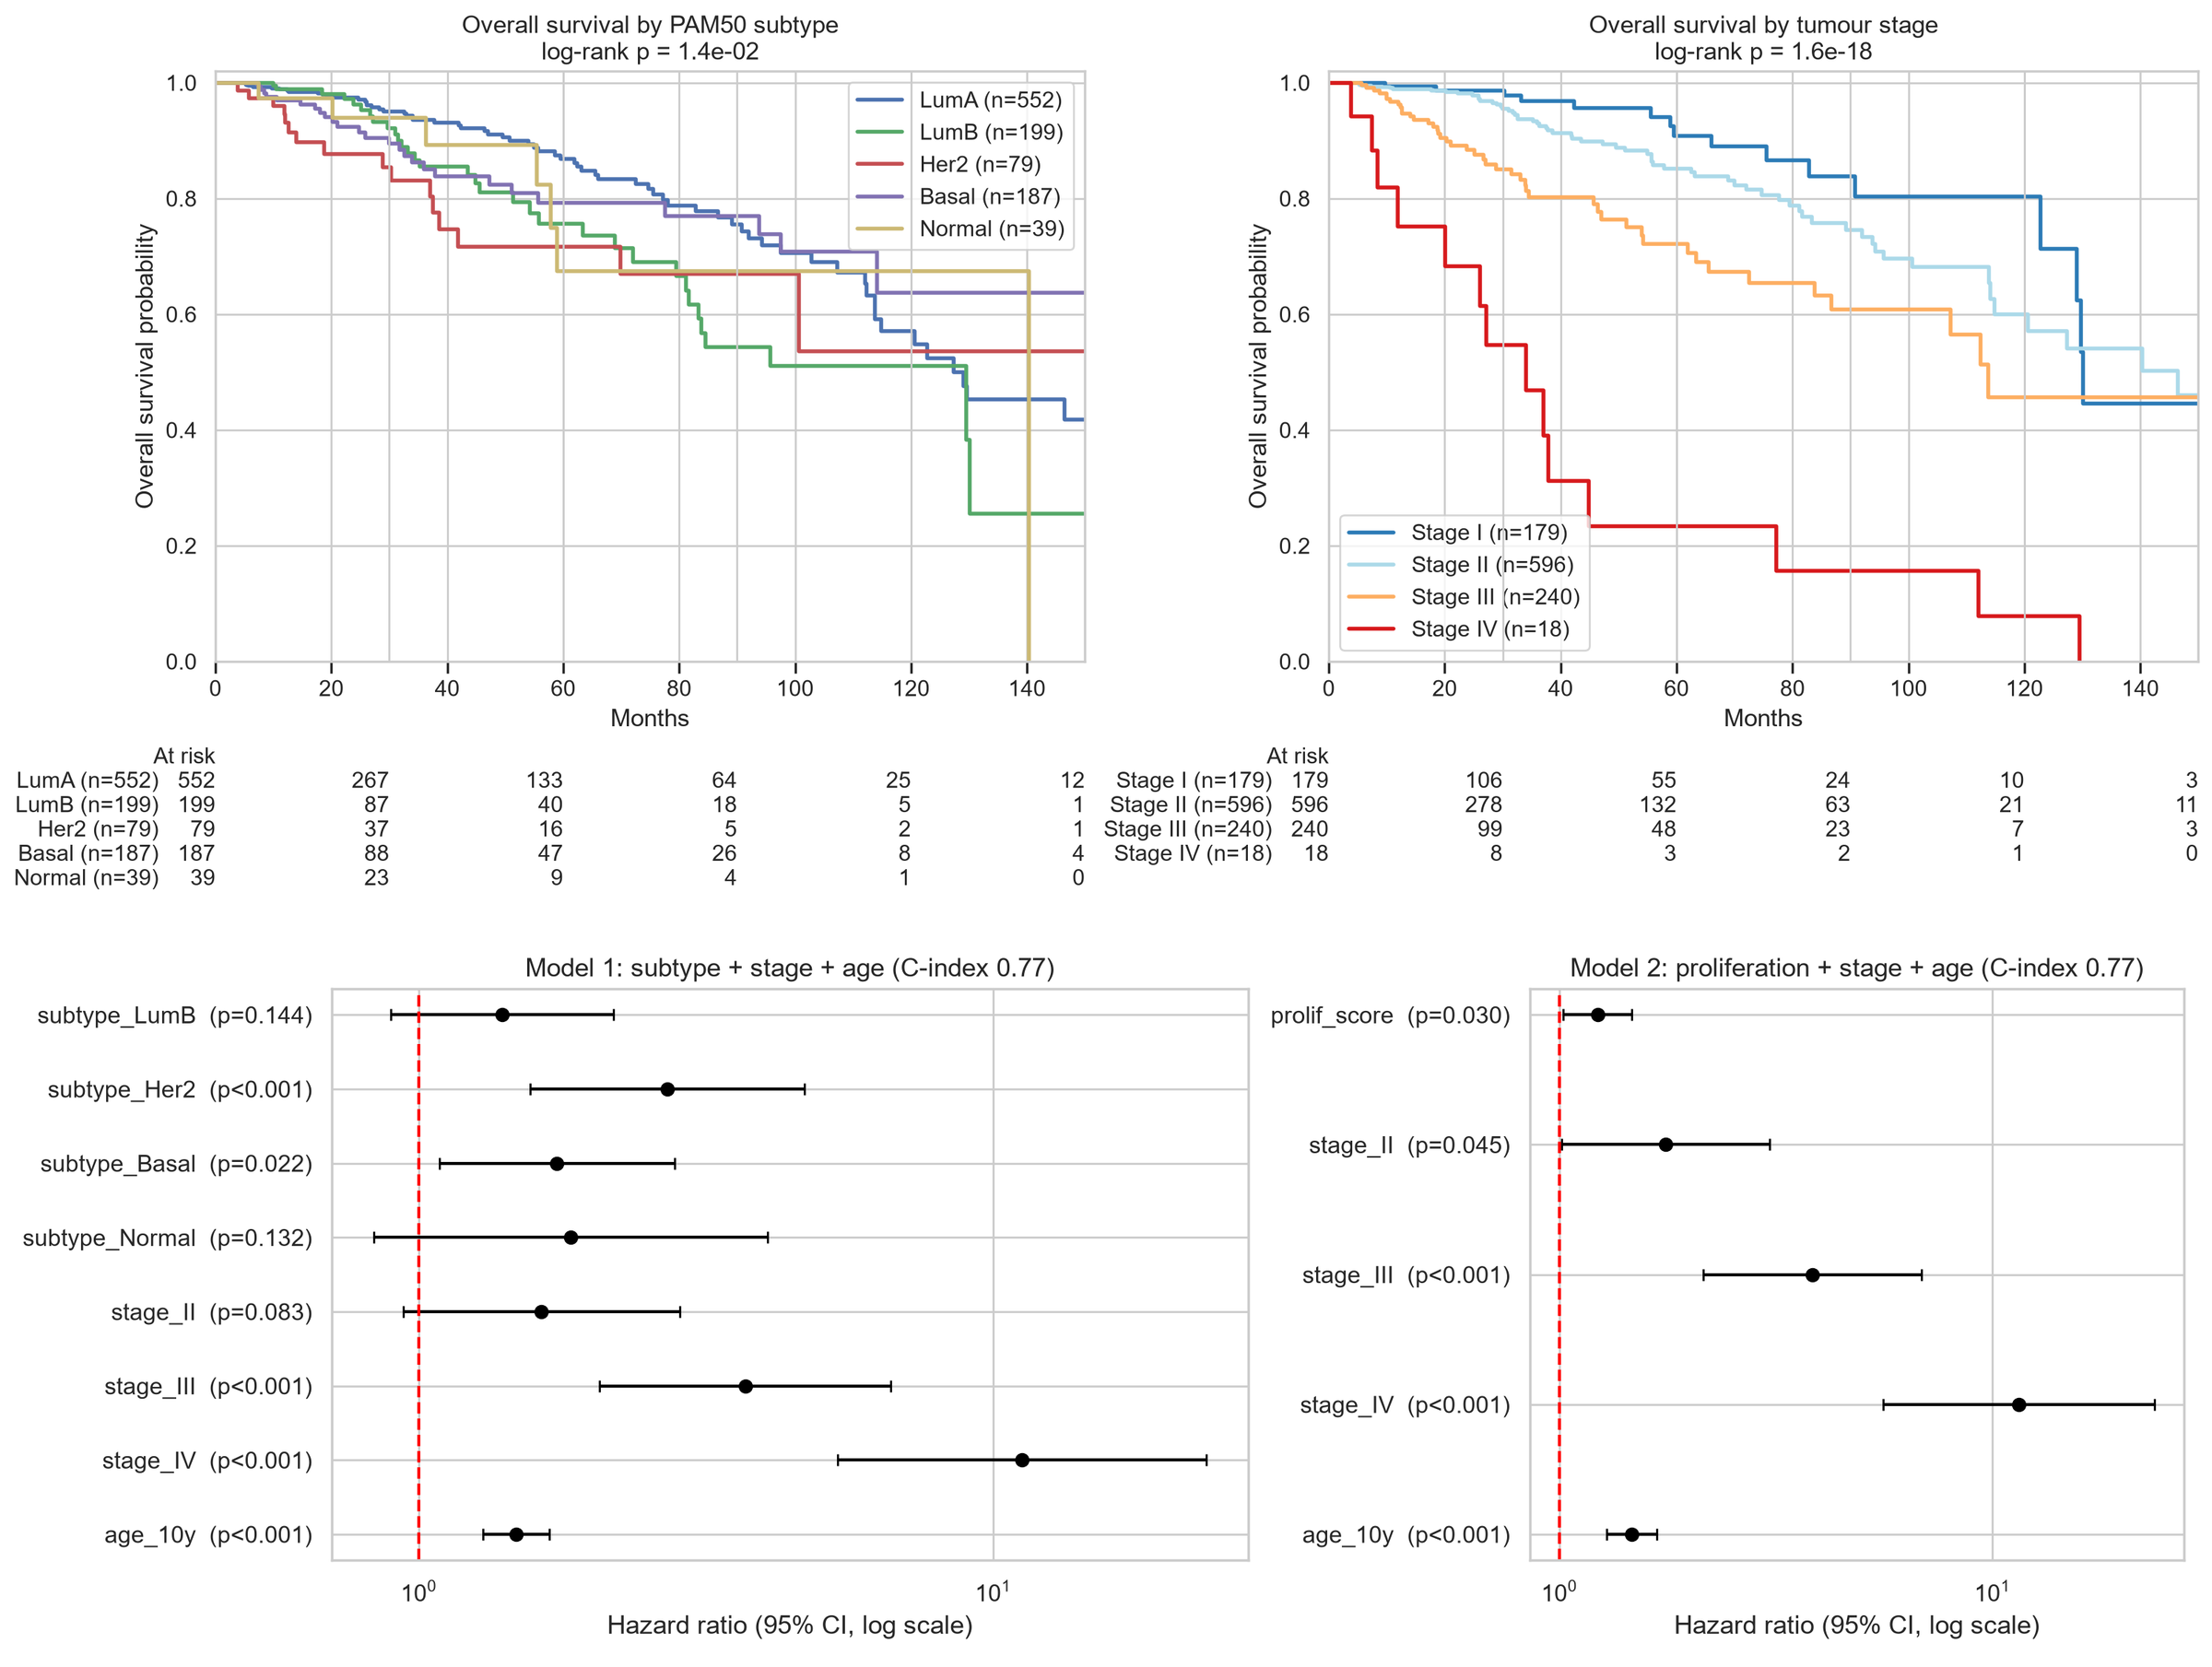
Figure 7: Kaplan–Meier survival curves by subtype and stage, and Cox regression hazard ratios.
- 5-year survival was 86.8% for LumA, 79.3% for Basal, 75.6% for LumB, 71.7% for Her2 and 67.4% for Normal-like (log-rank p = 0.014). Stage had a much stronger effect (p = 1.6 × 10⁻¹⁸).
- In the Cox model, Her2 (HR = 2.71) and Basal (HR = 1.74) had a higher risk of death than LumA, even after adjusting for stage and age.
- A higher proliferation score increased the risk of death (HR = 1.22, p = 0.03).
- Proliferation decreased with age and ESR1 expression increased with age (both p < 0.0001).

5. Conclusion & Discussion

5.1 Summary of Findings
- Basal tumours form a clearly separate group; LumA and LumB overlap and form a continuum.
- Thousands of genes differ between subtypes; proliferation genes are higher and estrogen-response genes lower in the aggressive subtypes.
- Logistic Regression predicted the subtype with 92% accuracy and found most of the known PAM50 genes.
- Her2 and Basal subtypes had worse survival than LumA, independent of stage and age.

5.2 Biological Interpretation
The results show that breast cancer subtypes are organised along two main axes: luminal versus basal identity (ESR1, FOXA1, GATA3 versus FOXC1 and basal keratins) and proliferation. LumB differs from LumA mainly because its cells divide faster, which is why the two overlap. Her2 tumours are driven by amplification of the ERBB2 region on chromosome 17. Normal-like tumours looked similar to normal breast and stromal tissue. These results agree with published studies of PAM50 and TCGA.

5.3 Limitations
- PAM50 labels were themselves made from gene expression, so predicting them is partly circular.
- The Normal-like group had only 40 samples, and all patients were female.
- Survival data were limited (150 deaths, median follow-up of 27 months).
- Bulk RNA-seq mixes tumour, stromal and immune cells, which affected the clustering.
- The models were tested only within TCGA.

5.4 Future Directions
The analysis can be improved further by:
- validating the results on an independent dataset such as METABRIC.
- correcting for tumour purity and immune cell content before clustering.
- using multivariate feature selection to better capture subtype-specific genes such as ERBB2.
- adding other data types such as copy number and DNA methylation.

5.5 Overall Conclusion
This project combined statistics and machine learning to analyse breast cancer subtypes in TCGA-BRCA. The workflow converted raw RNA-seq counts into meaningful biological insights and showed that gene expression can accurately identify breast cancer subtypes and predict differences in patient survival.

6. Contribution Statement
Naveen conducted the overall literature survey on breast cancer subtypes, helped in picking the problem statement and research questions, identified the relevant public datasets and decided which data to use, and wrote the introduction and biological interpretation.
Srikant downloaded the gene expression data from the GDC portal, merged the 1,231 count files into one dataset, and cleaned and matched the PAM50 labels, clinical data and survival data to provide the final dataset for analysis.
Piyush Kuldeep was involved in the preprocessing and normalization of the data, performed the exploratory analysis, PCA, UMAP and clustering, set up the code pipeline on GitHub and was involved in report preparation.
Vimal performed the clinical data analysis, the differential expression analysis with multiple-testing correction, and the pathway enrichment analysis (ORA and GSEA).
Madhavan designed and implemented the machine-learning classification models and the survival and regression analysis, and prepared the limitations, future directions and the presentation.
All team members reviewed the results and approved the final report.

References
- Perou, C. M., et al. (2000). Molecular portraits of human breast tumours. Nature, 406, 747–752.
- Parker, J. S., et al. (2009). Supervised risk predictor of breast cancer based on intrinsic subtypes. Journal of Clinical Oncology, 27(8), 1160–1167.
- The Cancer Genome Atlas Network. (2012). Comprehensive molecular portraits of human breast tumours. Nature, 490, 61–70.
- Love, M. I., Huber, W., & Anders, S. (2014). Moderated estimation of fold change and dispersion for RNA-seq data with DESeq2. Genome Biology, 15, 550.
- Subramanian, A., et al. (2005). Gene set enrichment analysis. PNAS, 102(43), 15545–15550.
- Benjamini, Y., & Hochberg, Y. (1995). Controlling the false discovery rate. Journal of the Royal Statistical Society B, 57(1), 289–300.
- Prat, A., & Perou, C. M. (2011). Deconstructing the molecular portraits of breast cancer. Molecular Oncology, 5(1), 5–23.

