Browser Opened Successfully

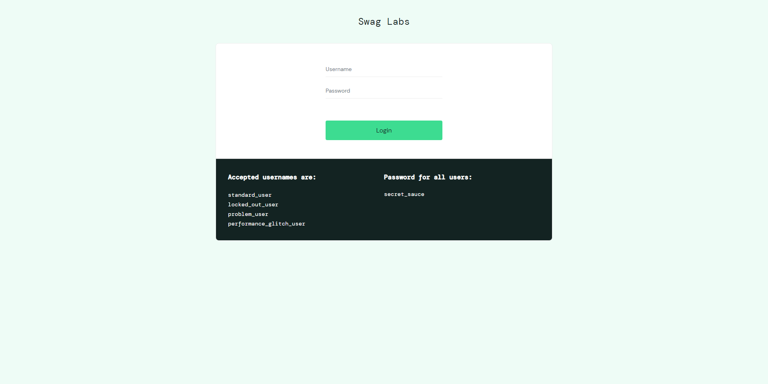

Login Successfully with user standard_user

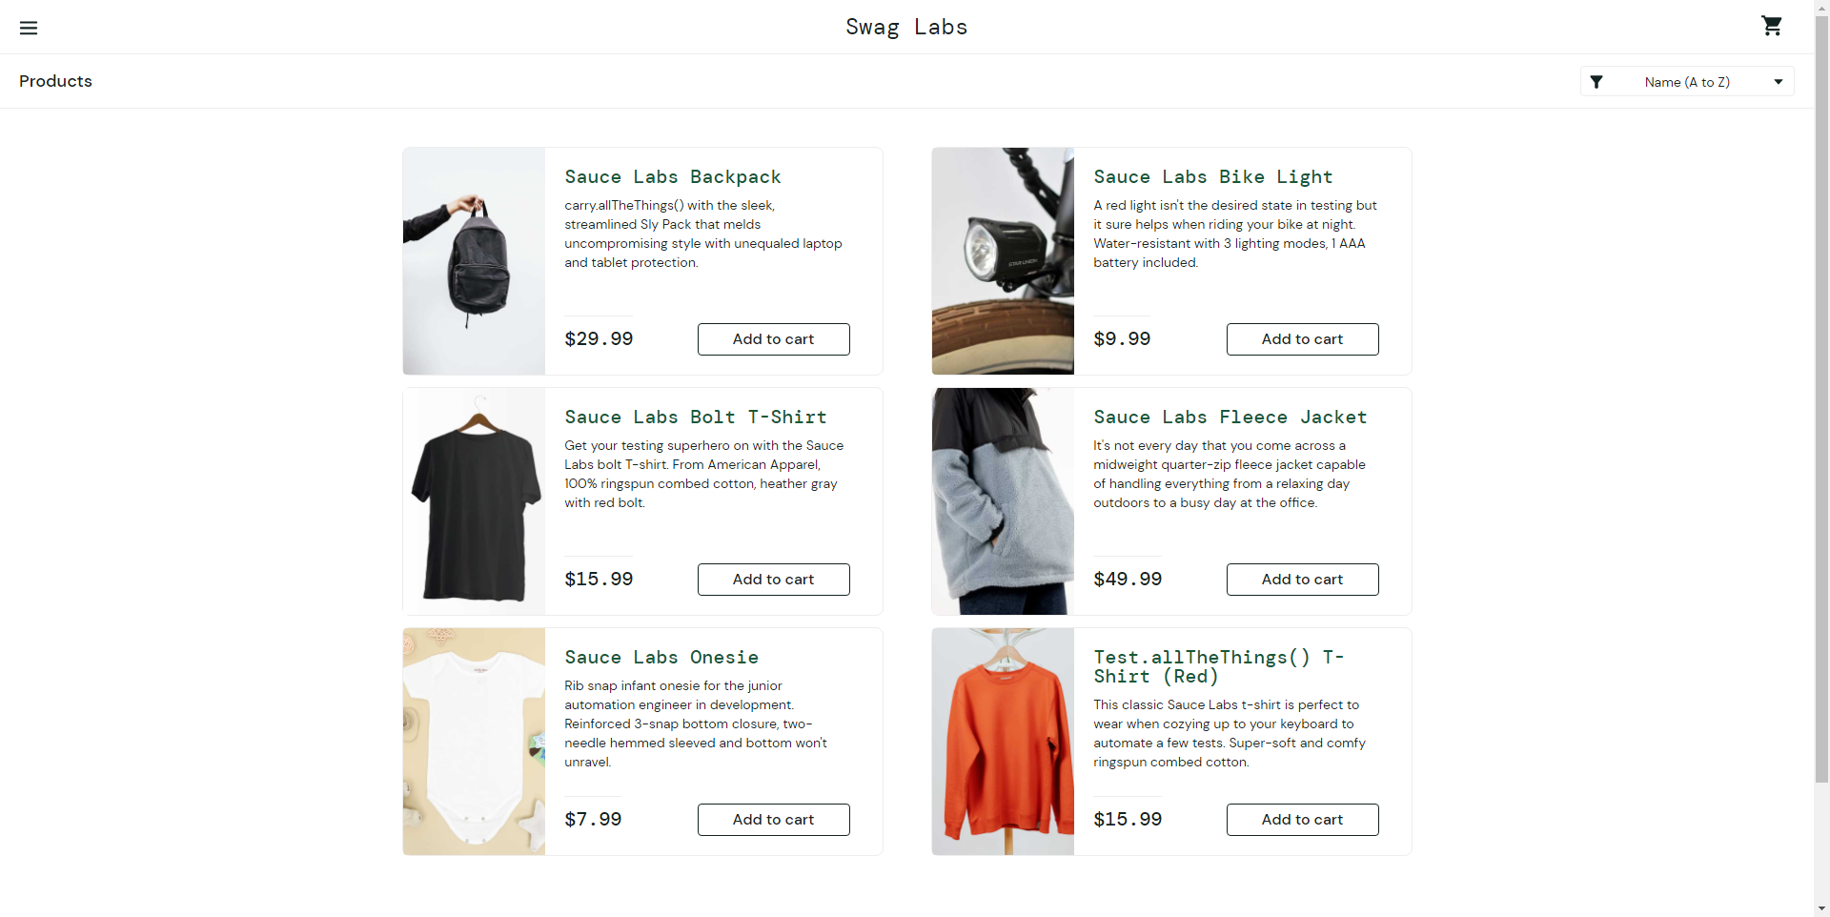

SwagLabs About

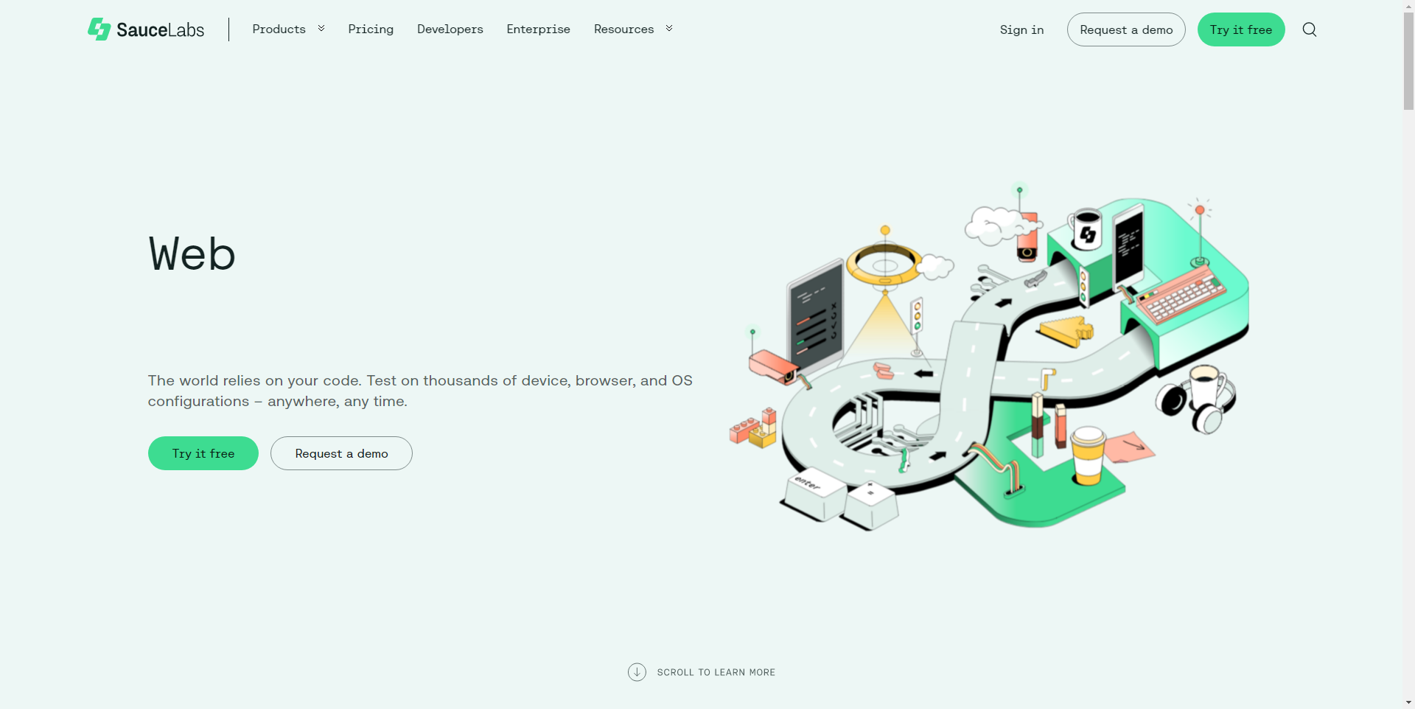

SwagLabs Logout Successful

