overloading in python 3

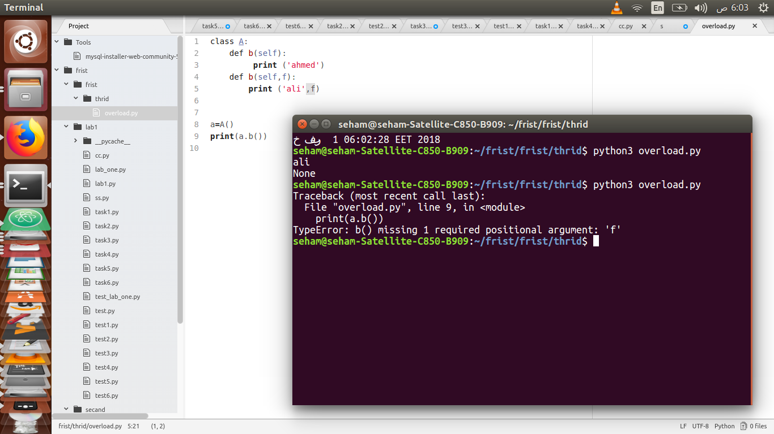
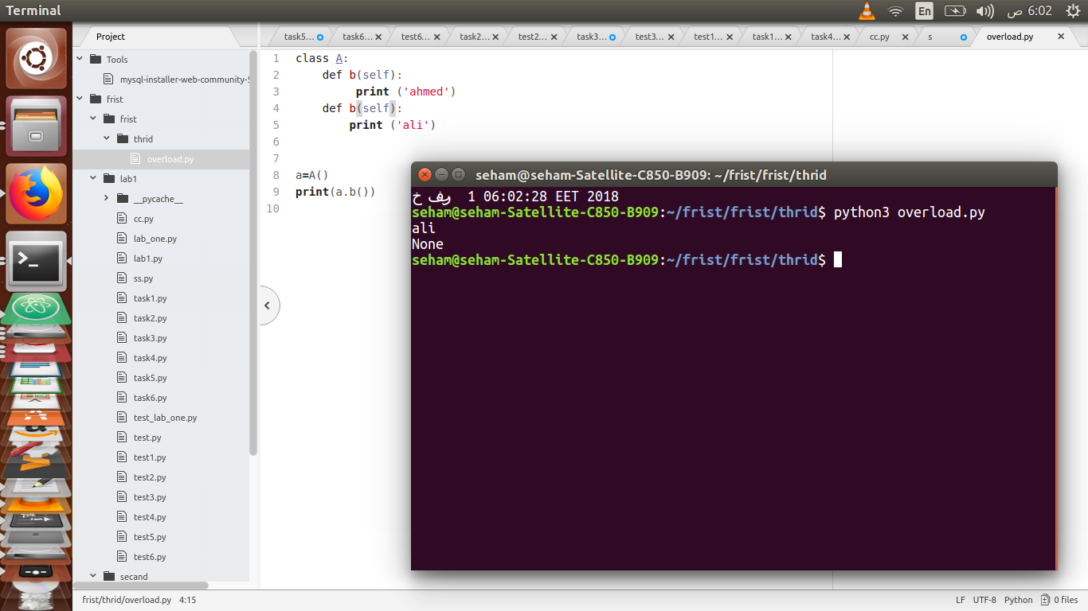
in the example:

python3 never have overloading in function becouse of prameters of function don’t have type.

