Multiple Inheritance in Python
a class can be derived from more than one base classes in Python. This is called multiple inheritance.
In multiple inheritance, the features of all the base classes are inherited into the derived class. The syntax for multiple inheritance is similar to single inheritance.
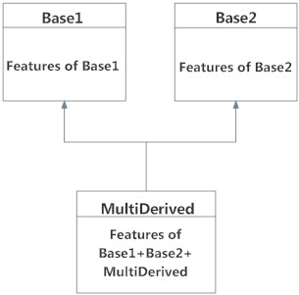

The class MultiDerived inherits from both Base1 and Base2.

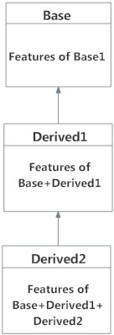

Multilevel Inheritance in Python

We should know the difference between multilevel inheritance&multiple inheritance

Method Resolution Order in Python
When class c inherit from class (a,b)
first class can be acess is b then a

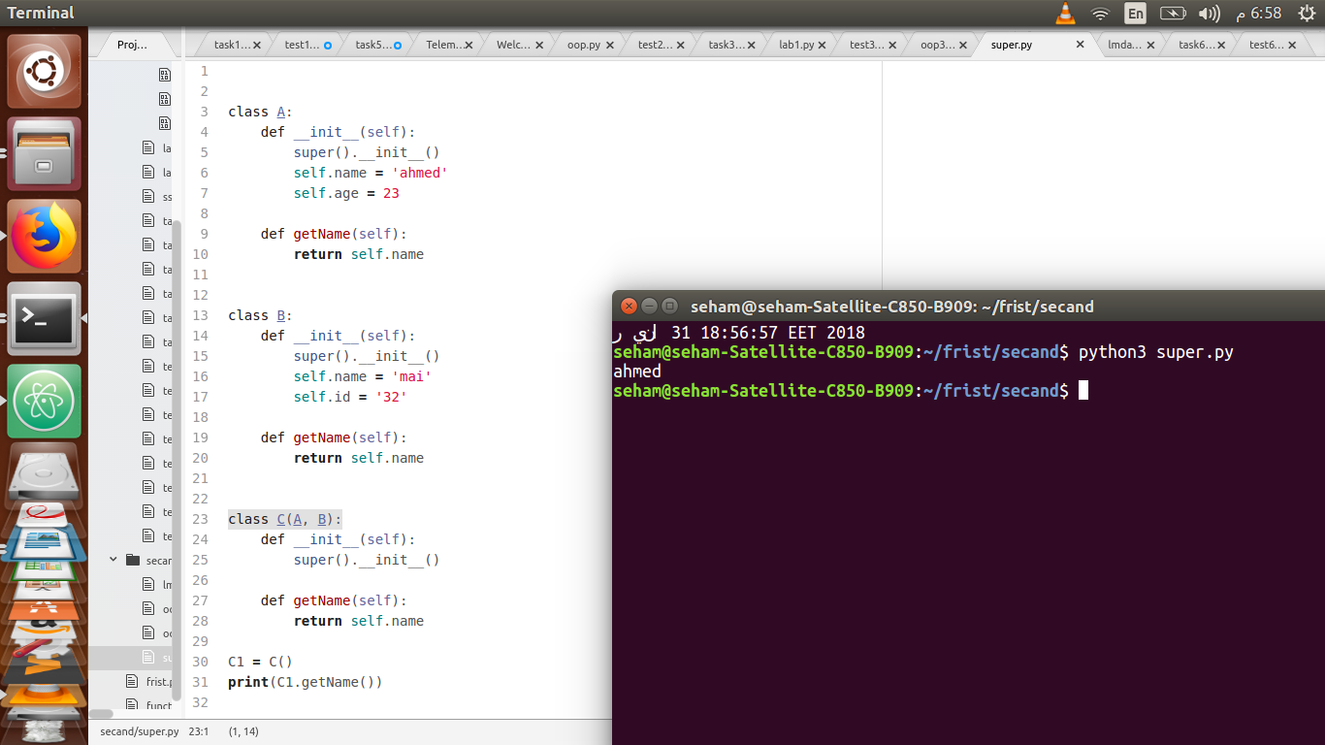

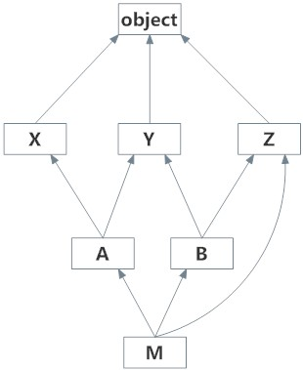

super
class First(object):
def __init__(self):
super(First, self).__init__()
print("first")

class Second(object):
def __init__(self):
super(Second, self).__init__()
print("second")

class Third(First, Second):
def __init__(self):
super(Third, self).__init__()
print("third")
The super() call finds the next method in the MRO at each step, which is why First and Second have to have it too, otherwise execution stops at the end of Second.__init__().

>>> Third()
second
first
third

