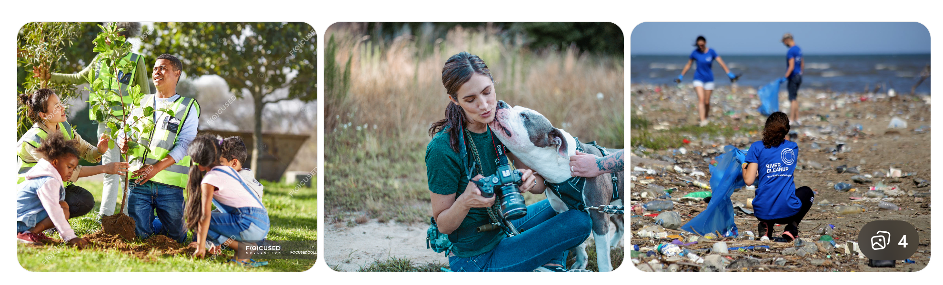
Be the Voice for the Voiceless
Millions of vulnerable people, animals, and ecosystems suffer in silence.
Together, we can protect nature and give muted beings the safety, dignity, and care they deserve.
Call-to-Action Buttons
Primary CTA
🧡 Donate Now
Secondary CTA
🤝 Join the Movement

The Problem
The World Is Losing Its Voice
Every day:
- Forests disappear at an alarming rate
- Oceans fill with pollution
- Wildlife habitats vanish
- Animals face cruelty and abandonment
- Vulnerable communities struggle without support
These crises are deeply connected.
When ecosystems collapse, animals suffer.
When nature is damaged, human lives become more vulnerable.
Yet the most affected beings rarely have the power to speak for themselves.

Our Story
A Mission Born from Compassion
Shalvi.org was founded in 2025 by Rakhi Singh, inspired by a simple but powerful belief:
Every living being deserves protection, dignity, and a chance to thrive.
What began as a vision to protect both nature and muted beings has grown into a global mission connecting communities, volunteers, and advocates across the United States and India.
Shalvi exists to bridge the gap between environmental protection, animal welfare, and human compassion.

Our Mission
To conserve nature, reduce the most pressing threats to biodiversity, and be a voice for the voiceless—protecting vulnerable people and animals while promoting sustainable coexistence with our planet.

What We Protect
Nature 🌿
We defend ecosystems that sustain life on Earth.
Focus areas include:
- Climate change and rising CO₂ levels
- Deforestation and habitat loss
- Ocean and freshwater degradation
- Biodiversity conservation

Muted Beings 🕊️
Many lives suffer in silence.
We work to protect:
Vulnerable people
- Access to shelter, food, and healthcare
- Human rights protection
- Community support
Animals
- Rescue and rehabilitation
- Anti-cruelty advocacy
- Responsible care and adoption

Our Impact Vision
Although Shalvi is a young organization, our ambition is bold:
- Restore ecosystems and protect biodiversity
- Rescue and protect animals in need
- Support vulnerable communities
- Build a global movement for compassion and sustainability
Every action—large or small—helps create lasting change.

Why This Work Matters
The health of our planet is inseparable from the well-being of people and animals.
Protecting forests protects wildlife.
Protecting oceans protects food systems.
Protecting animals strengthens ecosystems.
Protecting communities builds a sustainable future.
At Shalvi, we believe that compassion for one life protects many.

Join the Movement
Real change happens when people come together.
You can help protect nature and give a voice to the voiceless.
Ways to Help
❤️ Donate — Support life-saving programs
🌍 Volunteer — Use your time and skills for impact
📣 Advocate — Spread awareness for compassion and conservation
🤝 Partner — Collaborate to expand our mission

Final Message
The world does not need more silence.
It needs more voices.
Be the Voice for the Voiceless.
Together, we can protect nature, defend vulnerable lives, and build a more compassionate future.

Shalvi.org
Protect Nature. Protect Life. Inspire Compassion.

