
AWS Glue
AN ETL SERVICE
What Is AWS Glue?
◆
AWS Glue is a fully managed ETL (extract, transform, and load) service that makes it simple and cost-effective
to categorize your data, clean it, enrich it, and move it reliably between various data stores.
◆
AWS Glue consists of a central metadata repository known as the AWS Glue Data Catalog, an ETL engine that
automatically generates Python or Scala code, and a flexible scheduler that handles dependency resolution, job
monitoring, and retries.
◆
AWS Glue is serverless, so there’s no infrastructure to set up or manage.
Use the AWS Glue console to discover data, transform it, and make it available for search and querying
The console calls the underlying services to orchestrate the work required to transform your data.
You can also use the AWS Glue API operations to interface with AWS Glue services. Edit, debug, and test your
Python or Scala Apache Spark ETL code using a familiar development environment.
◆
◆
◆
When Should I Use AWS Glue?
◆
You can use AWS Glue to build a data warehouse to organize, cleanse, validate,
and format data.
You can transform and move AWS Cloud data into your data store.
You can also load data from disparate sources into your data warehouse for
regular reporting and analysis.
◆
◆
AWS Glue simplifies many tasks when
you are building a data warehouse:
◆
◆
◆
◆
◆
Discovers and catalogs metadata about your data stores into a central catalog.
You can process semi-structured data, such as clickstream or process logs.
Populates the AWS Glue Data Catalog with table definitions from scheduled crawler programs.
Crawlers call classifier logic to infer the schema, format, and data types of your data.
This metadata is stored as tables in the AWS Glue Data Catalog and used in the authoring process
of your ETL jobs.
Generates ETL scripts to transform, flatten, and enrich your data from source to target.
Detects schema changes and adapts based on your preferences.
Triggers your ETL jobs based on a schedule or event. You can initiate jobs automatically to move
your data into your data warehouse. Triggers can be used to create a dependency flow between
jobs.
◆
◆
◆
◆
Gathers runtime metrics to monitor the activities of your data warehouse.
Handles errors and retries automatically.
Scales resources, as needed, to run your jobs.
◆
◆
You can create event-driven ETL
pipelines with AWS Glue.
◆
You can run your ETL jobs as soon as new data becomes available
in Amazon S3 by invoking your AWS Glue ETL jobs from an AWS
Lambda function.
◆
You can also register this new dataset in the AWS Glue Data
Catalog as part of your ETL jobs.
You can use AWS Glue to
understand your data assets
◆
You can store your data using various AWS services and still
maintain a unified view of your data using the AWS Glue Data
Catalog.
◆
View the Data Catalog to quickly search and discover the datasets
that you own, and maintain the relevant metadata in one central
repository. The Data Catalog also serves as a drop-in replacement
for your external Apache Hive Metastore.
AWS Glue: How It Works
◆
AWS Glue uses other AWS services to orchestrate your ETL (extract, transform, and load) jobs to build a data
warehouse. AWS Glue calls API operations to transform your data, create runtime logs, store your job logic, and create
notifications to help you monitor your job runs.
The AWS Glue console connects these services into a managed application, so you can focus on creating and
monitoring your ETL work.
The console performs administrative and job development operations on your behalf. You supply credentials and other
properties to AWS Glue to access your data sources and write to your data warehouse.
AWS Glue takes care of provisioning and managing the resources that are required to run your workload.
You don't need to create the infrastructure for an ETL tool because AWS Glue does it for you. When resources are
required, to reduce startup time, AWS Glue uses an instance from its warm pool of instances to run your workload.
With AWS Glue, you create jobs using table definitions in your Data Catalog. Jobs consist of scripts that contain the
programming logic that performs the transformation.
You use triggers to initiate jobs either on a schedule or as a result of a specified event. You determine where your target
data resides and which source data populates your target. With your input, AWS Glue generates the code that's required
to transform your data from source to target.
You can also provide scripts in the AWS Glue console or API to process your data.
◆
◆
◆
◆
◆
◆
◆
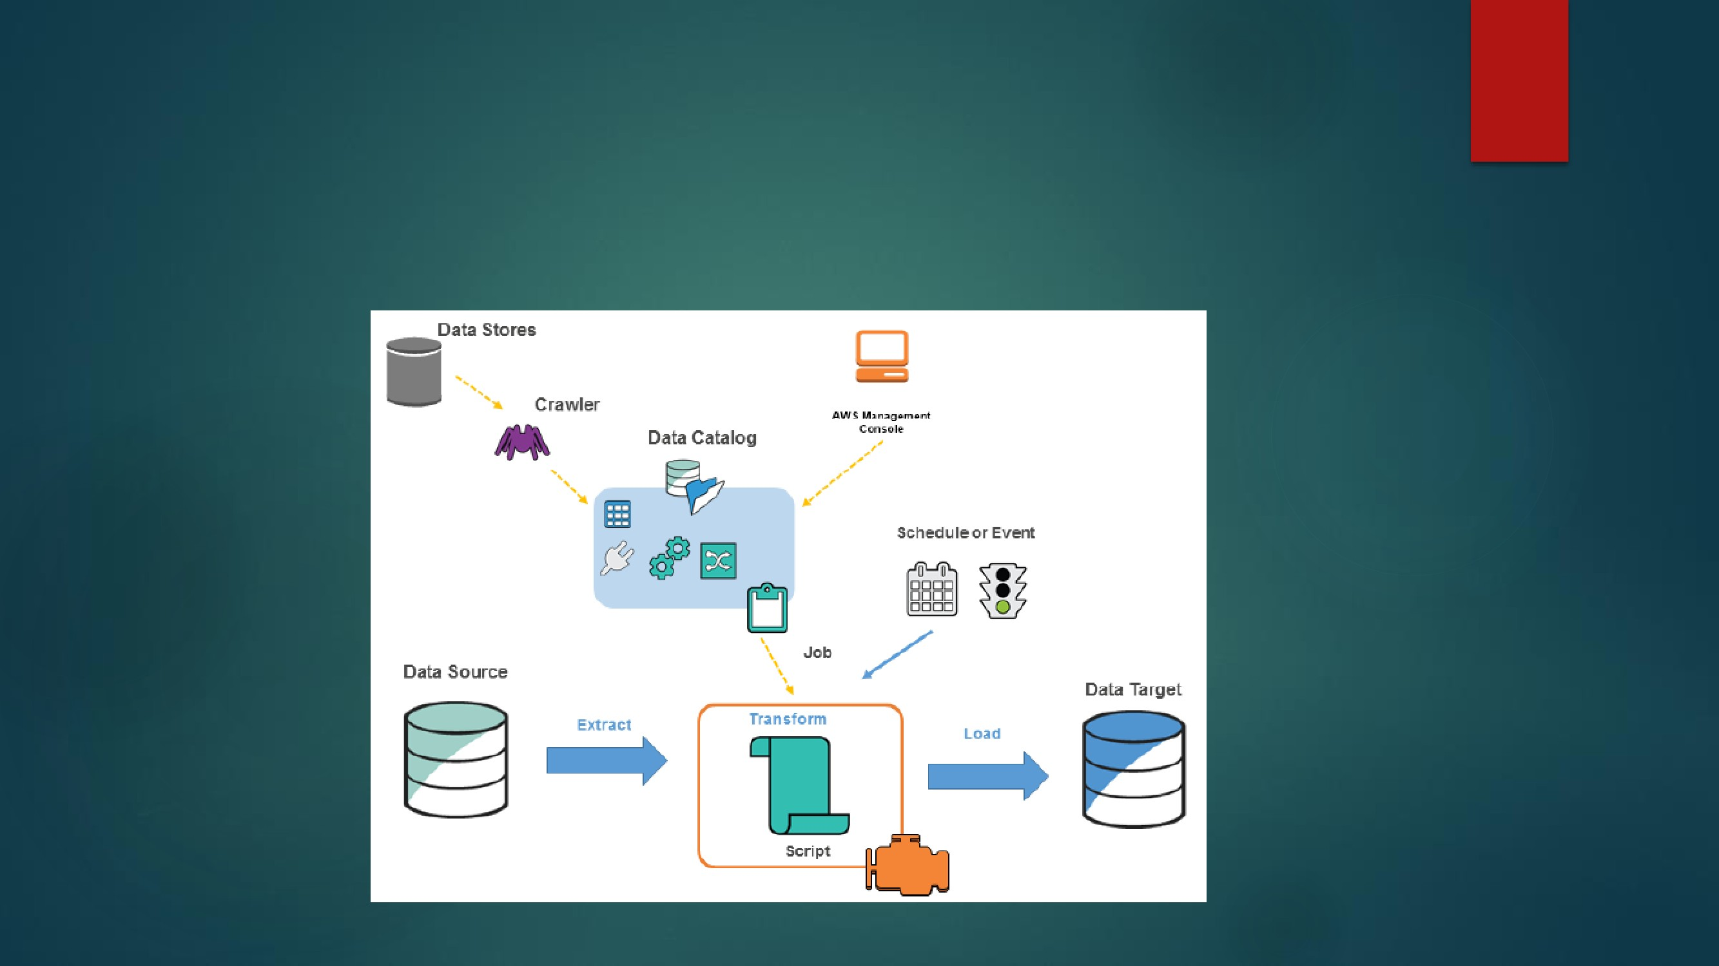
AWS Glue Concepts
The following diagram shows the architecture of an AWS Glue environment
◆
You define a crawler to populate your AWS Glue Data Catalog with
metadata table definitions. You point your crawler at a data store, and the
crawler creates table definitions in the Data Catalog.
In addition to table definitions, the AWS Glue Data Catalog contains other
metadata that is required to define ETL jobs. You use this metadata when
you define a job to transform your data.
AWS Glue can generate a script to transform your data. Or, you can
provide the script in the AWS Glue console or API.
You can run your job on demand, or you can set it up to start when a
specified trigger occurs. The trigger can be a time-based schedule or an
event.
When your job runs, a script extracts data from your data source, transforms
the data, and loads it to your data target. The script runs in an Apache
Spark environment in AWS Glue.
◆
◆
◆
◆
◆
Important
◆
Tables and databases in AWS Glue are objects in the AWS Glue Data
Catalog. They contain metadata; they don't contain data from a data
store.
AWS Glue Components
◆
AWS Glue relies on the interaction of several components to create and
manage your data warehouse workflow.
◆
◆
AWS Glue Data Catalog
Classifier
Connection
Crawler
Database
Data store, data source, data target
Development endpoint
Job
Notebook server
Script
Table
Transform
Trigger
◆
◆
◆
◆
◆
◆
◆
◆
◆
◆
◆
AWS Glue Data Catalog :
◆
The persistent metadata store in AWS Glue. Each AWS account has one
AWS Glue Data Catalog. It contains table definitions, job definitions, and
other control information to manage your AWS Glue environment.
Classifier:
◆
Determines the schema of your data. AWS Glue provides classifiers for
common file types, such as CSV,JSON, AVRO, XML, and others. It also
provides classifiers for common relational database management systems
using a JDBC connection. You can write your own classifier by using a grok
pattern or by specifying a row tag in an XML document.
Connection:
◆
Contains the properties that are required to connect to your data store.
Crawler :
◆
A program that connects to a data store (source or target), progresses
through a prioritized list of classifiers to determine the schema for your data,
and then creates metadata in the AWS Glue Data Catalog.
A set of associated table definitions organized into a logical group in AWS
Glue.
A data store is a repository for persistently storing your data. Examples
include Amazon S3 buckets and relational databases.
Database :
◆
Data store, data source, data target :
◆
◆
A data source is a data store that is used as input to a process or transform.
A data
target is a data store that a process or transform writes to.
◆
Development endpoint :
◆
An environment that you can use to develop and test your AWS Glue
scripts.
Job
◆
The business logic that is required to perform ETL work. It is composed of a
transformation script, data sources, and data targets. Job runs are initiated
by triggers that can be scheduled or triggered by events.
A web-based environment that you can use to run your PySpark
statements. You can set up a notebook server on a development endpoint
to run PySpark statements with AWS Glue extensions.
Code that extracts data from sources, transforms it, and loads it into targets.
AWS Glue generates PySpark or Scala scripts. PySpark is a Python dialect for
ETL programming.
Notebook server
◆
Script :
◆
Table
◆
The metadata definition that represents your data. Whether your data is in an
Amazon Simple Storage Service (Amazon S3) file, an Amazon Relational Database
Service (Amazon RDS) table, or another set of data, a table defines the schema of
your data.
A table in the AWS Glue Data Catalog consists of the names of columns, data
type definitions, and other metadata about a base dataset. The schema of your
data is represented in your AWS Glue table definition. The actual data remains in
its original data store, whether it be in a file or a relational database table.
AWS Glue catalogs your files and relational database tables in the AWS Glue Data
Catalog. They are used as sources and targets when you create an ETL job.
The code logic that is used to manipulate your data into a different format.
Initiates an ETL job. Triggers can be defined based on a scheduled time or an
event.
◆
◆
Transform :
◆
Trigger :
◆

