MAKE SKILLED IoT INTERNSHIP

ASSIGNMENT – 7

ARDUINO CONNECTIONS WITH LDR SENSOR & LED

* + HERE WE WILL BE USING ARDUINO INTERFACE.
  + COMPONENTS REQUIRED:
  1. ARDUINO UNO BOARD
  2. PC / LAPTOP INSTALLED WITH ARDUINO IDE SOFTWARE
  3. LED
  4. LDR SENSOR
  5. JUMPING WIRES
  + CIRCUIT DIAGRAM
  + 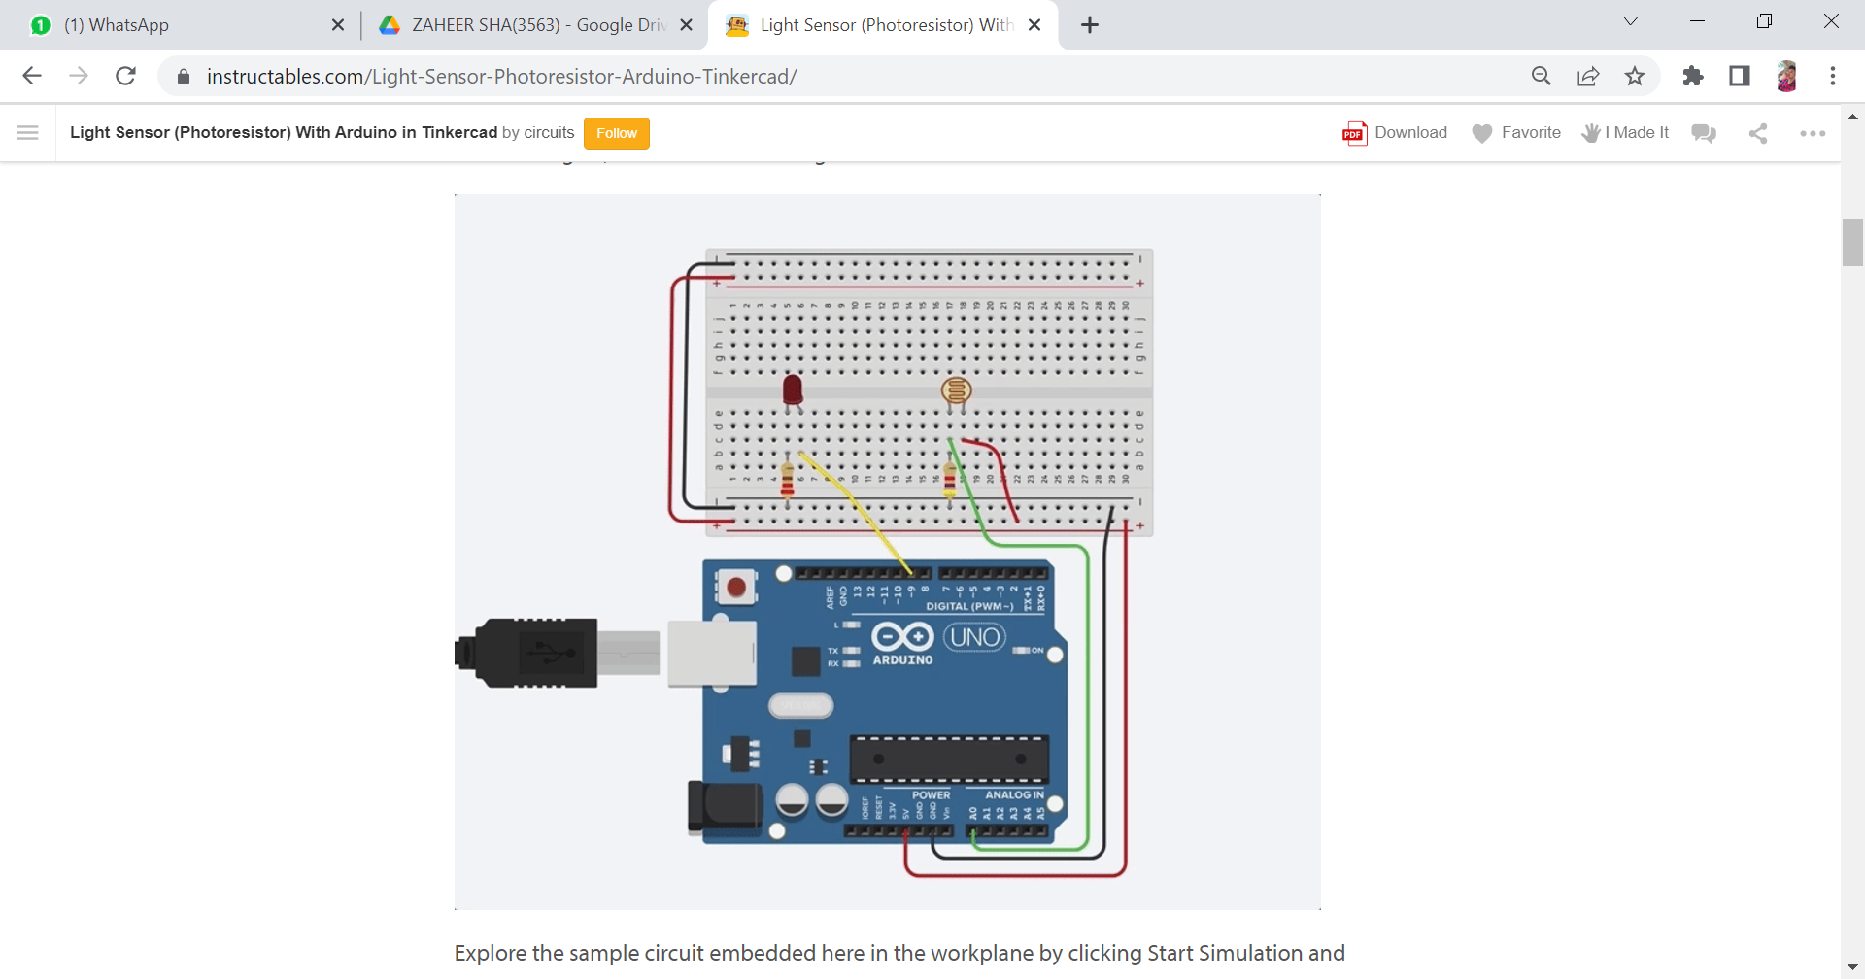
* PROGRAM

int LDRPin=A0;

int LEDPin=9;

void setup() {

Serial.begin(9600);

pinMode(LDRPin,INPUT);

pinMode(LEDPin,OUTPUT);

}

void loop() {

float LDRValue=analogRead(LDRPin);

Serial.println(LDRValue);

if(LDRValue<300)

digitalWrite(LEDPin,HIGH);

else

digitalWrite(LEDPin,LOW);

delay(500);

}

**By Team : AKULA ZAHEER SHA , TAUFEEQ BASHA & QUIZER SHAH**