MAKE SKILLED IoT INTERNSHIP

ASSIGNMENT – 1

USING ARDUINO CONTROLING LED WITH PUSH BUTTON

* + HERE WE WILL BE USING ARDUINO INTERFACE.
  + COMPONENTS REQUIRED:
  1. ARDUINO UNO BOARD
  2. PC / LAPTOP INSTALLED WITH ARDUINO IDE SOFTWARE
  3. PUSH PUTTON
  4. LED
  5. JUMPING WIRES
  + CIRCUIT DIAGRAM

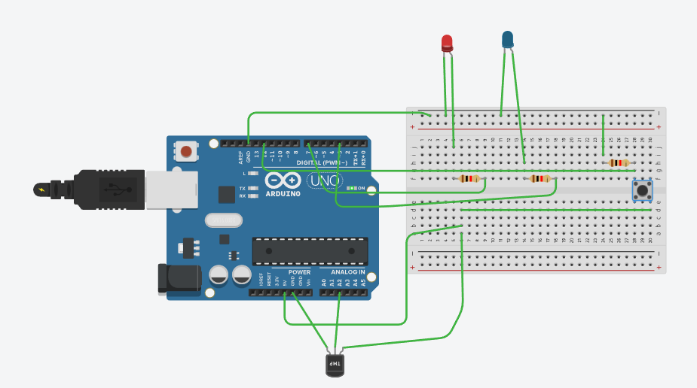

* PROGRAM

const int BUTTON = 12;

const int LED2 = 7;

const int LED = 3;

int BUTTONstate = 0;

int temperaturePin = 2;

void setup()

{

pinMode(BUTTON, INPUT);

pinMode(LED, OUTPUT);

pinMode(LED2, OUTPUT);

Serial.begin(9600);

}

void loop()

{

float voltage, degreesC, pinValue;

pinValue = analogRead(temperaturePin);

voltage = pinValue*5/1024;

degreesC = (voltage - 0.5) * 100.0;

BUTTONstate = digitalRead(BUTTON);

if (BUTTONstate == HIGH)

{

digitalWrite(LED, HIGH);

delay(1000);

digitalWrite(LED, LOW);

delay(1000);

digitalWrite(LED2, HIGH);

delay(1000);

digitalWrite(LED2, LOW);

delay(1000);

Serial.print("deg C: ");

Serial.println(degreesC);

delay(100);

}

else{

digitalWrite(LED, LOW);

digitalWrite(LED2, LOW);

}

}

**By Team : AKULA ZAHEER SHA , TAUFEEQ BASHA & QUIZER SHAH**