Organization of Intel 8085 Microprocessors :

The microprocessors that are available today came with a wide variety of capabilities and architectural features . All of them , regardless of their diversity , are provided with at least the following functional components , which form the central processing unit (CPU) of a classical computer .

- Register Section : A set of registers for temporary storage of instructions , data and address of data .
- Arithmetic and logic unit : Hardware for performing primitive arithmetic and logical operations .
- Interface Section : Input and output lines through which the microprocessor communicates with the outside world .
- Timing and control Section : Hardware for coordinating and controlling the activities of the various sections within the microprocessor and other devices connected to the interface section .

The block diagram of the microprocessor along with the memory and input / output (I/O) devices is shown in the figure .
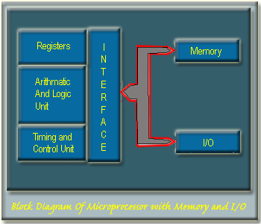

Intel Microprocessors :

Intel 4004 is the first 4-bit microprocessor introduced by Intel in 1971 . After that Intel introduced its first 8-bit microprocessor 8088 in 1972 .
These microprocessors could not last long as general purpose microprocessors due to their design and performance limitations .
In 1974 , Intel introduced the first general purpose 8-bit microprocessor 8080 and this is the first step of Intel towards the development of advanced microprocessor .
After 8080 , Intel launched microprocessor 8085 with a few more features added to its architecture , and it is considered to be the first functionally complete microprocessor .
The main limitations of the 8-bit microprocessors were their low speed , low memory capacity , limited number of general purpose registers and a less powerful instruction set .
To overcome these limitations Intel moves from 8-bit microprocessor to 16-bit microprocessor .
In the family of 16-bit microprocessors , Intel’s 8086 was the first one introduced in 1978 .
8086 microprocessor has a much powerful instruction set along with the architectural developments which imparted substantial programming flexibility and improvement over the 8-bit microprocessor .

Microprocessor Intel 8085 :

Intel 8085 is the first popular microprocessor used by many vendors . Due to its simple architecture and organization , it is easy to understand the working principle of a microprocessor .

Register in the Intel 8085 :

The programmable registers of 8085 are as follows –

- One 8-bit accumulator A .
- Six 8-bit general purpose register (GPR’s)
B, C, D , E , H and L .
- The GPR’s are also accessible as three 16-bit register pairs BC, DE and HL .
- There is a 16-bit program counter(PC) , one 16-bit stack pointer(SP) and 8-bit flag register . Out of 8 bits of the flag register , only 5 bits are in use .

The programmable registers of the 8085 are shown in the figure –

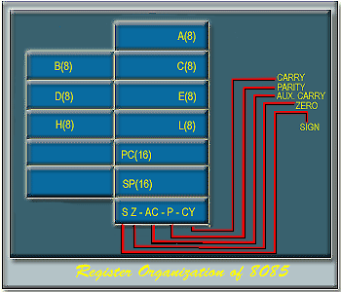

Apart from these programmable registers , some other registers are also available which are not accessible to the programmer . These registers include –
- Instruction Register ( IR)
- Memory address and data buffers (MAR & MDR)
- Temporary register for ALU use .

ALU of 8085 :

The 8-bit parallel ALU of 8085 is capable of performing the following operations –
Arithmetic : Addition , Subtraction , Increment , Decrement , Compare .
Logical : AND , OR , EXOR , NOT , SHIFT / ROTATE , CLEAR .

Because of limited chip area , complex operations like multiplication , division , etc are not available , in earlier processors like 8085 .

The operations performed on binary 2’s complement data .
The five flag bits give the status of the microprocessor after and ALU operation .

The carry (C) flag bit is set if the parity of the accumulator is even .
The Auxiliary Carry (AC) flag bit indicates overflow out of bit –3 ( lower nibble) in the same manner , as the C-flag indicates the overflow out of the bit-7.

The Zero (Z) flag bit is set if the content of the accumulator after any ALU operations is zero .
The Sign(S) flag bit is set to the condition of bit-7 of the accumulator as per the sign of the contents of the accumulator(positive or negative ) .

The Interface Section :

Microprocessor chips are equipped with a number of pins for communication with the outside world . This is known as the system bus .
The interface lines of the Intel 8085 microprocessor are shown in the figure –

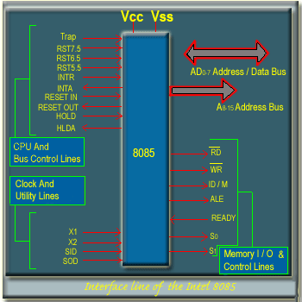

Address and Data Bus
The AD0- AD7 lines are used as lower order 8-bit address bus and data bus , in time division multiplexed manner .
The A8-A15 lines are used for higher order 8-bit of address 8-bit of address bus.
There are seven memory and I/O control lines –

RD : indicates a READ operation when the signal is LOW .

WR : indicates a WRITE operation when the signal is LOW .

IO/M : indicates memory access for LOW and I/O access for HIGH .

ALE : ALE is an address latch enable signal , this signal is HIGH when address information is present in AD0-AD-7 . The falling edge of ALU can be used to latch the address into an external buffer to de-multiples the address bus .

READY : READY line is used for communication with slow memory and I/O devices .

S0 and S1 : The status of the system bus is difined by the S0 and S1 lines as follows –

S1 | S0 | Operation Specified
0 | 0 | Halt
0 | 1 | Memory or I/O WRITE
1 | 0 | Memory or I/O READ
1 | 1 | Instruction Fetch

There are ten lines associated with CPU and bus control –

- TRAP , RST7.5 , RST6.5 , RST5.5 and INTR to acknowledge the INTA output
- RESET IN : This is the reset input signal to the 8085.
- RESET OUT : The 8085 generates the RESET-OUT signal in response to RESET-IN signal , which can be used as a system reset signal .
- HOLD : HOLD signal is used for DMA signal .
- HLDA : HLDA signal is used for DMA GRANT .

Clock and Utility Lines :

X1 and X2 : X1 and X2 are provided to connect a crystal or a RC network for generating the clock internal to the chip .
SID : input line for serial data communication
SOD : output line for serial data communication
V_{CC} and V_{SS} : Power supply .

The block diagram of the Intel 8085 is shown in the figure –
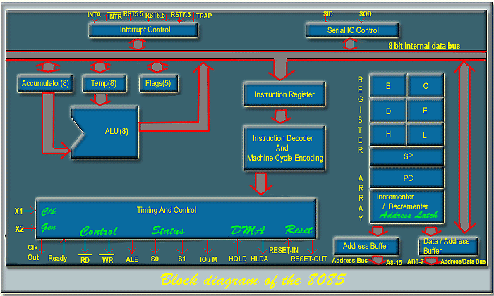

Instruction and data formats :

Memory used in the Intel 8086 microprocessor is organized in 8-bit , i.e. It is byte organized .

Every byte has a unique location in physical memory .

The address bus of 8085 is 16-bit wide , so the location of memory is described by one of a sequence of 16-bit binary address .

The 8085 can address up to 64k(i.e. 65,535) bytes of memory , which may consist of both RAM and ROM .

Data in 8085 is stored in the form of 8-bit binary integers –

XXXXXXXXXXXXXXXX

And 8085 program instruction may be one , two or three bytes in length .

Multiple byte instructions must be stored in successive memory location s; the address of the first byes is always used as the address of the instruction .

XXXXXXXXXXXXXXXX

Addressing Modes :

The 8085 has four different modes for addressing data stored in memory or in registers –

Direct : Bytes 2 and 3 of the instruction contains the exact memory address of the data item( the low-order bits of the address are in byte 2 , the high-order bits in byte 3 )

Register : The instruction specifies the register or register pair in which the data are located .

Register Indirect : The instruction specifies a register pair which contains the memory address where the data are located .( the high-order bits of the address are in the first register of the pair and the low order bits in the second ).

Immediate : The instruction contains the data itself . This is either and 8-bit quantify or a 16-bit quantify (least significant byte first , most significant byte second ).

Unless directed by and interrupt or branch instruction the execution of instructions proceeds through consecutively increasing memory locations.

A branch instruction can specify the address of the next instruction to be executed in one of two ways -

Direct: The branch instruction contains the address of the next instruction to be executed .

Regular Indirect : The branch instruction indicates a regular pair which contains the address of the next instruction to be executed .

Instruction Set :

The complete instruction set of 8085 can be grouped in five different functional groups –

- Data Transfer group : Moves data between registers , or between memory location and registers ,includes moves , loads , stores and exchanges .
- Arithmetic group : Adds , subtracts , increments , or decrements data in registers or memory .
- Logic group : AND’s , OR’s , XOR’s , compares , rotates , or complements data in registers or between memory and a register .
- Branch group : Initiates conditional or unconditional jumps , calls , returns , and restarts .
- Stack , I/O and machine control group : Includes instructions for maintaining the sack , reading from input ports , writing to output ports , setting and reading interrupt masks , and setting and clearing flags .

