**SMART WATER FOUNTAINS**

**Describe the project's objectives, IoT sensor setup, mobile app development, Raspberry Pi integration, and code implementation.**

**PROJECT OBJECTIVES:**

The primary objective of this project is to create a system that collects data from various IoT sensors, processes that data using a Raspberry Pi, and presents it to users through a mobile app. The project may have specific goals such as monitoring environmental conditions, home automation, or industrial process control.

1. **IOT SENSOR SETUPS:**

* **Sensor Selection**:

Choose appropriate IoT sensors for collecting the required data. This could include temperature sensors, humidity sensors, motion detectors, light sensors, etc.

* **Sensor Placement**:

Install and position the sensors in the target environment. Ensure they are connected to a network, either via Wi-Fi, Bluetooth, or other communication protocols.

* **Data Transmission**:

Set up a protocol for the sensors to transmit data to a central hub, such as a Raspberry Pi, over the network.

1. **RASPBERRY PI INTEGRATION:**

* **Raspberry Pi Selection**:

Choose the Raspberry Pi model that suits the project's needs. The Raspberry Pi will act as a data aggregator and processor.

* **Data Reception**:

Write code to receive data from the IoT sensors connected to the Raspberry Pi. This code may include socket programming or utilizing IoT-specific libraries.

* **Data Processing**:

Implement algorithms to process and analyze the incoming sensor data. This could involve data filtering, transformation, or triggering alerts based on predefined conditions.

* **Data Storage**:

Decide on a data storage strategy. You might use a local database on the Raspberry Pi or send the data to a cloud server for storage and further analysis.

1. **MOBILE APP DEVELOPMENT :**

* **Platform Selection**:

Choose the mobile app development platform (iOS, Android, or cross-platform) based on the target audience.

* **User Interface Design**:

Design the app's user interface. Create wireframes and prototypes to plan the layout and functionality.

* **App Development**:

Write code for the mobile app. Integrate features for user registration, login, and data visualization. The app should be able to fetch and display real-time or historical data from the Raspberry Pi.

* **User Interaction**:

Implement user interaction features like notifications, alerts, and control mechanisms if the project involves IoT devices that can be controlled through the app.

**3.CODE IMPLEMENTATION :**

* **IoT Sensor Code**:

Write code for the IoT sensors to collect data and transmit it to the Raspberry Pi. Ensure proper error handling and data integrity.

* **Raspberry Pi Code**:

Develop the code that runs on the Raspberry Pi. This includes setting up a server to receive data, data processing logic, and data storage.

* **Mobile App Code**:
* Write the code for the mobile app, including front-end and back-end components.
* Use programming languages and frameworks relevant to the chosen platform (e.g., Java/Kotlin for Android, Swift for iOS).
* **Integration Code**:

Develop code to facilitate communication between the Raspberry Pi and the mobile app. This might involve APIs or communication protocols like MQTT or WebSocket.

* **Testing and Debugging**:

Rigorously test the entire system, identify and fix bugs, and ensure that the IoT sensors, Raspberry Pi, and mobile app work seamlessly together.

**In summary, this project involves setting up IoT sensors, integrating them with a Raspberry Pi for data processing, and developing a mobile app to provide users with access to the collected data. Proper planning, coding, and testing are critical to the project's success. The specific implementation details will depend on the project's scope and objectives.**

**DIAGRAM AND SCHEMATICS :**

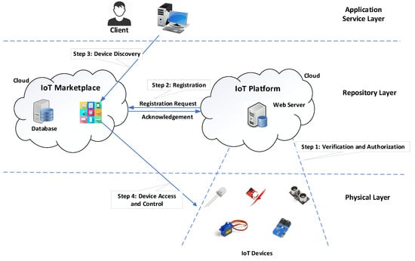

A well-designed fountain adds freshness to any public space, boosting it both socially and economically by attracting more tourists and also local residents. In this way, people from near and far will have a place for leisure, fun, or just simple relaxation.

The pump forces water upwards to create a falling effect into a lower basin. The pump uses water pressure and tubes to force the water back into the reservoir to start the cycle over again. The number of reservoirs and pumps in a fountain can vary, with large outdoor fountains commonly having multiple basins.

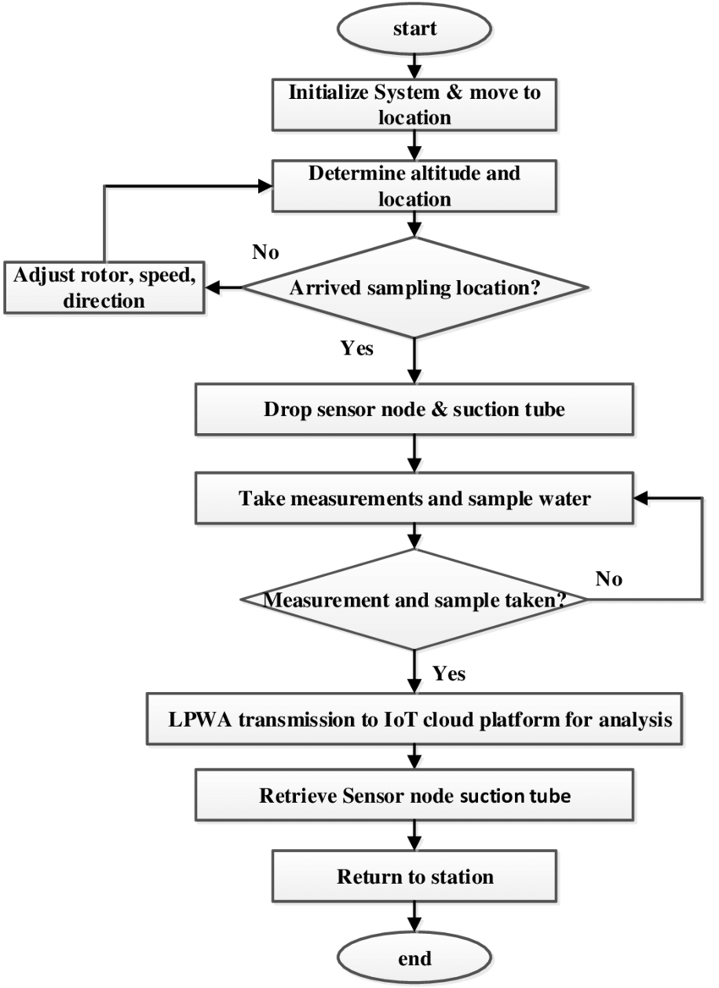

**Explain how the real-time water fountain status system promotes water efficiency and public awareness.**

A real-time water fountain status system can promote water efficiency and public awareness in several ways:

**1.WATER CONSERVATION :**

* **Real-time Monitoring:**

By continuously monitoring the water fountains' status, the system can detect issues such as leaks or wasteful water consumption in real-time. This allows for immediate action to be taken, preventing water wastage.

* **Automated Shut-off:**

The system can be designed to automatically shut off fountains when not in use or when a malfunction is detected. This reduces the chances of water being wasted if a fountain is left running accidentally or due to a malfunction.

* **Usage Patterns Analysis :**

By collecting data on fountain usage patterns, the system can identify areas with high or unnecessary water consumption, enabling authorities to optimize water fountain placement or make informed decisions about water infrastructure improvements.

**2. PUBLIC AWARENESS :**

* **Interactive Mobile App:**

The real-time status system can be linked to a mobile app accessible to the public. This app can display the locations of nearby water fountains, their status (e.g., operational, inactive, under maintenance), and even water quality information.

* **Water Quality Information:**

In addition to the status, the system can measure and display water quality data. Users can see if the water is safe to drink, encouraging environmentally friendly behavior by reducing the need for single-use plastic bottles.

* **Push Notifications:**

The mobile app can send push notifications to users about the closest working fountains, promoting the use of tap water and the concept of free, accessible drinking water.

* **Education and Engagement:**

The app can include educational materials about the importance of water conservation and the environmental impact of single-use plastics. Users can be engaged through quizzes, challenges, or incentives for using refillable bottles.

1. **DATA VISUALIZATION AND REPORTING :**

* **Public Display Screens :**

In public spaces or near water fountains, digital display screens can be set up to show real-time water conservation data, encouraging people to use water responsibly.

* **Annual Reports :**

Water authorities can compile annual reports on water conservation achieved through the system, showcasing the positive impact on water efficiency and raising awareness among stakeholders and the public.

1. **INCENTIVIZING SUSTAINABLE BEHAVIOUR :**

* **Rewards and Recognition:**

Implement a rewards system where users who consistently use refillable bottles and reduce single-use plastics are recognized and rewarded for their efforts, encouraging others to follow suit.

* **Community Challenges :**

Organize community challenges or competitions around water conservation and publicize the results through the system to encourage friendly competition and engagement.

**In summary, a real-time water fountain status system can actively promote water efficiency by preventing waste, while also raising public awareness about water conservation, tap water safety, and the environmental benefits of reducing plastic bottle usage. By combining technology, data, and public engagement, this system can contribute to a more sustainable and environmentally conscious society.**