PROJECTNAME
PROJECT
MANAGEMENT
PLAN

DOCUMENT INFORMATION
 | Information
Document Id | 0812
Document Owner | Name of Document Owner
Issue Date | [Date DD/MM/YYYY]
File Name | 0812_ProjectName_Project_Management_Plan
File Location | -

DOCUMENT HISTORY
Version | Rev Date | Description | Prepared by | Approved by | Status

Table of Contents

DOCUMENT INFORMATION 2
DOCUMENT HISTORY 2
ABBREVIATIONS 4
REFERENCES 4
ORGANIZATION SPECIFIC REFERENCES 4
PROJECT SPECIFIC REFERENCES 5
1. INTRODUCTION 6
1.1 PURPOSE OF PROJECT MANAGEMENT PLAN 6
2. PROJECT SUMMARY 6
2.1 SCOPE OF THE PROJECT 7
2.2 DELIVERABLES & ACCEPTANCE CRITERIA 7
3. PROJECT TEAM ORGANIZATION 7
3.1 PROJECT TEAM STRUCTURE 7
3.2 RASIC CHART 10
4. PROJECT EXECUTION 11
4.1 PROJECT LIFECYCLE 11
4.1.1 SOFTWARE REQUIREMENT ANALYSIS 12
4.2 PROJECT PHASES 13
5. CONFIGURATION MANAGEMENT PLAN 13
6. SCOPE MANAGEMENT PLAN 13
7. CHANGE MANAGEMENT PLAN 14
8. SCHEDULE MANAGEMENT PLAN 15
8.1 MILESTONE LIST 15
9. COST MANAGEMENT PLAN 16
10. QUALITY MANAGEMENT PLAN 16
11. RESOURCE MANAGEMENT 17
11.1 HUMAN RESOURCE MANAGEMENT 17
11.2 TOOLS 17
11.3 HARDWARE SOFTWARE INFRASTRUCTURE 17
12. COMMUNICATION MANAGEMENT PLAN 17
13. RISK & ISSUE MANAGEMENT PLAN 17
13.1 RISK REGISTER 17
14. PROCUREMENT MANAGEMENT 17
15. ESCALATION MATRIX 18
16. TAILORING 19

ABBREVIATIONS
PMP | Project Management Plan
PCA | Physical Configuration Audit
PCL | Project Closure
PCP | Project Concept
PDT | Project development
PI | Project Initiation
PM | Project Management
PPL | Project Planning
PRL | Project Release
PCA | Physical Configuration Audit
PCL | Project Closure
SYS | System Engineering Process Groups
SWE | Software Engineering Process Groups
TPL | Technical Project Lead

REFERENCES

ORGANIZATION SPECIFIC REFERENCES
  - Quality Management Plan
  - ASPICE 3.1
  - ASPCE3.1 Checklist
  - Safety Development Lifecyle (ISO26262_2018): IAST as an organization decided to comply with ISO26262 Safety development lifecycle for safety related projects. Supporting process [Part-8] of Safety development lifecycle complimented with ASPICE 3.1.
  - Cyber Security Standard:
  - System Modeling Language:

PROJECT SPECIFIC REFERENCES
  - Project Scope Management Plan
  - Project Schedule
  - Work Break-Down Structure
  - Change Management Plan
  - Cost Management Plan
  - Communication Matrix
  - Communication Management Plan
  - Configuration Management Plan
  - Risk Management
  - Procurement Management Plan
  - Model Based Development Guideline

INTRODUCTION

PURPOSE OF PROJECT MANAGEMENT PLAN
Project management plan defines how a project is executed, monitored, and controlled. It ensures customer expectations & requirements are met by outlining project scope, schedule, budget management plan, identifying project team with required skill set. It also creates management plan for project communication, stakeholder management, quality management and risk management.

PROJECT SUMMARY
(A project summary is a document or part of a larger document that’s comprehensive but concise in providing an overview of the proposed project, including key details. It also outlines the project’s objectives, background information to place it in context, requirements, problems, analysis and ends with a conclusion.)
Name of the project
Project ID |  | Estimated budgetary cost
Name of the Customer |  | Planned Start Date
Project Type |  | Planned End Date
Estimation Details |  | Total
Efforts (in person says)
Size |  | Warranty period, if applicable
Key Stakeholders
Name of the person | Role | E-mail ID | Phone

SCOPE OF THE PROJECT
(State the scope of the project in this section of the Project Management Plan. The scope statement from the project charter should be used as a starting point; however, the project plan needs to include a much more detailed scope than the charter. This detail should include what the project does and does not include. The more detail included in this section, the better the product. This will help to clarify what is included in the project and help to avoid any confusion from project team members and stakeholders.)

DELIVERABLES & ACCEPTANCE CRITERIA
Deliverables | Acceptance Criteria

[Insert a deliverables acceptance criterion that are defined as a formal statement of needs, rules, tests, requirements, and standard that must be using in reviewing project outcome and coming to agreement with the customer on the point the project has produced the deliverables that meet the initial expectations of the customer.]

PROJECT TEAM ORGANIZATION

PROJECT TEAM STRUCTURE
(The project team structure is the group of people responsible for executing the tasks and producing deliverables outlined in the project plan and schedule, as directed by the project manager, at whatever level of effort or participation defined for them.)
Role | Name | Responsibilities
Project Manager |  | - Plan and Develop the Project Idea. Every project starts as an idea.  - Monitor Project Progress and Set Deadlines.  - Ensure Stakeholder Satisfaction.  - Motivating the team to achieve organizational goals.  - Developing and implementing a timeline to achieve targets.  - Delegating tasks to team members.  - Conducting training of team members to maximize their potential.  - Providing expertise.  - Working with users to establish and meet business needs.
Project Sponsor |  | - Aligning the project with business goals, strategy, and objectives.  - Ensuring the project's proper launch and execution.  - Managing risks and changes while ensuring the project's quality.
Project Lead Architect (Technical) |  | - Motivating the team to achieve technical & quality goals.  - Developing and implementing a timeline to achieve targets.  - Delegating tasks to team members.  - Conducting training of team members to maximize their potential.  - Analyse documents, coordinate and manage requirements regarding project aimed at optimizing operational efficiency.
Business Analyst |  | - Creating a detailed business analysis, outlining problems, opportunities and solutions for a business.  - Budgeting and forecasting.  - Planning and monitoring.  - Variance analysis.  - Pricing.  - Reporting.  - Defining business requirements and reporting them back to stakeholders.
Expertise Support (Safety) |  | - Planning and coordination of the functional safety activities.  - Collaborate with project manager, development team, suppliers, and customers on Functional Safety.  - Lead development teams for safety analysis completion.  - Coaching the development team in the functional safety development processes and methods.  - Understanding all aspects of the technology, the architecture, and the function of the product, to define a safety concept and context.  - Participate in Safety Audits and Assessments.
System Team Lead |  | - Proactively ensure the highest levels of systems and infrastructure availability.  - Participate in the design of information and operational support systems.  - Maintain security, backup and redundancy strategies.  - Recommend and implement changes to the overall systems through the change management process.
Quality Engineer |  | - Determining quality metrics for all manufacturing procedures.  - Monitor the entire production cycle and perform regular tests to identify potential malfunctions as early as possible.  - Auditing systems based on ISO 9001:2015 requirements.  - Work with internal teams to increase customer satisfaction by improving the quality of the products.
Application Software Team Lead |  | - Create coding standards and manage SDLC processes for team continuity.  - Supervise the development team members in pair programming, code reviews.  - Ensure effective communication between the team members and the other IT functions.
Base Software Team Lead |  | - Manages a team through the entire process of software development.  - Analyse the project, identify errors, and conduct troubleshooting.  - Ensure that all deadlines are met, and that work is conducted efficiently.
Software Integration Lead |  | - Responsible for the design, development, and operation of application interfaces, data flows, and APIs, utilizing both vendors delivered services and internal API management tools.  - Evaluate existing components and systems to determine integration requirements.  - Manage the integration, analysis and assessment of plans and strategies across the project.
Expertise Support  (System V&V) |  | - Participates in the definition of the validation test strategy, in accordance with sub-system requirement, system architecture.  - Specifies, designs, and develops validation environment & tools.  - Establishes validation procedures (test sheets) / criteria and elaborates the work products.

RASIC CHART
Responsible, Approving, Supporting, Informed and Consulting
Roles \ Process | Requirements | Architecture | Detailed Design, Unit Construction | Test Specification & report | Validation & Verification
Requirement Engineer
Architect
Developer
Project Lead
Test Engineer
Project Manager
Delivery Manager
Quality Engineer

PROJECT EXECUTION

PROJECT LIFECYCLE
Project will follow V-model to meet ASPICE L2 compliance and implementation requirements. Following shall be phases for the project –

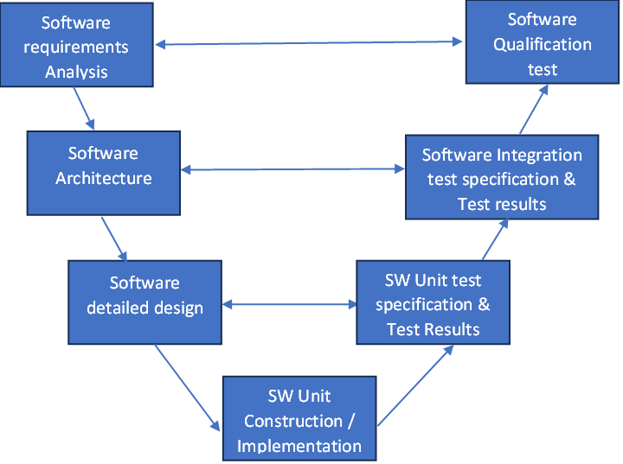
Fig 1: Project Lifecycle

SOFTWARE REQUIREMENT ANALYSIS
This phase of project will cover -
- software requirement analysis based on bootloader requirements,
- develop verification criteria,
- establish bidirectional traceability.

Process Flow -

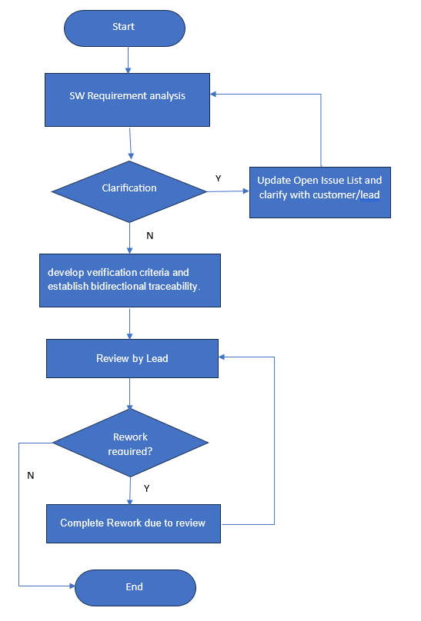

Fig 2: Requirement Analysis Process Flow
Process Output-
Process Input | Process Output | Used by
Bootloader Requirements | Software Requirements | SW Architecture, SW Unit
 | Review Log | Quality
 | Verification Criteria | Quality
 | Bidirectional Traceability | Quality

PROJECT PHASES
The 6 basic phases in the project management process are:
    - Project Initiation (PI)
    - Project Concept (PCP)
    - Project Planning (PPL)
    - Project Development (PDT)
    - Project Release (PRL)
    - Project Closure (PCL)

CONFIGURATION MANAGEMENT PLAN
Refer Project Configuration Management Plan[14]

SCOPE MANAGEMENT PLAN
Refer Project Scope Management Plan [7]
It is important that the approach to managing the projects’ scope be clearly defined and documented in detail. Failure to clearly establish and communicate project scope can result in delays, unnecessary work, failure to achieve deliverables, cost overruns, or other unintended consequences. This section of our project management plan template provides a summary of the Scope Management Plan in which it addresses the following:
- Who has authority and responsibility for scope management?
- How the scope is defined (i.e., Scope Statement, WBS, WBS Dictionary, Statement of Work, etc.)
- How the scope is measured and verified (i.e., Quality Checklists, Scope Baseline, Work Performance Measurements, etc.)
- The scope change process (who initiates, who authorizes, etc.)
- Who is responsible for accepting the final project deliverable and approves acceptance of project scope.

CHANGE MANAGEMENT PLAN
Refer Change Management Plan [10]
This part of the Change Management Plan should describe the change control process from beginning to end. By following all the steps, the project team can successfully incorporate approved changes, communicate the changes, and update project documentation.
The Change Control Process is performed by a Change Control Board (CCB).
The project manager has overall responsibility for executing the change management process for each change request.
The Change Control Process includes two types of changes:
• Major Change (Class 1 change)
• Minor Change (Class 2 change)
Major Change is defined as a change in at least one of the following parameters (FFFFLS): F- Form (What does it look like) F- Fit (How does its interface) F- Function (What does it do) F- Fee/Cost (What should we charge for it) L- Logistics S- Safety
Major change requires new Function ID.
Major change needs customer’s approval
Any other change is a Minor Change with no necessity to change the Function ID.

CHANGE CONTROL RECORD
Mention all the changes in Change Control Record
1321_ProjectName_Change_Control_Record.xlsx
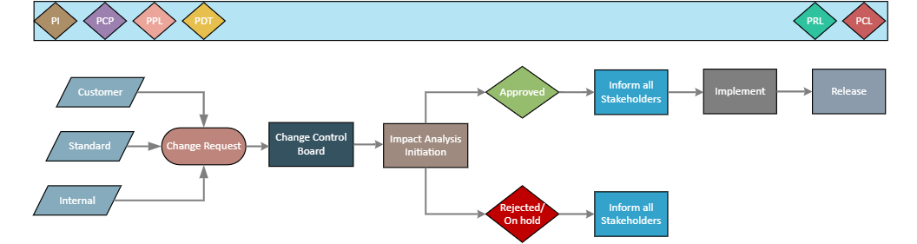

SCHEDULE MANAGEMENT PLAN
Refer Schedule Management Plan [8]
This section of the Project Plan provides a general framework for the approach which will be taken to create the project schedule. Effective schedule management is necessary for ensuring tasks are completed on time, resources are allocated appropriately, and to help measure project performance. This section of the Project Plan should include discussion of the scheduling tool/format, schedule milestones, and schedule development roles and responsibilities.

MILESTONE LIST
Provide a summary list of milestones including dates for each milestone. This section of the project plan template should also mention or discuss actions taken if any changes to the milestones or delivery dates are required.
Milestone | Description | Date  (DD-MM-YYYY)

COST MANAGEMENT PLAN
Refer Cost Management Plan [11]
The Cost Management Plan clearly defines how the costs on a project will be managed throughout the project’s lifecycle. It sets the format and standards by which the project costs are measured, reported, and controlled. Working within the cost management guidelines is imperative for all project team members to ensure successful completion of the project. These guidelines may include which level of the WBS cost accounts will be created in and the establishment of acceptable variances.
The Cost Management Plan:
- Identifies who is responsible for managing costs.
- Identifies who has the authority to approve changes to the project or its budget.
- How cost performance is quantitatively measured and reported upon
- Report formats, frequency and to whom they are presented.

QUALITY MANAGEMENT PLAN
Refer Quality Management Plan [1]
Quality Management System (QMS) is defined as a structured system that documents processes, procedures, and responsibilities for continuously delivering high-quality products and services that meet regulatory and customer requirements.

RESOURCE MANAGEMENT

HUMAN RESOURCE MANAGEMENT
Mention Organization Chart including roles of each resource working on the project.

TOOLS
Mention list of tools used in the project.

HARDWARE SOFTWARE INFRASTRUCTURE
Mention System & Software Description and Architecture required for project.

COMMUNICATION MANAGEMENT PLAN
[Insert the project’s communication management plan [12] or provide a reference to where it is stored]

RISK & ISSUE MANAGEMENT PLAN
Refer Risk & Issue Management Plan [15]
This part of the Project Plan provides a general description for the approach taken to identify and manage the risks associated with the project. It should be a short paragraph or two summarizing the approach to risk management on this project.

RISK REGISTER
Every project must maintain a risk register in order to track risks and associated mitigation strategies. This section describes the risk register criteria as well as where the risk register is maintained and how these risks are tracked in the project schedule.

PROCUREMENT MANAGEMENT
Refer Procurement Management Plan [16]
The Procurement Management Plan should be defined enough to clearly identify the necessary steps and responsibilities for procurement from the beginning to the end of a project. The project manager must ensure that the plan facilitates the successful completion of the project and does not become an overwhelming task in itself to manage. The project manager will work with the project team, contracts/purchasing department, and other key players to manage the procurement activities.

ESCALATION MATRIX
PM will be responsible and will work on issues/open items Escalated after 3rd Level.
Operation | 1st level | 2nd Level | 3rd Level
System Req | Requirement Lead | TPL, Line Manager | PM
System Architecture | Architecture Lead | TPL, Line Manager | PM
Systems Engineer System Test | System Test Lead | TPL, Line Manager | PM
Software Requirements | Software Req Lead | TPL, Line Manager | PM
Software Architecture | Architecture Lead | TPL, Line Manager | PM
Software Component test | Software Test Lead | TPL, Line Manager | PM
SW Test and Integration Test | Software Integration Test Lead | TPL, Line Manager | PM
Validation Engineer | Validation Lead | TPL, Line Manager | PM
Functional Safety | FuSa Lead | TPL, Line Manager | PM
Cyber Security | Cyber Security Lead | TPL, Line Manager | PM
Quality (System & Software) | Quality Lead | TPL, Line Manager | PM

TAILORING

Tailored Item | Description | Remark

TEMPLATE HISTORY
Version | Release Date | Description | Prepared by | Approved by | Status
1.0 | 12/11/2023 | Generic Project Management Plan is updated | Purvi Sahu | NA | Obsolete
1.1 | 23/11/2023 | Project Summary & Abbreviation Table are added | Purvi Sahu | NA | Draft
1.2 | 27/11/2023 | Scope Management & Project Summary are update | Purvi Sahu | NA | In-review
1.3 | 06/12/2023 | Updated Section 7 & added Change Control Record | Purvi Sahu | NA | In-review
1.4 | 23/04/2024 | All the review findings closed & approved. | Purvi Sahu | Dinesh Sharma | Approved

