PROJECTNAME
REQUIREMENT MANAGEMENT
PLAN

DOCUMENT INFORMATION
 | Information
Document Id | [Document Management System #]
Document Owner | [Owner Name]
Issue Date | [Date DD/MM/YYYY]
Last Saved Date | [Date DD/MM/YYYY]
File Name | Requirement_Management_Plan
File Location

DOCUMENT HISTORY
Version | Rev Date | Description | Prepared by | Approved by | Status
1.0 | 11-07-2022 | Generic Requirement Management plan has been released. | Purvi Sahu | Nishant Kumar | Released

DOCUMENT APPROVALS
Role | Name | Date  (DD/MM/YYYY)
Project Sponsor
Project Review Group
Project Manager
Quality Manager
(if applicable)
Procurement Manager
(if applicable)
Communications Manager
(if applicable)
Project Office Manager
(if applicable)

Table of Contents
1. INTRODUCTION 4
2. ROLES AND RESPONSIBILITIES 4
3. ENVIRONMENT 6
4. REQUIREMENT HIERARCHY 8
4.1.1 MODULE TYPE 9
4.1.2 ARTIFACTS TYPE 9
5. REQUIREMENT FOLDER STRUCTURE 10
6. TRACEABILITY & CONSISTENCY 11
7. REVIEW & ACCEPTANCE 14
8. REQUIREMENT CHANGE MANAGEMENT 14
9. VERIFICATION & VALIDATION 15
10. DELIVERABLES 18

INTRODUCTION
The Requirements Management plan is used to document the necessary information required to effectively manage project requirements from definition, through traceability, to delivery.
The purpose of requirements management is to ensure product development goals are successfully met. It is a set of techniques for documenting, analyzing, prioritizing, and agreeing on current and approved requirements.
Requirements management provides a way to avoid systematic errors by keeping track of changes in requirements and fostering communication with stakeholders from the start of a project throughout the development lifecycle.

ROLES AND RESPONSIBILITIES
Roles: This is to define who needs to be aware of and informed about the project, how and how often information will be distributed, and who will be responsible for the distribution.
Responsibilities: Specifies the different tasks of the person.
The project manager will assume overall responsibility for requirements management. The people listed below will assume the following requirements management responsibilities:
Role | Name | Responsibilities
Project Manager | TBD | - Plan and Develop the Project Idea. Every project starts as an idea.  - Monitor Project Progress and Set Deadlines.  - Ensure Stakeholder Satisfaction.
Requirement Manager | TBD | - Carrying out classic requirements analyses.  - Formulation of requirements.  - Review and creation of requirement specifications or user stories and identification of improvement potential.  - Optimization of the requirement processes.  - Execution of requirement reviews.
Project Sponsor | TBD | - Aligning the project with business goals, strategy, and objectives.  - Ensuring the project's proper launch and execution.  - Managing risks and changes while ensuring the project's quality.
Project Team Lead | TBD | - Motivating the team to achieve organizational goals.  - Developing and implementing a timeline to achieve targets.  - Delegating tasks to team members.  - Conducting training of team members to maximize their potential.
Project Team Members | TBD | - Contributing to overall project objectives. Completing individual deliverables.  - Providing expertise.  - Working with users to establish and meet business needs.
Business Analyst | TBD | - Creating a detailed business analysis, outlining problems, opportunities and solutions for a business.  - Budgeting and forecasting.  - Planning and monitoring.  - Variance analysis.  - Pricing.  - Reporting.  - Defining business requirements and reporting them back to stakeholders.
Function Safety Manager | TBD | - Planning and coordination of the functional safety activities.  - Collaborate with project manager, development team, suppliers and customers on Functional Safety.  - Lead development teams for safety analysis completion.  - Coaching the development team in the functional safety development processes and methods.
System Requirement Engineer | TBD | - Managing and monitoring all installed systems and infrastructure.  - Installing, configuring, testing and maintaining operating systems, application software and system management tools.  - Ensuring the highest levels of systems and infrastructure availability.
Software Requirement Engineer | TBD | - Analyses, documents, coordinates, and manages requirements regarding new software projects aimed at optimizing operational efficiency.
Security Manager | TBD | - Creates all security policies and procedures.  - Conducts regular security inspections.  - Investigates security threats and breaches.  - Writes comprehensive security reports.
Table 1: Roles & Responsibilities

ENVIRONMENT
  - DEVELOPMENT LIFECYCLE
V-Model (where V stands for verification and validation) splits the development process into two parts – the left arm of the V consists of requirement analysis, function design, and software development while the right arm concentrates on the verification and validation activities followed by the release. The V-model is an extension of the waterfall methodology. V-Model emphasizes testing, particularly the need for early test planning. Each phase of the V-model aligns with the ASPICE standard and helps in clearly defining a life cycle.
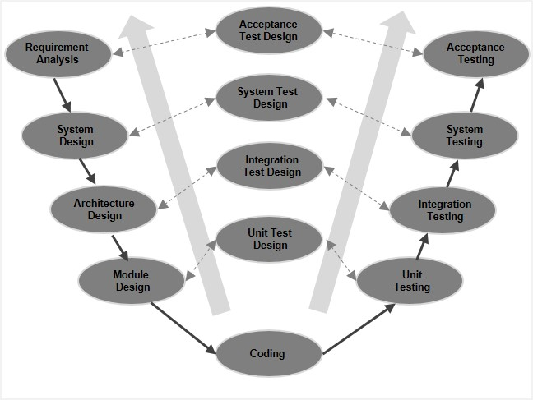
Figure 1: V-model
  - STANDARD
ISO 26262, titled “Road vehicles — functional safety”, is a functional safety standard used in the automotive industry, and ASIL is a key component to determine safety requirements for software development.
TBD: Add more standard based on project need.

  - QUALITY PROCESS
ASPICE is a two-dimensional model which comprises Process dimension and Process Capability dimension. ASPICE identifies different process like Requirement elicitation, System requirement analysis, process management etc.

ASPICE has its own Process Reference Model (PRM) which is tailored considering the specific needs of the automotive industry. The ASPICE Process Assessment Model (PAM) uses the PRM when performing an assessment.

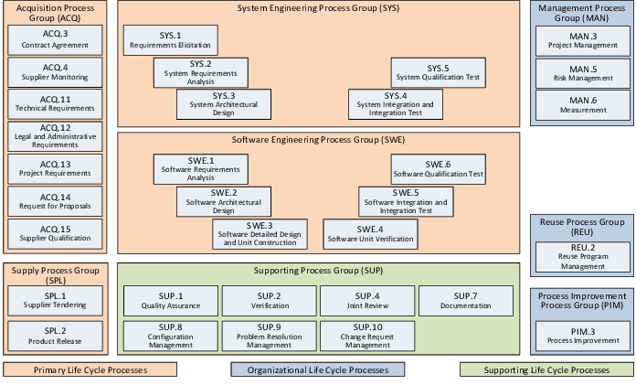
Figure 2: ASPICE 3.1 Process Reference Model
  - TOOLS
IBM DOORS: IBM® Engineering Requirements Management DOORS® (DOORS) is a leading requirements management tool that makes it easy to capture, trace, analyze, and manage changes to information.
TBD: Add more tools based on project need.

REQUIREMENT HIERARCHY
  - GENERIC DOORSNG STRUCTURE
DOORSNG uses a hierarchical structure for its databases. The top level is the global configuration for the project. Inside this, multiple DOORSNG project can be implemented for referenced. Inside a DOORSNG project multiple modules are created for a different purpose. A module is built from different artifacts, with different object types, which includes the requirements and architectural implementations. Each artifacts has dependent on its object type, different attributes.
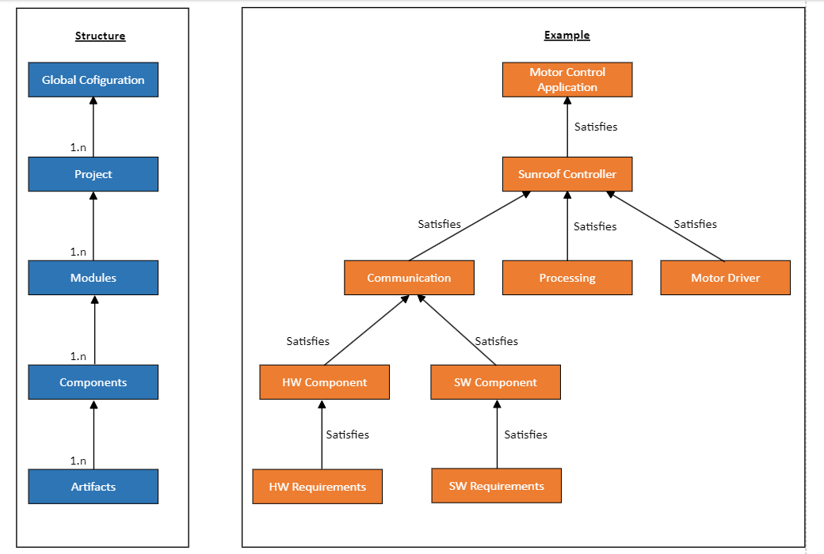
Figure 3: Generic DOORSNG Structure

MODULE TYPE
The listed module types are define for the requirements management setup. Dependent on the contents, different modules are used: Templates.RS for requirement specification artifacts, Template.AS for architectural specification artifacts; Template.TS for test specification artifacts, Template.TR for test reports allocation.
Name | Descriptions
RS (Requirement specification) | Collects the requirements for one module/level
AS (Architectural specification) | Collects the architecture for one module/level
TS (Test specification) | Define the test (Validation/ Integration) of the requirements of one module/ level
TR (Test reports) | Hold the results of the test (Validation/ Integration) of the test specification of module/ level
Table 2: Module Type

ARTIFACTS TYPE
The following artifacts type are used for the individual elements in the requirement, architecture, and test specifications.
A requirement artifact shall only be used in a unique module. It is not allowed to use a unique requirement artifact in several modules.
Name | Descriptions
Characteristics | Performance characteristics with Min, typ, max, unit and symbol
Heading | Chapter heading
Information | Information
Requirement | Default requirement type
Assumption | Assumption
Test Item | Test Item
Architecture | Architectural decision / Implementation
Table 3: Artifacts type
  - LINKAGE & RELATIONSHIPS
Links can show relationship properties such as artifact origin, derivation, dependency, hierarchy, and associations between requirements, development, and test artifacts.

Link relationships are directional, and labels typically differ at either end of the link.

A satisfy relationship describes that a design element satisfies a requirement.
A verify relationship connects a test case with the requirement that is verified by that test case.
A refine relationship specifies that a model element describes the properties of a requirement in more detail.
An implements relationship used to show that a model element implements a Requirement. Typically it would be used by an architect or designer to indicate that the need expressed in the Requirement would be met by a particular module, Use Case or Component in the system.
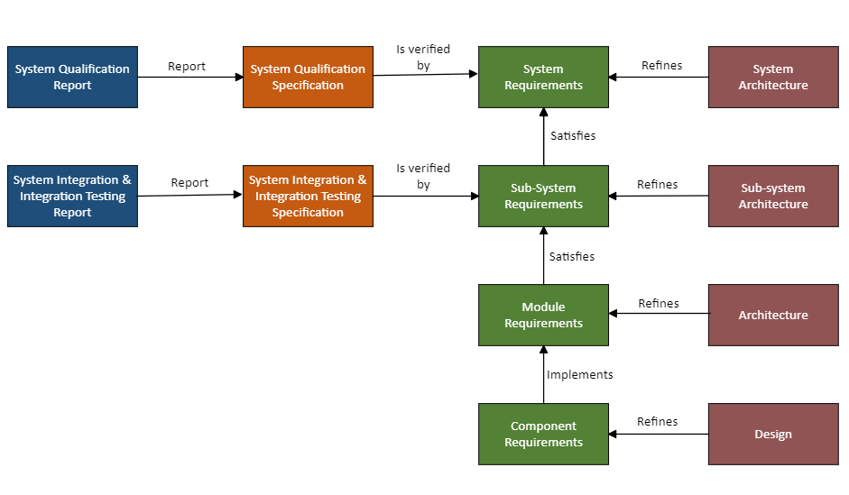
Figure 4: Requirement Linkage & Relationships

REQUIREMENT FOLDER STRUCTURE
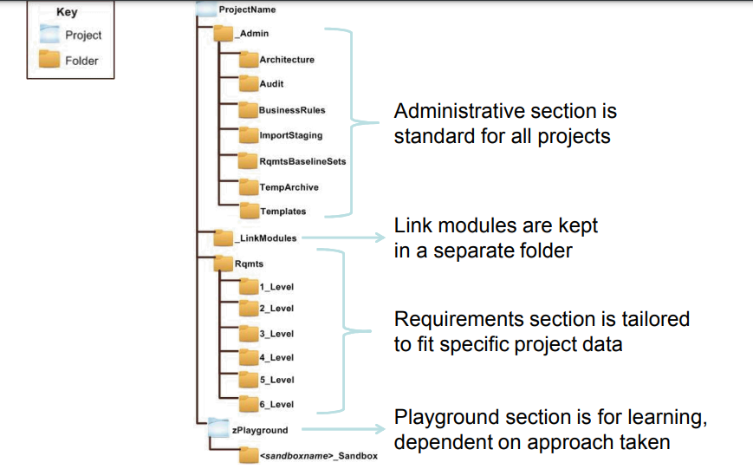
Figure 5: Requirement Folder Structure

TRACEABILITY & CONSISTENCY
Traceability refers to the existence of references or links between work products thereby further supporting coverage, impact analysis, requirements implementation status tracking etc.
In contrast, consistency addresses content and semantics.
Furthermore, bidirectional traceability has been explicitly defined between
- Test cases and test results, and
- Change requests and work products affected by these change requests.

An overview of bidirectional traceability and consistency is depicted in the following figure.

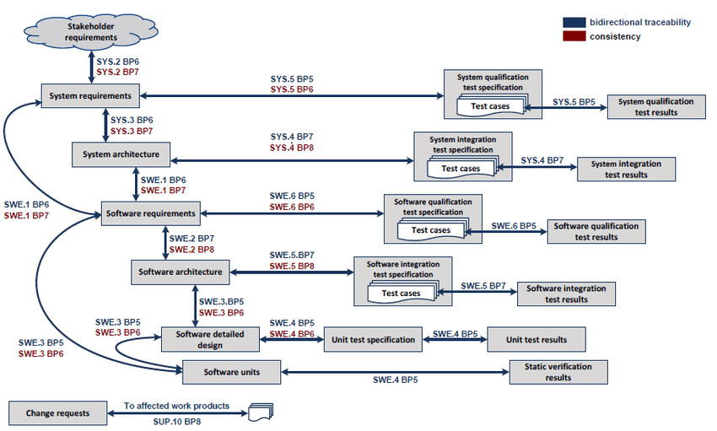
Figure 6: Traceability & Consistency
NOTE: Refer Figure 2- ASPICE 3.1 Process Reference model to understand the meaning of SYS.2, SYS.3, SWE.1, etc

For more details, follow the table below:
- System Engineering Process (SYS)
SYS.2.BP6 | Establish bidirectional traceability | Establish bidirectional traceability between stakeholder requirements and system requirements.
SYS.2.BP7 | Ensure consistency. | Ensure consistency between stakeholder requirements and system requirements.
SYS.3.BP6 | Establish bidirectional traceability | Establish bidirectional traceability between system requirements and elements of the system architectural design.
SYS.4.BP7 | Establish bidirectional traceability | Establish bidirectional traceability between elements of the system architectural design and test cases included in the system integration test specification.
SYS.4.BP8 | Ensure consistency | Ensure consistency between elements of the system architectural design and test cases included in the system integration test specification.
SYS.5.BP5 | Establish bidirectional traceability. | Establish bidirectional traceability between system requirements and test cases included in the system qualification test specification. Establish bidirectional traceability between test cases included in the system qualification test specification and system qualification test results.
SYS.5.BP6 | Ensure consistency. | Ensure consistency between system requirements and test cases included in the system qualification test specification.
Table 4: System Engineering Process
- Software Engineering Process (SWE)
SWE.1.BP6 | Establish bidirectional traceability | Establish bidirectional traceability between system requirements and software requirements. Establish bidirectional traceability between the system architecture and software requirements.
SWE.1.BP7 | Ensure consistency. | Ensure consistency between system requirements and software requirements. Ensure consistency between the system architecture and software requirements.
SWE.2.BP7 | Establish bidirectional traceability. | Establish bidirectional traceability between software requirements and elements of the software architectural design  .
SWE.2.BP8 | Ensure consistency | Ensure consistency between software requirements and the software architectural design.
SWE.3.BP5 | Establish bidirectional traceability. | Establish bidirectional traceability between software requirements and software units. Establish bidirectional traceability between the software architectural design and the software detailed design. Establish bidirectional traceability between the software detailed design and software units.
SWE.3.BP6 | Ensure consistency. | Ensure consistency between software requirements and software units. Ensure consistency between the software architectural design, the software detailed design and software units.
SWE.4.BP5 | Establish bidirectional traceability. | Establish bidirectional traceability between software units and static verification results. Establish bidirectional traceability between the software detailed design and the unit test specification. Establish bidirectional traceability between the unit test specification and unit test results.
SWE.4.BP6 | Ensure consistency. | Ensure consistency between the software detailed design and the unit test specification.
SWE.4.BP7 | Summarize and communicate results. | Summarize the unit test results and static verification results and communicate them to all affected parties.
SWE.5.BP7 | Establish bidirectional traceability. | Establish bidirectional traceability between elements of the software architectural design and test cases included in the software integration test specification. Establish bidirectional traceability between test cases included in the software integration test specification and software integration test results.
SWE.5.BP8 | Ensure consistency. | Ensure consistency between elements of the software architectural design and test cases included in the software integration test specification.
SWE.6.BP5 | Establish bidirectional traceability. | Establish bidirectional traceability between software requirements and test cases included in the software qualification test specification. Establish bidirectional traceability between test cases included in the software qualification test specification and software qualification test results.
SWE.6.BP6 | Ensure consistency. | Ensure consistency between software requirements and test cases included in the software qualification test specification.
Table 5: Software Engineering Process
- Supporting Life Cycle Process (SUP)
SUP.10.BP8 | Establish bidirectional traceability. | Establish bidirectional traceability between change requests and work products affected by the change requests. In case that the change request is initiated by a problem, establish bidirectional traceability between change requests and the corresponding problem reports.
Table 6: Supporting Life Cycle Process

REVIEW & ACCEPTANCE
This document shall be reviewed for release by all stakeholders.
Name | Email | Document Role | Project Role
TBD | TBD | TBD | TBD
… | … | … | …
Table 7: Review & Acceptance

REQUIREMENT CHANGE MANAGEMENT
Requirements change management is defined as a process “of managing changing requirements during the requirements engineering process and system development.” Having a requirements change management system and process in place is crucial since it ensures that changes are made systematically, changes are documented for, and the requirements change management document is updated. It also includes ensuring that the subsequent changes are communicated to stakeholders thus avoiding miscommunication. An overall analysis of the impact of change can be made so that change control practices can be initiated.
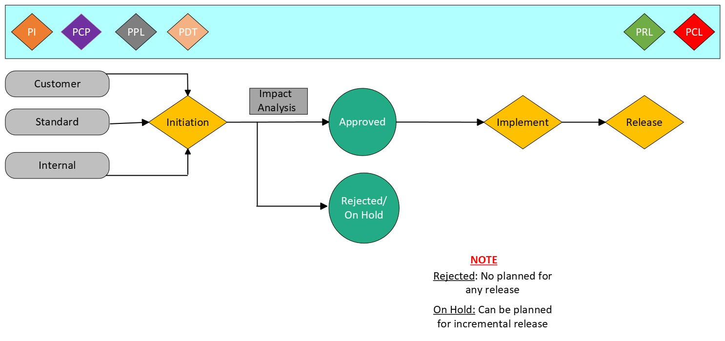Figure 7: Requirement Change Control
Requirement Change Management should follow these following points:
- Evaluate proposed change requests.
- Execute the proposed change.
- Communicate the Change.
- Validate or Seek Feedback.
- Reject or Batch.
- Implement and Integrate.
- Verify and Update.
- Review and Revise.

VERIFICATION & VALIDATION
This process involves taking the deliverables which have been internally checked in process Control Quality to see whether they meet the customer’s requirements, and then actually present them to the customer for formal acceptance. Note that these are only the interim deliverables because the final deliverables are formally accepted as part of the Close Project or Phase Process.
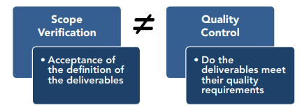
Figure 8: Verification & Validation
This differs from quality control because scope verification is concerned with the acceptance of the definition of the deliverables while quality control is concerned with whether or not the deliverables meet their quality requirements.
Scope validation confirms that the work being considered matches the details in the WBS, project scope management plan and project management plan. This is done using reviews or audits and user trials.
If a project has to be terminated early for any reason the process of scope verification is still required to determine the degree of project success. The verification report document should document what was achieved up to the point of termination because this information could establish the start point for follow up action.
Once the approval of a deliverable is formally declared, documentation should be generated to state acceptance of this fact. Sometimes confirmation of acceptance may need to be signed off by both the sponsor and customer before formal compliance is granted.
If a deliverable is not accepted then a formal document stating noncompliance should be produced instead. In other words, if the deliverables are accepted, then the project continues as before; however, if the deliverables are not accepted, then change requests are generated which will bring the deliverables in line with the customer’s requirements.
Input | Tools & Technique | Outputs
Project Management plan | Inspection | Accepted Deliverables
Requirement Documentation | Group Decision Making Techniques | Change Requests
Requirement Traceability Matrix |  | Work Performance information
Verified Deliverables |  | Project Document Updates
Work Performance Data
Table 8: Verification & Validation
The inputs, tools and techniques, and outputs of this process are summarized in the table below.
  - VALIDATE SCOPE:
Inputs There are five inputs to the Validate Scope process:

PROJECT MANAGEMENT PLAN
This set of documents includes the scope baseline consisting of the work breakdown structure and the work breakdown structure dictionary accompanied by the project scope statement. Since this is the agreement of what the project is to create, it acts as the benchmark against which the deliverable is measured.

REQUIREMENT MANAGEMENT PLAN
This key document describes the stakeholder requirements for the product, and therefore provides important information to be used when comparing what was documented with the actual product, service, or result.

REQUIREMENTS TRACEABILITY MATRIX
This identifies the source of each individual requirements and can therefore be helpful when performing the verify scope process since it provides background information on who requested the requirements and why.

VALIDATED DELIVERABLES
The process of verify scope is the activity of comparing the actual deliverables against what was documented within the scope baseline, and to ensure that all products have been delivered. Because of the nature of this process, validating deliverables may occur many times throughout a project.

WORK PERFORMANCE DATA
This can include the degree of compliance with requirements, number of nonconformities, severity of the nonconformities, or the number of validation cycles performed in a period of time.
9.2 VALIDATE SCOPE: Tools and Techniques
The tools and techniques that can be used include:

INSPECTION
Inspection includes activities such as measuring, examining, and verifying to determine whether work and deliverables meet requirements and product acceptance criteria. Inspections are sometimes called reviews, product reviews, audits, and walkthroughs. In some application areas, these different terms have narrow and specific meanings.

GROUP DECISION MAKING TECHNIQUES
These are used to reach a conclusion when the project team and other stakeholders perform the validation.
Validate Scope: Outputs
There are four outputs for the Validate Scope process
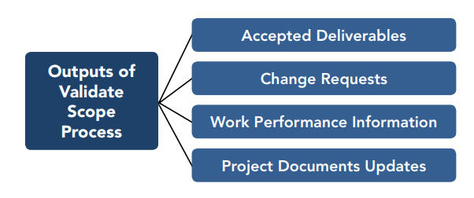
Figure 9: Validation output Diagram
1. Accepted Deliverables
This is the primary outputs of this process and is normally performed by the project manager, the customer, the sponsor, and the functional or operational managers. The product of accepted deliverables is normally a formal written acceptance by the appropriate stakeholder.
2. Change Requests
Since this process is all about verify and the scope of the actual deliverables against what was originally planned, then change requests are a normal result resulting from any such inspection, as change requests will often result from such inspection.
3. Work Performance Information
This is information about how much progress has been made towards the completion of each deliverable.
4. Project Documents Updates
As a result of verifying the project scope, there may be many updates to project documentation, in terms of schedule, budget, or scope.

DELIVERABLES
In this chapter, the deliverables of the requirements management process are defined. These deliverables are in accordance to the Automotive Master Deliverables List, where also all other deliverables (e.g. with respect to safety and project management) are stated.
The project phases are:
PI: Project Initiation
PCP: Project Concept
PPL: Project Planning
PDT: Project Development
PRL: Project Release
PCL: Project Closure
# | Deliverables | PI | PCP | PPL | PDT | PRL | PCL | Owner
1. | Requirements Set (Item) | I | A |  |  |  |  | Customer
2. | System Requirement Specification |  | I | U | A |  |  | System Engineer
3. | System Architecture Specification |  | I | U | A |  |  | System Architect
4. | Functional Safety Concept and Context |  | I | U | A |  |  | Function Safety Architect
5. | Technical Safety Concept |  |  | I | A |  |  | Function Safety Architect
6. | Module Requirement Specification (RS) |  |  | I | A |  |  | HW/SW Requirement Engineer
7. | Module Architecture Specification (AS) |  |  | I | A |  |  | HW/SW Architect
8. | Component and Elements Requirement Specification (RS) |  |  | I | A |  |  | HW/SW Requirement Engineer
9. | Component Architecture Specification (AS) |  |  | I | A |  |  | HW/SW Architect
10. | Component Test Specification (TS) |  |  | I | A |  |  | Component Verification
11. | Component Integration Test Specification (TS) |  |  | I | A |  |  | System Integration Engineer
12. | Component Test Report (TR) |  |  | I | A |  |  | Component Tester
Table 9: Deliverables

NOTE: I- Initiation, A- Approved, U-Update

List of Figures
Figure 1: V-model 6
Figure 2: ASPICE 3.1 Process Reference Model 7
Figure 3: Generic DOORSNG Structure 8
Figure 4: Requirement Linkage & Relationships 9
Figure 5: Requirement Folder Structure 10
Figure 6: Traceability & Consistency 11
Figure 7: Requirement Change Control 14
Figure 8: Verification & Validation 15
Figure 9: Validation output Diagram 17

List of Tables
Table 1: Roles & Responsibilities 6
Table 2: Module Type 8
Table 3: Artifacts type 9
Table 4: System Engineering Process 12
Table 5: Software Engineering Process 14
Table 6: Supporting Life Cycle Process 14
Table 7: Review & Acceptance 14
Table 8: Verification & Validation 16
Table 9: Deliverables 19

Abbreviation
ASIL | Automotive Safety Integrity Level
ASPICE | Automotive Software Performance Improvement & Capability dEtermination
DOORSNG | Dynamic Object Oriented Requirements System Next Generation
TBD | To be decided

