PROJECTNAME
SCOPE
MANAGEMENT
PLAN

Table of Contents
DOCUMENT INFORMATION 2
DOCUMENT HISTORY 3
ABBREVIATIONS 3
1. INTRODUCTION 3
2. SCOPE MANAGEMENT APPROACH 4
3. ROLES and RESPONSIBILITIES 5
4. SCOPE DEFINITION 5
5. PROJECT SCOPE STATEMENT 5
6. WORK BREAKDOWN STRUCTURE 6
7. SCOPE VERIFICATION 7
8. SCOPE CONTROL 7

DOCUMENT INFORMATION
 | Information
Document Id
Document Owner | Purvi Sahu
Issue Date | [Date DD/MM/YYYY]
Last Saved Date | [Date DD/MM/YYYY]
File Name | ProjectName_Scope_Management_Plan
File Location

DOCUMENT HISTORY
Version | Rev Date | Description | Prepared by | Approved by | Status

ABBREVIATIONS

INTRODUCTION
Scope Management is the collection of processes which ensure that the project includes all the work required to complete it while excluding all work which is not necessary to complete it. The Scope Management Plan details how the project scope will be defined, developed, and verified. It clearly defines who is responsible for managing the projects’ scope and acts as a guide for managing and controlling the scope. Download this free project Scope Management Plan template by clicking on the link above.
Project Scope Management follows a five-step process; Collect Requirements, Define Scope, Create WBS, Verify Scope, and Control Scope.
- Collect Requirements – this first step is the process by which we define and document the requirements needed to meet all project objectives. The foundation of this process is the project charter and stakeholder register. From these, the team can identify requirements, collectively discuss details associated with meeting each requirement, conduct interviews and follow-on discussion to clarify the requirements, and document the requirements in sufficient detail to measure them once the project begins the execution phase. This documentation also serves as an input to the next step in the process which is to define scope.
- Define Scope – this step is critical to project success as it requires the development of a detailed project/product description to include deliverables, assumptions, and constraints and establishes the framework within which project work must be performed.
- Create WBS – this process breaks project deliverables down into progressively smaller and more manageable components which, at the lowest level, are called work packages. This hierarchical structure allows for more simplicity in scheduling, costing, monitoring, and controlling the project.
- Verify Scope – this is the process by which the project team receives a formalized acceptance of all deliverables with the sponsor and/or customer.
- Control Scope – this is the process of monitoring/controlling the project/product scope as well as managing any changes in the scope baseline. Changes may be necessary to the project scope, but it is imperative they are controlled and integrated in order to prevent scope creep.

SCOPE MANAGEMENT APPROACH
It is important that the approach to managing the projects’ scope be clearly defined and documented in detail. This section of the Scope Management Plan provides a summary of the Scope Management Plan in which it addresses the following:
- Who has authority and responsibility for scope management?
- How the scope is defined (i.e., Scope Statement, WBS, WBS Dictionary, Statement of Work, etc.)
- How the scope is measured and verified (i.e., Quality Checklists, Scope Baseline, Work Performance Measurements, etc.)
- The scope change process (who initiates, who authorizes, etc.)
- Who is responsible for accepting the final project deliverable and approves acceptance of project scope?

ROLES and RESPONSIBILITIES
In order to successfully manage a projects’ scope, it’s important that all roles and responsibilities for scope management are clearly defined in the Scope Management Plan. This section of the template defines the role of the Project Manager, Project Team, Stakeholders, and other key persons who are involved in managing the scope of the project. It should state who is responsible for scope management and who is responsible for accepting the deliverables of the project as defined by the projects’ scope. Any other roles in scope management should also be stated in this section of the Scope Management Plan template.
Name | Role | Responsibilities

SCOPE DEFINITION
The scope definition section of this Scope Management Plan template details the process of developing a detailed description of the project and its deliverables. This can only be completed after the requirements have been identified and defined during the requirements definition process. During the requirements definition process three documents were created: Requirements Documentation, Requirements Management Plan, and a Requirements Traceability Matrix. You can refer to these documents when defining the projects’ scope.

PROJECT SCOPE STATEMENT
The project scope statement details the project’s deliverables and the work necessary to create these deliverables. The Project Scope Statement should contain the following components:
- Product Scope Description – describes what the project will accomplish.
- Product Acceptance Criteria – describes what requirements must be met in order for the project to be accepted as complete.
- Project Deliverables – detailed list of deliverables the project will result in
- Project Exclusions – description of work that is not included in the project and outside of the scope.
- Project Constraints – lists limits on resources for time, money, manpower, or equipment (capital)
- Project Assumptions – describes the list of assumptions the project team and stakeholders are working under to complete the project.

WORK BREAKDOWN STRUCTURE
The Work Breakdown Structure (WBS) and Work Breakdown Structure Dictionary are key elements to effective scope management and should be included in the Scope Management Plan. This section of the Scope Management Plan template discusses how the project scope is to be subdivided into smaller deliverables in the WBS and WBS Dictionary and how these smaller components are managed during the life of the project.
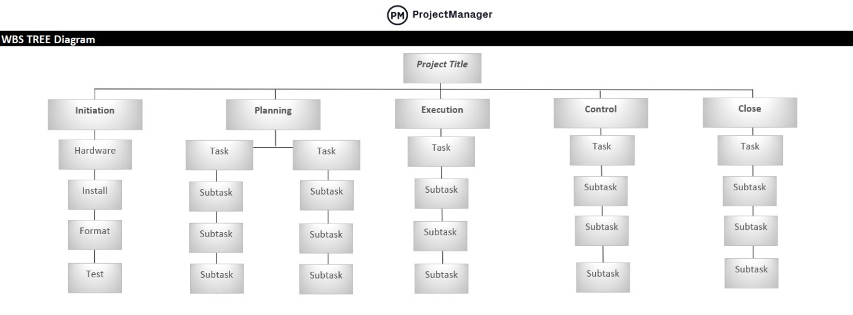
Figure 1: Work Breakdown Structure

Level | WBS Code | Element Name | Description of Work | Deliverables | Budget | Resources
Table 1:WBS Dictionary

SCOPE VERIFICATION
Scope verification discusses how the deliverables will be verified against the original scope and how the deliverables from the project will be formally accepted. The deliverables for the project should be formally accepted and signed off on by the customer throughout the lifecycle of the project and not held back as a single deliverable at the end of the project.

SCOPE CONTROL
Scope control is the process of monitoring the status of the scope of the project. This section of the Scope Management Plan template also details the change process for making changes to the scope baseline.

