ProjectName
QUALITY MANAGEMENT
PLAN

DOCUMENT INFORMATION
Information
Document Id | 1807_PROJECTNAME_QMP
Document Owner | Purvi Sahu
File Name | PROJECTNAME_Quality_Management_Plan
File Location | -

DOCUMENT CHANGE HISTORY
Version | Rev Date | Description | Prepared by | Approved by | Status
0.1 | DD/MM/YYYY | PROJECTNAME Quality Management plan first draft has been created. | Purvi Sahu | NA | Draft

Table of Contents
DOCUMENT INFORMATION 2
DOCUMENT CHANGE HISTORY 2
1. INTRODUCTION 4
1.1 Definition 4
1.2 Purpose 4
1.3 Requirements for Quality Control 4
1.4 Project Overview 4
2. CHARACTERISTICS OF QUALITY PLAN 5
3. QUALITY OBJECTIVES 5
4. REFERENCE 6
5. MANAGEMENT 6
5.1 Organization Chart 6
5.2 Tasks and Responsibilities 8
6. DOCUMENTATION 9
6.1 Quality Assessment Reports 9
6.2 Meeting Minutes 9
7. QUALITY CRITERIA 9
7.1 Quality Assurance Process 10
8. METRICS 10
9. REVIEW & ASSESSMENT 10
9.1 ASPICE Assessment 10
9.2 Assessment Approach 11
9.3 Assessment Reports 11
10. PROBLEM RESOLUTION & CORRECTIVE ACTIONS 11
11. ESCALATION Matrix 12
12. TOOLS & ENVIRONMENTS 12
13. DEFECTS MANAGEMENT 12
14. Configuration and Change Management 13
13. CONTINUOUS IMPROVEMENT 13
14. TRAINING 14

INTRODUCTION

Definition
The Quality Management Plan sets out to analyze the actions required to fulfill the project requirements such that the software meets its specifications and software quality is maintained.

Purpose
This Quality Management Plan defines the quality objectives, processes, roles, methods, tools, and metrics required to ensure that the Central Gateway Vehicle Control Unit (PROJECTNAME) project meets its quality, safety, and compliance requirements according to Automotive SPICE, ISO 26262, and OEM-specific quality standards.

1.3 Requirements for Quality Control
The basic requirements of Quality Control are to fulfill all the valid requirements of the PROJECTNAME project. It also requires planning, documentation of the project development activities, and constant supervision of designer throughout the development process. It also requires the developer to ensure that all the project activities are coordinated and completed as per schedule and reviews are made periodically.

1.4 Project Overview
Mention Project Overview.

CHARACTERISTICS OF QUALITY PLAN
- Consistent: The plan should follow the standard and guidelines set by ISO 9001:2015 standard.
• Complete: The plan should include the overall representation of the project requirements, features, documentation of the project plan. Such a plan should be developed through all the stages of the project development activity.
• Clear: The plan thus developed should be very clear to the developer and to the stakeholders regarding project requirements and other project details.
• Correct: The project details will be very clear to stakeholders regarding product delivery date of its postponement or cancellation of the product.
- Constructible: The project development plan should be such that if by chance some defects occur in the software development then it should be constructible within a short time span.
To achieve 5 C’s, it is recognized that communication between stakeholders and developers is very necessary.

QUALITY OBJECTIVES
The main objective of Quality Control Plan is to provide a mechanism by which all the plans are executed consistently without any systematic errors. It ensures that the procedures are continuously reviewed by the stakeholders. To achieve quality control, a project file document is created where feedback is given at regular intervals. Periodic review of the feedback results in appropriate changes in the development process.

• Ensure ASPICE Capability Level 2 for SYS and SWE processes
• 100% Requirements Traceability
• 95% Test Coverage
• 100% compliance to change and configuration management processes

REFERENCE
- Automotive SPICE v4.0
- ISO 26262: Functional Safety
- ISO 9001: Quality Management System
- ISO 21434: Cybersecurity Engineering
- OEM-specific guidelines
- ASPICE PAM

MANAGEMENT

Organization Chart

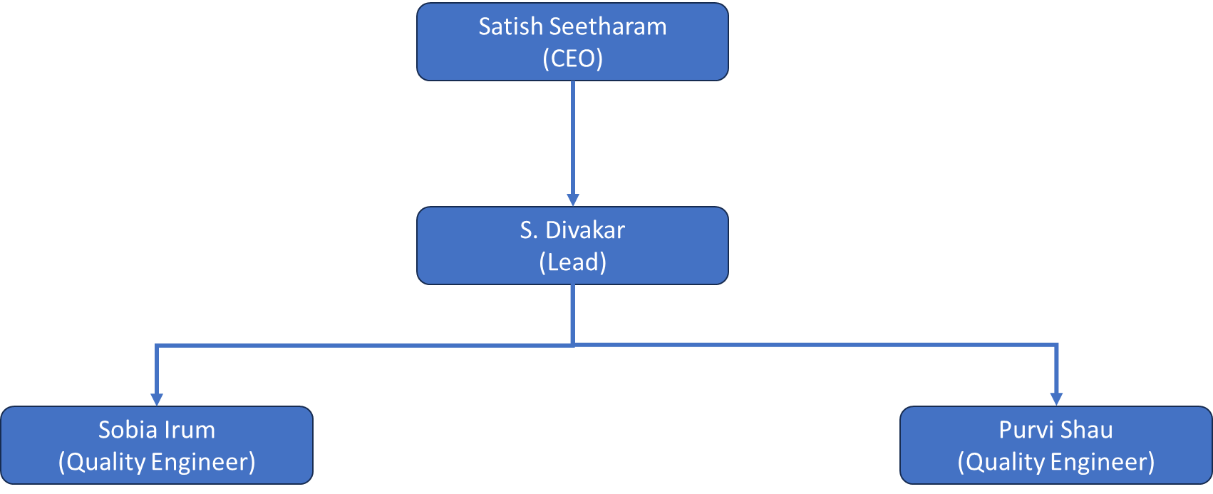

Tasks and Responsibilities
Directors-
- Overall Responsibility for formulating and communicating Quality Policy & Quality objectives.
- Formulation of Strategy for continuous up gradation of Business and Quality System.
- Ensure periodic assessment of the performance of Quality System.
- Approval of Quality System Manual.
- Budget Approval for the organization
- Overall Responsibility for Business Development & all financial issues.
- Provision of resources as required.
- Strategic decisions on developments and technical setups.

Project Manager-
- Planning and defining scope.
- Resource planning
- Time estimating
- Cost estimating
- Creating charts and schedules
- Risk analysis
- Controlling quality

Quality Engineer-
      - Developing and implementing quality standards.
      - Developing and implementing quality control systems.
      - Monitoring and analyzing quality performance.
      - Inspecting and testing, equipment, processes to ensure quality specifications are met.
      - Reviewing codes, specifications, and processes.
      - Conducting Quality Assessments.

DOCUMENTATION
The project quality management is documented by this quality plan and associated project procedures as listed together with project specific procedures and method statements that will be developed for the project.

6.1 Quality Assessment Reports
Record Name | Link
SYS.2
SYS.3
SWE.1
SWE.2
SWE.3
SWE.5
SWE.6
Cyber Security
Functional Safety

Meeting Minutes
Meeting minute documentation captures notable decisions made, issues to be tracked, and action items to be completed; as well as the owner responsible for ensuring the action items are completed in the time specified and that issues are added to the ADI (Actions Decisions and Issues) log in a timely manner.

Email can be used to capture and distribute these minutes. Meeting minutes are required, at a minimum, for the following:
• Facilitated Requirement Meetings
• Formal Project Meetings

QUALITY CRITERIA
The quality criteria include the internal process and attributes of the wok items that will be monitored throughout the project life cycle. The quality factors document the perceived aspects of the user regarding the deliverables of the project to determine if the project satisfies the expectations from customers.

7.1 Quality Assurance Process
Independent QA ensures compliance with defined processes, conducts assessments, and verifies corrective actions. Deliverables include QA reports, Defect Tracker, and monthly QA summaries.

Upload PROJECTNAME Master Tracker Link.

METRICS
This section deals with the high-level metrics that are employed during the life cycle of this project. It is vital for the success of the project that the important metrics are agreed upon upfront during the planning stage. Failure to do this will result in repetitive discussions and significant lost time while the metrics are debated, particularly in the heat of the moment, as project milestones are attempting to come to closure.
- Project Schedules will be created (in excel) and maintained on SharePoint. The Project Schedule will be updated with task status on a weekly basis. The overall percentage complete for ‘in-progress’ deliverables will be reported.

- Adherence to schedule - How close is the actual work delivered as compared to the effort expended? This is tracked based on percentage complete in the project plan. The schedules are updated weekly and available in Configuration management.

- Artifacts completed as compared to the plan. Formal artifacts are tracked in the schedules as Milestones and are tracked in an Artifact Tracking spreadsheet (upload PROJECTNAME Master Tracker link).

REVIEW & ASSESSMENT

9.1 ASPICE Assessment
The objective of the ASPICE Assessment is to evaluate and ensure the project’s process maturity and compliance with Automotive SPICE (ASPICE) framework. The assessment verifies that software and system development activities conform to ASPICE process areas, achieving the targeted capability levels and continuous improvement goals.

9.2 Assessment Approach
- Internal ASPICE Assessments will be performed by the Quality Assurance (QA) team during key project milestones (e.g., Gate Reviews, Major Releases).
- Assessments will use the Automotive SPICE PAM v4.0 and PRM as reference models.
- Evidence will be collected from project documentation, work products, and tool outputs (e.g. Polarion, EA, IQRM, etc).
- Assessment findings will be logged, categorized, and tracked to closure in the upload PROJECTNAME Master tracker link.

9.3 Assessment Reports
ASPICE Assessment Reports will be shared with the project team members and management.
Upload PROJECTNAME QA Report

PROBLEM RESOLUTION & CORRECTIVE ACTIONS
Severe deviations trigger immediate escalation, root cause analysis, and corrective action tracking. QA verifies closure and presents in quality review meetings.
Upload PROJECTNAME_OPL_Lists link
Upload Lessons Learned link

ESCALATION Matrix
To ensure timely visibility, decision-making, and corrective actions for risks, issues, or deviations impacting quality, schedule, resources, or compliance
Level | Escalated To | When to Escalate
Level 1 – Team Level | Team Leads, Quality Lead, Developers/ Testers | Minor deviations, expected to be resolved within the team; first detection of risks
Level 2 – Project Management Level | Project Manager, Scrum Master, QA Lead | Risks impacting milestones, repeated deviations, resource constraints
Level 3 – Executive / Customer Level | Business Unit Head, Customer SPOCs | Major quality gaps, milestone slippage, customer expectations at risk, Critical issues impacting delivery

TOOLS & ENVIRONMENTS
Requirements – Polarion
Architecture – Enterprise Architect
Configuration – Git
Change & Defect – Polarion, Excel
Testing – VectorCAST, CANoe, dSPACE
Functional safety – IQRM
Quality Assessment Reports – MS Word

DEFECTS MANAGEMENT
Issue Creation Process:
1. Defect Identification
- Any deviation from the expected process observed during quality audit is treated as an issue/defect.
- Quality auditors are responsible for raising issues immediately after they are identified.
2. Issue Logging
- Issues will be logged in the defect tracking in the Polarion tool
- Mandatory fields to be filled:
    - Title
    - Description (with clear steps to reproduce)
    - Severity
    - Assignees
    - Status
    - Modules
    - Milestone
    - Attachments (Root cause analysis file)
    - RCA
3. Issue Classification
- Severity Levels: Blocker, Critical, Normal, Major, Minor, Trivial
4. Issue Assignment
- Once logged, the issue will be assigned to the respective team for resolution.
- The QA Lead will review and validate proper categorization.
5. Issue Resolution Workflow
- Open → Accepted → In Progress → Retest → Closed
6. Issue Tracking & Reporting
- Every Release status report on open, closed, and deferred issues.

Configuration and Change Management
Maintain controlled baselines and track change requests through approved tools such as Polarion.

13. CONTINUOUS IMPROVEMENT
Lessons Learned Workshops, Process Improvement Backlogs, and integration into Process Asset Library for future enhancements.

14. TRAINING
Training is a fundamental component of the Quality Assurance plan. As roles and responsibilities are identified over the course of the project, technical and process standard training will be provided for all the resources associated with the project.

