PROJECT
CONFIGURATION MANAGEMENT
PLAN

DOCUMENT INFORMATION
Information
Document Id | 0804_ProjectName_SCM
Document Owner | Purvi Sahu
Issue Date | [Date DD/MM/YYYY]
Last Saved Date | [Date DD/MM/YYYY]
File Name | ProjectName_Configuration_Management_Plan
File Location | -

DOCUMENT CHANGE HISTORY
Version | Rev Date | Description | Prepared by | Approved by | Status

Table of Contents

DOCUMENT INFORMATION 2
DOCUMENT CHANGE HISTORY 2
ABBREVIATIONS 4
1. PURPOSE 5
2. SCOPE 5
3. CONFIGURATION IDENTIFICATION 6
4. CONFIGURATION ITEM STORAGE and CONTROL 6
4.1 ROLES & RESPONSIBILITIES 7
4.2 CM PROJECT COMMUNICATION 11
4.3 CONFIGURATION SETUP 11
5. CONFIGURATION MANAGEMENT 12
5.1 STRATEGY 12
5.2 CONFIGURATION MANAGEMENT STRUCTURE 13
5.3 VERSION CONTROL 13
6. SOFTWARE & HARDWARE ENVIRONMENT 14
6.1 TOOLS 14
7. CHANGE CONTROL PROCEDURES 14
7.1 CHANGE CONTROL BOARD (CCB) 14
7.2 CHANGE REQUEST TYPE 15
8. CHANGE REQUEST SEVERITY & PRIORITY 17
8.1 CHANGE REQUEST STATE TRANSITION 18
9. CONFIGURATION STATUS ACCOUNTING (CSA) 18
9.1 CONFIGURATION AUDITS 18
9.1.1 Functional Configuration Audit (FCA) 18
9.1.2 Physical Configuration Audit (PCA) 18
9.2 CONFIGURATION STATUS ACCOUNTING REPORT (CSAR) 19
10. BACK-UP, ARCHIVING and DISASTER RECOVERY 19
11. CONFIGURATION MANAGEMENT TRAINING 19
12. ADDITIONAL INFORMATION 20
12.1 LIST OF FIGURES 20
12.2 LIST OF TABLES 20

ABBREVIATIONS
ABL | Allocated Baseline
BOM | Bill of Material
CCB | Change Control Board
CI | Configuration Item
CM | Configuration Management
CSA | Configuration Status Accounting
CSAR | Configuration Status Accounting Report
ECP | Engineering Change Proposal
FBL | Functional Baseline
FCA | Functional Configuration Audit
PBL | Product Baseline
PCA | Physical Configuration Audit
PCL | Project Closure
PCP | Project Concept
PDT | Project development
PI | Project Initiation
PM | Project Management
PPL | Project Planning
PRL | Project Release
RQ | Requirement
SEC | Security
SFT | Safety
SW | Software
SYS | System
TBD | To Be Discussed
TS | Testing

PURPOSE
The Configuration Management (CM) is a methodology which provides a technical and administrative framework for managing the development, manufacturing, and maintenance of Configuration Items. CM is an integral part of the product life-cycle management. Activity for establishing and maintaining consistent record of the performance parameters of a product and its functional and physical characteristics compared to the product design.
This discipline is applicable to hardware, software, processed materials, services, and related technical documentation throughout the entire lifecycle of the product (i.e., development, production, deployment, maintenance, and disposal).
The CM plan identifies following topics:
- Organisation, Roles, and Responsibilities
- Identifies document management rules.
- Structure of CM database
- Activity Owners
- Access Control
- Retention Process
- Baseline/Release flows
- Change Management rule for Configuration item.
- Describes notification of changes

SCOPE
The CM Plan applies to the entire PROJECT (Project Name), including all Configurable Items identified in the Product Breakdown Structure.
CM applies to the entire life of the product and shall maintain conformance between the design domain of the observatory.
CM activities include CM planning, configuration identification, change control, configuration status accounting, and configuration auditing.

CONFIGURATION IDENTIFICATION
For each configuration item you need to know at any time the technical description of the item and the identification should be changed when the technical characteristics are changed and when the two items are not interchangeable. Every item which is defined as a Configuration Item (CI) must be marked as agreed.

CONFIGURATION ITEM STORAGE and CONTROL
All configuration items are stored in one of the IAST approved configuration management system (SharePoint, GitHub and JIRA).

Minimum set of work products items that need to be managed by the configuration management process are defined by IAST Deliverables found here against 6 different Quality Gates where PI: Project Initiation, PCP: Project Concept, PPL: Project Planning, PDT: Project Development, PRL: Project Release, PCL: Project Closure

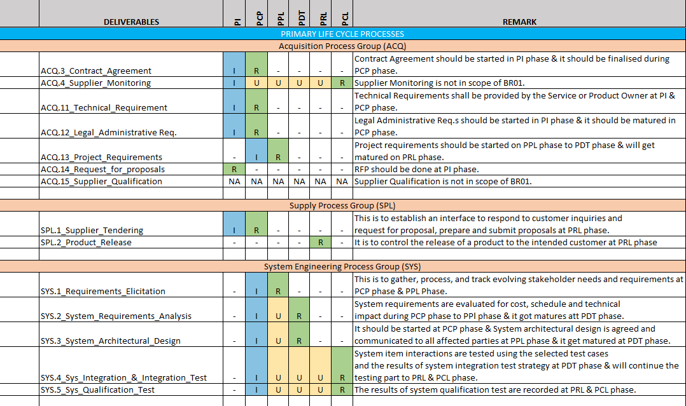
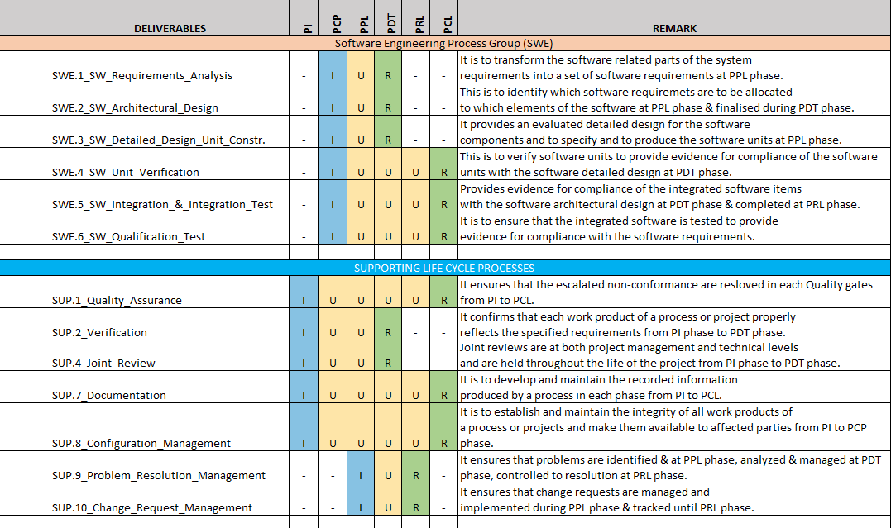
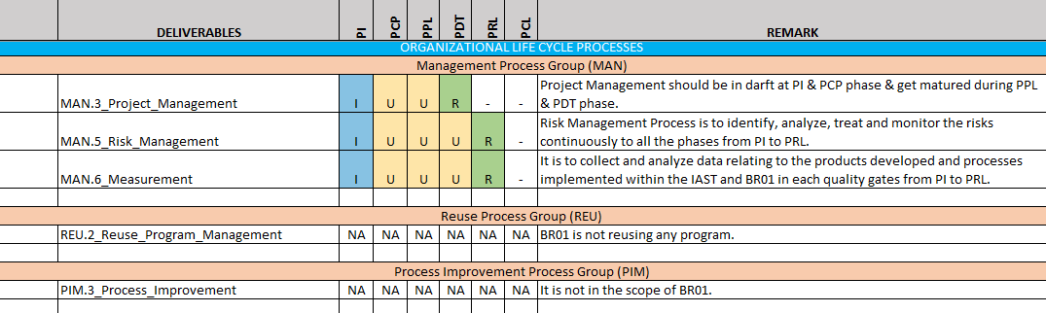Table 1: IAST Deliverables

4.1 ROLES & RESPONSIBILITIES
- Owner Description
- Functional areas
- Baseline/Release flows

There are owners for each & every role designated to all the functional areas.
Roles & responsibilities resides with designated owner of functional areas act as Configuration Manager. Owners are responsible for creating Baselines/Release flows and Bill of Material for each major quality gates and ensures deliverables.
Roles: This is to define who needs to be aware of and informed about the project, how and how often information will be distributed, and who will be responsible for the distribution.
Responsibilities: Specifies the different tasks of the person.
The project manager will assume overall responsibility for requirements management. The people listed below will assume the following requirements management responsibilities:

Role | Name | Responsibilities
Project Manager |  | - Plan and Develop the Project Idea. Every project starts as an idea.  - Monitor Project Progress and Set Deadlines.  - Ensure Stakeholder Satisfaction.  - Motivating the team to achieve organizational goals.  - Developing and implementing a timeline to achieve targets.  - Delegating tasks to team members.  - Conducting training of team members to maximize their potential.  - Providing expertise.  - Working with users to establish and meet business needs.
Project Sponsor |  | - Aligning the project with business goals, strategy, and objectives.  - Ensuring the project's proper launch and execution.  - Managing risks and changes while ensuring the project's quality.
Project Lead Architect (Technical) |  | - Motivating the team to achieve technical & quality goals.  - Developing and implementing a timeline to achieve targets.  - Delegating tasks to team members.  - Conducting training of team members to maximize their potential.  - Analyse documents, coordinate and manage requirements regarding project aimed at optimizing operational efficiency.
Business Analyst |  | - Creating a detailed business analysis, outlining problems, opportunities and solutions for a business.  - Budgeting and forecasting.  - Planning and monitoring.  - Variance analysis.  - Pricing.  - Reporting.  - Defining business requirements and reporting them back to stakeholders.
Expertise Support (Safety) |  | - Planning and coordination of the functional safety activities.  - Collaborate with project manager, development team, suppliers, and customers on Functional Safety.  - Lead development teams for safety analysis completion.  - Coaching the development team in the functional safety development processes and methods.  - Understanding all aspects of the technology, the architecture, and the function of the product, to define a safety concept and context.  - Participate in Safety Audits and Assessments.
System Team Lead |  | - Proactively ensure the highest levels of systems and infrastructure availability.  - Participate in the design of information and operational support systems.  - Maintain security, backup and redundancy strategies.  - Recommend and implement changes to the overall systems through the change management process.
Quality Engineer |  | - Determining quality metrics for all manufacturing procedures.  - Monitor the entire production cycle and perform regular tests to identify potential malfunctions as early as possible.  - Auditing systems based on ISO 9001:2015 requirements.  - Work with internal teams to increase customer satisfaction by improving the quality of the products.
Application Software Team Lead |  | - Create coding standards and manage SDLC processes for team continuity.  - Supervise the development team members in pair programming, code reviews, and good development principle promotions.  - Ensure effective communication between the team members and the other IT functions.
Base Software Team Lead |  | - Manages a team through the entire process of software development.  - Analyse the project, identify errors, and conduct troubleshooting.  - Ensure that all deadlines are met, and that work is conducted efficiently.
Software Integration Lead |  | - Responsible for the design, development, and operation of application interfaces, data flows, and APIs, utilizing both vendors delivered services and internal API management tools.  - Evaluate existing components and systems to determine integration requirements.  - Manage the integration, analysis and assessment of plans and strategies across the project.
Expertise Support  (System V&V) |  | - Participates in the definition of the validation test strategy, in accordance with sub-system requirement, system architecture.  - Specifies, designs and develops validation environment & tools.  - Establishes validation procedures (test sheets) / criteria and elaborates the work products.
Table 2: Roles & Responsibilities

4.2 CM PROJECT COMMUNICATION
If any changes or release occurs in the project IAST rely on tool that notifies to project team members. Project team members shall be able to subscribe configuration item to get notified.

4.3 CONFIGURATION SETUP
All the configuration items store under approved Configuration Management. IAST approved Configuration Management tools are GitHub, DOORS:NG and SharePoint, MATLAB, Rhapsody.

5. CONFIGURATION MANAGEMENT

5.1 STRATEGY
All the functional areas must have baseline for major quality gates.
The Configuration Management strategy consists of a combination of GitHub, Jira and approved Configuration Management Systems. GitHub is also used to create baselines at quality phase gates.
The following table represents Bill of Material corresponding to each of the tracked functional areas in which required baselines are made, where PI: Project Initiation, PCP: Project Concept, PPL: Project Planning, PDT: Project Development, PRL: Project Release, PCL: Project Closure
Required baselines are marked with an “x” in the table.
Each functional areas must have baselines for major quality gates.
Function Areas |  | PI | PCP | PPL | PDT | PRL | PCL
Requirements |  | x | x | x | x
System |  | x | x | x | x |  | NA
Software
 | BSW |  |  | x | x
 | ASW | NA | x | x | x
Testing
 | SW Unit Testing | NA | NA | NA | x | x | NA
 | SW Integration Testing |  |  |  | x | x
 | SW Qualification Testing |  |  |  | x | x
Safety |  | x | x | x | x | x
Security |  | - | - | - | - | - | -
Table 3: Bill of Material

5.2 CONFIGURATION MANAGEMENT STRUCTURE
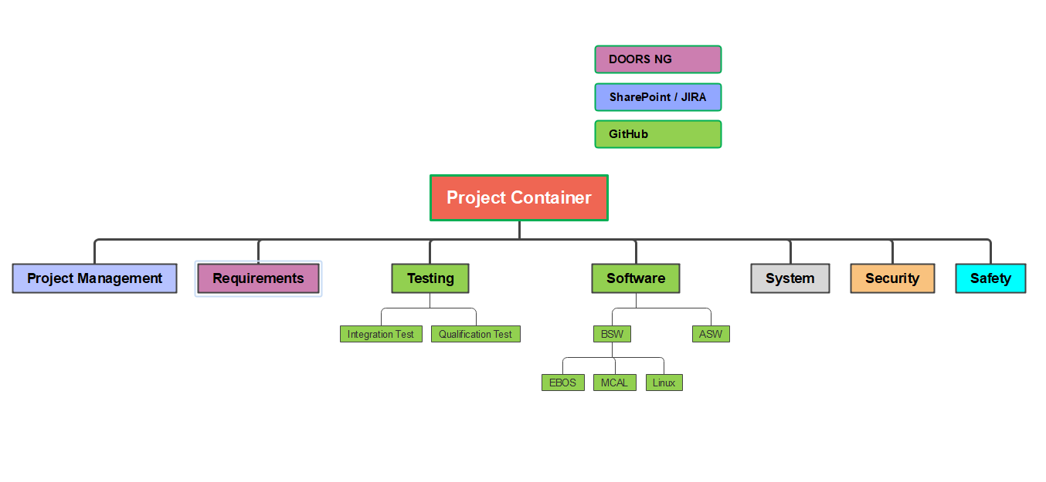Figure 1: CM Structure
Note: Security is not considered in current development plan.

BOM Items | Description
X_PM_Y_Z | Bill Of Material for Project Management
X_RQ_Y_Z | Bill Of Material for Requirements
X_TS_Y_Z | Bill Of Material for Testing
X_SW_Y_Z | Bill Of Material for Software
X_SYS_Y_Z | Bill Of Material for System
X_SEC_Y_Z | Bill Of Material for Cyber Security
X_SFT_Y_Z | Bill Of Material for Safety
Where X=Project Name, Y=Quality gate, Z=Version number
Ex: PROJECT_Software_PDL_1.0

5.3 VERSION CONTROL
When Major changes are released then the document version will be incremented by 1.
When Minor changes are released then the document version will be incremented by 0.1

6. SOFTWARE & HARDWARE ENVIRONMENT

6.1 TOOLS
GITHUB: Git is a free and open-source distributed version control system designed to handle everything from small to very large projects with speed and efficiency.
All configuration changes must flow through a git repository, centrally managed through GitHub.

SharePoint: Microsoft SharePoint is a web-based application used for document sharing, business intelligence, advanced search, content collaboration.

It is used as a secure place to store, organize, share, and access information from any device.

JIRA: Jira Software is an agile project management tool that supports any agile methodology, be it scrum, kanban, or your own unique flavor.

It is used for issue and backlog tracking, release planning, Continuous Integration & Continuous Deployment (CI/CD) and developer tools integrations, etc.

MathWorks (MATLAB-Simulink & its module): The MathWorks MATLAB is a system for technical computing that consists of a programming language and an environment for numerical computing.

It is used to analyze data, develop algorithms, and create models.

TBD: Add more tools based on project need.

7. CHANGE CONTROL PROCEDURES

7.1 CHANGE CONTROL BOARD (CCB)
Configuration Control Board (CCB) is a group of technical and administrative experts with the assigned authority and responsibility to make decisions on the configuration and its management. All proposed changes should be reviewed by the CCB to evaluate the change against the criteria and/or include as an alternate, not making the change.
In addition, it should evaluate all aspects of the change to include design, performance, cost, schedule, operational effectiveness, and logistics considerations.
To maintain robotized platform control, no change may be implemented without an approved change order or approved deviation/waiver request. The Configuration Manager and the CCB members are responsible for the change control process.
Configuration control is applied to established baselines, identifications and released engineering data. Configuration control system should be established to provide for screening, classification and processes changes that provide fully coordinated, approved change packages.
Configuration control should be applied to established baselines, identifications and released engineering data.
Configuration control should be implemented in stages corresponding to the project life cycle. Before reviews and establishment of baselines, control may be maintained manually by the development engineer or by use of automated tools as they are developed.
Upon freezing of the Bill of Material (BoM) and the order to procure components, changes should be controlled by CCB.

7.2 CHANGE REQUEST TYPE
1. Changing the robotized platform Structure (Bill of Materials)
2. Changing the Part Itself
3. Changing the Routing
4. Changing the Process
5. Changing the process sequence
6. Changing the Design

The Engineering process have three main milestones to start an engineering change control process:
1. Functional Baseline (FBL)
As part of the FBL, the following engineering documents are released.
- System Specification
- System Requirements
- System Interface Definition/Specification
Following the SDR & SRR, these documents are frozen.
2. Allocated Baseline (ABL)
As part of the ABL, the following engineering documents are released.
- Sub-Systems Specifications
- Sub-Systems Interface Specifications
Following the PDR, these documents are frozen.
3. Product Baseline (PBL)
As part of the PBL, all engineering documents are released.
Following the CDR, these documents are frozen.
After all engineering documents are released & frozen (per the Baselines), changes need to be done due to the following items:
- Design
- Performance
- Reliability
- Safety
- As results of operation, maintenance
- Change or new configurations (marketing)
- As a result of a failure requiring Engineering Change
The Engineering Change Proposal (ECP) should present the following data:
- General Data
- Argument for change
- Impact of change
- Change Cost
- Change Validity
- Change Priority
- Consolidating Change Order (Consolidating ECO)

8. CHANGE REQUEST SEVERITY & PRIORITY
The Change Control Process is performed by a Change Control Board (CCB).
Engineering, Purchasing, Customer, Subcontractors are permitted to ask CCB to handle any change request.
The Change Control Process includes two types of changes:
- Major Change (Class 1 change)
  - Minor Change (Class 2 change)
Major Change is defined as a change in at least one of the following parameters (FFFFLS): F- Form (What does it look like) F- Fit (How does its interface) F- Function (What does it do) F- Fee/Cost (What should we charge for it) L- Logistics S- Safety
- Major change requires new Function ID.
- Major change needs customer’s approval.
- Any other change is a Minor Change with no necessity to change the part number.

8.1 CHANGE REQUEST STATE TRANSITION
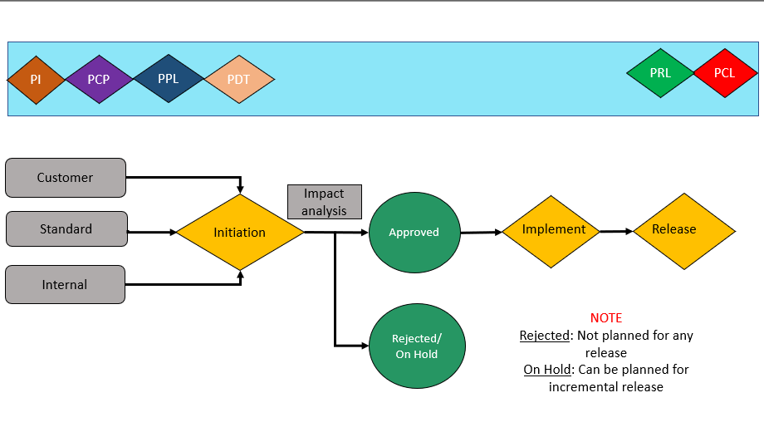Figure 2: Change Control Transition

9. CONFIGURATION STATUS ACCOUNTING (CSA)
A formal process of recording and reporting of feature configuration information, the status of proposed changes and the implementation status of approved changes.

9.1 CONFIGURATION AUDITS
Performed before the acceptance of a configuration baseline to assure the product complies with its specified requirements and to assure the product is accurately reflected by its configuration documents.

9.1.1 Functional Configuration Audit (FCA)
A formal examination of functional characteristics of a configuration item (final product), to verify that the item has achieved the performance specified in its configuration identification.

9.1.2 Physical Configuration Audit (PCA)
A formal examination of the "as-built" configuration of a product or a Configuration Item (CI) against its technical documentation, to establish conformance between the product and its current configuration identification.

9.2 CONFIGURATION STATUS ACCOUNTING REPORT (CSAR)
The configuration manager maintains CSAR for the purposes of internal control to assure compatibility of the product and its documentation and producing the status accounting reports necessary for configuration visibility and traceability.
Feed-back from the “As Planned/As Built Report” provides confirmation of the implementation of changes, deviations, etc.

10. BACK-UP, ARCHIVING and DISASTER RECOVERY
All project data is baselined in the target CM system. All data is located by information in the database. Back-up, Archiving and disaster recovery management of CM database are defined and perform by IAST and Customer IT department.

11. CONFIGURATION MANAGEMENT TRAINING
Pertinent training and associated links can be found in the Reference section of this document.

12. ADDITIONAL INFORMATION

12.1 LIST OF FIGURES
Figure 1: CM Structure 13
Figure 2: Change Control Transition 18

12.2 LIST OF TABLES
Table 1: IAST Deliverables 7
Table 2: Roles & Responsibilities 11
Table 3: Bill of Material 12

