PROJECTNAME
REQUIREMENT MANAGEMENT
PLAN

DOCUMENT INFORMATION
 | Information
Document Id | [Document Management System #]
Document Owner | [Owner Name]
Issue Date | [Date DD/MM/YYYY]
File Name | Requirement_Management_Plan
File Location

DOCUMENT HISTORY
Version | Rev Date | Description | Prepared by | Approved by | Status
 |  |  |  |  | Choose an item.

DOCUMENT APPROVALS
This document shall be approved by the following mandatory stakeholders:
Role | Name | Date  (DD/MM/YYYY)
Project Team Lead
Requirement Manager
Project Manager
Quality Manager
(if applicable)

Table of Contents
DOCUMENT INFORMATION 2
DOCUMENT HISTORY 2
DOCUMENT APPROVALS 2
1. INTRODUCTION 4
1.1 PROJECT OVERVIEW 4
2. DOCUMENTS DEFINITION and SHARING 5
2.1 STORAGE OF REQUIREMENT DOCUMENTS 5
2.2 DOCUMENT LANDSCAPE – PROJECT OVERVIEW 5
2.3 REUSE OF CORE REQUIREMENTS 6
2.4 TRACEABILITY STRATEGY 6
3. REQUIREMENTS MANAGEMENT PROCESS 7
3.1 LEVEL-1 INPUT DOCUMENTS 7
3.1.1 HANDLING OF LEGAL DOCUMENTS 7
3.1.2 PROJECT INTERNAL STAKEHOLDER REQUIREMENTS 8
3.1.3 DOCUMENT STATE 8
3.1.5 CRS REQUIREMENT ACCEPTANCE 9
3.1.6 CRS REQUIREMENT LIFECYCLE 9
3.1.7 ITEM FIELDS FOR CUSTOMER REQUIREMENTS 9
3.1.8 ACCEPTANCE STARTEGY 11
3.2 LEVEL 2 – REQUIREMENT DOCUMENTS 11
3.2.1 LEVEL 2 – SYSTEM LEVEL REQUIREMENTS (SYS.2) 11
3.2.2 LEVEL 3 – DISCIPLINE LEVEL REQUIREMENTS/SOFTWARE REQUIREMENT SPECIFICATION (SRS) 14
3.3 REQUIREMENT EXCHANGE 15
3.4 BASELINE 15
3.5 REVIEW PROCESS 16
3.5.1 Review Checklist 17
3.5.2 Types of Reviews 18
3.6 DEFECTS ON LEVEL 2/LEVEL 3 REQUIREMENTS 19
4. REQUIREMENTS DEVELOPMENT 19
5. STATUS and REPORTING of REQUIREMENTS 19
TEMPLATE HISTORY 19

INTRODUCTION

1.1 PROJECT OVERVIEW
Mention scope and overview of the project.

DOCUMENTS DEFINITION and SHARING

STORAGE OF REQUIREMENT DOCUMENTS
Mention Requirement Document Files sent by customer.

DOCUMENT LANDSCAPE – PROJECT OVERVIEW
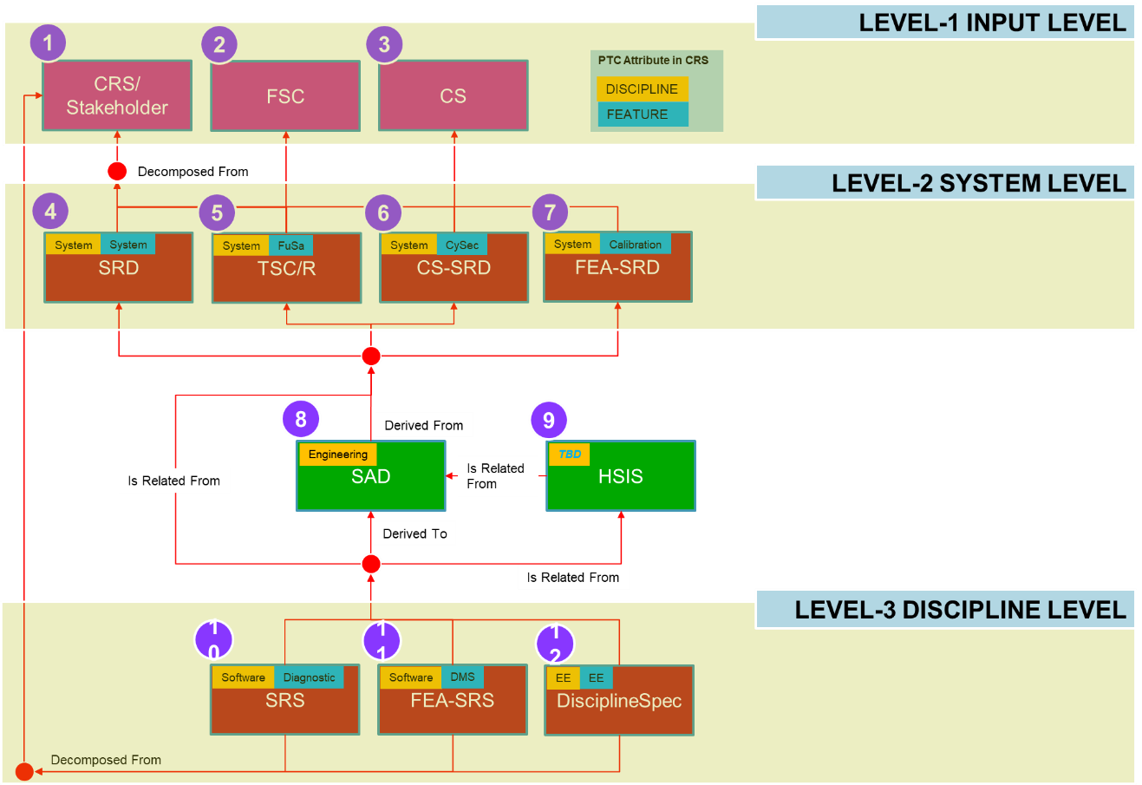

Doc | Description
1 | Customer requirement documents or other stakeholder input requirements documents
2 | Input requirements document for Functional Safety
3 | Input requirements document for Cyber Security
4 | Main System Requirement Document. Topics: refer Chapter “Main SRD List of Feature”
5 | Technical Safety Requirements Document. Document contains Technical Safety Concept.
6 | Cyber Security System Requirements Document
7 | Feature System Requirement Document
8 | System Architecture Document Specification
9 | Hardware Software Interface Specification
10 | Software Requirements Specification
11 | Feature Software Requirements Specification
12 | Discipline Requirements Specification (Electrical ERS, Mechanical MRS, Optical ORS)

REUSE OF CORE REQUIREMENTS
All the requirements reuse from other projects shall be documented.
NOTE: Give reference to baseline requirement which are reused.

2.4 TRACEABILITY STRATEGY
Mention the strategy, the team will be going to follow for establishing traceability.

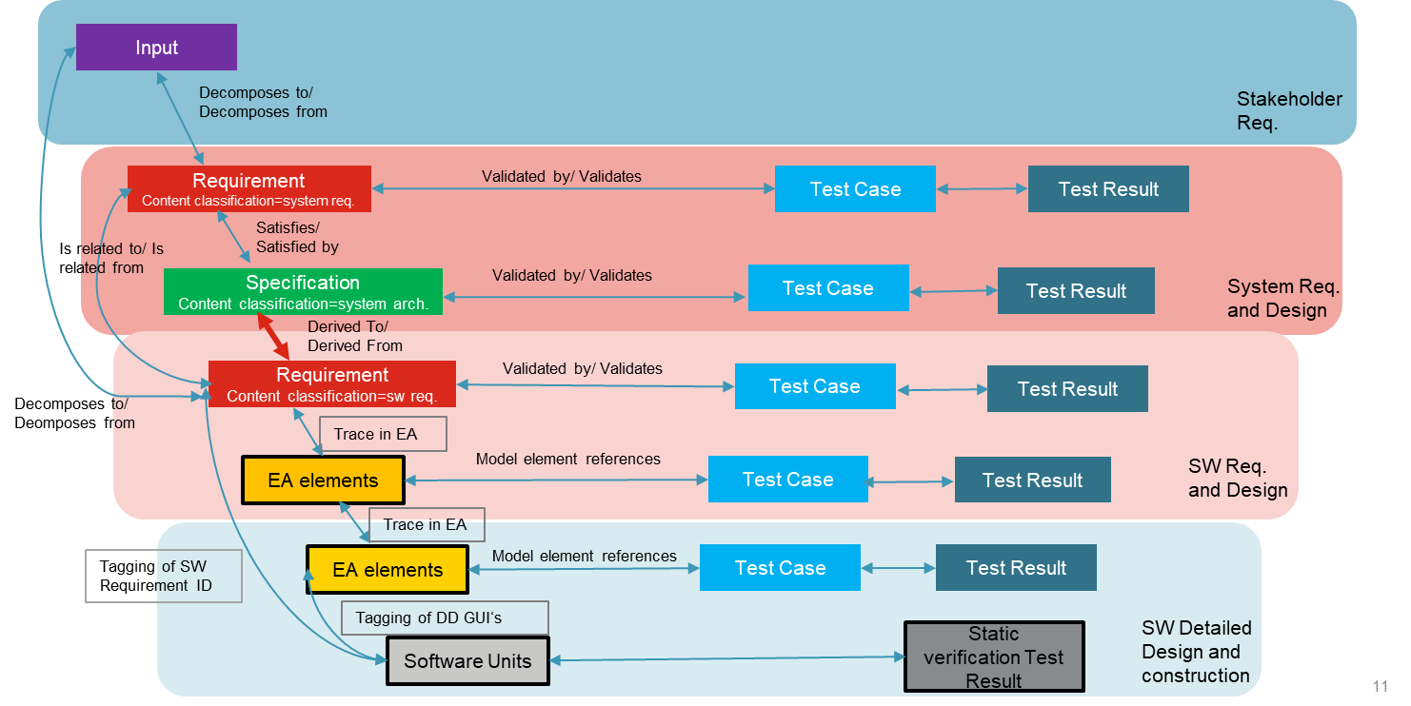

REQUIREMENTS MANAGEMENT PROCESS

LEVEL-1 INPUT DOCUMENTS
CUSTOMER REQUIREMENTS (SYS.1)
Generally, the most important source for the system requirements are the customer requirements. These can be available as one document (e.g. Word, PDF etc.) or as several documents exported from an RM tool such as Polarion, IBM Doors or PTC Integrity (e.g. as ReqIF files).

It is mandatory to import these documents into the RM tool, so that all editing, commenting, and evaluation carried out on them is irrevocably documented and recorded, and so that traceability is possible.

It is recommended to respective responsible person(s) (Requirements Engineer, FO Application, FO SW, HW Engineer, Test Engineer, etc.) to request ReqIF Files from the customer.

HANDLING OF LEGAL DOCUMENTS
All legal and regulation requirements based on the customer requirements will be identified.

After the requirements are identified the appropriate legal and regulation documents name will be allocated to the requirements confirmed by the technical responsible person (FO Application, FO SW, HW Engineer).

PROJECT INTERNAL STAKEHOLDER REQUIREMENTS
System requirements which specify functionalities that have no traceable link to customer requirements must be approved by the customer.
This means, all level 2 and level 3 requirements shall be linked upstream to an Input/Level 1 and shall be approved by customer.
All assumptions must be specified as requirements and agreed with the customer.

DOCUMENT STATE
Mention the different states of the document which is supposed to be maintained throughout the project lifecycle.
Document State | Definition | Responsibility
Draft | Document is active | Document/ Module Owner
In Review | Document in review | Document/ Module Owner
Approved | Document is approved after by expert reviewer | Document/ Module Owner
Released | Document is released after Quality team’s approval | Document/ Module Owner

3.1.4.1 HOW TO CHANGE DOCUMENT STATE

Provide the snip for changing the document sate in the requirement tool.
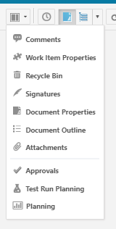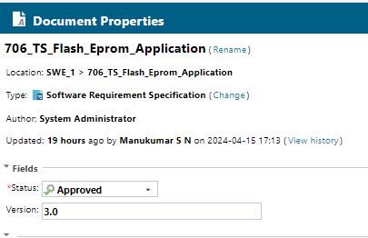

3.1.5 CRS REQUIREMENT ACCEPTANCE
Mention the criteria for accepting & rejecting the CRS requirements.

3.1.6 CRS REQUIREMENT LIFECYCLE

3.1.7 ITEM FIELDS FOR CUSTOMER REQUIREMENTS
This section can be project specific.

3.1.7.1 PROJECT
Mention Project ID as ProjectName_CustomerName_DDMMYYYY(Kick-offDate)

3.1.7.2 TYPE
Item type is given according to the document type, in which the item is created. For CRS, Type is Input.

3.1.7.3 ID
Mention unique identifier for the item.

3.1.7.4 EXCERPT ID
Mention Customer ID, optional provided by customer.

3.1.7.5 CATEGORY
Defines the category of the item. It is defined by customer and is usually set during import of the customer document.
Value | Description
Heading
Comment
Imported Requirement

3.1.7.6 TEXT
Contains either customer requirement text, or the heading, tables, figures or images or any comment as rich text.

3.1.7.7 DISCIPLINE
Each requirement must have at least one discipline allocated.
Discipline |  | Description | Feature assignment needed
Program Management | PM | This requirement will not be decomposed any further. This requirement needs to be considered on a (program) management level, but not on a product level.  This requirement will not be decomposed any further. | NO
Technical Project Lead | TPL | This requirement will not be decomposed any further. This requirement needs to be considered by Technical Project Lead (TPL) from technical project execution aspects.  This requirement will not be decomposed any further. | NO
System | SYS | Decomposition on System level necessary. | YES
Mechanic | ME | Requirements for mechanical topics.  Direct decomposition to Mechanic Requirement decomposition allowed. | YES
Electrical | EE | Requirements for electrical engineering. Direct decomposition to Hardware Requirement allowed. | YES
Software | SW | Direct decomposition on Software level necessary. | YES
Configuration Management | CM | This requirement will not be decomposed any further.  Requirements for Configuration Management related topics. | NO
Verification | VER | Requirement for Testing group(s).  Discipline Verification shall still be used regarding topics related to test management/process.  This requirement will not be decomposed any further. | NO
Validation | VAL | Requirement for Testing group(s). Direct decomposition to Validation Requirement allowed. | YES
Tools | TOOLS | Requirement for Tooling group(s). Used during RFQ phase to address Tooling group(s).  This requirement will not be decomposed any further. | OPTIONAL
Quality | QUAL | Requirements for Quality related topics (development as well as for Production).  Requirement for Quality group(s). | YES
Requirement | REQ | Used to address requirement team during RFQ phase. This requirement will not be decomposed any further. | NO

3.1.7.8 FEATURE
Defines the feature affected by the requirement or area of disciplines.

3.1.7.9 ADDITIONAL COMMENT
The allocated discipline(s) shall comment during the Quote Phase the acceptance of the requirement. This internal comment is not exchanged with the customer.
Acceptance Status | Description
ACCEPTED
PARTIALLY ACCEPTED
TO CHECK WITH
IN REVIEW
DECLINED

3.1.7.10 SAFETY
This attribute is used to show the safety ASIL Level of the customer requirement. The value in this attribute is set and provided by the customer.

3.1.7.11 CYBER SECURITY
This attribute is used to show the Security Level of the customer requirement. The value in this attribute is set and provided by the customer.

3.1.8 ACCEPTANCE STARTEGY
Mention acceptance strategy as defined by System Lead on team level.

LEVEL 2 – REQUIREMENT DOCUMENTS
Only Requirement Team shall create Requirement documents. If discipline needs a requirement document, they shall request Requirement team to create the document.

3.2.1 LEVEL 2 – SYSTEM LEVEL REQUIREMENTS (SYS.2)
Mention all the system level requirements.

3.2.1.1 CRITERIA TO DECIDE SYSTEM LEVEL REQUIREMENTS
Mention topic for main system requirement documents & criteria for identifying the customer requirements that need to be decomposed in the main system SRD.

3.2.1.2 MAIN SRD LIST OF FEATURES
Mention System Requirement Document list.

3.2.1.3 LINK TO SYSTEM ARCHITECTURE DOCUMENT
System Architecture shall write a specification in System Architecture Document (SAD) & linking shall be established properly.

3.2.1.4 ATTRIBUTES/ ITEM FIELDS FOR SYSTEM REQUIREMENT DOCUMENT
Mention item fields that shall be specified in a system requirement document used in a project.

3.2.1.5 STATUS FIELD
Mention the different life cycle/ status of the item.
Value | Description
Draft
Proposed
Reviewed
Released
Approved
Replaced
Deferred
Rejected

3.2.1.6 CATEGORY
Defines the category of the item.
Value | Description
Heading
Comment
Functional Requirement
Non-functional Requirement

3.2.1.7 SAFETY
Shall be provided by OEM and inherited from CRS, unless decided differently by Safety/Security/Homologation responsible engineer(s). By default, no value shall be set.

Requirements for which functional safety (FuSa) applies, shall set the attribute ‘Safety’ to the matching ASIL level required for the requirement.

Value | Description
QM | Select this value if the requirement is not safety relevant.
ASIL A, ASIL A (A)
ASIL B
ASIL C
ASIL D

3.2.1.8 CYBER SECURITY
Requirement which is applicable for cyber security shall have value Yes selected.
Value | Description
Yes | Applicable for cyber security
No | Not applicable for cyber security
<unspecified> | Not applicable for cyber security

3.2.1.9 DECOMPOSED FROM
Contains link(s) to “parent(s) according to V-model”. Link from system requirements to stakeholder requirements.

3.2.1.10 SUB-SUPPLIER STATUS NEW
Requirement acceptance by supplier.
Value | Description
accepted
Declined
In review
To check with

3.2.1.11 PLANNED RELEASE
Contains the release number for which release it is planned to implement the requirement.

3.2.1.12 VERIFICATION CRITERIA
Verification is the expected results or PASS/FAIL Define here how to verify the requirement as idea/input for the test case specification.
Responsible person defines the process of verifying the requirement as guideline to make a judgement to PASS or FAIL the requirement or test case.
Verification criteria define how to test a requirement and any specific parameters that must be used in the test cases.
 | Description | Examples
Verification method
Verification environment
Preconditions/special conditions
Constraints
Success criteria

3.2.1.13 TESTABILITY
Defines if the requirement can be tested. The Test Engineer shall confirm that the requirement is “good/clear” enough to derive test cases from the requirement.
Value | Description
yes | Requirement is fully testable.
conditional | Requirement is not fully covered by test case.
no | Requirement is not testable.

3.2.1.14 FEASIBILITY
Is used to give an indication about the feasibility of a requirement, considering following aspects:
• Conflicts between requirements
• Impacts on system resources
• Impacts on architecture and design
• Impacts on software/electrical/mechanical interfaces
• Impacts on/from operating environment
• Impacts on cost
• Impacts on projects milestones (achievable for the planned release)

3.2.1.15 RISK
The attribute “risk” identifies the risk of a non-fulfilment of the requirement. The risk is made up of the probability of non-fulfilment and the extent of damage occurring at the non-fulfilment.

3.2.2 LEVEL 3 – DISCIPLINE LEVEL REQUIREMENTS/SOFTWARE REQUIREMENT SPECIFICATION (SRS)
A requirement shall be decomposed to Level 3 (Discipline Level Requirement Documents) from SYS.1, SYS.2 or SYS.3 if Discipline contains only one of the following:
• Software (SWE.1)
• Validation

3.2.2.1 REQUIREMENT TEMPLATE FOR SRS

Generally, requirement shall have clear pre-conditions and results. (criteria to fulfil with template below)

Each specification of system and software requirements as well as system and software elements and components must follow a defined schema (e.g. [condition] [the system or software or component] [shall or must do] [action or procedure or interface requirement]).
Text | Verification Criteria

3.2.2.2 ATTRIBUTES/ ITEM FIELDS FOR DISCIPLINE LEVEL REQUIREMENT DOCUMENT
Mention item fields that shall be specified in a discipline level requirement document used in a project.

3.2.2.3 TESTABILITY
Defines if the requirement can be tested. The Test Engineer shall confirm that the requirement is “good/clear” enough to derive test cases from the requirement.
Value | Description
yes | Select this value if the requirement is testable
conditional | If requirement cannot be fully covered by discipline level test case, e.g. SW test case
no | If requirement is not testable at any level. Feature/Function Owner must give reason for not testing.

REQUIREMENT EXCHANGE
Mention the process of exchanging the requirements with customer & supplier. Also mention the process for handling of Change Request.

BASELINE
Mention the baseline strategy for Review, Release & Exchange Process. This baseline strategy shall also be defined in the Configuration Management Plan of the project.

3.5 REVIEW PROCESS
Mention the project specific details and review process of work products. Each work product must be reviewed according to the review process.
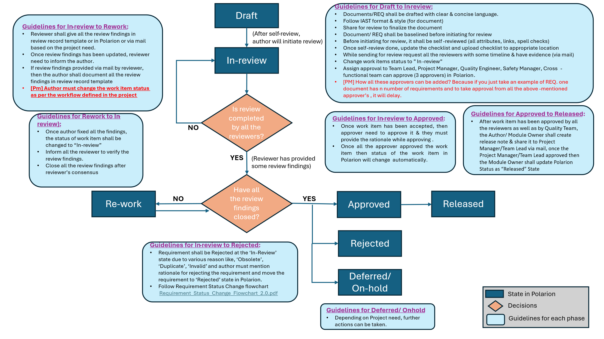
Roles and Responsibilities of the process:
Roles | Responsibilities
Author of Work Product | - Creates respective review items as per release objective and timeline.  - Sets the objective of the review.  - Provides review artifacts and supporting documents for review.  - He /she may identify additional mandatory reviewers (apart from what are defined  - Implement the review findings.  - Reworks on the artifacts.  - Asks for WP approval after the review.  - It is possible that Author can also cover the moderator role.
Moderator | - Ensures the mandatory reviewers are identified and informed about the review objectives and the review timelines.  - Organize review meeting as per the timeline, ensures all the reviewers are prepared with the review feedback.  - Ensures the review is focused on its objectives.  - Resolve Review Conflict  - Ensures that all the findings are recorded, Review checklist is filled, and rework completed and tracked to closure.
Reviewer | - Reviewer checks the WP including the Checklist Questions  - He documents review findings in the checklist (“Checklist” and “Review Findings” Tabs)  - Only after the reviewer has updated his/her comments in review checklist he/she can close the Analysis Task (Task ID should be included in the Checklist name)  - In case of no findings, same should be mentioned in analysis task “comments” section before closing analysis task.  - Checks for consistency of the Work products
Quality Engineer | - Closely supporting Authors and Moderators in setting up a working review process.  - Track all required reviews have been performed per release with appropriate resolution.  - Trigger review metrics per release per work-product to get an overview of the review status and Collects challenges and feedback towards improvements.  - Checks Implementation of Review findings

3.5.1 Review Checklist
Provide the link for the review checklist used in the project (Author’s, Reviewer’s, REQ Manager’s checklist).
Review Checklist_Polarion.xlsx

3.5.2 Types of Reviews
Review | Description | Goal
Walkthrough | - led by the authors.  - Author guides the participants through the document according to his or her thought process to achieve a common understanding and to gather feedback.  - especially useful for higher level documents like requirement specification, etc. | - To present the documents both within and outside the software discipline to gather the information regarding the topic under documentation.  - To achieve a common understanding and to gather feedback.  - To examine and discuss the validity of the proposed solutions.
Technical Review | - led by the trained moderator but can also be led by a technical expert.  - often performed as a peer review without management participation  - Defects are found by the experts (such as architects, designers, key users) who focus on the content of the document. | - To ensure that at an early stage the technical concepts are used correctly.  - To inform participants about the technical content of the document.  - To have consistency in the use and representation of technical concepts.
Inspection | - led by the trained moderators.  - During inspection, the documents are prepared and checked thoroughly by the reviewers before the meeting.  - It involves peers to examine the work item. | - helps the author to improve the quality of the document under inspection.  - removes defects efficiently and as early as possible.  - create common understanding by exchanging information.  - learn from defects found and prevent the occurrence of similar defects.  - improve quality of the work item.

3.6 DEFECTS ON LEVEL 2/LEVEL 3 REQUIREMENTS
Mention all the Defects related to Level 2 or Level 3 Requirements that shall be assigned to the corresponding Feature Owner. The Feature Owner needs to confirm if the Defect is valid from a technical point of view.

REQUIREMENTS DEVELOPMENT
Requirements are grouped based on Features assignment. Grouped of requirements are linked to Planning Item MLF (Mid-Level Function). Show the workflow of planning item.

STATUS and REPORTING of REQUIREMENTS
Reporting includes the following KPIs:
- Acceptance status of Customer Requirement
- Analysis and planning of Customer Requirement
- Status Decomposition of Customer Requirement
- Test coverage of Customer Requirement
- Implementation status of Customer Requirement
- Refinement of prioritized feature

TEMPLATE HISTORY
Version | Release Date | Description | Prepared by | Approved by | Status
0.01 | 10/01/2024 | Generic Requirement Management plan has created | Purvi | NA | Draft
0.02 | 08/01/2024 | Shared for review | Purvi | NA | In-review
0.03 | 22/01/2024 | Updated section 2 & 3 | Purvi | NA | Re-work
0.04 | 02/02/2024 | Walk-through with Preemal | Purvi | NA | In-review
0.05 | 09/02/2024 | Requirement Guidelines (section 6) has been removed from the document | Purvi | NA | Re-work
0.10 | 18/04/2024 | Walk-through with Preemal & closed all the review findings provided by her. | Purvi | Preemal | Approved
0.20 | 23/04/2024 | Walk-through with Dinesh & closed all the review findings provided by him. | Purvi | Dinesh | Approved

