SWE.2 SOFTWARE ARCHITECTURE TEMPLATE

DOCUMENT INFORMATION
 | Information
Document Id | 0405
Document Owner | Rohith D M
Issue Date | 18/03/2026
File Name | SWE.2 Software Architecture Template

DOCUMENT HISTORY
This section shows the description and timeline of the different phases of reviews. The Four phases of reviews i.e. Verification Review, Cross Functional Review, Reviewed baseline and Approval Baseline that will be created are mentioned in here.

An instance is shown below which shows who does the review in each different phase. The status of the previous rows is kept as “Obsolete” and for the latest row it is kept as “Approved”

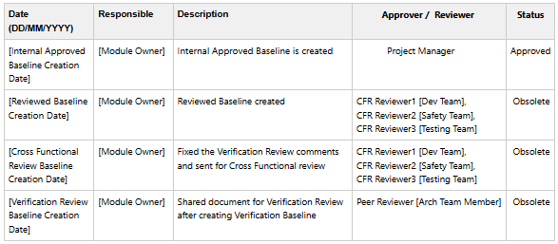

2. PURPOSE
This section describes the purpose of the SWE.2 document as to say the reference from where the SW Architecture work items are getting derived and who will refer the SWE.2 work items going forward.

3. SCOPE
Scope defines the overview or the description about the module portraying about the functionality.

4. REFERENCES
This section usually contains the Polarion link of the space which contains the SWE.1 Software Requirements.

5. ABBREVIATION

This section contains the full forms of all the Abbreviations that are used in SW Architecture work items.

6. SOFTWARE ARCHITECTURE
This section contains the 2 different Architectural views i.e. Context/Component view and Dynamic/Sequence View. All the SWE.2 Architectural work items will be traced with the applicable SWE.1 requirements upon creation of Reviewed/Approved baseline for the same.

Context View: This is the component view which shows the Module under consideration as the SW module which is communicating with other SW Modules via Client – Server interfaces. These views are created using the Enterprise Architect tool. The diagram complaint is “UML Structural”. The interfaces here are the Standard AUTOSAR API(s) which are available in the AUTOSAR SWS document for the module. A reference view of IMU Module Context view is added below

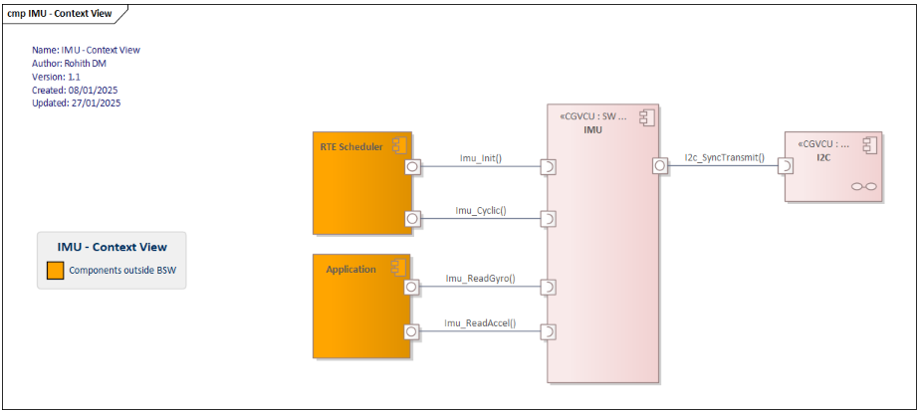

Dynamic View: This is the sequence view which shows the Module under consideration as Lifelines, which is communicating with other SW Modules in a sequential way i.e. which call is being invoked first and which call follows it next. This chronological order of calling the API(s) is seen in this Dynamic view only.

The timing related parameters, Interrupts and Clock Frequency if applicable would be aligned in this view. The diagram complaint is “UML Behavioral” and a reference view of IMU Module Dynamic view is added below

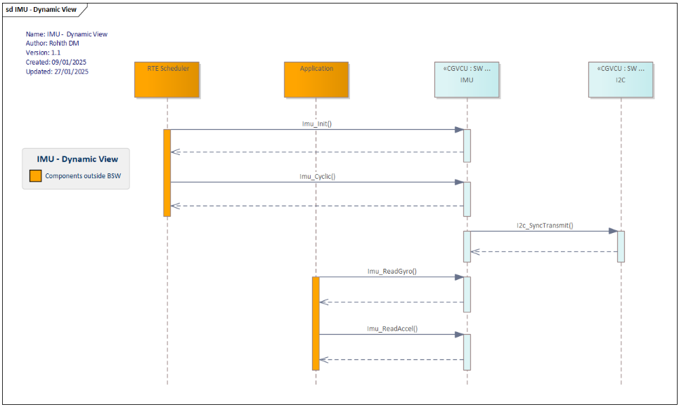

7. FUNCTIONAL DESCRIPTION

This section provides a detailed description of each API referenced in the architectural views. The API functionality, syntax including input arguments, datatype of arguments and return values (if applicable) are specified to serve as a reference for the testing team. Some examples are provided below.

