CGVCU
SOFTWARE DETAILED DESIGN AND UNIT CONSTRUCTION GUIDELINE DOCUMENT

Table of Contents
DOCUMENT INFORMATION 2
DOCUMENT HISTORY 2
REFERENCES 2
ABBREVIATIONS 3
1. INTRODUCTION 3
1.1 PURPOSE 3
1.2 Scope 4
2. DETAILED DESIGN 4
2.1 FUNCTIONAL BLOCKS 4
2.2 INTERFACES 5
Public Interfaces/Functions 5
2.2.1 ENUMERATION INTERFACE & EXPLANATION 6
2.2.2 FUNCTION CALL INTERFACES & EXPLANATION 6
2.2.3 MESSAGE INTERFACE & EXPLANATION 6
2.2.4 TRACEABILITY 6
2.3 FUNCTIONAL BLOCKS 7
2.3.1 NUMERATION INTERFACE & EXPLANATION 7
2.3.2 NUMERATION INTERFACE & EXPLANATION 7
2.4 ALGORITHMS EXPLAINATION (If applicable) 7
2.5 COMPONENT CONFIGURATION 7
2.5.1 PARAMETER CONFIGURATION 8
2.5.2 VARIANT CONFIGURATION 8
2.5.3 STACK SIZE CONFIGURATION 8
2.6 INTERRUPTS 8
2.7 TIMERS 9
2.8 COMPONENT/TASK SCHEDULE 9
2.9 MEMORY 9
2.10 REGISTERS 9
2.11 RESET/RESTART/RECOVERY MECHANISM 10
2.12 SYNCHRONIZATION & TIMING 10
3. CONFIGURATION MANAGEMENT(Optional) 11
3.1 FILES & RESPONSIBILITIES 11
3.2 FILE STRUCTURE & CONFIGURATION (optional) 11
4. PRECAUTIONS & LIMITATIONS 11
5. TOOL 12
6. SEQUENCE 12
7. INTEGRATION OF TOOLS 12
5.1 Integrate into Polarion 12
5.2 EA export to Polarion 13
8. POLARION REVIEW & DOCUMENT PROCESS 15
6.1 Document Process: 15
6.2 Review Process: 15
9. Unit Construction
9.1 PURPOSE: 19
9.2 DEFINATION: 19
9.3 CONTENTS: 19
9.4 DavINCI TOOL: 20
9.4.1 COMPONENTS 20
9.4.2 HOW TO OPEN DAVINCI TOOL 21
9. Software Detailed Design and Unit Construction Attributes 24
List of Figures 24

DOCUMENT INFORMATION
 | Information
Document Id | 0405
Document Owner | Dinesh Sharma
Issue Date | [Date DD/MM/YYYY]
File Name | 0405_ProjectName_Software_Detailed_Design_PlanDesign Document
File Location

DOCUMENT HISTORY
Version | Date | Responsible | Description | Approved / Reviewer | Status
3.0 | 13/11/2024 | Subramanya | Initiating the review Software Detailed Design guideline. | Rohith D M | Approved
2.0 | 12/11/2024 | Subramanya | Reworking on the review findings from Quality Team. | Rohith D M | Re-Work
1.0 | 11/11/2024 | Subramanya | Started Preparing the Software Detailed Design Guideline. | Rohith D M | Draft

REFERENCES
Document name | Section | Archive location
CGVCU Software Detailed Design guideline | DOCUMENT | CGM USA (Magna New mobility) - Documents - Management Planning (Supporting Process) - All Documents
- | - | -

ABBREVIATIONS
Abbreviation | Term | Description
CUT | Component Under Test | Means Software Component under Test.
DD | Detailed Design | Means detailed design of a Software Component. This includes the design of all nested units.  This is a process of synthesis of a software solution to the problems of the domain, given to that component during the creation of High-level Design.
UC | Unit Construction | Unit construction refers to the implementation of the smallest testable elements of the software, known as software units. These units are created according to the detailed design and can take the form of functions, classes, source files, or model elements, depending on the development approach. Each unit is expected to have well-defined interfaces, be consistent with the requirements, and maintain traceability to both the design and the originating requirements. The result of unit construction is a set of developed software units that are ready for verification in SWE.4 and for subsequent integration in later process steps.
HLD | High-level Design | Means the work product of the respective process.
DDS | Detailed Design Specification | Document containing detailed design. It could be the template [R1] or in UML format.
NVM | Non-Volatile Memory | Memory that can retain the data even after battery power of the device is removed.

INTRODUCTION

1.1 PURPOSE
The purpose of this document is …
Describe here the role of the software component. Include the items below in the software component description:
- The customer features software component will implement.
• The actions that the software component will do, for example, calculations, algorithms, data storage management, data flow management, event management, error management, timeout management and threads involved.
• The type of software component, for example, model, view, driver, library, wrapper of a supplier software.
• The plan/use in future projects.
• If the software component is safety related.

1.2 Scope
Defining the scope in detailed design is important because it clearly explains what the design will include and what it won’t. This helps the team stay focused, avoid extra or unwanted features, and make sure the design matches the requirements. A clear scope also makes the design easier to review, test, and understand. It supports building reusable and well-organized parts, and it guides developers by showing exactly what needs to be implemented.

DETAILED DESIGN

FUNCTIONAL BLOCKS
The goal is to show the CUT and its interacting components, parts CUT, public and private interfaces that are involved with CUT.

Data flow between blocks to be explained at generic level → which outputs will be result of which inputs. No need to explain the whole path via each function and internal executions. For the important parts of the design, data flow diagram can be used.

Explain the states and modes of the component → state-chart(s).

Example:
Component Under Design
Input component to your module
Interface component 1 if any

Interface component 2 if any
Output component module if any

INTERFACES
Describe the entire Interfaces expected or provided by the planned design. Interface source can be an either from external from software structure or internal. External sources are signals by CAN or Hardware inputs. Internal sources are either inspecting functions or IPCL messages. Above mentioned data shall be categorized as Public Interfaces and Private interfaces at a software component level.

Public Interfaces/Functions
Describe entirely all public interfaces of the component at static and dynamic level.
Public Interface means anything that links the component to the external world:
• Provided Interface is the Public Interface which component offers to other components.
• Required Interface is the Public Interface which component needs from other components to be able to operate.

The expectation is that all Provided and Required interfaces of the component are clear and reviewed by other component owners or leads & design experts before continuing with the Detailed Design of internal (private) design of the component.

One of the key design points is that private data/content must not be exposed to other components encapsulation principle.

Minimization/scalability across different projects of all public interfaces (not more, not less than needed) is essential to the success of the whole system.

Points to be noted: Software becomes more complex in terms of the number of components and links between them. Dealing with this issue is the responsibility of everybody: SW architects, design champions, developers, integrators.

Proper (means acceptable by DC’s/Architects) design of the public interfaces leads to simplification of the detailed design, reduces the risks of rework, and makes unit testing easier.

Please, spend enough time to think about the public interfaces. It will be paid off by reduction of the time for other development activities.

The Public Interfaces must be fed into HLD after agreement with the Designer is obtained.

2.2.1 ENUMERATION INTERFACE & EXPLANATION
List down & explain the enumerations that are available as part of public interfaces.
Example:
Enum name | Mention the enum name.
Enum Description | Explain the purpose of this enum.
Usage
Type | Variable Name | I/O | Description

2.2.2 FUNCTION CALL INTERFACES & EXPLANATION
List down & explain the function calls provided as part of public interfaces.
Example:
Function name
Function ID | D001
Function Description
Return type
Parameters
Type | Variable Name | I/O | Description

2.2.3 MESSAGE INTERFACE & EXPLANATION
List down & explain the messages that are available as part of public interfaces.
Example:
Message name
File Name
Message - Description
Payload length
Pay load description
Payload | Range | I/O |  | Default value | Description
Payload[0]
Payload[N]

2.2.4 TRACEABILITY
High Level Design | H001
Source Code
Unit Test | U001

FUNCTIONAL BLOCKS
Private interface means anything that links the files inside a CUT.
A CUT may contain one or more file decomposition. Describe the functions which provide data in a file and get data from a file

NUMERATION INTERFACE & EXPLANATION

List down & explain the enumerations that are available as part of public interfaces.
Example:
Struct name
File Name
Struct Description
Usage
Members of structure
Type |  | Elements Name | Description
Member type 1
Member type 2

NUMERATION INTERFACE & EXPLANATION
Example:
Function name
Function ID | U002
Function Description
Return type
Parameters
Type | Variable Name | I/O | Description

ALGORITHMS EXPLAINATION (If applicable)
Especially, Complex Algorithms need to be explained here.

COMPONENT CONFIGURATION
How is the component parameterized?
How are different variants configured?

Note: Parameters and Variant Configurations are not the same thing.

The same parameter could be used by several component variants.
Parameters are for the algorithms like damping factor for damping filter, but variants are about which functionality is enabled/disabled in operation.

Example:
1. TPMS feature can have the possibility to enable/disable at compile or run-time.
2. Trip Computer functionality can have several damping filters inside (each one separately parameterized).
3. In a specific radio variant, tweeter detection shall be disabled / enabled at compile or run time.

This section is essential for SW integration in a specific project or Component integration in different projects.

PARAMETER CONFIGURATION

With reference to the above (Section 2.5) explanation, mention the details of the parameter configuration that CUT offers.

VARIANT CONFIGURATION

With reference to the above (Section 2.5) explanation, mention the details of different variants considered in the design that you have proposed and elaborate how these variants are differentiated in the design.

STACK SIZE CONFIGURATION

Mention the details about the stack size allocation/reuse considered/agreed for this design. Justify the reasons for the same.

If this section is not applicable for the selected design, explain why.

INTERRUPTS
Mention the interrupts that are key input or the trigger to CUT.
Any hardware or software interrupts (Hardware timer) needs to be listed here and explain the purpose and the functionality that how it is used in CUT.

TIMERS
Mention the timers involved in CUT. No of the timers used and its periodicity.
Mention the states in which timers are active/ inactive.
Mention the counters used in CUT and its purpose of usage.
Mention the flags used in CUT and its states.

Rule of thumb: Do not use too many flags. In General, bunch of flags in a design will ruin the design in terms of maintainability & readability of the design. Prone to getting injected with defects when design is changed

COMPONENT/TASK SCHEDULE
Mention anything related to scheduling time or periodic function calls or blocking calls to trigger CUT until receive events.
How many threads in CUT are considered?
What are the timing intervals of these threads?
This section shall explain to the reader of this document about the task execution time of cut.

MEMORY
Mention memory related design points/assumptions. In case CUT has dependency with EEPROM/Flash or any other memory device, it must be mentioned about it.

REGISTERS
Extend the hardware peripheral related register information populated during high level design Phase.
Contents include - Whether utilized in the program, write access (write once register, write anytime), read access (read anytime, cannot read), whether initialized, initialized value (initialization events – power on, warm in it, sleep, wakeup, micro default), whether refreshed and monitored for errors (say in case mode and control registers), owned by SW component(s), any rationale, shared resources and how it is handled.
Based on the datasheet, capture the sequence related to operation of registers (e.g. initialization, normal, error handling etc.)

RESET/RESTART/RECOVERY MECHANISM
Is there a different behavior expected during warm or cold reset?
What is the recovery mechanism implemented?
Is CUT running in multi proceed environment (ex: Linus)?
Does CUT implemented with health monitor design/interfaces?
Is that enabled/disabled?
Explain the reasons/risks on the decisions.

SYNCHRONIZATION & TIMING
Is there synchronization required in the user interfaces in CUT?
Mention if their synchronization is a crucial part in CUT. For example, the
Telltale and Warning display need to blink at the same blinking rate. Synchronization
is more specific to DI.
Example: (DI specific)
1. Sync between Warning display ON, Telltale ON and Chime ON.
2. Sync between Telltale blink and Chime ON/OFF.
3. Sync between startup animation & dial pointer sweep.

Is there a Timing requirement/constraint in CUT?
Mention about the timing details of CUT. Startup time/shutdown time, wait
time, settling time, Request/Response time (IPCL message).

Example: (AI specific)
1. Tuner audio shall be available in <=1 second upon Radio startup.
2. Rear view camera image shall be available on display in <=2 second.

Does this CUT use Mutex or semaphore to realize its functionality?
If Yes, Mention about the list of mutex or semaphores usage in CUT to ensure the synchronization and to protect the data integrity of CUT. It must explain the purpose.

Does this CUT require real time processing in its execution scope?
If Yes, Mention about the priority of your CUT and how this decision justified to have the real time processing. It must explain the purpose.

Elaborate in detail on how CUT meets above requirements OR record if there’s any deviation.

CONFIGURATION MANAGEMENT(Optional)

FILES & RESPONSIBILITIES
Mention the list of files considered in CUT. There must be clear definition about each file on its functionality that which part of CUT is implemented.

File Name | File Scope | Function description of the file
Manager.c | Public | This File implements external component linkage. Receive messages.
Manager_cfg.h | Private | This file implements all the configurable parameters.
Manager_if.h | Public | This file provides interfaces to external components.

FILE STRUCTURE & CONFIGURATION (optional)
Describe in detail the files and its folder structure here. Capture if there any shared file configurations. Example: NVM definition.
Example:

\ai-gui-logic \src\
logic\
hmi_eventfilter_input.c
hmi_eventfilter_input.h

PRECAUTIONS & LIMITATIONS
Enlist all important points that the user of the component must pay special attention to. Ex: What if your CUT requires real time processing execution and it didn’t get its
execution?

TOOL
Explanation about the needed input artifacts like:
• Models
• Configuration data (Ex: NVM/DTC table, EQ table, Tuner alignment data)
• Resource makers (Ex: xml->TBD-Tool->Resources to be integrated)
• Code generators
• Databases (Ex: Phonebook)
• External object libs

Use-case diagram and/or Collaboration diagram can illustrate how the tools are producing the needed things for the component. Installation notes of the tools.

If component contains 3rd party SW that is configured by a tool (Ex: Geny), it is needed to explain how to run this configurator. At least the version and link to the user-guide of that tool are needed.

SEQUENCE

Each function is represented through a sequence diagram illustrating the flow of execution. These diagrams depict the interactions between components, the order of message exchanges, and the transitions between different states or operations.

For every function:
- The starting trigger and termination points are identified.
- All participating components and their message flows are shown.
- External interactions, if present, are included for clarity.
- The diagram reflects the intended logical flow for implementation.

INTEGRATION OF TOOLS

Integrate into Polarion
The Detailed Desigh shall follow the below procedure to export the Software Detailed Design from Sparx Enterprise Architect to Polarion:

Steps to Connect to Cloud in Enterprise Architect (EA):
- Initialize the Enterprise Architect (EA) application
- Open the project server, where Detailed Design have been designed.
- Connect to the Cloud server of the respective project. Example: - Add this details to access the CGVCU Detailed Design repository:

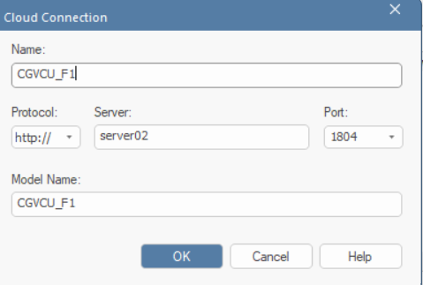
Figure 1: Cloud Server Connection Selection

EA export to Polarion
- Select on the Module’s Detailed Design folder you would like to export from Sparx Enterprise Architect to Polarion.
- Right click on the Module’s Detailed Design folder you would like to export from Sparx Enterprise Architect to Polarion.
- Click on the “Specialize” option and select the “Polarion Integrator” option from the dropdown list.
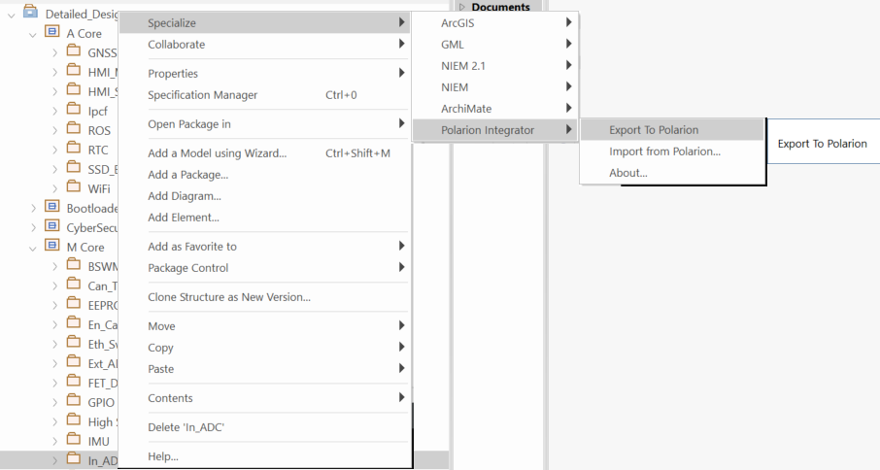
Figure 2: Folder Selection and Exporting to Polarion

- Enter the required details for the required project in the Pop-Up box that appears and enter your Polarion credentials (ID and Password).

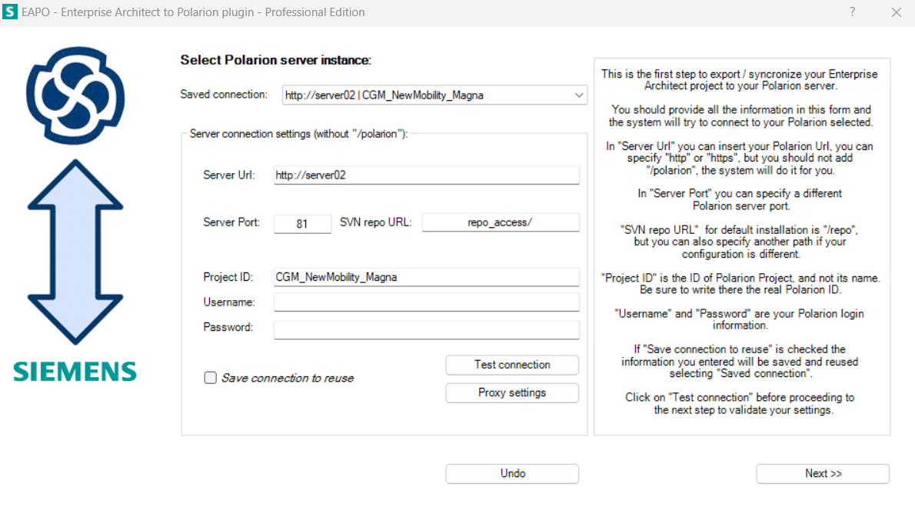
Figure 3: Server Connection and Testing Connection

- Select the “New Mapping” option then give the name as “Module_Number” for preparing the local Database.

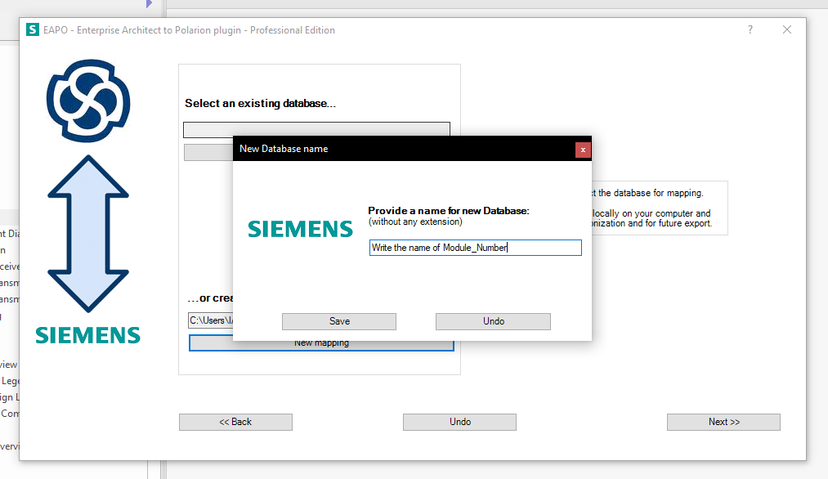
Figure 4: New Mapping and Name for Database

- Select the Polarion Type of every item or required items, by selecting the “Detailed Design” by clicking on the dropdown option on Polarion Type section.
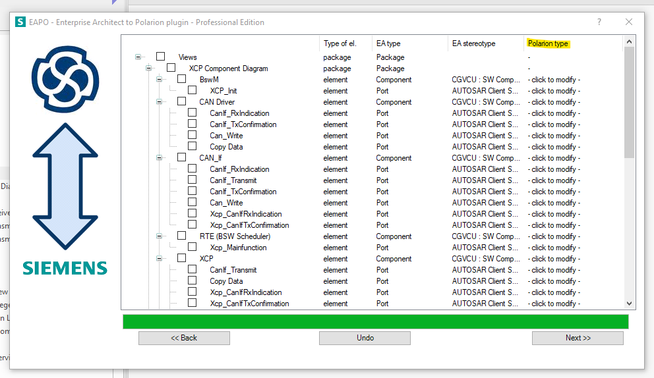
Figure 5: Selecting Polarion Type for Required Elements

- Click on the Next Button then the Export of the selected elements will start.
- The export results will pop up which means the selected elements have been exported successfully and, if it doesn’t it means the architecture have not been exported.

POLARION REVIEW & DOCUMENT PROCESS

6.1 Document Process:
- The Document History section of the Polarion Document should be updated before every baseline.
- Scope and Purpose section of the Polarion Document should be updated.
- Status of pulled elements, especially the architectural designs, should be updated from “Draft” to “Proposed” and finally to “In-Review” when creating baselines and even while moving the elements to document.

6.2 Review Process:
Verification Review:

- Author sets the work items from “Draft” state to “Proposed” state.
- After changing the status of the work items in Polarion from “Proposed” to “In Review”, it shall be baselined as – “CGVCU_ModuleName_VerificationReview_SYS.3/SWE.3_SubModuleName_DDMMYYYY” before sharing it for review.
- Author shall create the review task in Polarion (Work Item → Review) in which the link of the Verification Review Baseline shall be mentioned, scope of the review shall be defined along with the traceable requirements that needs to be reviewed and assign the reviewer.
- Review checklist shall be updated and attached by the Author in the review task. The status of the review checklist shall be “Draft”.
- The reviewer shall change the status of the review task from “To Do” to “In Progress”, perform the review and provide feedback against each work item as a fresh comment in the review task.
- After providing all the review findings, reviewer shall change the status of the review task to “Done”.
- Author shall request the reviewer to change the status of review task to “Accepted” or “Conditionally Accepted”.

Status | Description
Accepted | Task completed (requirements reviewed, Bidirectional traceability achieved) This is the final state of the review task.
Conditionally Accepted | Task completed (requirements reviewed); traceability not achieved.  The task must be moved from Conditionally accepted to Accepted once the traceability is completed with a new baseline.

Cross-Functional Review:

- After completion of Verification Review, the author shall create another review task for the cross-functional team.
- Mention the previous baseline “CGVCU_ModuleName_CrossFunctionalReview_SYS.3/SWE.3_SubModuleName_DDMMYYYY” in the description of Cross Functional Review task.
- Author shall mention one cross-functional reviewer’s name in the description of the review task who’ll have the authority to change the status of the review task and scope of the review shall be defined along with the traceable requirements that needs to be reviewed.
- Review checklist shall be updated and attached by the Author in the review task. The status of the review checklist shall be “Draft”.
- Inform the cross-functional reviewers about the review task via mail, so that the communication is documented and mention the target completion date to provide all the review findings.
- One cross-functional reviewer whose name is mentioned in the description of the review task can change the status of the review task from “To Do” to “In Progress”.
- All the cross-functional reviewers shall perform review of the work items related to the review task and shall provide their feedback.
- Once all the review findings have been provided by the cross functional reviewers then the status of the review task shall be changed to “Done”.
- Author shall request the reviewer to change the status of the review task to “Accepted” or “Conditionally Accepted”.
Status | Description
Accepted | Task completed (requirements reviewed, Bidirectional traceability achieved) This is the final state of the review task.
Conditionally Accepted | Task completed (requirements reviewed); traceability not achieved.  The task must be moved from Conditionally accepted to Accepted once the traceability is completed with a new baseline.

- Once the comments have been resolved the review findings both the review tasks should be in “Accepted” state.
- Create reviewed baseline.
- Attach the reviewed baseline in Cross functional review task.
- Attach the review findings mail as pdf if any received through mail.
- Attach the checklist and confirm it is updated.

Internal Approval:

  - Now when we have both the Verification review and CFR tasks in “Accepted” state, the document will be sent for Approval from Software Detailed Design Expert.
  - This approval will be the final version of the document which is being shared with the customer with 100% module maturity.
  - A baseline will be created for the same in the document in the format “CGVCU_ModuleName_InternalApproved_SWE.3_ddmmyyyy”
  - This also suggests that there will be no further modification in module document.

Unit Construction
9.1 PURPOSE
The purpose of Unit Construction is to describe the process followed during AUTOSAR ECU configuration using the Vector DaVinci Tool. This process ensures that configuration changes are traceable to requirements and work items, while supporting compliance with ASPICE and ISO 26262 guidelines.

9.2 DEFINITION
Unit Construction refers to the process of creating self-contained configuration snapshots from DaVinci, each linked to a specific requirement or work item. A unit represents the smallest manageable piece of ECU configuration (e.g., CAN communication setup, DIO channel, DEM event). Each unit is independently configured, documented, reviewed, and verified.

9.3 CONTENTS
- Document History: This section records the revision history of the document. It includes date, author name, description of review, status (Draft/VFR/CFR), reviewer details.
- Index: The index provides a structured list of all sections, subsections, tables, and figures included in the document, allowing readers to quickly locate specific content.
- Purpose: This section explains the objective of the document. It provides a detailed description of the AUTOSAR component or process (e.g., Unit Construction with DaVinci), highlighting why it is required and its role in the overall project.
- Scope: Defines the boundaries of the document. It specifies what is covered (e.g., configuration snapshots, linking with work items) and what is excluded, ensuring clarity on the intended use.
- References: Lists all supporting documents, standards, guidelines, and manuals referred to in the document.
- Abbreviation: Provides a list of all abbreviations and acronyms used in the document, along with their full forms.
- Software detailed design: It includes snapshots of the configuration collected from the De-Vinci tool. Under this section we include configuration snapshots.
- Tools: Lists all tools used to support the process.

9.4 Da-Vinci Tool

The DaVinci Tool Suite from Vector Informatik is a set of tools used to configure, develop, and integrate AUTOSAR Basic Software (BSW) and RTE (Runtime Environment) for automotive ECUs. DaVinci Configurator is a tool for creating ECU Configuration Descriptions according to the AUTOSAR standard.
It includes specific functionality for configuring AUTOSAR basic software modules and the RTE. It helps generate ECU-specific AUTOSAR software without manually coding the entire stack.

9.4.1 Components
- DaVinci Configurator Pro: Used for configuring Basic Software (BSW) modules (like COM, DCM, DEM, CAN, LIN, Ethernet stacks, etc.). Allows to enable/disable parameters, set memory mapping, and define communication channels. Generates ECU configuration code (ARXML, C, H files)
- DaVinci Developer: Used for application software component (SWC) development. Supports system architecture design, port mapping, and signal connections between SWCs and BSW. Generates ARXML and interfaces to be used by Configurator

9.4.2 How to open DaVinci tool
- Double click on the DaVinciCFG.exe present inside the Installation-> Core folder.
- Once the configurator opens, a disclaimer or warning will be displayed.
- Click on “I accept” to accept the warning and proceed to next step.
- Now DaVinci Configurator SIP.MCAL window will be displayed and ready to use.

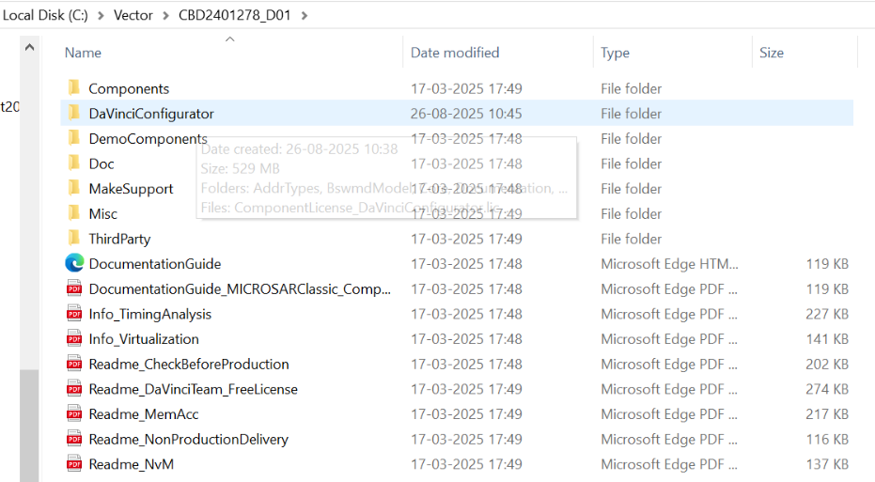

Figure 6: Selecting DaVinciConfigurator

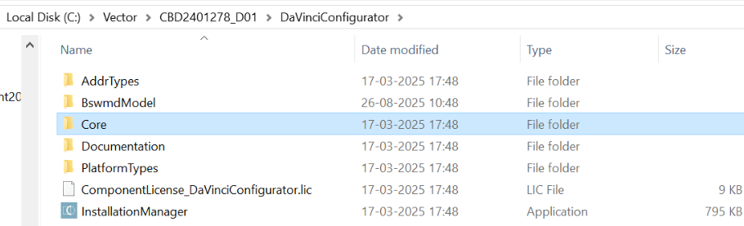

Figure 7: Selecting Core folder

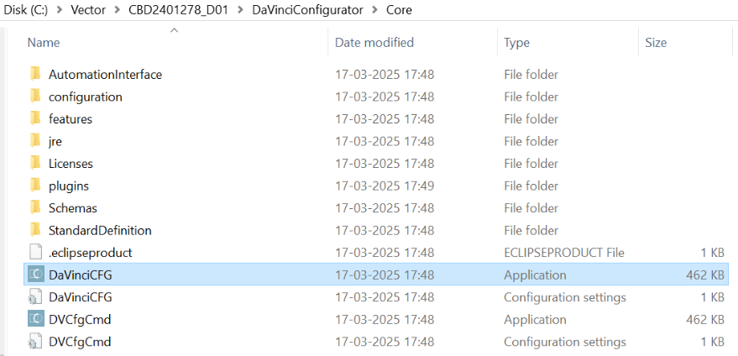

Figure 8: SelectingDaVinciCFG

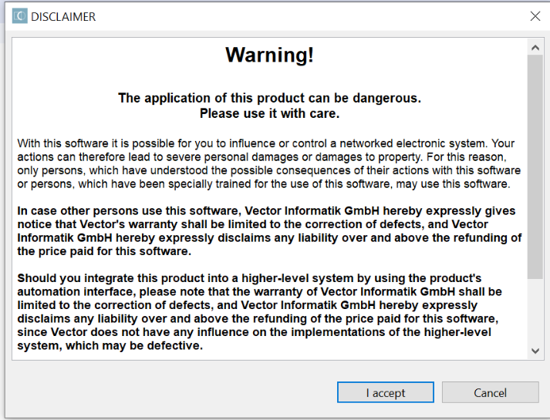

Figure 9: Warning displayed when opened

Click on the option “File”: Open: To open an existing project. User can select an already available project by browsing its location or path.
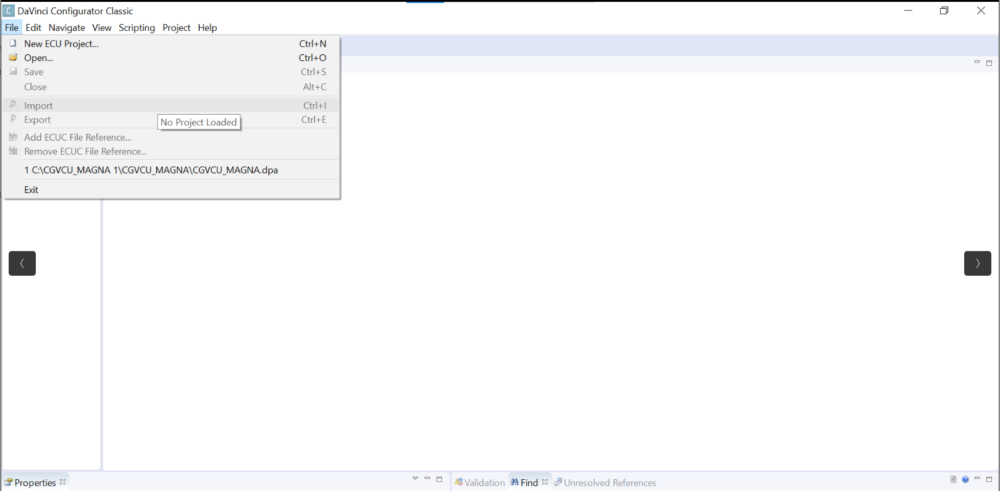
Figure 9: Click on open file to select available project

Click on the option “Project”: Basic Editor: The Basic Editor displays all module configuration of the ECU configuration. This will basically provide an editor for the user to analyze and modify the configuration.
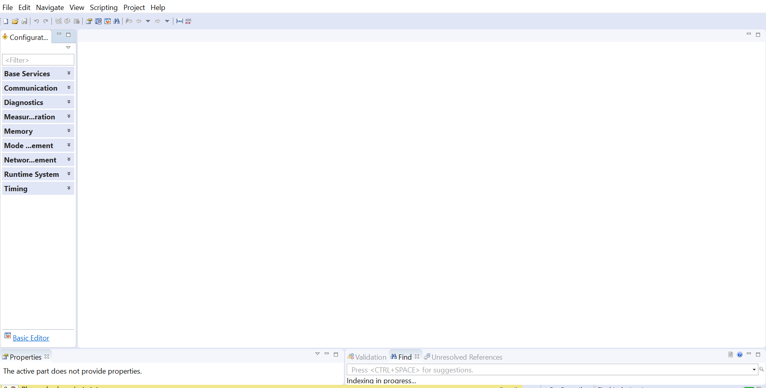
Figure 10: Click on Basic editor at left corner

Software Detailed Design and Unit Construction Attributes

  - Artifact Type
  - Status
  - Categories
  - Cyber Security
  - Safety
  - ASIL Levels
  - Severity
  - Milestone
  - Feasibility
  - Risk

List of Figures

Figure 1: Cloud Server Connection Selection………………………………………………………..14
Figure 2: Folder Selection and Exporting to Polarion…………………………………………….15
Figure 3: Server Connection and Testing Connection……………………………………………15
Figure 4: New Mapping and Name for Database………………………………………………….16
Figure 5: Selecting Polarion Type for Required Elements……………………………………..16
Figure 6: Selecting DaVinciConfigurator……………………………………………………………….21
Figure 7: Selecting Core folder……………………………………………………………………………..21
Figure 8: SelectingDaVinciCFG……………………………………………………………………………..22
Figure 9: Warning displayed when opened………………………………………………………….22
Figure 10: Click on Basic editor at left corner……………………………………………………….23

