SOFTWARE TEST PLAN

Project: General
Author: Meeravalli
Version: 1.6
File name: IAST_SWTestPlan.docx
Status: Draft
Last Modified: 20.06.2023

Change History
Date | Version | Status | Name | Description
05/07/2022 | 1.0v | Draft | Meeravalli | Initial draft
15/08/2022 | 1.1v | In review | Meeravalli | Review findings fixed
27/10/2022 | 1.2v | Draft | Meeravalli | Added 5.2.3.1 Software Qualification Test Preparation
06/12/2022 | 1.3v | Draft | Meeravalli | 5.2.4.1 Test Entry Criteria
13/03/2023 | 1.4v | Draft | Meeravalli | 5.2.11.2 Prioritization of Test Cases
17/03/2023 | 1.5v | Draft | Meeravalli | 8 Schedule
25/04/2023 | 1.6v | Reviewed | Meeravalli | 10 Software Test Completion

References
List of all the applicable reference documents and standards considered as basis for designing the testing concepts are named below. The references are separated into “external” references that are imposed external to the project and “internal” references that are imposed from within to the project.

External References
Ref-No. | Document Number/Revision | Document Title/reference
1 | ISO26262 – Road Vehicles - Functional safety | www.iso.org
2 | ISO/IEC 15504 Automotive Spice | www.iso.org
3 | ISTQB® | International Standard Testing Qualification Board http://www.istqb.org/
4 | ISO 29119-3-2013 | Software and systems engineering – Software testing
5 | ISO 29119-4-2013
6 | ISO 26262-6-2011
7 | IEEE 1028

Internal References
Ref-No. | Document Title | Document Reference
[Ref 1] | RMP
[Ref 2] | Configuration Management Plan

Glossary
Abbr. | Full Text
SWQT | Software Qualification Test
SWIT | Software Integration Test
SRS | Software Requirement Specification
SAD | Software Architecture Design

Table of Contents
Software Test Plan 1
Project: General 1
1 Introduction 9
1.1 Process 9
1.2 Document Scope 9
2 Context of the testing 10
2.1 Project(s) / test sub-process(es) 11
2.1.1 Software Integration 11
2.1.2 Review Process 11
2.1.3 Defect Management Strategy 11
2.1.4 Test Priority 11
2.1.5 Feature Evaluation Criteria in Test Report 12
2.1.6 CUSTOMER Specific Requirements 12
2.1.7 Status_fld attribute 12
2.1.8 Test Coverage 13
2.1.9 Automation – Continuous Testing 14
2.2 Assumptions and constraints 16
3 Testing Communication 17
4 Risk register 18
5 Test Strategy 19
5.1 Software Integration Test 19
5.1.1 Test Objective 19
5.1.2 Test Scope 20
5.1.3 Test item(s) 20
5.1.4 Test Criteria 26
5.1.5 Test Deliverables 29
5.1.6 Environment Requirements 30
5.1.7 Test Metrics 31
5.1.8 Assumptions and Constraints 31
5.1.9 Stakeholders 32
5.1.10 Reporting Tool 33
5.1.11 Regression for Software Integration Test 34
5.2 Software Test 35
5.2.1 Test Objective 36
5.2.2 Test Scope 37
5.2.3 Test Item(s) 37
5.2.4 Test Criteria 41
5.2.5 Test Deliverables 43
5.2.6 Environment Requirements 44
5.2.7 Test Metrics 45
5.2.8 Assumptions and Constraints 45
5.2.9 Stakeholders 45
5.2.10 Reporting Tool 46
5.2.11 Regression for Software Test 46
6 Testing activities and estimates 48
6.1 Effort estimation for Component and Integration Tests 48
6.2 Effort estimation for Software Qualification Test 49
7 Staffing 50
7.1 Roles, activities, and responsibilities 50
7.2 Hiring needs 50
7.3 Training needs 50
7.4 Testing Communication 50
8 Schedule 52
8.1.1 Test Planning/Timeline 52
9 Open Question 53
10 Software Test Completion 54
10.1 Archive Software Test Assets 54
10.2 Clean Up Software Test Environment 54
10.3 Identify Lessons Learned 54
10.4 Test Completion Report 54
11 Roles and Responsibilities 55

List of Figures
Figure 1: Related GPEP Process 9
Figure 2: Software Test Organization 11
Figure 3: IAST test levels corresponding to ASPICE base practices 12
Figure 4: SWIT – Related GPEP process 19
Figure 5: SWIT - Test Concept: Interface testing between the Application components 20
Figure 6: SWIT - Interface testing between the Application and BSW 20
Figure 7: SWIT - Interface testing between the Application and BSW – Tools and approach 21
Figure 8: SWIT - Test Concept: Interface testing – IPC communication 21
Figure 9: SWIT - Test Script Design procedure 25
Figure 10: SWIT – Bidirectional Traceability and consistency 26
Figure 11: SWIT - Tiny Bench 31
Figure 12: SWQT – Related GPEP process 37
Figure 13: SWQT – Test Script Design Procedure 40
Figure 14: SWQT - Bidirectional traceability and consistency 41
Figure 15: SWQT – Tiny bench 46
List of Tables
Table 1: Review Checklists 13
Table 2: Feature Evaluation Criteria 14
Table 3: Key Features to be tested 16
Table 4: SWIT - Methods for verification of Software Integration 24
Table 5: SWIT - Methods for deriving test cases for Software Integration testing 24
Table 6: SWIT – Preparation Entry Criteria 28
Table 7: SWIT – Execution Entry Criteria 28
Table 8: SWIT – Preparation Exit Criteria 28
Table 9: SWIT – Execution Exit Criteria 29
Table 10: SWIT - Pass/Fail Criteria 30
Table 11: SWIT – Testing Tools 32
Table 12: SWIT - Stakeholders 34
Table 13: SWQT - Methods for Tests 40
Table 14: SWQT - Methods for deriving TC for SW testing 40
Table 15: SWQT – Preparation Entry Criteria 43
Table 16: SWQT – Execution Entry Criteria 43
Table 17: SWQT – Preparation exit Criteria 43
Table 18: SWQT – Execution Exit Criteria 44
Table 19: SWQT – Pass/Fail Criteria 44
Table 20: SWQT – Test Environment 46
Table 21: SWQT – Testing tools 47
Table 22: SWQT - Stakeholders 49
Table 23: Standard KPIs for effort estimation 52

Introduction
The purpose of this document is to provide the information and the framework required to plan and perform all software test processes needed for the testing of all software test items in a software-testing project.

This plan provides the Software Integration Testing and Software Qualification Testing strategy, and approach required to ensure that all software requirements and software architecture are tested adequately and efficiently.

Process
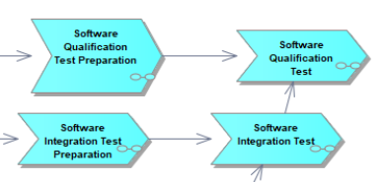
Figure 1: Process

Document Scope
This document defines, at a high-level, how it is verified that all Software Requirements and Software Architecture Designs in the project have been met.

The following topics are described for Software Integration Test and Software Qualification Test:
- Description of the test object
- Test strategy
- Test planning
- Test deliverables
- Resource definitions / usage and roles
- Description of used test methods
- Test environment
- Reporting (including KPI´s and metrics)
The key questions this document should answer are:
- What types of requirements do we have to test?
- What is the scope of the tests? (What is tested? What is not tested?)
- Which tests will we perform?
- Where (locally) will we conduct the tests?
- Who (organizationally) is responsible for which tests?
- How long will it take to run the tests?
- How are the Test executions planned (including Test case selection)?
- What tools do we need to execute these tests?

Context of the testing
Each Test Level mentioned in below Figure
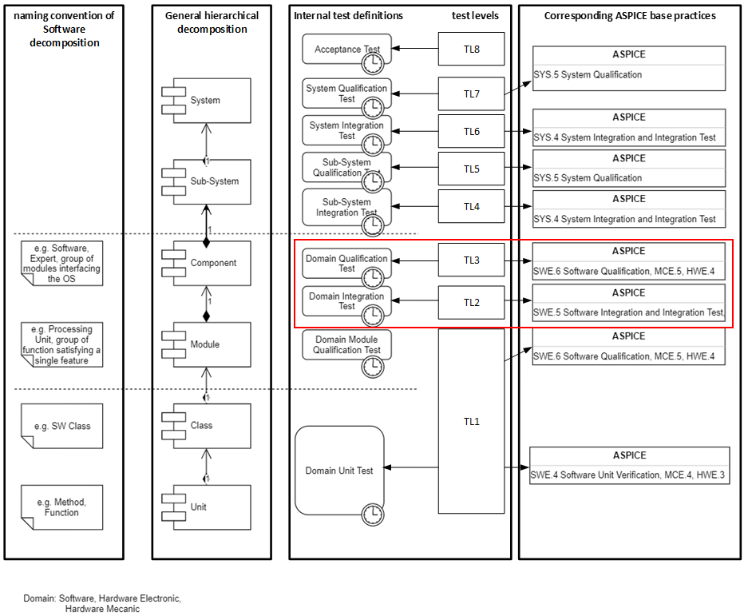
Figure 3: Test levels corresponding to ASPICE base practices

Project(s) / test sub-process(es)

Software Integration
The software integration strategy refers to an integration sequence to integrate different SW components together

Below marked SW Integration strategy document is intended to provide the guidelines for the SW Integration
Project consist of many SW Components, Packages, modules, and SW sub systems. There after we refer as Module for SW Component, package, SW sub system, scope for this document.

Before Integrated SW is handed over to testing team, build verification tests are triggered automatically in context of a GitHub Pull-Request creation and every subsequent git commit.

Review Process
Each work product must be reviewed according to the process defined in the below document.

Review checklists:
SW Test WP Checklist | Review Checklist Path
SW Component Test Specification
SW Integration Test Specification
SW Qualification Test Specification
SW Test Report
SW Test Plan
Table 1: Review Checklists

Defect Management Strategy
When Test Cases are failing, or Static Test Methods are detecting issues during the Software Test process it must be evaluated and shall be processed according to the defined procedures in the Defect Management process.

Test Priority
The priority level to each test case.

Feature Evaluation Criteria in Test Report
Below is feature evaluation criteria applicable for all levels of testing.

N | Not achieved | 0 to <= 15% achievement or any critical severity defect is raised against failed TC (irrespective of number of TC count), then feature will be marked as Red.
P | Partially achieved | >15 to <= 50% achievement or any High severity defect is raised against failed TC (irrespective of number of TC count), then feature will be marked as Yellow (SW Tester and FOs Assessment)
L | Largely achieved | >50 to <= 85% achievement or any low severity defect is raised against failed TC and more than 15% TC failed then feature will also be marked as Yellow (ASPICE NPLF criteria)
F | Fully achieved | >85 to <= 100% achievement or any low severity defect is raised against failed TC and less than 15% TC failed then feature will also be marked as Green (ASPICE NPLF criteria)
NA | NA | Test skipped/not executed
Table 2: Feature Evaluation Criteria

CUSTOMER Specific Requirements
SW test team shall also customer Basic Requirements. The purpose of the Group Basic Software Requirements, (“Konzern Grundanforderungen Software”) is to specify the requirements of the customer the software quality in vehicles. This document describes the basic demands set by the Customer Group on vehicle software and on software related to the vehicle and its development processes.

The degree of fulfillment of the requirements shall be demonstrated transparently through the defined inspection measures by the supplier and be verified by the customer if required.

Requirements for SW Testing are embedded into SW Testing Work product Review Checklists defined in the section.

Status_fld attribute

Transition | State change | Explanation
T1 | Initial state of the test case | test case development in progress
T2 | Draft -> Proposed | Review of test cases has been initiated  - Test specifications exist in DNG  - Test Scripts exist in GitHub
T3 | Proposed -> Reviewed | Review of test cases is passed. i.e., Test case specification and script has been accepted during cross functional review  Review Item in DNG is required.
T4 | Draft, Proposed, Reviewed -> Rejected | Requirement is no more applicable
T5 | Reviewed -> Draft | Requirement is changed and therefore test case needs an update.

Test Coverage
The Software test need to cover 100 %of requirements with test
The SW test tracking the coverage of each Test Domain and level with Metric reports and tools which Provided by IAST like DNG and Rectify

Software Test Metrics are used to estimate the progress of testing and its results. Through metrics, we can track the status of test activities, measure product quality and team efficiency, and optimize the processes.
A metric usually conveys a result, or a prediction based off the combination of data.
- Result Metrics: metrics that are mostly an absolute measure of an activity/process completed.
  - Example: Time taken to run a set of test cases in a suite

- Predictive Metrics: metrics that are derivatives and act as early warning signs of an unfavorable result.
  - Example: Defects created vs. Resolved chart shows the rate of defect fixing. This grabs the team’s attention if this rate is slower than the rate desired.
DNG Dashboard:
- Requirement Coverage (Valid reviewed Req. for SW Test) also track the requirements.
- Test Gaps
- Defect State
- Tracking Tasks and items assigned to test team.
Main Metrics:
- Status and Coverage of Input WPs (e.g., SADs)
- Planned Coverage of Input WPs
- Status of Test Specifications
- Automation of Test Specifications
- Test Results of Test Executions
- Tracking of Traceability and Consistency
- Covering of mandatory Aspects of FUSA

Methods of reqtify tools to establish the traceability are defined by tools team,
Elements | Definition Delta CUSTOMER | Definition Combined (all CUSTOMER)
Software Requirement (Parent)  Tool: DNG Integrity | Project=General  Type=” Requirement”  Valid for Project=  Content Classification=” Software Requirement”  Category! =Heading or! =Comment  Status_fld != “replaced” or “rejected”  Document ID!=0 or !=unspecified  Document State is not invalid | Project= General  Type=” Requirement”  Valid for Project=  Content Classification=” Software Requirement”  Category! =Heading or! =Comment  Status_fld != “replaced” or “rejected”  Document ID!=0 or !=unspecified  Document State is not invalid
Software Requirement which requires traceability (Testable) | Software Requirement (Parent) with  Testability=Yes or Conditional or unspecified and Required Test Type=Software Test or unspecified. | Same as Delta
Software Qualification Test Case (Child)  Tool: DNG Integrity | Project=”5050”  Type=Test Case  Category=Software Test  ValidForProject= “ 0”  Status_fld= draft, proposed, reviewed, released, approved, unspecified  Document State is not invalid | Project=”L2H45050”  Type=Test Case  Category=Software Test  ValidForProject= “ 0”  Status_fld= draft, proposed, reviewed, released, approved, unspecified  Document State is not invalid
Traceability Coverage, Parent à Child | Software Requirements (Testable) with Status_fld attribute set to “reviewed”, “released” or “approved” that have relationship "Validated By" linked to at least one Software Qualification Test Case with Status_fld attribute set to “reviewed”, “released” or “approved” divided by the total Software Requirements (Testable). | Same
Traceability Coverage, Child àParent | Software Qualification Test Cases with Status_fld attribute set to “reviewed”, “released” or “approved” with relationship "validates" linked to at least one Software Requirement (Testable) with Status_fld attribute set to “reviewed”, “released” or “approved” by the total Software Qualification Test Cases (child definition). | Same

Automation – Continuous Testing

Git Repository – Strategy
Git repo for SWQT: Git repo for SWQT:

The directory structure of a Shared Library repository is as follows:
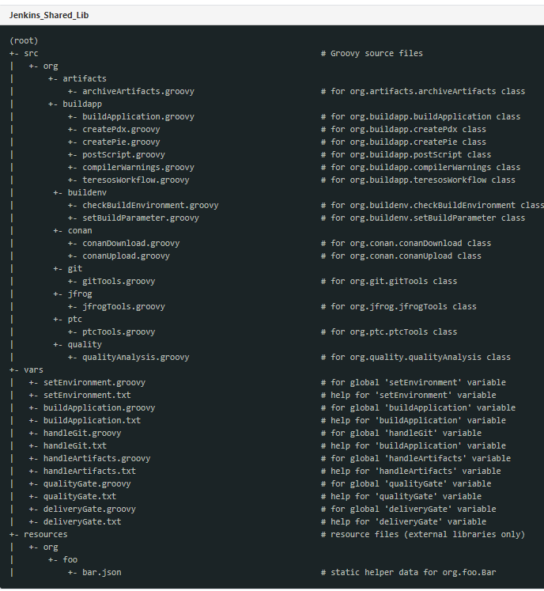
The src directory should look like standard Java source directory structure. This directory is added to the classpath when executing Pipelines.
The vars directory hosts script files that are exposed as a variable in Pipelines. The name of the file is the name of the variable in the Pipeline. So, if you had a file called vars/log.groovy with a function like def info(message)…​ in it, you can access this function like "hello world" in the Pipeline. You can put as many functions as you like inside this file.
The base name of each. groovy file should be a Groovy (~ Java) identifier, conventionally camelCased. The matching .txt, if present, can contain documentation, processed through the system’s configured (so may really be HTML, Markdown, etc., though the .txt extension is required). This documentation will only be visible on the pages that are accessed from the navigation sidebar of Pipeline jobs that import the shared library. In addition, those jobs must run successfully once before the shared library documentation will be generated.
The Groovy source files in these directories get the same “CPS transformation” as in Scripted Pipeline.
A resources directory allows the libraryResource step to be used from an external library to load associated non-Groovy files. Currently this feature is not supported for internal libraries.

Assumptions and constraints
None

Testing Communication

The communication with the stockholders is done via e-mail, Teams and DNG. List of stakeholders for SWE.6 and SWE.5 are defined at their respective sections in this document.

Additionally, guides about the activity owner and participants involved for the activities.

Risk register

Refer for risks management.

Test Strategy

Software Integration Test

The SW Integration Test Process is to ensure that the software items are tested to provide evidence for compliance of the integrated software items with the software architectural design, including the interfaces between the software units and between the software items/modules.

The test items are all software components included in the integration paths, also referring to the Software Architecture Specification.

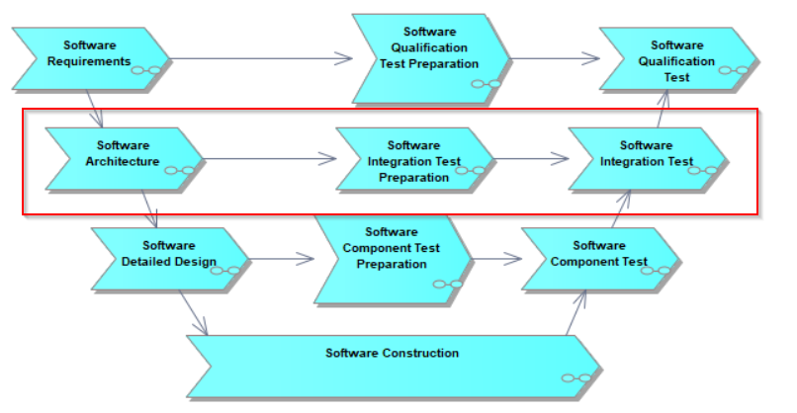
Figure 4: SWIT –Process

Test Objective
The implemented functionality and the required data exchange via the interfaces of the Software Components shall be verified against the Software Architecture.
- Static Behavior Coverage:
  - SWIT shall verify the correct interactions (Data flow, Control flow) between software components based on SW Architecture.
- Dynamic Behavior Coverage:
  - SWIT shall verify timing aspects and call sequences if defined any

(Ex: Scheduling of tasks and runnable, End to End test of all external signals, Startup to Shut down, Timing of messages)
  - Resource usage tests (CPU Load, stack consumptions)
- The SWIT shall demonstrate that the test item does not contain undesired functionality

Test Goal:
- 100% coverage of the reviewed and released SW Architecture (EA elements)
- At least 90% of total available SWIT tests shall be automated. Test Cases shall be automated as far as possible to improve comparability of test results and to reduce test execution efforts.

All test cases shall be implemented by a different person than the person who has implemented the interface which is to be tested.

Selection of Test cases needs always to be reconsidered for all iterations (specific time periods, releases). It will be outlined in the Test Schedule and is part of the activity “Plan Test Activities”. This schedule will evolve based on project situation and respects circumstances which effects the testing, e.g. availability of Hardware.

For the selection of Test cases the Software Test Lead is considering the Feature Release Plan, Master Timing Plan, Defects, CRs, … and also the Software Integration Test Strategy.

Selected Testcase based on criteria defined for the Input Workproducts.

Criteria to select test cases includes
- the coverage of new or changed requirements
- the coverage of change requests
- the coverage of item changes
- the consideration of dependencies, based on the analysis of changes (e.g. causal chain analysis)
- the re-verification of found defects
- the selection of appropriate test cases for regression testing including a set of test cases selected as a basis set to be executed.

Test Scope

In scope
Software Integration test will be performed only for releases targeted on Sitara platform.

Software Integration test of the software components for the

Not in scope
For releases targeted Software Integration test is not in scope.

Test item(s)

Software Integration Test Preparation
A Test Case is a set of conditions or variables under which a tester will determine whether a software item under test satisfies requirements or works correctly. The process of developing test cases can also help find defects in the Software Architecture.

Software Integration Test Specifications are defined in DNG Integrity tool as Document Item.
SW IT Master test Specification can be found out in <DNG_ID>

Test Case Design
The main purpose of test design techniques is to test the functionalities and features of the software with the help of effective test cases.

Test Cases shall be designed in such a way that they are independent of each other. (i.e., mutual dependencies are not allowed)
Mandatory attributes that shall be filled in a test case specification are:
- Category – Identifies the test level. Here, it is Software Integration Test
- Assigned User – Responsible test engineer
- Text/Description – A clear, unique short summary of Test goal.
- Preconditions - preconditions required for a test to be carried out. Failure or error in these steps results in the test result verdict as Test not executed
- Test Sequence – Step by step procedure to set inputs and check the outputs.
- Expected Results – Expected results for all the check steps in “Test Sequence.”
- Postconditions – Postconditions to restore the test environment to a normal state.
- Model Element reference – List of EA elements GUIDs that the test case validates. Here, Architecture Specifications.
- Status_fld – State of the test case. Values for this attribute shall be set according to the section Status_fld attribute
- External ID – Automation status. Values for this attribute shall be automated, manual, semi-automated
- External Script Name – Test script reference to Automated/Semi-Automated test cases.
- ASIL Method – Selected ASIL test technique (like, boundary value analysis, Equivalence class partition, etc.)
- Priority – Execution priority of the test case as defined in the section Test Priority.

Test Methods
For designing the TC for SWIT, following methods shall be used (Refer FuSa Strategy document for more information) for all ASIL and QM components. Negative test Scenarios shall also be considered where applicable.
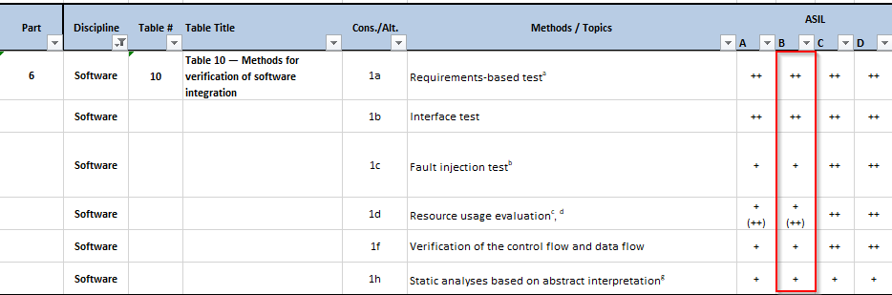
Table 4: SWIT - Methods for verification of Software Integration

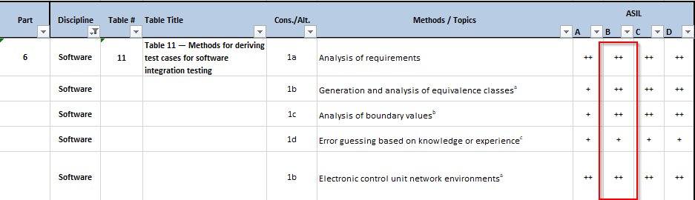
Table 5: SWIT - Methods for deriving test cases for Software Integration testing

1c = This method applies to interfaces, values approaching and crossing the boundaries and out of range values.(inbound/outbound)

Test Script Design

Test Script is a set of instructions (written using a scripting/programming language) that is performed on a software under test to verify that the software performs as expected. Test scripts are used in automated testing.

Test Cases shall be automated in such a way that the execution of test case has no impact on other test case execution(i.e., No mutual dependencies are allowed. However, a test case can be used as a precondition to another test case, if this does not otherwise influence the test result)

Test Execution Suite is generated
Base on Test Cases from DNG
Test Script are created

Figure 9: SWIT - Test Script Design procedure

Test Script are written in vTESTstudio environment using Lauterbach debugger. Using dlls for Lauterbach debugger, test scripts shall be created that will reproduce step by step the sequence from Test Cases that are described in DNG Integrity document (‘Test Suite’).

Bidirectional Traceability

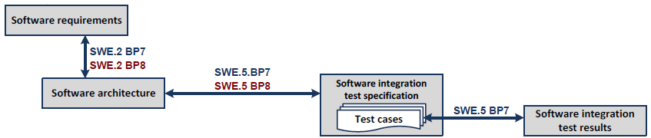

Figure 10: SWIT – Bidirectional Traceability and consistency

Elements in the Software Architectural Design [SAD] shall be linked with Test Cases included in the Software Integration Test Specification [SITS]
- Each testable element in [SAD] will have a unique GUID defined which will be traced by SW IT Test case using the attribute “Model Element Reference”
- Traceability is established between Test Script and Test Cases using attribute “External Script Name” in test case
- The test case implementation done in chosen Test Tool e.g., vTESTstudio is to be synchronized by referring the Test Case ID, defined by DNG-Integrity
- Results of Software Integration Tests shall be recorded by each documented test run (DNG Item Test Session) and be linked to the related Software Integration Test Cases.

Bi-directional traceability shall be assured and demonstrated by review records.

Software Integration Test Execution

Test execution is concentrating on three main activities:
- Create Test Objective and Test Session
- Execute Test Session and Upload the Test Result
- Analyze failed TC and Create Defect

Create Test Objective and Test Session
A “Test Plan” item defines overall testing scope for a specific release containing one or multiple test Objectives. The “Test Plan” is for single project which is selected during creation of the item. “Test Plan” item will be created before the Release being available and shall be done in the Test preparation phase.

Test Objective is created by Software Test Manager in DNG Integrity for planned release.

Test Objective Item contains a group of Test Session Items that must be tested for a specific release.

MLF planning is an input to create Test Objective. Execute Test Suite, Analyse Test and Upload the Test Result
The selection of test cases for execution shall be based on the regression strategy defined in the section Regression for Software Integration Test.

Test Session shall be created for each targeted release by the test engineer and relationship shall be established to test objective in DNG.

After the execution of test cases, test reports are generated and are stored in DNG. The test engineer shall provide the Build ID, Test Environment, Verdict, Annotation for each test result, Relation to Defect for failed test cases in the test sessions.

Analyse failed TC and Create Defect
After the test execution, the test engineer shall analyze the failed Test Cases and identify the root cause of the test fails.
- If the failure is a consequence of Input data (SWAD) change, the test engineer is responsible to update the Test Case and the Test Script according to the new inputs received via MLF planning items.
- If the failure is due to incorrect implementation, the test engineer shall create a Defect Item in DNG and relationship to failed test case shall be established.

All the possible logs shall be attached to the defect, which in turn helpful to the defect pre-analysis team to identify root cause of it.

Test Criteria

Test Entry Criteria

Entry Criteria for Test Case Preparation | Typ
DNG Tasks (with clear inputs) from SW Test Lead | DNG
Software Architectural Design (EA Model) | at least in reviewed state
Software Implementation (. PDX, elf, etc) | Pre-release email from SW Integration lead that specifies the path to SW in DNG or Jenkins and any limitations already identified.
Table 6: SWIT – Preparation Entry Criteria
Entry Criteria for Test Execution | Typ
DNG Tasks (with clear inputs) from FO or SW Test Lead | DNG
Test Cases (in DNG) and Test Scripts (in Git) | at least in reviewed state and pull request approved
Test Objective and test Session- Assigned state | DNG
Software Integration Test Environment | Refer section Environment Requirements
Release Software | Release email from SW Integration lead that specifies the path to SW in DNG and any limitations already identified.
Table 7: SWIT – Execution Entry Criteria

Test Exit Criteria

Exit Criteria for Test Preparation | Typ
JIRA tasks | in completed/verification state
Test Specifications (in DNG) and Test Scripts (in Git) | at least in reviewed state and pull request approved
Bidirectional traceability between SAD and SWIT specifications | DNG
Review Record closure of Test Specification and Test Scripts- Cross Functional review | Checklist in DNG
Table 8: SWIT – Preparation Exit Criteria

Exit Criteria for Test Execution | Typ
Software Integration Test Reports | Release in DNG
JIRA Tasks closure | Release in DNG
Review Record for Test Reports- Cross Functional Review | Checklist in DNG
Bidirectional traceability between Test Cases and Test Session | Test cases to be added in DNG
Test Objective and Test Session- Closure | DNG
Table 9: SWIT – Execution Exit Criteria

Pass-/Fail Criteria
Test type | Criteria
 | Passed | Failed
Software Integration Test | For FTTI tests, if any, if the time measurements are less than the times (Detection, Processing & Response times) defined in the Architecture. | For FTTI tests, if the time measurements are greater than the times (Detection, Processing & Response times) defined in the Architecture.
 | For static behavior if the expected interfaces and datatypes are respected | For static behavior if the expected interfaces and datatypes are not respected
 | For Dynamic behavior if the expected call sequences are according to Architecture | For Dynamic behavior if the expected call sequences are not according to Architecture
Table 10: SWIT - Pass/Fail Criteria

Note: the applicable blow error will be mentioned in defects if applicable
Observed behaviour is not the same as expected behaviour, the reason will vbe mention in defects with

error types: division by zero, overflows,
value range violations, infinite loops, type mismatches, initialization errors, unauthorized access,
unreachable code.

Test Completion criteria
When test goals and test exit criteria are achieved for a release, then it shall be considered as test completed for the target release.

Suspension, Resumption and Abort Criteria
The Software Integration Test shall be aligned with the. Abortion shall happen based on project management decision. The test execution can be suspended due to major needed defect resolution and can be resumed if this fixing phase was done and confirmed by the responsible software developer.

Test Deliverables
Test Deliverables are the test artifacts which are given to the stakeholders of a software project during the SDLC (Software Development Life Cycle)

Test deliverables:
- Test specification
- Automated scripts
- Test plan
- Communication records, if applicable
- Review records
- Traceability records
- Test results
- Test Summary report for a release
- Analysis reports (defects)

# | Test deliverables | Stakeholders
1 | Test Specifications document | Software Test Lead  QA Engineer  Software Requirement Engineer  Software Architect  SW Integration Test Lead  Software Test Engineer
2 | Test Plan document | Software Test Lead  QA Engineer  Software Requirement Engineer  Software Architect  SW Integration Test Lead  Software Test Engineer
3 | Test Strategy | Software Test Lead  QA Engineer  Software Requirement Engineer  Software Architect  SW Integration Test Lead  Software Test Engineer
4 | Review record | Software Test Lead  QA Engineer  Software Requirement Engineer
5 | Defect Record | Software Test Lead  Software Requirement Engineer  Defect Manager
6 | Test result | Software Test Lead  Software Requirement Engineer  Software Architect  SW Integration Test Lead  Software Test Engineer

Environment Requirements

Test Environment

The Software Integration Test bench consists of a power supply, Lauterbach debugger, Vector CANoe and SPI host adapter/Analyzer. This bench offers the debug facilities such as execution halt, stepping throughs or over, watch windows and provide access to internal software variables

Testing Tools

Tool | version
DNG Integrity
Lauterbach
- LA3500-PowerDebug Module USB 3.0
- LA7843 – Debugger for Cortex-A/R
CANoe | v15.0
vTESTstudio | v6.0
Gliwa | Under discussion
ODX/PDX flasher
ODIS
Table 11: SWIT – Testing Tools

DNG Integrity Tool is used for:
- Store the Input Data Items or Document.
- Create traceability between SAD and SWIT Test cases.
- Store the result for execution process.
- Configuration management.
- Store and generate Test Metrics.
- Review Checklists
vTESTstudio used for:
- Creating the Test Script based on Test Case Specifications.
- Create Test Execution Suite.
Canoe used for:
- Execute Test Suite
- Generate Report base on execution of the Test Suite
Git:
- Git Repository is used for storing the vTESTstudio scripts

Test Metrics
For Test Management estimation and tracking following metrics are applied:
Progress of Software Integration Test Process, measured daily/weekly
- Amount of software architecture design covered by SWIT
- Amount of Test Cases (reviewed, approved, released)
- Amount of Test Cases automated
- Amount of test cases (reviewed, approved, released) executed for a release
- Pass/Fail status of test cases
- Number of defects identified and defect rejection ratio.

Assumptions and Constraints
For Interface requirements in SRS, Required Test type shall be set to Software Integration Test and required test type justification shall state that no Software Integration tests will be linked to SRS.
Test Coverage for interface requirements will be covered in SWIT via Software Architecture, if these requirements are linked to Software Architecture. If Software Architecture does not have this information, test team is not responsible to create test cases.

Due to unavailability of Sitara platform and the dependency of Software architecture, Software Integration test for release is not planned.
For release onwards, this sub-process will be applicable.

Stakeholders

A stakeholder is an individual or group that has an interest in the software under development, for our project we defined below the list of Stakeholders involved in Software Integration Test level.

Nr. | Stakeholder’s position
1 | Program Manager | Test Results and at least the defects with Priority Critical/High for each release.
2 | Defect Manager | Incident records for failed Test Cases.
3 | Developer | Test Results and at least the defects with Priority Critical/High for each release.
4 | Quality Engineer | Quality of the software deliverables and software test process.
5 | FUSA Engineer | All ISO26262 related activities.
8 | Configuration Manager | Released state of the DNG Items.
9 | Integration Team | Test Results and at least the defects with Priority Critical/High for each release.
10 | Software Architect Team | Provides the SAD’s needs to be inform about the deviation between source code and SAD. To update SAD´s and to Baseline them
11 | System Test Lead | Test Results and at least the defects with Priority Critical/High for each release.
Table 12: SWIT - Stakeholders
The communication with the stockholders is done via Mail, Teams and DNG.

Reporting Tool
DNG Integrity is the reporting tool used for this project and test summary reports are generated out of test sessions in the test objective.

Test Report Summary shall be created for each release and the report is stored in DNG/JIRA.

Template of the summary report is located here.

For the report metric, a custom script is used that collects the data from Test Objective and generate a report for SWQT.

The content of the test report includes but is not limited to the following:
- Test Session ID
- Test Case ID
- Related Requirement ID(s)
- Test Case Summary / Title
- Priority / Classification
- Test Environment
- Test Pass Criteria / Expected Result
- Test Result (Pass/Fail/Skipped)
- Defect ID
- Result Comment from tester from test session
- Rating of Feature

Regression for Software Integration Test
The goal for Software Integration Test is to have as much as possible test automation. Only in case of performance issues, occurring during the automated Software Integration Test execution in the CI environment, a selection and prioritization of the test cases must be applied.

Prioritization: FuSA test cases will always remain high priority irrespective of automation state. The evaluation of test results shall focus the high priority test cases and additional test cases, which are again executed after a defect was solved or a Software Component was changed due to some other reasons.

Due to timing constraints, it might be possible to execute only the changed components in the internal intermediate releases. However, the goal is that all automated tests will be executed for Regression test as there is no plan to define manual test cases since it is time consuming and delays release. For every customer release, no such exceptions are allowed, and full test suite is required to be executed.

Selection of Test cases needs always to be reconsidered for all iterations (specific time periods, releases). It will be outlined in the Test Schedule and is part of the activity “Plan Test Activities”. This schedule will evolve based on project situation and respects circumstances which effects the testing, e.g. availability of Hardware.

For the selection of Test cases the Software Test Lead is considering the Feature Release Plan, Master Timing Plan, Defects, CRs, … and also the Software Integration Test Strategy.

Selected Testcase based on criteria defined for the Input Workproducts.

Criteria to select test cases includes
- the coverage of new or changed requirements
- the coverage of change requests
- the coverage of item changes
- the consideration of dependencies, based on the analysis of changes (e.g. causal chain analysis)
- the re-verification of found defects
- the selection of appropriate test cases for regression testing including a set of test cases selected as a basis set to be executed.

Regression for Software Test Overview:
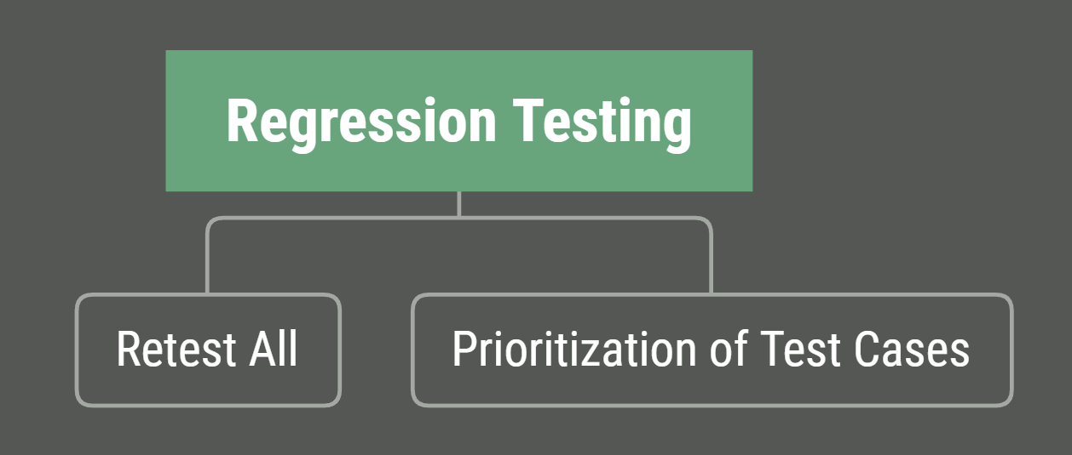
Figure 35 Regression for Software Integration Test Overview
All test cases are automatically re-executed with each official release (Retest All).
Execution Order: test cases with higher priority will be executed before test cases with lower priority (Critical à High à Medium à Low)

Retest All
- This is one of the methods for Regression Testing in which all the tests in the existing test suite should be re-executed.

Prioritization of Test Cases
- Prioritize the test cases depending on business impact, critical & frequently used functionalities.
- Selection of test cases based on priority will greatly reduce the regression test suite.

The goal for Regression Test Strategy shall also be, to have as much as possible test automation. Only in case of performance issues, occurring during the automated Software Integration Test execution in the CI environment, a selection and priorization of the test cases must be applied. The evaluation of test results shall focus the high priority test cases and additional test cases, which are again executed after a defect, was solved or a Software Component was changed due to some other reasons

Selection of Test cases needs always to be reconsidered for all iterations (specific time periods, releases). It will be outlined in the Test Schedule and is part of the activity “Plan Test Activities”. This schedule will evolve based on project situation and respects circumstances which effects the testing, e.g. availability of Hardware.

For the selection of Test cases the Software Test Lead is considering the Feature Release Plan, Master Timing Plan, Defects, CRs, … and also the Software Integration Test Strategy.

Selected Testcase based on criteria defined for the Input Workproducts.

Criteria to select test cases includes
- the coverage of new or changed requirements
- the coverage of change requests
- the coverage of item changes
- the consideration of dependencies, based on the analysis of changes (e.g. causal chain analysis)
- the re-verification of found defects
- the selection of appropriate test cases for regression testing including a set of test cases selected as a basis set to be executed.

Software Test
The test item is the integrated software. The purpose of the Software Test process is to verify the integrated software against the Software Requirements Specification.

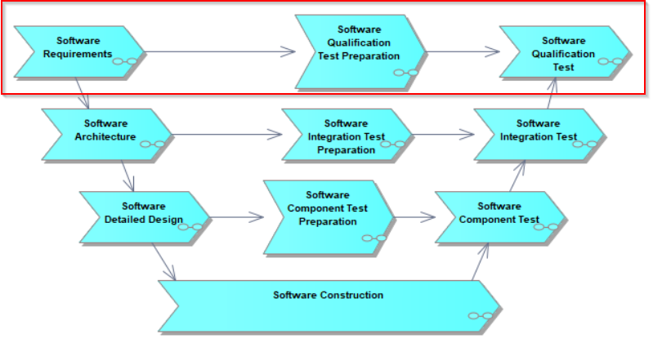
Figure 12: SWQT – Related GPEP process

Test Objective
The Software Qualification Test (SWQT) shall verify the compliance with specified functional and non-functional Software Requirements.
For each testable SW requirement, test cases shall be generated based on the verification criteria. At least one test case for a SW requirement shall be defined. If it is appropriate, negative test scenarios shall also be defined. Test Cases in SWQT shall be consistent with Software Requirements.

Test Goal:
- 100% coverage of the reviewed SW Requirements
- At least 90% of total available SWQT tests shall be automated. Test Cases shall be automated as far as possible to improve comparability of test results and to reduce test execution efforts.
- The goal must be to execute SWQT on the final hardware configuration.
All test cases shall be implemented by a different person than the person who has implemented the interface which is to be tested.
Bi-directional links between Software Requirements and Software Qualification Test Cases shall be established.

Selection of Test cases needs always to be reconsidered for all iterations (specific time periods, releases). It will be outlined in the Test Schedule and is part of the activity “Plan Test Activities”. This schedule will evolve based on project situation and respects circumstances which effects the testing, e.g., availability of Hardware.

For the selection of Test cases the Software Test Lead is considering the Feature Release Plan, Master Timing Plan, Defects, CRs, … and the Software Integration Test Strategy.

Selected Testcase based on criteria defined for the Input Workproducts.

Criteria to select test cases includes-
- the coverage of new or changed requirements.
- the coverage of change requests
- the coverage of item changes
- the consideration of dependencies, based on the analysis of changes (e.g., causal chain analysis)
- the re-verification of found defects.
- the selection of appropriate test cases for regression testing including a set of test cases selected as a basis set to be executed.

Test Scope

In Scope

The Software Requirements Specification is a direct input for SWQT, the test engineer shall review the requirements and analyse the testability and Verification Criteria together with SW Requirement Engineer. A Requirement shall not reach Reviewed state without this step completed.

SW Qualification tests (SWQT) are black box tests. There shall be a mechanism provided to access SW internal parameters (Ex: via XCP). Therefore, Reviewed Software requirements with “Required Test Type” set to “Software Test” and “Testability” is set as “Yes” are in the scope of software test.

For, SWQT of below base software features are in scope and the MLF planning items with planned release (containing) has the targeted requirements.
- Vehicle Communication
- Diagnostics
- Flashing
- Ecu Handling

Not in Scope
Reviewed Software requirements with “Required Test Type” set other than “Software Test” and “Testability” field set as “No”, are not in the scope of software test.

For SW requirements that cannot be tested at SWQT level and is only possible at System test level, Required Test Type shall be set to “System Bench”. Therefore, such SW requirements will not be in the scope of SWQT.

For Software Testing of Customer functions is not in the scope due to unavailability of Software requirements

Test Item(s)

Software Qualification Test Preparation
A Test Case is a set of conditions or variables under which a tester will determine whether a software under test satisfies requirements or works correctly. The process of developing test cases can also help find defects in the Software Requirements Specification.

Software Qualification Test Specifications are defined in DNG Integrity tool as Document Item.

Test Preparation is concentrating on two main activities:
- Create Test Cases based on Input Data (Software Requirements)
- Create Test Script base on Test Cases Description

Test Case Design
The main purpose of test design techniques is to test the functionalities and features of the software with the help of effective test cases.

Test Cases shall be based on the agreed verification criteria of the Software Requirement

Test Cases shall be designed in such a way that they are independent of each other. (i.e., mutual dependencies are not allowed)

If applicable, test cases shall be designed or structured in such a way that the number of tests that validates an atomic requirement is less than 10.
Mandatory attributes that shall be filled in a test case specification are:
- Category – Identifies the test level. Here, it is Software Qualification Test
- Assigned User – Responsible test engineer.
- Text/Description – A clear, unique short summary of Test goal.
- Preconditions - preconditions required for a test to be carried out. Failure or error in these steps results in the test result verdict as Test not executed.
- Test Sequence – Step by step procedure to set inputs and check the outputs.
- Expected Results – Expected results for all the check steps in “Test Sequence.”
- Postconditions – Postconditions to restore the test environment to a normal state.
- Validates – List of requirements that the test case validates. Here, SRS IDs
- Status_fld – State of the test case. Values for this attribute shall be set according to the section Status_fld attribute
- External ID – Automation status. Values for this attribute shall be automated, manual, semi-automated.
- External Script Name – Test script reference to Automated/Semi-Automated test cases.
- ASIL Method – Selected ASIL test technique (like, boundary value analysis, Equivalence class partition, etc.)
- Priority – Execution priority of the test case as defined in the section Test Priority.

Test Methods
For designing the TC for SWQT, following tables shall be used (Refer FuSa Strategy document for more information) for both QM and ASIL features. Negative test Scenarios shall also be considered where applicable.
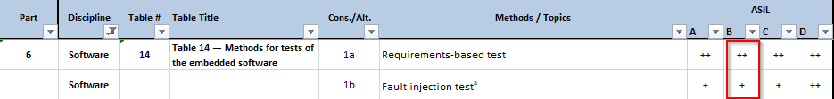
Table 13: SWQT - Methods for Tests

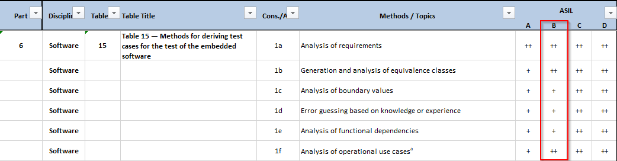

Table 14: SWQT - Methods for deriving TC for SW testing

Test Script Design
Test Script is a set of instructions (written using a scripting/programming language) that is performed on a software under test to verify that the software performs as expected. Test scripts are used in automated testing.

Test Cases shall be automated in such a way that the execution of test case has no impact on other test case execution (i.e., No mutual dependencies are allowed. However, a test case can be used as a precondition to another test case, if this does not otherwise influence the test result)
Figure 13: SWQT – Test Script Design Procedure
Base on Test Cases from
Base on Test Cases from PTC
Test Script are created.
Test Execution Suite is generated

Test Scripts are written in vTESTstudio and then be converted to executable files which are supported by CANoe environment. Also, test scripts designed in CAPL as part of CANoe tool from Test Cases are described in DNG Integrity document (‘Test Suite’).

Test Scripts (.vtt, .,. can) shall be stored in GIT repo.

Bidirectional Traceability
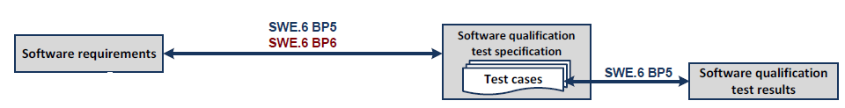
Figure 14: SWQT - Bidirectional traceability and consistency
Software Requirements in the Software Requirements Specification [SRS] shall be linked with Test Cases included in the Software Qualification Test Specification [SQTS]
- Each testable requirement shall have a Test case defined and traced by DNG trace/linkage. Traceability to Software Requirements shall be established via DNG field “Validates”.
- Traceability between Test Script and Test Cases using attribute “External Script Name” in test case
- The test case implementation done in chosen Test Tool e.g., vTESTstudio is to be synchronized by referring the Test Case ID, defined by DNG-Integrity
- Results of Software Qualification Tests shall be recorded by each documented test run (DNG Item Test Session) and be linked to the related Software Qualification Test Cases.

Bi-directional traceability shall be assured and demonstrated by review records.

Software Qualification Test Execution

Test execution is concentrating on below activities:
- Create Test Objective and Test Session in DNG
- Execute Test Cases and Upload the Test Result
- Analyze failed TC and Create Defect.

All the test cases shall be executed on target-based hardware.

Create Test Objective and Test Session
A “Test Plan” item defines overall testing scope for a specific release containing one or multiple test Objectives. The “Test Plan” is for single project which is selected during creation of the item. “Test Plan” item will be created before the Release being available and shall be done in the Test preparation phase.

Test Objective is created by Software Test Manager in DNG Integrity for planned release.

Test Objective Item contains a group of Test Session Items that must be tested for a specific release.

Execute Test Suite, Analyze and Upload the Test Result
The selection of test cases for execution shall be based on the regression strategy defined in the section Regression for Software Test.

Test Session shall be created for each targeted release by the test engineer and relationship shall be established to test objective in DNG.

After the execution of test cases, test reports are generated and are stored in DNG. The test engineer shall provide the Build ID, Test Environment, Verdict, Annotation for each test result, Relation to Defect for failed test cases in the test sessions.

Analyze failed TC and Create Defect
After the test execution, the test engineer shall analyze the failed Test Cases and identify the root cause of the test fails.
- If the failure is a consequence of Input data (SRS) change, the test engineer is responsible to update the Test Case and the Test Script according to the new changes.
- If the failure is due to incorrect implementation, the test engineer shall create a Defect Item in DNG and relationship to failed test case shall be established.

Defect workflow as mentioned in the below document should be followed:
Defect Management Strategy

All the possible logs shall be attached to the defect, which in turn helpful to the defect pre-analysis team to identify root cause of it.

Test Criteria

Test Entry Criteria
To start the Software Qualification Test process following input artifacts must be available, at least in partly state

Entry Criteria for test preparation | Typ
DNG Tasks (with clear inputs) from FO or SW Test Lead | DNG
Software Requirements Specification | reviewed requirements in DNG
Table 15: SWQT – Preparation Entry Criteria

Entry Criteria for Test Execution | Typ
DNG Tasks (with clear inputs) from FO or SW Test Lead | DNG
Test suite (in DNG) and Test Scripts (in Git) | Test specifications at least in reviewed state and pull request approved in Git
Test Objective and test Session- Assigned state | DNG
Software Qualification Test Environment | Refer section Environment Requirements
Release SW | Release email from SW Integration lead that specifies the path to SW in DNG and any limitations already identified.
Table 16: SWQT – Execution Entry Criteria

Test Exit Criteria

Exit Criteria for Test Preparation | Typ
DNG tasks | in completed/verification state
Test Cases (in DNG) and Test Scripts (in Git) | at least in reviewed state and pull request approved
Bidirectional traceability between SRS and SWQT specifications | DNG
Review Record closure of Test Specification and Test Scripts- Cross Functional Review | Checklist in DNG
Table 17: SWQT – Preparation exit Criteria

Exit Criteria for Test Execution | Typ
Software Qualification Test Reports | DNG
DNG tasks closure | DNG
Software Test Summary Report | Released in DNG
Test Objective and test Session | Completed State
Table 18: SWQT – Execution Exit Criteria

Pass-/Fail Criteria
The Pass/Fail Criteria for the Software Qualification Test provides information to decide if it is applicable to execute the next following test level

Test type | Criteria
 | Passed | Failed
Specification-Based Software Qualification Test | Observed behavior is the same as expected behavior | Observed behaviour is not the same as expected behaviour
Table 19: SWQT – Pass/Fail Criteria
Note: the applicable blow error will be mentioned in defects if applicable
Observed behaviour is not the same as expected behaviour, the reason will vbe mention in defects with
error types: division by zero, overflows,
value range violations, infinite loops, type mismatches, initialization errors, unauthorized access,
unreachable code.

Test Completion criteria
When test goals and test exit criteria are achieved for a release, then it shall be considered as test completed for the target release.

Suspension, Resumption and Abort Criteria
The Software Qualification Test shall be aligned with the. Abortion shall happen based on project management decision. The test execution can be suspended due to major needed defect resolution and can be resumed if this fixing phase was done and confirmed by the responsible software developer.

Test Deliverables
Test Deliverables are the test artifacts which are given to the stakeholders of a software project during the SDLC (Software Development Life Cycle)

Test deliverables:
- Test specification
- Automated scripts
- Test plan
- Communication records, if applicable
- Review records
- Traceability records
- Test results
- Test Summary report for a release
- Analysis reports (defects)

# | Test deliverables | Stakeholders
1 | Test Specifications document | Software Test Lead  QA Engineer  Software Requirement Engineer  Software Architect  SW Integration Test Lead  Software Test Engineer
2 | Test Plan document | Software Test Lead  QA Engineer  Software Requirement Engineer  Software Architect  SW Integration Test Lead  Software Test Engineer
3 | Test Strategy | Software Test Lead  QA Engineer  Software Requirement Engineer  Software Architect  SW Integration Test Lead  Software Test Engineer
4 | Review record | Software Test Lead  QA Engineer  Software Requirement Engineer
5 | Defect Record | Software Test Lead  Software Requirement Engineer  Defect Manager
6 | Test result | Software Test Lead  Software Requirement Engineer  Software Architect  SW Integration Test Lead  Software Test Engineer

Environment Requirements

Testing Environment

Selected Test environment from the below table is 1b (ECU network environments and RBS simulations)

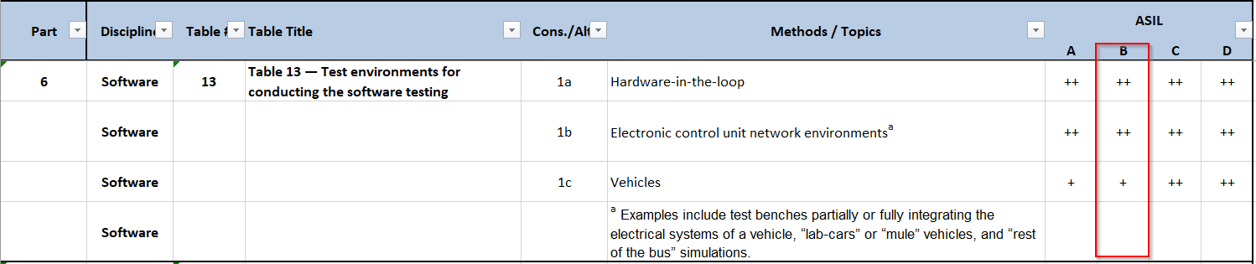

Table 20: SWQT – Test Environment
SWQT are black box tests and therefore, Lauterbach debugger mentioned here is not applicable for test purpose itself and may be used only for flashing the binaries until PDX flasher is available. It is only applicable for Software Integration testing.
Additionally, Cheetah/Beagle are not mandatory tools, but however, these are presented here if there are any scenarios in future that require these tools to drive and analyse the serial bus signals if any.

Testing Tools
Tool | version
DNG Integrity | v11.0
CANoe | v15.0
vTESTstudio | v6.0
Gliwa | Under discussion
ODX/PDX flasher
ODIS
Table 21: SWQT – Testing tools
Additional Scripting tools like Python, C#, Git, Jenkins to support Automation and continuous testing.

DNG Integrity Tool is used for:
- Configuration management to store the Input Data Items or Document.
- Create traceability between SRS and SWQT Test cases.
- Store the result of execution process.
- Store and generate Test Metrics.
- Review Checklists
vTESTstudio used for:
- Creating the Test Script based on Test Case Specifications.
- Create Test Execution Suite.
Canoe used for:
- Execute Test Suite
- Generate test report base on execution of the Test Suite
Git used for:
- Git Repository is used for storing the vTESTstudio scripts

Note: SW Test team not required to test with ODIS

Test Metrics
Progress of Software Qualification Test Process, measured daily/weekly
- Amount of software requirements covered by SWQT
- Amount of Test Cases (in the state draft, proposed, reviewed)
- Amount of Test Cases automated
- Amount of test cases (in the state reviewed) executed for a release
- Pass/Fail status of test cases
- Number of defects identified and defect rejection ratio.

Assumptions and Constraints
Assumption is that there shall be an external interface available (via XCP or Diagnostics) for all input/output parameters specified in the requirements.

Constraints: As there are no external SW interfaces for functionalities on A-Core processors, black box test might not be possible and therefore tests must rely on using debugger. However, this is not a standard rule and depends on case to case and shall be identified during SRS reviews.

Stakeholders
A stakeholder is an individual or group that has an interest in the software under development, for our project we defined below the list of Stakeholders involved in Software Qualification Test level.

Nr. | Stakeholder’s position
1 | Program Manager | Test Results and at least the defects with Priority Critical/High for each release.
2 | Defect Manager | Incident records for failed Test Cases via defect.
3 | FO / Developer | Test Results and at least the defects with Priority Critical/High for each release.
4 | Quality Engineer | Quality of the software deliverables and software test process.
5 | FUSA Engineer | All ISO26262 related activities.
8 | Configuration Manager | Released state of the DNG Items.
9 | Integration Team | Test Results and at least the defects with Priority Critical/High for each release.
10 | Software Requirement Team | Provides the SRS needs to be informed about the deviation between source code and SRS. To update SRS´s and to Baseline them if required.
11 | System Test Lead | Test Results and at least the defects with Priority Critical/High for each release.

Table 22: SWQT - Stakeholders
The communication with the stockholders is done via Mail, Teams and DNG.

Reporting Tool
DNG Integrity is the reporting tool used for this project and test summary reports are generated out of test sessions in the test objective.

Test Report Summary shall be created for each release and the report is stored in DNG.

For the report metric, a custom script is used that collects the data from Test Objective and generate a report for SWQT.

The content of the test report includes but is not limited to the following:
- Test Session ID
- Test Case ID
- Related Requirement ID(s)
- Test Case Summary / Title
- Priority / Classification
- Test Environment
- Test Pass Criteria / Expected Result
- Test Result (Pass/Fail/Skipped)
- Defect ID
- Result Comment from tester from test session
- Rating of Feature

Regression for Software Test
The goal for Software Qualification Test is to have as much as possible test automation. Only in case of performance issues, occurring during the automated Software Qualification Test execution in the CI environment, a selection and prioritization of the test cases must be applied.

Prioritization:
- Safety/critical test cases will always remain high priority irrespective of automation state (i.e., tests with Priority set as high or critical)
- Functionalities that have been changed
- Fixed defects related to test cases and the features which are affected due to the change
- Modules that have frequent defects

Apart from above scenarios, All Automated Test cases will be targeted for Regression runs. Only in case of performance issues occurring during the automated Software Qualification Test execution in the CI environment or timing constraints, a selection and prioritization of the test cases must be applied.

Due to timing constraints, it might be sufficient to execute only the changed components in the internal intermediate releases. For every customer release, no such exceptions are allowed, and full test suite is required to be executed.

Selection of Test cases needs always to be reconsidered for all iterations (specific time periods, releases). It will be outlined in the Test Schedule and is part of the activity “Plan Test Activities”. This schedule will evolve based on project situation and respects circumstances which effects the testing, e.g. availability of Hardware.

For the selection of Test cases the Software Test Lead is considering the Feature Release Plan, Master Timing Plan, Defects, CRs, … and also the Software Integration Test Strategy.

Selected Testcase based on criteria defined for the Input Workproducts.

Criteria to select test cases includes
- the coverage of new or changed requirements
- the coverage of change requests
- the coverage of item changes
- the consideration of dependencies, based on the analysis of changes (e.g. causal chain analysis)
- the re-verification of found defects
- the selection of appropriate test cases for regression testing including a set of test cases selected as a basis set to be executed.

Regression for Software Test Overview:

Figure 35 Regression for Software Integration Test Overview
All test cases are automatically re-executed with each official release (Retest All).
Execution Order: test cases with higher priority will be executed before test cases with lower priority (Critical à High à Medium à Low)

Retest All
- This is one of the methods for Regression Testing in which all the tests in the existing test suite should be re-executed.

Prioritization of Test Cases
- Prioritize the test cases depending on business impact, critical & frequently used functionalities.
- Selection of test cases based on priority will greatly reduce the regression test suite.

The goal for Regression Test Strategy shall also be, to have as much as possible test automation. Only in case of performance issues, occurring during the automated Software Integration Test execution in the CI environment, a selection and priorization of the test cases must be applied. The evaluation of test results shall focus the high priority test cases and additional test cases, which are again executed after a defect, was solved or a Software Component was changed due to some other reasons

Testing activities and estimates

Below, a general work breakdown structure for the necessary testing activities based on the test process. Every listed activity applies separately for the Test Levels Software Unit Test, Software Integration Test and Software Qualification Test.

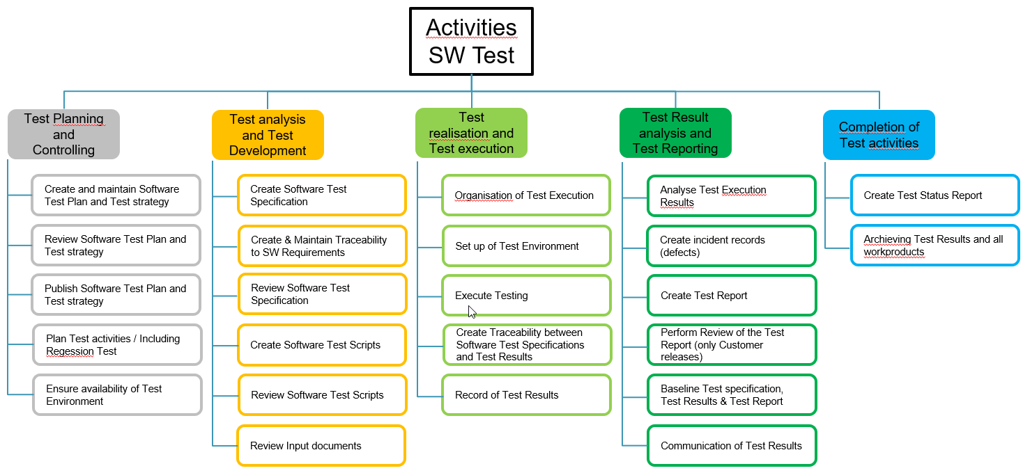

Activities can be found in GPEP but also listed in RASIC

The Software Test activities are organized and scheduled via DNG Test Plan Items / Test Objective Items / Test Session Items and corresponding Tasks.

Below are the IAST standard estimates for the identified test activities on each level. These are the primary KPIs used for effort estimation. As a minimum, the standard estimated test cases for a requirement to be verified is two test cases covering positive and negative scenarios.

Effort estimation for Component and Integration Tests
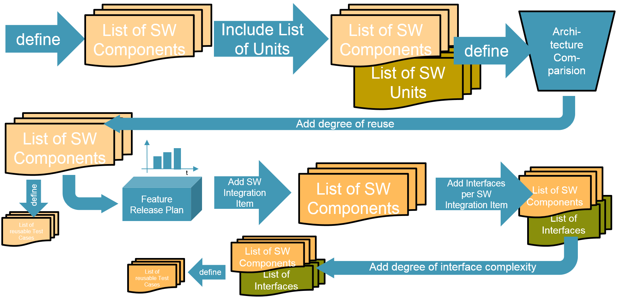

- Based on architectural design is defined
- For already available, reusable Software Components the List of Units can be added for each Software Component. The static code analysis should provide up to date information for currently implemented Software Units.
- Determine degree of complexity and reusability for each Software Component
- Check for already available Software Component Tests to be integrated in the project (to integrate them in the CI process)
- Software Project Management needs to clarify together with Software Architect about required.
- Define which Software Components belongs to a Software Integration Item.
- Add required interface definitions to the List of Software Components
- Add information about interface complexity.

For better understanding, these activities shown, are not executed sequentially in every case. It is always useful to fill in the List of Software Components all already available information.

Effort estimation for Software Qualification Test
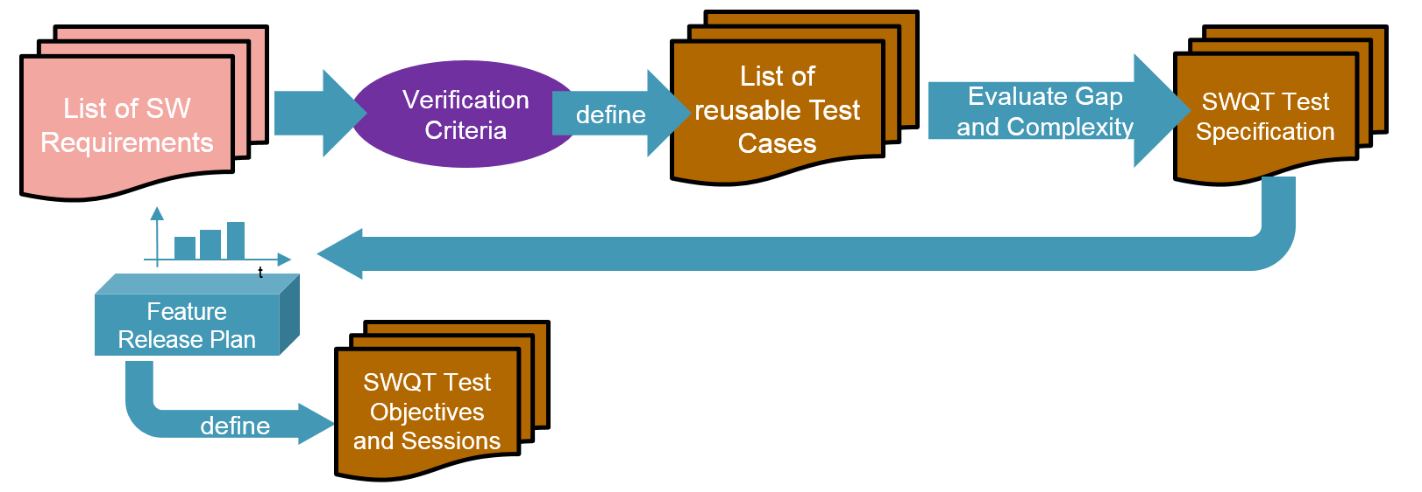
- Evaluate the available Software Requirements, including the defined verification criteria to check about possible reusable existing Test Cases
- Define the gap between existing and newly to be specified Test Cases
- Evaluate the complexity of Software Requirements to perform SWQT Test specification.
- Use the Feature Release Plan to define required Test Objectives
- Define to be executed Test Cases per Session (use placeholder, if Test Cases are not specified yet)
For better understanding, these activities shown, are not executed sequentially in every case. It is always useful to fill in the List of Software Components all already available information.

Staffing

Roles, activities, and responsibilities

Hiring needs

Base SW: SWIT and SWQT are covered with SOW to

Core: Responsible for core functionalities and therefore no hiring is needed in this context

App Features: SWIT and SWQT are covered with SOW to LLTS, India

Training needs
IAST Process and Strategy trainings are needed by Supplier. On-job training or briefing sessions are done based on the need.

Testing Communication
This Chapter describes communication within the Project, it outlines for the Test Item activities who is involved or need to be informed. Usually these communication happens via Email or Meetings.

The picture below shows the usual counterparts of the Test Team.

Test Case Design
- Before Test Specifications were written
  - 1. Test Cases base depending on Testlevel on Software Detail Designs usually provided by Development, Software Architecture Designs usually provided by Software Architect and Software Requirement Designs usually provided by Software Requirement Engineers and/or FO. For functional safety related topics on all levels the FuSA engineer shall be involved. While Review meetings the Input will be checked on Quality and Completeness.
  - 2. Further communication between the Test Team and Input provider needs to be done mainly about Planning (e.g., Implementation), deepen Understanding and Clarification of provided Input to be able to create proper Test cases.
- While Test Specifications were written
  - Status of progress for writing Test Specifications based on provided Input will be informed regularly to SW Lead/ PM
- After Test Specifications were written
  - Created Test Specifications needs to be reviewed by involving for Software Unit Testing the Developer, Software Integration Testing the Software Architects, Software Qualification Testing the Software Requirement Engineers and/or FO. For functional safety related topics on all levels the FuSA engineer shall be involved. Additionally, the QA Engineer should participate to Review Meetings for Test Specifications.

Test Case Execution

- Before Test Execution
  - Based on communication, release Plan and implementation status with SW Lead/ PM and FO the selection of Test cases needs to be specified, to organize the Test execution
- After Test Execution
  - Test Results will be analyzed and correspondingly defects could be identified and needs to be informed to Defect Manager. In case of needed clarification for the defect raised by SW Test Team Defect Manager will contact corresponding Tester.
  - Test Results which are summarized in the Test Report needs to be communicated to all stake holders, before the Test Report will be reviewed according to the process by inclusion of QA Engineer, SW Lead/PM (only for official releases)
  - Communication of Test Report to whole SWTeam (including also the FUSA Engineer) to be informed about status of their functionalities, higher Test Levels (e.g. Software Qualification Test Team informs System Integration Test and System Test) to be informed already about critical issues or gaps in Software/functionalities which could effect the testing on the higher level, SW Lead/ PM to be able to adopt were necessary the planning and reaction on short notice.
  - Communication of Test Report to Customer, either by Software Test Team or by SW Lead/PM

Schedule

Test Planning/Timeline
- The Software Test activities are planned based on FRP plan.
- The Software Test activities are planned based on FRP plan and test schedule updated.
- The Software Test activities are planned based on FRP plan and test schedule updated.
- For the Test Planning for each release, Test Plan DNG item is created where test objective is linked and ultimately test sessions are created and linked to Test objectives.

The time to start the test and to end the test should be documented in the test session, as an item in DNG having workflow.

Open Question

It must be possible to execute each test case independently. Mutual dependencies of test cases on
each other are not allowed. The set up of test chains to fulfill the test preconditions of lower level
test cases is permitted, provided that this does not otherwise influence the test result.
Black-box tests must be specified before white-box tests.

If more than 10 test cases are necessary for verification of a requirement, the quality of the require-
ment must be assessed (e.g., check if it is atomic). If the requirement cannot be improved, an appro-
priate structuring of the test cases must be used
Each test result must be documented (e.g., "ok", "not ok").

Each requirement must be verifiable by at least one dedicated test case on its level

Software Test Completion

Archive Software Test Assets
The Software Test Team shall
- Identify for each test level all important test cases to be executed during regression tests
- Document the used tools and maintain HowTo documents how these tools were used in the Software Project
- Make sure all test assets are stored in DNG Integrity
- Apply a Baseline in DNG Integrity

Clean Up Software Test Environment
The Software Test Team shall
- Provide any local stored documents, tools or testing implementations and to be checked-in in DNG-Integrity
- Make sure not maintained documents are updated
- Make sure the installation of testing environment is documented and can be reinstalled easily

Identify Lessons Learned
The Software Test Lead shall
- Invite for and execute a lesson learned meeting.
- Generate DNG items for Lessons learned
- Provide a Lessons Learned Overview
The Lessons Learned session shall record about
- Issues during software test project setup phase (e. g. missing requirements, missing resources, …)
- Issues during test execution (e. g. tooling issues and workarounds, …)
- Evaluate recorded Software Test Metrics (get feedback about test execution performance, …)
- Customer feedback
- Recommended improvements

Test Completion Report
The Software Test Lead shall
- Collect all required information necessary to restart the Software Test again
- Create links to the documents in the report, which are results of the afore mentioned completion activities.
- Include final set of metrics in the completion report
- Store the completion report in DNG Integrity
- Apply a Baseline
- Provide the Report to the Software Project Manager

Roles and Responsibilities
In this section we will describe the role and responsibilities for every team member of the software test team. This information is centralized from document.
Role | Duties | Competences
Area Manager Test (aka Test Manager) | - Defines overall Test Strategy  - Delivers Test Report to Customer  - Defines Milestones and Shedule  - Monitors test Teams in weekly meetings  - Interface to project management  - Supports on GPEP Standard Process  - Creates Metrics and reports to customer  - Creates Overall Test Schedule  - Monitors Customer Milestones  - Defines Supplier Milestones and Goals  - Assigns the test volumes  - Defines the test strategy on SW Level  - Responsible for the Test process (initialize, planning, controlling, reporting) and the test instances  - Creates the base planning  - Initiates Reviews  - Initiates SW Test Automation  - Creates SW Test Report | - Point of contact for customer as well as Level Test leads  - Aligns Test Strategy with customer and subsuppliers  - Ensures Tool availability  - Organizes the test resources  - Generates the status  - Defines the test environments  - Responsible for formal forms
SW Test Engineer | - Creates the test cases  - Creates Test Designs  - Shares reusable Tests out of Bookshelf  - Prepares the test environment  - Executes the manual tests  - Evaluates the test results  - Documents the results and errors  - Creates and performs automated Test Lists  - Review forms  - Creates Test Scripts  - Creates Automation Strategies  - Shares reusable Test Scripts out of bookshelf  - Modifies Framework functions  - Reviews forms and Test Scripts  - Initializes the test specification and workout of detailed specification | - Defines the test equipment  - Defines the test cases  - Gives advise for test plans and test specifications  - Decides the test run  Continous update on Coding Style Guide and best programming practises  - Fulfil of Skillset and Experience as defined in GPEP role definition for SW Testing  - Experience of all ASPICE defined Test disciplines (-/Software Integration and Software Qualification Test)  - CAPL,Python and C++ expertise, ADAS Domain, C, C++, EA,  - RBS, Debugger, CAPL Scripting, Autosar, RTE, SW integration & Build,  - DNG Integrity, ASPICE, ISO 26262, Cyber Security, SW Integration test, Jenkins, ISTQB  - Deep understanding of Software Testing Tool Vector Cast and VTest Studio and CANOE  - Understanding of operation system from CUSTOMER  - Working to conformity in ASPICE Level 2  - Experience on working in conformity of ISO 26262  - ISTQB Certified Tester - (at least parts of the assigned team)  - Experience with Windchill DNG and Enterprise Architect  - Deep understanding from Architecture and Development  - Knowledge about requirements according to quality and correct functionality on Software  - Knowledge in analysis and evaluation of found defects and feature development for support of SW Development  - Working with GIT and Jenkins

Roles And responsibilities are defined based on the IAST defined RASIC
