PROJECTNAME
VERIFICATION MEASURE

DOCUMENT INFORMATION
Information
Document Id
Document Owner
Issue Date
File Name
File Location

DOCUMENT HISTORY
Version | Rev Date | Description | Prepared by | Approved by | Status
 |  |  |  |  | Choose an item.
 |  |  |  |  | Choose an item.
 |  |  |  |  | Choose an item.
 |  |  |  |  | Choose an item.

Contents
DOCUMENT INFORMATION 2
DOCUMENT HISTORY 2
1. Introduction 9
2. Bi-Directional Traceability 10
3. Test Document: 11
3.1 Overview of Testing 11
3.1.1 Testing Types: 11
3.1.2 Common Attributes 11
4. Validation Scope 15
4.1 In Scope 15
4.2 Out of Scope 15
5. Baseline and Review Process 17
5.1 BASELINE CONCEPT FOR A REVIEW and APPROVAL 17
5.2 REVIEW PROCESS 17
5.2.1 REVIEW TYPES 17
5.2.2 PROCEDURE TO BE FOLLOWED FOR REVIEWS 17
5.2.3 ROLES AND RESPONSIBILITIES DURING THE PROCESS: 20
6. Test Strategy and Validation Methods 21
6.1 System Test Strategy and Validation Methods 21
6.1.1 System Verification 21
6.2 Software Test Strategy and Validation Methods 24
6.2.1 Software Unit Verification (Unit Test) 24
6.2.2 Software Integration and Integration Verification 29
6.2.3 Software Verification 33
7. Open-Source Code/SW Validation 37
8. Test Environment 38
8.1 Test Bench Flow Diagram and Bench Setup View 38
8.2 Hardware and Software Test Tools 38
8.2.1 Hardware Tool 38
8.2.2 Software Tools 38
9. Resource Allocation 39
10. Test Schedule 40
11. Test Reporting and Documentation 41
11.1 Test Reporting and Documentation. 41
11.2 Test Artifacts and Documentation. 41
11.3 Test Report and Test Case Document Naming convention. 42
12. Abbreviation and Definition 43
13. Reference 44

Introduction

Brief about project and highlight process groups in ASPICE Process Reference Model which are in project scope.
Below is the reference ASPICE process model 4.0
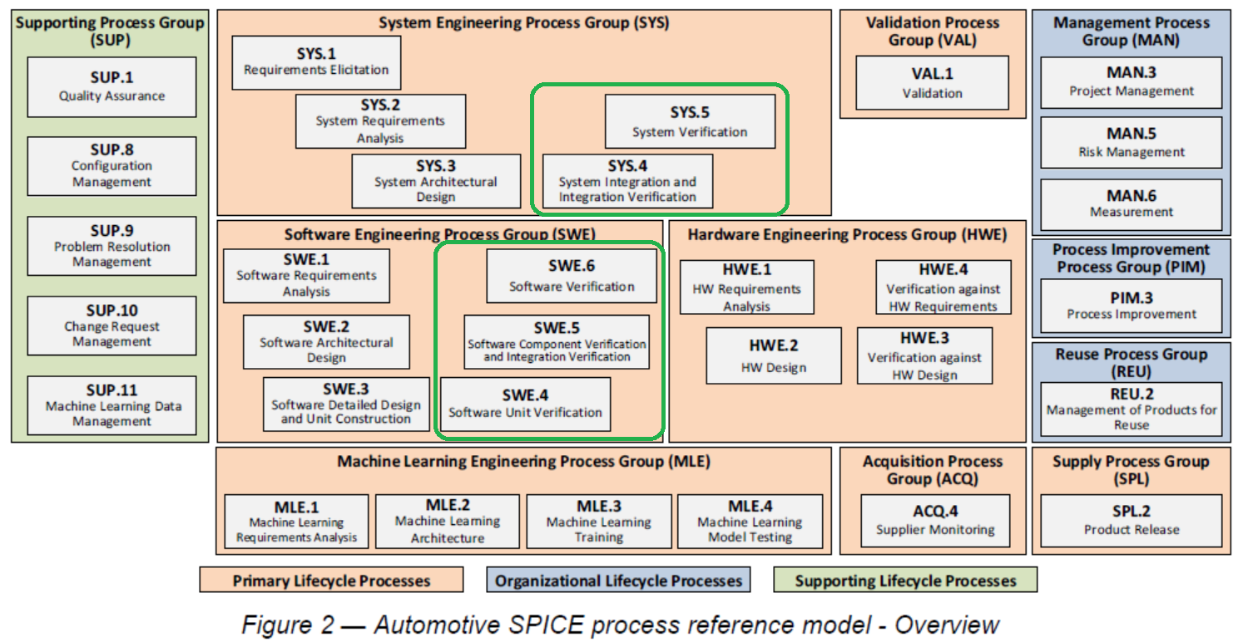

Bi-Directional Traceability
This chapter describes about the traceability of requirements with test cases and test results with respect to particular SW.
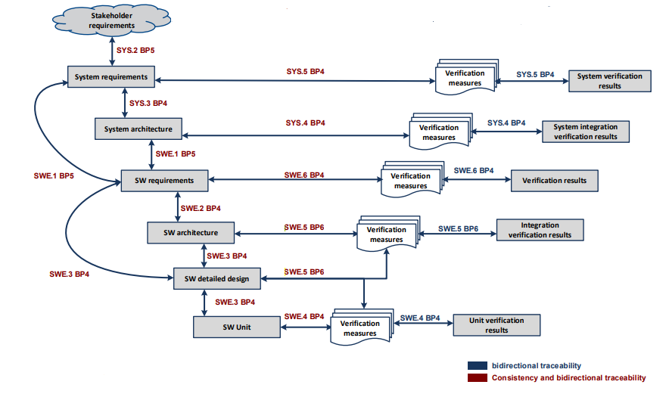

To achieve Bi-Directional traceability below strategy is followed,

- All the SWE.4 Unit test case shall have corresponding SWE.3 Design ID’s (SDD) are mentioned in test case and test script
- All the SWE.5 Integration test cases shall have corresponding SWE.2 Design ID’s (SAD) are mentioned in test case and test script
- all the SWE.6 qualification test cases shall have corresponding SWE.1 Requirement IDs are mentioned in test case and test script
- Similar way we have SYS.4 and SYS.5 tests are mapped for SYS.3 and SYS.2 requirement IDs, respectively.

Test Document:
The following information must be at least available for all test documents:
- Name
- Document History
- Index
- Purpose
- Scope
- References
- Abbreviations
- Test Case Specification

3.1 Overview of Testing
The Testing of PROJECTNAME is divided into two categories:
Level | Description
System Test Cases | Comprise of system testing considering PROJECTNAME as a black box.
Software Test Cases | Comprise of software testing for S32G3. Application software is not in the scope.
Each category will have its own list of documents covering all the related functionalities.

3.1.1 Testing Types:
- System Test Cases:
System Integration and Integration Verification
System Verification
- Software Test Cases:
Software Unit Verification
Software Integration and Integration Verification
Software Verification

3.1.2 Common Attributes
The Test Cases at both the System and Software shall have some common attributes. Following is the list of all the attributes which are common to both levels:

ID:
A unique identifier for the item is automatically generated by Polarion.

Title:
Title or Name of the Test Case.

Author:
Person who initiated this work item

Project Name:
PROJECTNAME

Estimate:
Amount of effort required to perform the test case in Days

Test Level:
We must use the appropriate Test levels below
Test Level
Software Verification
Software Integration and Integration Test
Software Unit Test Case

Test Techniques:
We must use the appropriate Test Techniques as below,
Test Techniques | Description
Requirements Based Test | Where tests are derived directly from the documented requirements
Fault Injection Test | Used when deliberately faults are introduced in the system
State Transition Test | Validating the behaviour of a system when transitioning between different states based on events or conditions
Boundary Value Test | Testing the limits or boundaries of input values to identify errors that occur at edge cases.
Architecture Based Test | Where test cases are derived directly from the document of architecture
Detail Design Based | Where test cases are derived directly from the document of detailed design
Static Code Analysis | Where test case is derived directly from the rules and defects by static code analysis

Automation Status:
The Test Type either Automated or Manual need to select.

Priority:
These attributes are for the priority of the test case
Note: Default Medium, these attributes are handled by Magna

Weight:
Default is 100 this is a mandatory field Magna could add a default value to allow upload into out system
Note: For PROJECTNAME, it’s NILL, Magna will take care of this attribute

Milestone:
This attribute shall define which release we are writing a test case
F1, F2, F3, F4, F4.1, F4.2, F5, F5.1, F6, F7…, and so on

ASIL Levels:
This attribute shall define the ASIL level of the Test case. The following values are possible, as listed in the table:
Value | Description
QM | Select this value if the test case is not safety relevant.
ASIL A | The automotive safety integrity level is A.
ASIL B | The automotive safety integrity level is B.
ASIL C | The automotive safety integrity level is C.
ASIL D | The automotive safety integrity level is D.
If a test case is linked to multiple requirements (SWE.1, SWE.2 and SWE.3) and if they have different ASIL levels, then the Software shall take the high ASIL level of the input requirement, with ASIL D being the highest safety level and ASIL A being the lowest safety level.
Note: if ASIL Levels select any ASIL A or B or C or D, update the attribute of Safety criteria
Status Field:
Various states during lifecycle of the system requirement are tabulated below:
Value | Responsibility | Description
Draft | Author | The Test Case is with the author for the initial draft.
In Progress | Author | The Test case is in progress.
In Review | Author | The Test Case is with the reviewer(s) to give review findings.
Rework | Author | The Test Case is with the author for rework.
Reviewed | Test Lead | The Test Case has been reviewed internally by IAST.  Test document baseline is required.
Released/ External review | Test Manager | The Test Cases and test spec are released to the customer.
Approved | Test Manager and Quality team | Test Case(s) is/are executed and passed for corresponding release  All related system/software Test Cases are released / approved.
Rejected | Test Manager | The reviewed/ approved/ released Test Cases is rejected by IAST or by customer.
Deferred | Test Manager | The Test Case is deferred by IAST or by customer. The Test Case could be used for future release.

STATUS FLOW DIAGRAM IN POLARION FOR V & V.
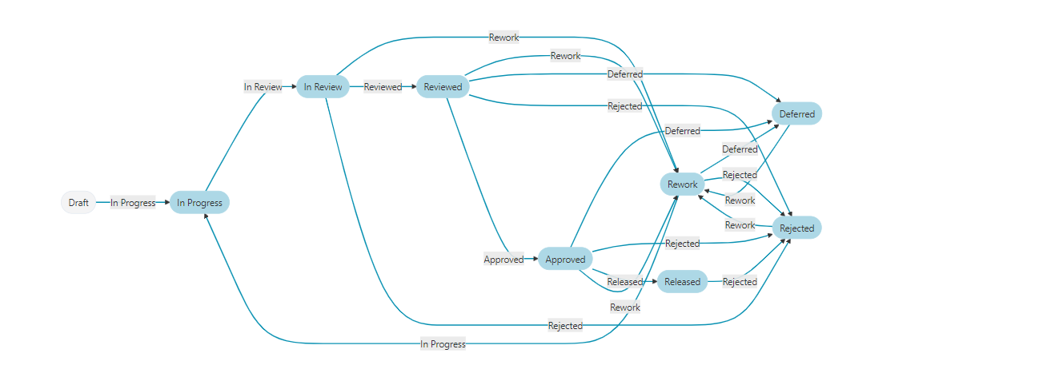 Transitions/ life cycle of the Test Case
Description:
The name of the Test Case should be proper

Scope:
Overview of the test case.

Pre-Conditions:
Pre-Conditions of the Test Case.

Test Step Description:
Action steps of the test case.

Expected Results:
Expected Results as per the test description steps.

Post-Conditions:
After the test execution conditions.

Safety Criteria:
Update the conditions as per the ASIL Levels.

Test Records:
Test Results (Pass/Fail) should be attached.
For Manual Test Results: Step-by-step screenshots document.
For Automation Test Results: Automation Script log or HTML Report.

Validation Scope
Below section and table of contents describe areas that are In-Scope and Out-Of-Scope of validation.

4.1 In Scope
Below table defines the test area’s In-Scope for IAST V&V team based on the DIA and keeping PROJECTNAME’s BSW level as scope of validation.
ASPICE | Work Product | Responsible | Tool | Repository/Location
SWE.4 | Software Unit Verification | IAST | Vector Cast | Polarion/GIT Hub
SWE.5 | Software Component Verification and  Integration Verification | IAST | Lauterbach | Polarion/GIT Hub
SWE.6 | Software Verification | IAST | CAPL/Python | Polarion/GIT Hub
SYS.4 (BSW) | System Integration and Integration Verification – Based on Application Availability & Test Infrastruxur availability. | IAST(BSW) | CANoe/CAPL/Python | Polarion/GIT Hub
SYS.5 (BSW) | System Verification | IAST(BSW) | CANoe/CAPL | Polarion/GIT Hub

4.2 Out of Scope
Below table defines the test area’s Out-Of-Scope for IAST V&V team based on the DIA and keeping PROJECTNAME’s BSW level.
Subject to agreement with Magna this scope shall be redefined or shall support Magna testing team.
For the auto-generated code & 3rd Party Code is not under scope of software unit test and same is agreed with Magna.
ASPICE | Work Product | Responsible
SYS.4 (ASW) | System Integration and Integration Verification at PROJECTNAME System Level | Magna (ASW)
SYS.5 (ASW) | System Verification at PROJECTNAME System Level | Magna (ASW)

Adding below screen shot to support above topics for scope of validation for clarity.
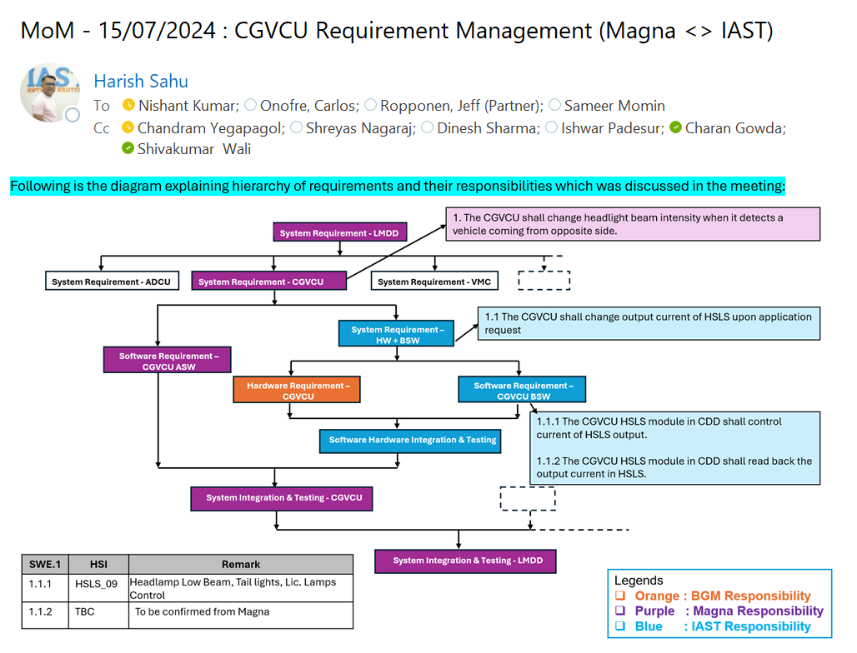

Baseline and Review Process
This section contains details about baselining System/Software Requirements Document.

5.1 BASELINE CONCEPT FOR A REVIEW and APPROVAL
A Requirement Document is baselined before and after the review of work products.
Example:
PROJECTNAME_ModuleName_VerificationReview_SYS.x/SWE.x_SubModuleName_DDMMYYYY
PROJECTNAME_ModuleName_CrossFunctionalReview_SYS.x/SWE.x_SubModuleName_DDMMYYYY
PROJECTNAME_ModuleName_Reviewed_SYS.x/SWE.x_SubModuleName_DDMMYYYY
PROJECTNAME_ModuleName_InternalApproved_SWE.x_SubModuleName_DDMMYYYY
PROJECTNAME_ModuleName_CustomerApproved_SYS.x/SWE.x_SubModuleName_DDMMYYYY

5.2 REVIEW PROCESS

5.2.1 REVIEW TYPES
Review Types | Purpose | Focus
Peer Review/ Verification Review (VR) | Formal review with other members of the appropriate team (i.e. System or Software) to review proposed requirements prior to Cross Functional Review. | Review within your Area / Competency (e.g., SYS/SW Req Review with other SYS/SW Req engineer(s)).
Cross Functional Review (CFR) | Formal reviews are held at a functional team level where functional leads of other teams review the requirements according to their expectations from it. | Review with Roles outside the respective Area / Competency (e.g., SYS Req Review with SYS Arch, SYS Qualification Test engineer, Safety Engineer, SW Req Engineer).
Customer Review | Formal review with customer for approval of work items. | Review with roles outside IAST with customer. The customer shall review the items and approve the items. The same status shall be updated in Polarion at IAST through customer review task.
There shall be three level of reviews:

Note: for Safety requirements if that requirements derived from the ‘Standard’ will undergo a single verification review task, followed by two baseline verification reviews & the reviewed baselines.

5.2.2 PROCEDURE TO BE FOLLOWED FOR REVIEWS

5.2.2.1 VERIFICATION REVIEW
- Author sets the work items from “Draft” state to “Proposed” state.
- After changing the status of the work items in Polarion from “Proposed” to “In Review”, it shall be baselined as – “PROJECTNAME_ModuleName_VerificationReview_SYS.x/SWE.x_SubModuleName_DDMMYYYY” before sharing it for review.
Note: The document shall always be baselined before the review.
- Author shall create the review task in Polarion (Work Item à Review) in which the link of the Verification Review Baseline shall be mentioned, scope of the review shall be defined along with the traceable requirements that needs to be reviewed and assign the reviewer.
Note: The relationship of the review task with the work items shall be “Reviewed”.
- Review checklist shall be updated and attached by the Author in the review task. The status of the review checklist shall be “Draft”. If the status of any of the points in the review checklist is “NOK” then some rationale shall be provided in the remarks section.
- Give briefing session to the internal expert reviewer regarding scope of the work items and inputs for those work items. Inform reviewer about the review task and the target date for completion of review via mail, so that the communication is documented.
- The reviewer shall change the status of the review task from “To Do” to “In Progress”, perform the review and provide feedback against each work item as a fresh comment in the review task.
- After providing all the review findings, reviewer shall change the status of the review task to “Done”.
- Once the review task is in “Done” state, the author can start re-working on the review findings. If not agreed with the review finding, then convince the reviewer and reject it.
- The author shall the change the status of the work items from “In Review” to “Rework” before initiating for rework.
- After rework and consulting with the reviewer, the author shall resolve the review comments provided by the reviewer and change the status of the work items from “Rework” to “In Review” before creating the Cross Functional Review Baseline.
- Create new baseline of work items after the rework has been done as: “PROJECTNAME_ModuleName_CrossFunctionalReview_SYS.x/SWE.x_SubModuleName_DDMMYYYY”.
- Attach one more checklist with the status as “Completed”.
- Author shall request the reviewer to change the status of review task to “Accepted” or “Conditionally Accepted”.
Status | Description
Accepted | Task completed (requirements reviewed, Bidirectional traceability achieved) This is the final state of the review task.
Conditionally Accepted | Task completed (requirements reviewed); traceability not achieved.  The task must be moved from Conditionally accepted to Accepted once the traceability is completed with a new baseline.

5.2.2.2 CROSS FUNCTIONAL REVIEW
- After completion of Verification Review, the author shall create another review task for the cross-functional team.
- Mention the previous baseline “PROJECTNAME_ModuleName_CrossFunctionalReview_SYS.x/SWE.x_SubModuleName_DDMMYYYY” in the description of Cross Functional Review task.
- Author shall mention one cross-functional reviewer’s name in the description of the review task who’ll have the authority to change the status of the review task and scope of the review shall be defined along with the traceable requirements that needs to be reviewed.
Note: The relationship of the review task with the work items shall be “Reviewed”.
- Review checklist shall be updated and attached by the Author in the review task. The status of the review checklist shall be “Draft”. If the status of any of the points in the review checklist is “NOK” then some rationale shall be provided in the remarks section.
- Inform the cross-functional reviewers about the review task via mail, so that the communication is documented and mention the target completion date to provide all the review findings.
- One cross-functional reviewer whose name is mentioned in the description of the review task can change the status of the review task from “To Do” to “In Progress”.
- All the cross-functional reviewers shall perform review of the work items related to the review task and shall provide their feedback.
- Once all the review findings have been provided by the cross functional reviewers then the status of the review task shall be changed to “Done”.
- Once the review task is in “Done” state, the author can start re-working on the review findings provided by the cross-functional reviewers. If not agreed with the review finding, then convince the reviewer and reject it.
- The author shall the change the status of the work items from “In Review” to “Rework” before initiating for rework.
- After the rework and consulting with the reviewers, the author shall resolve the review comments provided by the reviewer and change the status of the work items from “Rework” to “Reviewed” before creating the Reviewed Baseline.
- Create new baseline which is the final baseline of work items after the rework has been done as “PROJECTNAME_ModuleName_Reviewed_SYS.x/SWE.x_SubModuleName_DDMMYYYY” and this final baseline shall be mentioned in the description of the cross-functional review task.
- Attach one more checklist with the status as “Completed”.
- Author shall request the reviewer to change the status of the review task to “Accepted” or “Conditionally Accepted”.
Status | Description
Accepted | Task completed (requirements reviewed, Bidirectional traceability achieved) This is the final state of the review task.
Conditionally Accepted | Task completed (requirements reviewed); traceability not achieved.  The task must be moved from Conditionally accepted to Accepted once the traceability is completed with a new baseline.

5.2.2.3 CUSTOMER REVIEW
- After completion of the Cross Functional Review, the author shall send the documents required for the ReqIF export.
- Once the approval is received from the customer, the author shall create Customer Review task and assign it to self.
- The author shall mention the previous baseline “PROJECTNAME_ModuleName_Reviewed_SYS.x/SWE.x_SubModuleName_DDMMYYYY” in the description of the Customer Review task.
- The author shall link all the requirements with this review task and make sure the traceability is correct.
- The author shall change the status of the review task from “To Do” to “In Progress”.
- The author shall attach the approval status sheet received by the customer then the status of the review task shall be changed to “Done”.
- The author shall change the status of the requirements from "Reviewed" to "Released" then to "Approved".
- The author shall create new baseline as “PROJECTNAME_ModuleName_CustomerApproved_SYS.x/SWE.x_SubModuleName_DDMMYYYY” and mention this baseline in the description of the customer review task.
- The author shall change the status of review task to “Accepted”
- System Information requirements should be “Approved” by the System Team Lead.

Status | Description
Approved / Accepted | Task completed (requirements reviewed, Bidirectional traceability achieved)  This is the final state of the review task.
Conditionally Approved / Accepted | Task completed (requirements reviewed); traceability not achieved.  The task must be moved from Conditionally accepted to Accepted once the traceability is completed with a new baseline.

5.2.3 ROLES AND RESPONSIBILITIES DURING THE PROCESS:
Roles | Responsibilities
Author of Work Product | Creates respective WPs as per release objective and timeline.  Sets the objective of the review.  Provides revie w artifacts and supporting documents for review.  He /she may identify additional mandatory reviewers (apart from what are defined)  Implement the review findings.  Reworks on the artifacts.  Asks for WP approval after the review.  It is possible that Author can also cover the moderator role.
Moderator/ Requirement Manager | Ensures the mandatory reviewers are identified and informed about the review objectives and the review timelines.  Organize review meeting as per the timeline, ensures all the reviewers are prepared with the review feedback.  Ensures the review is focused on its objectives.  Resolve Review Conflicts.  Ensures that all the findings are recorded, Review checklist is filled, rework is completed and tracked to closure.
Reviewer | Reviewer checks the WP including the Checklist Questions  Reviewer documents review findings in the checklist (“Checklist” and “Review Findings” Tabs)  Only after the reviewer has updated his/her comments in review checklist he/she can close the Review Task (Task ID should be included in the Checklist name)  In case of no findings, same should be mentioned in review task “comments” section before closing review task.  Checks for consistency of the WP.
Quality Engineer | Closely supporting Authors and Moderators in setting up a working review process.  Track all required reviews have been performed per release with appropriate resolution.  Checks Implementation of Review findings
Requirements shall have approved/Not approved/ Not Applicable (NA) status from different stakeholders

Test Strategy and Validation Methods
This chapter describes test strategies and validation methods for PROJECTNAME project as defined by ISO 26262 at various level of Automotive SPICE process areas.
Below list is applicable for the M-core side modules.

6.1 System Test Strategy and Validation Methods

6.1.1 System Verification
This chapter describes the purpose and strategy to perform System Verification test and the evidence that the embedded software fulfills its requirements in the target environment. This evidence can be provided by using the suitable results of verification activities.
The scope of system testing is within PROJECTNAME and to achieve the System Verification Testing, Test Application will act as Application Software.
Following shall be states for System Verification Test Cases –
  - Draft - test cases development on going.
  - In-Progress – updating of test steps.
  - In-Review – test cases are assigned for peer review.
  - Re-Work – Close review comments.
  - Reviewed – The Reviewer reviewed the Test Cases and there were no review comments
  - Approved – test cases approved for testing.
To verify that the embedded software fulfils the software safety requirements in the target environment test shall be conducted in suitable test environments as listed in the below table.
The following methods of software testing are specified in part-6 of the ISO 26262 standard.
As the PROJECTNAME is considered as ASIL C product hence,
1a | based on the availability of the HIL Setup at Magna, derived and intended tests for HIL will be performed.
1b | this is considered and feasible test environment option at the IAST location
1c | not considered as it's not under the scope of the IAST V&V team at the PROJECTNAME level

Process Flow:
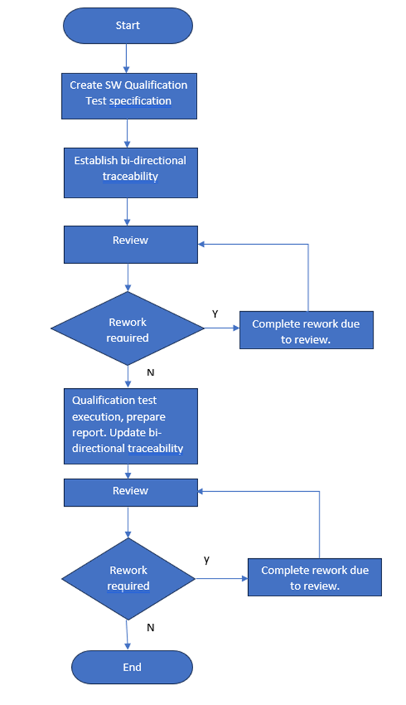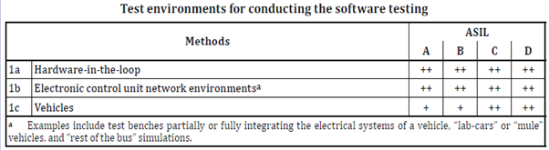
V&V team shall refer to methods from below table ‘1a’ with requirement-based test and ‘1b’ fault injection at possible levels.
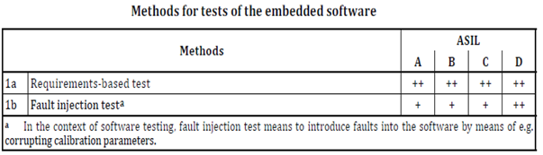
V&V team shall refer below table with ‘1a’, ‘1b’, ‘1c’, ‘1e’, ‘1f’ to derive test cases along tool-generated tests.
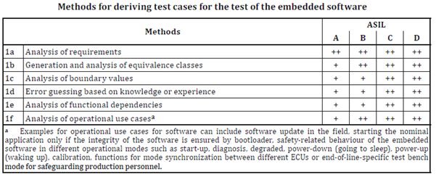
Path for SYS.2 Requirements in Polarion:
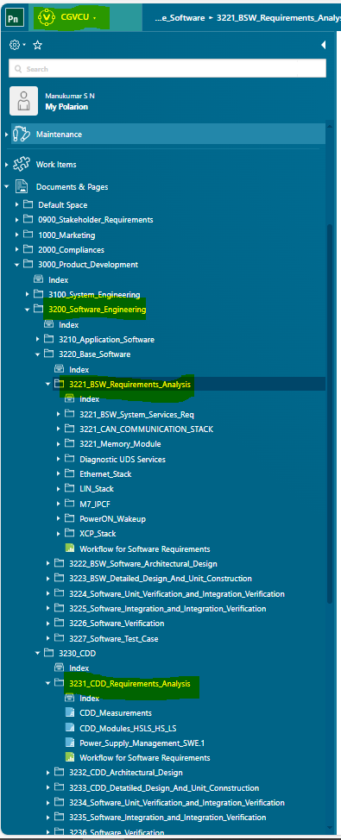
Hardware/Software Tools
Sl. No | Description
1 | CANoe
2 | CANap
3 | S32 Flash Tool
4 | CAPL/Python
5 | Oscilloscope
6 | A-Sample Rev B-Board
7 | IO Expander Board
8 | Exerciser Board

Issue Creation Process:
1. Issue Identification
  - Any deviation from the expected result observed during test execution is treated as an issue/defect.
  - Testers are responsible for raising issues immediately after they are identified.
2. Issue Logging
  - Issues will be logged in the defect tracking in the Polarion tool
  - Mandatory fields to be filled:
    - Title
    - Description (with clear steps to reproduce)
    - Test Case ID (if applicable)
    - Reproduce Steps (Issue reproduce steps)
    - Severity (Impact of the Issue or Defect)
    - Assignees (Module Owner Name)
    - Status (Status of the Issue)
    - Modules (Module name of the Defect)
    - Milestone (Issue raised version)
    - Process Group (Process names like SYS.5 and SYS.4)
    - Priority (Urgency to fix Issue or Defect)
    - Fixed Version (Issue fixed version)
    - Root Cause (From where the issue gets, updated by Assignees (Developer))
    - Comments (If applicable)
    - Linked Work Items (Add the link of Issue related Test case)
    - Hyperlinks (It is for the reference link of the Report and others)
    - Attachments (screenshots, logs, videos if applicable)
3. Issue Classification
  - Severity Levels: Blocker, Critical, Normal, Major, Minor, Trivial
  - Priority Levels: Highest, High, Medium, Low, Lowest
  - Root Cause: Test Design, Test Execution, Calibration, Requirement, Hardware, Software, Tool, Process and Others (If select “Others”, provide the Additional Comments)
4. Issue Assignment
  - Once logged, the issue will be assigned to the development team for resolution.
  - The QA Lead / Test Manager will review and validate proper categorization.
5. Issue Resolution Workflow
  - Open → Accepted → In Progress → Retest → Successful → Closed
  - If the issue fix fails, then the issue is moved to Reopen.
  - If the issue is not proper, then the issue is moved to Reject
  - If the issue is a block of the module functionality, then the issue is moved to Blocked
  - If the issue is not implemented in the current phase, then the issue is moved to the next phase of development.
  - If the issue is a duplicate of another issue, then the issue is moved to Duplicated
6. Issue Tracking & Reporting
- Every Release status report on open, closed, and deferred issues.

6.2 Software Test Strategy and Validation Methods

6.2.1 Software Unit Verification (Unit Test)
Below are the two major area’s which are planned and will be executed at unit level validation
- Perform static code analysis using the Polysapce tool with defined MISRA-C2012guidelines(MISRA-C:2012 guidelines ASILC_for_MISRAC_2012.docx)
- Perform dynamic code analysis using Vector Cast Tool
Inputs for Unit Testing
- All the handwritten source code files along with any dependent source files (includes and defines) – V&V team shall refer the release mail shared by Integrator
Outputs/Deliverables of the Unit Testing:
- MISRA Summary Report
- Statement Coverage (80%) Report – C0
- Branch Coverage (80%) Report – C1
- MC/DC Coverage (70%) Report
- Detailed Status Summary Sheet
Following shall be states for unit test cases –
- Draft - Test cases development on going.
- In-Progress – Updating of test steps.
- In-Review – Test cases are assigned for peer review.
- Re-Work – Close review comments.
- Reviewed – The Reviewer reviewed the Test Cases and there were no review comments
- Approved – Test cases approved for testing.

Process Flow -
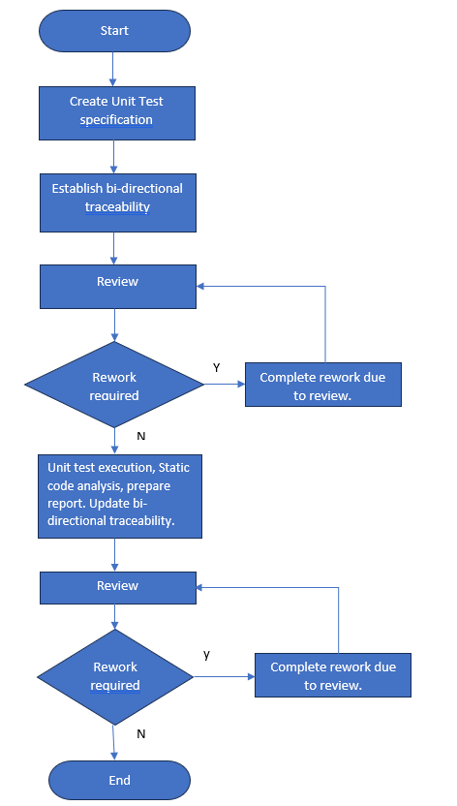
To achieve the objectives for a software (SW) unit test, laid out in ISO 26262-6:2018 Clause 9, it is recommended to follow methods defined in below table before releasing any SW for SW integration testing.
In PROJECTNAME’s ECU product/system falls under ASIL C, hence below table shows the list of methods are carefully chosen to satisfy the right ASIL level.
1a | as defined in the below table this method is not a recommended hence it is not considered.
1b, 1c | parts are not considered for this project as these sections are applicable only for model-based development with generated code
1d, 1e | formal and semi-formal verification. (need to cross check any review’s at development side can be considered as semi formal review?)
1f, 1g, 1h | These areas are considered and covered by V&V team by using the static code analysis tool ‘Polyspace’.
1i | as per the GHS compiler this part implicitly covered and hence no additional coverage is required and not considered, (Control flow and data flow are covered as part of Polysapce tool)
1j, 1k,1l | these areas are considered, which is based on the software detailed design this covered by V&V team by using Vector Cast tool.
1m | unit testing is not run on target hence this area is not considered
1n | we are not performing model generated code and handwritten code comparison hence this is not considered

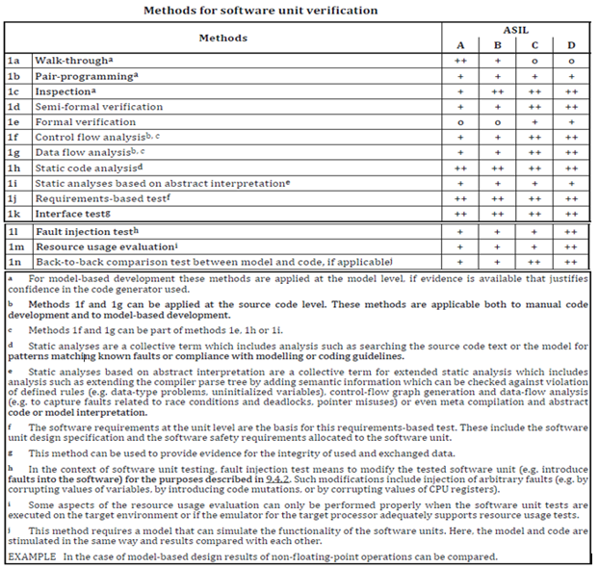‘
- For the auto-generated code it is not under scope of software unit test and same is agreed with Magna.
Validation team shall refer below table with ‘1a’, ‘1b’, ‘1c’ to derive test cases and along with tool generated tests (Polyspace Reports).
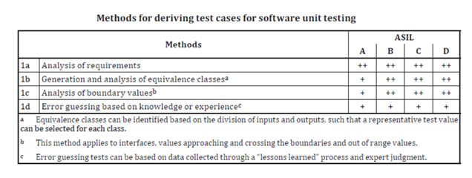
As part of unit testing deliverables ‘1a’, ‘1b’ & ‘1c’ coverage will be achieved through Vector Cast Tool.
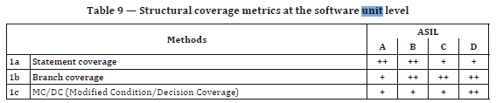
Below list attributes is covered by static code analysis tool (Polyspace tool) which is performed by V&V team and observations will be reported to respective developers.
Sl No | Attributes | Achievable by  IAST
1 | Number of Functions called from Function (Min: 0, Max: 10): | Yes
2 | Cyclomatic Complexity (Min:0, Max: 10): | Yes
3 | Number of Goto statements (max: 0): | Yes
4 | Number of functions calling this function (min: 0, Max: 5) | Yes
5 | Number of Function parameters (Min: 0, Max: 5) | Yes
6 | Comment ratio (Min: 10, Max: 30) | Yes

Path for SWE.3 Requirements in Polarion:
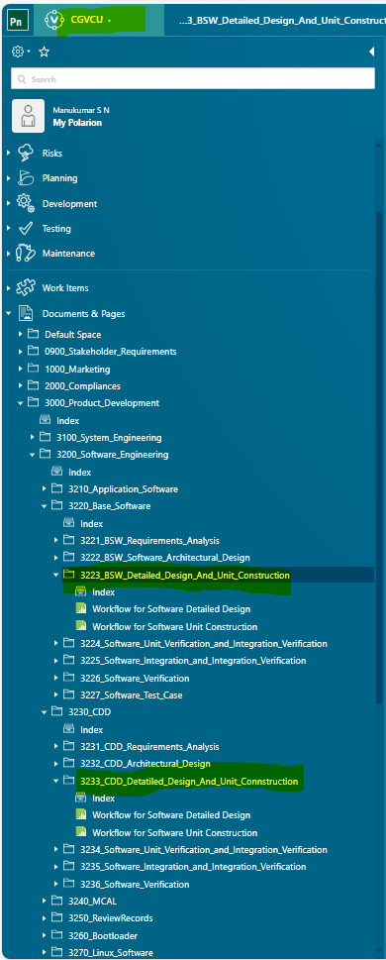

Tools Used:
Sl.No | Description | Location
1 | Vector Cast – Unit Test | NA
2 | Polyspace – Static Code Analysis | NA
3 | GIT | <git hyper link>
4 | Polarion | <polarion hyper link>
5 | SharePoint | CGM USA (Magna New mobility)

Issue Creation Process:
1. Issue Identification
  - Any deviation from the expected result observed during test execution is treated as an issue/defect.
  - Testers are responsible for raising issues immediately after they are identified.
2. Issue Logging
  - Issues will be logged in the defect tracking in the Polarion tool
  - Mandatory fields to be filled:
    - Title
    - Description (with clear steps to reproduce)
    - Test Case ID (if applicable)
    - Reproduce Steps (Issue reproduce steps)
    - Severity (Impact of the Issue or Defect)
    - Assignees (Module Owner Name)
    - Status (Status of the Issue)
    - Modules (Module name of the Defect)
    - Milestone (Issue raised version)
    - Process Group (Process names like SWE.4, SWE.5 and SWE.6)
    - Priority (Urgency to fix Issue or Defect)
    - Fixed Version (Issue fixed version)
    - Root Cause (From where the issue gets, updated by Assignees (Developer))
    - Comments (If applicable)
    - Linked Work Items (Add the link of Issue related Test case)
    - Hyperlinks (It is for the reference link of the Report and others)
    - Attachments (screenshots, logs, videos if applicable)
3. Issue Classification
  - Severity Levels: Blocker, Critical, Normal, Major, Minor, Trivial
  - Priority Levels: Highest, High, Medium, Low, Lowest
  - Root Cause: Test Design, Test Execution, Calibration, Requirement, Hardware, Software, Tool, Process and Others (If select “Others” provide the Additional Comments)
4. Issue Assignment
  - Once logged, the issue will be assigned to the development team via mail communication for resolution.
  - The QA Lead / Test Manager will review and validate proper categorization.
5. Issue Resolution Workflow
  - Open → Accepted → In Progress → Retest → Successful → Closed
  - If the issue fix fails, then the issue is moved to Reopen.
  - If the issue is not proper, then the issue is moved to Reject
  - If the issue is a block of the module functionality, then the issue is moved to Blocked
  - If the issue is not implemented in the current phase, then the issue is moved to the next phase of development.
  - If the issue is a duplicate of another issue, then the issue is moved to Duplicated
6. Issue Tracking & Reporting
- Every Release status report on open, closed, and deferred issues.

6.2.2 Software Integration and Integration Verification
This chapter describes the purpose of the integration test to check compliance with SW architecture checking interface, dynamic behavior, resource consumption according to SWE.2 (software architectural design).
Following shall be states for integration test cases –
    - Draft - test cases development on going.
    - In-Progress – updating of test steps.
    - In-Review – test cases are assigned for peer review.
    - Re-Work – Close review comments.
    - Reviewed – The Reviewer reviewed the Test Cases and there were no review comments
    - Approved – test cases approved for testing.
Process Flow:
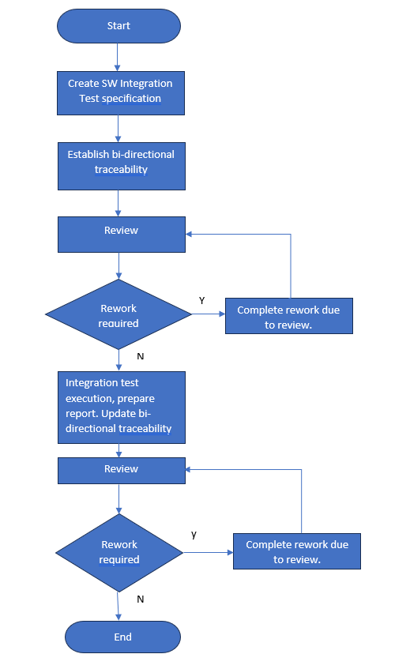
The following table shows methods of software integration testing are specified in part-6 of the ISO 26262 standard and assuming that PROJECTNAME ECU is considered as ASIL C product,
1a | This is considered and for each of the software architecture elements mapped with software requirement (SDD).
1b, 1c, 1d | This is considered and planned with vector cast tool Accelerating Software Testing Thoroughness (vector.com)
1e | we are not performing model-generated code and handwritten code comparison hence this method is not considered
1f, 1g | This is already considered at the unit level, hence this is not considered here.
1h | as per the GHS compiler this part implicitly covered, and no additional coverage is required and hence not considered

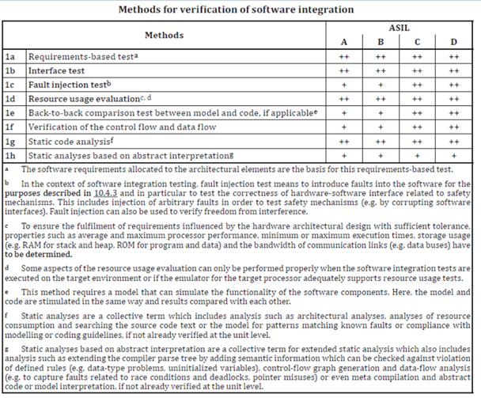
The V&V team shall refer to the table below with ‘1a’ and ‘1b’ to derive test cases and ‘1c’ is covered in the software unit test.
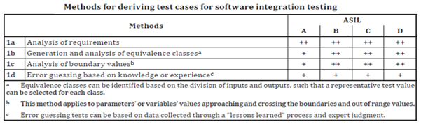
Path for SWE.2 Requirements in Polarion:
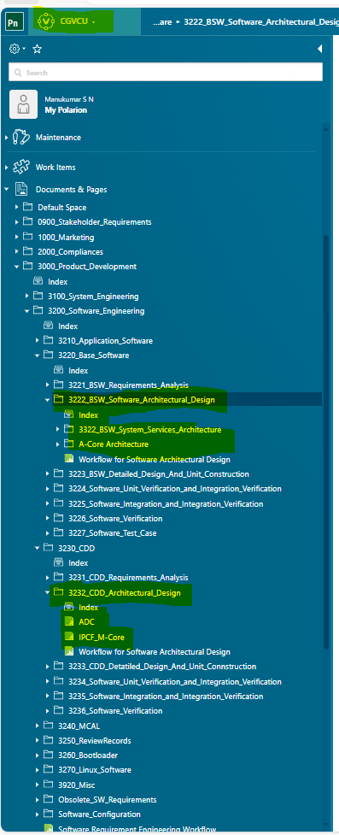

Hardware/Software Tools
Sl. No | Description
1 | Debugger/Trace32
2 | CANoe
3 | CANap
4 | S32 Flash Tool
5 | Vector Cast
6 | Python
7 | A-Sample Rev B-Board
8 | IO Board
9 | Exerciser Board

Issue Creation Process:
1. Issue Identification
  - Any deviation from the expected result observed during test execution is treated as an issue/defect.
  - Testers are responsible for raising issues immediately after they are identified.
2. Issue Logging
  - Issues will be logged in the defect tracking in the Polarion tool
  - Mandatory fields to be filled:
    - Title
    - Description (with clear steps to reproduce)
    - Test Case ID (if applicable)
    - Reproduce Steps (Issue reproduce steps)
    - Severity (Impact of the Issue or Defect)
    - Assignees (Module Owner Name)
    - Status (Status of the Issue)
    - Modules (Module name of the Defect)
    - Milestone (Issue raised version)
    - Process Group (Process names like SWE.4, SWE.5 and SWE.6)
    - Priority (Urgency to fix Issue or Defect)
    - Fixed Version (Issue fixed version)
    - Root Cause (From where the issue gets, updated by Assignees (Developer))
    - Comments (If applicable)
    - Linked Work Items (Add the link of Issue related Test case)
    - Hyperlinks (It is for the reference link of the Report and others)
    - Attachments (screenshots, logs, videos if applicable)
3. Issue Classification
  - Severity Levels: Blocker, Critical, Normal, Major, Minor, Trivial
  - Priority Levels: Highest, High, Medium, Low, Lowest
  - Root Cause: Test Design, Test Execution, Calibration, Requirement, Hardware, Software, Tool, Process and Others (If select “Others”, provide the Additional Comments)
4. Issue Assignment
  - Once logged, the issue will be assigned to the development team via mail communication for resolution.
  - The QA Lead / Test Manager will review and validate proper categorization.
5. Issue Resolution Workflow
  - Open → Accepted → In Progress → Retest → Successful → Closed
  - If the issue fix fails, then the issue is moved to Reopen.
  - If the issue is not proper, then the issue is moved to Reject
  - If the issue is a block of the module functionality, then the issue is moved to Blocked
  - If the issue is not implemented in the current phase, then the issue is moved to the next phase of development.
  - If the issue is a duplicate of another issue, then the issue is moved to Duplicated
6. Issue Tracking & Reporting
- Every Release status report on open, closed, and deferred issues.

6.2.3 Software Verification
This chapter describes the purpose and strategy to perform software qualification test and the evidence that the embedded software fulfills its requirements in the target environment, this evidence can be provided by using the suitable results of verification activities.
To verify that the embedded software fulfils the software safety requirements in the target environment test shall be conducted in suitable test environments as listed in the below table
Following shall be states for Software Verification test cases –
  - Draft - test cases development on going.
  - In-Progress – updating of test steps.
  - In-Review – test cases are assigned for peer review.
  - Re-Work – Close review comments.
  - Reviewed – The Reviewer reviewed the Test Cases and there were no review comments
  - Approved – test cases approved for testing

Process Flow:

The following methods of software testing are specified in part-6 of the ISO 26262 standard.
As the PROJECTNAME is considered as ASIL C product hence,
1a | based on the availability of the HIL Setup at Magna, derived and intended tests for HIL will be performed.
1b | this is considered and feasible test environment option at the IAST location
1c | not considered as it's not under the scope of the IAST V&V team at the PROJECTNAME level

V&V team shall refer to methods from below table ‘1a’ with requirement-based test and ‘1b’ fault injection at possible levels.

V&V team shall refer below table with ‘1a’, ‘1b’, ‘1c’, ‘1e’, ‘1f’ to derive test cases along tool-generated tests.


Path for SWE.1 Requirements in Polarion:


Issue Creation Process:
1. Issue Identification
  - Any deviation from the expected result observed during test execution is treated as an issue/defect.
  - Testers are responsible for raising issues immediately after they are identified.
2. Issue Logging
  - Issues will be logged in the defect tracking in the Polarion tool
  - Mandatory fields to be filled:
    - Title
    - Description (with clear steps to reproduce)
    - Test Case ID (if applicable)
    - Reproduce Steps (Issue reproduce steps)
    - Severity (Impact of the Issue or Defect)
    - Assignees (Module Owner Name)
    - Status (Status of the Issue)
    - Modules (Module name of the Defect)
    - Milestone (Issue raised version)
    - Process Group (Process names like SWE.4, SWE.5 and SWE.6)
    - Priority (Urgency to fix Issue or Defect)
    - Fixed Version (Issue fixed version)
    - Root Cause (From where the issue gets, updated by Assignees (Developer))
    - Comments (If applicable)
    - Linked Work Items (Add the link of Issue related Test case)
    - Hyperlinks (It is for the reference link of the Report and others)
    - Attachments (screenshots, logs, videos if applicable)
3. Issue Classification
  - Severity Levels: Blocker, Critical, Normal, Major, Minor, Trivial
  - Priority Levels: Highest, High, Medium, Low, Lowest
  - Root Cause: Test Design, Test Execution, Calibration, Requirement, Hardware, Software, Tool, Process and Others (If select “Others”, provide the Additional Comments)
4. Issue Assignment
  - Once logged, the issue will be assigned to the development team via mail communication for resolution.
  - The QA Lead / Test Manager will review and validate proper categorization.
5. Issue Resolution Workflow
  - Open → Accepted → In Progress → Retest → Successful → Closed
  - If the issue fix fails, then the issue is moved to Reopen.
  - If the issue is not proper, then the issue is moved to Reject
  - If the issue is a block of the module functionality, then the issue is moved to Blocked
  - If the issue is not implemented in the current phase, then the issue is moved to the next phase of development.
  - If the issue is a duplicate of another issue, then the issue is moved to Duplicated
6. Issue Tracking & Reporting
- Every Release status report on open, closed, and deferred issues.

Hardware/Software Tools
Sl. No | Description
1 | CANoe
2 | CANap
3 | S32 Flash Tool
4 | CAPL/Python
5 | Oscilloscope
6 | A-Sample Rev B-Board
7 | IO Expander Board
8 | Exerciser Board

Open-Source Code/SW Validation
This section is TBD as this needs to discuss across all the required stakeholders and come to to conclusion on this section.

Test Environment

8.1 Test Bench Flow Diagram and Bench Setup View

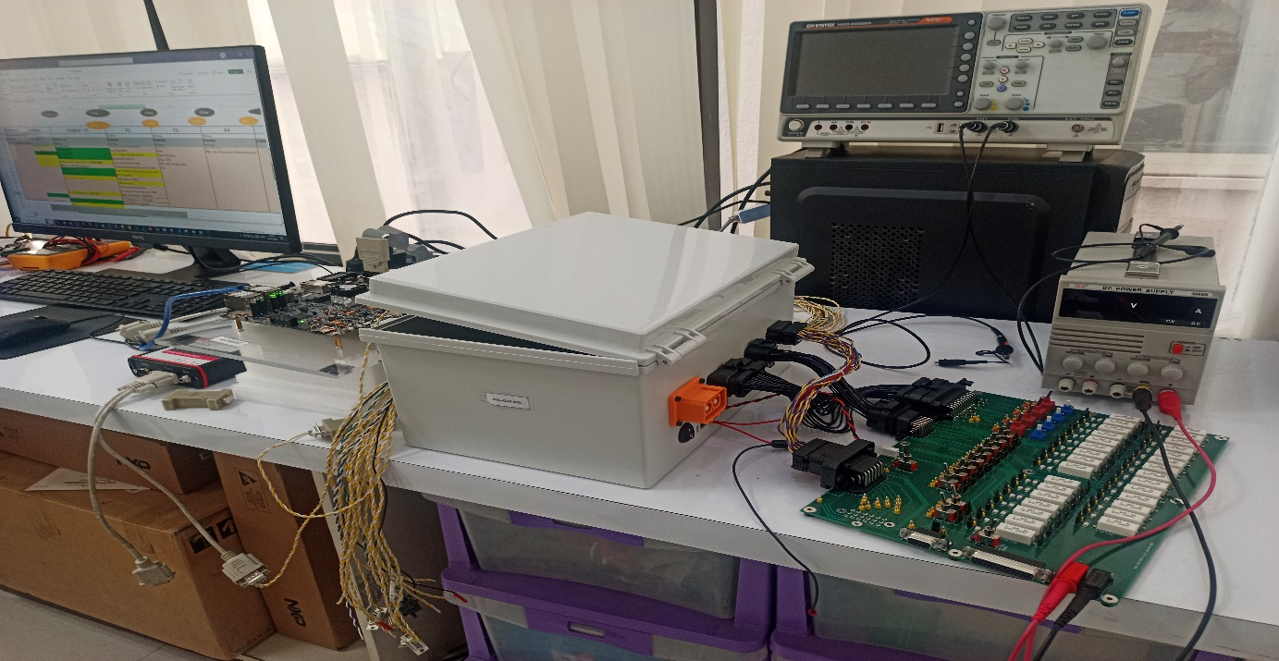
Reference to Test bench flow diagram - PROJECTNAME_Test_Bench_Setup.pptx

8.2 Hardware and Software Test Tools
Below details are the hardware and software tools used and help full for performing the validation for PROJECTNAME project.

8.2.1 Hardware Tool
HW Details
S32G Board
IO Board
Exerciser Board

8.2.2 Software Tools
SW Details
Vector Tools
CANoe
CANape
S32G Flash tool
CAPL
Python
Shell Scripting

Resource Allocation
Below is the list of resource and mapping as shown in the below diagram and here is the link for the resource allocation document PMP:
http://server02:81/polarion/svnwebclient/fileContent.jsp?url=CGM_NewMobility_Magna%2FCGM_NewMobility_Magna%2F05_Management%2F00_PMP%2FPROJECTNAME_Project_Management_Plan.docx

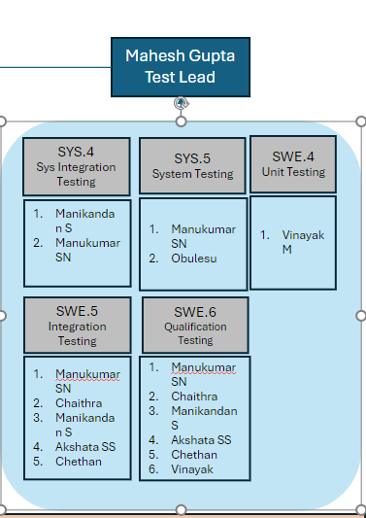

Test Schedule
Based on the milestone deliverables to Magna there will be planned validation for all the major deliverable example, F1, F2 and so on.

Test Reporting and Documentation

11.1 Test Reporting and Documentation.
This section describes on formal test summary report will be shared to respective module owners and identified stake holders on completion of planned test and bleow is defined list which shall be updated based on the request and role change.
Stake Holders | Intermediate  SW Release | Major  SW Releases  (F1, F2, ..)
Dinesh Sharma <dinesh.sharma@iast-software.com> | Yes | Yes
Charan Gowda <charan.gowda@iast-software.com> | Yes | Yes
Pietrasik, Bart < Bart.Pietrasik@magna.com > | No | Yes
Nishant Kumar <nishant.kumar@iast-software.com> | Yes | Yes
Chandram Yegapagol <chandram.yegapagol@iast-software.com> | Yes | Yes
Pooja S N <pooja.sn@iast-software.com> | Yes | Yes
Shivakumar Wali <shivakumar.wali@iast-software.com> | Yes | Yes
Mahesh Gupta Simhadri < mahesh.gupta@iast-software.com> | Yes | Yes
Ropponen, Jeff (Partner) <jeff.ropponen@partner.magna.com> | No | Yes
Validation Team(dlLMDD_Testing_CGM_USA) | Yes | Yes
Development Team(dlLMDD_Software_CGM_USA <dlLMDD) | Yes | Yes
BGM Team(Need to identify stakeholder list) | ? | ?

11.2 Test Artifacts and Documentation.
All the test specification and test reports documents which are reviewed by internal team are shared internally on IAST sharepoint and Magan sharepoint respectively.
Sharepoint location are mentioned for IAST and Magna
IAST Locaiotn : Test_Reports
Magna Locaiotn : IAST_Releases
Issues reported during testing activities team shall report the issues in JIRA tool and with all the required infomration for the issue to reproduce at developer side needs to be provided in the respective jira and please find the reference jira template to create an issue - [PROJECTNAME-857] Sample Bug Report JIRA - Brief about the issue in single line statement - Jira (atlassian.net)

11.3 Test Report Document Naming Convention.
The test report name should be like PROJECTNAME_ACore/MCore_Modulename_TestReport.

Abbreviation and Definition
Abbreviation | Definition
ASIL-C | Automotive Safety Integrity Level (Level C)
SWE.4,  SWE.5,  SWE.6 | Software Engineering Process Groups (SWE) (reference ASPICE4.0)
SYS.4,  SYS.5 | System Engineering Process Groups (SYS) (reference ASPICE4.0)
++ | Indicates that method is highly recommended for the identified ASIL
+ | Indicates that method is recommended for the identified ASIL
O | Indicates that method has no recommendation for or against its usage for the identified ASIL
PROJECTNAME | Connectivity Gateway Vehicle Control Unit (Module)
ECU | Electronic Control Unit
V&V | Independent Verification and Validation Team
DIA | Development Interface Agreement

Reference

  - 0813_ProjectName_Quality_Management_Plan.docx (sharepoint.com)
  - ASPICE 4.0
  - Safety Development Lifecyle (ISO26262_2018):
  - http://server02:81/polarion/svnwebclient/directoryContent.jsp?url=CGM_NewMobility_Magna%2FCGM_NewMobility_Magna%2F05_Management%2F00_PMP
  -  1700_PROJECTNAME_RMP_1.0 1.docx

