Small Recommendation Engine (Purchase Frequency Based)
This document provides a comprehensive overview of the "Small Recommendation Engine" project, a client-side web application designed to identify and rank top-selling products based purely on their purchase frequency. The application uses modern web technologies and includes data persistence via browser storage.

Project Overview
The core goal of this project is to simulate a basic product recommendation system. It takes dynamic input from the user (Product Name and Purchase Count) and processes this data using a simple purchase frequency algorithm to output the top 'N' products.
Key Features
- Dynamic Data Entry: Users can add and remove product rows dynamically.
- Recommendation Algorithm: Products are sorted in descending order of their purchase count.
- Top N Selection: Users can specify how many top products they want to see.
- Data Persistence: Product data is saved automatically in the browser's localStorage, allowing the user to refresh the page or return later without losing their entries.
- Aesthetic UI: A clean, modern, and colorful user interface built with aesthetic CSS.
- API-Style Logic: The core recommendation logic is structured as a clear JavaScript function, mimicking a server-side API endpoint for processing data.

🛠️ Technology Stack
This project is implemented entirely using front-end web technologies, making it easy to run locally without any server setup.
1. Core Technologies
Technology | Purpose
HTML5 | Provides the structure and content of the application.
CSS3 | Handles all styling, aesthetics, color schemes, and layout.
JavaScript (ES6+) | Contains the dynamic logic, recommendation algorithm, data validation, and persistence using localStorage.

2. Software / Applications Required
Since this is a client-side project, you only need basic tools installed on your computer:
Application | Requirement | Purpose
Web Browser | Required (e.g., Chrome, Firefox, Edge) | To open and run the index.html file.
Text Editor | Required (e.g., VS Code, Sublime Text) | To view, edit, or copy the source code.
No Server | Not Required | The project runs entirely on the browser's client side.

3. AI Tools & Libraries
To provide comprehensive documentation and develop the structure and aesthetic components efficiently, the following tools and resources were instrumental:
- Google Colab / Text Editor: The initial structure and logical flow for the JavaScript "API" were often drafted and refined in a clean coding environment.
- Gemini (AI Assistant): Yes, an AI assistant was used to help in the project's development phase, specifically for:
  - Structuring the Code: Providing the initial, clean, API-format structure for the HTML, CSS, and JavaScript.
  - Aesthetic Design: Suggesting and refining the aesthetic (good-looking) CSS styles, color palette, and dynamic button effects.
  - Logic Refinement: Implementing advanced features like data persistence (localStorage) and robust error handling (e.g., the alert for "Top N" versus available products).
  - Documentation: Generating and formatting this professional README document.

⚙️ flow chart
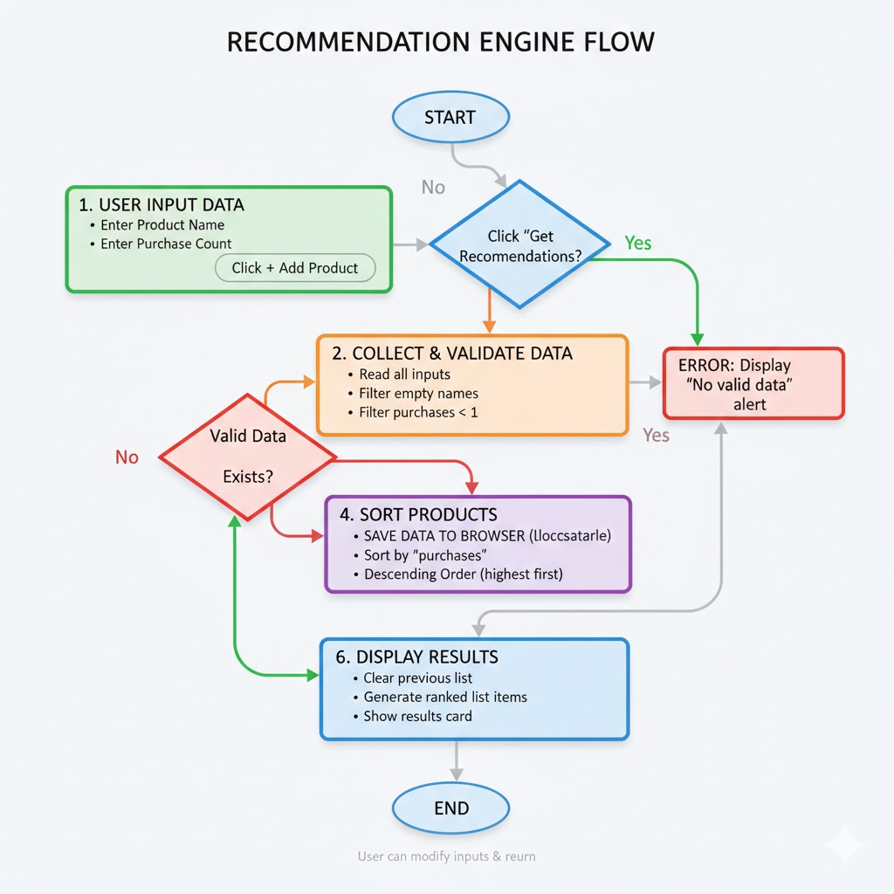
⚙️ How to Run the Project
This project is contained within a single file for maximum simplicity.
- Save the Code: Copy the entire combined HTML/CSS/JS code block and save it as a single file named index.html.
- Launch: Double-click the index.html file. It will automatically open in your default web browser.

🧩 Usage Instructions
- Enter Product Data: Input the Product Name and the corresponding Purchases count.
- Data Persistence: Click 🚀 Get Recommendations. This action not only shows the results but also saves the current data in your browser.
- Set Top N: Adjust the "Show Top N Products" number to filter the results.
- Error Handling: The system will alert you if you try to request more products than are currently entered.
