FEDF Exam:

Input:

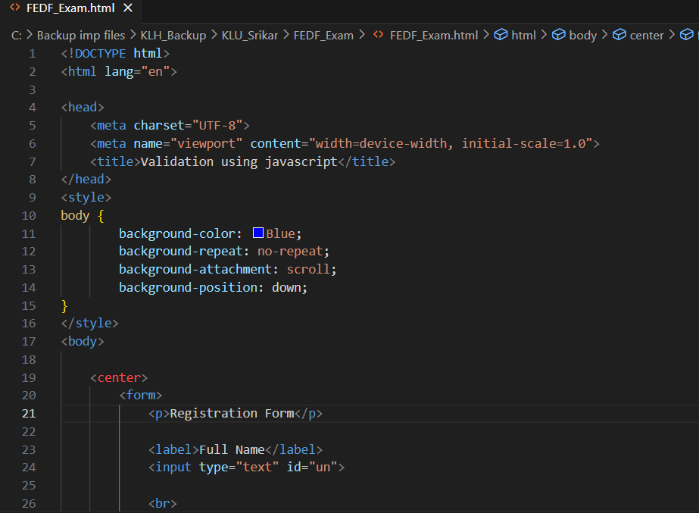

Output:

