**Wireframe**

**Document**

**Project Name:** Mushroom Classification

**Name:** Venkata Phani Srikar Pillalamarri

**E-Mail:** [pvpsrikar@gmail.com](mailto:pvpsrikar@gmail.com)

**Table of Contents**

|  |  |  |
| --- | --- | --- |
| **Sr.No** | **Topic** | **Page No** |
|  | Abstract |  |
| 1 | Home Page | 4 |
| 2 | Results Page | 6 |
| 3 | Conclusion | 7 |

**Abstract**

The Mushroom Classifier web application's design and layout are described in this wireframe paper. This application's main objective is to provide users a simple way to categorize mushrooms according to their qualities. The homepage and results page are among the important pages for which the paper includes comprehensive wireframes.

By offering a visual representation of the application’s structure, this wireframe document serves as a critical blueprint, facilitating efficient development and ensuring a seamless user experience.

**Chapter – 1**

**Home Page**

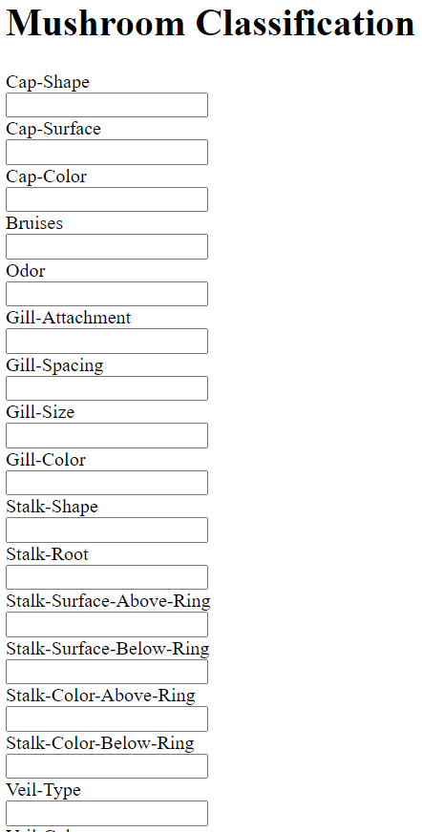

**Fig: Home Page of the application**

The Mushroom Classifier web application's homepage serves as the primary interface that greets visitors upon entering the platform. The design is minimalist and uncluttered, facilitating user navigation across the many choices. Located at the top of the page is a headline that is easily understood and succinctly states the topic, "Mushroom Classification." This is followed by a short explanation that tells visitors about the objective of the program, which is to categorize mushrooms as either edible or harmful. This first paragraph offers background information and aids users in quickly comprehending the features and purpose of the product.

The design of the home page in the Mushroom Classification Flask application is crafted to provide a seamless and engaging user experience. By focusing on clarity, ease of use, and visual appeal, the home page effectively guides users through the process of entering mushroom features and obtaining a classification result. This user-centric design helps attract and retain customers by making the application intuitive, informative, and valuable.

Each input field has a descriptive label (e.g., “Cap Shape”) to guide users on what data to enter. This reduces confusion and ensures that users can quickly and accurately fill out the form. Basic HTML validation ensures that required fields are filled out, preventing users from submitting incomplete forms and improving the overall user experience.

Users can enter all necessary information on a single page without needing to navigate through multiple pages. This simplicity enhances the user experience by making the process quick and efficient. A clear and prominent submission button (“Predict”) makes it easy for users to submit their information and get a prediction.

The home page can include brief, informative content about the application’s purpose and how it works. This can help users understand the value of the application and encourage them to use it. The submission button acts as a call to action, encouraging users to engage with the application by inputting data and getting a result.

**Chapter – 2**

**Results Page**

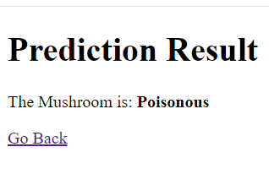

**Fig: Result Page When the result is Poisonous**

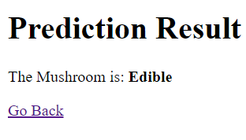

**Fig: Result Page When the result is Edible**

The results page of the Mushroom Classifier web application is specifically built to exhibit the categorization conclusion derived from the user's input characteristics. The result page of the Mushroom Classification Flask application is designed to provide clear and immediate feedback to the user after they submit their mushroom feature inputs. Its design aims to deliver the prediction result in a straightforward manner while encouraging further engagement with the application.

The result page prominently displays whether the mushroom is “Edible” or “Poisonous.” This immediate feedback ensures that users quickly understand the outcome of their input. After submission, the user is redirected to a result page that clearly displays whether the mushroom is edible or poisonous. This immediate feedback keeps users engaged and provides value quickly.

A link to go back to the home page allows users to easily perform multiple classifications without needing to manually navigate back. The layout and design of the results page are kept simple and uncluttered, focusing the user's attention on the classification result.

This straightforward approach helps users easily interpret the results without any distractions. Additionally, the use of clear and bold text for the result message enhances readability and ensures that the critical information is immediately noticeable. This design choice contributes to an overall user-friendly experience, making it easy for users to navigate the application and obtain the information they need efficiently.

**Chapter - 3**

**Conclusion**

The wireframing paper for the Mushroom Classifier web application presents a concise and user-friendly interface intended to assist the effortless and effective categorization of mushrooms as either edible or toxic. The document showcases a well-defined visual layout of both the homepage and results page, guaranteeing that users can easily and instinctively navigate the application. The wireframes prioritize simplicity and clarity to facilitate effortless data entry and rapid outcomes for users. The design decisions used in the wireframes are intended to optimize the overall user experience, ensuring that the application is user-friendly for a diverse audience, including both mycology aficionados and those seeking prompt information on mushroom safety.

The wireframing document not only presents a comprehensive layout but also highlights the need of maintaining consistent design components and effectively communicating outcomes. By including thorough comments and explanations into the wireframes, developers and designers are provided with a complete blueprint for carrying out the implementation process. This document functions as an essential plan for the development stage, ensuring that the end product fulfils user requirements and anticipations. The wireframing document is crucial in converting the conceptual design into a web application that is both practical and effective, ensuring dependable and user-friendly mushroom categorization.