A Project Report on
WATERNET: MUNICIPAL PIPELINE FLOW & PRESSURE TELEMETRY
submitted in partial fulfilment of the requirements for the course
FULL STACK WEB DEVELOPMENT
A.Y.: 2026–27
by
S.Srikar Prathap | 2520040006
D.Dakshesh Kumar | 2520040060
Under the Esteemed guidance of
Dr. Karumuri Sri Rama Murthy
Assistant Professor
Department of CSE
KLU Hyderabad, Hyderabad
Koneru Lakshmaiah Education Foundation
Deemed to be University
Hyderabad, Telangana



Abstract

WaterNet is a software-based municipal pipeline monitoring dashboard designed to demonstrate how flow rate, pressure and turbidity readings can be collected, stored and reviewed for possible network problems. The current implementation uses a telemetry simulator to generate sample readings at regular intervals, rather than requiring physical sensors. A React.js interface presents key metrics, recent readings, flow and pressure charts, and network alerts. A Node.js and Express.js backend exposes REST API endpoints, applies threshold-based alert rules, and communicates with a PostgreSQL database. Authentication routes support user registration and login, while protected telemetry routes provide readings, summaries and alerts. The dashboard refreshes automatically to show newly stored simulated data. The design can later be extended to accept real sensor or gateway data.

INDEX
Section | Page
Abstract | 2
1. Introduction | 3
i. Background and Motivation | 4
ii. Problem Statement | 4
iii. Objectives | 4
iv. Scope and Contributions | 4
v. Organization of the Report | 4
2. Background and Related Work | 5
3. System Architecture and Design | 5
4. Implementation Details | 6
5. Testing and Results | 7-10
6. Limitations and Future Enhancements | 11
7. Conclusion | 12
References | 14

1. Introduction

i. Background and Motivation
Municipal water distribution networks need regular observation to identify unusual flow patterns, pressure drops and changes in water-quality indicators. In practical deployments, sensors or telemetry devices can transmit measurements to a central application, where operators can inspect trends and respond to potential issues. A software dashboard can help demonstrate this workflow before any physical sensing hardware is installed.
WaterNet implements this concept as a full-stack web application. The current project is intentionally software-only: a simulator creates sample pipeline readings, the backend stores them in PostgreSQL, and the frontend visualises the data. This makes the application suitable for demonstrating the complete data path, alert rules and dashboard behaviour without claiming that physical pipeline sensors are currently connected.

ii. Problem Statement
Pipeline measurements can be difficult to interpret when readings are stored separately or reviewed manually. A compact monitoring application is needed to collect readings in a database, show recent and historical trends, and flag combinations of values that may indicate a problem. The project must also demonstrate the integration of a modern frontend, backend API, database and authentication.

iii. Objectives
- Develop a responsive dashboard using React.js.
- Create REST API endpoints using Node.js and Express.js.
- Store user accounts, telemetry readings and alerts in PostgreSQL.
- Generate simulated flow-rate, pressure and turbidity data at a regular interval.
- Display summary metrics, charts, recent readings and alert history.
- Apply threshold-based rules to raise possible-leak and high-turbidity alerts.
- Provide a foundation that can later accept real sensor or gateway inputs.

iv. Scope and Contributions
The current scope covers software simulation, data persistence, API communication, authentication and visualisation. It does not include physical sensors or a live municipal network connection. The principal contribution is a working end-to-end prototype that demonstrates how simulated telemetry can move from a generator through an API and database to a continuously refreshed dashboard.

v. Organization of the Report
Chapter 2 describes the context and related concepts. Chapter 3 presents the system architecture, modules and database design. Chapter 4 explains implementation. Chapter 5 documents tests and observed outputs. Chapter 6 lists limitations and future enhancements, followed by the conclusion and references.

2. Background and Related Work

i. Pipeline Telemetry and Monitoring
Telemetry is the collection and transfer of measurements from a remote system to a monitoring application. For water distribution, useful measurements may include flow rate, pressure and water-quality indicators such as turbidity. A monitoring interface can organise these values into current metrics, time-series charts and alerts. WaterNet demonstrates this pattern with generated values rather than real sensor streams.

ii. Simulated Data for Software Prototyping
A simulator creates representative data when physical equipment or a production data feed is unavailable. It allows developers to test database inserts, API responses, chart rendering, refresh behaviour and alert conditions. Simulated values must be labelled clearly so users do not confuse a demonstration with live field measurements. In WaterNet, the source field is recorded as “simulated” and the dashboard should describe the feed as simulated telemetry.

iii. Full-Stack Web Application
A full-stack application combines a user interface, server-side application logic and persistent storage. The frontend sends HTTP requests to backend endpoints. The backend validates requests, enforces authentication where required, performs database operations and returns JSON responses. This separation allows the UI and data source to evolve independently.

iv. Threshold-Based Alerts
Rule-based alerting compares incoming measurements with configured thresholds. In the current demonstration, a possible-leak alert is raised when flow is high while pressure is low; a high-turbidity alert is raised when turbidity exceeds its configured threshold. These are demonstration rules and should not be interpreted as a validated engineering diagnosis.

v. Technology Rationale
Technology | Role in WaterNet
React.js | Builds the interactive dashboard and authentication screens.
Recharts | Displays flow and pressure time-series charts.
Lucide React | Provides consistent interface icons.
Node.js | Runs the JavaScript server environment.
Express.js | Defines REST endpoints and middleware.
PostgreSQL | Persists users, telemetry and alert records.
pg | Connects the Node.js backend to PostgreSQL.
bcrypt | Hashes passwords before storing them.
JSON Web Token (JWT) | Provides token-based authentication for protected API routes.
Thunder Client | Tests API requests and responses during development.

3. System Architecture and Design

i. Overview of the Architecture
WaterNet follows a layered architecture. A telemetry simulator periodically generates readings and writes them to PostgreSQL. The Express API exposes endpoints for authentication, readings, summaries and alerts. The React dashboard calls these endpoints, renders the returned data and refreshes at the configured interval.
Telemetry Simulator | React.js Dashboard
Generate flow, pressure, turbidity | Metrics, charts, alerts, recent readings
PostgreSQL Database | Node.js + Express API
users • telemetry • alerts | REST endpoints • validation • auth • rules
Figure 1: Logical architecture of the WaterNet software prototype
Data flow: simulator → backend/database → REST API → React dashboard. User registration and login use the authentication API; protected telemetry requests include a bearer token.

ii. Main Modules
Module | Responsibilities
Authentication | Register users, validate credentials, hash passwords and issue JWTs.
Telemetry simulator | Generate representative readings on a configured interval and store them with source marked simulated.
Telemetry API | Accept and retrieve readings; validate numeric values and create alerts when rules match.
Summary API | Calculate overview statistics from stored readings and unresolved alerts.
Alerts API | Return recent alert records for the dashboard.
Dashboard UI | Present metric cards, flow and pressure charts, alert list and recent readings.
Database layer | Manage PostgreSQL connections and parameterised SQL queries.

iii. Database Design
The database contains three core tables. The users table stores account details and a password hash. The telemetry table stores measured or simulated values with a timestamp and a source label. The alerts table stores alert type, message, severity, timestamp and resolution state.
Table | Important fields | Purpose
users | id, name, email, password_hash, created_at | Account identity and authentication data.
telemetry | id, flow_rate, pressure, turbidity, recorded_at, source | Time-stamped pipeline readings and data provenance.
alerts | id, alert_type, message, severity, created_at, resolved | Threshold events shown in the alert panel.

iv. API Design
Method and endpoint | Purpose | Authentication
GET /api/health | Check server/database connectivity. | No
POST /api/auth/register | Create a user account. | No
POST /api/auth/login | Verify credentials and return a token. | No
POST /api/telemetry | Insert a telemetry reading and evaluate alert rules. | Bearer token
GET /api/telemetry | Return recent readings. | Bearer token
GET /api/telemetry/summary | Return dashboard summary metrics. | Bearer token
GET /api/telemetry/alerts | Return recent alerts. | Bearer token

4. Implementation Details

i. Software Requirements
Component | Tools / specification
Frontend | React.js, Vite, CSS, Recharts, Lucide React
Backend | Node.js, Express.js
Database | PostgreSQL with pg driver
Authentication | bcrypt password hashing and JWT tokens
Development tools | Visual Studio Code, pgAdmin 4, Thunder Client
Operating system | Windows 10/11

ii. Frontend Implementation
The frontend is a React application created with Vite. The dashboard uses reusable metric cards and chart components. It requests summary values, recent telemetry and alerts from the backend. A token saved after successful login is attached to protected API requests. The refresh function retrieves updated data and updates the React state, which causes the cards, charts and tables to re-render.
The dashboard includes the following main views and elements:
- Overview cards for average flow rate, pipeline pressure, turbidity and active alerts.
- Flow-rate and pressure charts based on recent stored readings.
- Network alerts showing alert type, message, severity and time.
- Recent readings showing timestamp, flow and pressure values.
- Login/register form and logout control.
- A manual “Add test reading” action for API demonstration.

iii. Backend Implementation
The Express server configures JSON parsing and CORS, mounts authentication and telemetry routes, and exposes a health endpoint. Database access is handled through a PostgreSQL connection pool. The authentication middleware verifies the bearer token before allowing access to protected telemetry endpoints.
Passwords are hashed with bcrypt and are not stored as plain text. The login route compares the submitted password with the stored hash and issues a time-limited JWT after successful verification. Database queries use parameterised values for user-supplied fields.

iv. Simulated Telemetry Generator
The simulator creates a new set of representative values for flow rate, pressure and turbidity at a fixed interval (configured by the project as 10 seconds, or 30 seconds if the interval is changed for the demonstration). Each generated record is inserted into PostgreSQL with a timestamp and source label “simulated”. The dashboard periodically requests fresh data, so new rows become visible without manually reloading the page.
The simulator can also generate abnormal combinations to demonstrate the alert panel. For example, a high flow rate combined with pressure below the configured threshold can create a possible-leak alert. Turbidity above the configured threshold can create a high-turbidity alert. These generated alerts demonstrate rule processing and do not confirm a real-world fault.

v. Alert Logic
Rule condition (demo) | Alert type | Severity shown
Pressure below 1.5 bar and flow above 20 L/min | POSSIBLE_LEAK | HIGH
Turbidity above 5 NTU | HIGH_TURBIDITY | MEDIUM

vi. Database Integration
The backend connects to the waternet_db PostgreSQL database using connection settings stored in a local .env file. Credentials and JWT secrets should not be committed to source control or included in the report. The health endpoint is used to confirm database connectivity, while telemetry endpoints perform inserts and select queries for the dashboard.

vii. Automatic Refresh
A React useEffect hook starts a recurring refresh when a user is authenticated and clears the interval when the component is unmounted or the token changes. The refresh interval should match the intended demonstration cadence. The backend simulator interval and frontend refresh interval are separate settings; keeping them aligned (for example, both at 10 seconds) makes new data appear promptly.

5. Testing and Results

i. Test Environment
Testing was performed locally using the React development server, the Express API and PostgreSQL. Thunder Client was used to submit HTTP requests. The browser dashboard was checked to verify that stored data appeared in the cards, charts, alert list and recent readings table.

ii. Functional Test Cases
Test | Action | Expected result | Status
T1 | Open GET /api/health | Server responds and reports database connectivity. | Passed in local test
T2 | Register a user | Account is stored with a password hash. | Passed in local test
T3 | Login with valid credentials | API returns a JWT token. | Passed in local test
T4 | POST a valid telemetry reading with token | Reading is stored in PostgreSQL. | Passed in local test
T5 | POST without a valid token | API rejects the protected request with 401 Unauthorized. | Expected security behaviour
T6 | Insert high-flow/low-pressure values | Possible-leak alert is created. | Passed in local test
T7 | Generate readings repeatedly | New rows are added at the configured interval. | Passed in local test
T8 | Wait for dashboard refresh | Recent readings and charts show newer timestamps. | Passed in local test

iii. Output Screenshots
Replace each placeholder below with a fresh screenshot from the running application. Capture the browser and API results from your own environment before final submission.

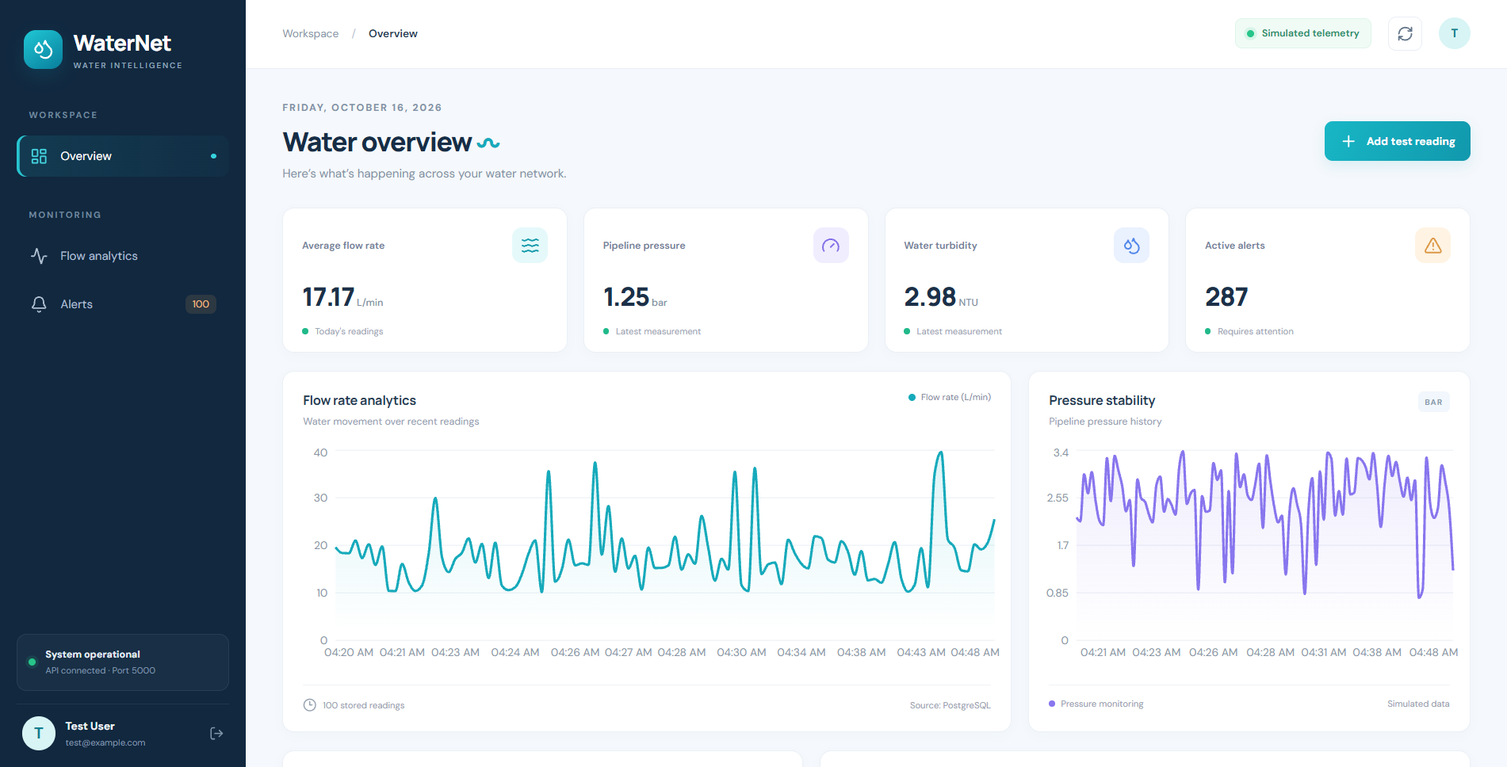

[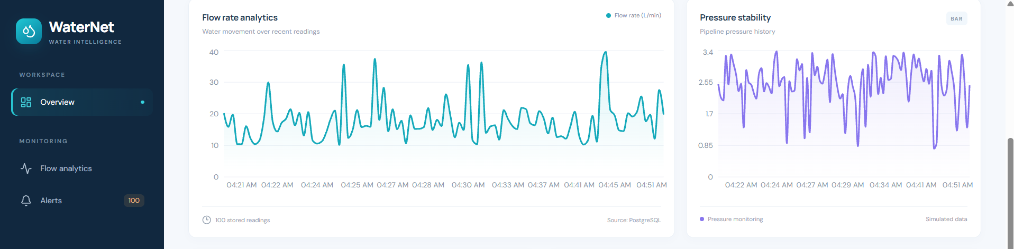

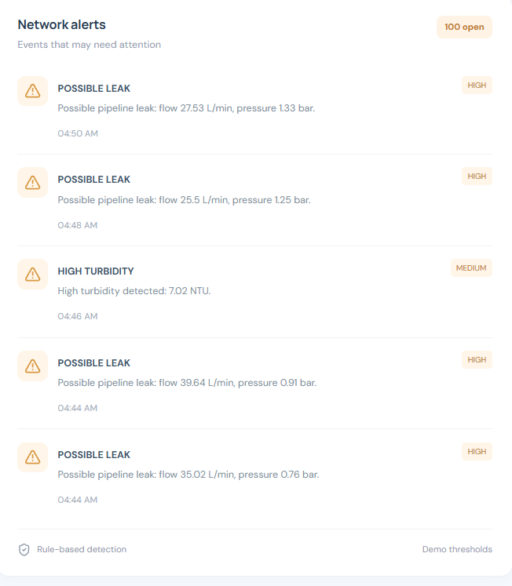

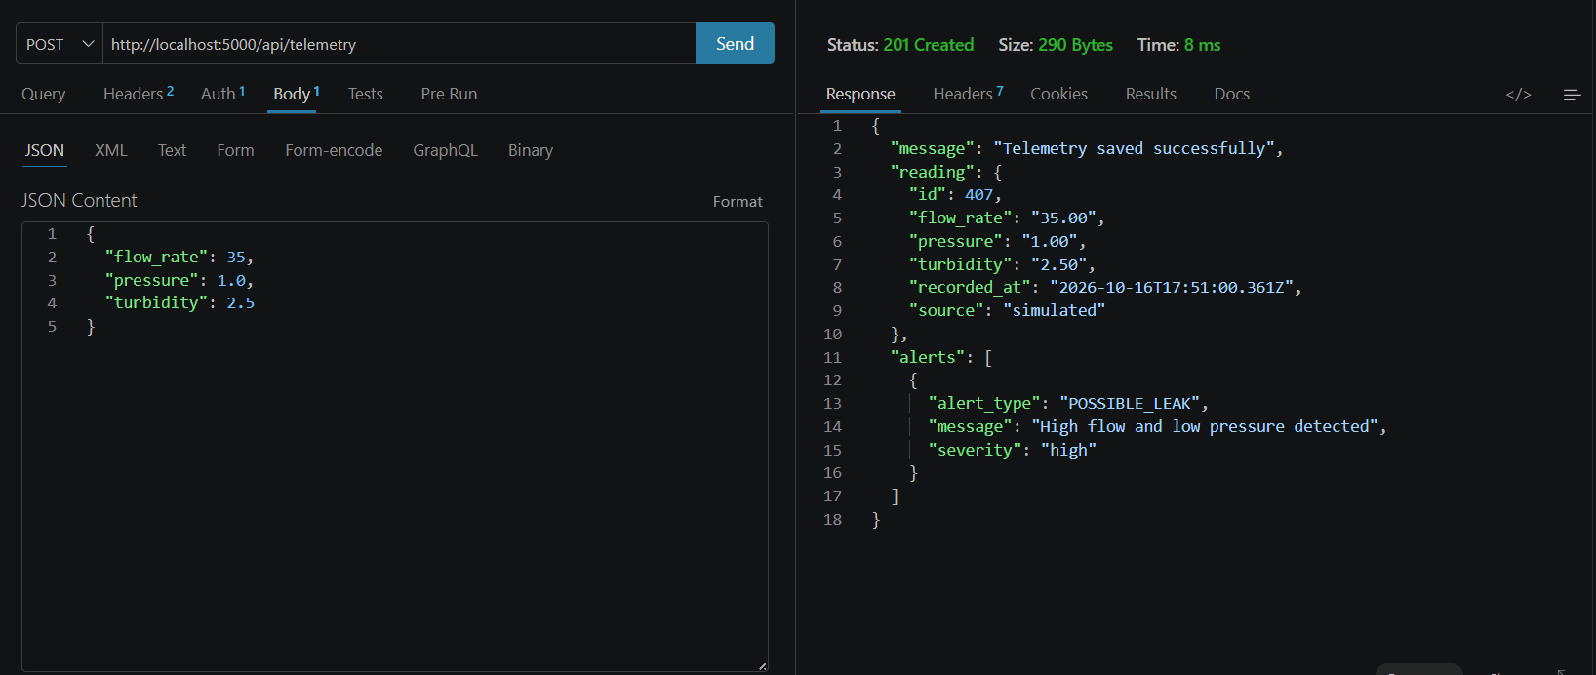

iv. Observed Results
The local test confirmed that the backend could connect to PostgreSQL, authentication routes returned a token for valid credentials, and protected telemetry routes accepted authorised requests. The simulator inserted new readings periodically. The dashboard refresh displayed newer timestamps and updated the flow and pressure charts. Test values that met the demonstration thresholds generated alert records visible in the network alerts section.

v. Result Interpretation
The results demonstrate the integration of the frontend, API, simulator and database. The project is a working software prototype; because the values are generated by software, the dashboard should be described as simulated telemetry rather than live field monitoring. Thresholds are illustrative and would require calibration and validation before use in a real water distribution system.

6. Limitations and Future Enhancements

i. Current Limitations
- The project currently uses generated telemetry and is not connected to physical flow, pressure or turbidity sensors.
- Threshold-based alerts are simple demonstration rules and may produce false positives or miss real events.
- Simulated values may not represent the full variation of a real municipal pipeline.
- The application is configured for local development and is not yet a hardened production deployment.
- The current interface focuses on core readings and alerts rather than advanced analytics or map-based network management.

ii. Future Enhancements
- Integrate physical sensors or an IoT gateway in a future phase and replace the simulator with incoming sensor readings.
- Add a configurable data-source mode so the application can switch between simulated and sensor-based telemetry.
- Use MQTT or another secure ingestion mechanism for streaming readings from an IoT gateway.
- Add pipeline zones, map visualisation and device status monitoring.
- Introduce configurable thresholds, alert acknowledgement and resolution workflows.
- Add historical date filters, CSV/PDF export and daily/weekly reports.
- Improve security with production secret management, HTTPS, rate limiting and role-based access.
- Validate alert thresholds with domain experts and representative field data.

iii. Migration from Simulation to Real Sensors
The existing separation between data ingestion, PostgreSQL storage, REST APIs and the dashboard makes future integration possible. A sensor gateway could send readings to a dedicated ingestion endpoint or message broker. The backend would validate the incoming payload, store the reading with a source/device identifier, and run the same alert logic. The dashboard could continue using the existing summary, readings and alerts endpoints with minimal UI changes.

7. Conclusion
WaterNet demonstrates a full-stack web application for municipal pipeline flow and pressure telemetry using a software-only simulation. The React dashboard displays key measurements, trends, recent records and rule-based alerts. The Node.js and Express.js backend provides authentication and REST endpoints, while PostgreSQL stores user, telemetry and alert data. Periodic generation and refresh demonstrate how a telemetry system can operate continuously during a software demonstration.
The project meets its prototype objective by showing the complete path from generated data to database persistence and visual presentation. It should not be represented as a physical sensor deployment: all current telemetry values are simulated. Future work can connect actual sensors or a gateway, strengthen alert validation, and deploy the application securely for operational use.

References
[1] React Documentation, “React: The library for web and native user interfaces.” https://react.dev/
[2] Vite Documentation, “Vite: Next Generation Frontend Tooling.” https://vite.dev/
[3] Express.js Documentation, “Express web framework for Node.js.” https://expressjs.com/
[4] Node.js Documentation, “Node.js Documentation.” https://nodejs.org/docs/
[5] PostgreSQL Global Development Group, “PostgreSQL Documentation.” https://www.postgresql.org/docs/
[6] Recharts Documentation, “Recharts: Redefined chart library built with React.” https://recharts.org/
[7] node-postgres Documentation, “node-postgres.” https://node-postgres.com/
[8] bcrypt npm package documentation. https://www.npmjs.com/package/bcrypt
[9] jsonwebtoken npm package documentation. https://www.npmjs.com/package/jsonwebtoken

