**Implementation**

**Step 1 :** Sign in to ServiceNow.

**Step 2 :** Sign up for a developer account on the ServiceNow Developer site “[https://developer.servicenow.com](https://developer.servicenow.com/)”.

**Step 3 :** Once logged in, navigate to the "Personal Developer Instance" section.

Click on "Request Instance" to create a new ServiceNow instance.

**Step 4 :** Fill out the required information and submit the request.

**Step 5 :** You'll receive an email with the instance details once it's ready.

**Step 6 :**Log in to your ServiceNow instance using the provided credentials.

Now you will navigate to the ServiceNow.

**Step 7 :**  Open “Maintain categories” >> New

**Step 8 :** Fill the details as below

**Step 9 :** To add a new Service Catalog item in ServiceNow, follow these steps to enter a title for the category, select the catalog, and upload the images. Here’s a step-by-step guide:

1. Enter a Title for Category

2. Select the Catalog in Which You Are Going to Add

3. Upload the Desktop Image

4. Upload the Icon Image

5. Save

**Step 10 :** Open “Maintain Items” >> New

**Step 11 :** Fill the details as below

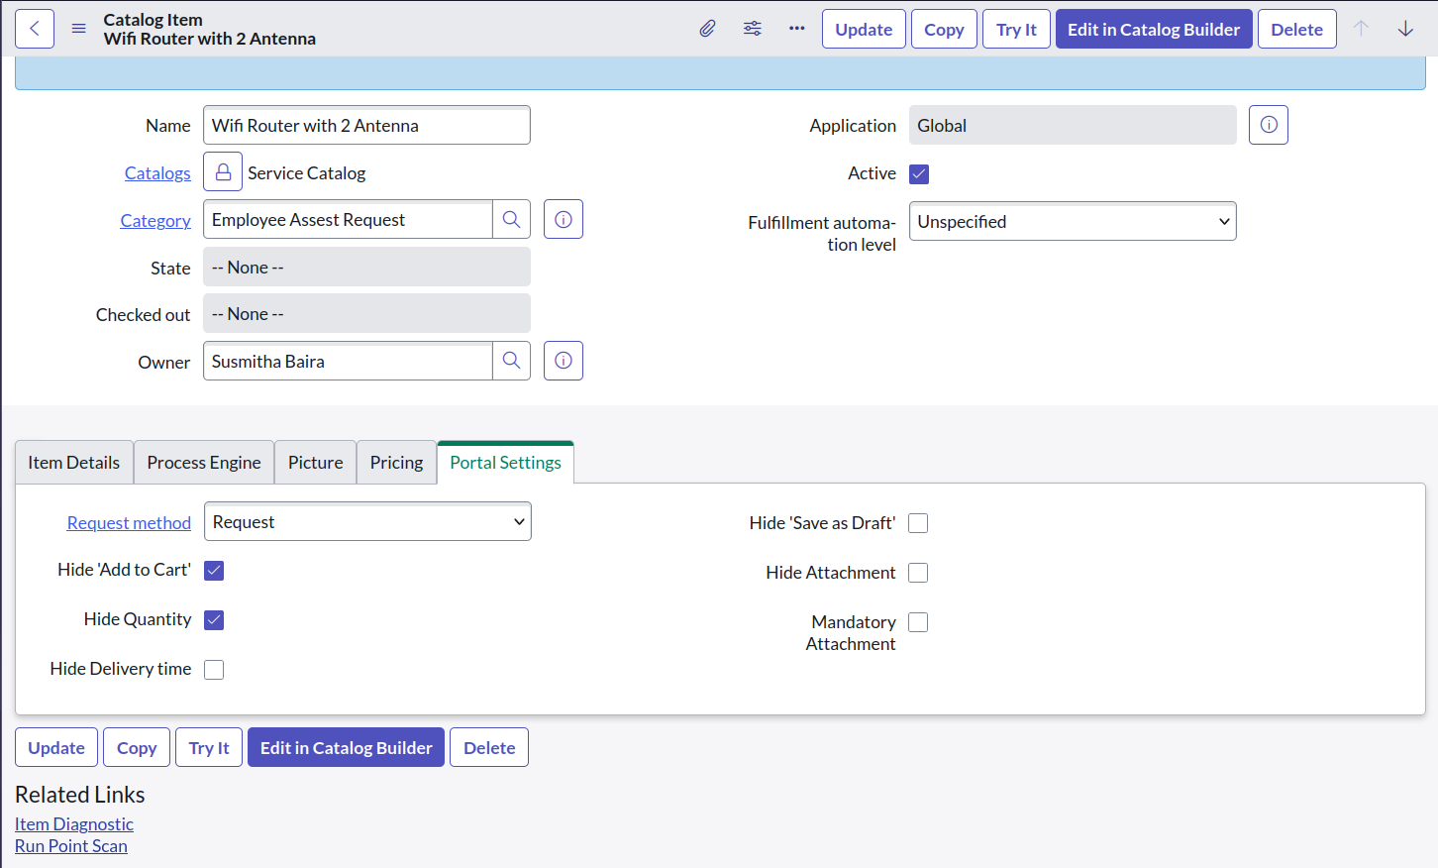

**Step 12 :** Steps to Add a New Service Catalog Item in ServiceNow

1. Give a Name for the Catalog Item

2. Select the Catalog

3. Select the Category

4. Save the Item

5.Go to Portal Settings and select the Request

**Step 13 :** Add variables to the Item

Click on Variables >> New

**Step 14 :** Fill the details as below

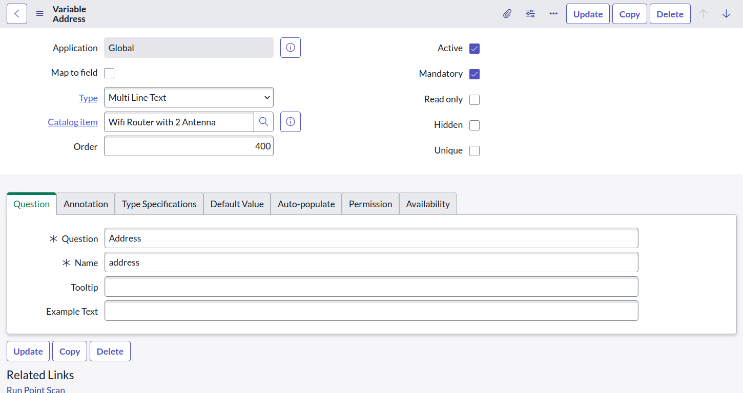

**Step 15 :** Steps to Add Variable for Catalog Item

1. Give a Question for Catalog Item

2. Name is Autopopulated

3. Save the variable

**Step 16 :** Open “Portals”

**Step 17 :**  Select Service Portal

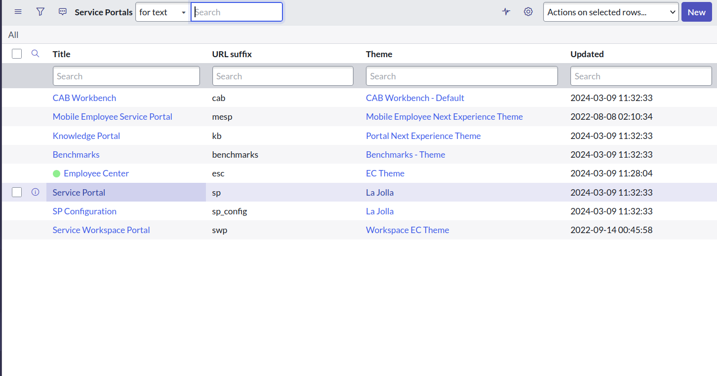

**Step 18 :** Select Catalogs

**Step 19 :** Select Edit

 Select the Category and Add to Service Portal and Save

**Step 20 :** Search for Workflow Editor

**Step 21 :** Open Workflow Editor >> New Workflow

**Create a workflow for process Automation**

Step-by-Step Implementation :

1. Item Request by User:

* A user submits a request for an item through a form or a specific request interface.

2. Approval Workflow:

* The request goes into a pending state, awaiting approval from an authorized user or admin.
* Notifications can be sent to potential approvers to review the request.

3. Catalog Task Creation:

* Upon approval, a task is created in the catalog or inventory system to process the request.
* This task involves verifying item availability, preparing the item for delivery, etc.

4. Email Notification:

* Once the catalog task is completed and the order is successfully placed, an email is sent to the user notifying them of the successful placement of their order.

**Step 22 :** Add the workflow to the item

**Step 23 :** Open Service Portal and make a Request for item

Enter additional variables (such as quantity, preferred delivery date, and comments) below the item field in a request form and then submit the request.

**Step 24 :** Placing Request

**Step 25 :** Open “My Requests”

**Step 26 :** Open Request Record

**Step 27 :** Open Request item

**Step 28 :** waiting for approval

**Step 29 :** Open the Service Catalog Task

Team Details :

A.J Muhammad Awuf - muhammadawuf210@gmail.com

V.G.Raagav - raagavraagav2004@gmail.com

S. Ragul - WWW.RAGULRAGUL777@GMAIL.COM

K. Srijith - g.klovely9842@gmail.com