This is master branch which content.txt like below
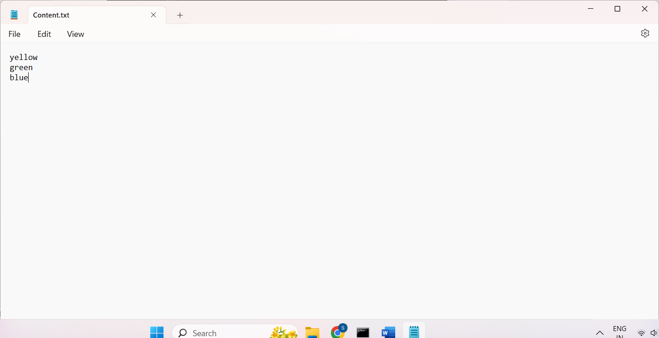
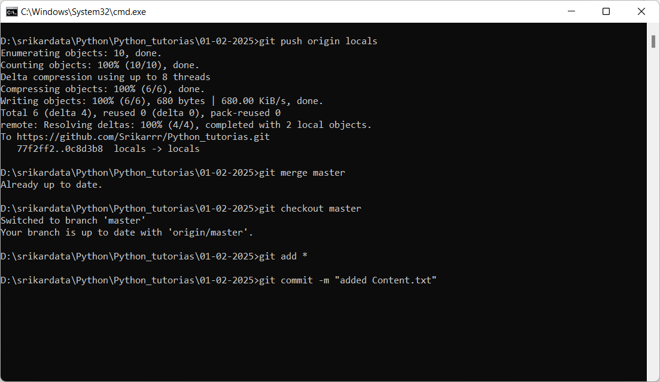

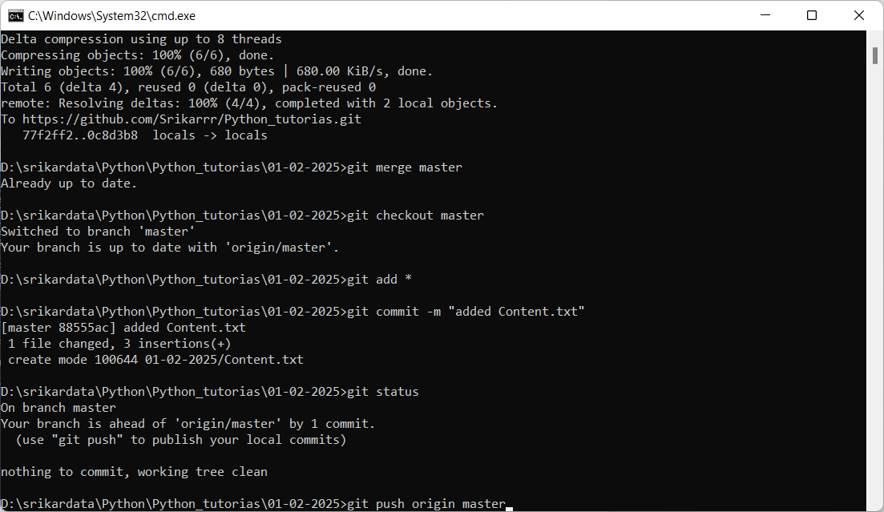

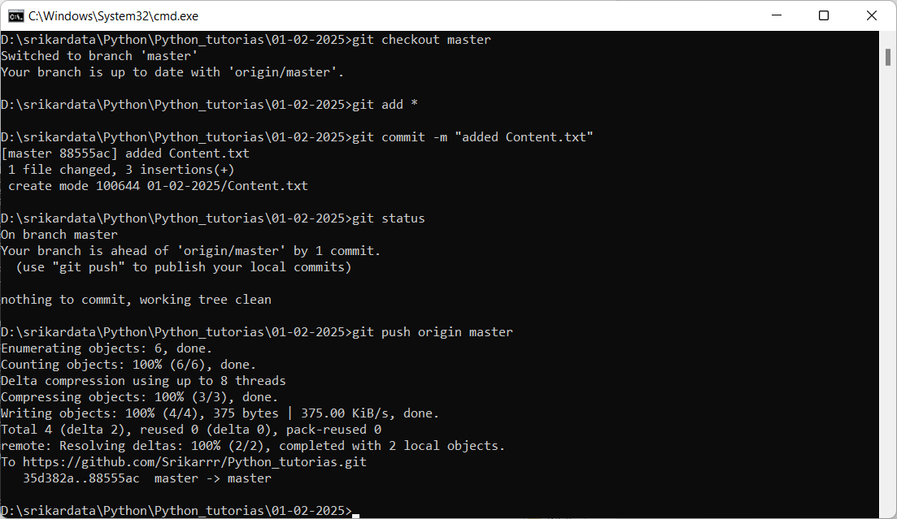
Now take 2 branches from master
git branch my-branch
git branch his-branch
git checkout his-branch

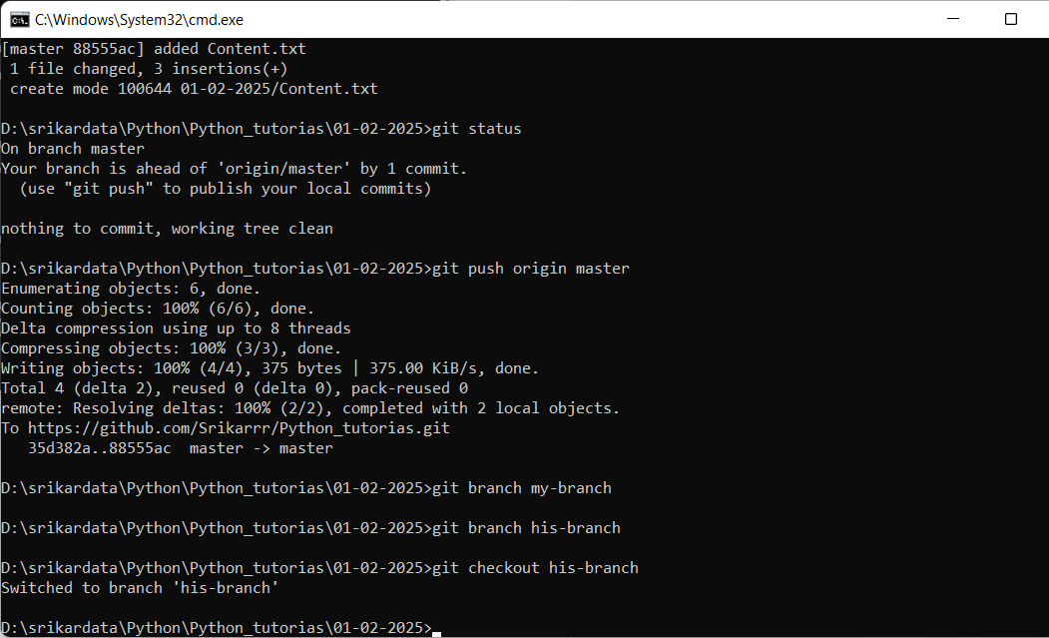

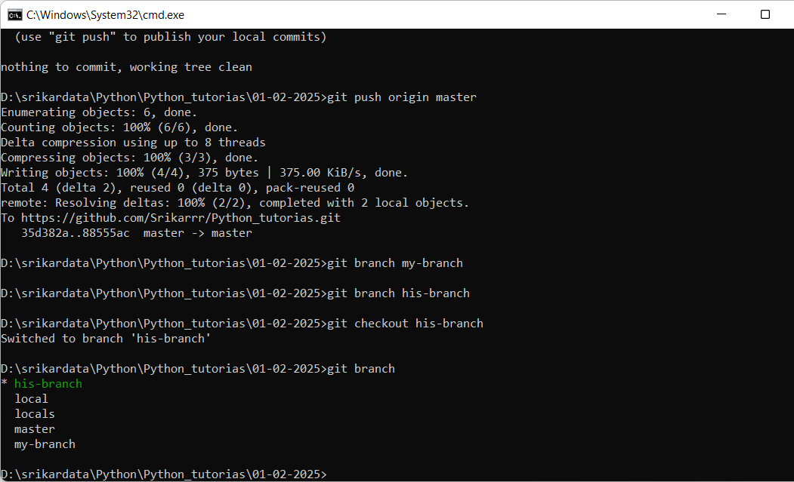
Add some data and commit the Content.txt file
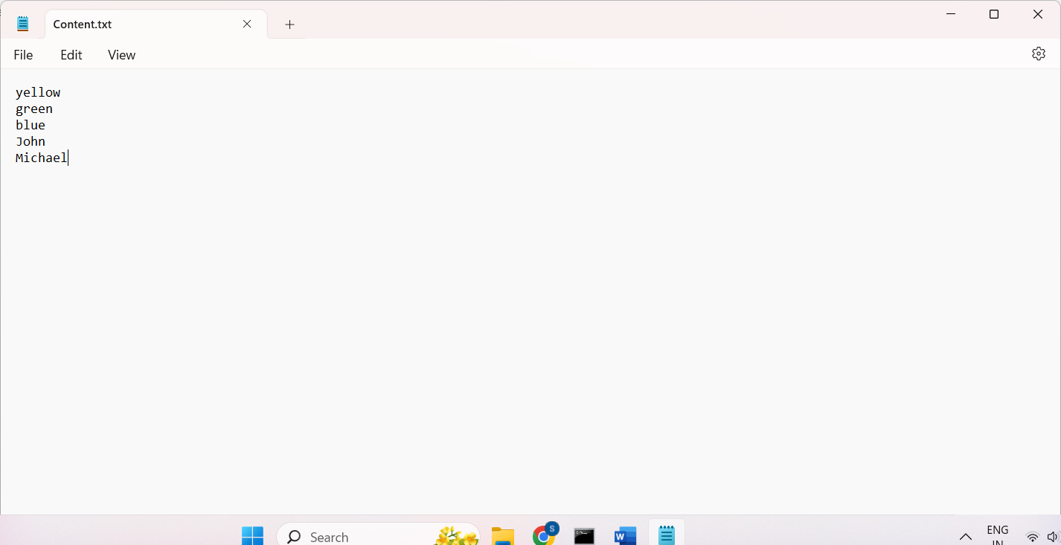

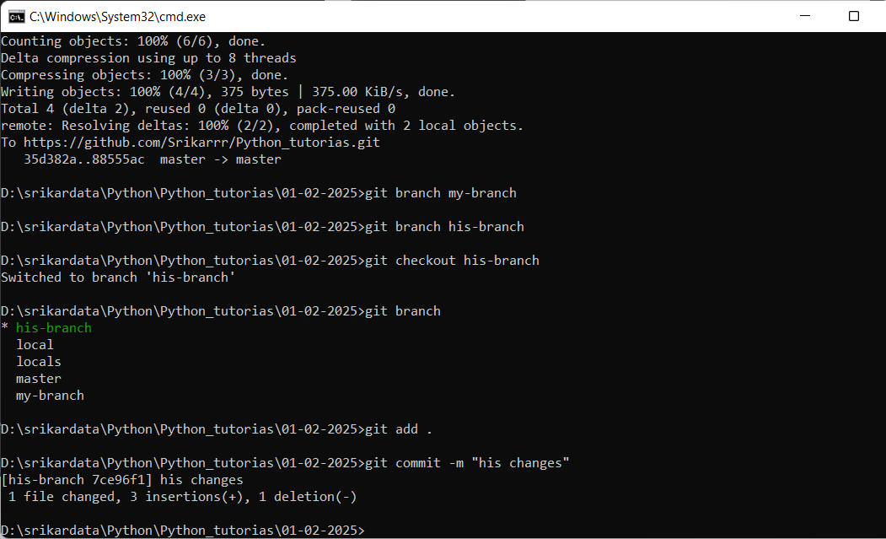
Commit done on his-branch
Now I will checkout to my-branch and add some other content in content.txt

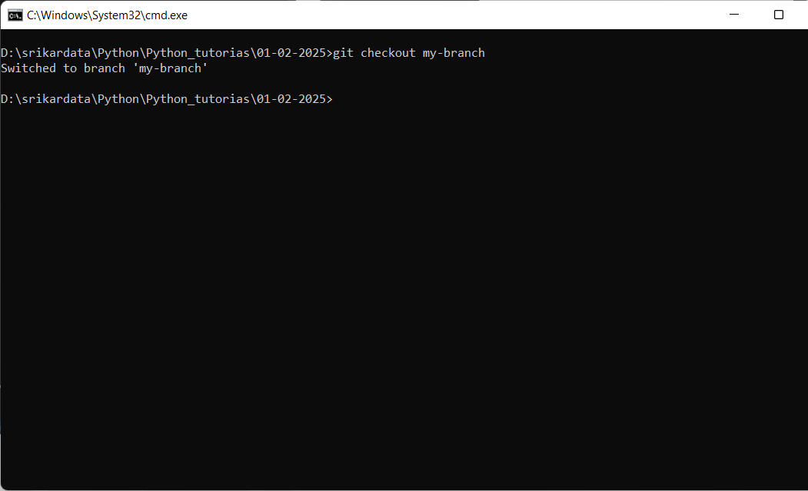

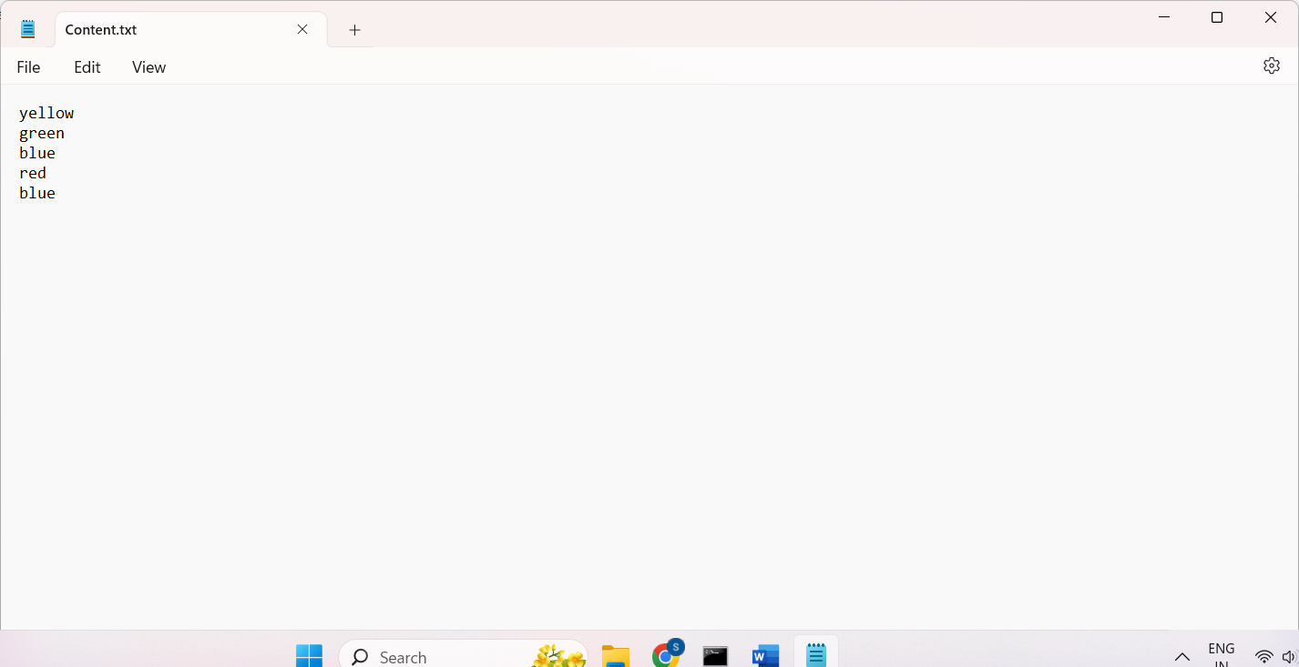

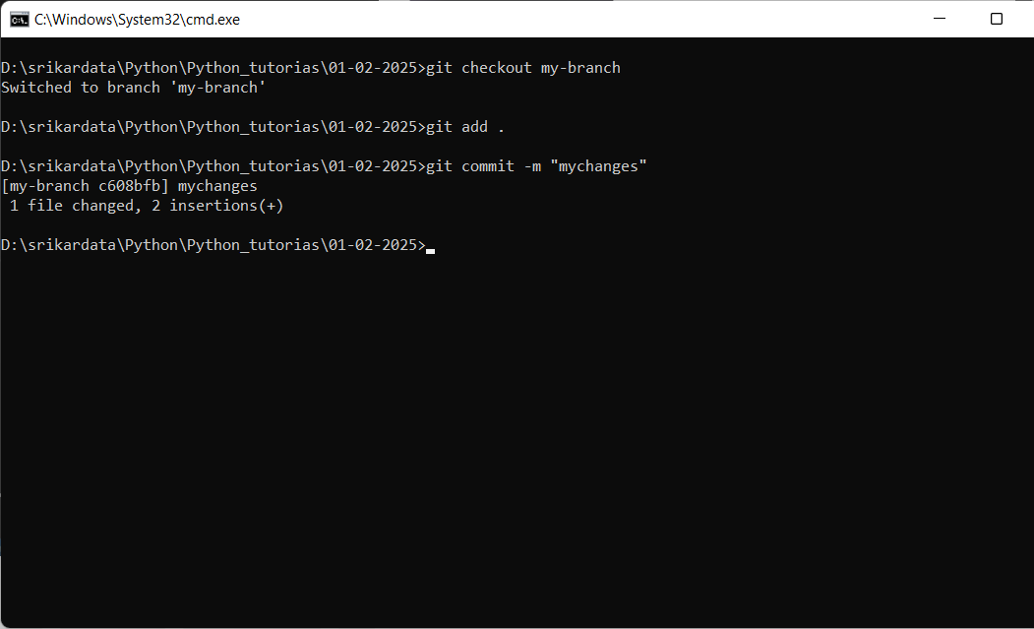
Now I want to merge his-branch to my-branch
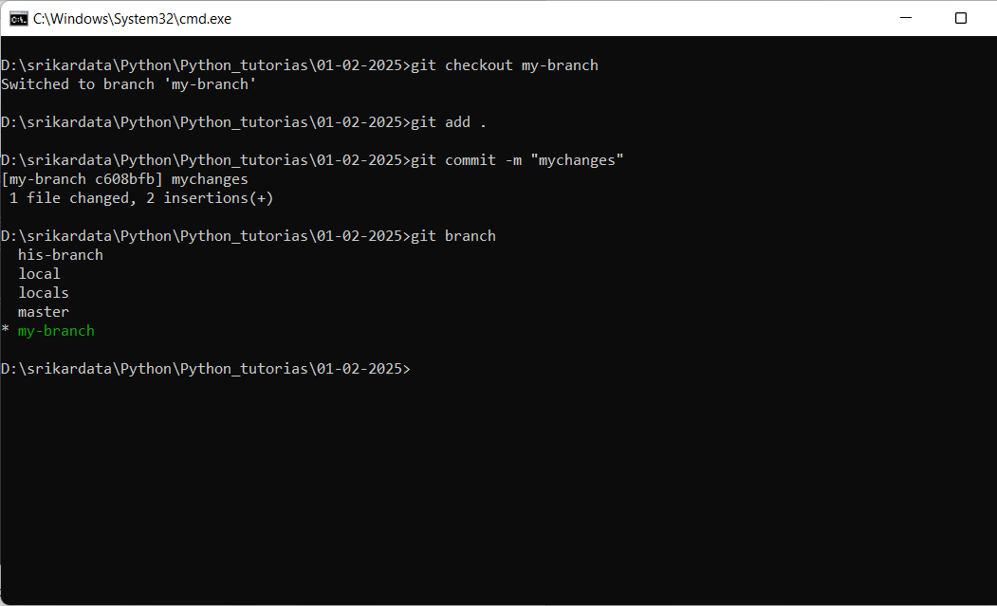

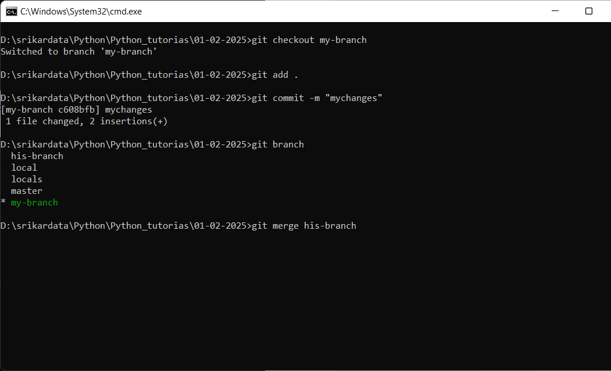

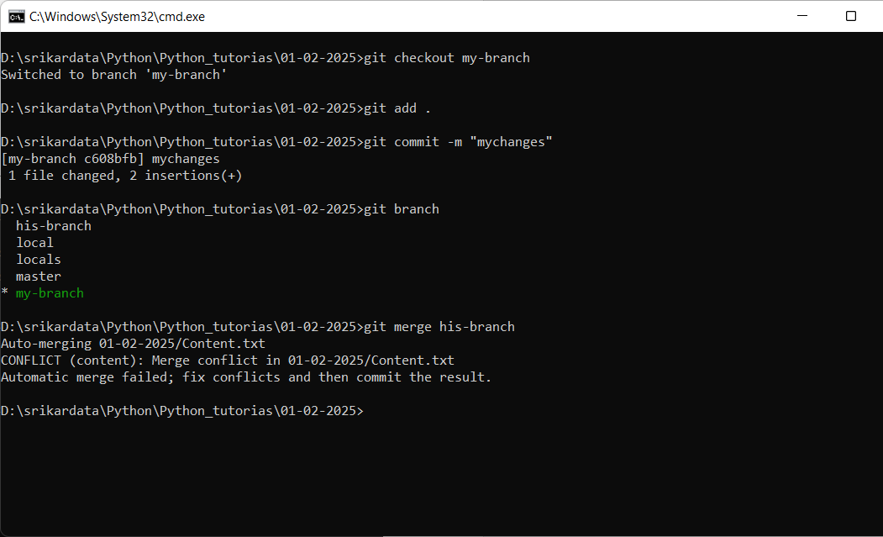
Now the conflicts came
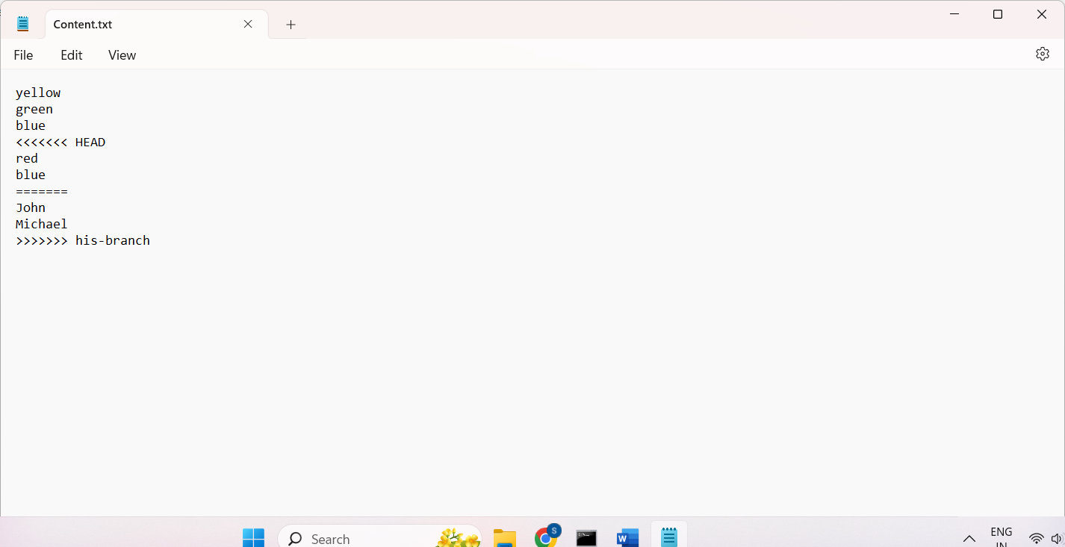
In My-branch it has red blue where as in his-branch it has John Michael so now the git is asking what you want to keep so here you need to work with your colleagues and you can keep only 1 code

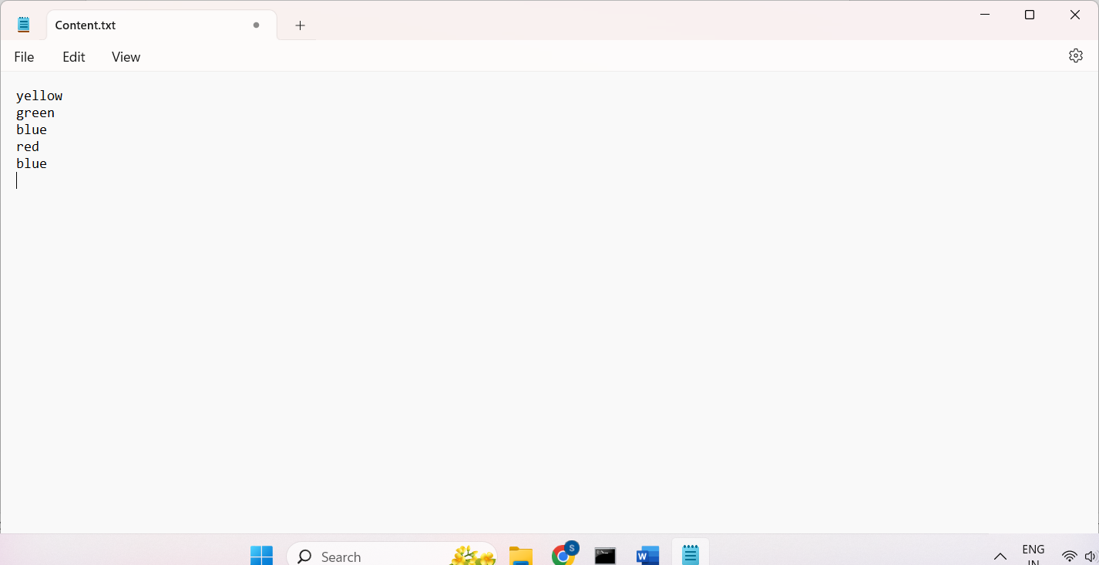

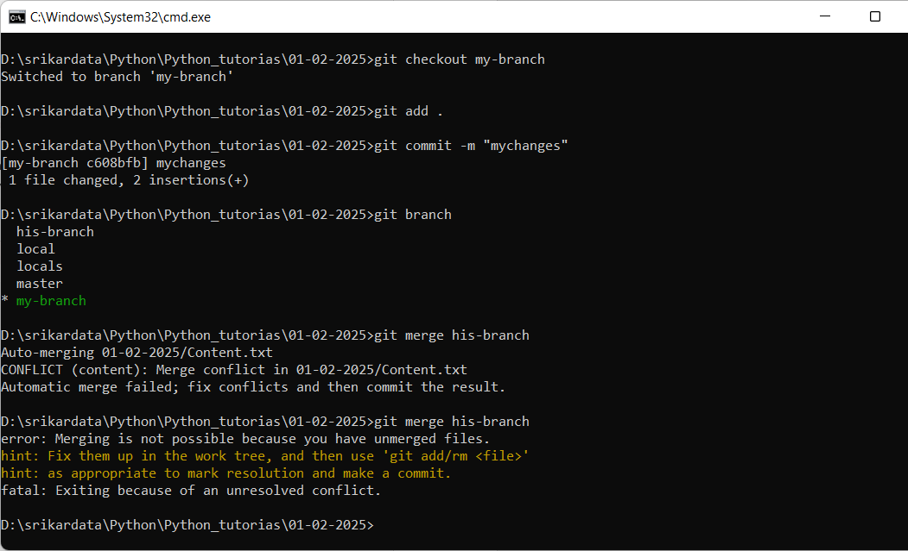
Again you need to add and commit its like new change
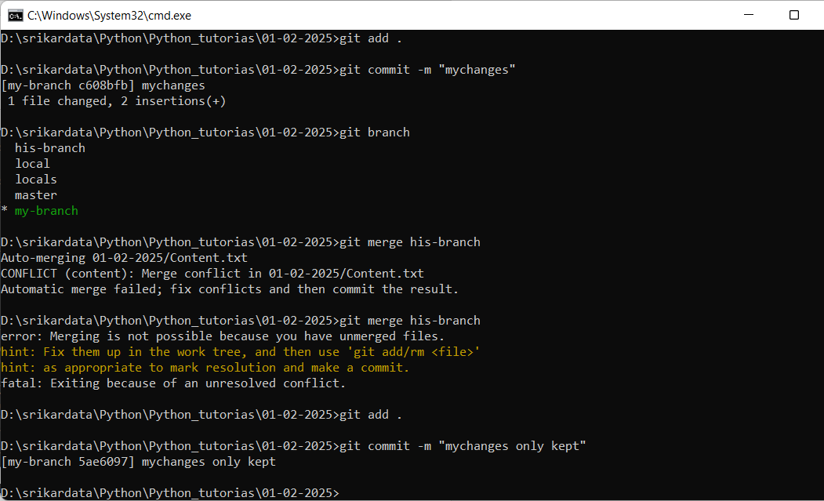

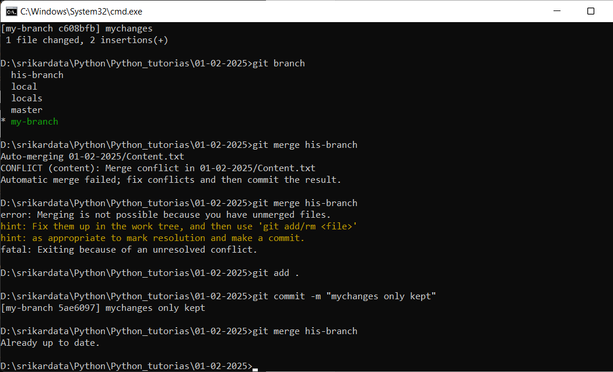
git merge –abort cancel the merge and keep it back where we are
Best practice is to always take the latest code daily from the master branch code to your branch (which you are working) because some other people may have already pushed their code to the master and when you push your code to master without taking latest master commit chance of losing data will happen

