Azure Machine learning is a cloud service – ui based interface.
Supervised Machine Learning Model
Machine Learning – is a method of teaching computers to make predictions based on Historical Data
In Supervised machine learning – We give a data and expect Output
Unlabeled Data- takes the data from the natural world ex :photos videos xrays
Labeled data – photo contains horse/cat
Square Footage | Zip Code | Price
2000 | 98052 | 5000 $
3000 | 75284 | 4000 $
3500 | 68164 | 5500 $
2000 | 45465 | 5400 $
7520 | 98645 | 10000 $

Pircing is real estate depends on location
so zipcode + Square Footage indicates prediction of Housing Price.
Advanced Mathematics usage depends on algorithm.
Linear regression example one of the mathematical problem

SuperVised machine learning
Classification | Predicting a discrete category
Regression | Prediciting a value
Anomaly Detection | Identifying unusual data
Clustering | Grouping similar data together

Fradulent transactions -

There are different modules for importing and cleaning data
Modules for importing and cleaning data
Create experiments to train and test models

Algorithm -> Train Model -> Score Model -> Evaluate Model
DataSet -> Data Cleaning -> Training Data -> Split -> TestData
In Supervised Machine learning model we will split the Training Data and Test Data.
Data preparation and Data Ingestion
Sample data
Upload dataset from local machine
Enter Data Manually
Import data from external website

Ordinal Regression | Data in rank ordered categories
Poisson regression | Predicting Event Counts
Fast forest quantile regression | Predicting a Distribution
Linear Regression | Fast Training, linear model
Bayesian linear regression | Linear model, small data sets
Neural Network Regression | Accuracy, long training time
Decision forest regression | Accuracy, fast training
Boosted decision tree regression | Accuracy, fast training, large memory footprint
Fast Training linear model | Multiclass logistic regression
Accuracy, long training times | Multi class neural network
Accuracy, fast training | Multiclass decision forest
Accuracy, small memory footprint | Multiclass decision jungle
Depends on the two-class classifier, | One-v-all multiclass
Two or More Predicting Categories
Three or More Predicting Categories
Multi-Class Classification
Anamoly detection
One-class SVM | 100 features aggressive boundary
PCA-based anamoly detection | Fast Training
TWO-class SVM | 100 features linear model
TWO-class averaged perception | Fast Training  linear model
Finding unusual data points
Start

Supervised Machine Learning is used for learning patterns from existing data and predicting future business scenarios
Predicting Values
Bayesian is a machine learning algorithm used in the Supervised Machine Learning
You split the dataset into a training set and testing set. Typically, the split is 70% and 30% respectively.
Azure ML Learning Studio – Drag and drop and deploy predictive analysis model
Crate Launch Studio:
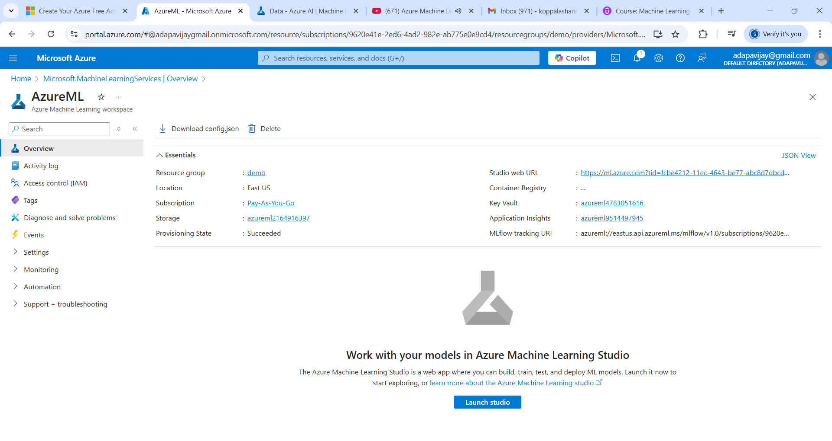

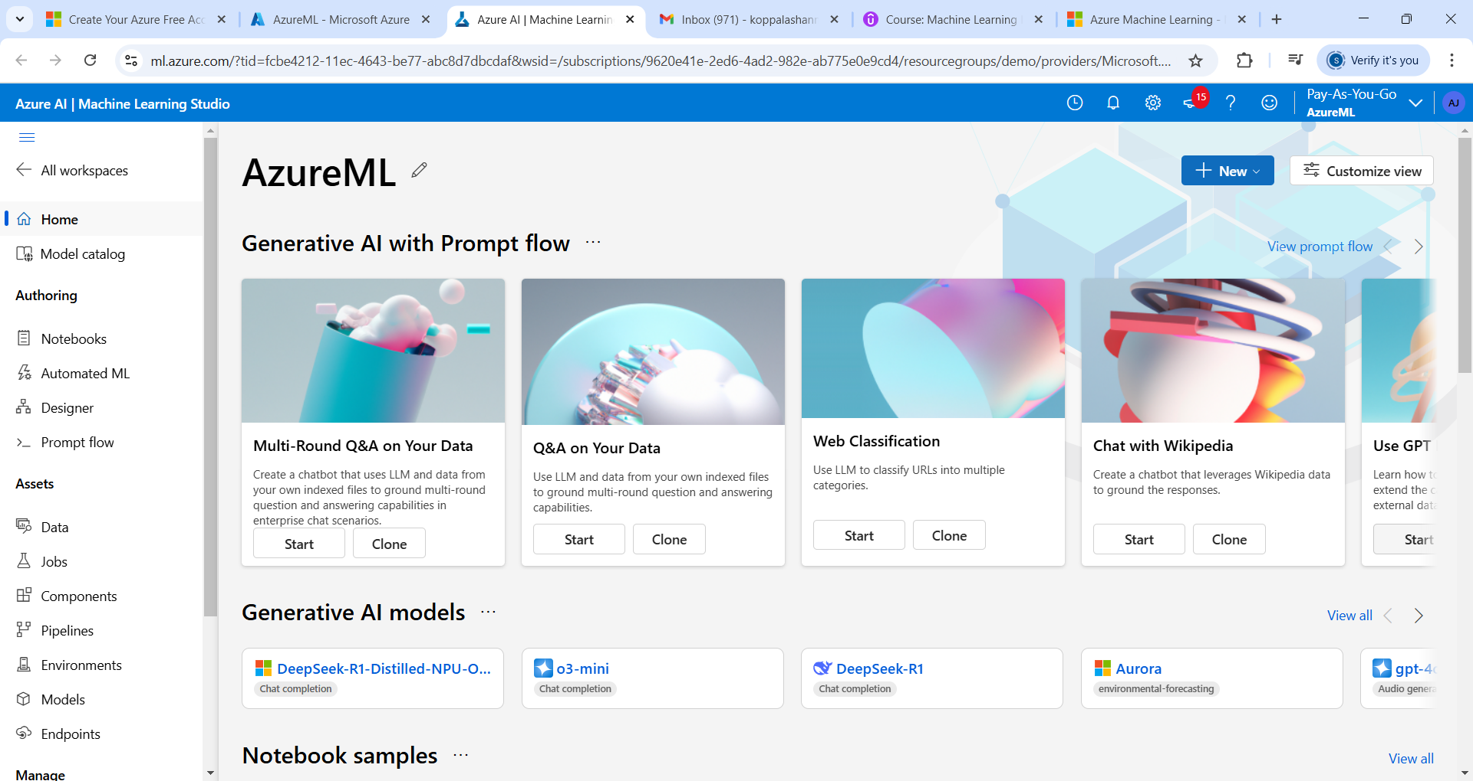
Automated ML – Just click on it
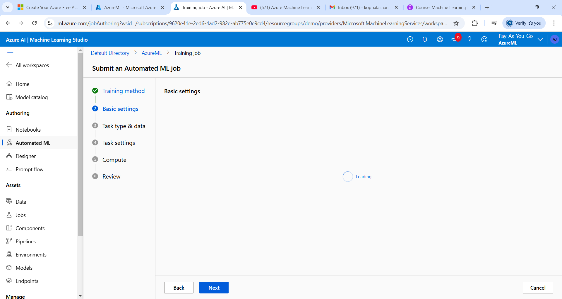
Can do expirement with different algorithms, different hyper parameters
Compute allows you to manage your computing resources under azures.
data storage is technically the URI and links to external data sources
Click on Designer
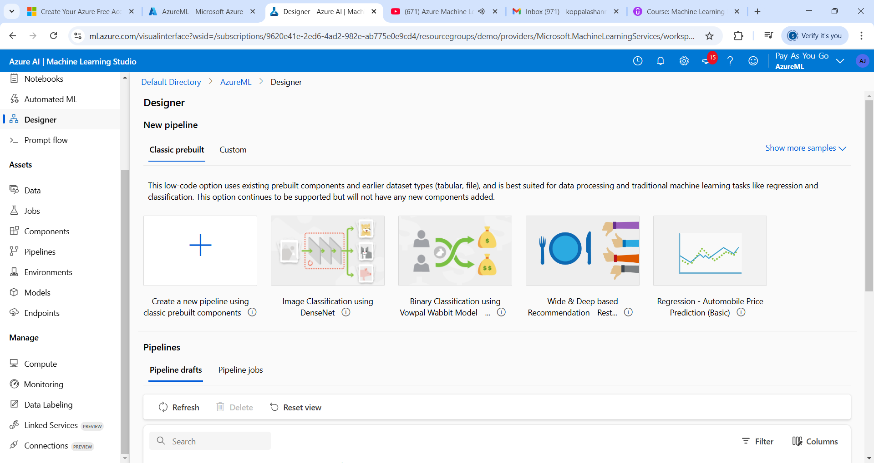

Take the titanic dataset csv
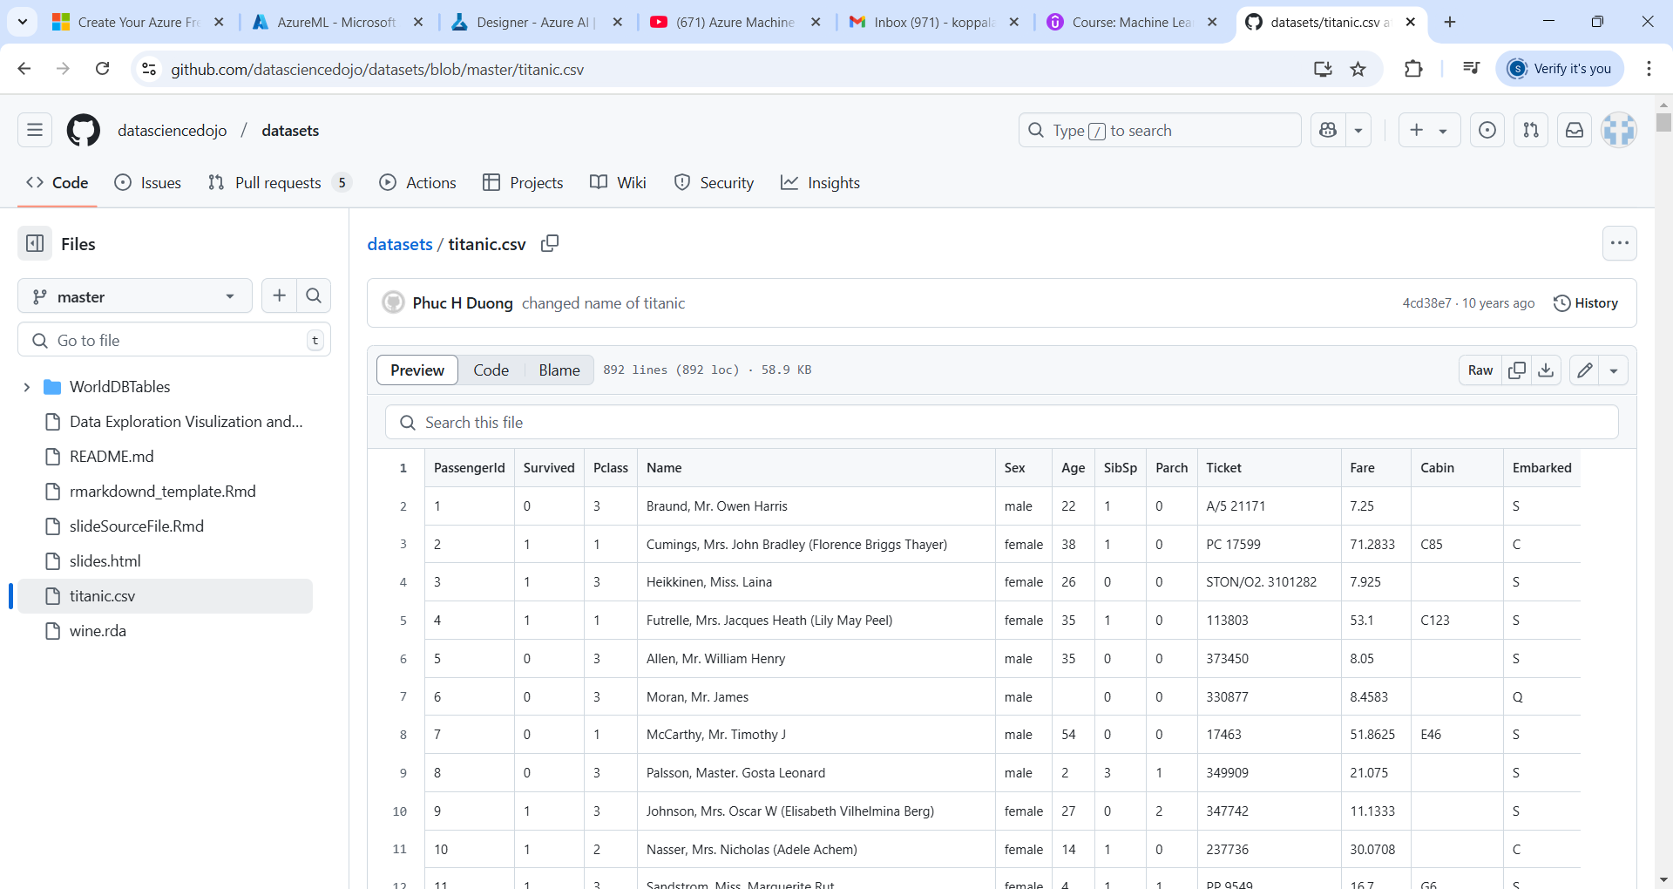

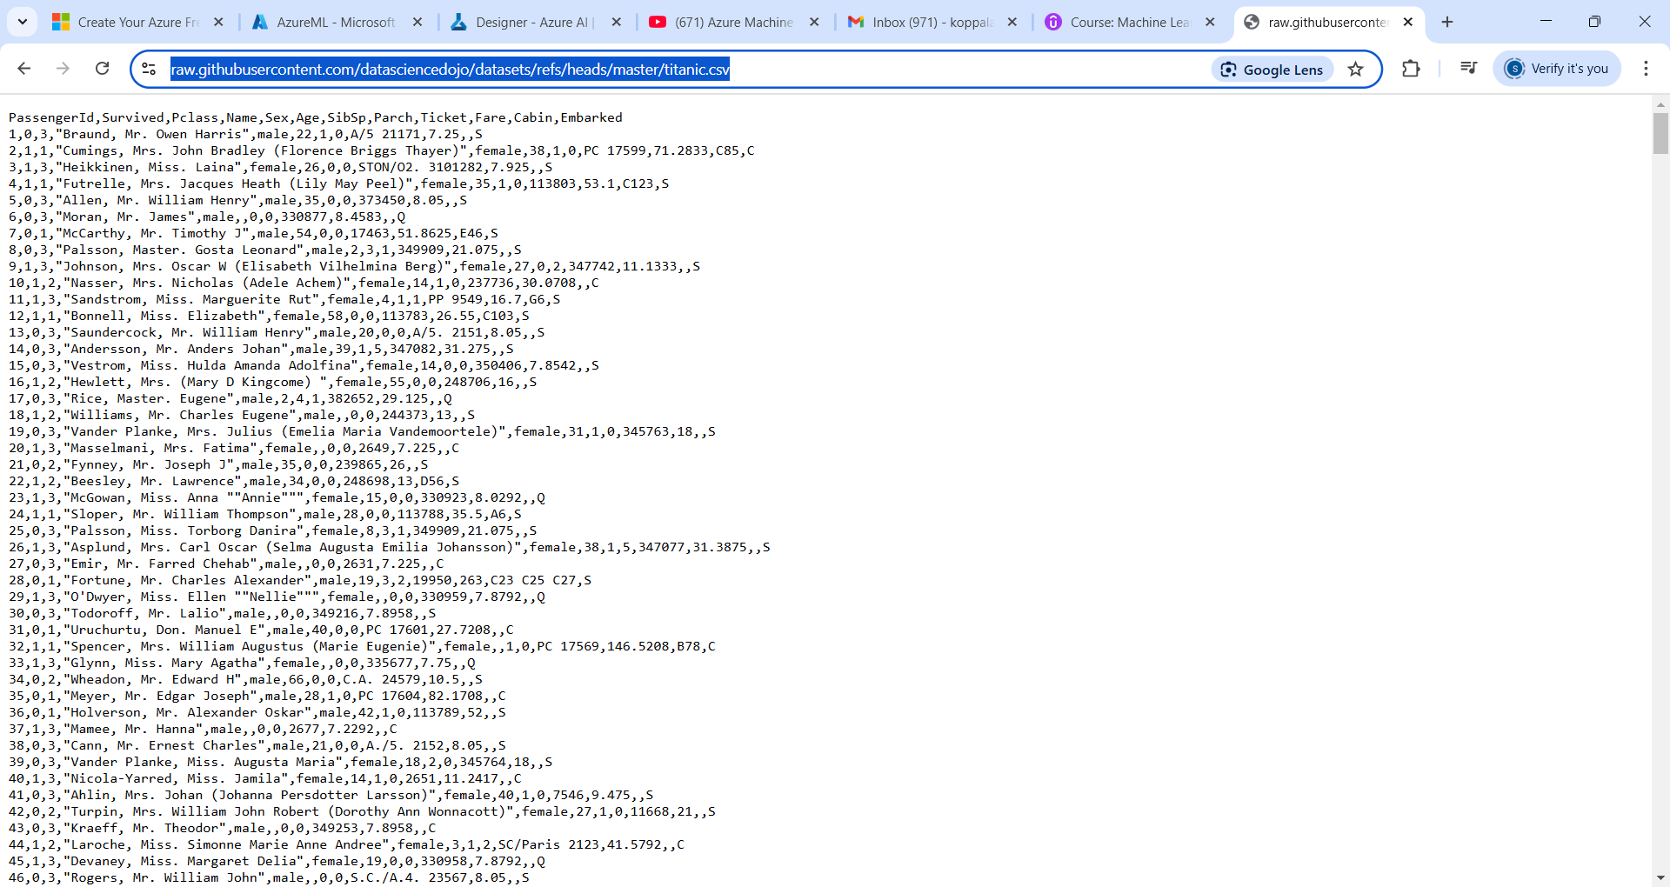
Take the titanic.csv
https://raw.githubusercontent.com/datasciencedojo/datasets/refs/heads/master/titanic.csv
click on + icon

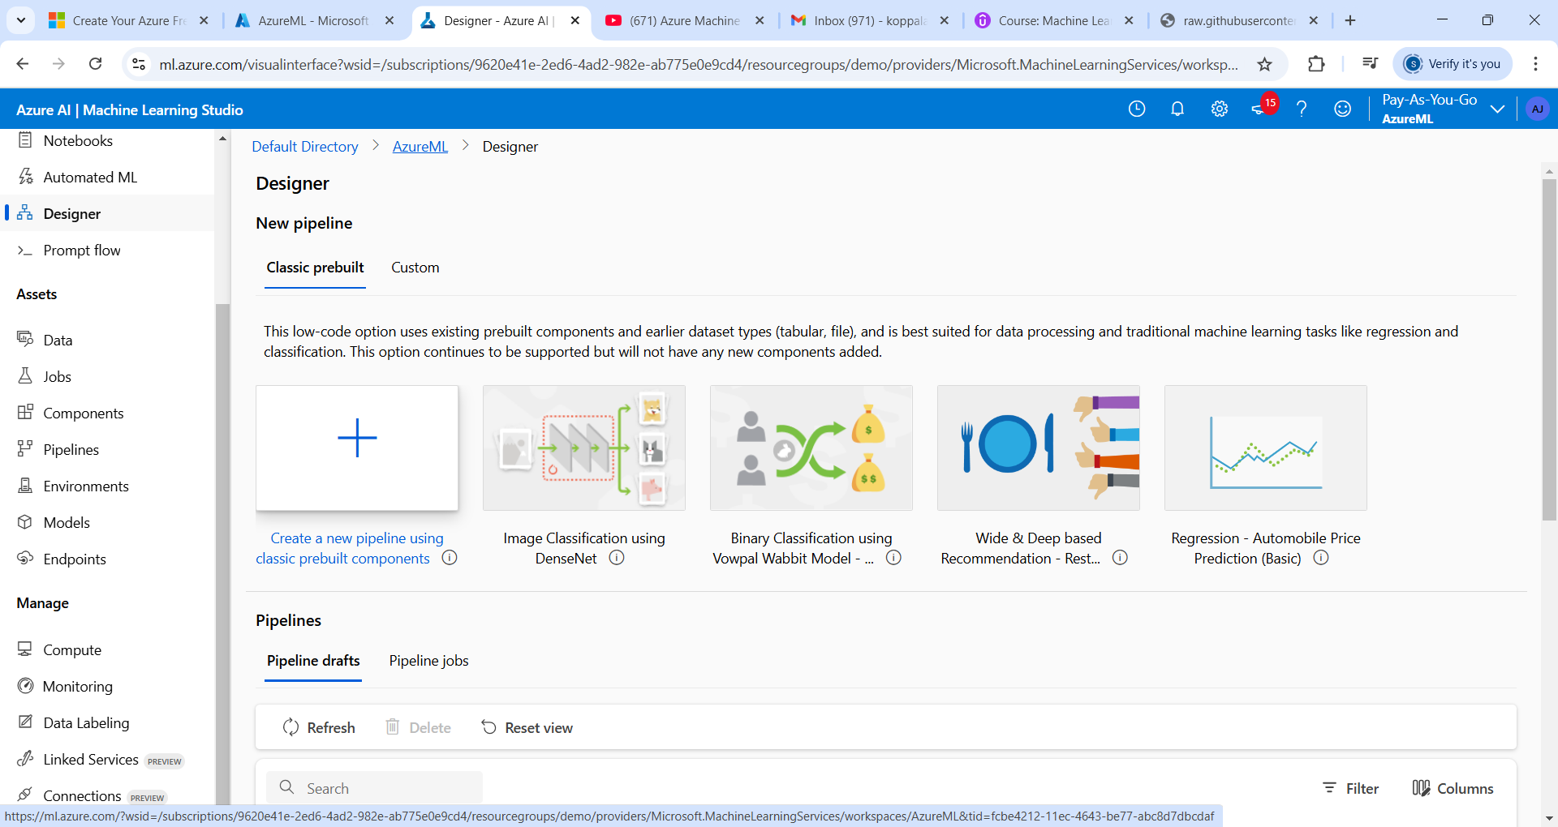

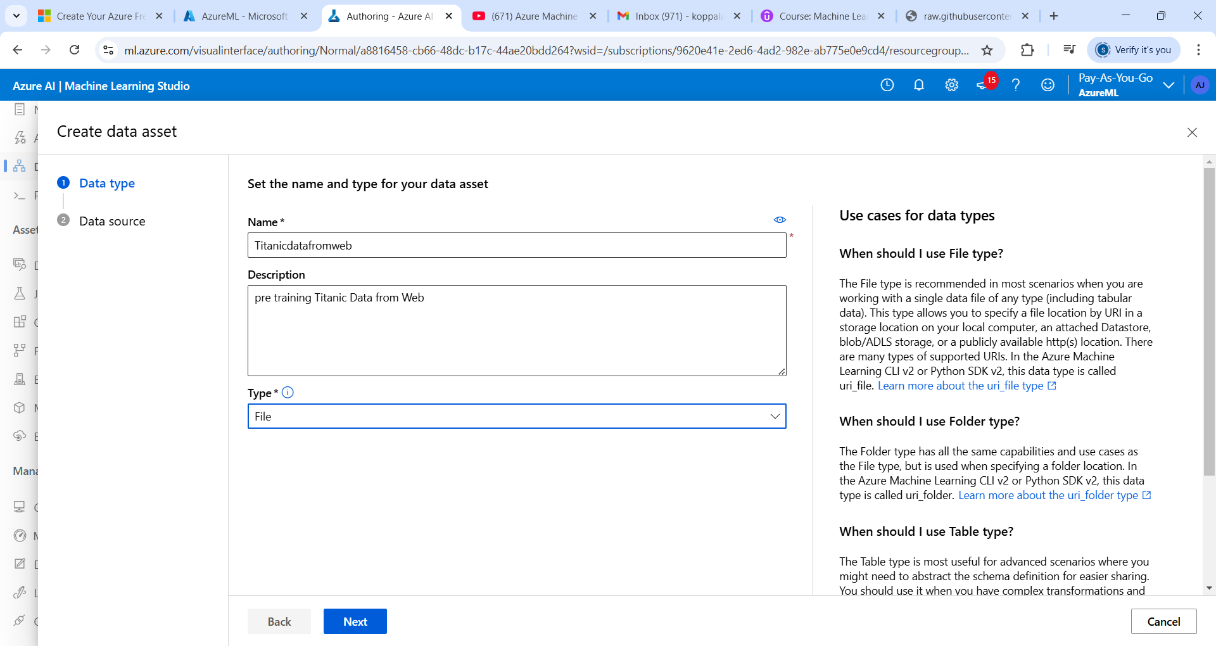

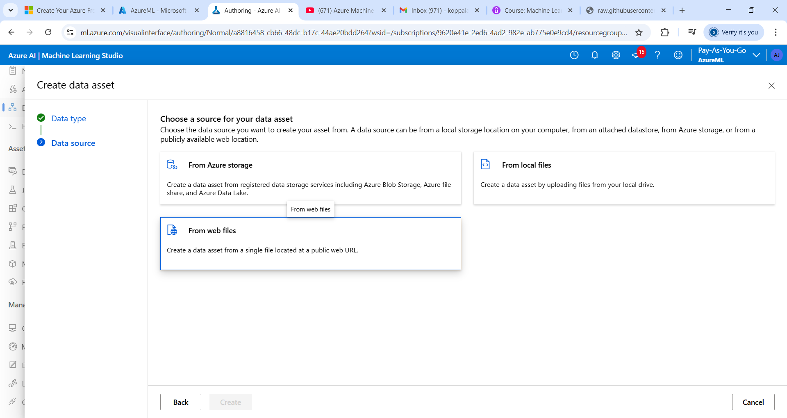
Click on from webfiles
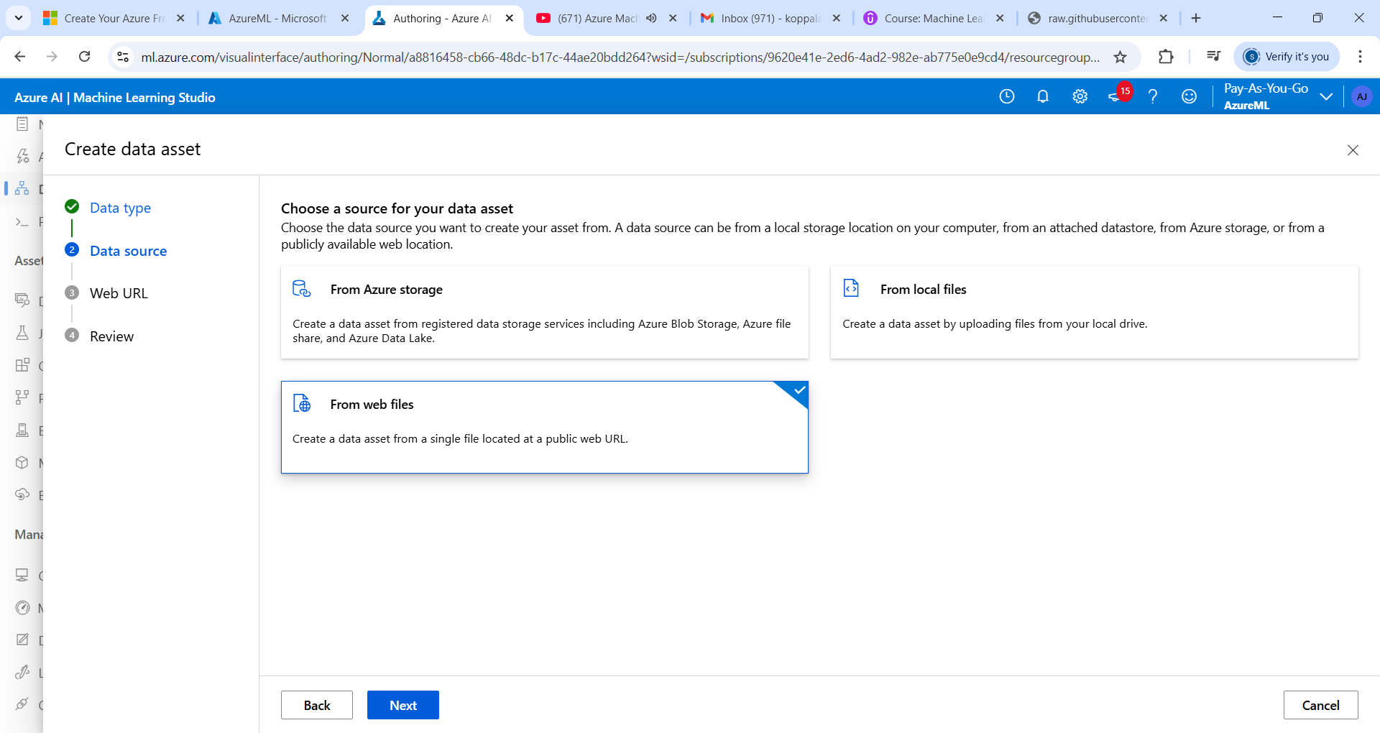
Enter url
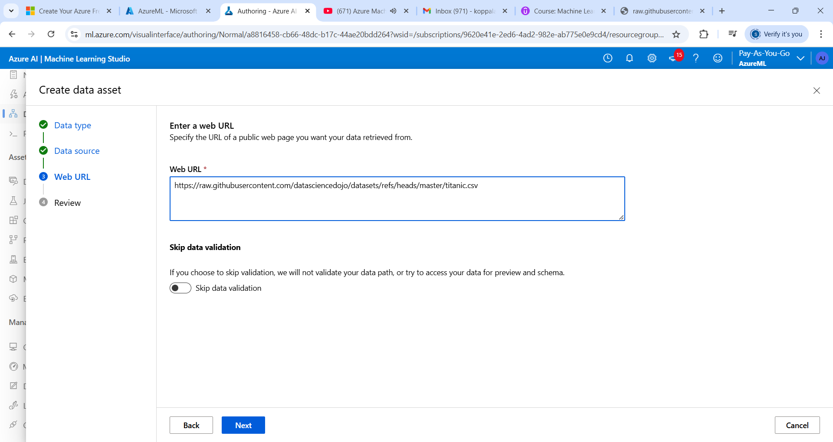

Click on Next
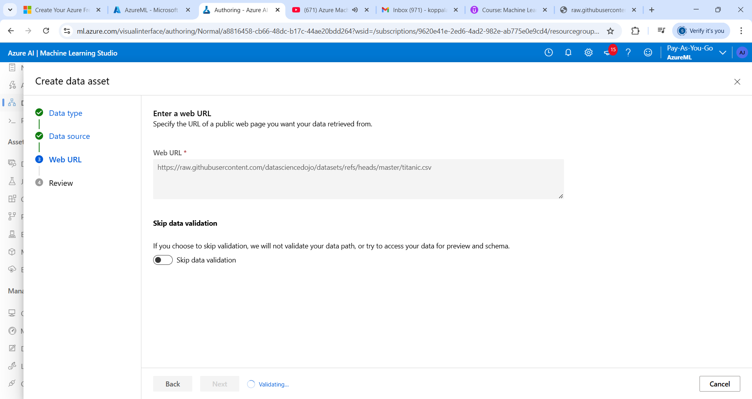
Click on create
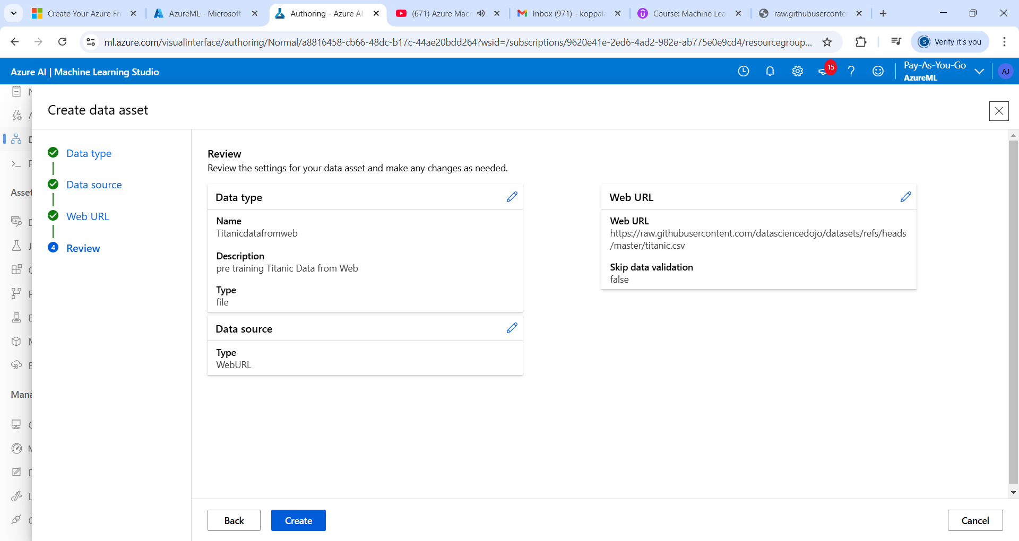

Drag and drop pipeline
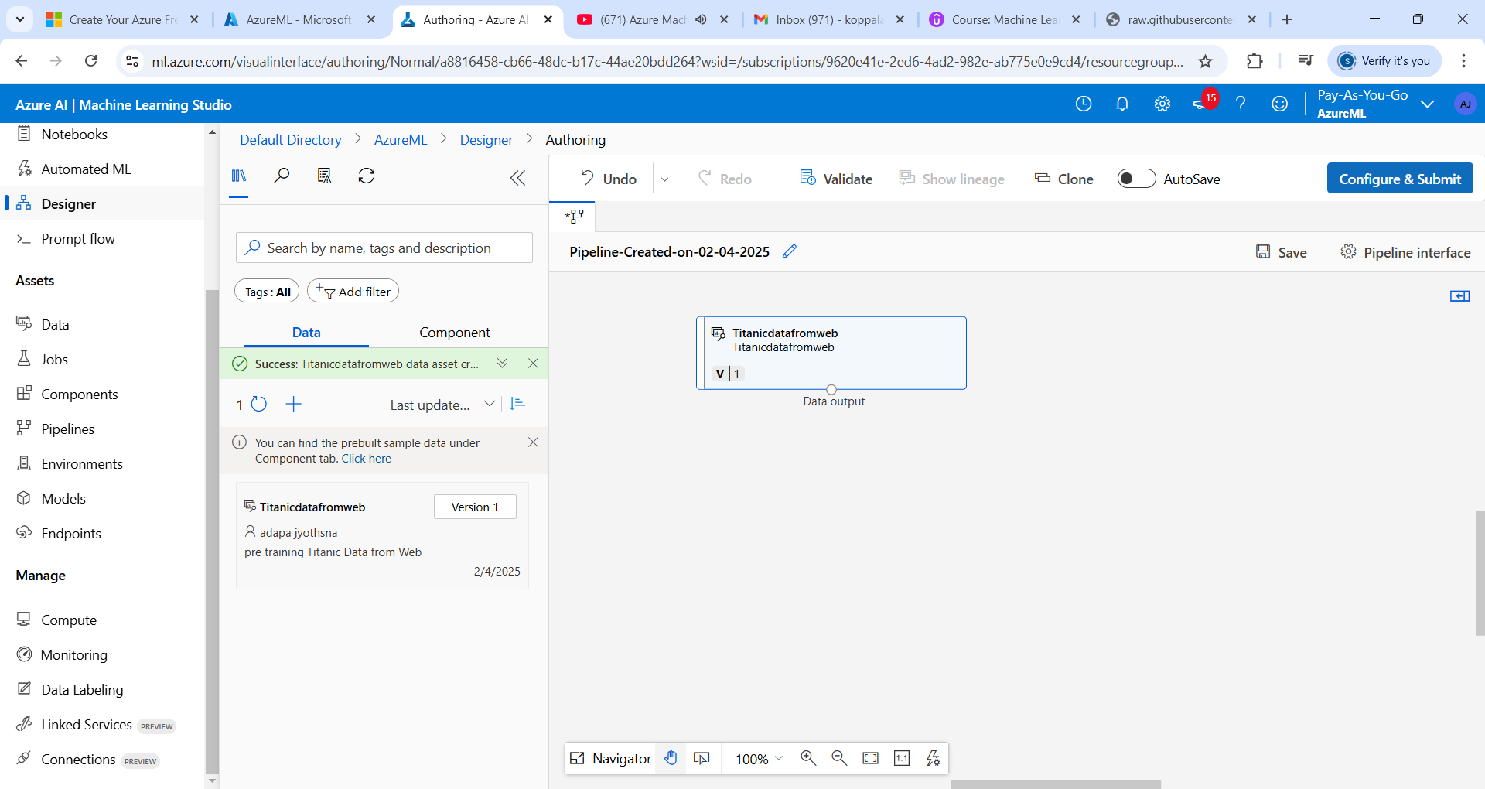

Clean missing data -> what parameters we should give

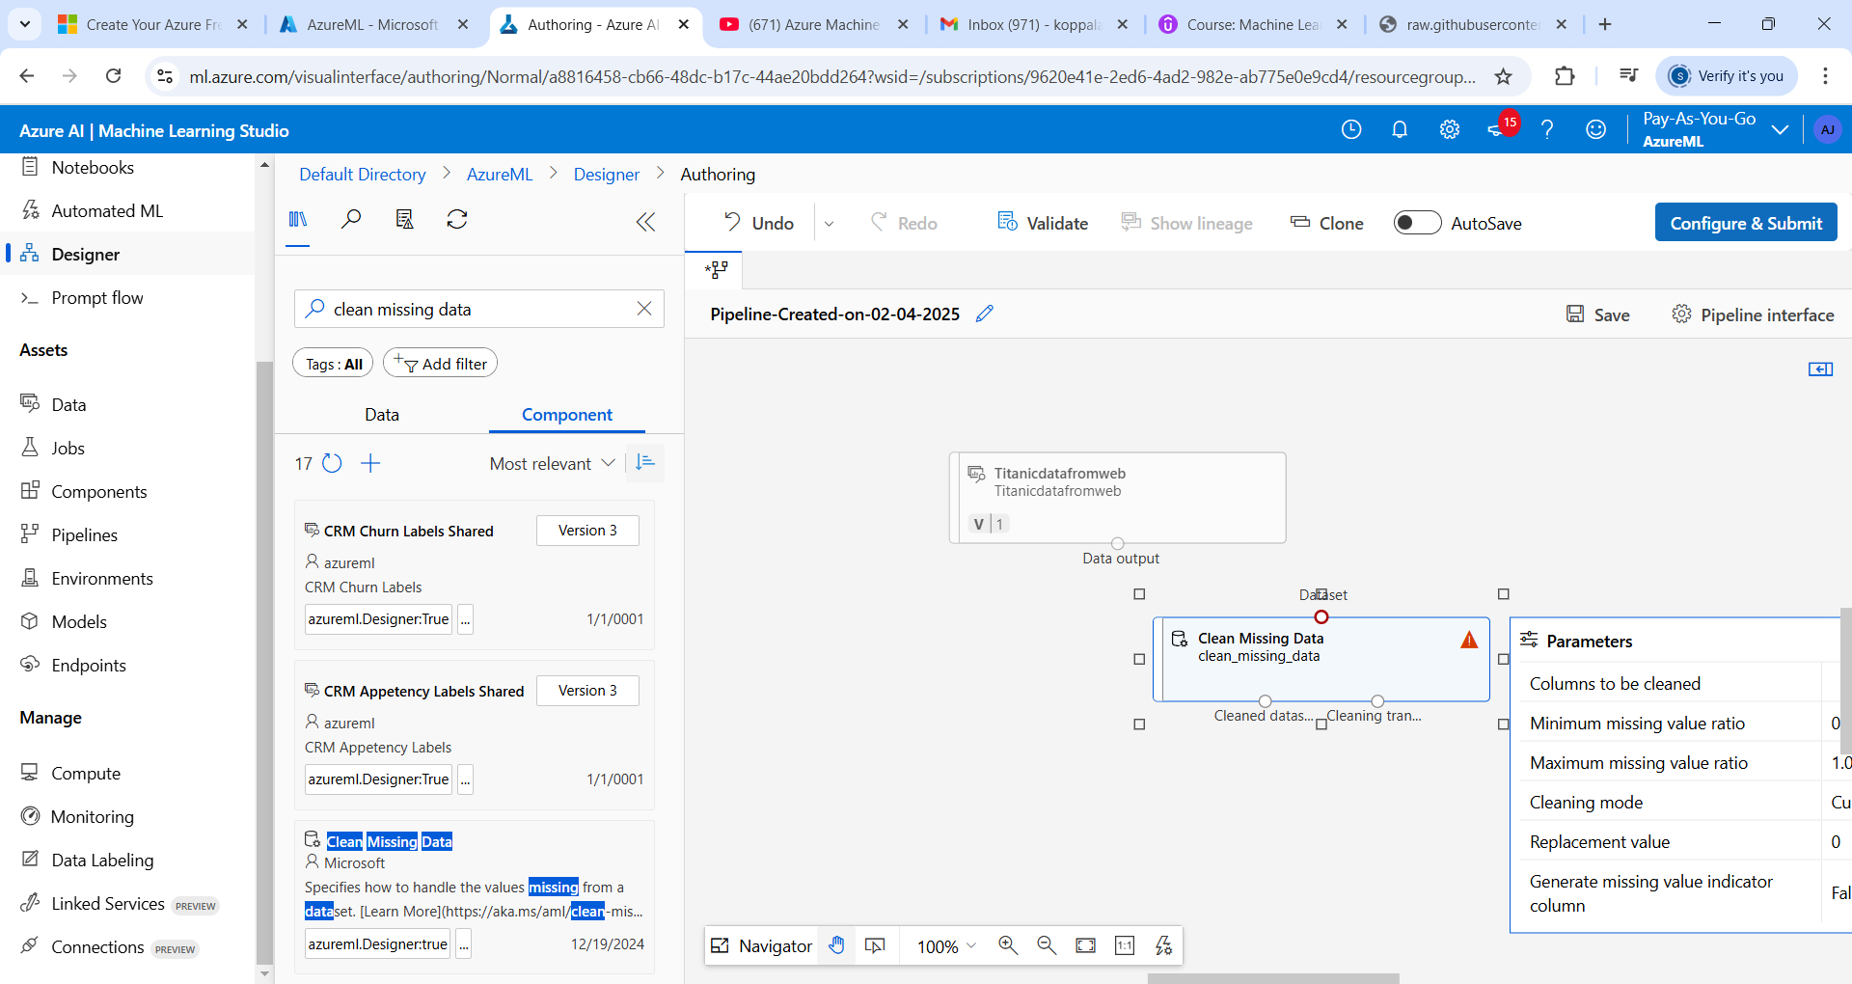
Just map the dataset
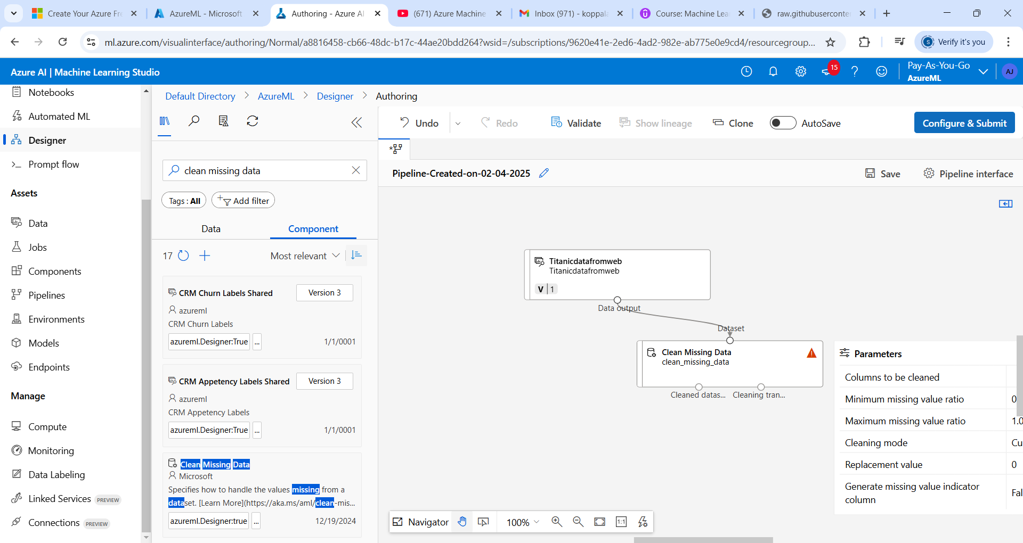

Double click on Clean Missing Data and click on Edit Column

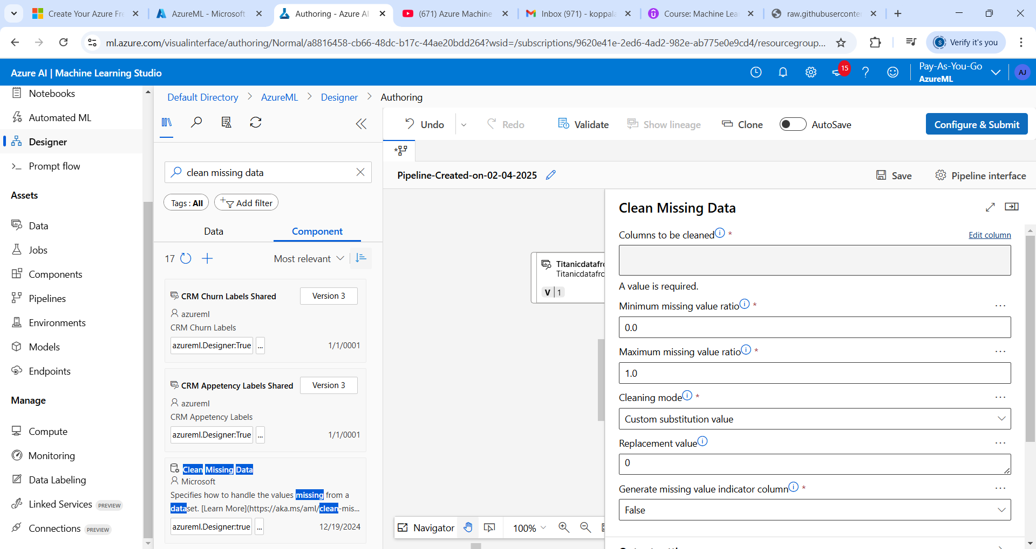

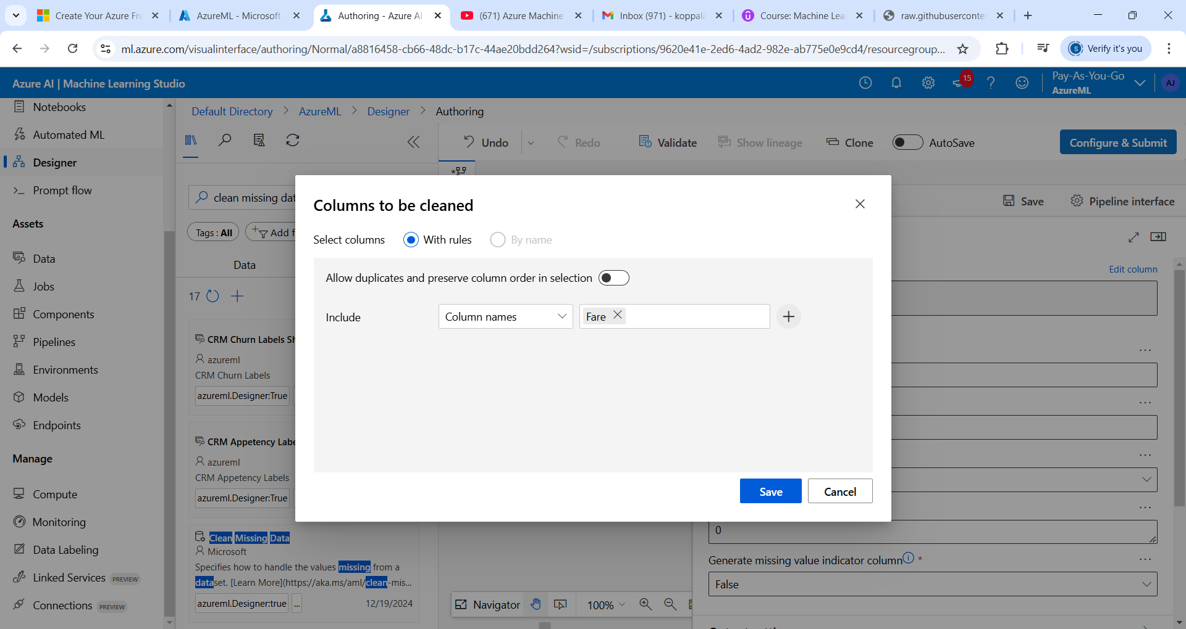
Column Names we can give ex: Fare
Click on close:

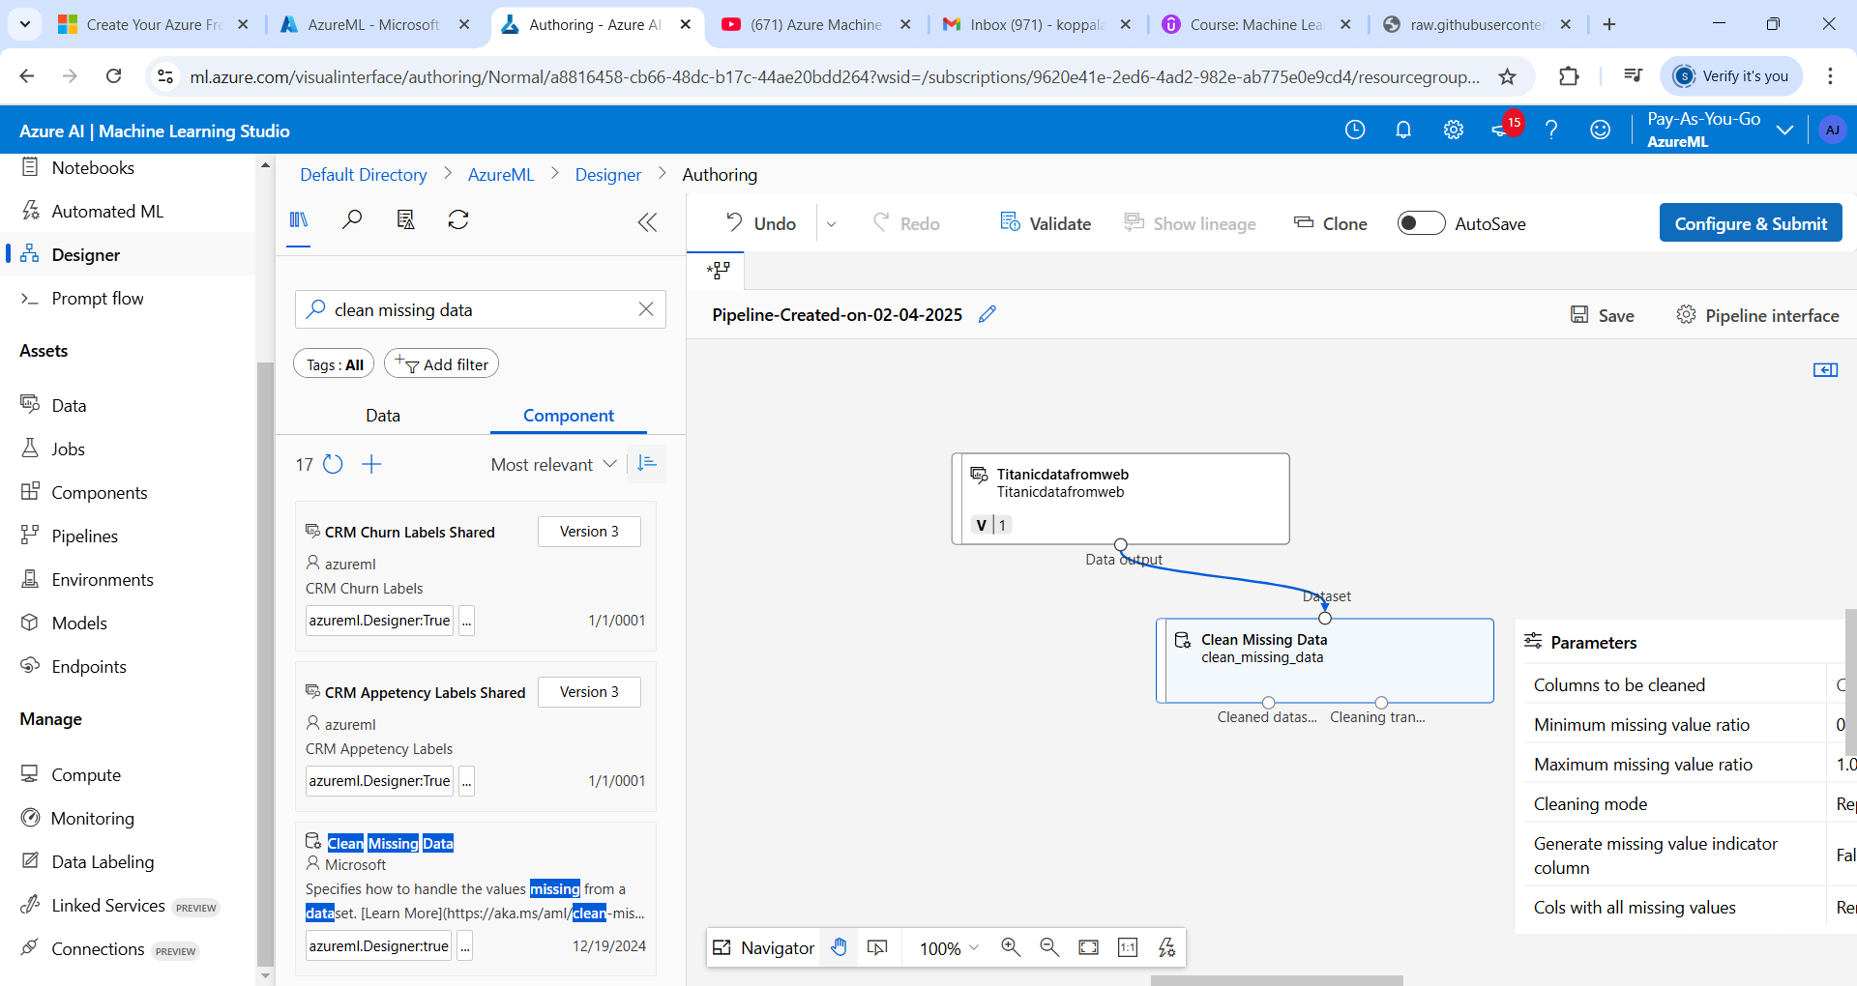
Select columns in data set
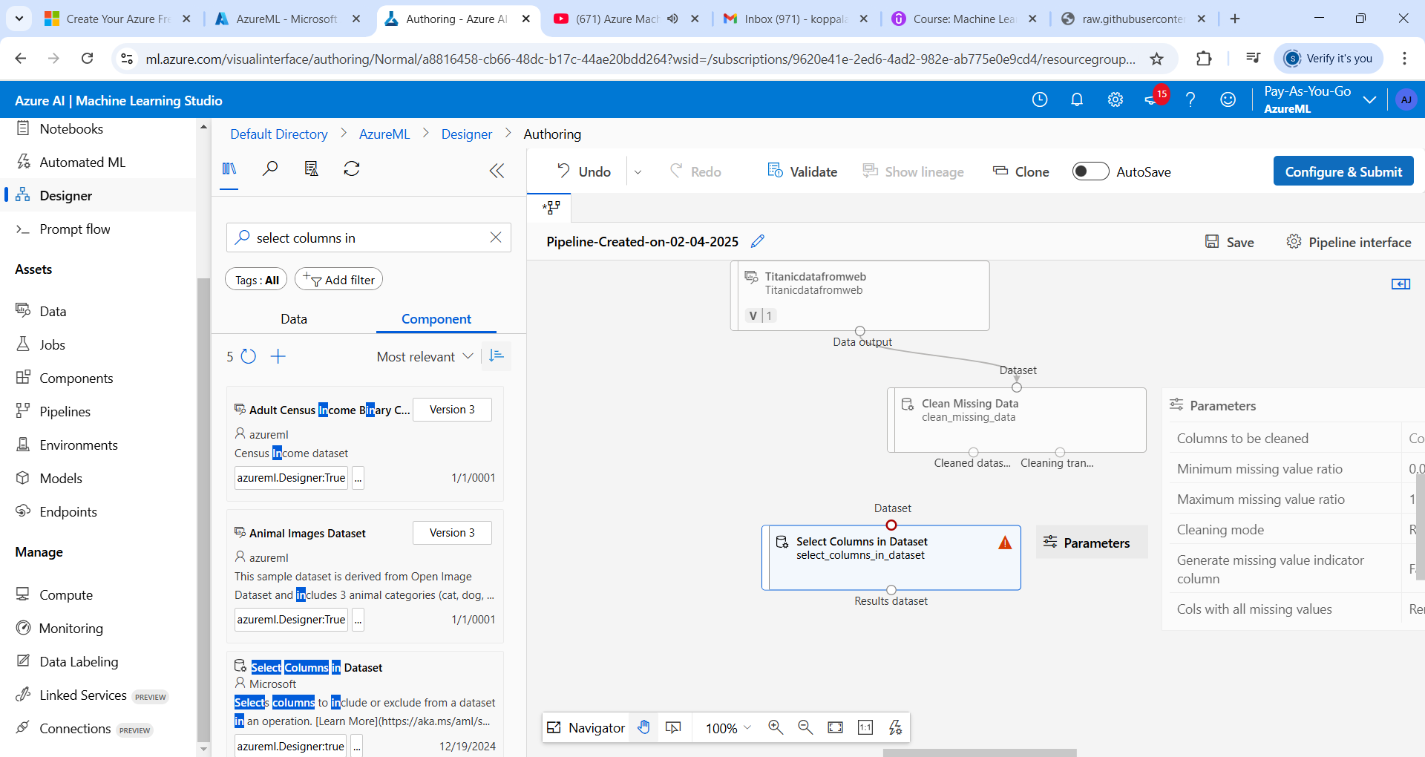

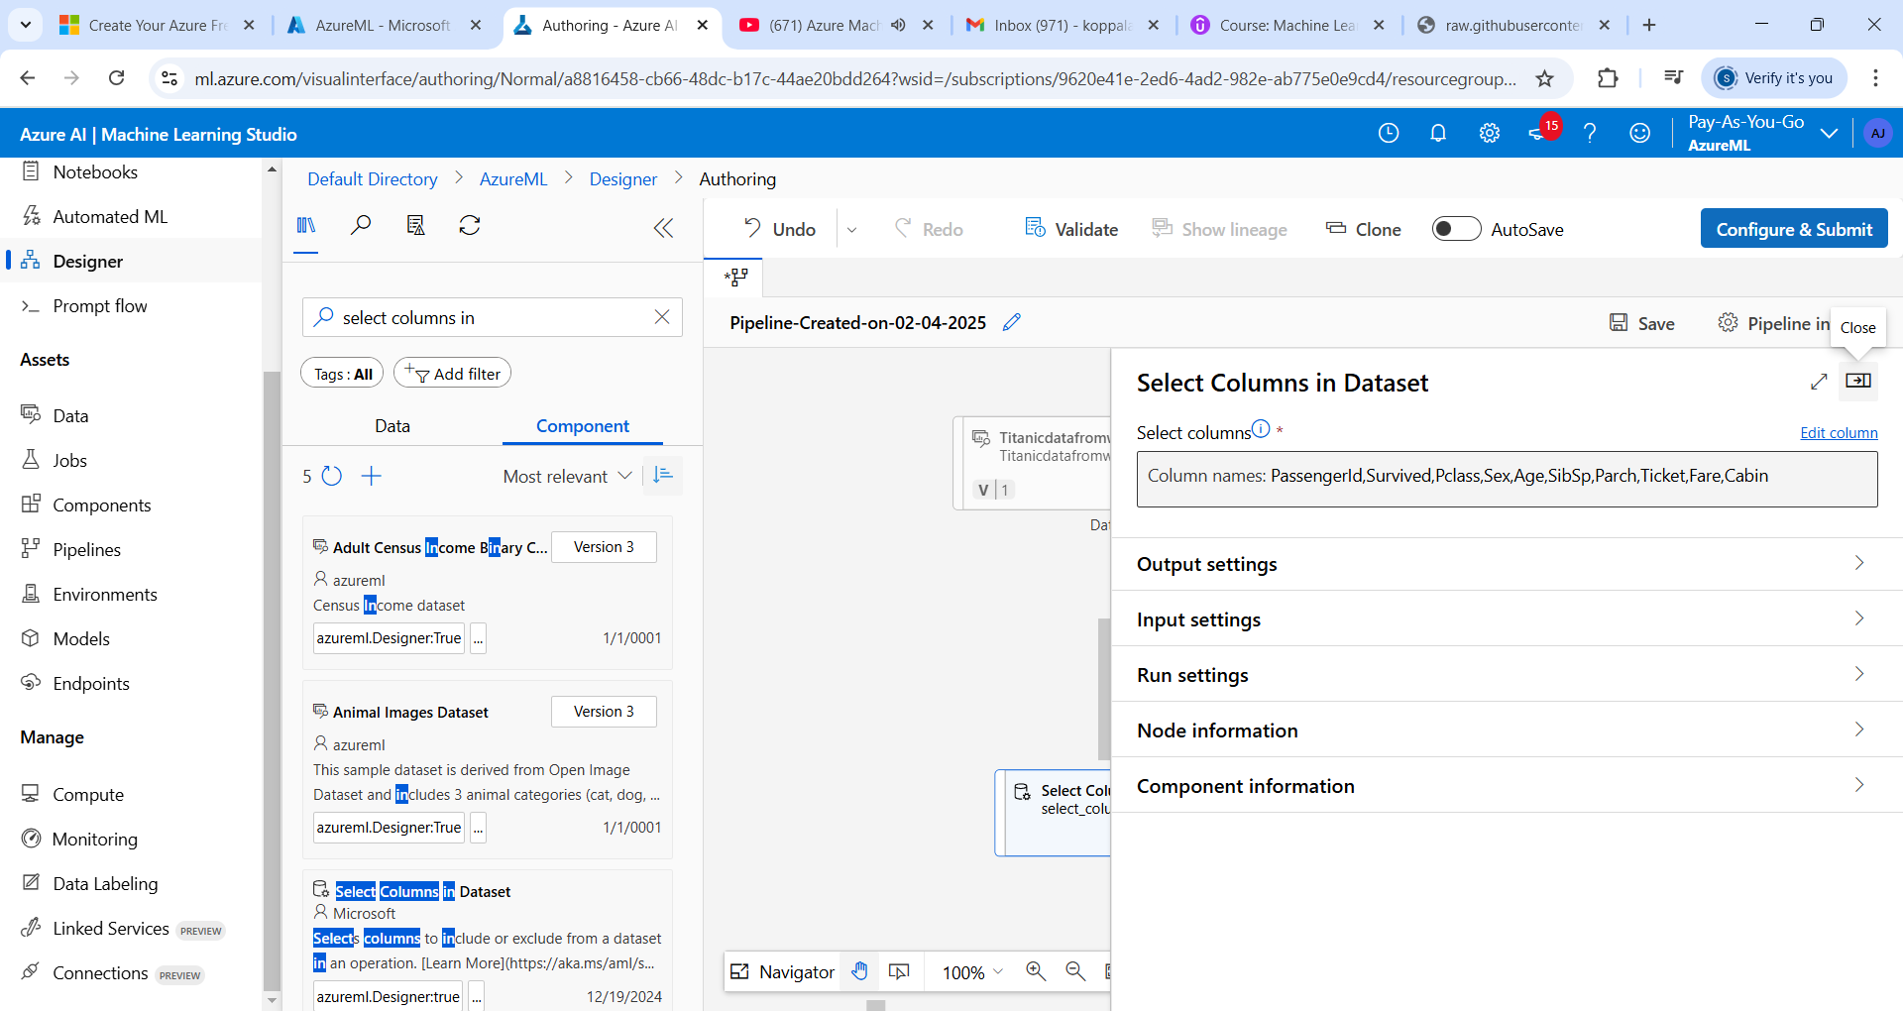

To Train Model – Two-Class Boosted Decision Tree (anything we can take)

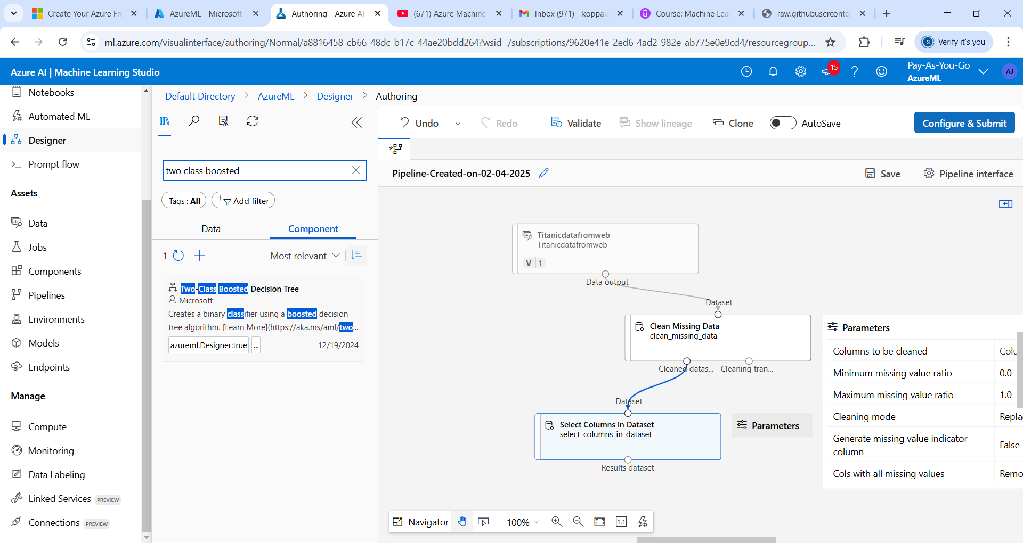

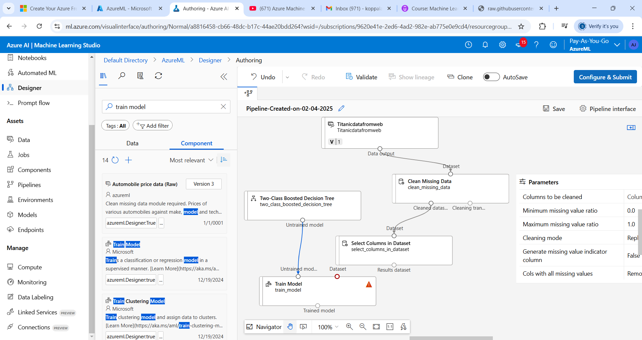
Drag and drop split data
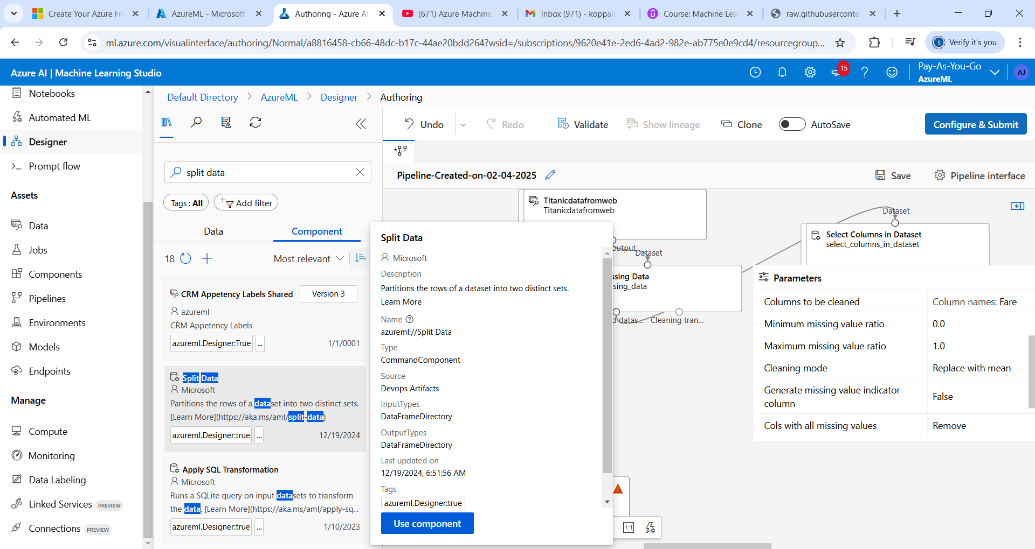
Do split 70%

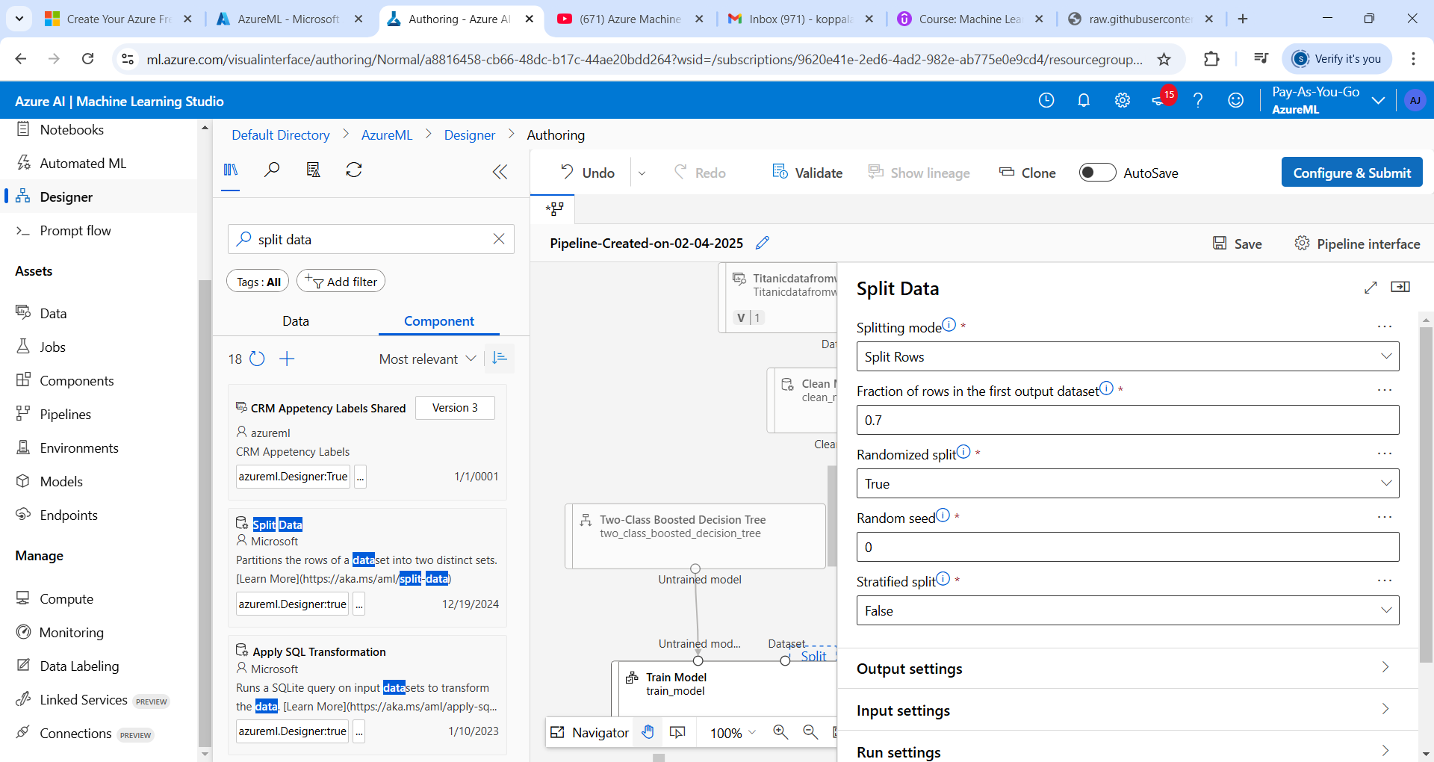
Compute cluster -> Where to deploy these Model
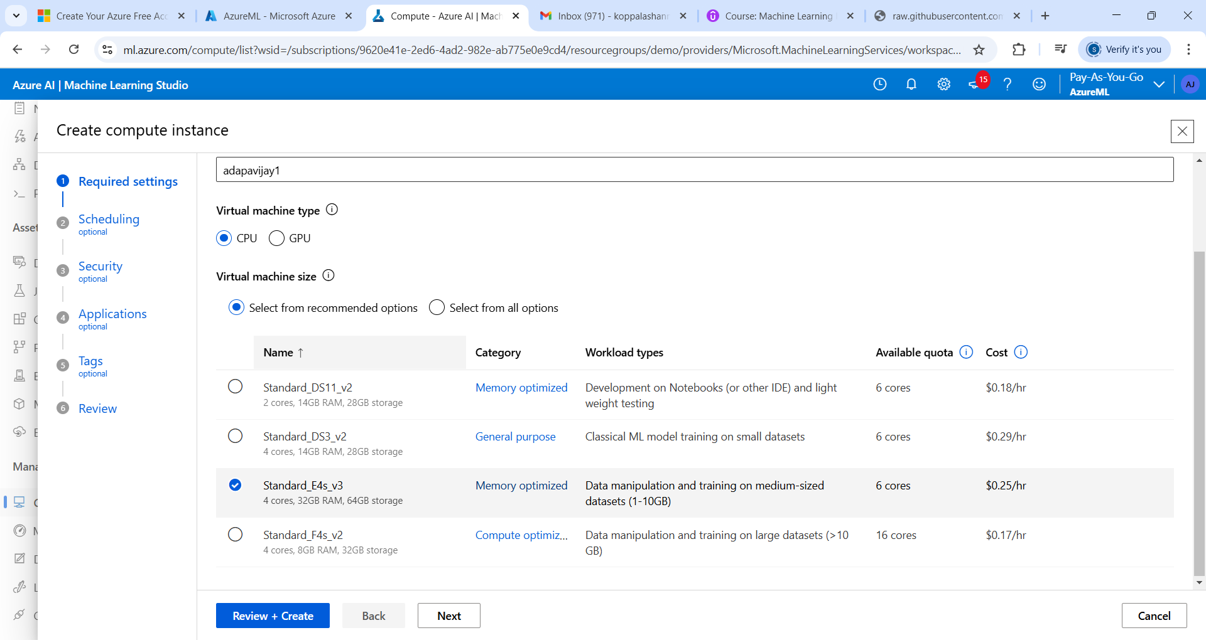
Add Schedule
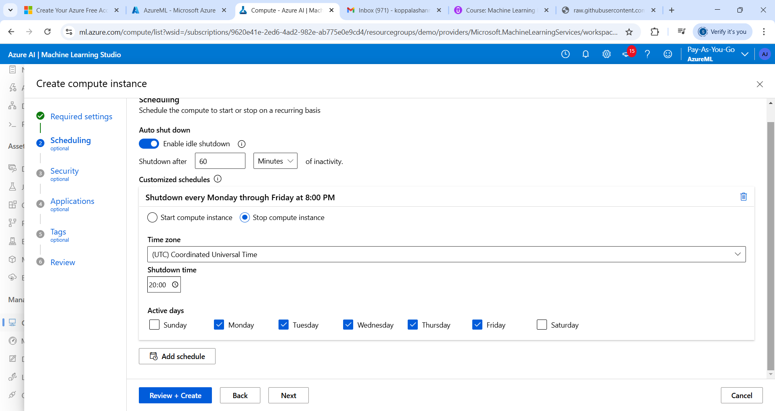

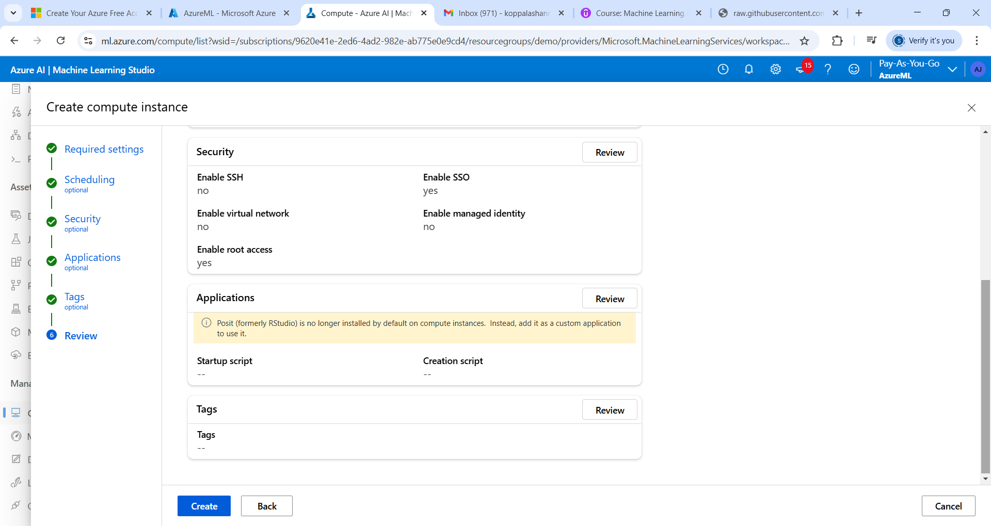

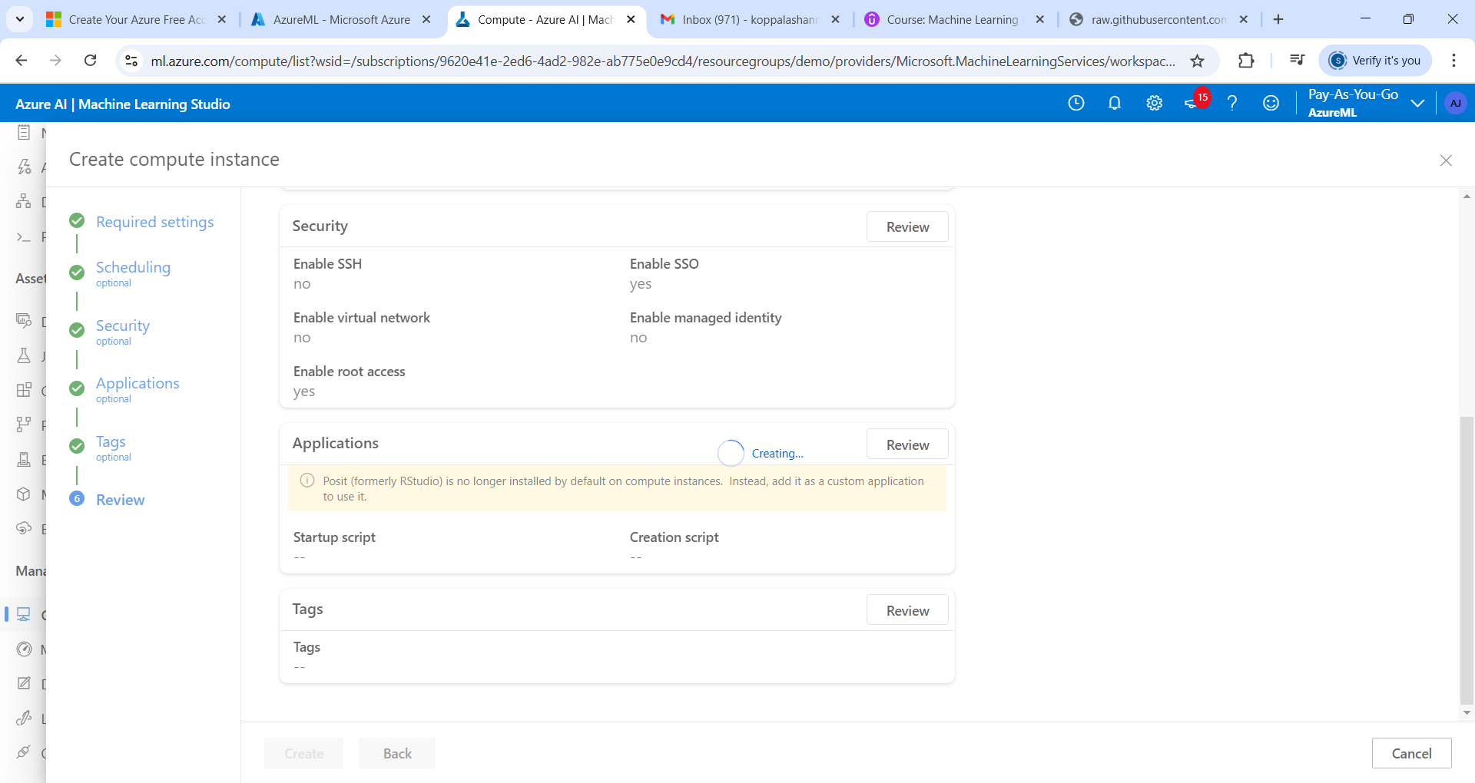

When you train model you need to add column to predict

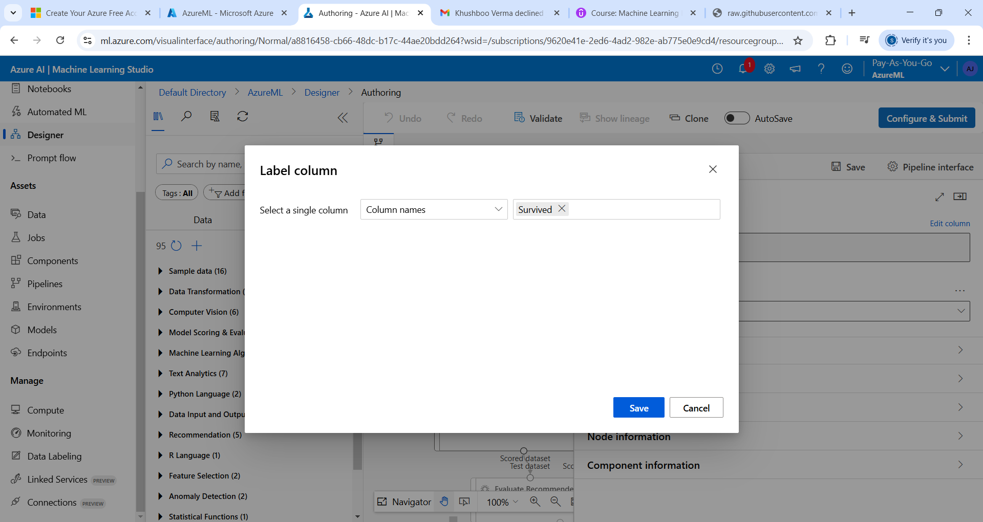

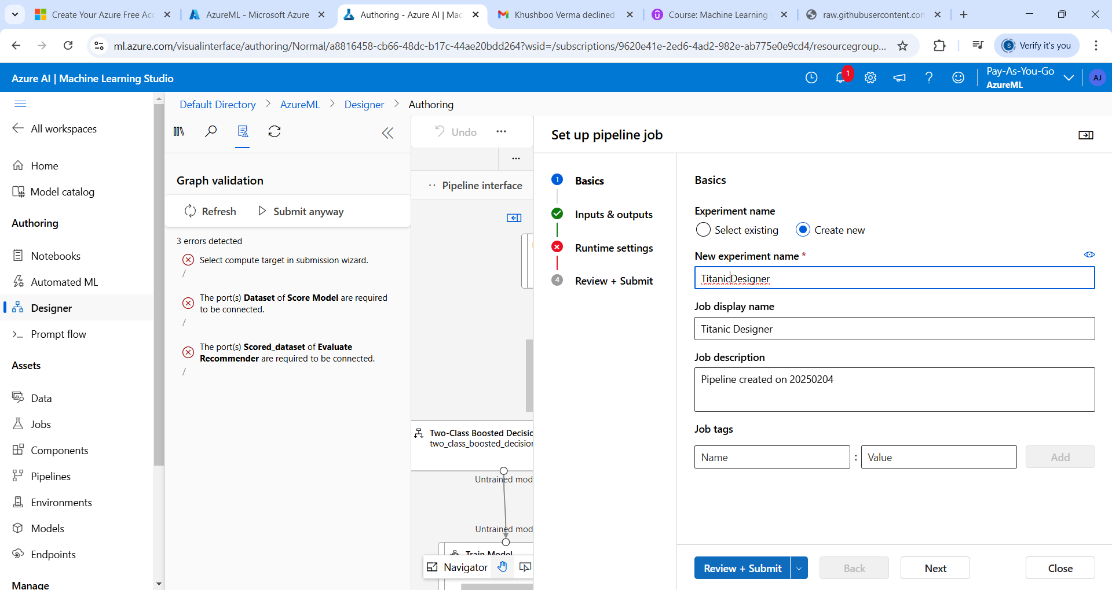

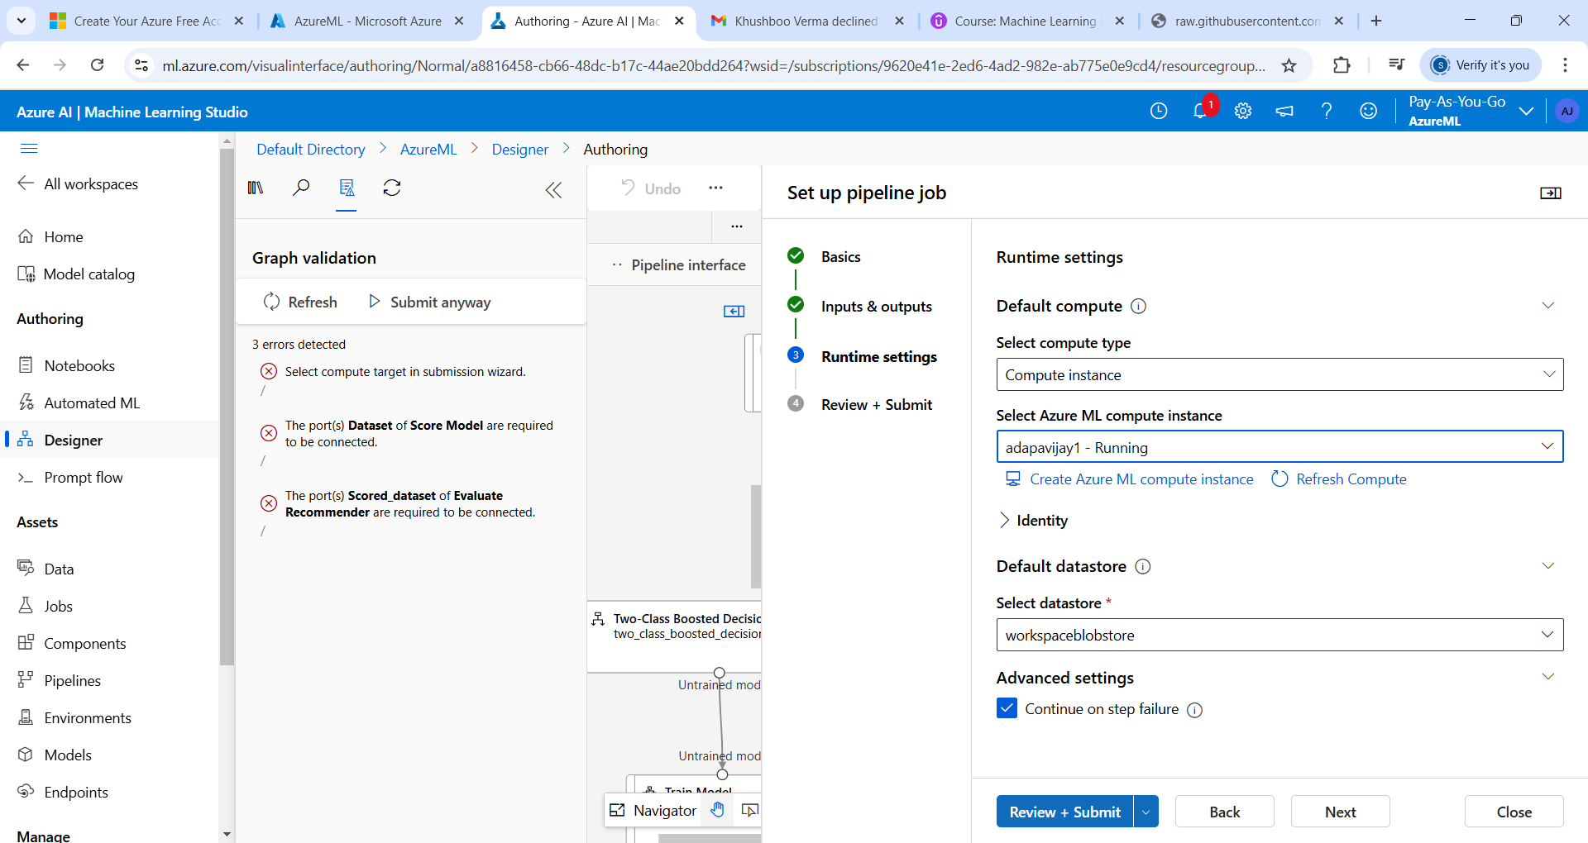

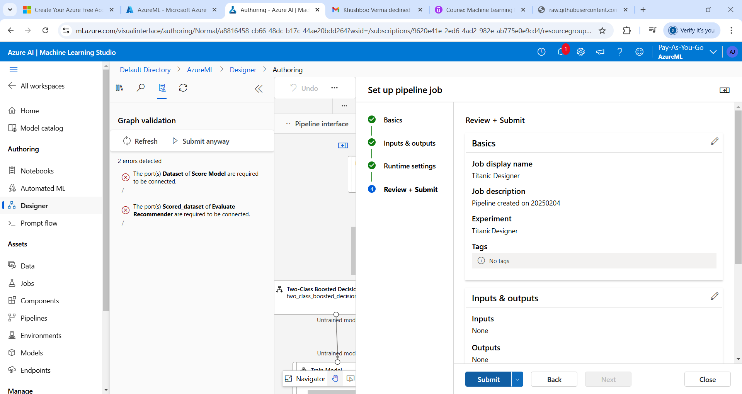

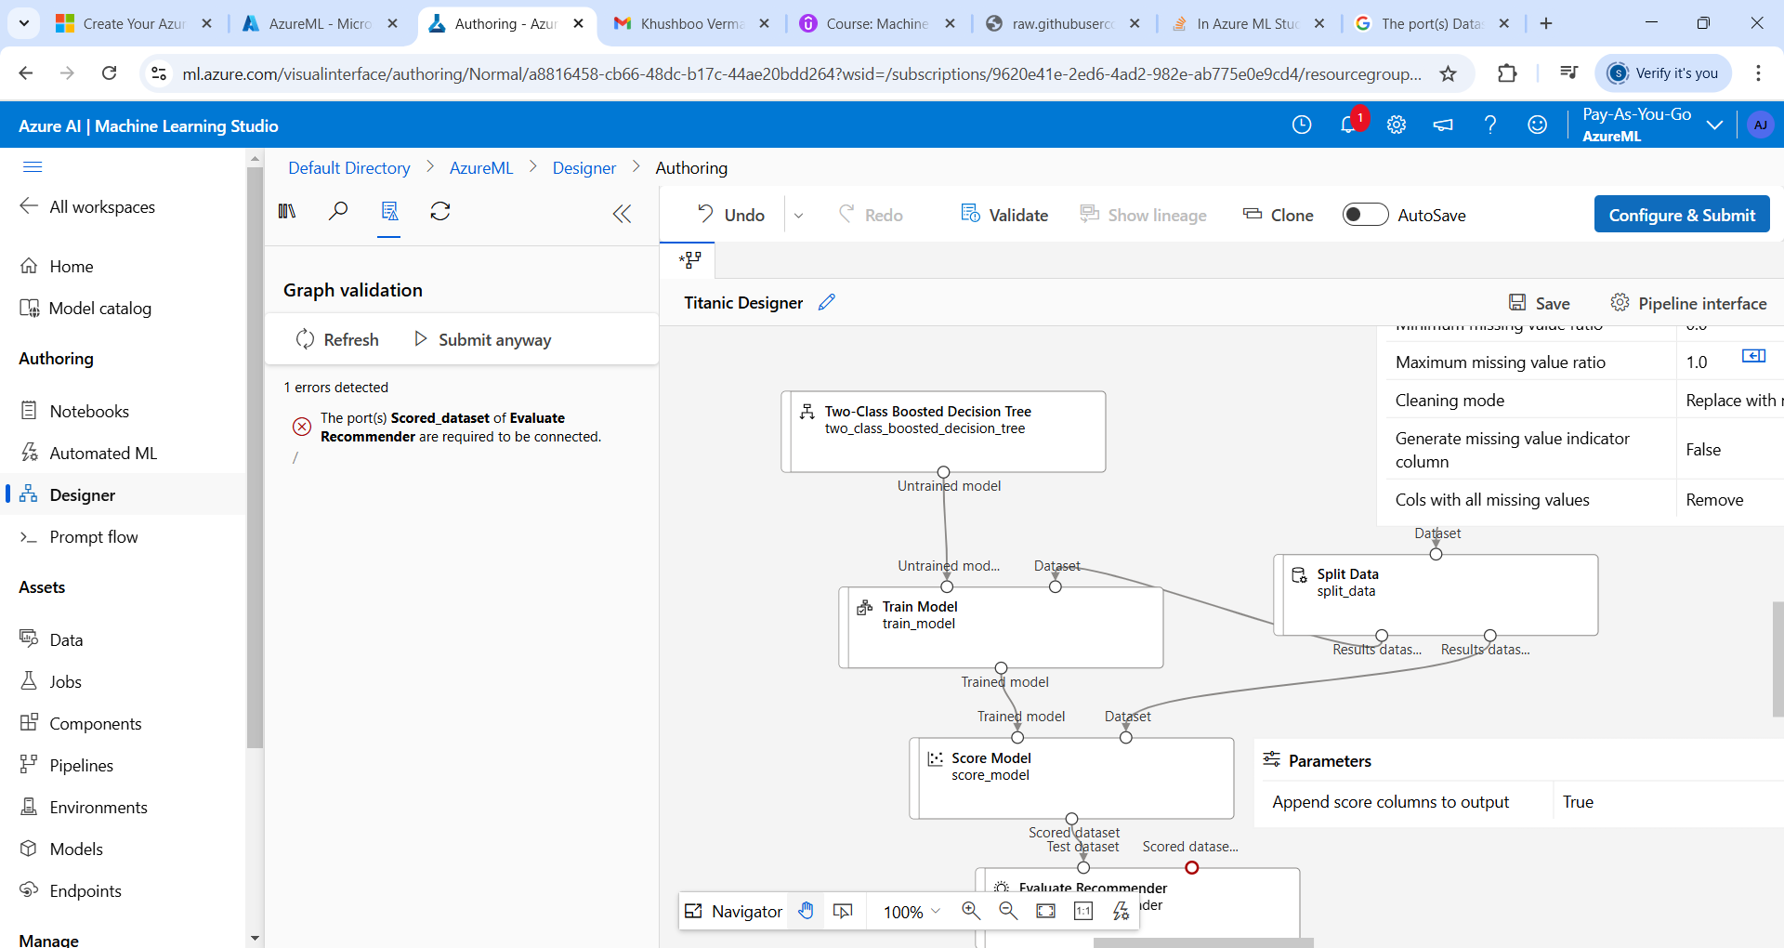
Evaluate Model has been added
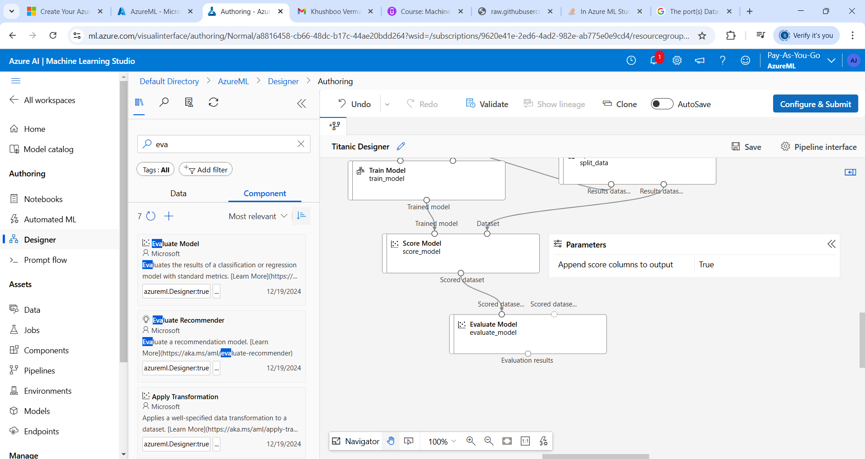

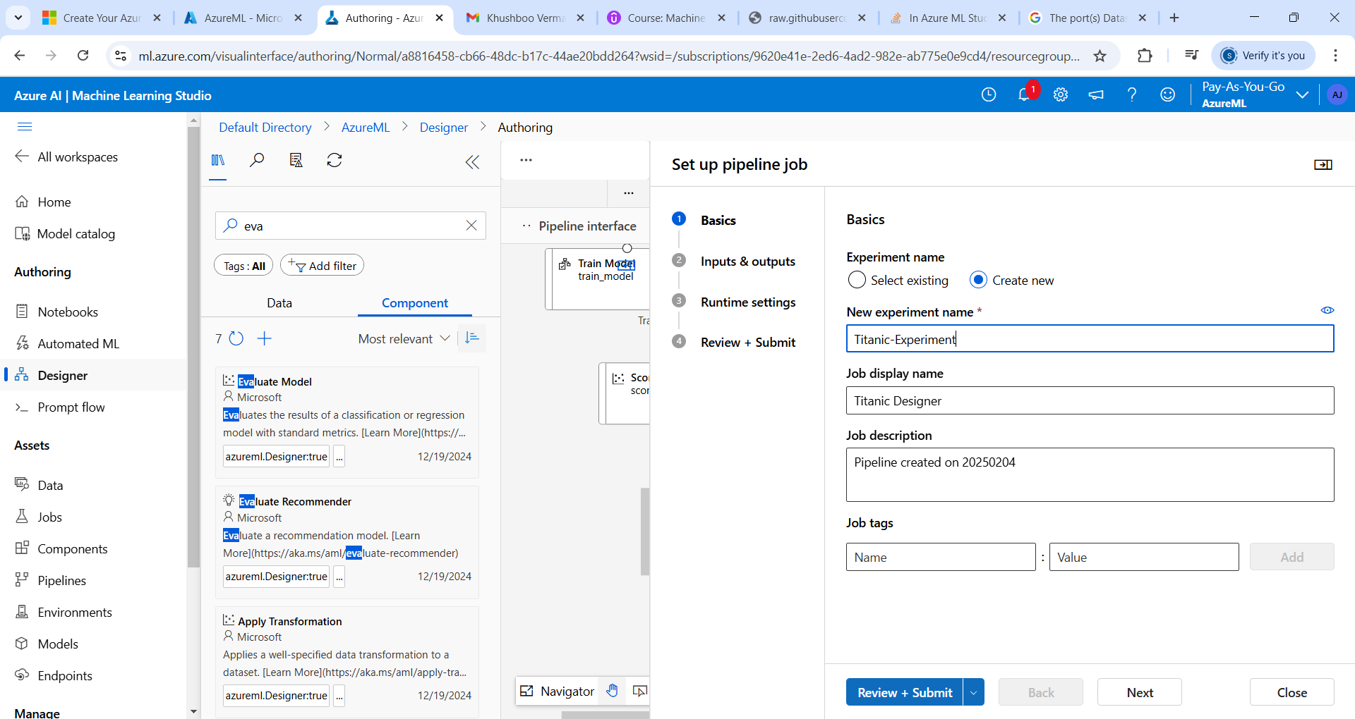
Submitting Job

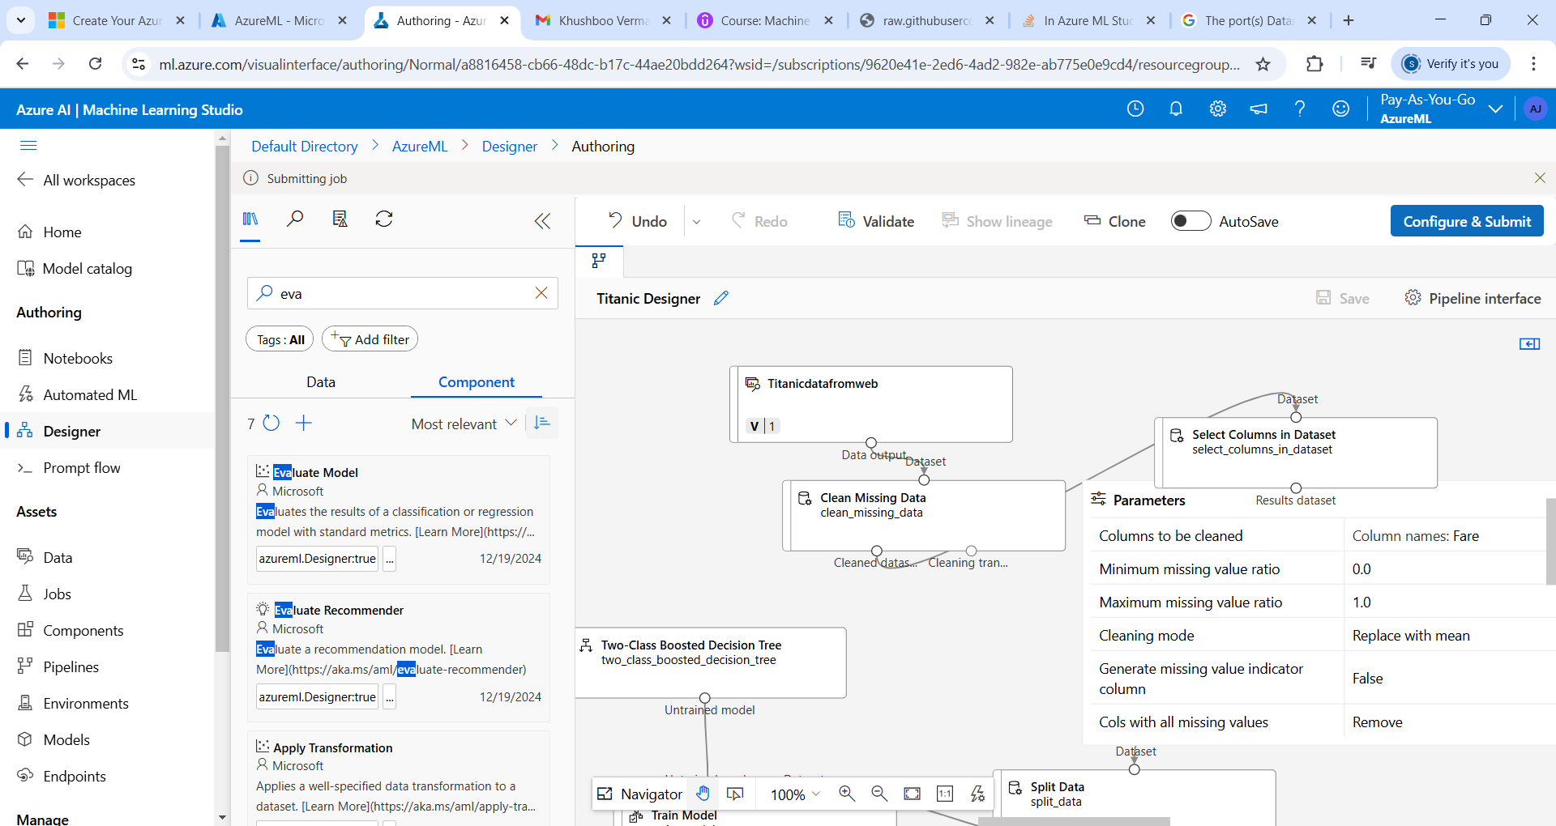

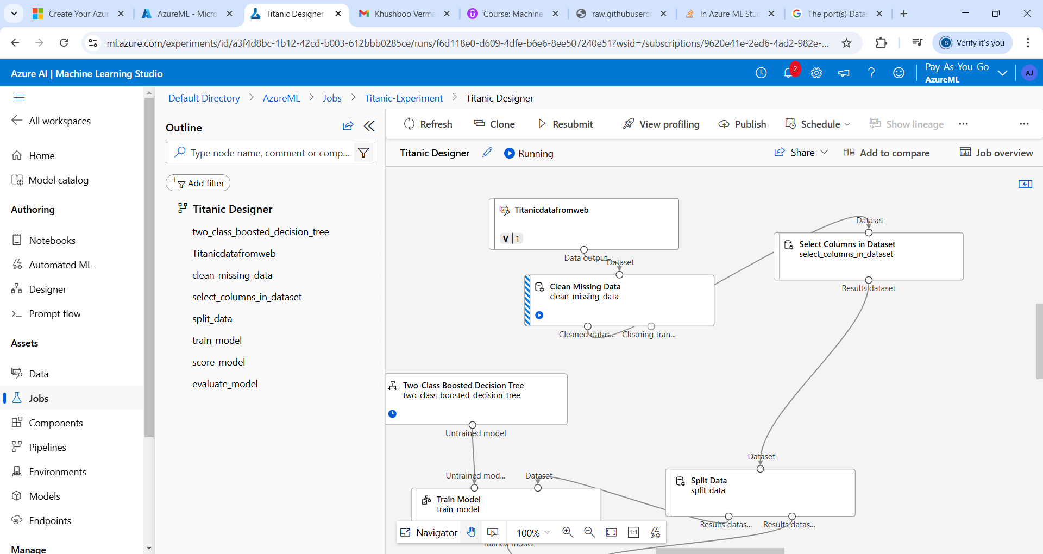

From Automated ML
