Agenda:
Developing a web application to Kubernetes Cluster
Steps:
Have a proper docker file handy before this steps
- Create a proper repository with a docker file which will be pushed to ACR (Azure container Registry) and then push it to Kubernetes Cluster Nodes.
- Create a new Devops project.
- Create a pipeline to push the docker image to ACR.
- Create a release pipeline which will be deploy image to Kubernetes cluster.

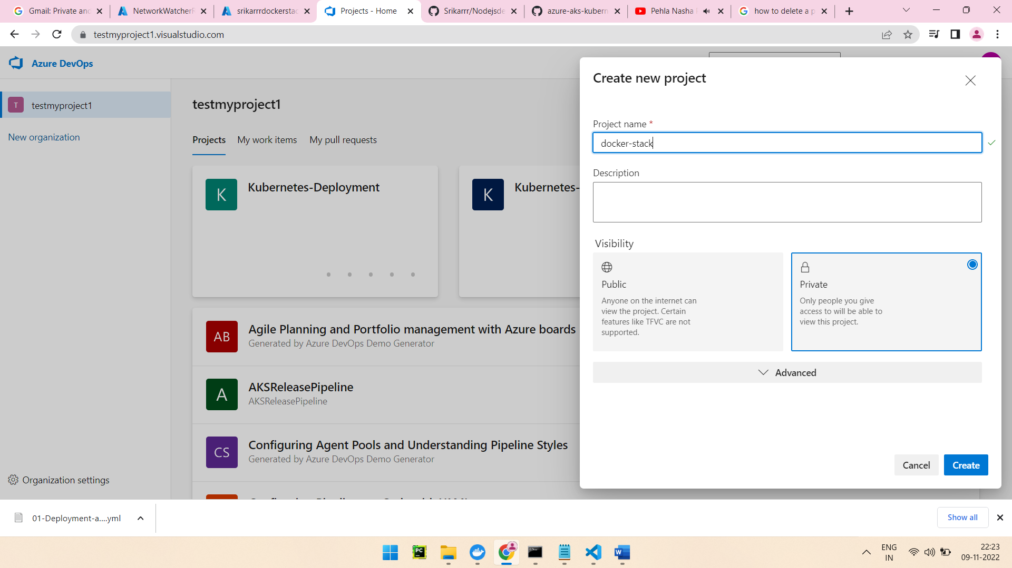
Select docker build and push and select the subscription which provided while creating Azure Container Registry and Kubernetes
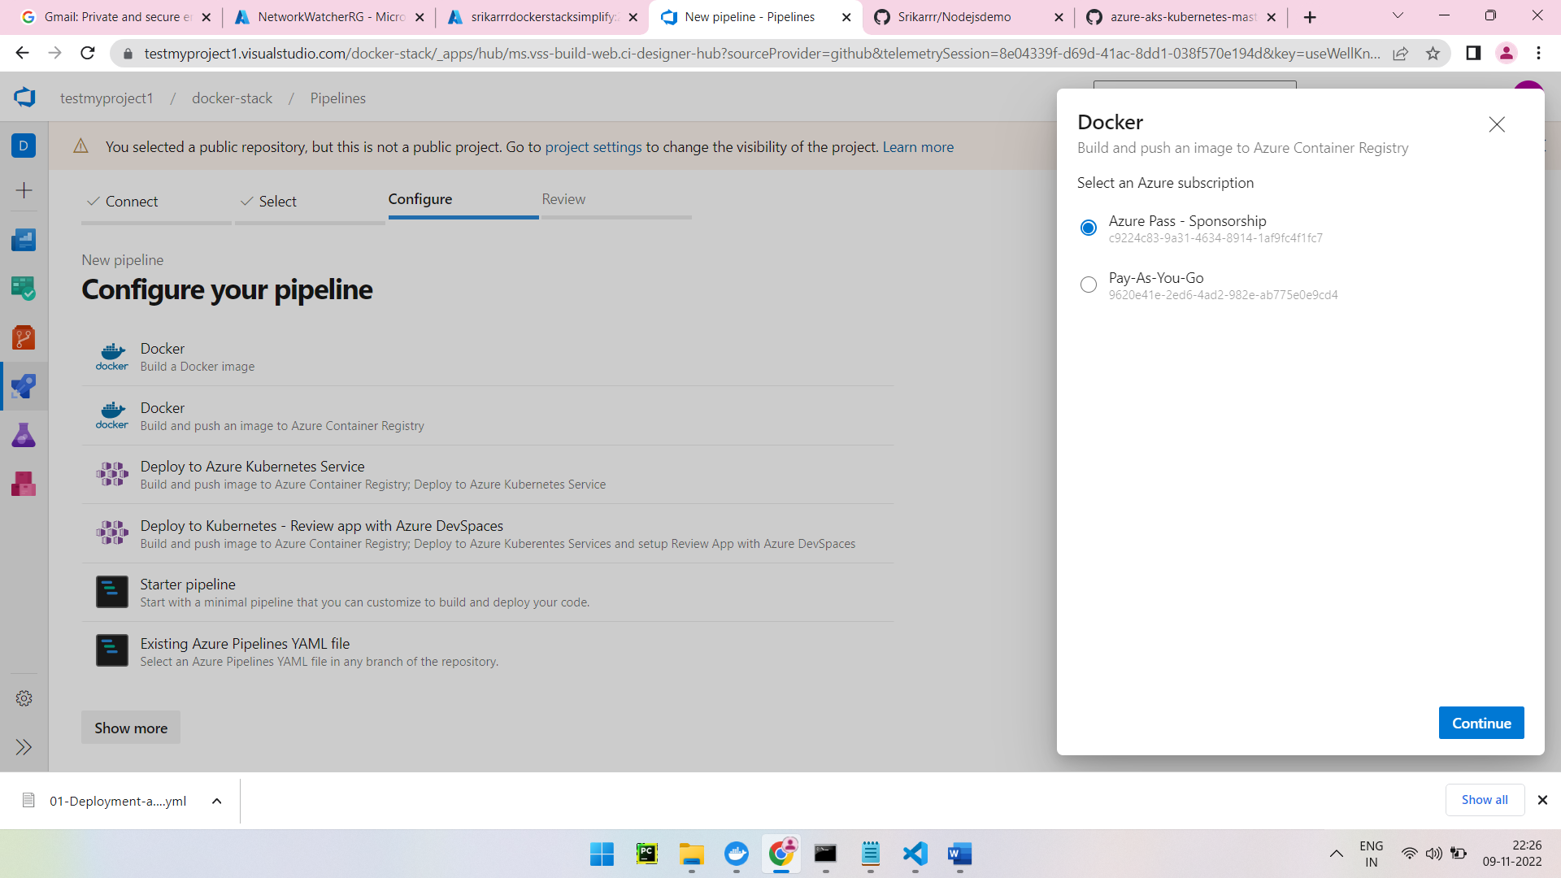
After providing Git_hub credentials provide docker details
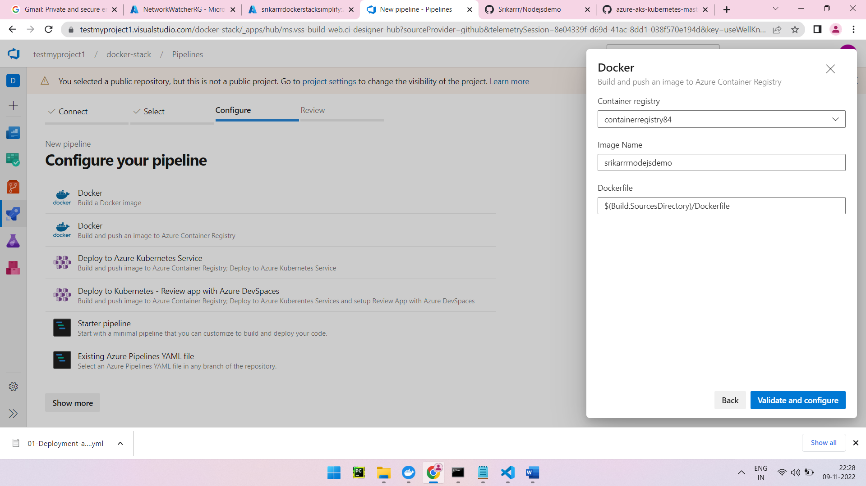
Imagename=srikarrrnodejsdemo(name of the Docker Image)
Containerregistry =containerregistry84(name of the container registry)
$(Build.SourcesDirectory)/Dockerfile dockerfile name from the image will be pushed

Click on validate and configure and the two tasks copy files and publish build artifacts and run the pipeline

Pipeline will be successful and artifact will be produced

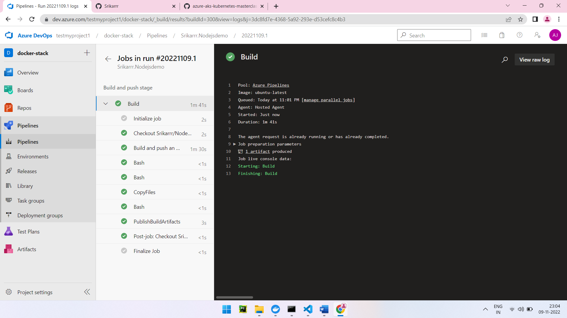



A repository will be created in ACR(Azure container registry)

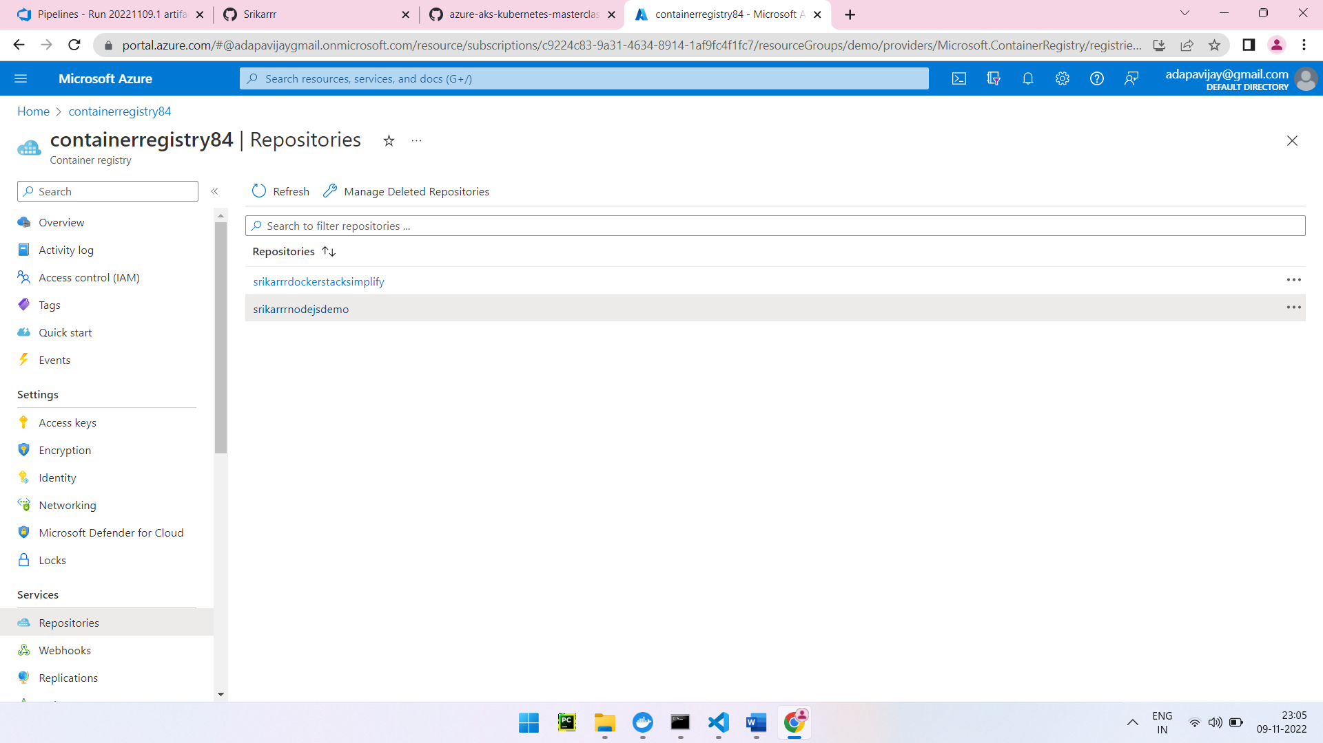

Provide proper container registry and image repository name which will be pushed to Kubernetes

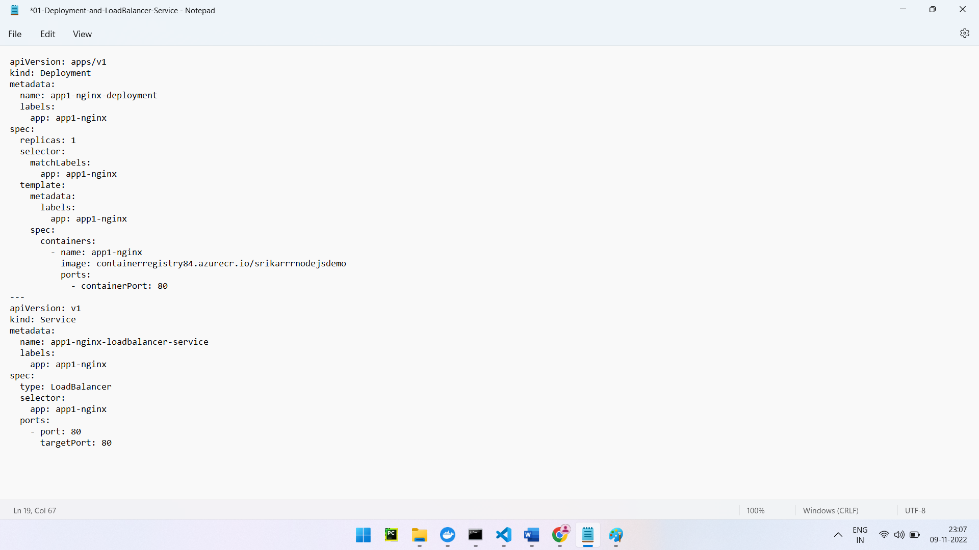

To Deploy docker image to Kubernetes Cluster create a release pipeline before that create below things

namespace its like a environment(ex: dev,qa,staging,prod)

az aks get-credentials --name k8cluster --resource-group demo
kubectl create ns qa
kubectl get svc -n qa

create a Kubernetes service connection (service connection name can be anything)

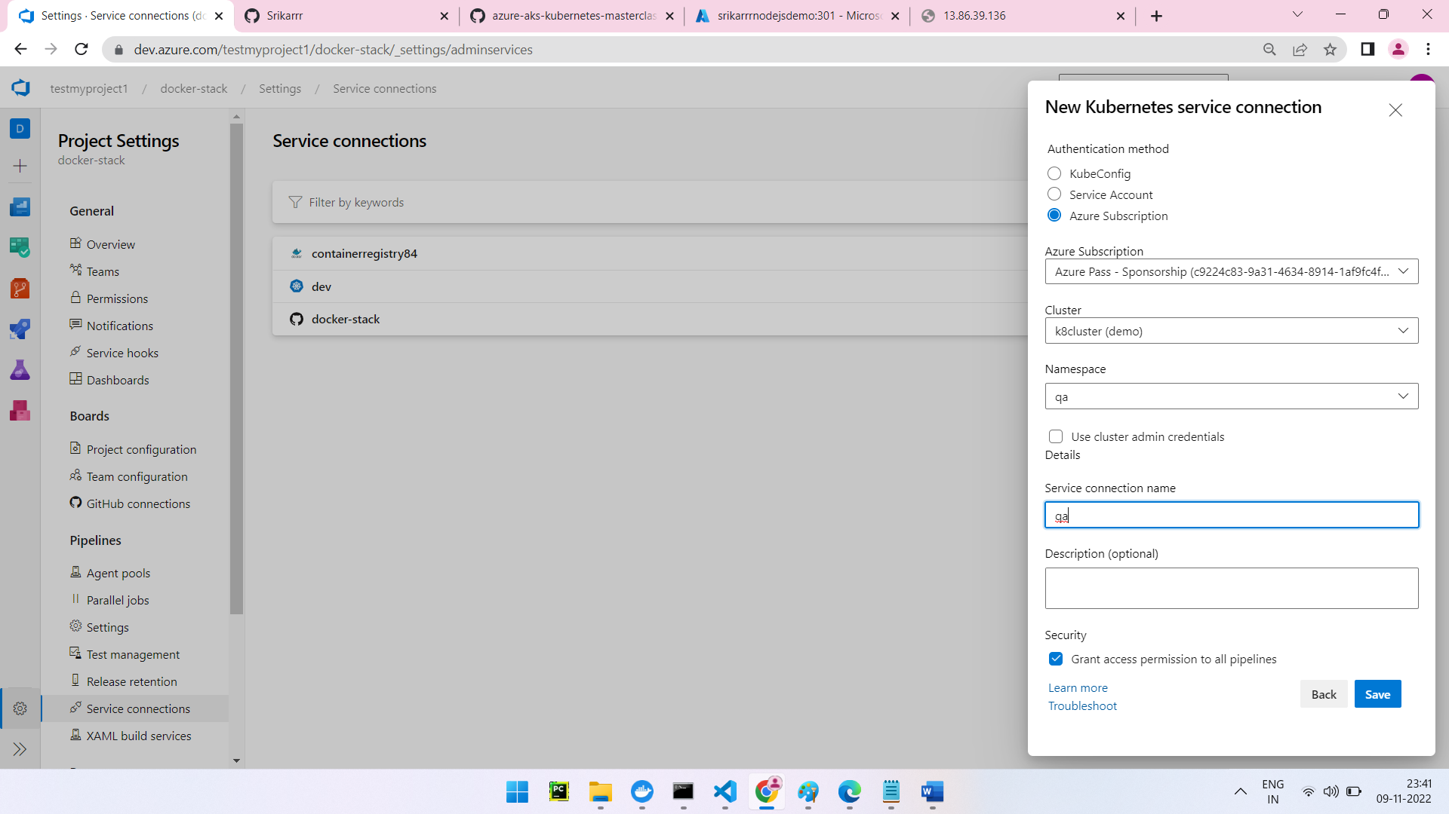

Create release

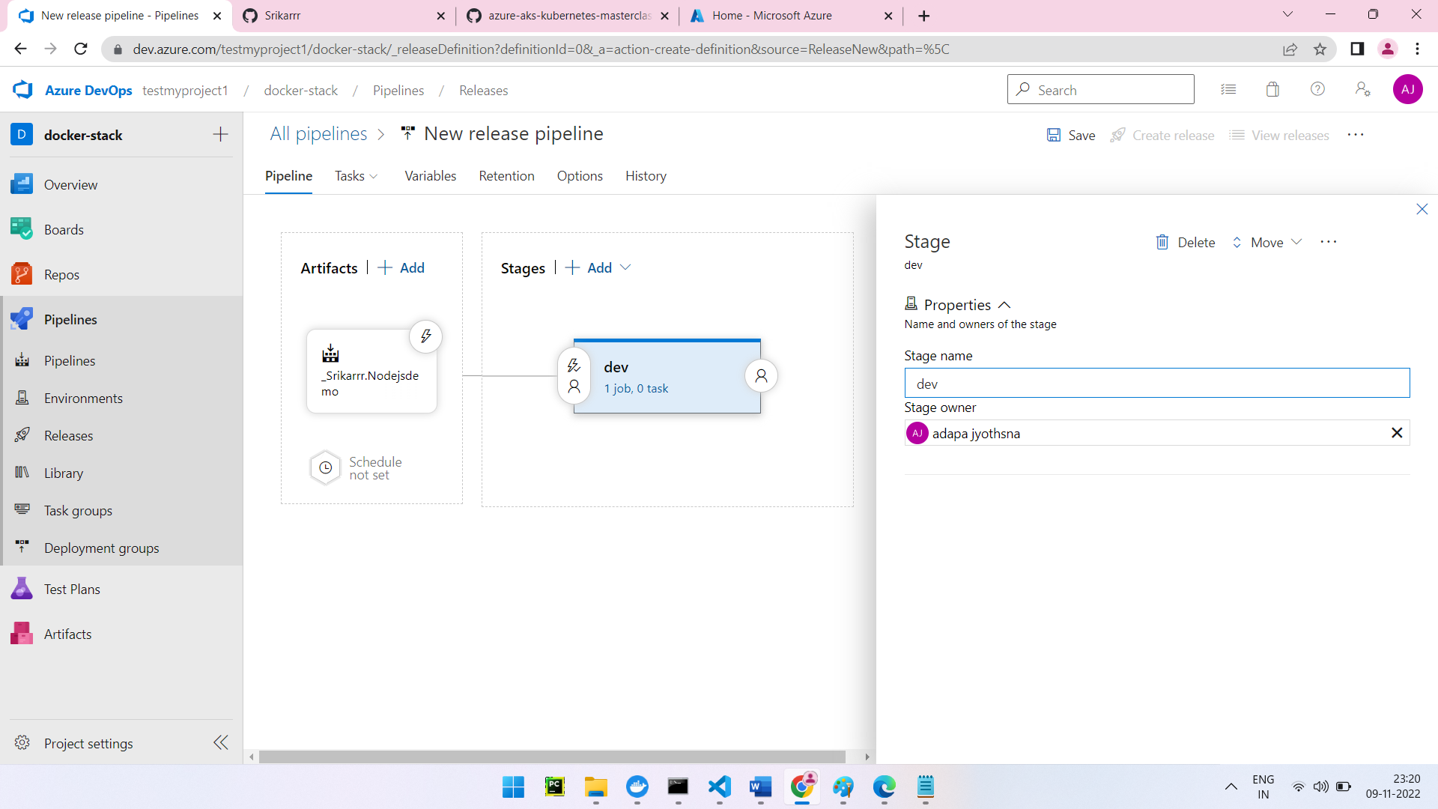

2 tasks should be created for deploy to Kubernetes:
Create secret: secrete name can be anything rest will be auto populated properly

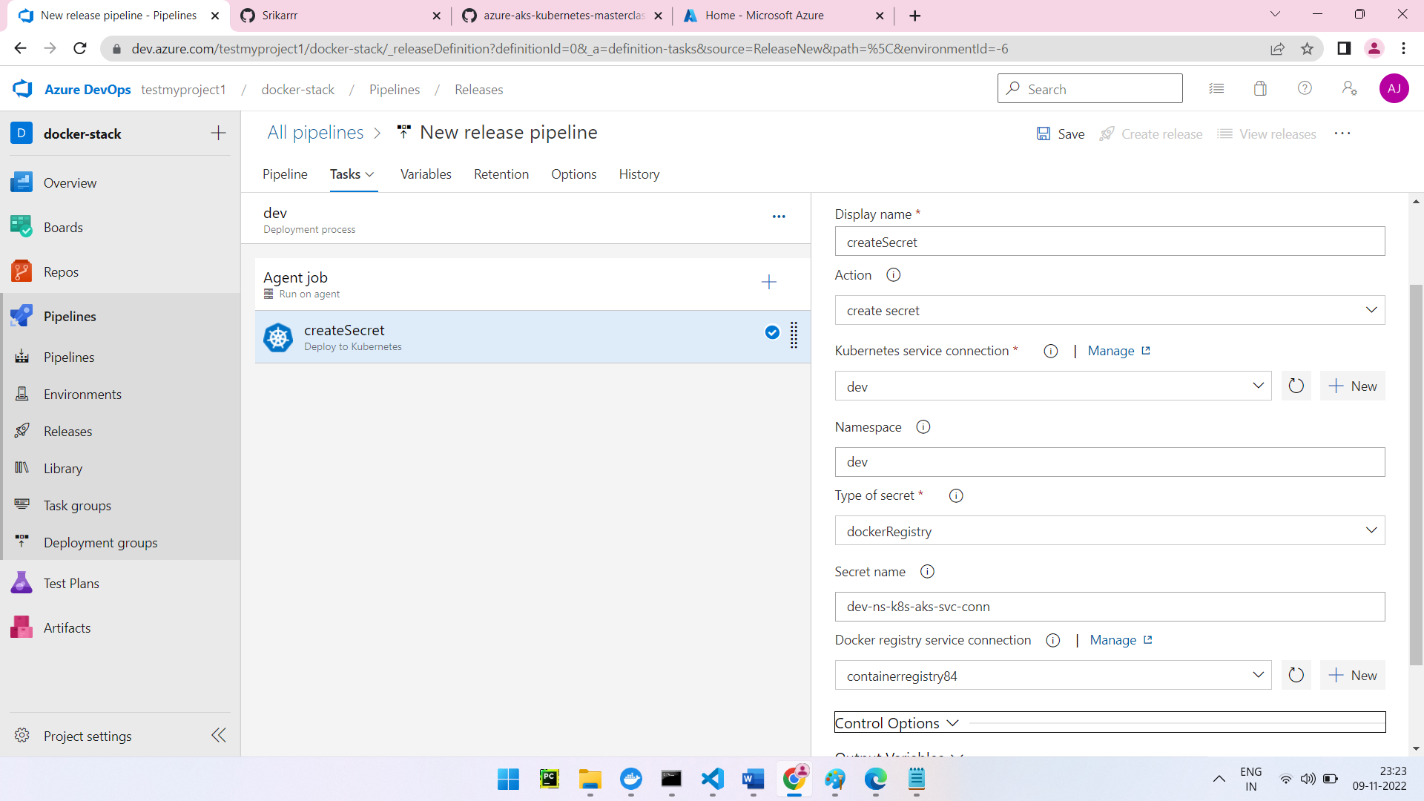

Deploy:

Provide the yaml file in the manifest path which has container registry and image repository
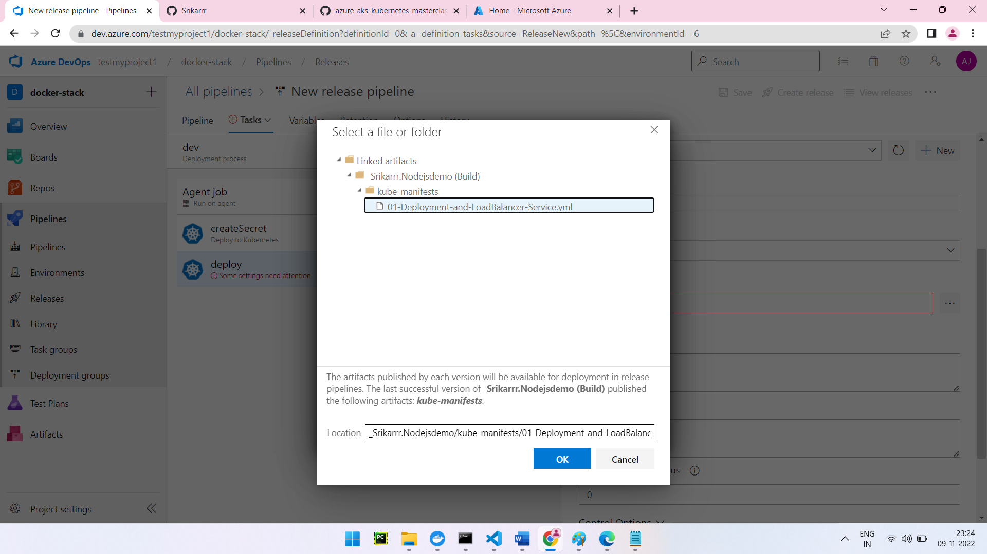
Image pull secret name will be the same as secret name in create secret -> secret name field
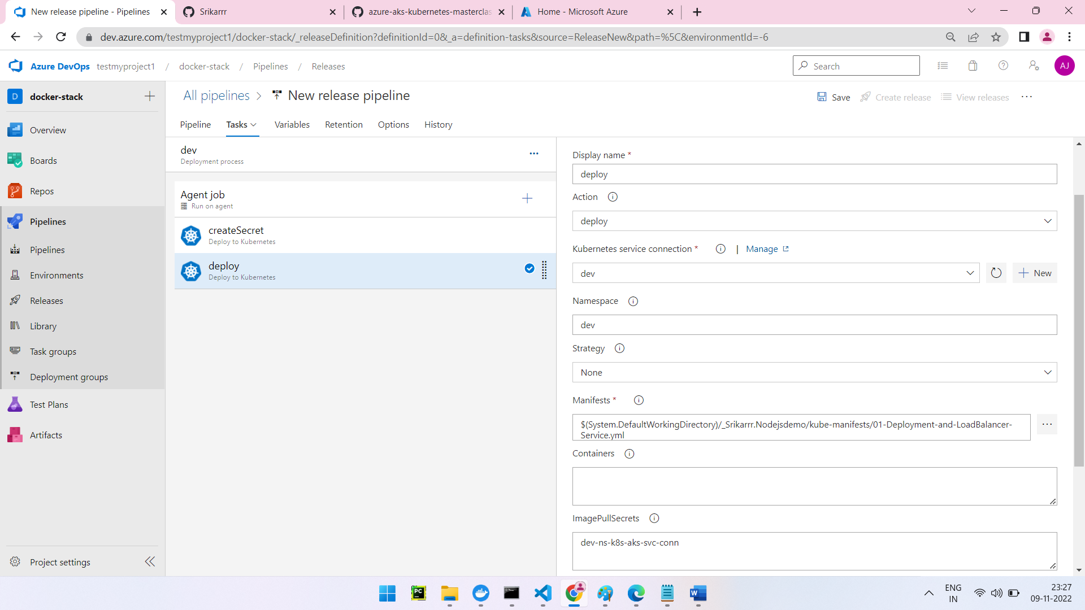
In the Containers provide the repositoryname:$(Build.BuildId)

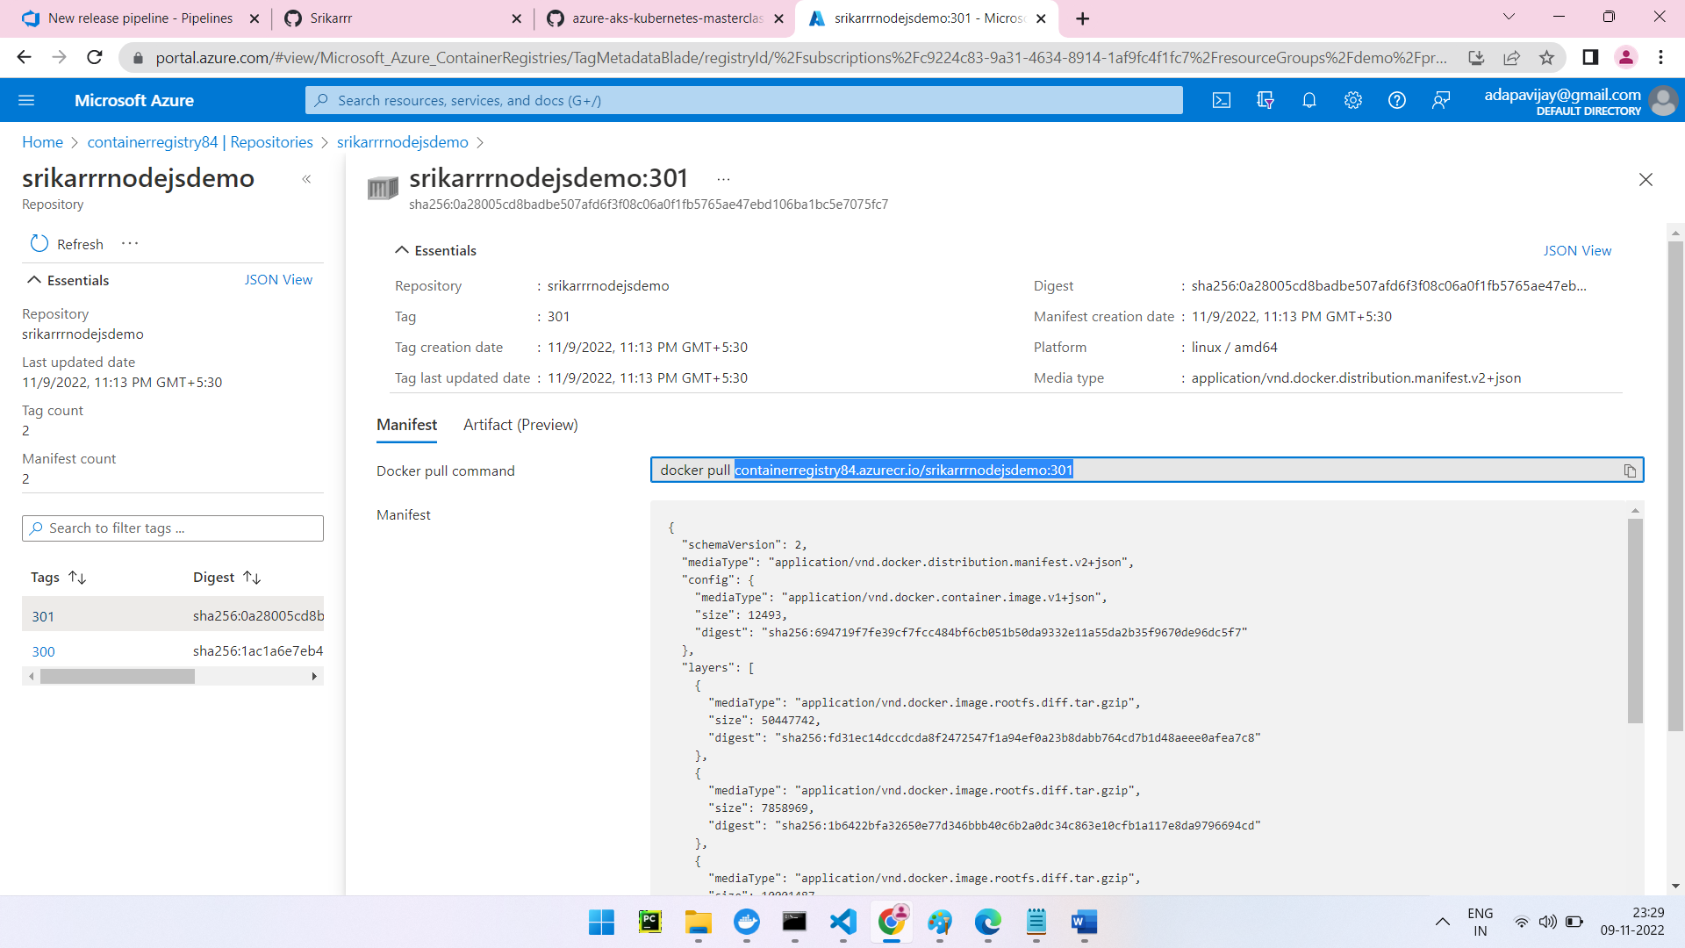

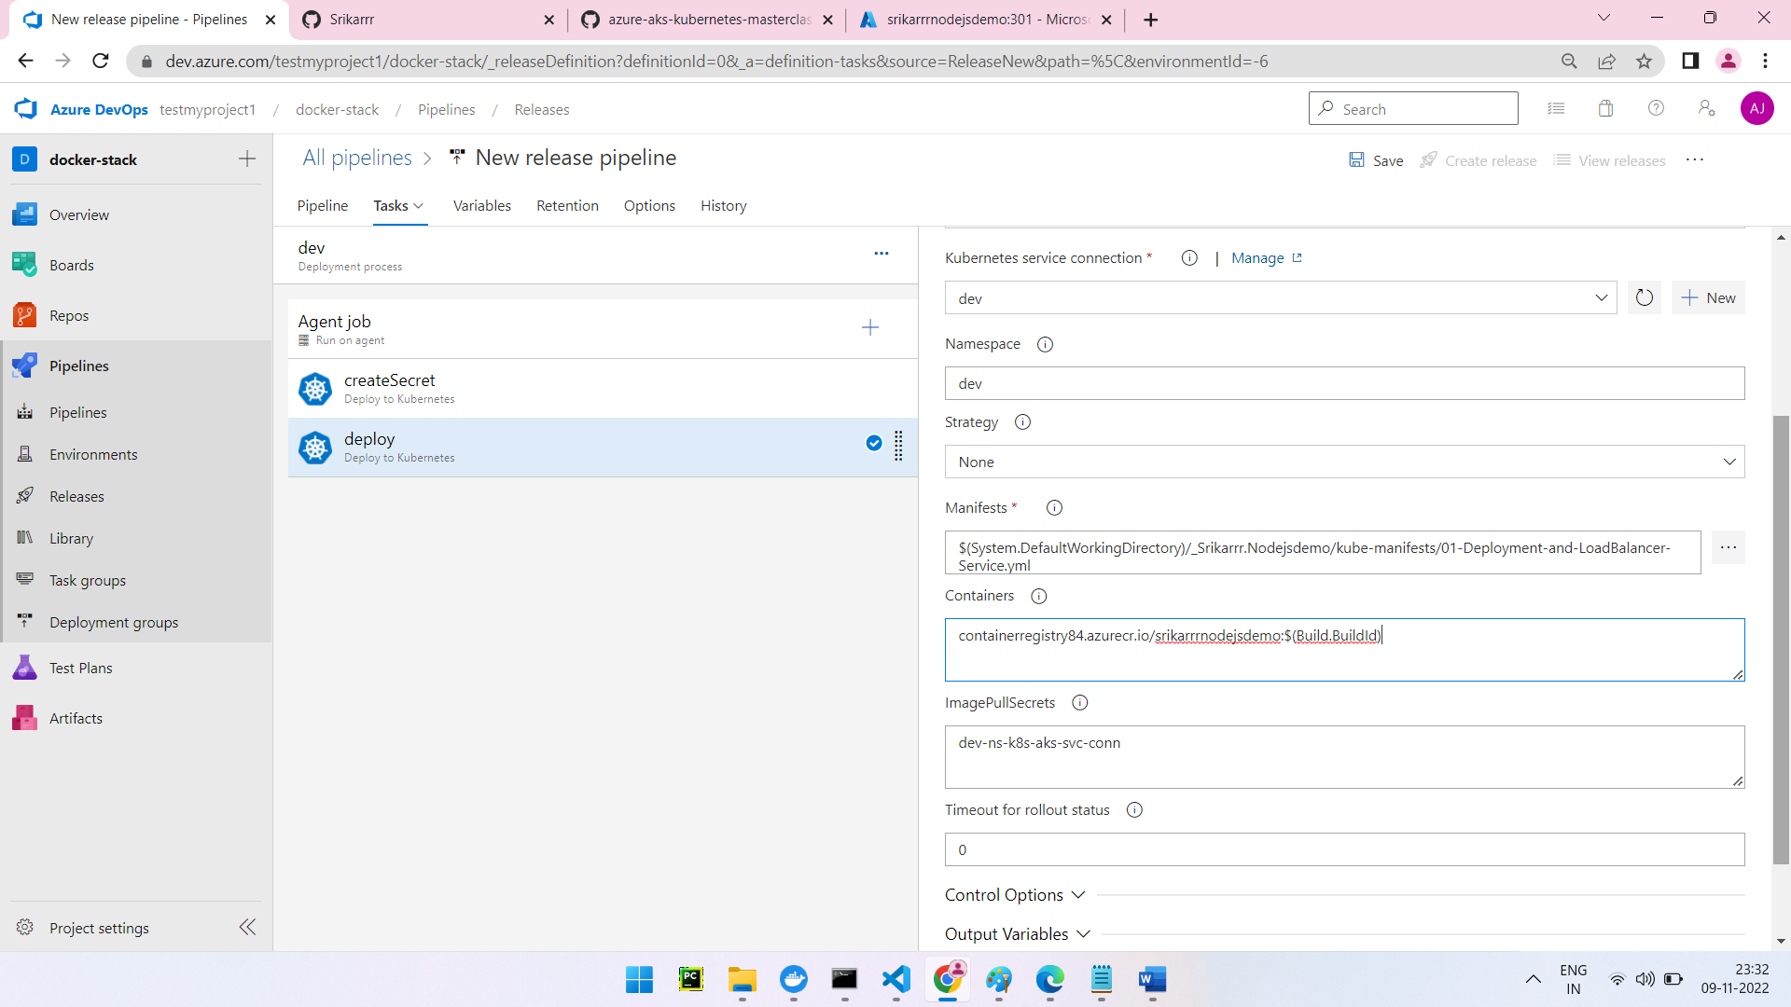
Deployed successfully
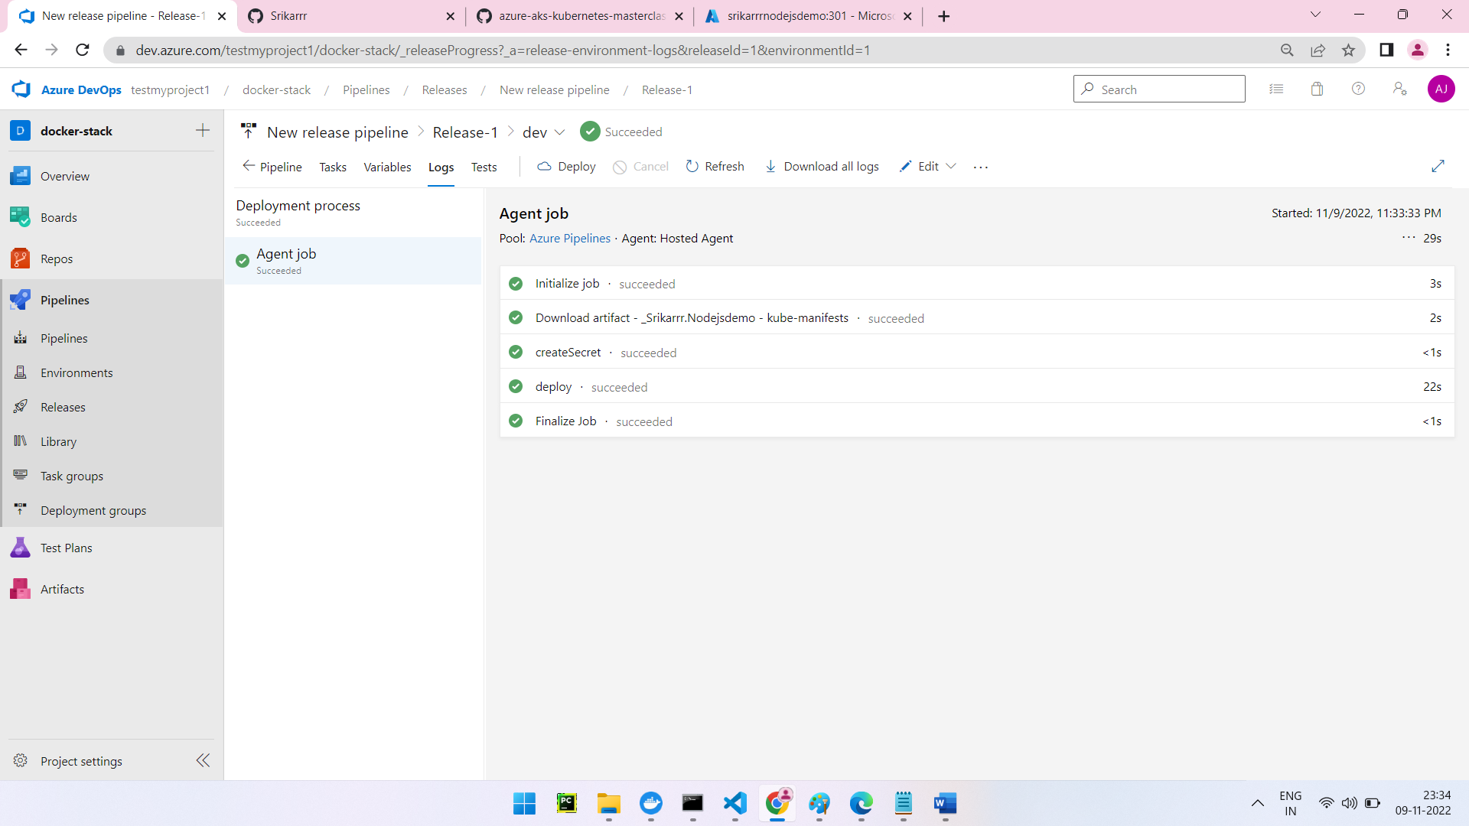
To check the application is deployed or not
kubectl get deploy -n qa
kubectl get svc -n qa
kubectl create ns dev
kubectl get pods -n qa
kubectl describe pod app1-nginx-deployment-n qa
kubectl scale --replicas=4 deployment/app1-nginx-deployment -n qa
kubectl scale --replicas=1 deployment/app1-nginx-deployment -n qa

az aks nodepool scale --cluster-name k8cluster --name agentpool --node-count 5 --resource-group demo

