AMRITA VISHWA VIDYAPEETHAM
CHENNAI CAMPUS

Second Year B. Tech (RAI)

Introduction to Python

WORK BOOK

Name: ________MANVITHA K___________
College Name: ______AMRITA VISHWAVIDYAPEETHAM______
Roll No.: ________CH.EN.U4RAI25025________
Department: _________RAI_________________
Academic Year: ____2025-29_____

Introduction

1. About the Work Book
This workbook is intended to be used by Second Year B. Tech (Computer Science and Engineering - AIE) students for the Introduction to Python Programming laboratory course in their curriculum. In the field of Computer Science, practical programming experience is essential for reinforcing and applying the theoretical concepts explored in lecture-based courses. This workbook serves as a structured guide that offers essential background knowledge along with a diverse set of Python-based programming exercises ranging from foundational to advanced levels.

The objectives of this workbook are:
- To clearly define the scope and expectations of the Python programming course.
- To ensure uniformity in course delivery across different faculty and institutions.
- To support continuous and outcome-based assessment of students’ practical skills.
- To introduce variety and flexibility in lab experiments, enabling differentiated learning experiences among students in the same batch.
- To serve as a quick reference and revision guide while performing lab activities.
- To cater to both novice and advanced learners by offering progressively challenging tasks and personalized learning paths.
2. How to use this workbook?
This workbook is mandatory for the completion of the laboratory course. It is a measure of the performance of the student in the laboratory for the entire duration of the course.

2.1 Instructions to the students
Please read the following instructions carefully and follow them
- Carry this book every time you come to the lab for computer science practical.
- You should prepare yourself beforehand for the Exercise by reading the material mentioned under.
- If the self-activity exercise or assessment work contains any blanks such as , get them filled by your instructor.
- Instructor will specify which problems you are to solve by ticking box
- You will be assessed for each exercise on a scale of 5
i. Not done 0.
ii. Incomplete 1
iii. Late Complete 2
iv. Needs improvement 3
v. Complete 4
vi. Well Done 5

2.2 Instructions to the Instructors
- Begin each lab session by explaining the concepts and objectives of the assignment for approximately 10 minutes. Use the whiteboard or live code demonstrations as necessary to aid understanding.
- Customize input values or case studies for each student to ensure personalized learning and assessment.
- Assign specific problems from the activity set by marking the appropriate boxes for each student.
- Ensure students read instructions carefully and follow the standard format while solving exercises and submitting outputs.
- Once a student completes the activity, the instructor must validate the output and sign the designated space in the activity sheet.
- Each student submission must be evaluated on a scale of 0 to 5, with criteria including correctness, completion, style, and adherence to instructions.
- The evaluated score should be recorded on the assignment completion page for continuous internal assessment purposes.

2.3 Instructions to the Lab Administrator
You are responsible for ensuring that all students have access to the necessary software and system configurations to successfully execute Python programs.

1) Server-Side Requirements:
- Operating System: Ubuntu LTS / Fedora Core / CentOS (latest stable)
- Software to be Installed:
  - Python 3.x (latest stable version)
  - pip (Python package manager)
  - PostgreSQL / MySQL (for database connectivity modules)
  - Required Python libraries:
  - numpy, pandas, matplotlib, seaborn, sqlite3, requests, beautifulsoup4, flask or django (depending on syllabus coverage).
  - Jupyter Notebook (optional, for data science-oriented tasks)

2) Client-Side Requirements:
- Operating System: Ubuntu Desktop / Fedora Workstation / Windows 10+
- Python Environment:
  - Python 3.x pre-installed or installed via Anaconda distribution
  - IDEs or Code Editors: VS Code / PyCharm Community Edition / Jupyter Notebook
  - Internet access (for web scraping and package installation)
  - Browser support for Django or Flask apps if web frameworks are used

Activity Completion Sheet

Introduction to Python
S. No | Assignment Name | Marks
 | Input & Output
 | Control Statements & Loops
 | Lists, Tuples, Ranges
 | Dictionaries, Sets
 | Functions and Recursion
 | Object-Oriented Programming
 | Exception Handling
 | Regular Expressions
 | Database Connectivity
 | Python Libraries (Numpy and Pandas)
 | Data Visualization (Matplotlib and Seaborn)
 | Dataframe Operations on Toyota Corolla Dataset

CERTIFICATE

This is to certify that, Mr./Miss. _________________________ Roll No. __________________ of IInd year B.Tech. (Computer Science and Engineering - AIE) has successfully completed ____out of ____ practical’s satisfactorily during the academic year 20 - 20 .

Practical In-charge Chairperson

Introduction to Python
You should read following topics before starting this exercise
Python is a high-level, general-purpose programming language developed by Guido van Rossum at the Centrum Wiskunde & Informatica (CWI), Netherlands, and was first released in 1991. The language was designed with the philosophy of prioritizing code readability, simplicity, and ease of learning, making it an ideal first programming language for students, as well as a powerful tool for professional software developers.
Python supports multiple programming paradigms, including procedural, object-oriented, and functional programming. It is a dynamically typed and interpreted language, which allows for rapid development and deployment of applications across a variety of domains.
Unlike many other programming languages, Python emphasizes a clear and expressive syntax. The language’s design encourages writing clean and maintainable code. Python’s standard library is extensive, offering built-in modules and functions that facilitate tasks such as file I/O, regular expressions, database access, web services, and data serialization.
Over the years, Python has evolved through major versions:
- Python 2.x: Now officially discontinued, it was widely used until 2020.
- Python 3.x: The actively maintained version, introducing improved syntax and features, and is the standard in modern Python development.
Python's popularity has grown significantly due to its robust ecosystem of third-party libraries and frameworks, including but not limited to:
- NumPy, Pandas – Scientific computing and data analysis.
- Matplotlib, Seaborn – Data visualization.
- Flask, Django – Web application development.
- Scikit-learn, TensorFlow – Machine learning and artificial intelligence.
- Tkinter, PyQt – Graphical User Interface (GUI) development.
- SQLite3, SQLAlchemy – Database interaction.

Python Execution Environment
Python code is executed using an interpreter, which can be accessed through various means:
- Command-line Interface (CLI) using commands such as python or python3
- Integrated Development Environments (IDEs) such as PyCharm, Visual Studio Code, and IDLE
- Notebook Interfaces, especially Jupyter Notebook, commonly used in data science and machine learning
A typical Python shell prompt is denoted as:
python-repl
CopyEdit
>>>

This interactive shell allows users to enter Python expressions and statements, and receive immediate feedback, making it a valuable tool for experimentation and learning.

File Structure and Extensions
- Python source code files use the .py extension.
- Notebook-based documents (e.g., for data science and education) use the .ipynb extension, compatible with Jupyter Notebooks.

Cross-Platform Support
Python is a cross-platform language, available on major operating systems including Windows, Linux, and macOS. It can be installed via the official Python distribution (from https://www.python.org) or through comprehensive environments such as Anaconda, which are particularly suited for scientific computing and data analysis.

Basic Python Programs – Understanding Errors and Error Handling

Objective:
To demonstrate the use of data types, basic input/output, arithmetic and relational operators, and error handling using Python programming constructs.

Reading:
Before starting this exercise, students should study the following topics:
- Steps involved in problem solving using computers: writing algorithms and implementing them in Python.
- Basic data types in Python (int, float, str, bool) and rules for declaring and assigning variables.
- Common Python operators: arithmetic (+, -, *, /, //, %, **), comparison (==, !=, <, <=, >, >=), and logical (and, or, not).
- Constructing expressions and understanding operator precedence in Python.
- Python syntax and indentation guidelines.

Problem Solving Using Computers

Steps:
- Understand the problem statement.
- Write the algorithm or pseudocode to represent the logic.
- Translate the logic into Python code.
- Run and test the code for correctness.
- Handle possible errors through exception handling.

Pseudocode to Python Mapping

Pseudocode Concept | Python Equivalent
Function name | def function_name():
Indexed data values | Lists: values[index]
Arithmetic expressions | length * breadth, a + b, x ** 2
Relational expressions | >, <, ==, !=, >=, <=
Logical expressions | and, or, not
Assignment | variable = expression
Conditional constructs | if, if-else, if-elif-else
Loops | while condition:, for i in range():
Input statements | input(), int(input()), float(input())
Output statements | print()
Return values from functions | return value1, value2

Illustrative Examples

Example #1: Calculate Area and Circumference of a Circle
Write a Python program that accepts the radius of a circle from the user and calculates both the area and the circumference of the circle. Use the formula:
- Area = π × r²
- Circumference = 2 × π × r
Assume π = 3.1416.
Python Code:
radius = float(input("Enter radius of the circle: "))
pi = 3.1416
area = pi * radius ** 2
circumference = 2 * pi * radius
print("Area of the circle =", area)
print("Circumference of the circle =", circumference)

Example #2: Check Whether a Number is Even or Odd
Write a Python program that accepts an integer from the user and checks whether it is even or odd. A number is even if it is divisible by 2, otherwise it is odd.

Python Code:
number = int(input("Enter a number: "))

if number % 2 == 0:
print("The number is Even.")
else:
print("The number is Odd.")

Example #3: Calculate the Sum of Digits of a Number
Write a Python program to calculate the sum of digits of a positive integer entered by the user. For example, if the input is 1234, the output should be 1+2+3+4 = 10.

Python Code:
num = int(input("Enter a number: "))
sum_digits = 0

while num > 0:
digit = num % 10
sum_digits += digit
num = num // 10

print("Sum of digits:", sum_digits)

Example #4: Error Handling in Python
Write a Python program that accepts two numbers from the user and performs division. The program should handle the following errors gracefully:
- Division by zero
- Invalid (non-numeric) input
Use try, except, and finally blocks for structured exception handling.
Python Code:
try:
num1 = int(input("Enter the numerator: "))
num2 = int(input("Enter the denominator: "))
result = num1 / num2
except ZeroDivisionError:
print("Error: Cannot divide by zero.")
except ValueError:
print("Error: Please enter valid numeric values.")
else:
print("Result of division:", result)
finally:
print("Program execution completed.")
Self -Activity:
Type the sample program given below. Execute it for different input values as shown in the table and calculate the corresponding output. Fill the last column based on the results obtained from the program.

Instructions to Execute Python Programs:
a. Open the terminal or Python IDE of your choice (e.g., VS Code, IDLE, or terminal).
b. Create a Python file with the .py extension. For example:
$ nano simple_interest.py
c. Type and save the following Python program:
# Program to calculate simple interest
principal = float(input("Enter the principal amount: "))
rate = float(input("Enter the rate of interest: "))
years = int(input("Enter the number of years: "))
simple_interest = (principal * rate * years) / 100
print("Simple Interest =", simple_interest)
d. To execute the file in terminal (Linux):
$ python3 simple_interest.py

Table for Input and Output:
Sr. No | Principal Amount | Number of Years | Rate of Interest (%) | Simple Interest
1 | 2000 | 3 | 5 | 300
2 | 4500 | 4.5 | 6 | 1215
3 | 6000 | 8.3 | 7.5 | 3735
💡 Note: Use the formula: Simple Interest = (Principal × Rate × Time) / 100

Activity Sheet – 1
Input and Output
Objectives:
- To understand how to accept user input using the input() function and perform type conversions.
- To learn how to display output using the print() function with formatting options like sep, end, and f-strings.
- To practice reading and processing multiple inputs from a single line.

Reading:
Before beginning this activity, you should be familiar with the following concepts:
- input() function:
  - Accepts input from the user as a string.
  - Syntax: variable = input("Enter something: ")
- Type Conversion:
  - Convert string input to other types using functions like int(), float(), etc.
  - Example: age = int(input("Enter age: "))
- print() function:
  - Displays output to the console.
  - Can print multiple values separated by commas.
  - Default behavior includes a newline at the end of output.
- Formatting Output:
  - Using sep and end in print():
    - print("A", "B", sep="-") ➝ Output: A-B
    - print("Hello", end=" ") ➝ No newline after print
  - Using f-strings for formatted output:
    - Example: name = "Ali" → print(f"Hello, {name}")
- Multiple Inputs in One Line:
  - Example: a, b = input("Enter two numbers: ").split()
  - With type casting: a, b = map(int, input().split())

Illustrative Examples:
Example #1:
Write a Python program that asks the user to enter their name and age, then prints a greeting message using formatted output.

Python Code:
name = input("Enter your name: ")
age = int(input("Enter your age: "))
print(f"Hello, {name}! You are {age} years old.")

Sample Input:
Enter your name: Anjali
Enter your age: 21

Sample Output:
Hello, Anjali! You are 21 years old.

Example #2:
Write a Python program to take two integers from the user in a single line, then print their sum and product.

Python Code:
a, b = map(int, input("Enter two numbers separated by space: ").split())
print("Sum =", a + b)
print("Product =", a * b)

Sample Input:
Enter two numbers separated by space: 7 4

Sample Output:
Sum = 11
Product = 28

Programming Questions:
Exercise: 1
Difficulty: Easy
Question: Write a Python program that prints the following line exactly as it appears:
Hello, World!

Program:
print("Hello, World!")

Output:
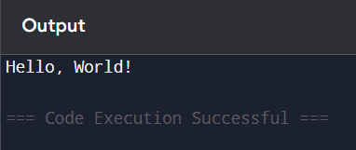

Exercise: 2
Difficulty: Easy
Question: Write a program to take your name and favorite color as input, and print a sentence using them.
Example output: "Hi Anil, your favorite color is Blue!"

Program:
name = input("Enter your name: ")
color = input("Enter your favorite color: ")

print("Hi", name + ", your favorite color is", color + "!")

Output:
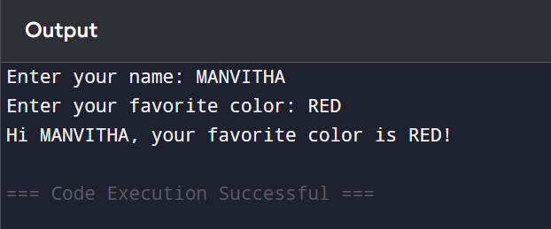

Exercise: 3
Difficulty: Easy
Question: Write a python program to accept two numbers from the user and display their difference.

Program:
num1 = float(input("Enter first number: "))
num2 = float(input("Enter second number: "))

difference = num1 - num2

print("Difference =", difference)

Output:
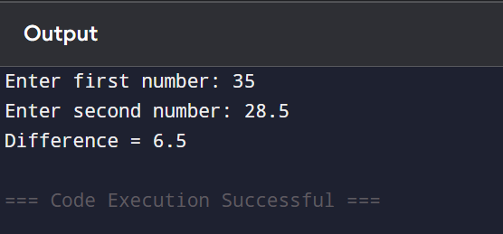

Exercise: 4
Difficulty: Easy
Question: Write a python program to take three space-separated numbers as input and display their average.

Program:
a, b, c = map(float, input("Enter three numbers separated by spaces: ").split())

average = (a + b + c) / 3

print("Average =", average)

Output:
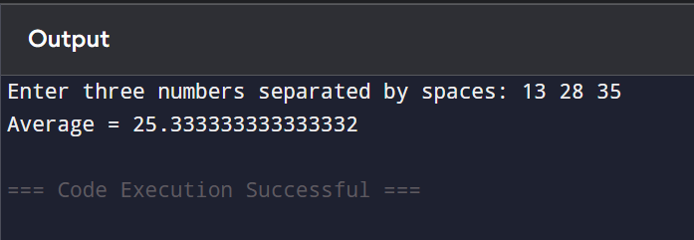

Exercise: 5
Difficulty: Easy
Question: Write a program to read a floating-point number and display it rounded to two decimal places.

Program:
num = float(input("Enter a floating-point number: "))

print("Rounded value =", round(num, 2))

Output:
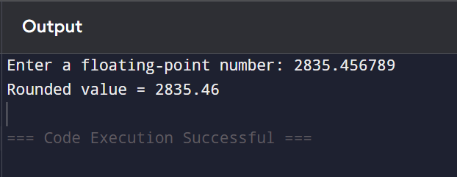

Exercise: 6
Difficulty: Easy
Question: Write a python program to accept a student's name and marks in three subjects. Calculate and print the total and average.

Program:
name = input("Enter student's name: ")

mark1 = float(input("Enter marks in Subject 1: "))
mark2 = float(input("Enter marks in Subject 2: "))
mark3 = float(input("Enter marks in Subject 3: "))

total = mark1 + mark2 + mark3
average = total / 3

print("Student Name:", name)
print("Total Marks:", total)
print("Average Marks:", average)

Output:
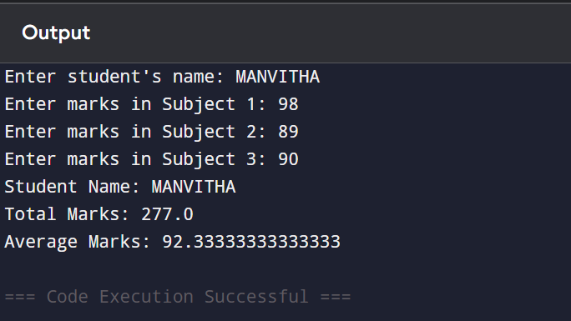

Exercise: 7
Difficulty: Easy
Question:
Write a python program Accept a user's first name and last name, and print the full name in the format:
"LastName, FirstName"

Program:
first_name = input("Enter your first name: ")
last_name = input("Enter your last name: ")

print(last_name + ", " + first_name)

Output:
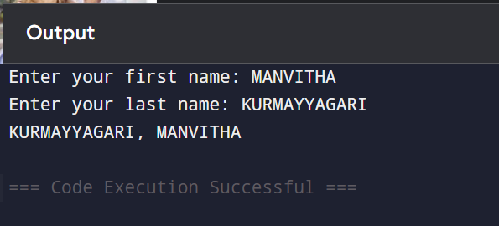

Assignment Evaluation:
0: Not Done [ ] 1: Incomplete [ ] 2: Late Complete [ ]
3: Needs Improvement [ ] 4: Complete [ ] 5: Well Done [ ]

Viva Questions:
- How do you convert user input into an integer?
- What is the purpose of the print() function in Python?
- How can you customize the separator between values in print()?
- What is the use of the end parameter in print()?
- How do you print output without moving to a new line?

Activity Sheet – 2
Control Statements and Loops
Objectives:
- To understand how conditional control structures (if, if-else, elif) guide program flow based on logic.
- To learn the use of iterative control structures (for, while) for repeating tasks.
- To apply loop control statements like break, continue, and pass in various programming scenarios.

Reading:
Before attempting exercises, students should review the following:
- Conditional Statements:
  - if, if-else, and if-elif-else constructs.
  - Indentation-based block structure.
  - Relational and logical operators (==, !=, <, >, and, or, not).
- Looping Constructs:
  - for loops (commonly used with range(), lists, tuples, etc.).
  - while loops (used when the number of iterations is not known beforehand).
  - Loop syntax and common patterns like counters and accumulators.
- Loop Control Statements:
  - break: exits the current loop prematurely.
  - continue: skips the current iteration and proceeds to the next.
  - pass: used as a placeholder when no action is required.
- Nested Loops and Conditions:
  - Loops inside loops, and conditional statements inside loops.
- Common Use Cases:
  - Generating number sequences, summing values, searching in collections, decision-making processes.

Illustrative Examples:
Example #1:
Write a program to accept a number from the user and check whether it is positive, negative, or zero.

Python Code:
num = float(input("Enter a number: "))

if num > 0:
print("Positive number")
elif num < 0:
print("Negative number")
else:
print("Zero")

Sample Input:
Enter a number: -7

Sample Output:
Negative number

Example #2:
Write a program to take 5 numbers as input and print them one by one. Stop the loop if the user enters 0.

Python Code:
for i in range(5):
num = int(input("Enter a number: "))
if num == 0:
print("Zero encountered! Stopping input.")
break
print("You entered:", num)

Sample Input:
Enter a number: 12
You entered: 12
Enter a number: 5
You entered: 5
Enter a number: 0
Zero encountered! Stopping input.

Sample Output:
You entered: 12
You entered: 5
Zero encountered! Stopping input.

Programming Questions:
Exercise: 1
Difficulty: Easy
Question: Given an integer,n, perform the following conditional actions:
- If n is odd, print Weird
- If n is even and in the inclusive range of 2 to 5, print Not Weird
- If n is even and in the inclusive range of 6 to 20, print Weird
- If n is even and greater than 20, print Not Weird

Program:
num=int(input(“Enter a number”))
if num%2 != 0:
print("weird")
elif(num%2 == 0):
if num in range (2,6):
print("not weird")
elif num in range (6,21):
print("weird")
elif num>20:
print("NOT WEIRD")

Output:
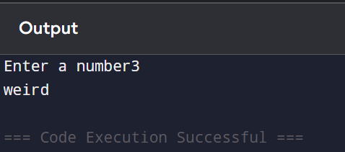

Exercise: 2
Difficulty: Medium
Question: Given a string s consisting of only the characters 'a' and 'b', return true if every 'a' appears before every 'b' in the string. Otherwise, return false.
Sample Input: s = "aaabbb"
Sample Output: true
Explanation: The 'a's are at indices 0, 1, and 2, while the 'b's are at indices 3, 4, and 5. Hence, every 'a' appears before every 'b' and we return true.

Program:
s = input("Enter the string: ")

found_b = False

for ch in s:
if ch == 'b':
found_b = True

if ch == 'a' and found_b:
print(False)
break
else:
print(True)

Output:
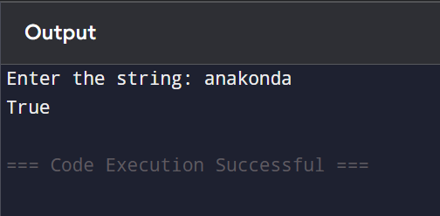

Exercise: 3
Difficulty: Easy
Question: Given an integer input of N, find the sum of all the natural numbers until the given input integer using loops.

Program:
n = int(input())

sum = 0

for i in range(1, n + 1):
sum = sum + i

print(sum)

Output:
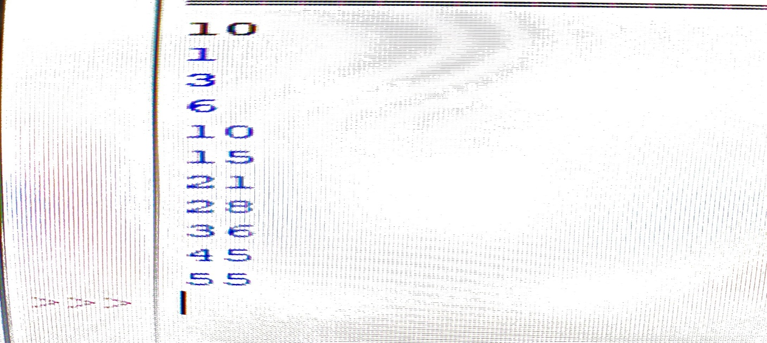

Exercise: 4
Difficulty: Medium
Question: Given an integer numRows, return the first numRows of Pascal's triangle. In Pascal's triangle, each number is the sum of the two numbers directly above it.
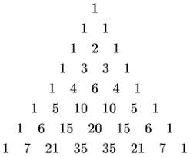

Program:
n = int(input("Enter the number of rows: "))

triangle = []

for i in range(n):
row = []

for j in range(i + 1):
if j == 0 or j == i:
row.append(1)
else:
row.append(triangle[i-1][j-1] + triangle[i-1][j])

triangle.append(row)

# Print the triangle
for i in range(n):
print(" " * (n - i), end="") # Print leading spaces
for num in triangle[i]:
print(num, end=" ")
print()

Output:
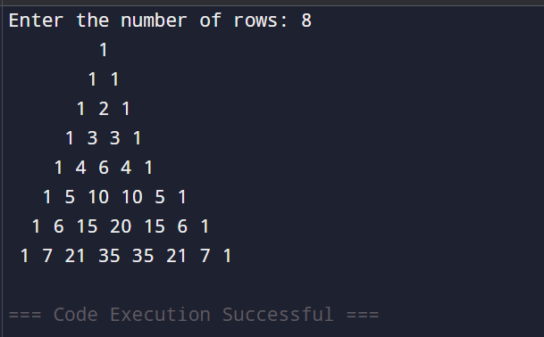
Exercise: 5
Difficulty: Hard
Question: Write a Python program to print all Armstrong numbers between 100 and 999.
An Armstrong number of 3 digits is an integer such that the sum of the cubes of its digits is equal to the number itself.

Program:
for num in range(100, 1000):

temp = num

digit1 = temp % 10
temp = temp // 10

digit2 = temp % 10
temp = temp // 10

digit3 = temp % 10

sum = digit1**3 + digit2**3 + digit3**3

if sum == num:
print(num)

Output:
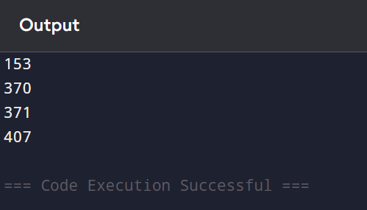

Exercise: 6
Difficulty: Hard
Question: Write a program to take an integer input n and print a pattern of numbers. For even rows, print in reverse order. For odd rows, print normally.

Program:
n = 5

num = 1

for i in range(1, n + 1):
start = num
end = num + i - 1

if i % 2 == 1:
for j in range(start, end + 1):
print(j, end=" ")
else:
for j in range(end, start - 1, -1):
print(j, end=" ")

print()
num = end + 1

Output:
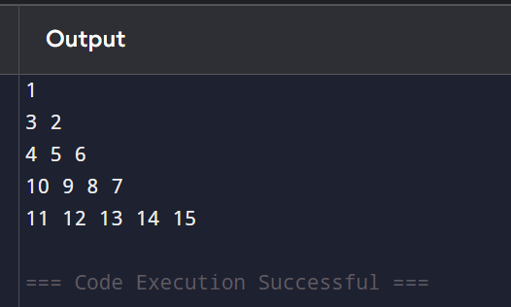

Exercise: 7
Difficulty: Hard
Question: Print a rotated triangle pattern for a given number n. The triangle should rotate every alternate row.

Program:
n = int(input("Enter the number of rows: "))

for i in range(1, n + 1):

if i % 2 != 0: # Odd row
for j in range(1, i + 1):
print(j, end=" ")
else: # Even row
for j in range(i, 0, -1):
print(j, end=" ")

print()

Output:
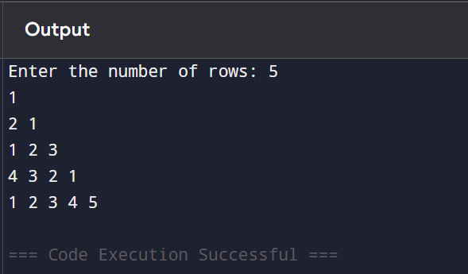

Assignment Evaluation:
0: Not Done [ ] 1: Incomplete [ ] 2: Late Complete [ ]
3: Needs Improvement [ ] 4: Complete [ ] 5: Well Done [ ]

Viva Questions:

- Can you use an else clause with a for loop? What does it do?
Ans: Yes. A for loop can have an else clause. The else block executes only if the loop completes normally without encountering a break statement.

- How do you use range() to print even numbers from 2 to 20?
Ans: Use the range() function with a step size of 2.
for i in range(2, 21, 2):
print(i)

- What is a control structure? Name three types used in Python.
Ans: A control structure determines the order in which program statements are executed.
The three main types are:

- Sequence – Statements execute one after another.
- Selection (Decision Making) – Uses if, if-else, elif.
- Iteration (Looping) – Uses for and while loops

- How do you skip the current iteration of a loop?
Ans: Use the continue statement. It skips the remaining statements in the current iteration and moves to the next iteration.

- Can we use a loop without any condition or body in Python?
Ans: Without a condition: Yes, using while True:. It creates an infinite loop until a break statement is used.
Without a body: No. Every loop must contain at least one statement. If no action is required, use the pass statement.

Activity Sheet - 3
Lists, Tuples, Ranges
Objectives:
- To understand how to create and manipulate lists, tuples, and range objects in Python.
- To explore indexing, slicing, iteration, and basic operations on lists and tuples.
- To apply range objects for generating sequences and controlling loop iterations.

Reading:
Before beginning the exercises, learners should be familiar with the following concepts:
Lists:
- Lists are ordered, mutable sequences of elements.
- Created using square brackets:
my_list = [1, 2, 3]
- Common operations:
  - Accessing elements: my_list[0]
  - Modifying values: my_list[1] = 10
  - List methods: append(), remove(), pop(), insert(), sort(), reverse()
  - Slicing: my_list[1:4]
Tuples:
- Tuples are ordered, immutable sequences of elements.
- Created using parentheses:
my_tuple = (1, 2, 3)
- Cannot modify values once created.
- Useful for fixed data and as keys in dictionaries.
Ranges:
- The range() function is used to generate a sequence of numbers.
- Common forms:
range(stop)
range(start, stop)
range(start, stop, step)
- Often used in loops:
for i in range(1, 6): print(i)

Illustrative Examples
Example #1:
Write a Python program to create a list of 5 student names. Add a new name to the end of the list, remove one name by index, and print the final list and its first three names using slicing.

Python Code:
students = ["Arun", "Meena", "John", "Priya", "David"]
students.append("Neha")
students.pop(2) # Removes "John"
print("Final List:", students)
print("First 3 students:", students[:3])
Sample Output:
Final List: ['Arun', 'Meena', 'Priya', 'David', 'Neha']
First 3 students: ['Arun', 'Meena', 'Priya']

Example #2:
Create a tuple of even numbers between 2 and 10 using the range() function and convert it into a tuple. Then print each element of the tuple using a loop.

Python Code:
even_numbers = tuple(range(2, 11, 2))
print("Even Number Tuple:", even_numbers)

for number in even_numbers:
print("Element:", number)

Sample Output:
Even Number Tuple: (2, 4, 6, 8, 10)
Element: 2
Element: 4
Element: 6
Element: 8
Element: 10

Programming Questions:
Exercise: 1
Difficulty: Easy
Question: You are given a sorted unique integer array nums. A range [a,b] is the set of all integers from a to b (inclusive). Return the smallest sorted list of ranges that cover all the numbers in the array exactly. That is, each element of nums is covered by exactly one of the ranges, and there is no integer x such that x is in one of the ranges but not in nums. Each range [a,b] in the list should be output as:
- "a->b" if a != b
- "a" if a == b
Program:
Output:

Exercise: 2
Difficulty: Easy
Question: Given an array nums of distinct positive integers, return the number of tuples (a, b, c, d) such that a * b = c * d where a, b, c, and d are elements of nums, and a != b != c != d.
Program:
Output:

Exercise: 3
Difficulty: Medium
Question: You are given two lists of closed intervals, firstList and secondList, where firstList[i] = [start_{i}, end_{i}] and secondList[j] = [start_{j}, end_{j}]. Each list of intervals is pairwise disjoint and in sorted order. Return the intersection of these two interval lists. A closed interval [a, b] (with a <= b) denotes the set of real numbers x with a <= x <= b. The intersection of two closed intervals is a set of real numbers that are either empty or represented as a closed interval. For example, the intersection of [1, 3] and [2, 4] is [2, 3].

Program:
Output:

Exercise: 4
Difficulty: Medium
Question: Given four integer arrays nums1, nums2, nums3, and nums4 all of length n, return the number of tuples (i, j, k, l) such that:
- 0 <= i, j, k, l < n
- nums1[i] + nums2[j] + nums3[k] + nums4[l] == 0
Program:
Output:

Exercise: 5
Difficulty: Medium
Question: You are given an integer array nums. The range of a subarray of nums is the difference between the largest and smallest element in the subarray. Return the sum of all subarray ranges of nums. A subarray is a contiguous non-empty sequence of elements within an array.

Program:
Output:

Exercise: 6
Difficulty: Hard
Question: Given an array of intervals where intervals[i] = [start_{i}, end_{i}], merge all overlapping intervals, and return an array of the non-overlapping intervals that cover all the intervals in the input.

Program:
Output:

Exercise: 7
Difficulty: Hard
Question: Given an integer array nums, return all the triplets [nums[i], nums[j], nums[k]] such that i != j, i != k, and j != k, and nums[i] + nums[j] + nums[k] == 0.

Program:
Output:

Assignment Evaluation:
0: Not Done [ ] 1: Incomplete [ ] 2: Late Complete [ ]
3: Needs Improvement [ ] 4: Complete [ ] 5: Well Done [ ]

Viva Questions:
- How do you sort a list in descending order?
- What is the difference between remove() and pop() methods in a list?
- What is the output of list(range(10, 0, -2))?
- Can you convert a range() object directly into a tuple? If yes, how?
- What does the count() method do in a list or a tuple?

Activity Sheet – 4
Dictionaries and Sets
Objectives:
- To understand the concepts of key-value pairs using dictionaries and explore operations such as insertion, deletion, updating, and searching.
- To learn the properties of sets as unordered collections of unique elements and perform set operations.
- To implement common dictionary and set methods in practical problem-solving scenarios.

Reading:
Dictionaries:
- A dictionary is an unordered, mutable collection of key-value pairs.
- Defined using curly braces {}:
student = {'name': 'Arun', 'age': 20}
- Common operations:
  - Access: student['name']
  - Add/update: student['grade'] = 'A'
  - Delete: del student['age']
  - Useful methods: keys(), values(), items(), get(), pop()
Sets:
- A set is an unordered collection of unique elements.
- Defined using {} or the set() constructor:
colors = {'red', 'blue', 'green'}
- Common operations:
  - Add: set.add(element)
  - Remove: set.remove(element)
  - Set operations: union(), intersection(), difference(), issubset(), issuperset()
- Useful for removing duplicates and performing fast membership testing.

Illustrative Examples:
Example #1: Create a dictionary to store a student's name, age, and course. Add a new key-value pair for grade and print the dictionary.

Python Code:
student = {
'name': 'Priya',
'age': 19,
'course': 'B.Tech'
}
student['grade'] = 'A'
print("Student Info:", student)

Sample Output:
Student Info: {'name': 'Priya', 'age': 19, 'course': 'B.Tech', 'grade': 'A'}
Example #2: Create two sets of students who play football and basketball. Print the names of students who play both sports, and those who play only football.

Python Code:
football = {'Amit', 'Sonal', 'Ravi', 'Priya'}
basketball = {'Sonal', 'Priya', 'Arjun'}

both = football.intersection(basketball)
only_football = football.difference(basketball)

print("Students playing both sports:", both)
print("Students playing only football:", only_football)

Sample Output:
Students playing both sports: {'Priya', 'Sonal'}
Students playing only football: {'Amit', 'Ravi'}

Programming Questions
Exercise: 1
Difficulty: Easy
Question: A sentence is a string of single-space separated words where each word consists only of lowercase letters. A word is uncommon if it appears exactly once in one of the sentences, and does not appear in the other sentence. Given two sentences s1 and s2, return a list of all the uncommon words. You may return the answer in any order.

Program:
Output:

Exercise: 2
Difficulty: Easy
Question: Given an array of strings strs, group the anagrams together. You can return the answer in any order.
Sample Input: strs = ["eat","tea","tan","ate","nat","bat"]
Sample Output: [["bat"],["nat","tan"],["ate","eat","tea"]]

Program:
Output:

Exercise: 3
Difficulty: Medium
Question: Given a string s and a dictionary of strings wordDict, return true if s can be segmented into a space-separated sequence of one or more dictionary words.
Note that the same word in the dictionary may be reused multiple times in the segmentation.

Program:
Output:

Exercise: 4
Difficulty: Medium
Question: Design a data structure that is initialized with a list of different words. Provided a string, you should determine if you can change exactly one character in this string to match any word in the data structure. Implement the MagicDictionary class:
- MagicDictionary() Initializes the object.
- void buildDict(String[] dictionary) Sets the data structure with an array of distinct strings dictionary.
- bool search(String searchWord) Returns true if you can change exactly one character in searchWord to match any string in the data structure, otherwise returns false.
Program:
Output:
Exercise: 5
Difficulty: Medium
Question: Write a Python program that takes a string input from the user and counts the frequency of each character in the string. You should store the result in a dictionary, where the keys are the characters and the values are the number of times each character appears. Ignore spaces in the string and treat uppercase and lowercase letters as distinct (case-sensitive). After processing the string, print the dictionary displaying the character frequencies

Program:
Output:

Exercise: 6
Difficulty: Medium
Question: Design a Python program that allows the user to input the names and marks of five students. Store this data in a dictionary where the student’s name is the key and their mark (out of 100) is the value. After storing all data, display the name of the student who scored the highest marks. Additionally, print a list of all students who scored more than 75. This exercise will help you practice dictionary creation, data traversal, and conditional filtering.

Program:
Output:

Exercise: 7
Difficulty: Hard
Question: You are given a list of words from a dictionary, where the words are sorted lexicographically according to an unknown alien language. Your task is to derive the order of characters in the alien language.
Sample Input:
- A list of n words, where n ≥ 2.
- Each word is a lowercase string.
- The list is sorted in alien lexicographical order.
Sample Output:
- A string representing the characters in the correct order of the alien alphabet.
- If multiple valid outputs are possible, return any one.
- If no valid ordering exists (e.g., due to cycles), return an empty string.

Program:
Output:

Assignment Evaluation:
0: Not Done [ ] 1: Incomplete [ ] 2: Late Complete [ ]
3: Needs Improvement [ ] 4: Complete [ ] 5: Well Done [ ]

Viva Questions:
- What are mutable and immutable data types in the context of sets and dictionaries?
- How do you merge two dictionaries in Python 3.9+?
- How can you count the frequency of elements in a list using a dictionary?
- How do you convert a list of tuples into a dictionary?
- Why are sets considered unordered collections?
Activity Sheet – 5
Functions and Recursions
Objectives:
- To understand how to define and use functions in Python for code modularity and reusability.
- To explore how parameters, return values, and scope operate within functions.
- To learn the concept of recursion and apply it to solve problems involving repetitive logic using self-referential function calls.

Reading:
Functions:
- A function is a reusable block of code that performs a specific task.
- Defined using the def keyword:
def greet(name):
print(f"Hello, {name}")

- Function Components:
  - Parameters/Arguments: Inputs to a function.
  - Return Statement: Sends output back to the caller.
  - Scope: Variables defined inside functions are local to them.
- Types of Arguments:
  - Positional arguments
  - Keyword arguments
  - Default arguments
  - Variable-length arguments (*args, **kwargs)
Recursion:
- Recursion is a technique where a function calls itself to solve a smaller instance of the same problem.
- Every recursive function must have:
  - A base case to stop recursion.
  - A recursive case to approach the base case.
- Example Use Cases:
  - Calculating factorial, Fibonacci series, sum of digits, reverse a string, etc.

Illustrative Examples:
Example #1: Write a function that accepts an integer and returns "Even" if it is even, otherwise returns "Odd".

Python Code:
def check_even_odd(n):
if n % 2 == 0:
return "Even"
else:
return "Odd"

number = int(input("Enter a number: "))
print("Result:", check_even_odd(number))

Sample Input:
Enter a number: 7

Sample Output:
Result: Odd

Example #2: Write a recursive function to calculate the factorial of a number n.

Python Code:
def factorial(n):
if n == 0 or n == 1:
return 1
else:
return n * factorial(n - 1)

num = int(input("Enter a number: "))
print("Factorial:", factorial(num))

Sample Input:
Enter a number: 5

Sample Output:
Factorial: 120

Programming Questions
Exercise: 1
Difficulty: Easy
Question: The count-and-say sequence is a sequence of digit strings defined by the recursive formula:
- countAndSay(1) = "1"
- countAndSay(n) is the run-length encoding of countAndSay(n - 1).
Run-length encoding (RLE) is a string compression method that works by replacing consecutive identical characters (repeated 2 or more times) with the concatenation of the character and the number marking the count of the characters (length of the run). For example, to compress the string "3322251" we replace "33" with "23", replace "222" with "32", replace "5" with "15" and replace "1" with "11". Thus, the compressed string becomes "23321511". Given a positive integer n, return the n^{th} element of the count-and-say sequence.
Program:
Output:

Exercise: 2
Difficulty: Easy
Question: Write a program to calculate the factorial of a given positive integer n using recursion.
Sample Input: A single integer n (where n ≥ 0)
Sample Output: The factorial of n

Program:

Output:

Exercise: 3
Difficulty: Medium
Question: The function accepts two positive integers ‘r’ and ‘unit’ and a positive integer array ‘arr’ of size ‘n’ as its argument ‘r’ represents the number of rats present in an area, ‘unit’ is the amount of food each rat consumes and each ith element of array ‘arr’ represents the amount of food present in ‘i+1’ house number, where 0 <= i.

Program:

Output:

Exercise: 4
Difficulty: Medium
Question: The Binary number system only uses two digits, 0 and 1 and number system can be called binary string. You are required to implement the following function:
int OperationsBinaryString(char* str);
The function accepts a string str as its argument. The string str consists of binary digits separated with an alphabet as follows:
- A denotes AND operation
- B denotes OR operation
- C denotes XOR Operation
You are required to calculate the result of the string str, scanning the string to right taking one operation at a time, and return the same.
Program:
Output:

Exercise: 5
Difficulty: Medium
Question: Write a Python program that defines a function named count_vowels(text) which takes a string as input and returns the total number of vowels present in the string. The function should be case-insensitive and should count all vowels: 'a', 'e', 'i', 'o', and 'u'. The user should be prompted to enter a sentence or word, and the program should print the number of vowels using the return value of the function. This exercise helps reinforce string traversal, condition checking, and function definition.

Program:
Output:

Exercise: 6
Difficulty: Hard
Question: 5-year-old Shinchan had just started learning mathematics. Meanwhile, one of his studious classmates, Kazama, had already written a basic calculator which supports only three operations on integers: multiplication, addition, and subtraction. Since he had just learned about these operations, he didn't know about operator precedence, and so, in his calculator, all operators had the same precedence and were left-associative. As always, Shinchan started to irritate him with his silly questions. He gave Kazama a list of n integers and asked him to insert one of the above operators between each pair of consecutive integers such that the result obtained after feeding the resulting expression in Kazama's calculator is divisible by 101. At his core, Shinchan is actually a good guy, so he only gave lists of integers for which an answer exists. Can you help Kazama create the required expression? If multiple solutions exist, print any one of them.

Program:
Output:

Exercise: 7
Difficulty: Hard
Question: Create a recursive function in Python named fibonacci(n) that returns the nth number in the Fibonacci sequence. Then, write another function print_fib_sequence(count) that calls the fibonacci() function repeatedly to print the first count numbers of the Fibonacci sequence. The Fibonacci sequence starts with 0 and 1, and each subsequent number is the sum of the two preceding ones. Your program should take an integer input from the user and display that many Fibonacci numbers. This exercise tests the understanding of recursion, function calling, and mathematical reasoning.

Program:
Output:

Assignment Evaluation:
0: Not Done [ ] 1: Incomplete [ ] 2: Late Complete [ ]
3: Needs Improvement [ ] 4: Complete [ ] 5: Well Done [ ]

Viva Questions:
- What is memoization in recursion?
- How does Python distinguish between global and local variables inside functions?
- What are pure functions? Give an example.
- Can recursive functions lead to infinite loops? How can it be avoided?
- Write a recursive function to print the Fibonacci sequence up to n terms.

Activity Sheet – 6
Object-Oriented Programming

Objectives:
- To understand the concept of classes, objects, and the principles of Object-Oriented Programming (OOP) such as encapsulation and abstraction.
- To learn how to define classes, constructors, attributes, and methods in Python.
- To apply OOP concepts by creating and manipulating objects to build reusable and organized code structures.

Reading:
Before starting, learners should be familiar with the following OOP concepts in Python:
Classes and Objects:
- A class is a blueprint for creating objects (instances).
- An object is an instance of a class that holds its own data and methods.
- Syntax to define a class:
class Student:
def __init__(self, name):
self.name = name
Constructor (__init__) Method:
- A special method called automatically when an object is created.
- Used to initialize object attributes.
Instance Variables and Methods:
- Instance variables are unique to each object.
- Methods define behavior and often use self to access instance data.
Encapsulation and Access Control:
- Data hiding using private variables (prefix with _ or __).
- Access/modification via getter and setter methods.

Illustrative Examples:
Example #1: Define a class Student with attributes name and age. Create a constructor to initialize them and a method display() to print student details.

Python Code:
class Student:
def __init__(self, name, age):
self.name = name
self.age = age

def display(self):
print("Name:", self.name)
print("Age:", self.age)

# Creating object
s1 = Student("Ananya", 20)
s1.display()

Sample Output:
Name: Ananya
Age: 20

Example #2: Create a class BankAccount with attributes account_holder and balance. Add methods to deposit and withdraw money, and to display the current balance.

Python Code:
class BankAccount:
def __init__(self, account_holder, balance=0):
self.account_holder = account_holder
self.balance = balance

def deposit(self, amount):
self.balance += amount

def withdraw(self, amount):
if amount <= self.balance:
self.balance -= amount
else:
print("Insufficient balance!")

def display(self):
print(f"Account Holder: {self.account_holder}")
print(f"Balance: ₹{self.balance}")

# Using the class
account = BankAccount("Rahul", 1000)
account.deposit(500)
account.withdraw(300)
account.display()

Sample Output:
Account Holder: Rahul
Balance: ₹1200

Programming Questions:
Exercise: 1
Difficulty: Easy
Question: Kristen is a contender for valedictorian of her high school. She wants to know how many students (if any) have scored higher than her in the exams given during this semester. You are given a class named Student with the following specifications:
- An instance variable named scores to hold a student's exam scores.
- A void input() function that reads 5 integers and saves them to scores.
- An int calculateTotalScore() function that returns the sum of the student's scores.
The first line of input contains n, the number of students. The next n lines contain each student's 5 exam grades. You need to determine how many students have a total score greater than Kristen's.

Program:

Output:

Exercise: 2
Difficulty: Medium
Question: Design a parking system for a parking lot. The parking lot has three kinds of parking spaces: big, medium, and small, with a fixed number of slots for each size.
Implement the ParkingSystem class:
- ParkingSystem(int big, int medium, int small) Initializes object of the ParkingSystem class. The number of slots for each parking space are given as part of the constructor.
- bool addCar(int carType) Checks whether there is a parking space of carType for the car that wants to get into the parking lot. carType can be of three kinds: big, medium, or small, which are represented by 1, 2, and 3 respectively. A car can only park in a parking space of its carType. If there is no space available, return false, else park the car in that size space and return true.

Program:

Output:

Exercise: 3
Difficulty: Hard
Question: You have a movie renting company consisting of n shops. You want to implement a renting system that supports searching for, booking, and returning movies. The system should also support generating a report of the currently rented movies. Each movie is given as a 2D integer array entries where entries[i] = [shopi, moviei, pricei] indicates that there is a copy of movie moviei at shop shopi with a rental price of pricei. Each shop carries at most one copy of a movie moviei.The system should support the following functions:
Search: Finds the cheapest 5 shops that have an unrented copy of a given movie. The shops should be sorted by price in ascending order, and in case of a tie, the one with the smaller shopi should appear first. If there are less than 5 matching shops, then all of them should be returned. If no shop has an unrented copy, then an empty list should be returned.
Rent: Rents an unrented copy of a given movie from a given shop.
Drop: Drops off a previously rented copy of a given movie at a given shop.
Report: Returns the cheapest 5 rented movies (possibly of the same movie ID) as a 2D list res where res[j] = [shopj, moviej] describes that the jth cheapest rented movie moviej was rented from the shop shopj. The movies in res should be sorted by price in ascending order, and in case of a tie, the one with the smaller shopj should appear first, and if there is still tie, the one with the smaller moviej should appear first. If there are fewer than 5 rented movies, then all of them should be returned. If no movies are currently being rented, then an empty list should be returned.

Implement the MovieRentingSystem class:
MovieRentingSystem(int n, int[][] entries) - Initializes the MovieRentingSystem object with n shops and the movies in entries.
List<Integer> search(int movie) - Returns a list of shops that have an unrented copy of the given movie as described above.
void rent(int shop, int movie) - Rents the given movie from the given shop.
void drop(int shop, int movie) - Drops off a previously rented movie at the given shop.
List<List<Integer>> report() - Returns a list of cheapest rented movies as described above.

Program:

Output:
Assignment Evaluation:
0: Not Done [ ] 1: Incomplete [ ] 2: Late Complete [ ]
3: Needs Improvement [ ] 4: Complete [ ] 5: Well Done [ ]

Viva Questions:
- What is Object-Oriented Programming?
- What are the main principles of OOP?
- What is a class and how is it different from an object?
- How do you define a class in Python?
- How do you create an object of a class?

Activity Sheet – 7
Exception Handling
Objectives:
- To understand what exceptions are and why handling them is essential in Python programming.
- To learn how to use try, except, else, and finally blocks for effective error management.
- To implement custom exception handling and ensure safe program execution during runtime errors.

Reading:
What is an Exception?
- An exception is a runtime error that interrupts the normal flow of program execution.
- Examples: division by zero, file not found, invalid input type.
Basic Syntax:
try:
# risky code
except SomeException:
# handler
else:
# executes if no exception
finally:
# always executes
Common Exceptions:
- ZeroDivisionError: Dividing by zero
- ValueError: Invalid type conversion (e.g., int("abc"))
- IndexError: Accessing an invalid list index
- TypeError, KeyError, FileNotFoundError, etc.
Custom Exceptions:
- You can define your own exception classes by inheriting from the built-in Exception class.

Illustrative Examples:
Example #1: Write a program that asks the user for two numbers and divides them. Handle the case where the second number is zero.

Python Code:
try:
a = int(input("Enter numerator: "))
b = int(input("Enter denominator: "))
result = a / b
print("Result:", result)
except ZeroDivisionError:
print("Error: Cannot divide by zero.")

Sample Input:
Enter numerator: 10
Enter denominator: 0

Sample Output:
Error: Cannot divide by zero.

Example #2: Write a program that takes two numbers from the user and performs division. Handle both invalid input and division by zero errors.

Python Code:
try:
a = int(input("Enter numerator: "))
b = int(input("Enter denominator: "))
print("Quotient:", a / b)
except ValueError:
print("Error: Please enter valid integers.")
except ZeroDivisionError:
print("Error: Denominator cannot be zero.")
finally:
print("Program execution completed.")

Sample Input:
Enter numerator: 25
Enter denominator: abc

Sample Output:
Error: Please enter valid integers.
Program execution completed.

Programming Questions
Exercise: 1
Difficulty: Easy
Question: You are given two values, a and b. Perform integer division a // b and print the result. If an error occurs (e.g., division by zero or invalid input), print an appropriate error message.
Input Format:
- The first line contains an integer T, the number of test cases.
- Each of the next T lines contains two space-separated values: a and b.
Output Format:
For each test case, print the result of a // b. If an exception occurs, print "Error Code:" followed by the exception message
Program:

Output:

Exercise: 2
Difficulty: Medium
Question: Create a program that accepts a list of integers from the user and allows them to access an element at a specified index. Handle:
- ValueError for invalid integer input
- IndexError for accessing an index that doesn't exist
Also, display an appropriate message if the list is empty.

Program:

Output:

Exercise: 3
Difficulty: Medium
Question: Write a program that asks the user to enter a filename and attempts to open and read it. Handle:
- File not found errors (FileNotFoundError)
- Attempt to read a non-text file
- Use finally to ensure the file is closed properly

Program:

Output:

Exercise: 3
Difficulty: Medium
Question: Write a program that asks the user to enter a filename and attempts to open and read it. Handle:
- File not found errors (FileNotFoundError)
- Attempt to read a non-text file
- Use finally to ensure the file is closed properly

Program:

Output:

Exercise: 4
Difficulty: Medium
Question: Create a Python program that accepts a list of student names and their corresponding scores (out of 100). The program should:
- Take n inputs from the user in the format:
Name,Score (e.g., Alice,85)
- Validate each input:
  - Raise and handle a ValueError if:
    - The score is not a number.
    - The score is outside the range 0–100.
  - Raise and handle a CustomNameError if:
    - The name is missing or contains numbers.
- After validating all inputs, print a dictionary mapping each student to their grade based on the score:
  - A: 90–100
  - B: 75–89
  - C: 50–74
  - F: <50

Program:

Output:

Exercise: 5
Difficulty: Hard
Question: Create a class InvalidAgeError that inherits from Exception. Write a program that takes a user's age as input and raises this exception if the age is:
- Less than 0
- Greater than 130
Display a friendly message using the custom exception when the age is invalid.

Program:

Output:

Assignment Evaluation:
0: Not Done [ ] 1: Incomplete [ ] 2: Late Complete [ ]
3: Needs Improvement [ ] 4: Complete [ ] 5: Well Done [ ]

Viva Questions:
- What happens if an exception is not caught using try-except?
- How do you handle multiple exceptions in a single try block?
- What does the raise keyword do in Python?
- Why is it considered bad practice to use a bare except: clause?
- What is the use of else in a try-except-else-finally structure?

Activity Sheet – 8
Regular Expressions

Objectives:
- To understand the concept and syntax of regular expressions for pattern matching.
- To learn how to use Python’s re module for searching, matching, and extracting patterns from strings.
- To apply regex in solving problems like input validation, data cleaning, and text parsing.

Reading:
What is a Regular Expression?
- A regular expression is a sequence of characters that forms a search pattern used for string matching and manipulation.
- In Python, regular expressions are supported through the re module.

Common Regex Syntax:
Regex Pattern | Description
. | Matches any character except newline
\d | Matches any digit (0–9)
\D | Matches any non-digit
\w | Matches any alphanumeric character (letters, digits, underscore)
\W | Matches any non-word character
\s | Matches any whitespace character
\S | Matches any non-whitespace character
^ | Matches the beginning of a string
$ | Matches the end of a string
* | Matches 0 or more occurrences of the preceding pattern
+ | Matches 1 or more occurrences of the preceding pattern
? | Matches 0 or 1 occurrence of the preceding pattern
{m,n} | Matches between m and n repetitions of the preceding pattern
[abc] | Matches either 'a', 'b', or 'c'
[a-z] | Matches any lowercase letter from a to z
(...) | Groups multiple tokens together and remembers the match
| | Matches either the expression before or after the |

Core Functions from re module:
- re.match() – checks for a match at the beginning of a string
- re.search() – searches the string for a match anywhere
- re.findall() – returns all matches as a list
- re.sub() – replaces pattern matches with a specified string
- re.compile() – compiles a regex pattern for reuse

Illustrative Examples:
Example #1: Write a program that checks if an email address is valid using regular expressions.

Python Code:
import re

email = input("Enter your email: ")
pattern = r'^[a-zA-Z0-9._]+@[a-zA-Z]+\.(com|in|edu)$'

if re.match(pattern, email):
print("Valid email")
else:
print("Invalid email")

Sample Input:
Enter your email: user123@gmail.com

Sample Output:
Valid email

Example #2: Write a Python program to extract all numbers from a given text using regular expressions.

Python Code:
import re

text = "Order IDs: 1024, 5678, and 9823 are pending."
numbers = re.findall(r'\d+', text)
print("Extracted numbers:", numbers)

Sample Output:
Extracted numbers: ['1024', '5678', '9823']

Programming Questions
Exercise: 1
Difficulty: Easy
Question: Write a regex to match the exact string "hackerrank".

Program:

Output:

Exercise: 2
Difficulty: Medium
Question: You have a test string S. Your task is to write a regex that will match S using the following conditions:
- S must be of length equal to 45.
- The first characters should consist of letters (both lowercase and uppercase), or of even digits.
- The last 5 characters should consist of odd digits or whitespace characters.

Program:

Output:

Exercise: 3
Topic: Regular Expressions
Difficulty: Hard
Question: Given an input string s and a pattern p, implement regular expression matching with support for '.' and '*' where:
- '.' Matches any single character.​​​​
- '*' Matches zero or more of the preceding elements.
The matching should cover the entire input string (not partial).
Sample Input: s = "aa", p = "a"
Sample Output: false
Explanation: "a" does not match the entire string "aa".

Program:

Output:

Assignment Evaluation:
0: Not Done [ ] 1: Incomplete [ ] 2: Late Complete [ ]
3: Needs Improvement [ ] 4: Complete [ ] 5: Well Done [ ]

Viva Questions:
- What does \s and \S represent in regex?
- How do you replace all spaces in a string with a dash using regex?
- What is the role of character classes like [a-z] in regex?
- What will re.split(r"\W+", "welcome_to@python3.10!") return?
- What is a greedy vs non-greedy match in regex?

Activity Sheet – 9
Database Connectivity
Objectives:
- To understand how to connect Python applications with databases such as SQLite or MySQL using connector libraries.
- To learn how to execute SQL queries (CREATE, INSERT, SELECT, etc.) from Python.
- To implement CRUD (Create, Read, Update, Delete) operations using cursor objects and manage connections safely.

Reading:
Basic Concepts:
- A database connection allows Python programs to interact with structured data stored in tables.
- Commonly used libraries:
  - sqlite3 – built-in module for SQLite databases.
  - mysql.connector – for MySQL database connections (external module).
Basic Workflow for Database Operations:
- Connect to the database
  - conn = sqlite3.connect('mydata.db')
- Create a cursor object
  - cursor = conn.cursor()
- Execute SQL queries
  - cursor.execute("INSERT INTO students VALUES (?, ?)", (name, marks))
- Commit changes (if needed)
  - conn.commit()
- Close connection
  - conn.close()
Types of SQL Queries in Python:
- CREATE TABLE – to define table structure
- INSERT INTO – to add new records
- SELECT – to fetch data
- UPDATE / DELETE – to modify or remove data

Illustrative Examples:
Example #1: Write a Python program to connect to an SQLite database and insert a new record into the students table.

Python Code:
import sqlite3

conn = sqlite3.connect('school.db')
cursor = conn.cursor()

cursor.execute('''CREATE TABLE IF NOT EXISTS students (
name TEXT,
marks INTEGER)''')

name = input("Enter student name: ")
marks = int(input("Enter marks: "))

cursor.execute("INSERT INTO students (name, marks) VALUES (?, ?)", (name, marks))

conn.commit()
conn.close()
print("Record inserted successfully.")

Sample Input:
Enter student name: Anjali
Enter marks: 89

Sample Output:
Record inserted successfully.

Example #2: Write a Python program to connect to a MySQL database, insert a new record into a table called students, and then retrieve and display all records.

Python Code:
import mysql.connector

# Step 1: Connect to MySQL
conn = mysql.connector.connect(
host="localhost",
user="root",
password="your_password", # Replace with your MySQL password
database="school" # Make sure this database exists
)

cursor = conn.cursor()

# Step 2: Create table if it doesn't exist
cursor.execute("""
CREATE TABLE IF NOT EXISTS students (
id INT AUTO_INCREMENT PRIMARY KEY,
name VARCHAR(100),
marks INT
)
""")

# Step 3: Take input and insert data
name = input("Enter student name: ")
marks = int(input("Enter marks: "))

sql = "INSERT INTO students (name, marks) VALUES (%s, %s)"
val = (name, marks)
cursor.execute(sql, val)
conn.commit()

print("Record inserted successfully.")

# Step 4: Fetch and display records
cursor.execute("SELECT * FROM students")
rows = cursor.fetchall()

print("\nStudent Records:")
for row in rows:
print("ID:", row[0], "| Name:", row[1], "| Marks:", row[2])

# Step 5: Close connection
conn.close()

Sample Input:
Enter student name: Priya
Enter marks: 85

Sample Output:
Record inserted successfully.

Student Records:
ID: 1 | Name: Priya | Marks: 85
ID: 2 | Name: Anil | Marks: 78

Programming Questions:
Exercise: 1
Difficulty: Medium
Question: You are required to build a Python-based Library Management System that connects to an SQL database and performs complete CRUD operations. The system should maintain three relational tables: Books, Borrowers, and Transactions. The Books table will store fields like BookID, Title, Author, Genre, Price, and Stock. The Borrowers table should record BorrowerID, Name, and Email, while the Transactions table must log each book borrowing event with fields such as TransactionID, BookID, BorrowerID, DateBorrowed, and DateReturned.

Implement functionalities that allow administrators to add, update, delete, and view books. Borrowers should be able to register, borrow available books (only if stock allows), and return them, which should automatically update stock and transaction status. Include validation to ensure that a book cannot be borrowed if it’s out of stock, and make sure stock is incremented on return. Your script must also support querying the database to show the top 5 most borrowed books, list all overdue books (not returned within 14 days), and provide a count of books per genre.

To enhance usability, include search functionality by book title or author, use parameterized SQL queries to prevent SQL injection, and log all write operations into a library.log file. Optionally, allow exporting of the tables into .csv or .xlsx format using Pandas, and display output using the prettytable library for a clean terminal-based UI. This assignment integrates SQL schema design, Python scripting, and database-driven logic to simulate a real-world application.

Program:

Output:

Assignment Evaluation:
0: Not Done [ ] 1: Incomplete [ ] 2: Late Complete [ ]
3: Needs Improvement [ ] 4: Complete [ ] 5: Well Done [ ]

Viva Questions:
- What Python module is commonly used to connect to a MySQL database?
- What is a cursor object, and why is it required in database operations?
- How do you connect to a database using mysql.connector or sqlite3 in Python?
- What is the difference between fetchone(), fetchall(), and fetchmany()?
- Why should we use commit() after executing a data-modifying SQL query?

Activity Sheet – 10
Python Libraries (Numpy and Pandas)

Objectives:
- To understand the purpose and basic usage of NumPy for numerical operations and array manipulation.
- To learn how to create, access, and manipulate data using Pandas Series and DataFrames.
- To apply both libraries for performing real-world data analysis tasks efficiently.

Reading:
NumPy (Numerical Python):
- NumPy is used for numerical computations and handling n-dimensional arrays.
- Key features:
  - Efficient array operations
  - Vectorization
  - Mathematical/statistical functions
Common NumPy Functions:
- np.array(): Create arrays
- np.zeros(), np.ones(): Initialize arrays
- np.mean(), np.sum(), np.max(), np.min(): Statistical ops
- array.reshape(): Change dimensions

Pandas (Python Data Analysis Library):
- Pandas is used for data analysis and manipulation.
- Key data structures:
  - Series: 1D labeled array
  - DataFrame: 2D table of rows and columns
Common Pandas Functions:
- pd.Series(), pd.DataFrame(): Create Series or DataFrame
- df.head(), df.tail(): View first/last rows
- df.info(), df.describe(): Metadata and stats
- df['column']: Access column
- df.loc[], df.iloc[]: Label-based and index-based row access

Illustrative Examples:
Example #1: Create a 1D NumPy array of integers from 1 to 10, calculate the mean, and print the reshaped array as a 2x5 matrix.

Python Code:
import numpy as np
arr = np.arange(1, 11)
print("Original array:", arr)

mean = np.mean(arr)
print("Mean:", mean)

reshaped = arr.reshape(2, 5)
print("Reshaped Array:\n", reshaped)

Sample Output:
Original array: [ 1 2 3 4 5 6 7 8 9 10]
Mean: 5.5
Reshaped Array:
[[ 1 2 3 4 5]
[ 6 7 8 9 10]]

Example #2: Create a DataFrame with student names and marks. Add a new column for grades based on marks and display students who scored above 75.

Python Code:
import pandas as pd
data = {
'Name': ['Amit', 'Neha', 'Ravi', 'Sara'],
'Marks': [88, 74, 92, 67]
}
df = pd.DataFrame(data)
# Add Grade column
df['Grade'] = ['A' if m >= 75 else 'B' for m in df['Marks']]
# Filter high scorers
high_scorers = df[df['Marks'] > 75]
print("Full DataFrame:\n", df)
print("\nHigh Scorers:\n", high_scorers)

Sample Output:
Full DataFrame:
Name Marks Grade
0 Amit 88 A
1 Neha 74 B
2 Ravi 92 A
3 Sara 67 B

High Scorers:
Name Marks Grade
0 Amit 88 A
2 Ravi 92 A

Programming Questions
Exercise: 1
Difficulty: Easy
Question: Write a Python program using NumPy to create a 1D array containing values from 1 to 12. Then, reshape the array into a 2D array of 3 rows and 4 columns.

Program:

Output:

Exercise: 2
Difficulty: Medium
Question: Consider a CSV file containing the following columns with dummy values:
- StudentID, Name, Gender, Department, Subject1, Subject2, Subject3, Subject4, Attendance (%)
Your task:
- Compute:
  - Total Marks, Average Marks (NumPy)
  - Add a Grade column based on average: A (≥90), B (75–89), C (50–74), F (<50)
  - Add a Result column: Pass/Fail based on marks AND Attendance ≥ 75%
- Group by Department and Gender:
  - Calculate average score, number of passes/fails
Program:
Output:

Assignment Evaluation:
0: Not Done [ ] 1: Incomplete [ ] 2: Late Complete [ ]
3: Needs Improvement [ ] 4: Complete [ ] 5: Well Done [ ]

Viva Questions:
- What is broadcasting in NumPy? Give an example.
- How do you read a CSV file into a DataFrame using Pandas?
- What is the purpose of the groupby() function in Pandas?
- Explain how slicing works in NumPy arrays.
- How can you find the mean and standard deviation of a column in a DataFrame?

Activity Sheet – 11
Data Visualization (Matplotlib and Seaborn)
Objectives:
- To understand the role of data visualization in data analysis and decision-making.
- To learn how to use Matplotlib and Seaborn libraries to create charts such as line plots, bar charts, histograms, and heatmaps.
- To apply formatting, labeling, and styling techniques for effective and readable plots.

Reading:
Matplotlib:
- Matplotlib is a 2D plotting library used for creating static visualizations in Python.
- Core functions:
  - plt.plot() – line plots
  - plt.bar() – bar charts
  - plt.scatter() – scatter plots
  - plt.xlabel(), plt.ylabel(), plt.title(), plt.legend() – for labeling
  - plt.show() – displays the plot
Example:
import matplotlib.pyplot as plt
plt.plot([1, 2, 3], [4, 1, 6])
plt.show()

Seaborn:
- Seaborn is built on top of Matplotlib and provides a high-level interface for drawing attractive and informative statistical graphics.
- Common functions:
  - sns.lineplot(), sns.barplot(), sns.boxplot()
  - sns.histplot(), sns.heatmap()
- Works well with Pandas DataFrames
Example:
import seaborn as sns
sns.histplot([1, 2, 2, 3, 4, 5, 5, 5])

Illustrative Examples:
Example #1: Create a line graph to display sales data over 5 months.

Python Code:
import matplotlib.pyplot as plt
months = ['Jan', 'Feb', 'Mar', 'Apr', 'May']
sales = [12000, 15000, 17000, 14000, 16000]
plt.plot(months, sales, marker='o', color='blue')
plt.title("Monthly Sales")
plt.xlabel("Month")
plt.ylabel("Sales in ₹")
plt.grid(True)
plt.show()

Sample Output:
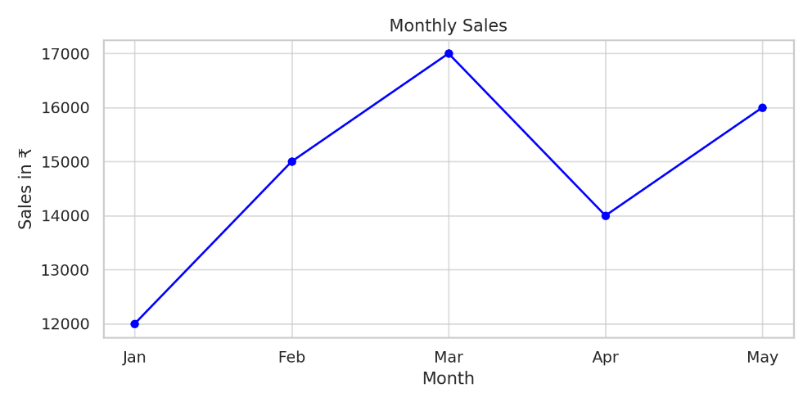

Example #2: Display average marks of students in three subjects using a Seaborn bar plot.

Python Code:
import seaborn as sns
import matplotlib.pyplot as plt
import pandas as pd
data = {
'Subject': ['Math', 'Science', 'English'],
'Average Marks': [78, 85, 72]}
df = pd.DataFrame(data)
sns.barplot(x='Subject', y='Average Marks', data=df, palette='viridis')
plt.title("Subject-wise Average Marks")
plt.ylabel("Marks")
plt.show()

Sample Output:
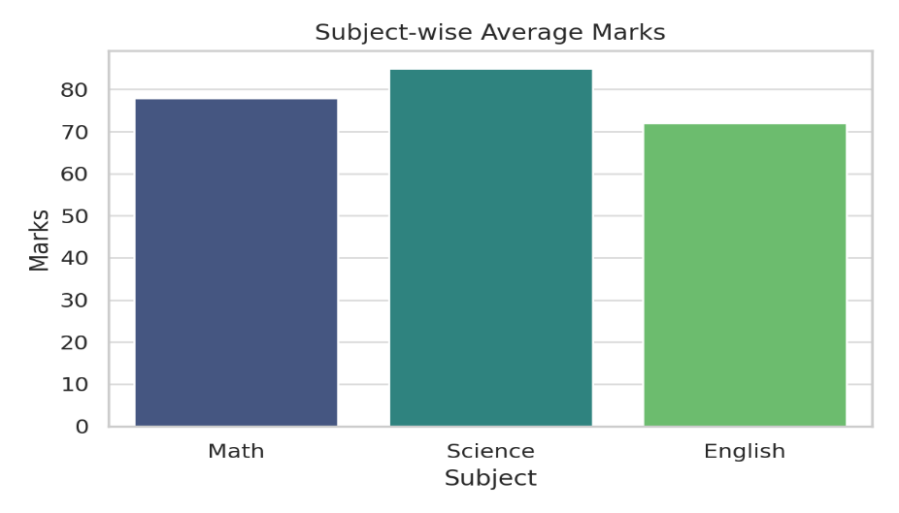
Programming Question:
Exercise: 1
Difficulty: Medium
Question: Consider a CSV file containing the following columns with dummy values:
- OrderID, Date, Product, Category, Region, Units Sold, Unit Price, Revenue, Profit
You must create the following visualizations:
- Monthly Revenue and Profit Line Chart (dual axis)
- Top 5 Categories by Revenue (horizontal bar chart)
- Profit Distribution by Region (boxplot using Seaborn)
- Heatmap of correlation among Units Sold, Revenue, and Profit
- Pie chart of order share by region (exclude <2% regions)
Program:
Output:

Assignment Evaluation:
0: Not Done [ ] 1: Incomplete [ ] 2: Late Complete [ ]
3: Needs Improvement [ ] 4: Complete [ ] 5: Well Done [ ]

Viva Questions:
- What is the purpose of Matplotlib in Python?
- How do you plot a line graph using Matplotlib?
- What are the differences between plt.plot() and sns.lineplot()?
- How can you add labels and title to a Matplotlib chart?
- What function in Seaborn is used to draw a histogram with a KDE curve?

Activity Sheet – 12
Dataframe Operations on Toyota Corolla Dataset

Objectives:
- To learn how to load, view, and manipulate real-world tabular data using Pandas.
- To perform filtering, grouping, and transformation operations on a structured dataset.
- To apply statistical and conditional logic to extract insights from automotive data (like price trends, fuel types, mileage, etc.).

Reading:
About the Dataset:
- The Toyota Corolla Dataset typically contains features like:
  - Model, Price, Age, KM, Fuel_Type, HP, CC, Doors, Gears, Weight, Met_Color, Automatic
Essential Pandas Operations to Know:
- pd.read_csv() – Load dataset
- df.head(), df.tail() – View top/bottom rows
- df.columns, df.info() – View structure
- df.describe() – Summary statistics
- df['column'], df[['col1', 'col2']] – Column selection
- df.loc[], df.iloc[] – Row selection
- df[df['Fuel_Type'] == 'Diesel'] – Filtering
- df.groupby('Fuel_Type')['Price'].mean() – Aggregation
- df.sort_values('Price', ascending=False) – Sorting
- df.dropna() / df.fillna() – Handling missing values

Programming Questions:
Exercise: 1
Difficulty: Medium
Question: Using the Toyota Corolla dataset, perform the following:
- Preprocess:
  - Drop irrelevant columns (e.g., Model, ID, Color)
  - Handle missing values with strategy (drop or impute)
- Feature Engineering:
  - Add Car_Age column from Age and Manufacture_Year (if available)
  - Create a Usage_Rate column = KM / Car_Age
  - Label Encode categorical variables
- Group and Analyze:
  - Average Price and KM grouped by Fuel_Type and Transmission
  - Identify price outliers using IQR method and mark them
- Visualization:
  - Scatter plot of Price vs KM colored by Fuel_Type
  - Line chart: Average Price by Age Category (New, Mid, Old)
Deliverables:
- Export final cleaned and engineered DataFrame to corolla_processed.xlsx
- Include two sheets: Cleaned_Data, Analysis_Summary

Program:

Output:

Assignment Evaluation:
0: Not Done [ ] 1: Incomplete [ ] 2: Late Complete [ ]
3: Needs Improvement [ ] 4: Complete [ ] 5: Well Done [ ]

Viva Questions:
- How do you create a DataFrame from a dictionary in Pandas?
- What is the difference between drop() and del in removing columns from a DataFrame?
- How do you filter rows in a DataFrame based on a condition?
- What does the groupby() function do in Pandas?
- How do you merge or join two DataFrames?

