Assingment-1

Task-1

This is a python programme to calculate factorial without using function

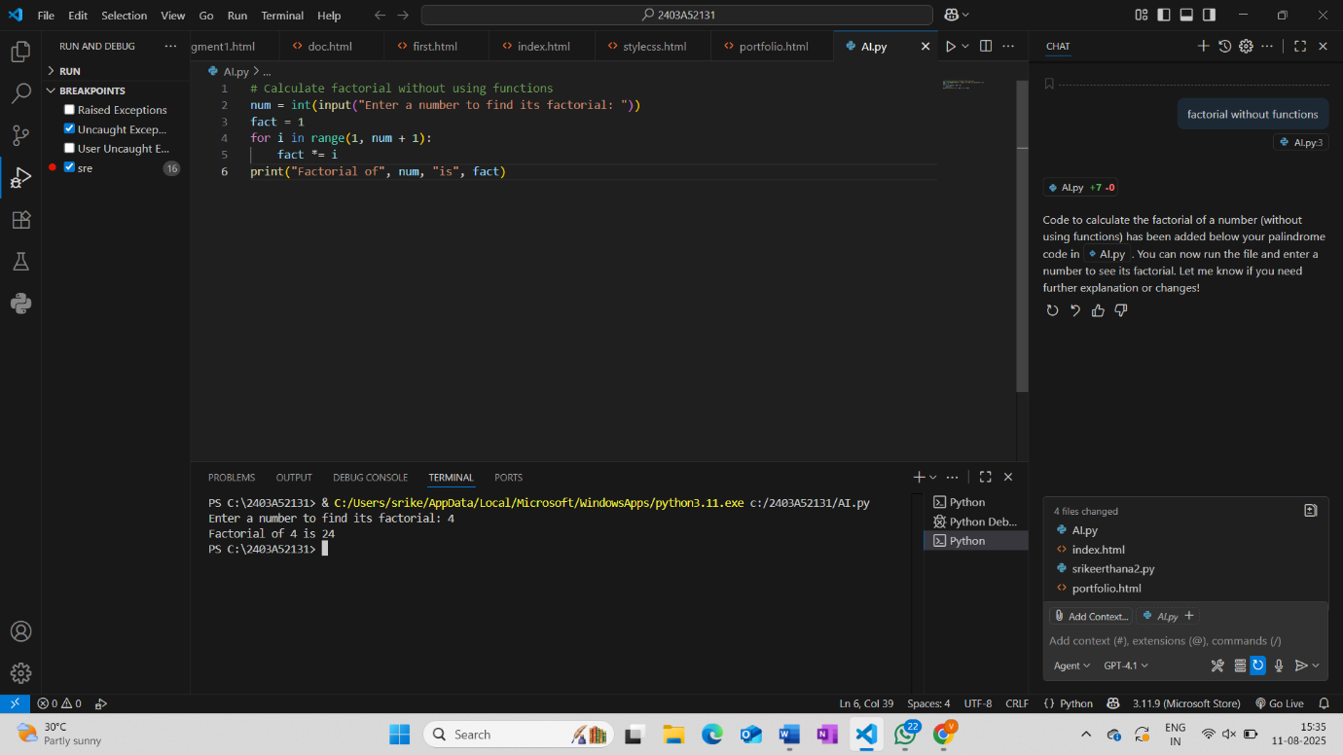Task-3

This is a python Programme to calculate factorial with using function

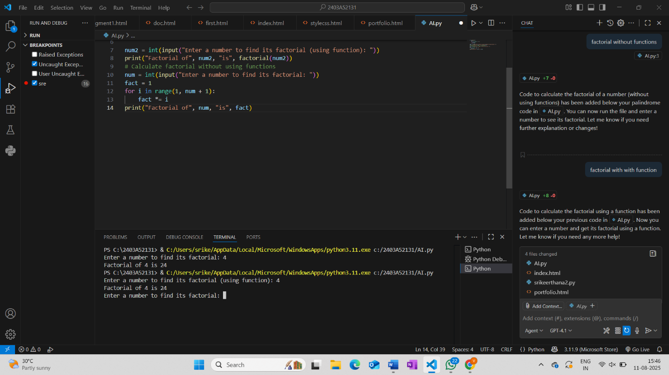

Task-4

* **Without a function:** The code for calculating the factorial is written directly in the main program. You cannot reuse it easily, and if you need to calculate factorial in multiple places, you have to repeat the code.
* **With a function:** The factorial logic is placed inside a function (e.g., factorial(n)). You can call this function whenever needed, making your code reusable, organized, and easier to maintain. Functions also help break down complex problems into smaller, manageable parts

**Task-5**

Iterative and recursive are two different approaches to solving problems in programming:

* **Iterative:** Uses loops (like for or while) to repeat actions until a condition is met. It is usually more memory-efficient and faster because it does not involve function call overhead.
  + Example: Calculating factorial with a for loop.
* **Recursive:** A function calls itself to solve smaller instances of the same problem. It is often simpler and more elegant for problems that have a natural recursive structure, but can use more memory due to the call stack.
  + Example: Calculating factorial by calling the function within itself.

