**20) Design a wireframe in Figma for a mobile application showcasing power management approaches.**

**Aim:**

Design a wireframe in Figma for a mobile application showcasing power management approaches.

**Procedure:**

1. Create a file
2. Add The First Frame
3. Add Shapes
4. Add Text
5. Create The Second Frame
6. Add Prototyping

**Step By Step Procedure :**

**Prototype:**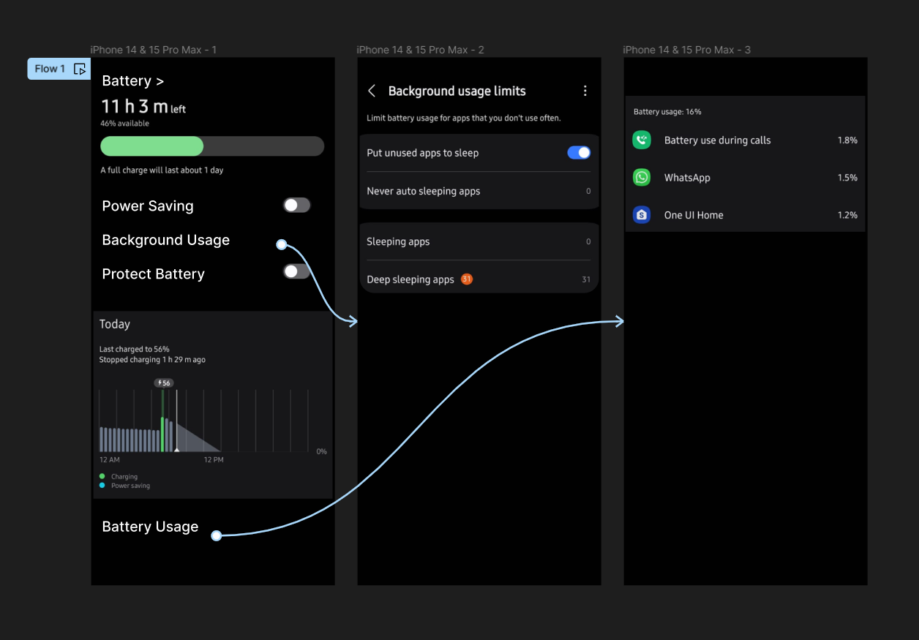

**Result:**

Hence the mobile application showcasing power management is created and executed successfully.