1. Brief yourself , tell about your Self..

-----------Name

---------Education

-----------Experience: I am totally having 3 years of experience in QA , Out of which 2 years automation & 1 year in maul testing . &currently working in TY as Software test Eng & previous company details.

----------roles & responsibility

1. Why are switching the company ?

I am not changing the company, testYnatra is trying deploying me Here.

1. What is your roles & responsibility?

* Whenever we get manual test case from the manual team, our team lead is going to allocate test case to us
* When test case is allocated, we do execute test manually to understand the business flow of the application, if test case is not clear talk to author/team lead & get the clarity, or else consider for automation
* Involved in segregation of test cases is automatble or not?
* Involved in test scripts automation
* Before test scripts development, get the latest framework form the Git Repo
* Involved in test data creation
* Involved in test POM class creation & adding elements in to repository
* Involved in business/ workFlow library creation
* Involved in generic library creation if required
* Involved in review test scripts
* Involved in verifying execution reports, when Jenkins send out execution report
* Involved in debugging the test scripts & raise regression defect if test failed because of Product issue or else fix the test scripts
* Involved in daily stand Up meeting
* Involved in framework development
* Involved in creation of webdriver action for every element in GUI like select , mouseMove() , swucthToWindow() etc..
* Involved on giving KT to team members
* Involved configuration of suite execution in Jenkins
* Involved in maintenance of test scripts in Git Location
* Involved in Sprint Review * retrospect meetings
* Involved in tracking automation defect in Jira

1. Explain Automation Life cycle

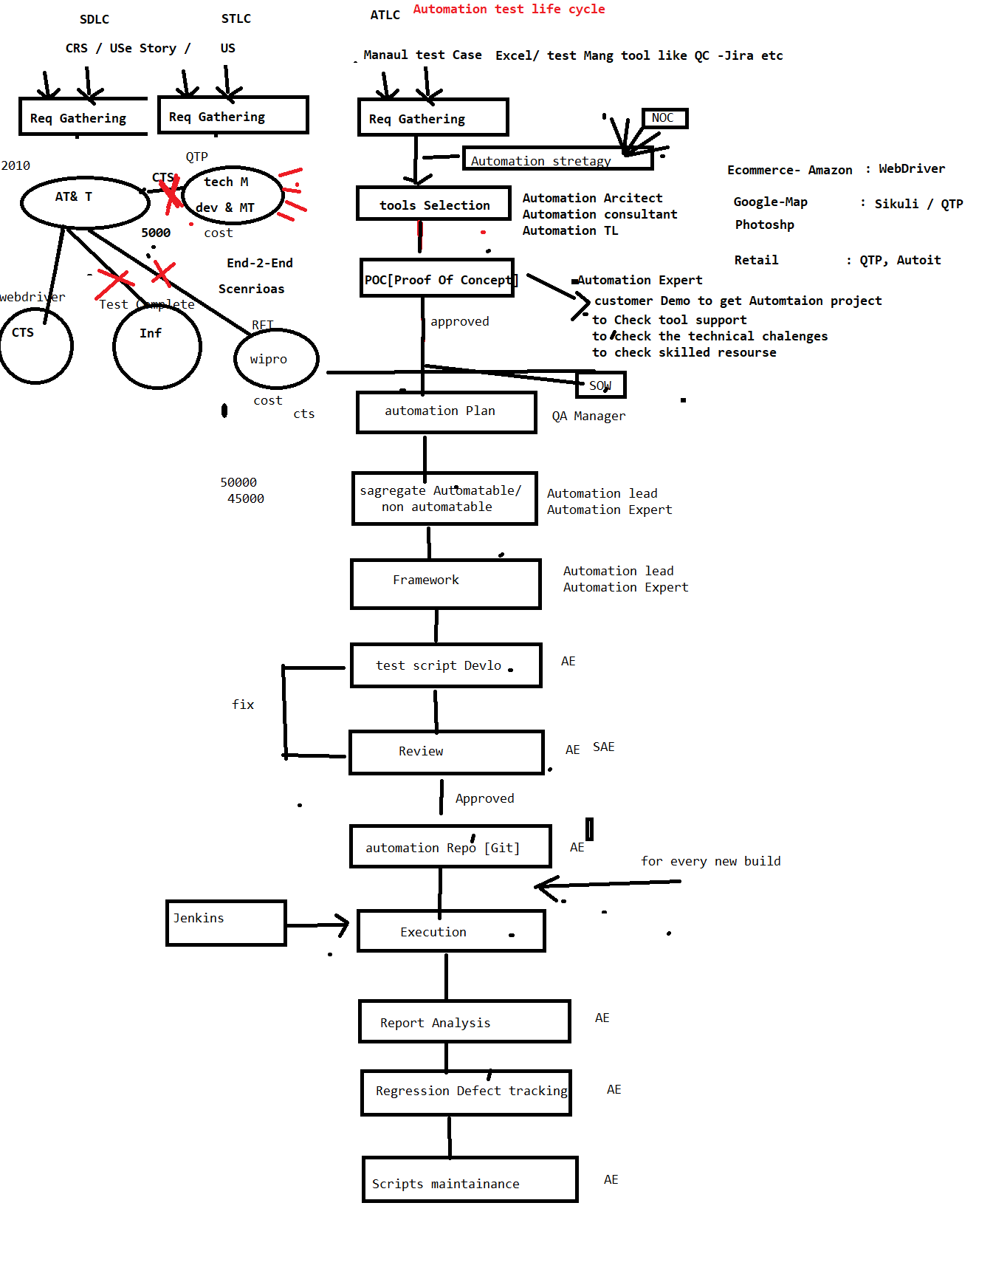

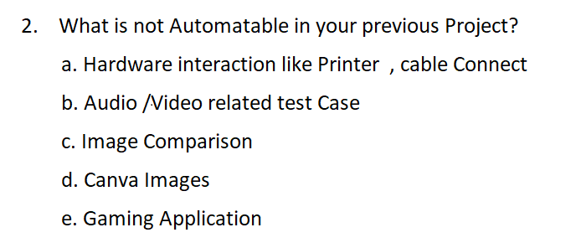

EG-1 : In my previous project , there was a scenario , where create Customer along with image of the Customer , in that scenario , i have automated Upload image but could not verify the Image Pixel

EG-2 : In my previous project , their was a scenario , where create a Quotation & print the Quto Document , in that scenario , i have automated click on print button , but

could not verify print response

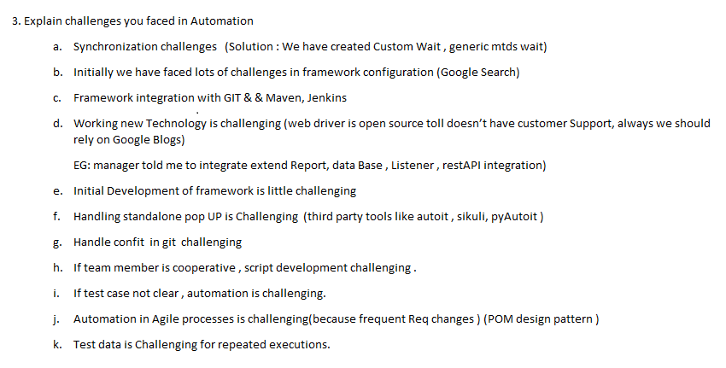

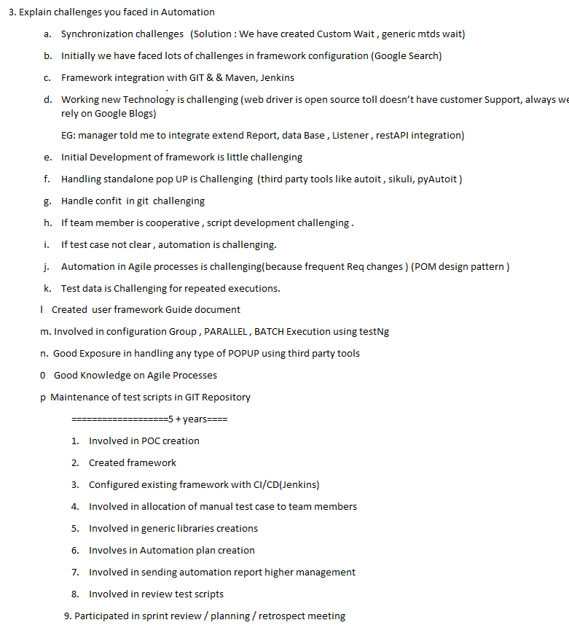

========================================================

1. Explain few complicated scenarios which you automated in your previous Project & explain the Challenged
2. Explain one critical bug which you got via automation
3. What is daily Activity

When Ever I reach Office to Check Email

Email => WRT 🡺 Review

Email => WRT 🡺 test Script Allocation

Email => WRT 🡺 Meeting

Email => WRT 🡺 JIRA (retest the defect)

Email=> WRT 🡺 JENKINS 🡺 verify the report

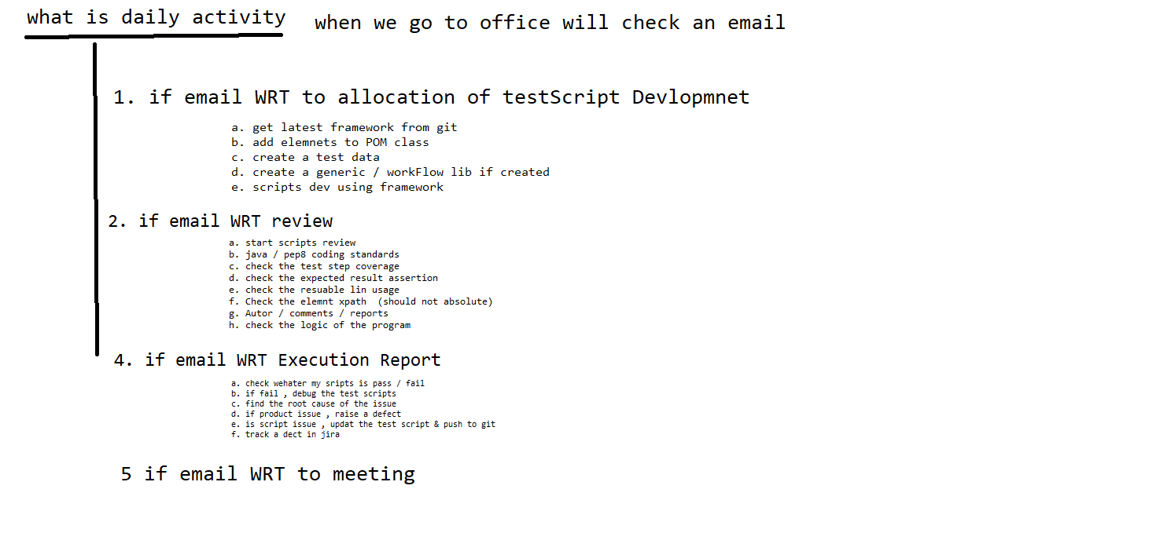

What is duration of the Project?

What is sprint duration in your previous project

**How many build you get in one sprint?**

How many test case you had in your previous project?

Which processes you followed

How many test case used to get for automation in every sprint / release?

How many test case you automated /day/month/year/ in entire project?

What is your team size

I will give 100 test case , what is your estimation ?

How long automation batch execution take place ?

How may defect you found via automation in your previous project ?

Percentage of manual & automation in your previous project ?

How may smoke test u had in your previous Project

120 test case / 3000

**400 /year**

**4 year**

**1 year**

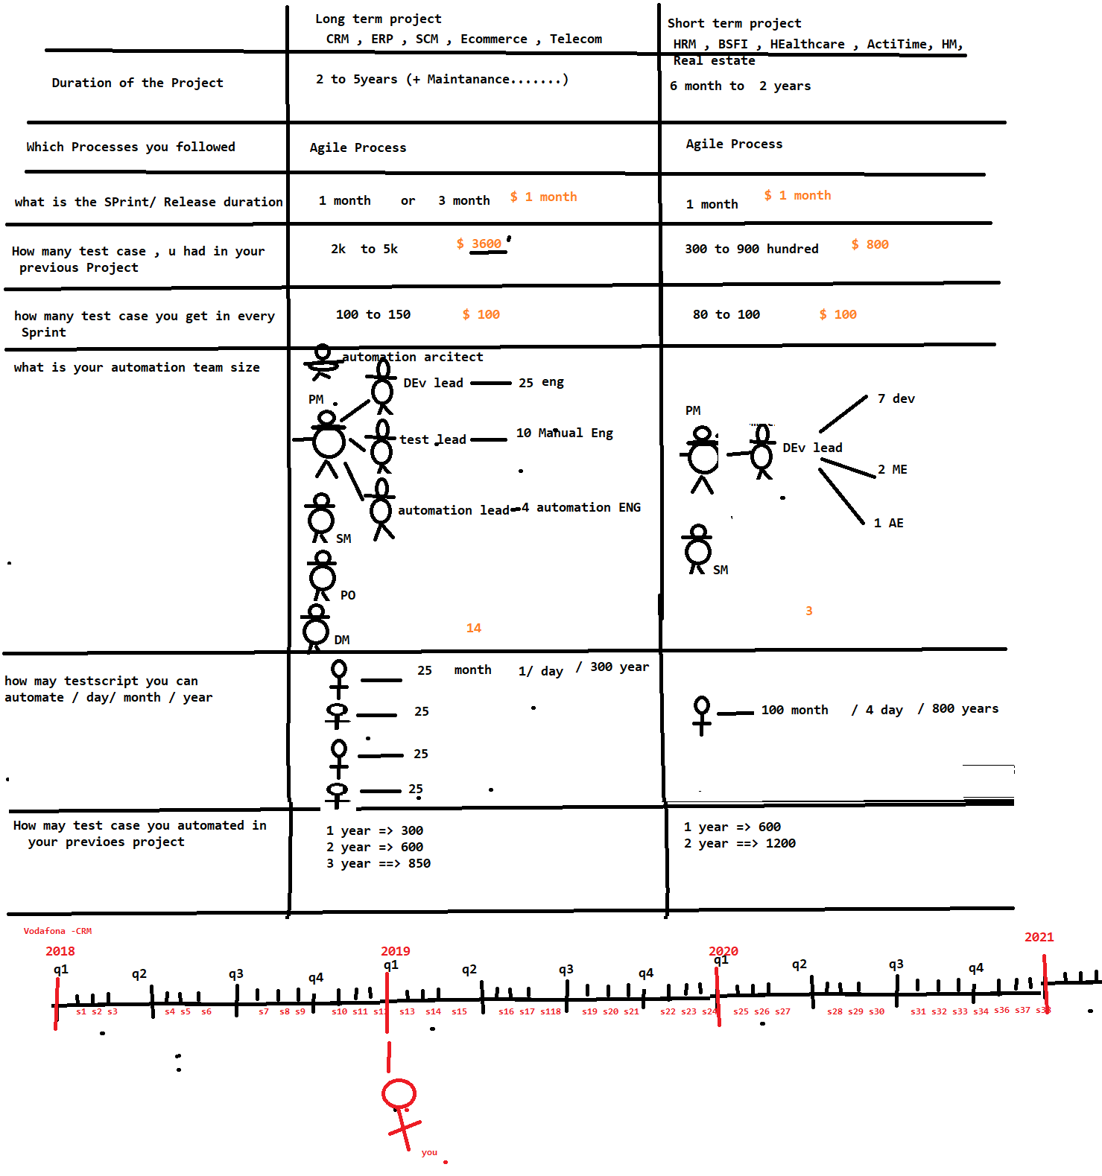

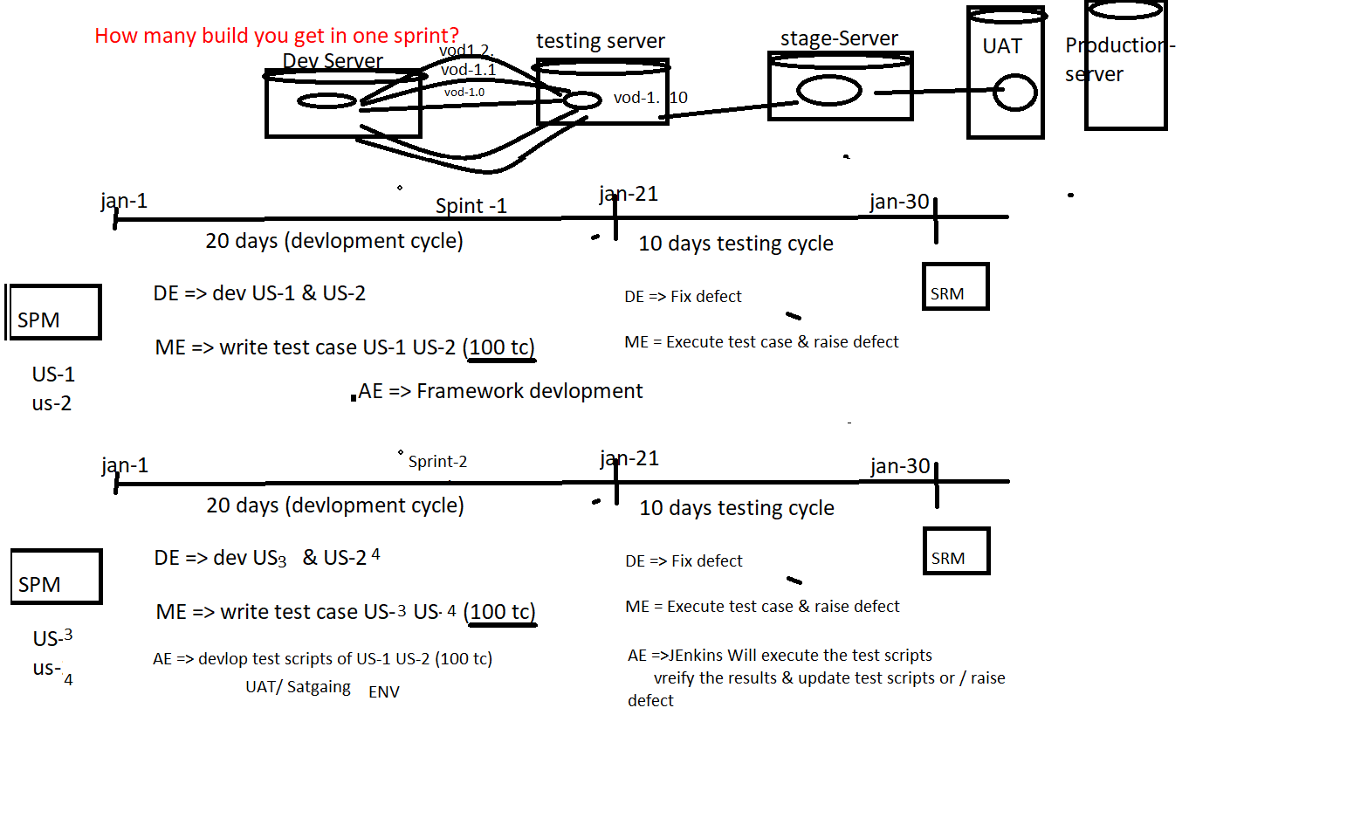

Feb-21

Feb-1

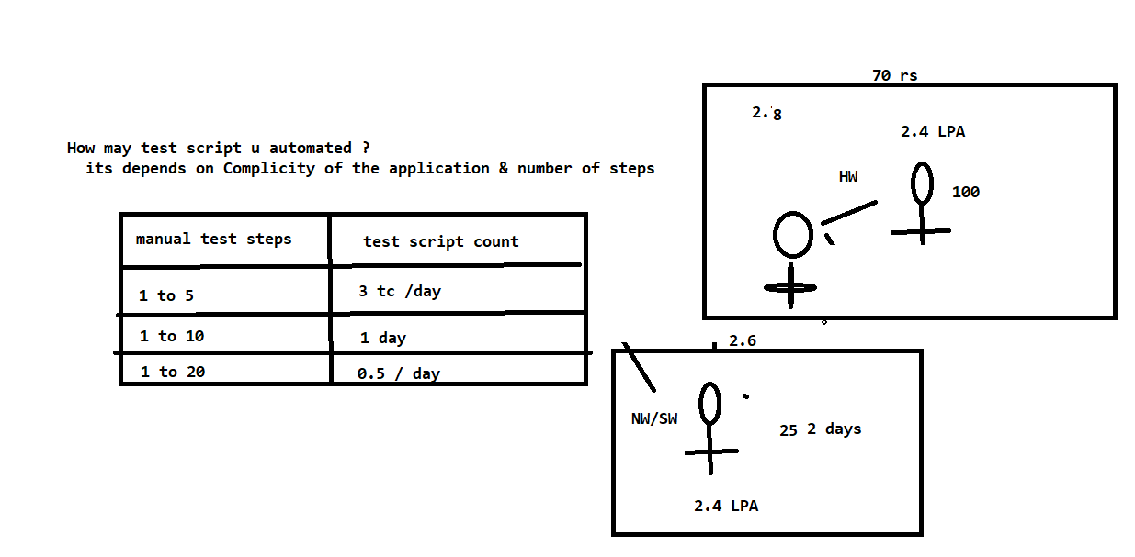

What is your automation Estimation for 100 manual test case ?

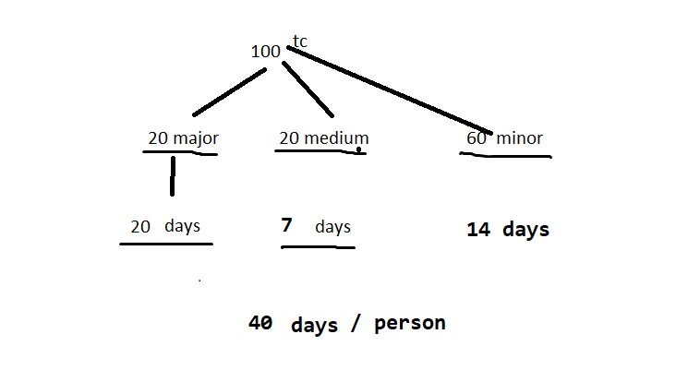

How long automation batch execution take place ?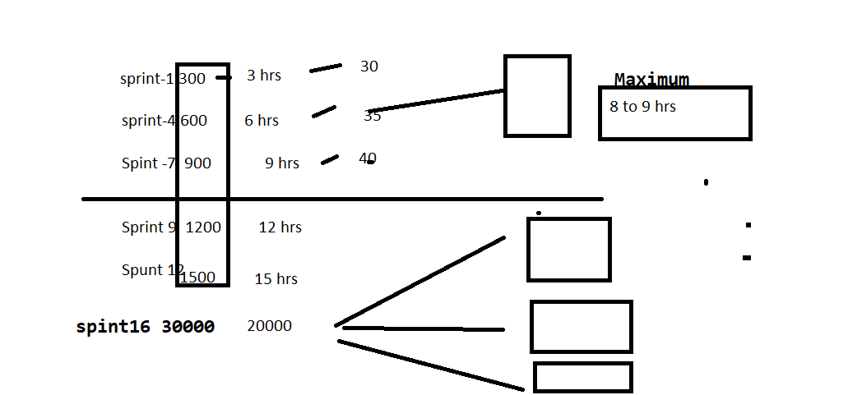

How may defect you found via automation in your previous project ?

