**Manufacturing Data Platform**

**The functionality of a web portal and manufacturing data platform, including its components, processes, and integration details. The platform is designed for managing and visualizing manufacturing data using Power Apps, Power Automate, Azure Blob Storage, and SharePoint.**

**1. Web Portal and Manufacturing Data Platform**

**1.1. Purpose**

**The web portal and manufacturing data platform is a comprehensive application used for managing and visualizing manufacturing data. It provides content management capabilities and integrates with various data sources to facilitate decision-making and performance tracking.**

**1.2. Key Components**

* **Content Management: Manages and organizes data in various formats.**
* **Data Formats: Utilizes Pipe-Separated Values (PSV) for data handling.**
* **KPI Integration: Works with Key Performance Indicators (KPIs) to evaluate factory performance.**

**2. Data Structure and Management**

**2.1. Factory and Line Data**

* **Factory Codes and Lines: The platform supports multiple factories categorized by region, each with its own factory code and production lines.**
* **Data Selection: Users can select factories and lines via a Power Apps interface.**

**2.2. Data Management Tabs**

* **Data Management: Handles data entry and updates.**
* **Data Visualization: Provides links to existing Power BI dashboards for visualization purposes.**

**3. Data Files and Storage**

**3.1. File Types**

* **Reference Data: Comprises four PSV files:**
  + **Changeover Data**
  + **TOC Data**
  + **Equipment Data**
  + **Items Data**
* **Actual Data: Consists of three PSV files:**
  + **Production Calendar**
  + **Loss Categories**
  + **Deviation Log**

**3.2. Azure Blob Storage**

* **Storage Account: Utilizes Azure Blob Storage for storing PSV files.**
* **Containers: Two main containers for storing PSV files:**
  + **Reference Data Container**
  + **Manual Entry (Actual Data) Container**
* **Folder Creation: Automatically creates folders for new factories and saves data in PSV format.**

**4. User Interface and Interaction**

**4.1. Landing Page**

* **Header Component: Standard header with navigation options.**
* **Tabs:**
  + **Data Management: For managing data entries and updates.**
  + **Data Visualization: For accessing Power BI dashboards.**

**4.2. Data Selection and Entry**

* **Site Selection Screen: Allows users to select factories and production lines.**
* **Dropdowns: Sequential dropdowns for selecting factory codes and lines.**
* **Form Functionality: Includes options for creating, editing, and deleting records.**

**5. Functionalities and Features**

**5.1. Data Entry Forms**

* **Reference Data Forms: Separate forms for different PSV files with varying column requirements.**
* **Validation: Ensures mandatory fields are filled and performs necessary validations.**

**5.2. Deviation Log**

* **Deviation Log Details: Captures deviation information using sequential dropdowns and saves in the backend.**

**5.3. Power Automate and Azure Functions**

* **Data Processing: Uses Power Automate and Azure Functions to handle PSV file updates and storage.**
* **Azure Functions: Generates PSV files from SharePoint data using CSV helpers.**

**6. Integration and Updates**

**6.1. SharePoint Integration**

* **Data Storage: Data is initially stored in SharePoint lists and then transferred to PSV files.**
* **URL Mapping: Provides SharePoint URLs for factories without actual data.**

**6.2. Handling New Entries**

* **Factory Data: Automatically creates new folders and PSV files for new factory entries.**
* **Manual Data Entry: Users can add or edit data through the application, which is then reflected in the PSV files.**

**7. Limitations and Considerations**

**7.1. Data Restrictions**

* **PSV File Types: Specific PSV files are used for reference and actual data, with no hard restrictions on the number of entries.**
* **Current Week Limitation: Displays current week items only in some views.**

**7.2. Data Validation**

* **Mandatory Fields: Ensures all required fields are completed before data is saved.**
* **Editable Grids: Allows users to update data in grids with mandatory fields.**

**Manufacturing Data Platform**

**Manufacturing Data Platform (MDP)**

The MDP is designed to manage and visualize manufacturing data. It comprises a web portal, data management functionalities, and integration with external tools and storage solutions.

**Key Components**

* **Web Portal**: Interface for user interaction with the MDP.
* **Data Management**: Handling and updating of reference and actual data.

**Data Visualization**: Integration with Power BI dashboards.

**. Technologies Used**

* **Azure Blob Storage**: For data storage.
* **Power Apps**: For user interaction.
* **Power Automate**: For automation of data flows.

**Azure Functions**: For processing and generating PSV files.

**Data Management Features**

**Site Selection**

* Factories and production lines are sourced from SharePoint lists and presented in dropdown menus.

**Reference Data**

* **Types of PSV Files**: Changeover, Equipment, Items, TOC.

**Actual Data**

**Types of PSV Files**: Production Calendar, Loss Categories, Deviation Log.

**Screens Overview:**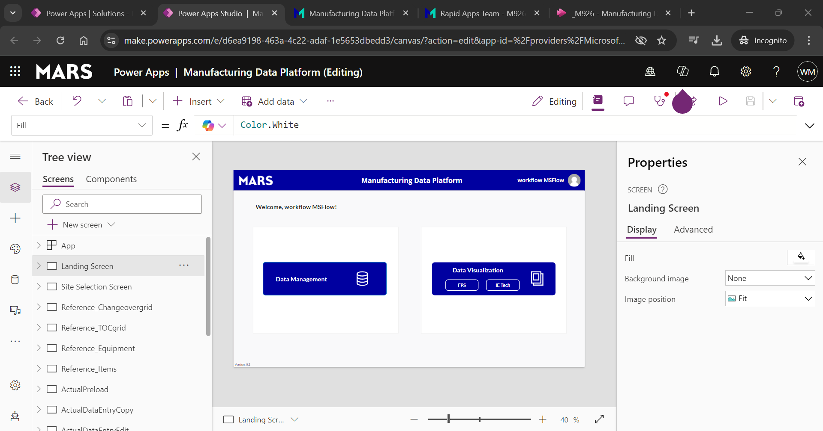

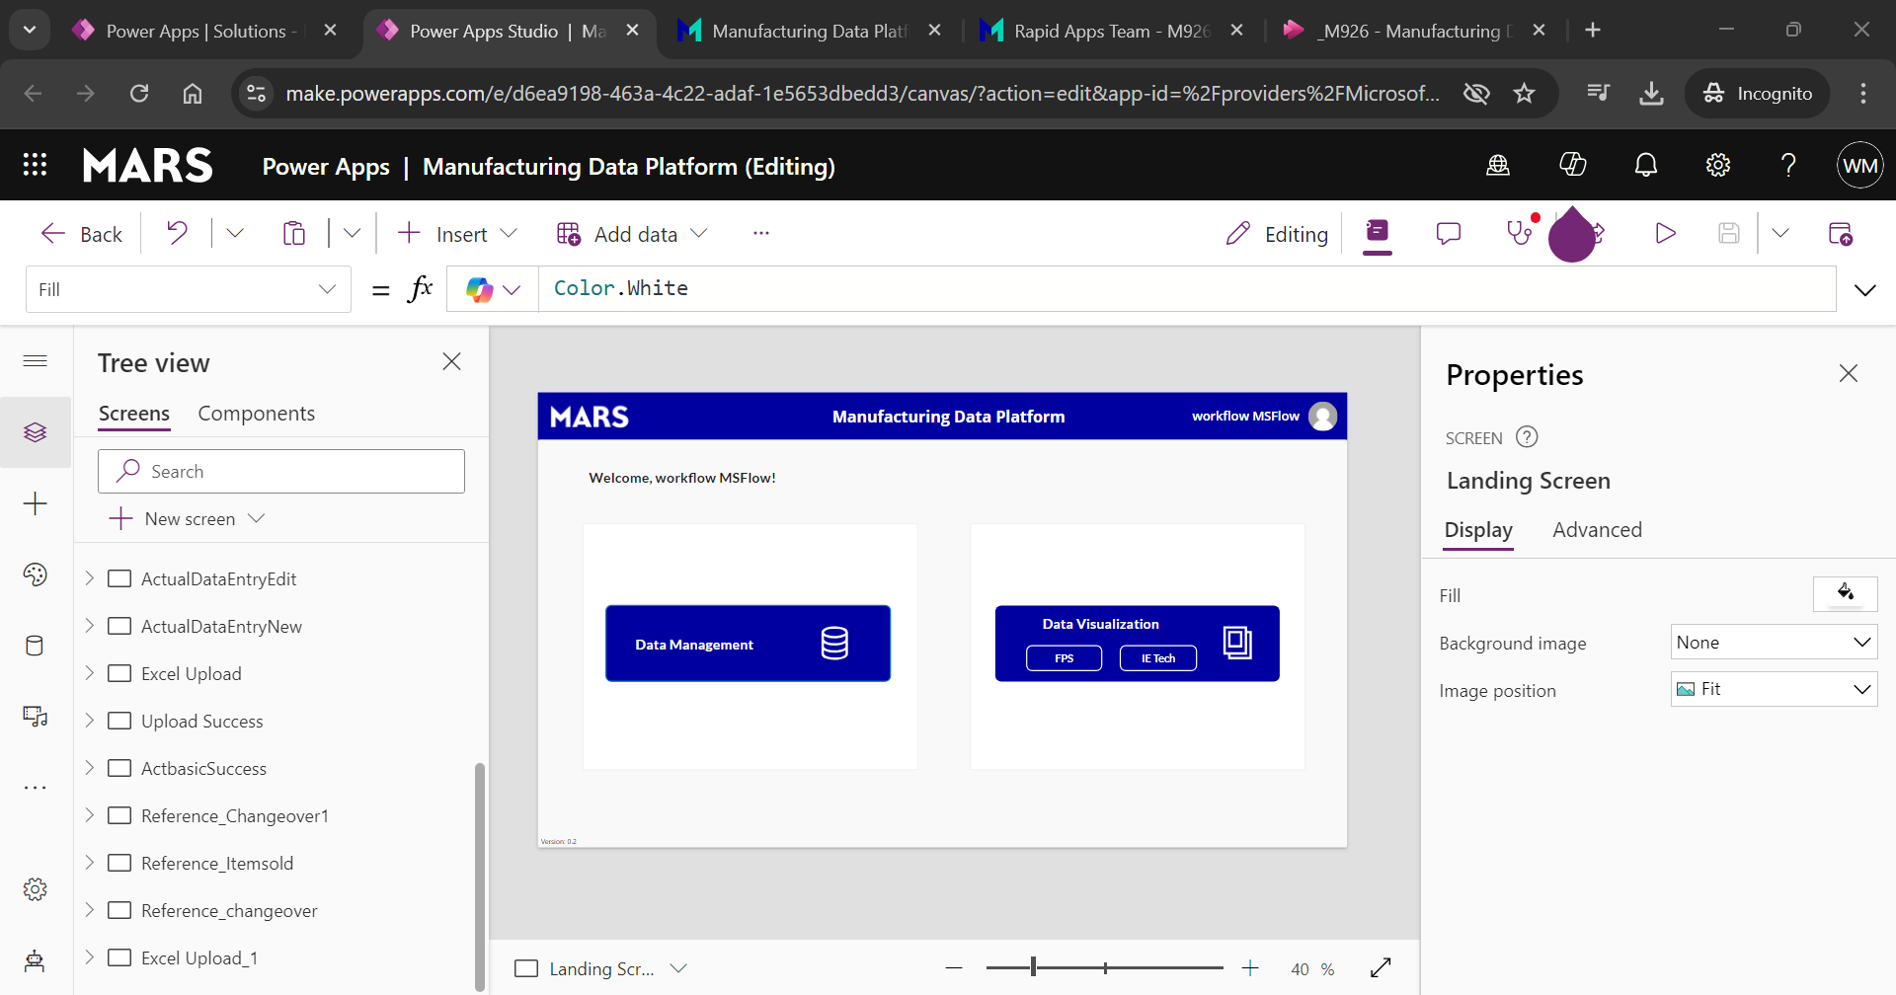

**Landing screen is default screen: (pls refer MDP pdf doc for reference)**

* 1. **Landing screen**
  2. **Site selection screen or Line & Data Operation Selection Screen.**
  3. **Reference Data Screen.**
  4. **Actual Data with Bulk Upload Screen or Excel upload.**
  5. **Actual data screen**
  6. **Deviation Log Popup Screen**

**MDP: We will be having a content management, and they are using the data in PSV (Pipe separated value) format.** Mostly so there's Supply KPI team will have the factories.

**There are different regions,** they will be having the different factories which will be having the factory codes as you see in this list.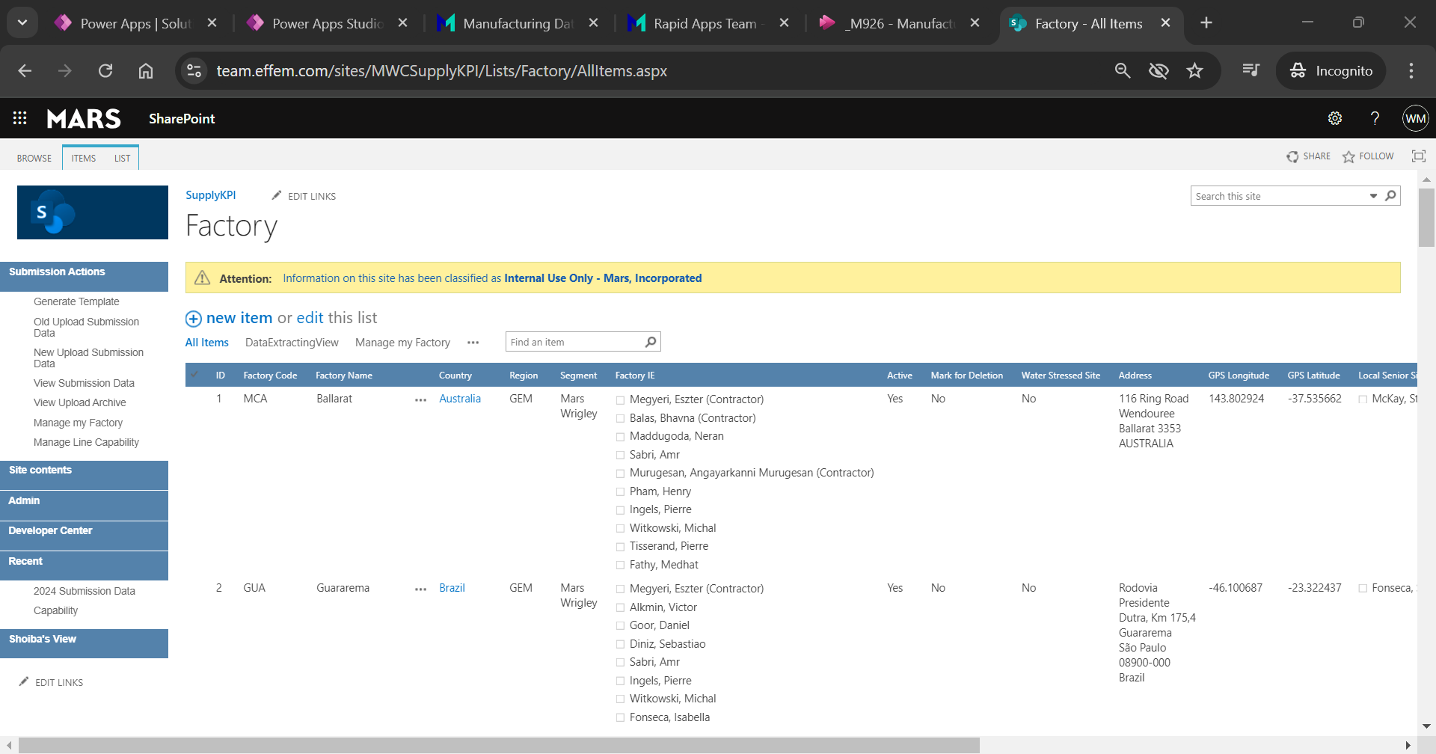

we'll be basically selecting them over in the power up for the content management.

**Landing page**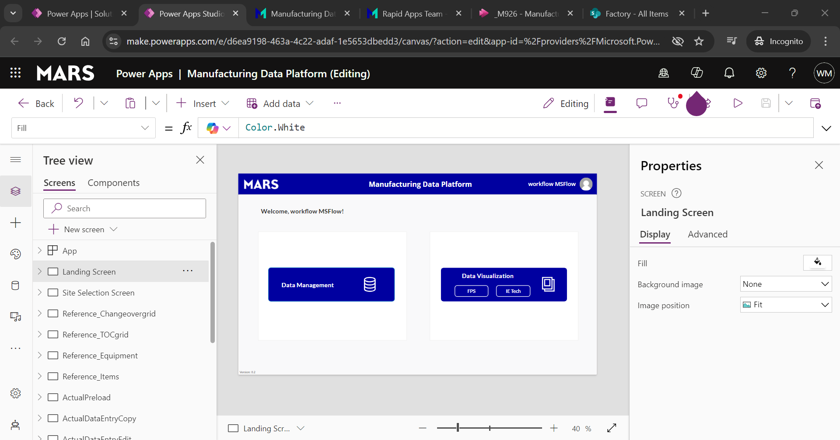

**Data validation for data management -> On click site selection screen below ( check below pic)**

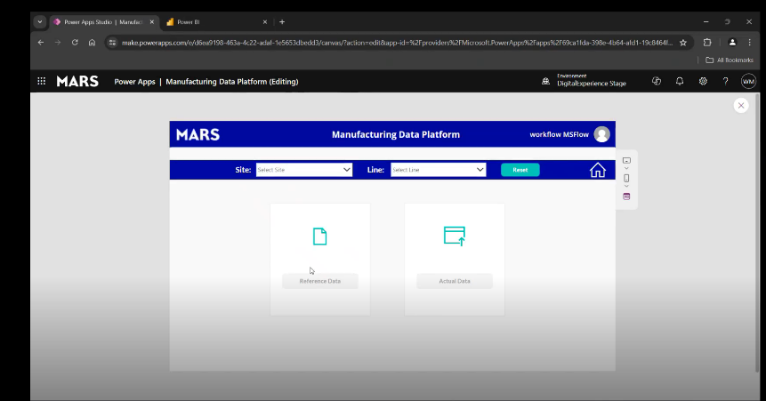

**Here, list of site details coming from factory list and Lines list coming from Production list of SharePoint site.**

There will be two sub selections and miss reference data and actual data. So basically, in this in this manufacturing data platform, there will be the seven PSP files.

4 will be from the reference data and three will be from the actual data. So, the total count will be the seven files.

To check these two sections dealing with Azure blob storage. ( see below image for reference)

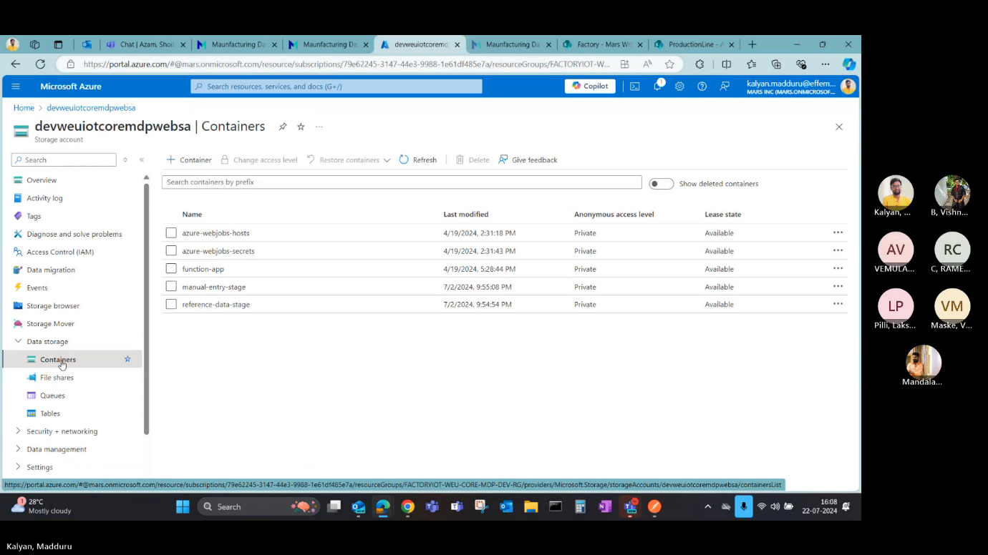

**Here, Reference data storage is related to reference section and manual entry stage is nothing but actual data in power apps.**

**On click reference data->**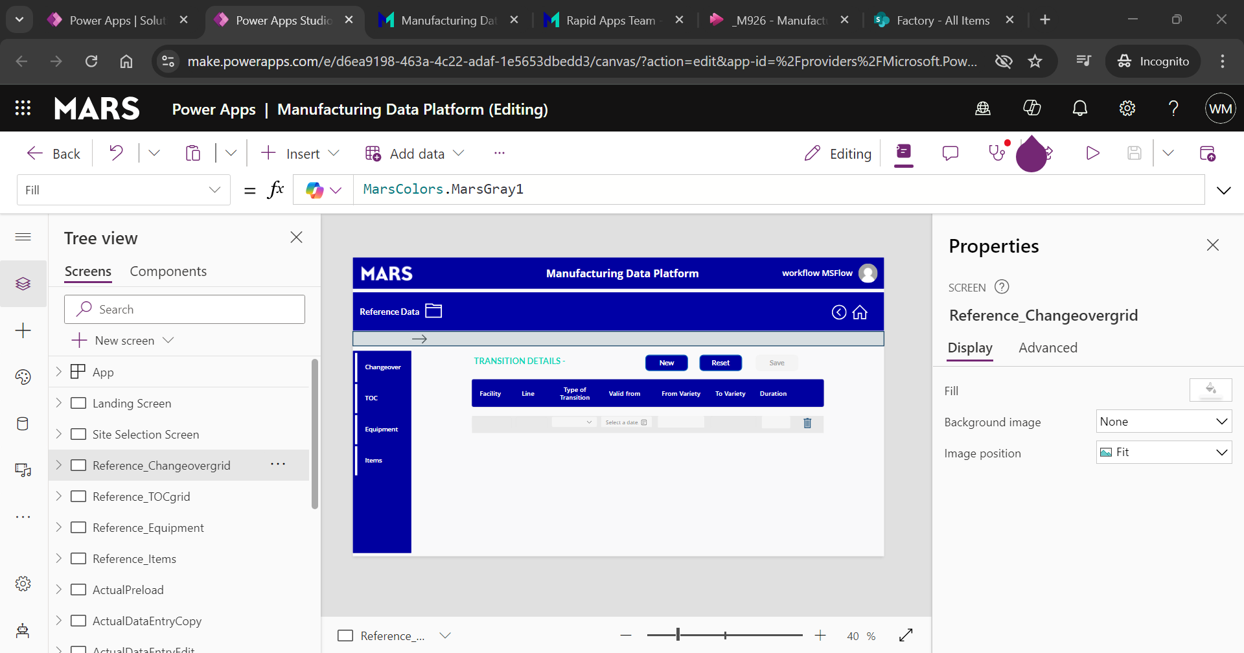

**There will be four PSV files on backend ->changeover, TOC, Equipment and Items.**

**So,every screen like Equipment, TOC, Changeover has mandatory fields edit and save creating new records.**

**Creating new records for reference data -> Items -> below image**

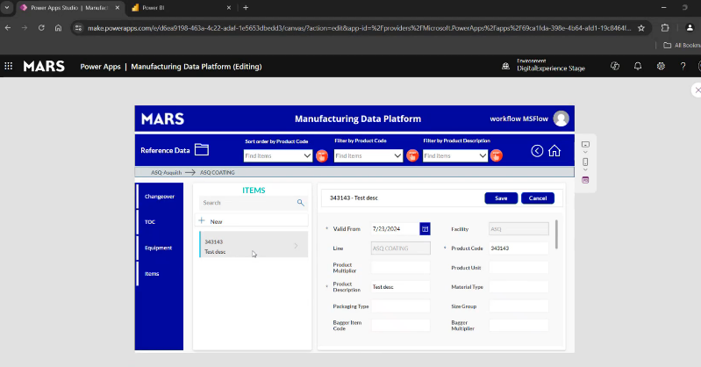

**Then it will be saved to below ASQ Azure PSV.**

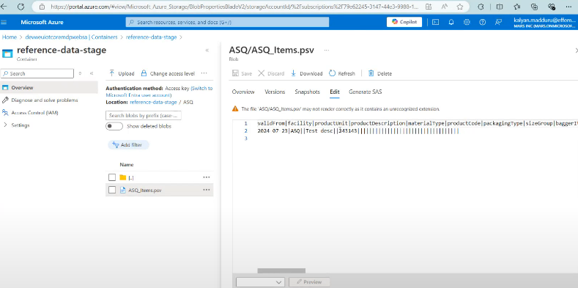

**Coming to the Actual data -> Other three PSV files are capturing from here.**

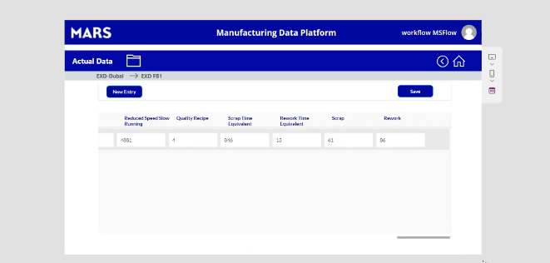

This this gallery is basically filtered to have shown the current week items only.

**From here, we can create and edit a record.**

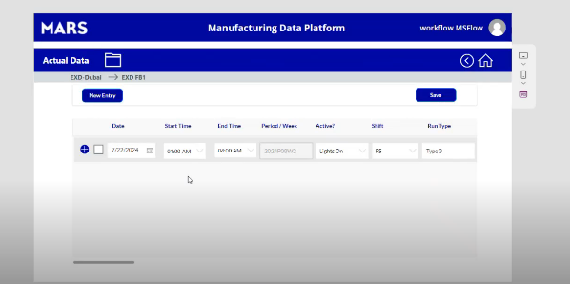

we'll be having some few operations based on this column whether it is lights on or lights off.

If it is lights off, then no other details are necessary, all the other details.

So we'll be just giving the values in the drop down for that particular lights of vorticities are causing that lights of operation.

For example, if we select and if we save and close, so that particular item will be modified like this OK And all other values which are being captured are are deleted and it will be disabled for entry in the gallery.

Also all the other values after runtime but if it is lights on then all the other values will also be populated here.

that is the basic difference between the slides on and lights off and this.

From the above image-> if you select check particular item -> can edit the record.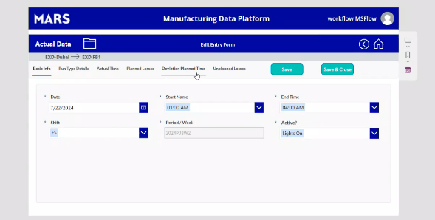

**WE have a one more functionality here,** If you can see there is an add icon here plus icon.  
So which will be basically capturing the deviation log details.

**Check below for reference**

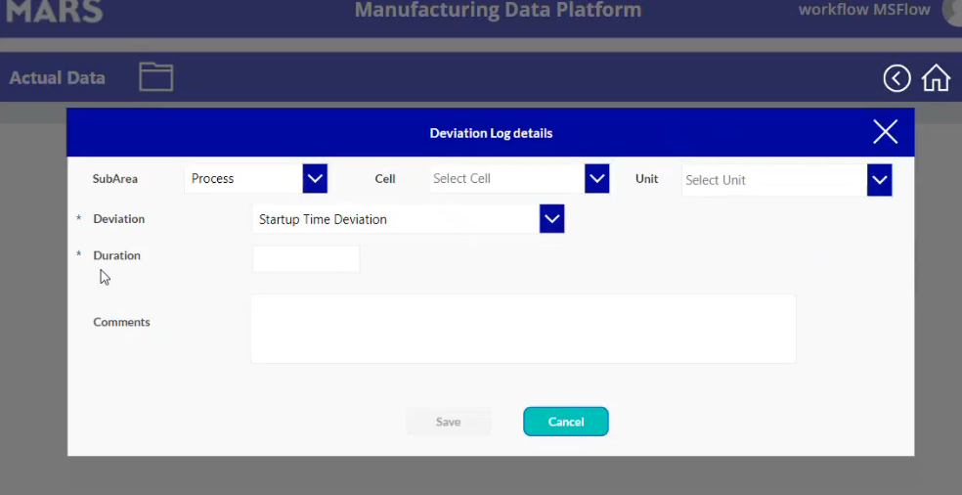

So for example, manual entry, which is nothing but actual data.

So we'll be having three PSPS here, which is basically the production calendar, if you can see so from the list of all these values.

So from the list of all these values, so we had taken only some 7 to 8 values from here and we had segregated that into the production calendar, date, start time and time facility line.

These are all the mandatory columns which will be there in every every PSV.

Other than that it will be having only the five or six columns in production calendar.

And similarly, this loss categories is the biggest PSV where almost all the details are being captured.  
So it will be having all the details operated, the pipes for each and every value and the other PSVS deviation log where we had entered the details.

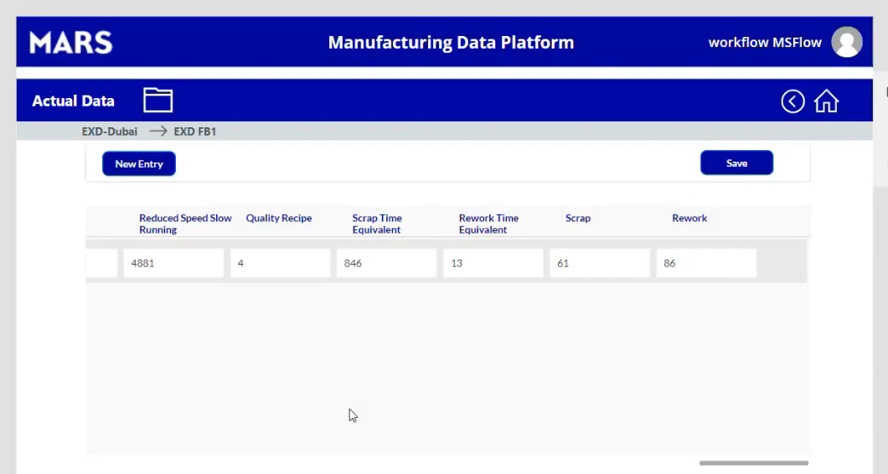

Above data will be saved to backend sp list -> that list spilt into three psv like prod cal, dev log, loss categ.

And also, we have one more functionality like for example in the factory list, if you can see in the factory list, basically we'll be having a column called Excel upload column.

for example, we have only two values for this which will be having the SharePoint link to it like SharePoint site URL for this particular set of factories when we select using that site selection screen.

which is the viewer for example, if we select the actual data, so it should not navigate to our actual data view which we had seen.

So it should basically it doesn't have any actual data to be basically show to end users.

So that's why they'll be having the SharePoint links.

So, by clicking on that.

So, we have to basically redirect that SharePoint link here for these two for whatever the in the in the future also if any of the particular factory if they had enabled Excel.

So, we should map those two with these respect to SP URLs that they are going to provide.

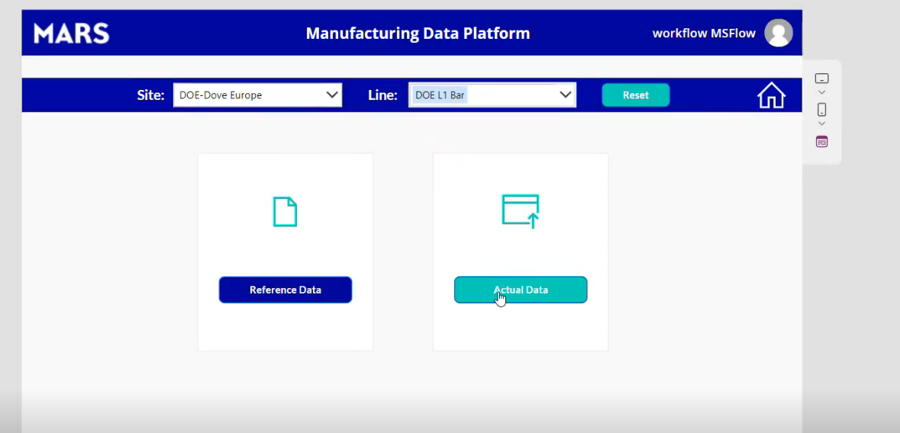

If u select site and line -> click on actual data ->Excel upload screen



