DAY1 – GIT INTRO n HOW TO TRACK & COMMIT THE FILES
->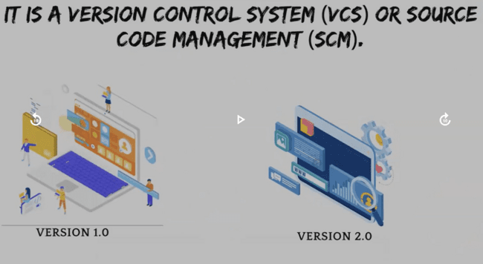
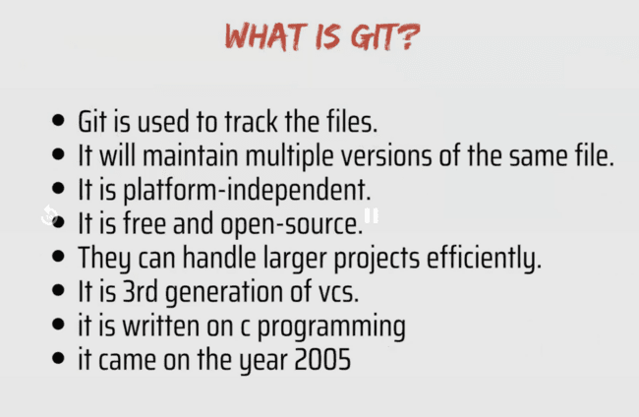
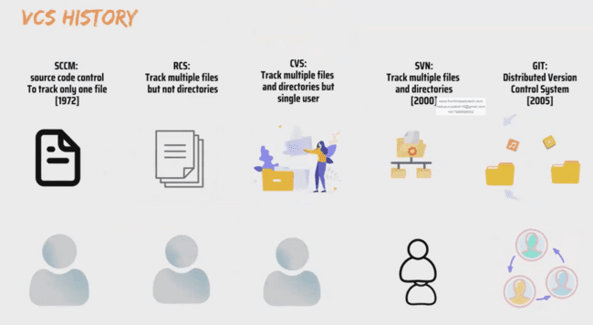
Rcs- revision control sys
Cvs – concurrent version system
Svn-sub version
Git – global information tracker
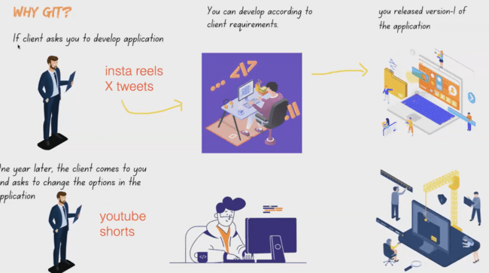
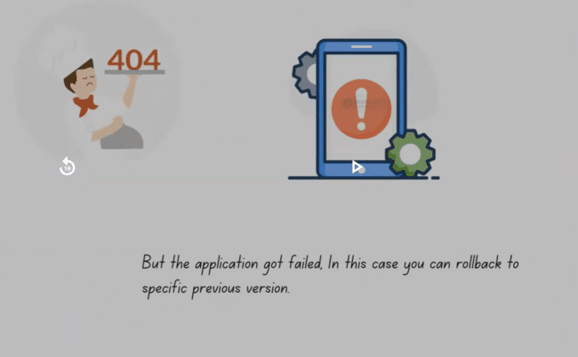
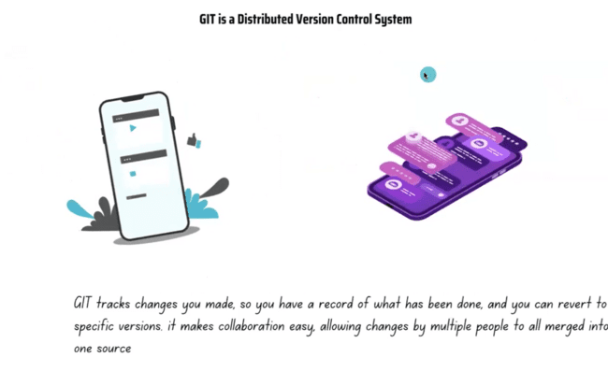
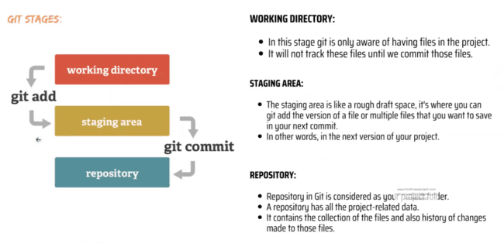
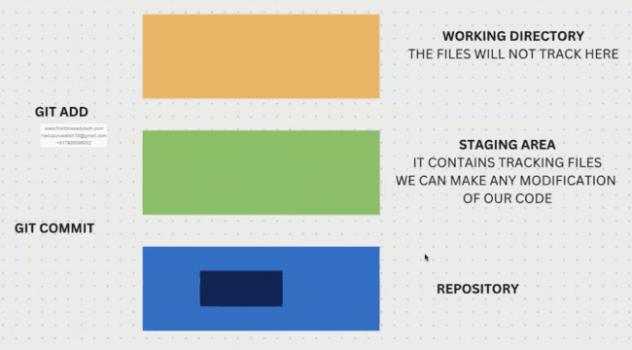
->to install any package
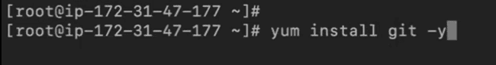
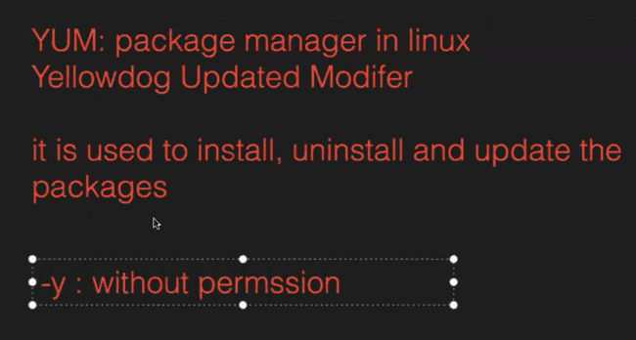
NOTE – to clear screen use ctrl+l
->to chk git installed or not
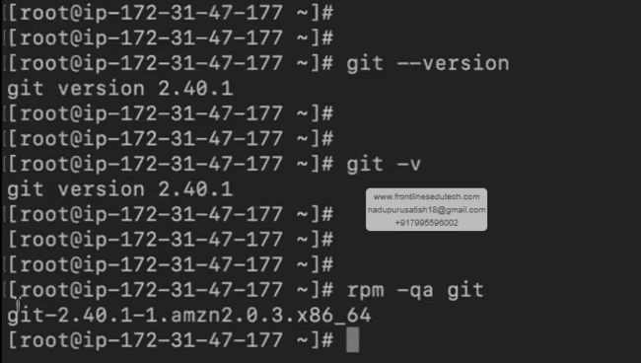
->creating a folder(it’s a mandatory)
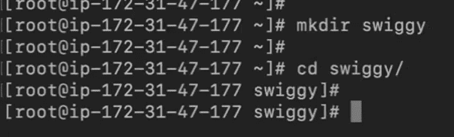
->after creating folder we need to initialize git here
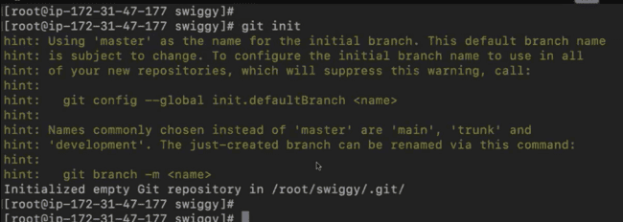
->after initializing we can chk whether it is initialized or not
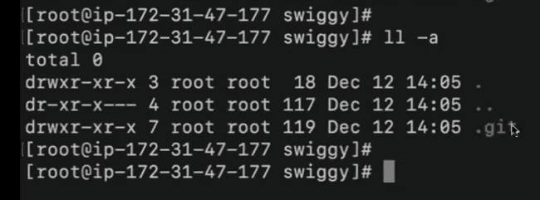
NOTE – why we initializing the git in a folder bcz to track the files only in that particular folder. Mana sys lo chala folders untai like movies,albums,personal data,project..etc manaki only project related files access chesukuntey chalu.

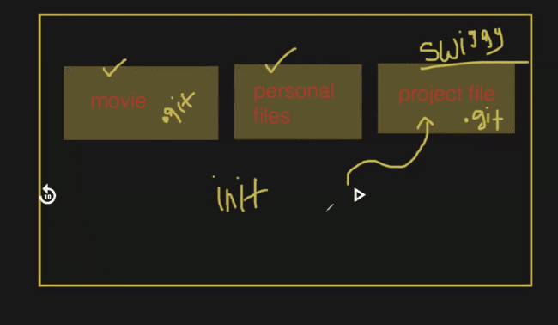
->konni files create chesamu, avi working directory lo untai(manaki ela telustundi avi working directory lo unnai ani- using git status cmd).
With git status cmd we see the untracking files
->to track the files, we use git add cmd
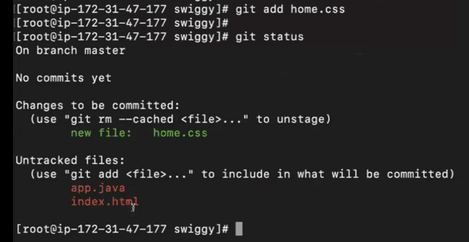
To check the tracking/un-tracking files use git status cmd
->a home.css file lo konta code rasamu(since we are nt developers, jst added some text)
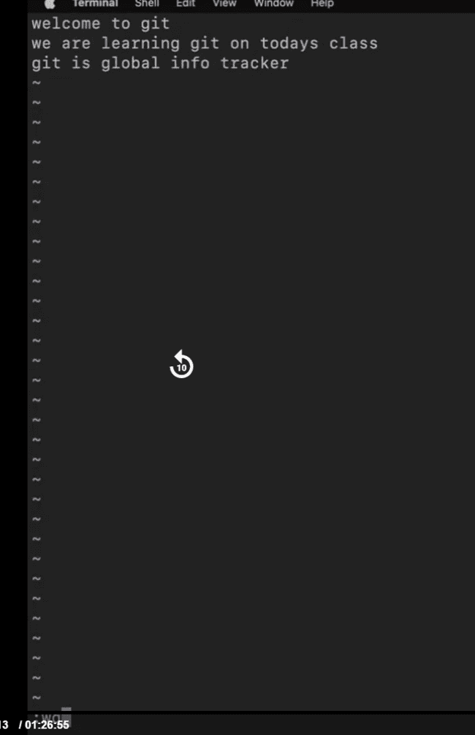
->now chk the status of a file
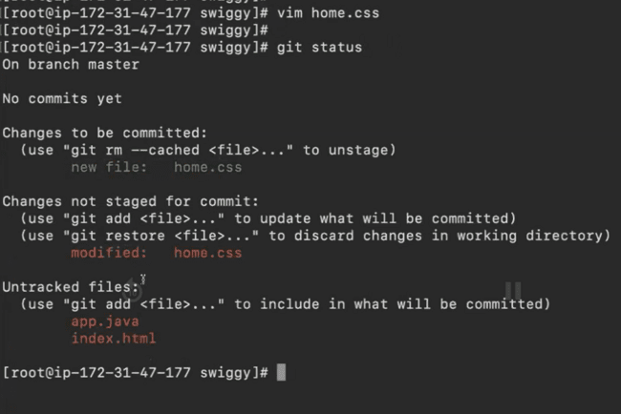
NOTE- when u modify a tracking file, we must commit. When we commit we can see the history( when,who,what)
->to commit
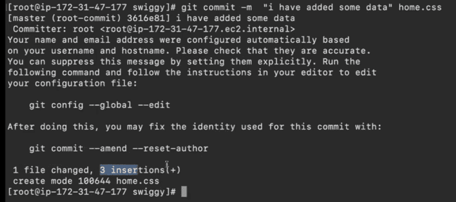
->to check the history, use git log(that id is imp)
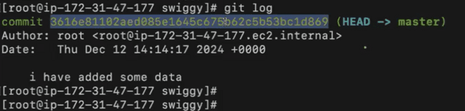
->to see wht they modified, use git show vth id
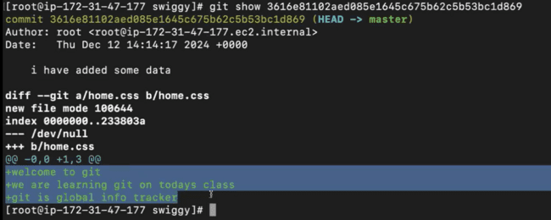
->to commit all files(which r in staging area) at a time
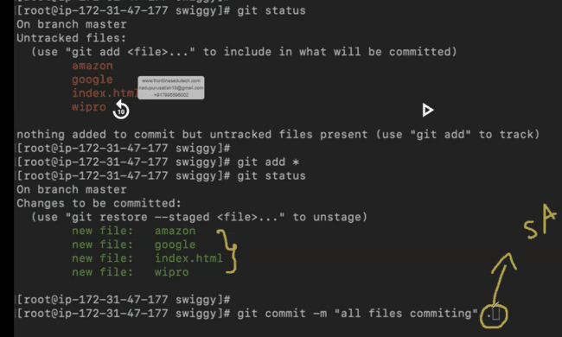
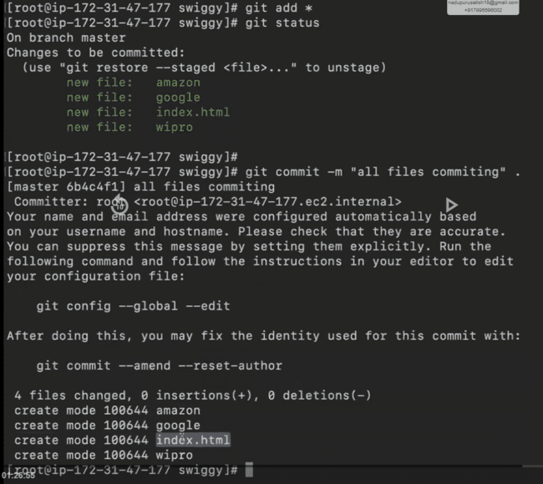
->to chk whether files commited or not
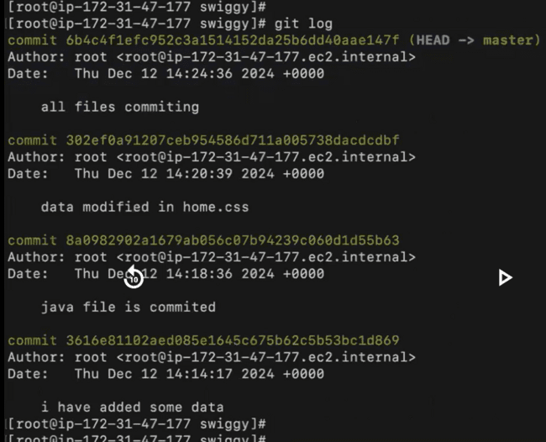
->to add user n email, chudamu user add ayyada ani(root ey kanipistadi bcz a commits anni mundu vi)
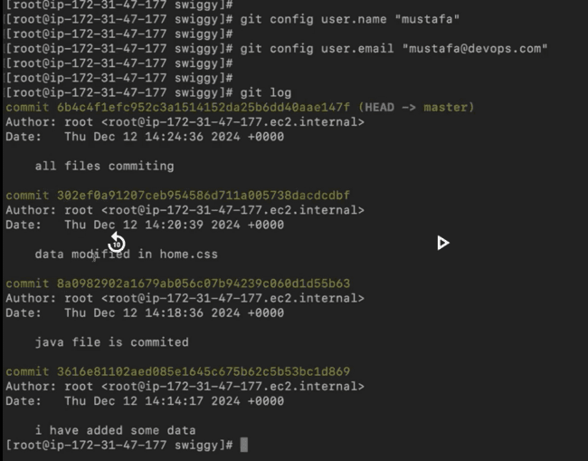
->index.html file lo modify chesi, commit chesanu
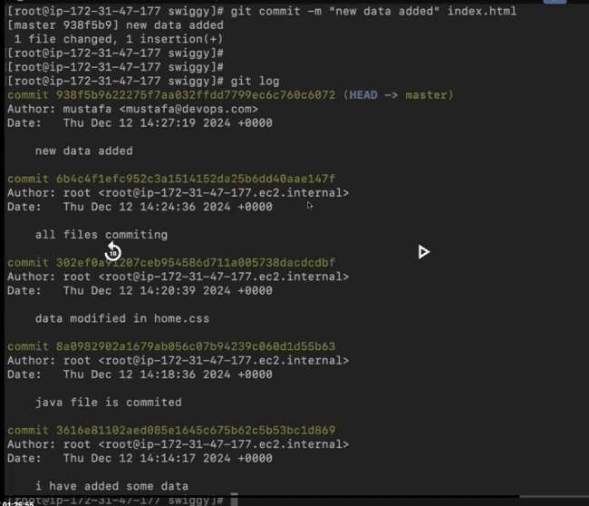
Ippudu user kanipistadi
->commits ekkuva untey screen back ki ravali antey q ivvandi
NOTE – suppose we have folders within a parent folders, we shd initiate only in parent that is enough(no need of initiating in child folders)

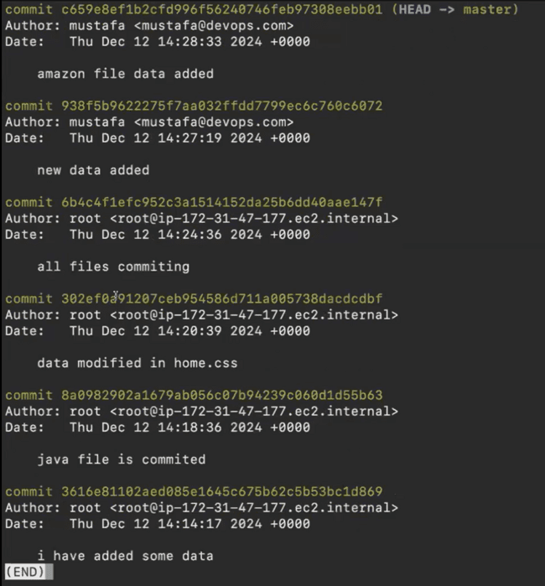
Q/A
1 staging lo unna tracking files ni untrack cheyyacha
2 oka person modify chesaru but commit cheyyaledu, manam valla login chesi commit cheyyachu
3 repository lodi mana local sys lo store avutadi,once build n unit testing chesaka, danni github lo store chestaru(github data cloud lo store avutadi)
4
DAY2 – GIT CONFIG, RESET, AMEND, CHERRY-PICK, REFLOG
->to untrack the tracking file
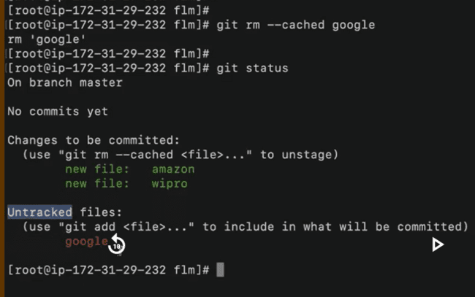
->if we use git log, we’ll get all the committed files. But wanna see last committed 2 files use git log -n 2
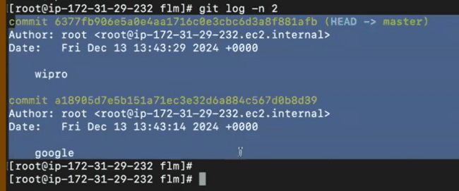
->I want only commit-id n commit msg
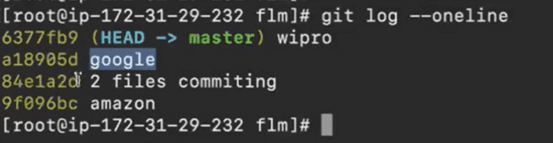
->if want full commit-id
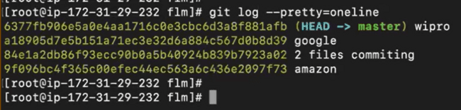
->oka 50 files lo 48 track cheyyali n 2 untrack cheyali use gitignore
1 oka vim .gitignore lo a particular file ni pettali
2 pettaka git status cmd tho chusthey a file hide avutadi
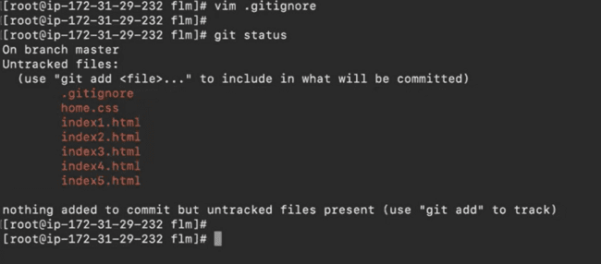
3 ippudu git add * ivvandi, anni track avutai but a particular file matram undadhu
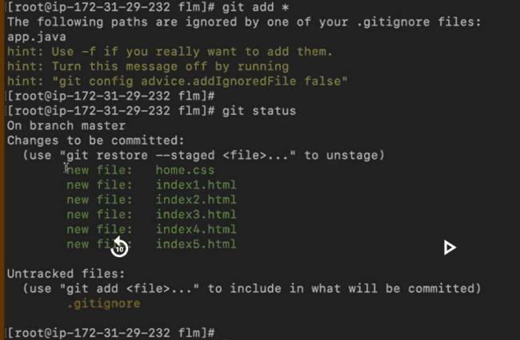
4 a file ni track cheyyali antey a vim .ignoregit open chesi, a particular file del chesthey saripotadi, malli manam track chesukovachu
5 manam kavali antey track chesukovachu
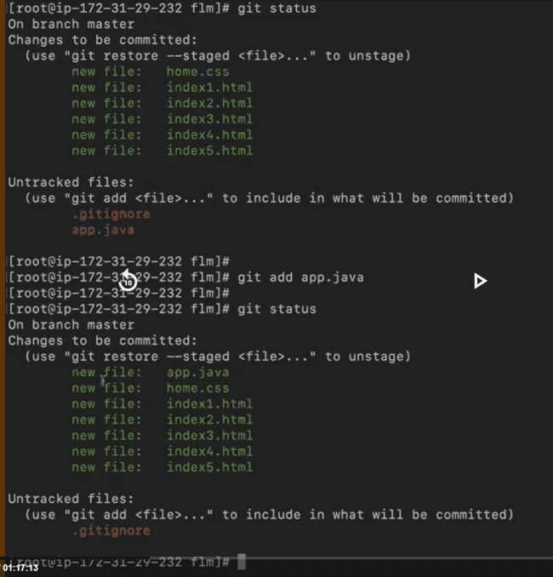
GIT RESET COMMAND
->realtime lo oka developer oka 500lines of code rasadu, a file ni commit chesadu,chesaka err’s unnai ani telisindhi. So malli modifications chesadu, commit chesadu……ila continue – WHICH IS NOT A BEST PRACTICE
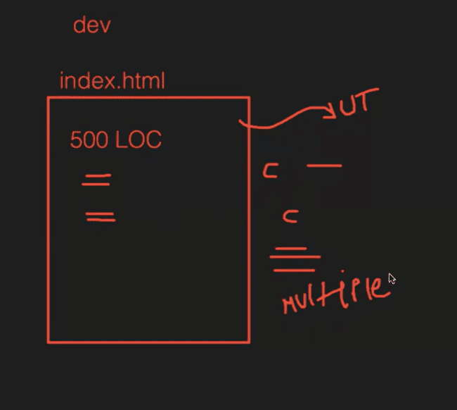
->idi best practice kadu kabatti,a commit ni del chesi, ekkada aithey err undho adi modify chesi commit chestanu- so no of commits dec avutai
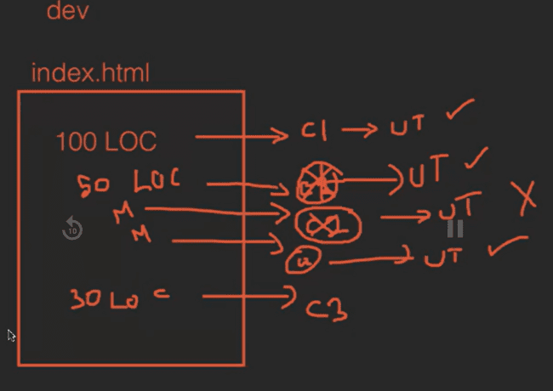
->here I committed 2times
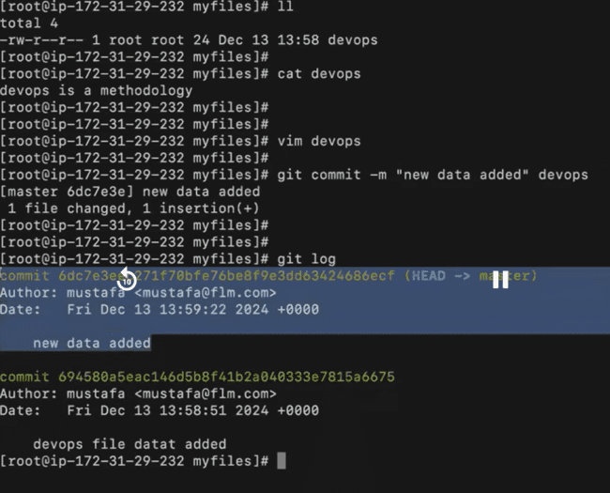
->if we del commit, it’ll del only that commit not changes
->if we want to del commit+changes, need to do both
->del the 1st latest commit(~no – no represents latest how many commits need to del)
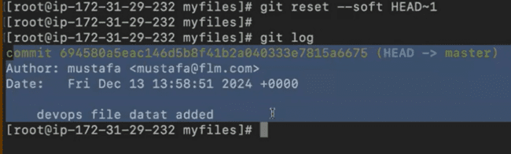
->I came to know that it has some err’s, so need to modify n then commit
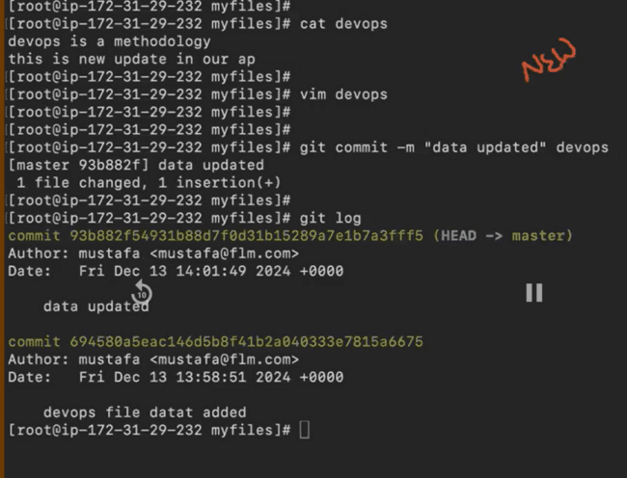
->to del the commit+data
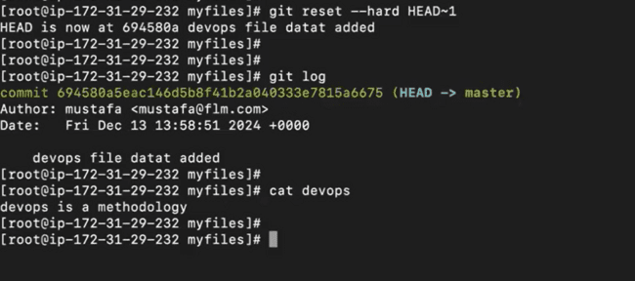
NOTE – 1. If suppose our file has less errs prefer to del commit
2. if suppose our file has many errs prefer to del commit+data
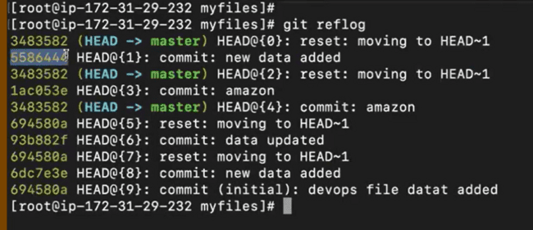
When we want to get back the commit, we need to remember the id or data wht we added(it comes from experience)
-> to get the deleted commit, use git cherry-pick commit_id
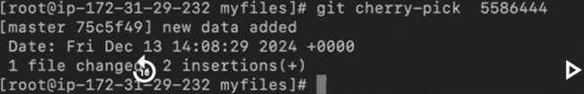
->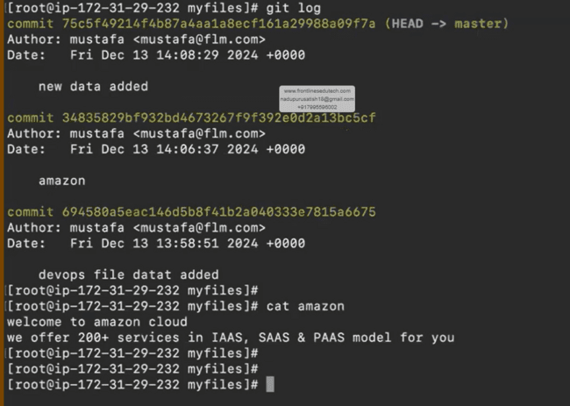

NOTE- can we del all the commits?
No(it’s nt possible vth git reset but del all commits vth someother cmd)
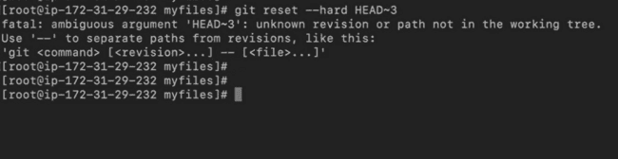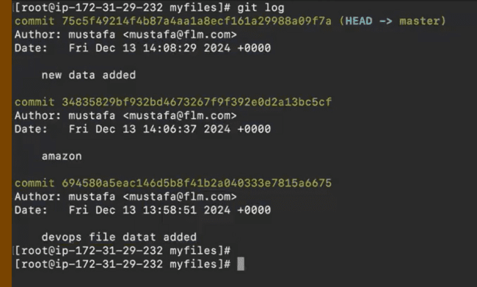
Since we have total of 3
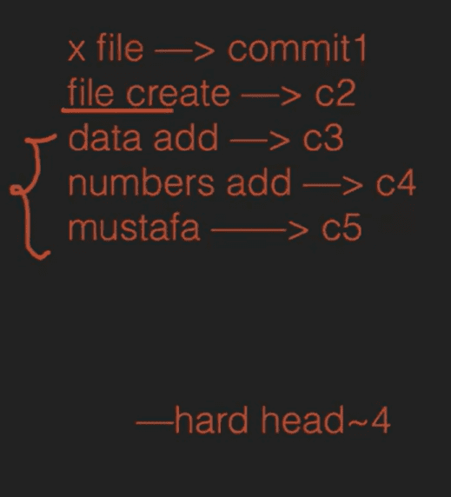
->can we del the in between commits
No
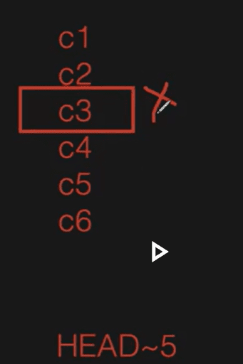
->if we want to modify the commit msg, only we can modify the latest one only
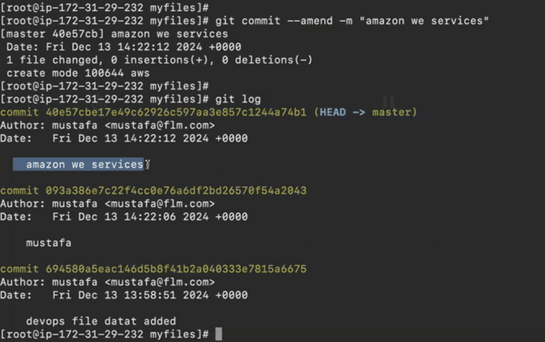
NOTE – when we modify the commit msg then commit id also gets modified(nothing but commit overwrite avutundi)
->if we want to modify the author
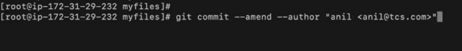
Enter ichaka oka file open avutundi,jst shift+column+wq
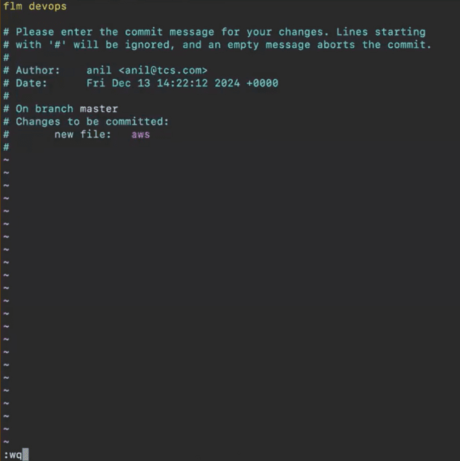
Give git log to chk author got changed or not
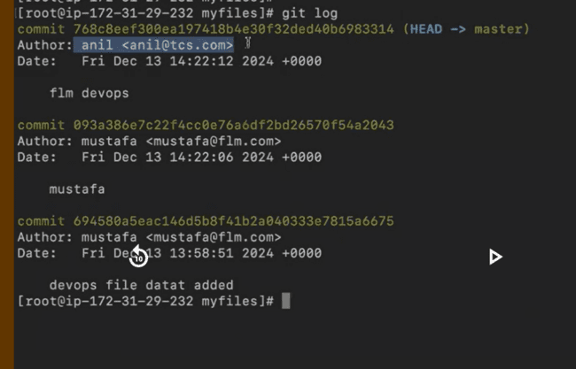
NOTE – if we change the author name, then commit id also changes
->manager oka 5 files ichi vatini commit chesi dani commit id share cheyyamanaru but nen oka 4 files commit chesanu marchipoyye and later 5th file commit chesanu. So that 2 commit id’s vachai- manager arustaru ala 2 id’s send chesthey
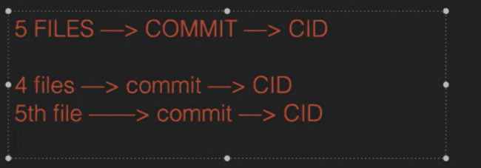
Soft cmd tho commit id del chesi, 5files commit chesaka vachina id share chestanu. But as a experience ala cheyyakunda oka cmd use cheyyachu

->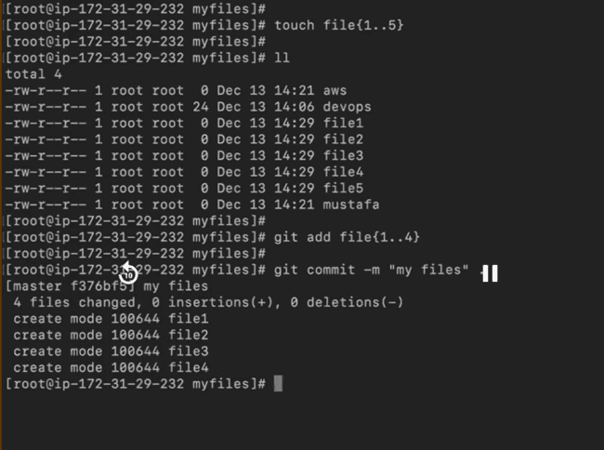
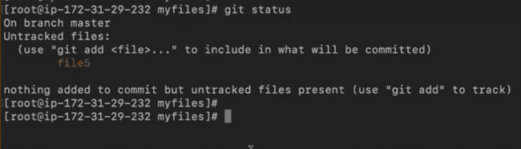
A okka file ni separate ga staging ki add chestamu
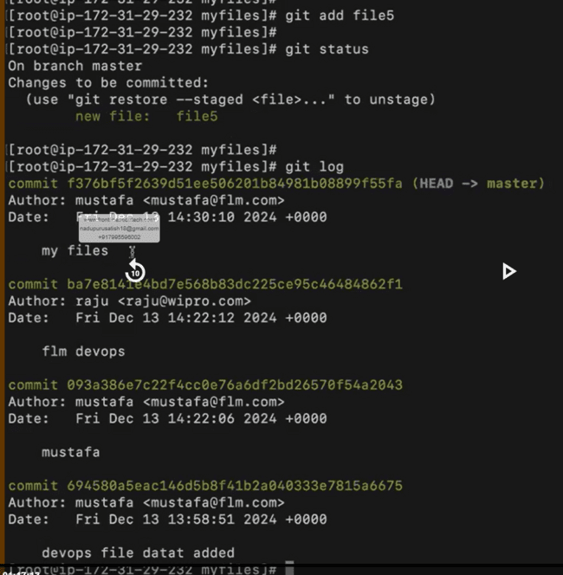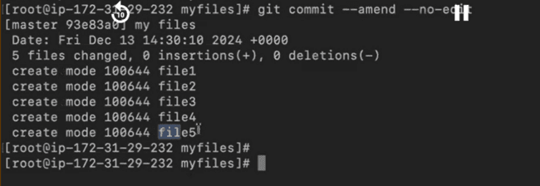
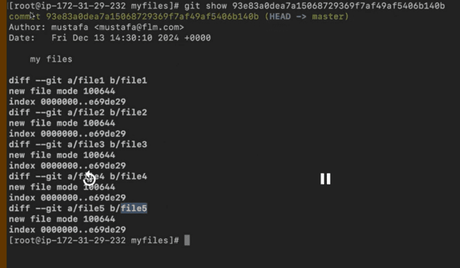
Ila chesthey oka commit ki a file attach avutadi
Q/A
DAY3 – GIT BRANCHES, MERGE & REVERT
GIT BRANCHES
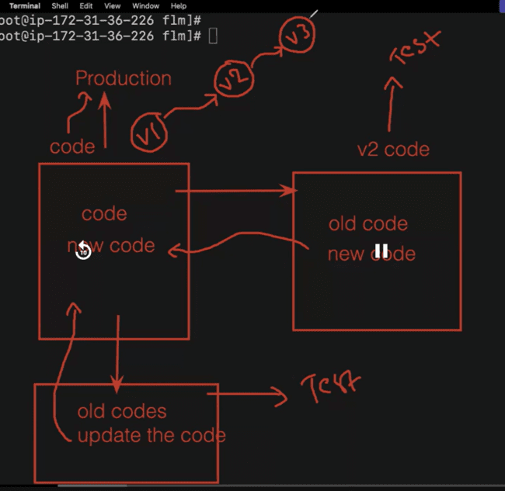
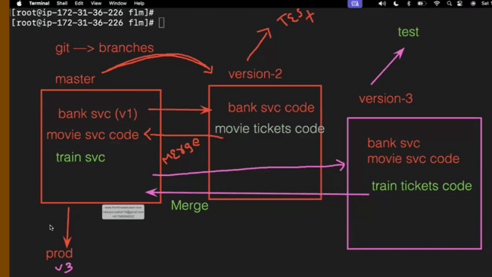
->suppose oka application, lets say paytm, ee paytm lo only bank vi undevi starting(which is a version1).ippudu nen movie tickets add cheyyali anukuntunna. So nen master branch(version1) lo unna code inko branch loki teesukuntanu,na movie related dhi add chestanu,chesaka testing team ki pampinchi test chepistanu-anta working annapudu,na changes ni master code tho add(nothibg but merging).nxt tym naku train tickets add chedam anukunna- so ee process ala continue avutadi.
->to see list of branches
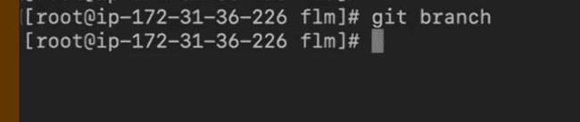
->oka commit aina chesthey appudu mana ki branches kanipistai
->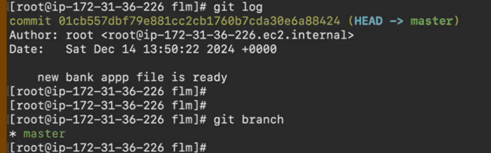
->to create a branch
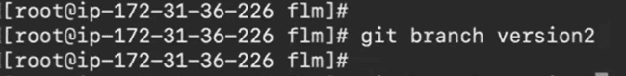
->manam master branch lo undi version2 branch create chesamu(manaki ela telustadi master branch lo unnam ani-git branch isthey * master ani vasthey manam master branch lo unnatu).master branch lo undi inko branch create chesam kabatti, a mster branch lo unna commits+files vastai.
->to move frm one branch to other branch
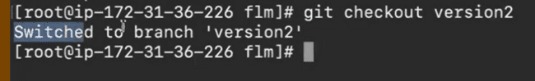
->to chk in which branch we are
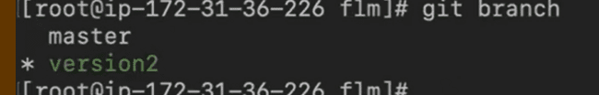
*+branch clr(these 2 represents we’re in that branch)
->chking all commits n files in other branch or not
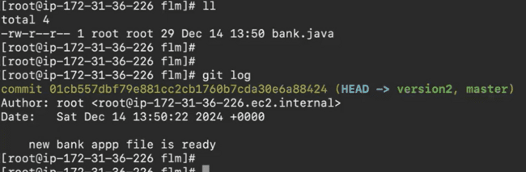
->created one movie file in branch2 n committing
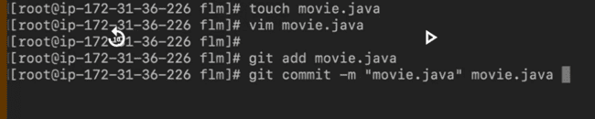
->master branch lo movie file ledu
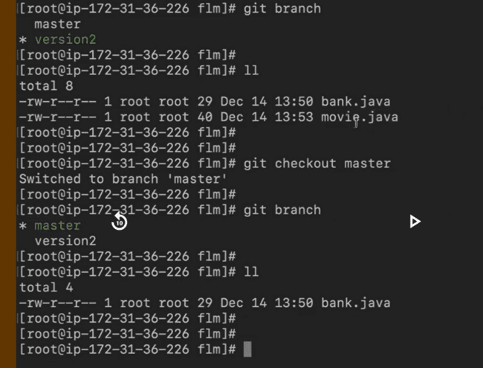
Manam ippudu a movie file master branch ki merge cheyyali
->to create a new branch n switch to it at a time
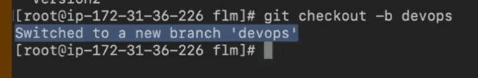
->to del a branch
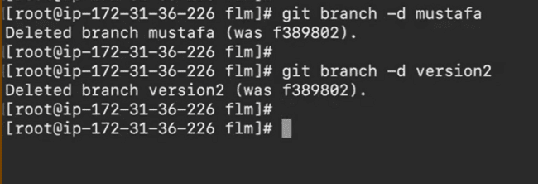
->we can’t del branch if we are in that branch
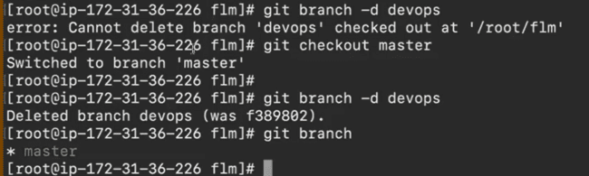
NOTE – 1.we can’t del master branch
2.we can’t retrieve the deleted branches
->rajini branch lo konni files add chesi commit chesam, a commits ey branch loki merge cheyyaledu,so del avvadu
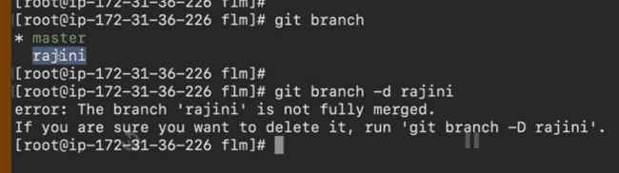
->but merge cheyyakunda del chedam anukuntunna a branch ni forceful ga
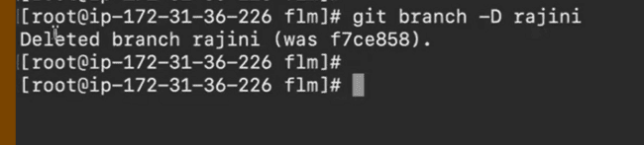
->to rename branch
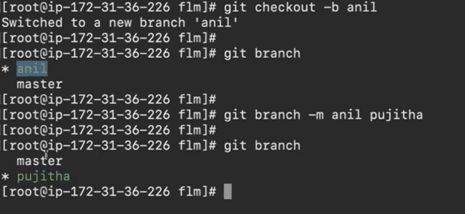
->only oka specific commit ni oka branch loki ravali antey
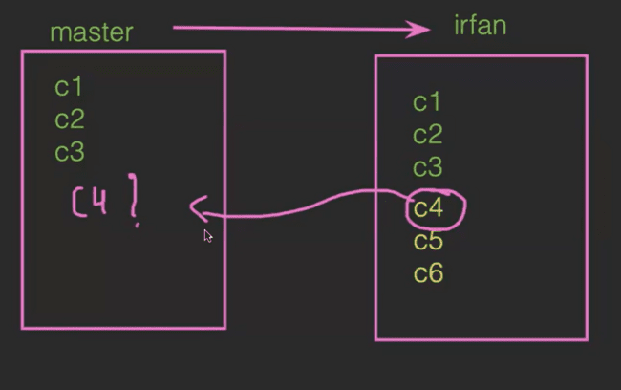
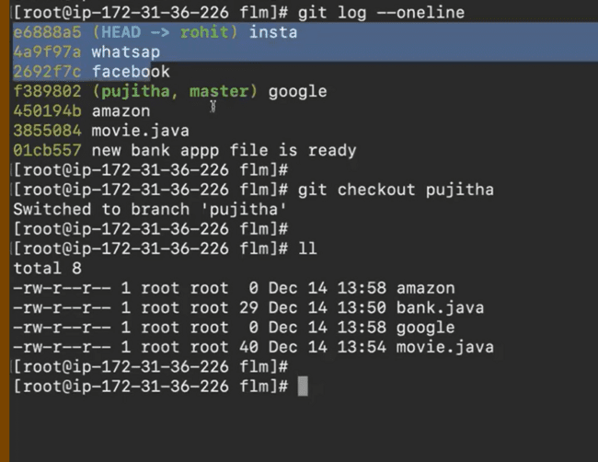
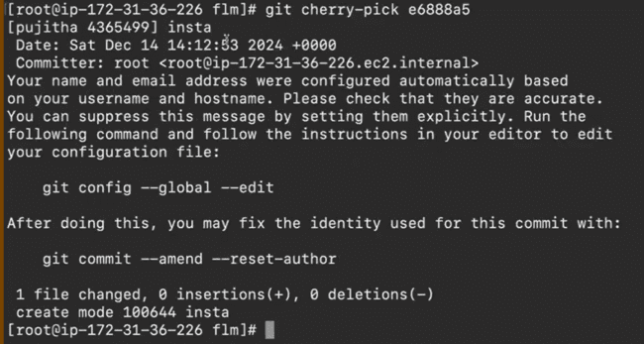
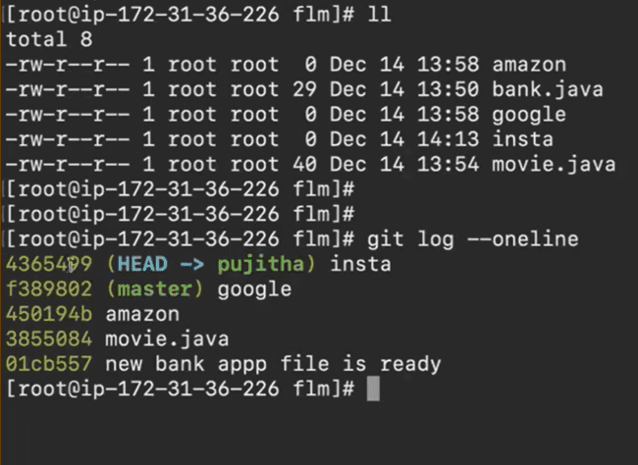
NOTE – reset cmd tho in b/w commits ni del cheyyalemu, but revert cmd tho cheyyachu
->kinda example lo c2 commit del chesthey a c2 commit del avvadu only a c2 commit lo chesina changes del avutai n del aye automatic ga new commit create aye danlo a data anta store chesukuntadi
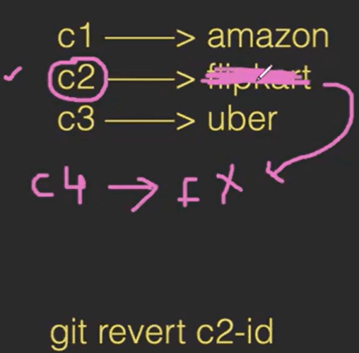
->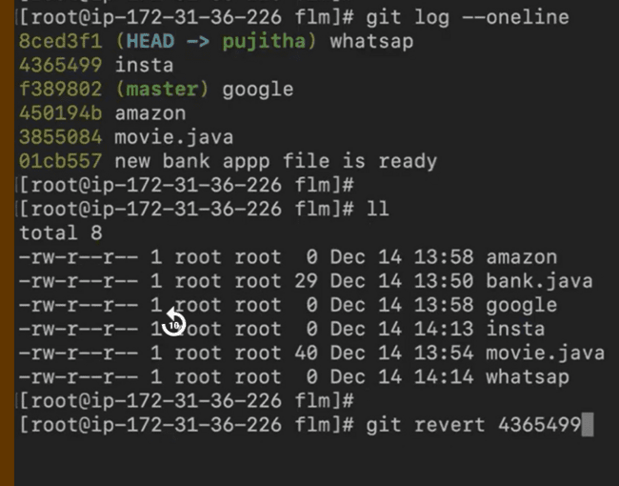
Git revert commit_id enter ichaka oka file open avutadi, jst a file lo save n continue cheyyandi like shown below

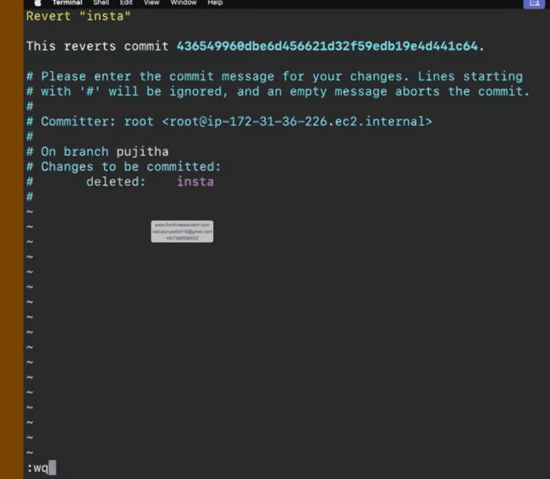
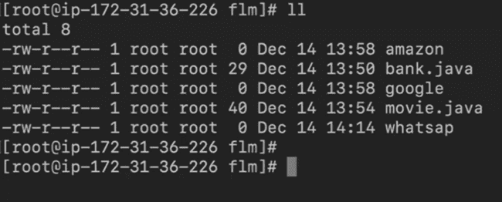
Chusthey a file del ayyindi
->git log chusthey em del chesammu ani details vastai
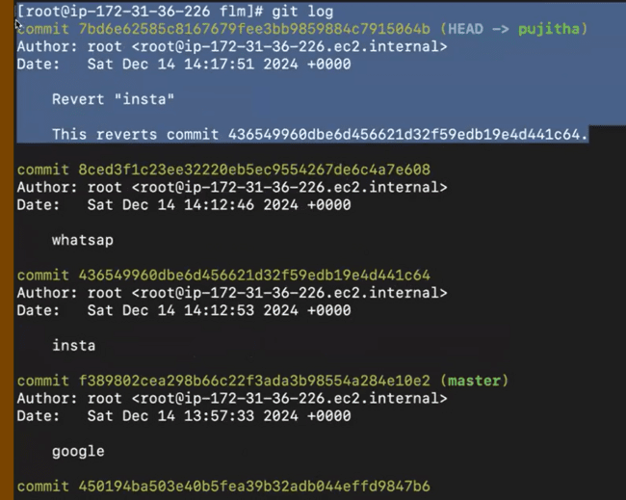
Q/A
1.git lo manaki atleast oka branch aina undali that need not to be a master
2.deleting multiple branches at a time
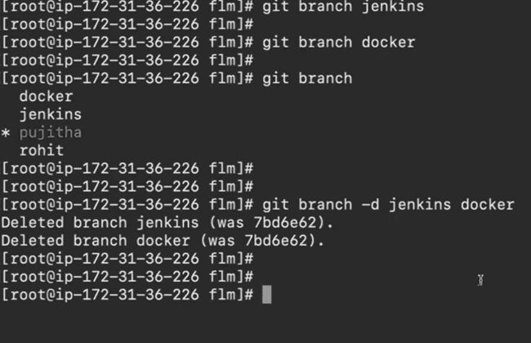
DAY4 – GIT STASH
->idi oka troubleshooting ki use avutadi
->oka b1,b2 branches unnai.b2 branch lo oka file modify cheyyalisi vachindi chesi commit chesanu and 2nd tym malli modify cheyyalisi vachindi chesanu but coomit cheyyala(bcz b1 branch lo app.java file oka API kosam vellali).b2 branch lo commit cheyyakunda b1 branch loki vellalemu bcz oka err vastundi nv modify chesavu file but commit cheyala(before gng to b1 branch either commit/stash ani oka suggest chestadi, commit chesthey changes ani repository loki veltai but stash chesthey a changes anni temporary ga del avutai,avi stash lo untai). So nen ippudu happy ga b1 branch ki velli a api file techukoni, prev ga chesina modifications tho commit chestanu.
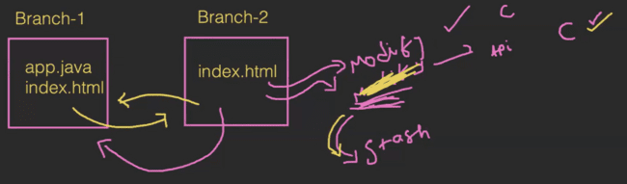
->eg
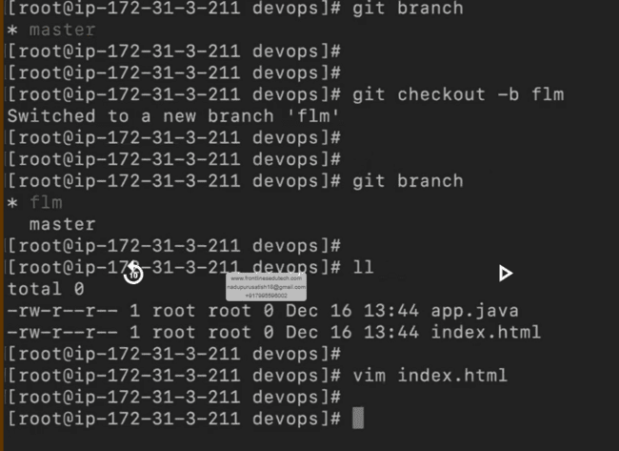
1st commit
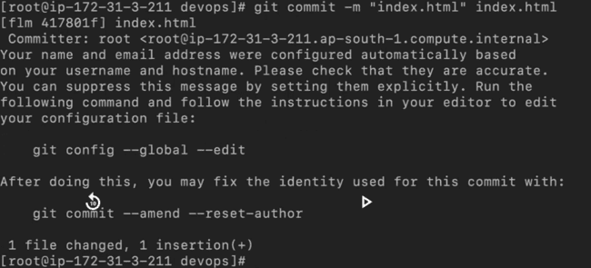
2nd modification chesanu but nt committing
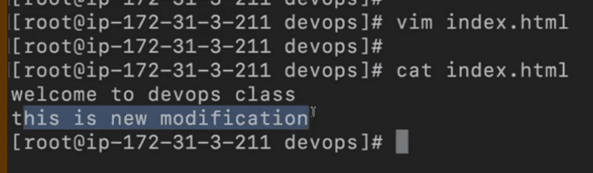
Ippudu master branch ki veldam ani try chesthey either commit/stash cheyye ani vastundi
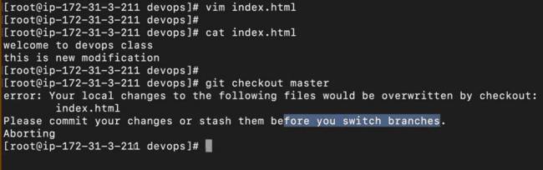
Commit chedam antey akkada unna data crt/wrong telidu
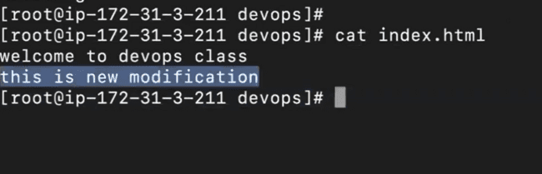
So stash chesthey temp ga store avutadi
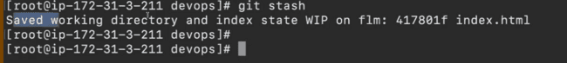
Stash chesaka 2nd tym add chesina data ledhu
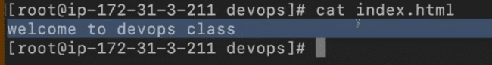
So happy ga master branch ki vellachu
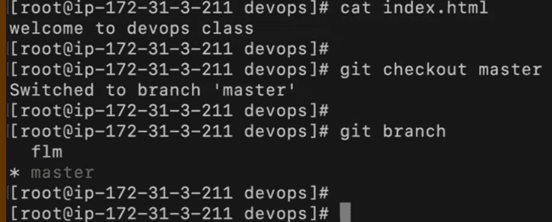
Ippudu kavalisina data master branch lo teesukoni, flm branch ki veltunna
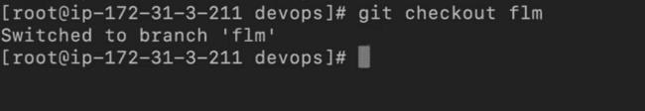
Previous ga manam chesina changes stash lo unnai, avi back ki techukundham
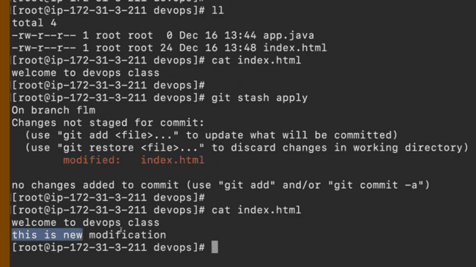
Ippudu commit chesukuntamu
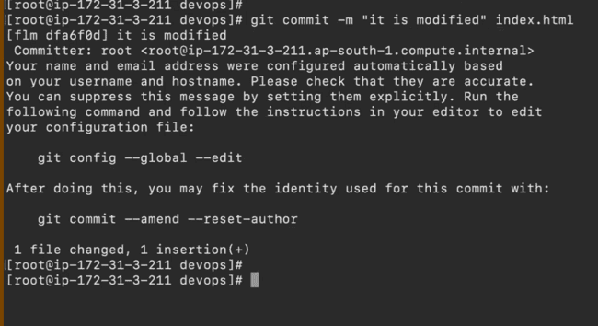
NOTE – stash is used to del all the changes which are present in staging area temporarily.
->to see list of stash’s
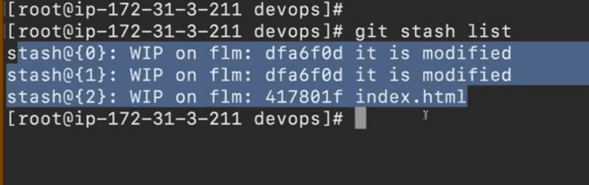
->to del the latest stash
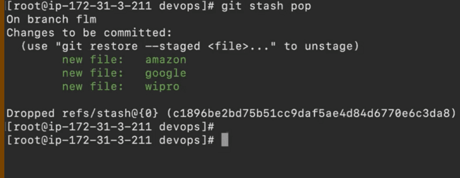
->to del all stash’s at a time

