CLASS-1 INTRODUCTION TO K8S (k8s, advantages of k8s, architecture, cluster)
Do we have down-time when we use docker?
Yes
Do we have auto-scaling in docker?
No
Is there possibility to rollback to specific version?
No
Security provides 60% only in docker
->to overcome all above pbms we use k8s
IQ – in realtime where we are using docker?
Web’s which have less updates, we can update these app’s during mid-time
->without docker no k8s
Dev>code+dockerfile>image>k8s(containers create cheyyachu)
->docker tho image create chestamu, k8s tho container create chestamu
->k8s lo pod create chesi, a pod lo container create chestamu
->what is k8s?
It’s a orchestration, used to create containers in high availability
K8S ARCHITECTURE
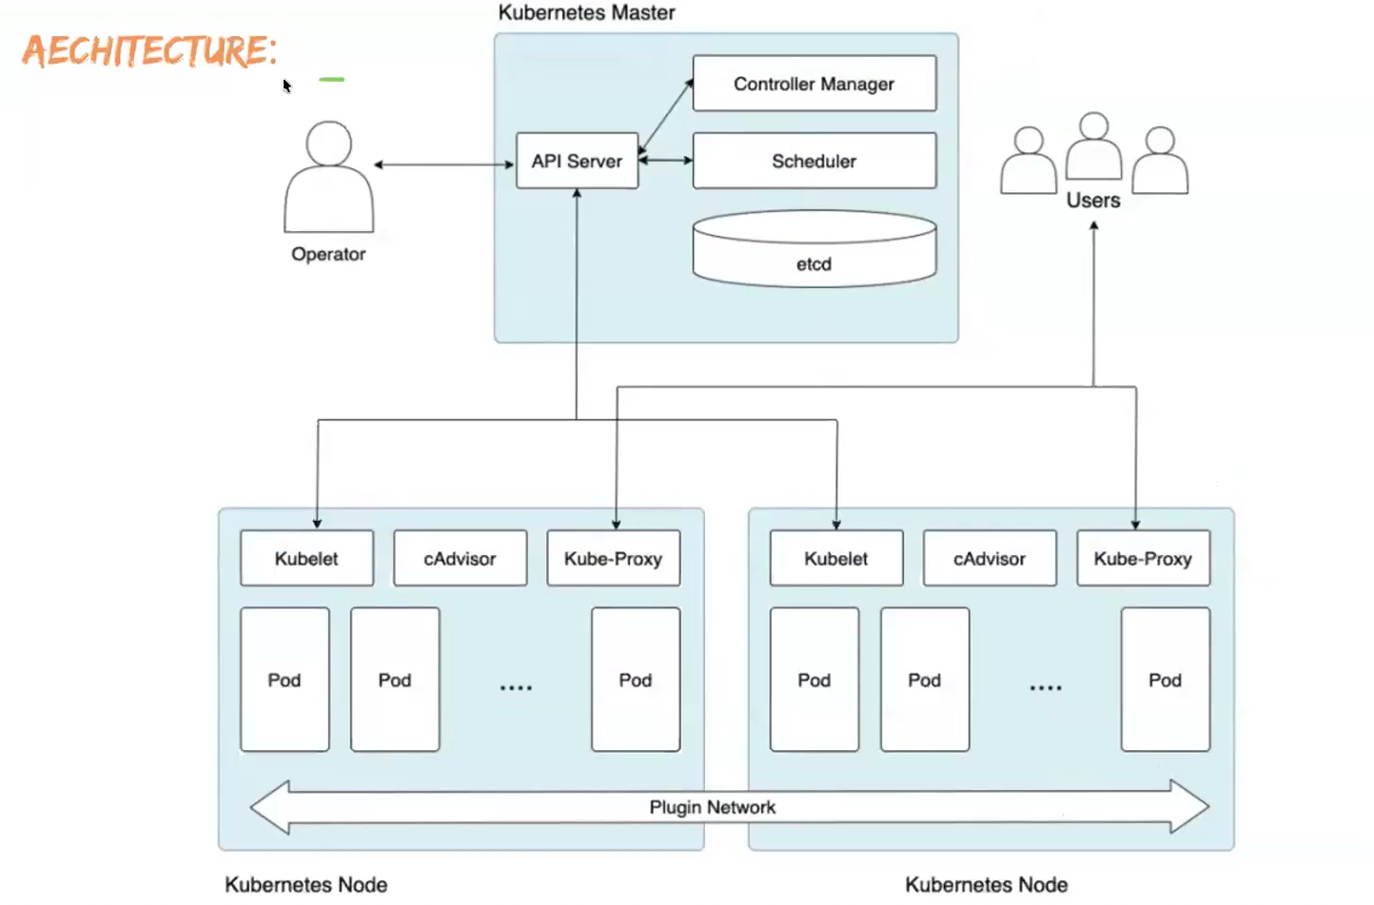
->nen oka operator ni, oka pod create cheyyamani oka cmd run chesanu
->na req api server teesukuntadi, a req etcd lo store avutadi
etcd - enni pods running lo unnai, enni services…. Prathidi key-value format lo etcd lo store chesukuntadi
scheduler – mana req scheduler ki pampistadi, a user wanna create a pod
->scheduler decide chestadi ey worker node lo create avvali pod ani based on availability(resources)
NOTE- 1. master ni k8s lo control-plane ani antaru
2. master lo pod ey create avvadu
IQ – in k8s who creates pod?
Kubelet
->scheduler decide chesi, api server ki cheptadi, ee api server particular node kubelet ki cheptadi pod create cheyyamani
->kubelet cheptadi nen pod create chesanu api server ki, a api server etcd lo update avutadi
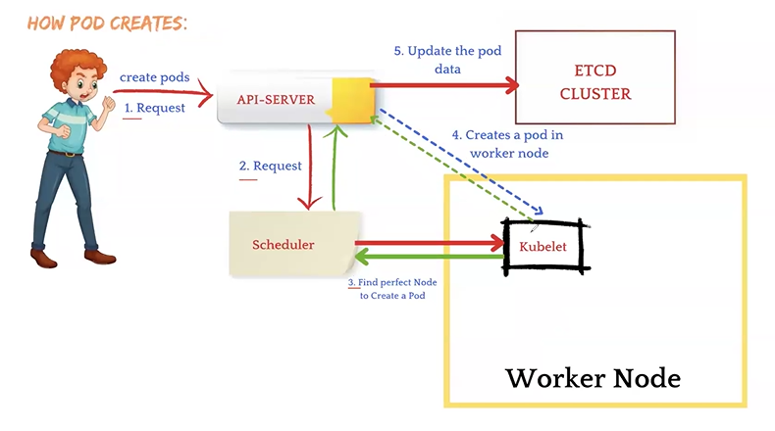
TYPES OF CONTROLLERS
Ee controllers valla mana drawbacks overcome chestunnai
- replication controller
- node controller
- service controller
replication controller – prathi pod tho every 5 secs ki req pampistadi, em ani pods running lo unnaya leda ani. Incase pod running lo untey response veltadi otherwise response rakapothey replication controller oka 40secs wait chestadi, ee 40secs lo koda response rakapothey inko pod create chestadi
->by def ga 5, 40 secs – if needed we can modify these timings
->node monitor period = 5sec, node monitor grace period=40secs
->it also chk desired no of pods, if needs creates/deletes
node controller – will take care of worker nodes(servers running lo unnaya leva), same like 5secs, if not wait fr 40secs and then create new server
service controller – will take care of services, same like 5secs, if not wait fr 40secs and then create new service
service – k8s lo pod lo cont’s create chestamu ga, a cont ni access chesukovali antey pod ni expose cheyyali, ee expose ki manam service ni use chestamu
kubelet – prathi worker node lo untadi, use to create a pod in worker node.kubelet ey image pull chesukoni,pod create chesi, a pod lo cont create chestadi automatic ga
kube-proxy - will mainatain nkt configurations of cluster
pod – pod is a grp of conts, oka pod lo enni conts aina create chesukovachu, but real time lo oka 2 ey create chestaru.
1.oka pod lo 2 conts create chestamu annaru ga okati-app run avutadi,2nd -helper/sidecar. Ee helper thoney app run avutadi
2.we can create pod using imperative(cmd),declarative(file)
3.oka pod lo unna conts anni same nkt n vol lo untai
Cluster- 2 types self-managed(using tools minikube,kops,kubeadm,k3d,kind) nd cloud-managed(eks,aks,gke)
CLASS-2 MINIKUBE, KUBECTL N POD INTRODUCTION
minikube=it is a tool used to create a single node cluster
->ee node loney worker,manager components untai
MINIKUBE setup
->fr minikube need 2cpu's,20gb n install docker
->search for minikube setup>under installation sel linux n copy those 2 cmds and run in server
->chk minikube version
->chk status minikube status
->to start a user vth admin access is required. so goto driver pages>docker>run the cmd minikube start --driver=docker
->after running we shd use --force bcz we are running the cmd vth root admin user
minikube start --driver=docker --force
->now chk the minukube status
->minikube got installed successfully
->to create a pod/service... we shd have kubectl
to install kubectl
search by kubectl install>copy below cmd in server
curl -LO "https://dl.k8s.io/release/$(curl -L -s https://dl.k8s.io/release/stable.txt)/bin/linux/amd64/kubectl"
->now kubectl is file got downloaded into server
->give x permissions
chmod +x kubectl
->move the kubectl file to def path
mv kubectl /usr/local/bin/
->ee cmds anni a offcial web lo untai
CREATING A POD
->we can create a pods in 2 ways
1.imperative(using cmds)
2.declarative(using manifest files)
1.imperative
->to create a pod
kubectl run pod-name --image=image-name
kubectl run pod-mypod --image=nginx
oka pod create ayye, a pod lo container create ayye, a container nginx image tho run avutundi
NOTE - pod name shd be in small
->to se list of pods
kubectl get pods
->to see particular pod
kubectl get pods pod-name
->to get some more details of a pod
kubectl get pods --o wide
->to get pod details in yml/json format
kubectl get pods --o yaml
kubectl get pods --o json
->to get the all details of pod
kubectl describe pods pod-name
NOTE - imperative lo nkts, port,volumes ivvalemu jst pod cretae cheyyachu
2.declarative
->realtime lo declarative tho pods create chestamu
->vim pod-name.yml
NOTE - 1.pod name can be anything in declartive but extension is imp
2. to chk apiversion n kind of a pod using cmd kubectl api-resources(anni objects ki telustai)
apiVersion : v1
kind: Pod
metadata:
name: pod-name
spec:
containers:
- name: cont-name
image: image-name
ports:
- containerPort: container-port
example for nginx
apiVersion : v1
kind: Pod
metadata:
name: pod2
spec:
containers:
- name: mustafa
image: shaikmustafa/dm
ports:
- containerPort: 80
NOTE - 1.while writing manifest files, make sure v is capital in apiVersion, p is capital in Pod n p shd be capital in containerport
2.image shd be frm docker-hub
3.indentation shd be crt
->to run manifest file
kubectl create -f file-name
kubectl create -f pod.yml
CLASS-3 KOPS CLUSTER CREATION
->kops is a multi-node cluster
->kops=Kubernetes operation
->in multi-node cluster it’ll create manager, worker-nodes
CREATE A CLUSTER USING KOPS TOOL

->mana cluster requirements
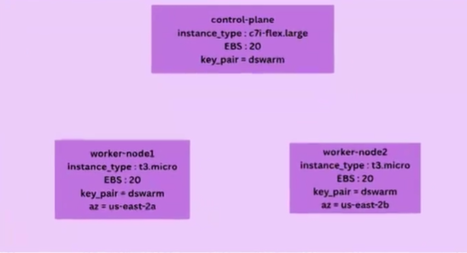
-> an ec2 instance vth t3-micro nd storage 25gb
KOPS INSTALLATION
curl -Lo kops https://github.com/kubernetes/kops/releases/download/$(curl -s https://api.github.com/repos/kubernetes/kops/releases/latest | grep tag_name | cut -d '"' -f 4)/kops-linux-amd64
chmod +x kops
sudo mv kops /usr/local/bin/kops
->chk kops installed or not
kops version
KUBECTL INSTALLATION
curl -LO "https://dl.k8s.io/release/$(curl -L -s https://dl.k8s.io/release/stable.txt)/bin/linux/amd64/kubectl"
chmod +x kubectl
mv kubectl /usr/local/bin/
->chk kubectl installed or not
kubectl version
CREATING S3 BUCKET
->cluster may be del avutadi, so we s3 bucket to store the data
->to chk any s3 buckets are available in server(iam permission untey chudagalam)
Aws s3 ls
->to chk s3 in aws acc, in search bar search by s3
->iam role lo prev class lo create chesamu(docker-class16 lo undi), a role ni mana server ki attach chesthey saripotadi
Sel instance>actions>sec>modify iam role
->we can create s3 by cmd/manual
By cmd
aws s3 mb s3://Mustafa.devops77flm
NOTE – bucket name should be same format n unique
->chk s3 created or not
Aws s3 ls
->to store data in that bucket
export KOPS_STATE_STORE=s3://Mustafa.devops77flm
->oka s3 bucket lo 5gb varaku free

CLUSTER CREATION
kops create cluster --name mustafa.k8s.local --zones=us-east-2a,us-east-2b --master-size=c7i-flex.large --master-count=1 --master-volume-size=20 --node-size=t3.micro --node-count=2 --node-volume-size=20 --image=ami-0fe18bc3cfa53a248
NOTE – No need to remember this cmd bcz there is an alternate way to create cluster n in interviews also they won’t ask.
->server lo a cmd run chesaka, finally configure ur cluster with…., copy that cmd n run it
kops update cluster --name mustafa.k8s.local --yes --admin
->it takes tym to create a cluster
->aws acc loki velli chudandi 1manager,2 worker create ayyayo ledo
->to see cluster
kops get clusters
->to see list of nodes
kubectl get nodes
NOTE – nodes fast ga refelect avvavu, so wait for sometime
->to del cluster
kops delete cluster –name Mustafa.k8s.local –yes

NOTE: 1 don’t forgot to delete the cluster after practice, del cheyyakapothey continuous ga create avutuney untadi – billing mamulu ga radu and never try to del cluster manually
2. kops delete cluster --name cluster-name –yes or kops delete cluster --name=mustafa.k8s.local --yes
3. chk any cluster is there or not after deletion also
kops get cluster

CLASS-4 KOPS LABELS, SELECTORS, NODE-SELECTORS
->monna chesina process thoney cluster create avutundi jst try once/twice
CREATING A POD USING DECLARATIVE WAY
->vim pod.yml
apiVersion : v1
kind: Pod
metadata:
name: pod2
spec:
containers:
- name: mustafa
image: shaikmustafa/dm
ports:
- containerPort: 80
->create a pod
Kubectl create -f pod.yml
->to chk pod created or not
Kubectl get pods
NOTE – manam create chestunna nodes using cluster avi ready state loki vachaka ey pod create cheyyandi(using cmd kubectl get nodes)
->ekkada create ayyindi ee pod
Kubectl get pods -o wide
->malli inko pod create cheyyadaniki inko yml file akkarledu, same file lo pod-name change chesthey chalu(container-name,ports same undachu)
->2nd dhi create chesaka pods chudu
Kubectl get pods -o wide
Diff nodes lo create ayyaye, confirmation kosam node-id ni aws lo searchbox lo ivvu
->inko pod create chesthey ekkada create avutundi, sure ga worker loney
NOTE – scheduler never create a pod in control-plane
IQ – reason telusuko why it’s not creating pod in control-plane
LABEL for new pods
->suppose oka 9-pods lo swiggy, uber, rapido app’s run avutunnai
->kubectl get pods tho anni pods list avutai but nak only swiggy vi ey kavali(del case also)
->labelling isthey mana pod ki easy ga identify chesukovadaniki
->to label a pod
vim pod.yml
apiVersion : v1
kind: Pod
metadata:
name: pod2
labels:
env: dev
project: swiggy
client: FLM
spec:
containers:
- name: mustafa
image: shaikmustafa/dm
ports:
- containerPort: 80
->to get list pods vth their labels
Kubectl get pods –show-labels
LABEL for existing pods
->to give label for existing pods
Kubectl label pod pod-name env=dev
->chk label added or not
Kubectl get pods –show-labels
->to give mul labels at a time
Kubectl label pod pod-name env=dev client=TCS
UNLABELING THE PODS
->to unlabel the pods
Kubectl label pod pod-name env-
->chk unlabeled or not
->by def ga konni labels unnai ga avi koda unlabel cheyyachu
SELECTORS
->to get dev env pods only
Kubectl get pods -l env=dev
-> to get not dev env pods
Kubectl get pods -l env!=dev
-> to get dev=env n client=flm pods only
Kubectl get pods -l env=dev, client=flm
CREATING A POD IN PARTICULAR NODE (node-selector)
->by def schedular pod ni create chestadi particular node lo but manam decide chesukovachu
->chk label of node
Kubectl get nodes –show-labels
->to give label for existing node
Kubectl label node node-id worker=worker1
->oka worker node ni sel chesi, kindha instace-id untadi
-> to give label for new pods
->to label a node
vim pod.yml
apiVersion : v1
kind: Pod
metadata:
name: pod2
labels:
env: dev
project: swiggy
client: FLM
spec:
containers:
- name: mustafa
image: shaikmustafa/dm
ports:
- containerPort: 80
RESUME AT 48 minsss--------------------------
CLASS-5 SERVICES & IT'S TYPES(clusterIP, nodeport, loadbalancer)
K8S SERVICES
->manam k8s lo oka pod lo cont create chestamu, a cont ki port istunnam kani, host port ekkada ivvadam ledu- so app ni access cheyyalemu
->in order to access app frm cont we need to expose it(using services we can expose it)
->k8s svc is used to expose our containers
->there are 3 types of svc's
i)ClusterIP
ii)NodePort
iii)LoadBalancer
->ClusterIP = to access cont within the same server
for db's,logs,scripts....
we get static-ip
using curl cmd we can chk(curl static-ip=ey server lo create chesthey danloney access chesukovali)
->NodePort = to access cont within the same server n host/node/instance/server
nodeport range - 30,000 to 32,767
we get static-ip,nodeport
to access app server_ip:range
we can access app internally n externally(server_ip:port)
IQ - why shd be that particular range for a nodeport service?
scenario - suppose mana app 2 nodes lo run avutundi, a cont ki nodeport thoney create chesamu. users ki 2 server ip's ichamu but ey server aina vadachu.Lest's assume oka server ey use chestunaru anukundam, appudu req's anni a server ki ey veltai so app down ayye chance undi.
so loadbalancer use chesthey traffic equal ga veltadi
->LoadBalancer = to expose our app's we use loadbalancer
using loadbalancer we'n access app internally n externally
we get static-ip,nodeport n dns
IQ - what is dif b/w nodeport n loadbalancer?
nodeport req's anni oka server ki ey veltai, ade loadbalancer lo aithey req's distribute avutai
PRACTICAL IMPLEMENTATION OF SERVCIES
1. clusterIP
->Create a server vth t3micro, 25gb n attach iam role also(which created previously)
->install kops,attach s3 bucket also n install kubectl
->create a pod
vim pod.yml
apiVersion : v1
kind: Pod
metadata:
name: pod1
labels:
app:swiggy
spec:
containers:
- name: cont1
image: shaikmustafa/dm
ports:
- containerPort: 80
NOTE - It's mandatory to give label to every pod
->create a service(service name can be anything)
vim myservice.yml
apiVersion: v1
kind: Service
metadata:
-name: myservice
spec:
type: ClusterIP
selector:
app: swiggy
ports:
- port: 1111
targetPort: 80
NOTE - 1 to access app curl ip:1111
2 port= svc port, targetport = app port
3 targetport lo p capital
->to create a service
kubectl create -f service.yml
explanation - oka pod lo chala conts unnai, oka cont ni ip:1111 tho access chesamu- appudu a cont ki req ela veltadi antey, 1st mana browser nunchi req svc ki veltadi, a svc nunchi particular target cont ki veltadi
->to see list of svc's
kubectl get services
manaki o/p lo cluster-ip vastadi
->to access app, goto any worker-node of cluster, give cmd
curl cluster-ip:1111
2.nodeport
->no need to write new manifest file, jst change svc name n type
vim myservice.yml
apiVersion: v1
kind: Service
metadata:
-name: my2ndservice
spec:
type: NodePort
selector:
app: swiggy
ports:
- port: 1111
targetPort: 80
nodePort: 30002
->to create a service
kubectl create -f service.yml
->to chk svc's
kubectl get svc
->to access app
ip:nodeport
3)LoadBalancer
->creating servc
apiVersion: v1
kind: Service
metadata:
-name: my2ndservice
spec:
type: LoadBalancer
selector:
app: swiggy
ports:
- port: 1111
targetPort: 80
nodePort: 30002 //idi ivvakapothey random ga create avutadi
->create a serv
kubectl create -f service.yml
->chk svc created or not
kubectl get svc
-> we can access using nodeport/dns
-> access vth dns using dns:1111
CLASS-6 REPLICATION CONTROLLER nd REPLICASET
->launch an instance nd install kops,kubectl,create a cluster
REPLICATION CONTROLLER
->pod is smallest obj in kops,crash koda avutai easy ga, so pods ki gurantee ivvalemu
->replication controller maintain desired no of pods(if needed it will create or del those)
->RC keeps an eye desired no of pods, if pod gets deleted automatically creates new pod
->mundu varaku pod>container now RC>pod>container
pod ni create chesthey, pod ey automatic ga container ni create chestadi
now rc we will create, rc will automatically creates pod, pod will automatically create containers
->pod with replicas
vim pod.yml
apiVersion: v1
kind: ReplicationController
metadata:
name: myrc
spec:
replicas: 3
selector:
app: swiggy
template:
metadata:
labels:
app: swiggy
spec:
containers:
- name: cont1
image: shaikmustafa/dm
ports:
- containerPort:80
let's divide manifest file into 3 parts
1st -part
apiVersion: v1
kind: ReplicationController
metadata:
name: myrc
exp - creating a rc nd named myrc
2nd-part
spec:
replicas: 3
selector:
app: swiggy
template:
metadata:
labels:
app: swiggy
->prathi RC ki oka template untadi, a template lo cont name, image untai. ee template nunchi ey pods create avutai
->template lo label enduku mention chesamu antey label isthey easy ga identify cheyyadaniki. so we are selecting the swiggy by giving as label
->create 3 pods vth the labeled template as swiggy
3rd -part
spec:
containers:
- name: cont1
image: shaikmustafa/dm
ports:
- containerPort:80
->execute by cmd
kubectl create -f pod.yml
->chk rc created or not
kubectl get rc
->chk 3 pods created or not
kubectl get pods
->chk whether pods created vth same label(swiggy) or not
kubectl get pods --show-labels
->lets create servc
vim mysvc.yml
apiVersion: v1
kind: Service
metadata:
name: mysvc
spec:
type: LoadBalancer
selector:
app: swiggy
ports:
- port: 80
targetPort: 80
->kubectl create -f mysvc.yml
->chk svc created or not
kubectl get svc
->access app vth loadbalancer
no need to give port = loadbalancer:port
->wanted ga pods cretae chesi, access cheyye app--we can see no downtime
->to del rc
kubectl delete rc rc-name
rc ni del chesthey automatic ga pods koda del avutai
REPLICA-SET
->same like rc but rc lo equality based selector nd in rs lo set-based sel
->set-based-sel lo multiple labels tho sel chesukovachu
->now a days rs ey use chestaru
->RS manifest file
vim pod.yml
apiVersion: apps/v1
kind: ReplicaSet
metadata:
name: myrs
spec:
replicas: 3
selector:
matchLabels:
app: swiggy
template:
metadata:
labels:
app: swiggy
spec:
containers:
- name: cont1
image: shaikmustafa/dm
ports:
- containerPort:80
->create rs
kubectl create -f pod.yml
->chl rs created or not
kubectl get rs
->indaka rc ni del chesamu, so dani tho create aina pods koda del ayyaye
->ippudu kottaga create ayyaye rs tho pods
->chk list of pods, so that we can know rs nunchi vachaya
->lets scale-in in rs
file lo>replicas lo tagginchu
kubectl apply pod.yml
NOTE - same fr rc also
->>lets scale-out in rs
file lo>replicas lo penchu
kubectl apply pod.yml
NOTE - same fr rc also
->through cmd scale-in or scale-out
kubectl scale rs myrs --replicas=4
IQ - 1.diff b/w kubectl apply n create?
2. diff rc n rs?
kubectl create - create new resources nd apply will update the changes
NOTE - in realtime we won't use RC n RS bcz we don't have auto-scaling, we can't update image, down-time
CLASS-7 DEPLOYMENT
->mundu varaku pod cont ni create chestadi anukunnam
->nxt rs pod ni create chestadi nd pod cont ni create chestadi
->final ga deploy rs ni create chestadi, rs pod ni create chestadi nd pod cont ni create chestadi
->deploy lo update, rollback, auto-scaling, no-downtime anni achieve cheyyachu
->vim deploy.yml
apiVersion: apps/v1
kind: Deployment
metadata:
name: mydeploy
spec:
replicas: 3
selector:
matchLabels:
app: swiggy
template:
metadata:
labels:
app: swiggy
spec:
containers:
- name: cont1
image: shaikmustafa/dm
ports:
- containerPort:80
->create svc file
->run deploy file to create conts
MANUAL-SCALING
1)using file
->manual scale-in/scale-out the pods using file
Replicas lo num change cheyye
Kubectl apply -f deploy.yml
->chk pods inc/dec ayyaya leda
2)using cmd
->cmd ni use chesi
Kubectl scale deploy file_name –replicas=num
UPDATE IMAGE
1 using file
->manifest file loki velli image change cheyye
->now run file
Kubectl apply -f file_name
->access app n chk app got changed vth new image or not
2 using cmd
->using cmd
Kubectl set image deploy file_name cont=cont_name
Kubectl set image deploy deploy cont=shaikmustafa/paytm:bus
->chk app got changed or not
NOTE – 1 cmd tho image update chesthey manifest file lo update avvadhu
2 image ela update avutadi antey deploy nunchi oka rs create avutadi kada, manam eppudu aithey apply cmd run chestamo oka new replica-set create avutadi, a rs nunchi oka new pod create avutadi, a new-pod healthy state ki vachaka old-pod del avutadi so ….ala new ga create ayyaka old pods del avutai
3 but replica-set matram del avvava, rollback ki use avutai
ROLLBACK
->to see wht deploy we have done till now vth deploy manifest file
Kubectl rollout history deploy deploy-name
Kubectl rollout history deploy deploy

->to rollback to particular version
Kubectl rollout undo deploy deploy-name –to-revision=2
Ippudu ee 2nd dhi last loki veltadi(order change avutadi)
->rollback ayyaka app ni prathisari chk cheyyalisina avasaram ledu, we can chk vth cmd
Kubectl rollout status deploy deploy-name
->rollback ayyam but enduku ayyam ani change-cause lo em ledu(projects konni yrs nunchi run avutai mundu ey version nunchi new version ki enduku vacham ani teliyali ga, so ee change-cause lo msg ivvachu)
->we can give change-cause in 2 ways
1 USING CMD
->using cmd
Kubectl annotate deploy deploy-name Kubernetes.io/change-cause=”rollbacking to v2 version”
Kubectl annotate deploy deploy Kubernetes.io/change-cause=”rollbacking to v2 version”
->suppose image update chesam, appudu mundu unna change-clause ey carry-forward avutadi, so prathisari change-cause update chesthu undali
2 FILE
->vim deploy.yml file lo metadata lo ivvu
apiVersion: apps/v1
kind: Deployment
metadata:
name: mydeploy
annotations:
Kubernetes.io/change-cause: “image updated vth cycle”
spec:
replicas: 3
selector:
matchLabels:
app: swiggy
template:
metadata:
labels:
app: swiggy
spec:
containers:
- name: cont1
image: shaikmustafa/cycle
ports:
- containerPort:80
->now update deployfile
Kubectl apply -f mydeploy
->chk deploy history
Kubectl rollout history deploy mydeploy
->1st oka image petti nd next 2nd image petti update chesi, list of replicas chudu, telustadi mundu vi del aye 2nd rs lo untai
AUTO-SCALING
->auto-scaling cheyyali antey metrics server install cheyyali
->manaki ela telustadi req lu ekkuva vastunaya leda ani based on cpu-utlization
->cpu-utilization ekkuva untey req’s ekkuva cpu-utilization takkuva aithey req’s takkuva
-> ey enta cpu teesukuntundi ani, metric server tho oka pod enta cpu teesukuntafi ani
INSTALL METRIC SERVER
->in google search fr install metrics server Kubernetes
Copy that cmd n paste in server
kubectl apply -f https://github.com/kubernetes-sigs/metrics-server/releases/latest/download/components.yaml
->chk pod cpu utilization
kubectl top pod pod-name
->auto-scaling lo 2 types
1 horizontal pod autoscaling(HPA)2 vertical
1 horizontal pod autoscaling(HPA)
->suppose oka 2 pods unnai, manam threshold 60% icham anukundam
->ee threshold val increase aithey(avg of 2 pods), automatic ga inko pod create avutadi….3 pods avg more than 60 aithey malli inko pod create avutadi
2 vertical
-> suppose oka 2 pods unnai, manam threshold 60% icham anukundam
->ee threshold val increase aithey(avg of 2 pods),automatic ga edoka pod resources increase avutai(like cpu’s ,ram..etc increase cheyyadam)
NOTE – realtime lo hpa ey ne use chesedi
HORIZONTAL POD AUTO-SCALING
->vim hpa.yml
apiVersion: autoscaling/v2
kind: HorizontalPodAutoscaler
metadata:
name: myhpa
spec:
scaleTargetRef:
apiVersion: apps/v1
kind: Deployment
name: flm(here we need to give deployment name)
minReplicas: 2
maxReplicas: 10
metrics:
- type: Resource
resource:
name: cpu
target:
type: Utilization
averageUtilization: 50
->exec hpa file
kubectl create -f hpa.yml
->chk hpa created or not
Kubectl get hpa
->chk pods also
INSTALLING STRESS PACKAGE(adds dummy load)
->same server ni inkosari access cheyye
->go inside the pod
Kubectl exec -it pod-name –bash
->apt update -y
->apt install stress -y
->stress -c 4 -t 300
->old server lo ippudu pods chk cheyye automatic ga stress padam valla pods inc avutai
->ippudu ctrl+c tho stress ni stop cheyye
->old server lo pods taggutai
CLASS-8 STATEFULSETS, DAEMONSETS nd NAMESPACES
->install kops,kubectl n attach s3
->create cluster
STATEFULSET
->in k8s for app running we are using deployment, fr database we are using statefulset
IQ- can we run db's using deployment?
no
->we have 2 types of app's in k8s
1)stateless = no past data is saved
2)stateful = stores data forever
->for stateless app's we use deployment nd for stateful we use staefulset
IQ - diff b/w deployment n statefulset?
deployment
->pods names are random
->pods dels randomly
statefulset
->pod names in sequential(flm0 flm1 flm2)
->pods del last created(last in first out)
IQ - why we are using statefulset for db's?
deployment lo 2 pods unnai scaling tho increase chesthey at a tym cretae avutai, ade statefulset one by one by cloning the data frm prev pod data
take img at 18mins
NOTE -1 db ni deployment tho create chesamu(a db only oka data undi pod create chesetapudu,customer 2nd tym add chesadu data), now we scaled app and increased pods 2nd pod lo only oka customer data ney vastadi
2 thats the drawback of deployment
3 ade manam statefulset use chesthey prev data clone avutadi - so use staefulset fr db's
->write manifest file fr deployment, observe pods are creating at a time
->write manifest file fr statefulset, observe pods creates sequentially
NOTE - manifest file is same fr statefulset as deployment only kind is diff

DAEMONSETS
->monitoring, logging ki use chestamu
->suppose hyb city lo diff ganges untaru like theives, smuggling, mafia untai
-> so ee ganges lo em jarugutundi ani teliyali antey secret ga prathi gang lo oka person ni inject chestaru
->a persons chusthu untaru em jarugutundi prathi team lo ani
->likewise mana cluster lo prathi pod lo em jarugutundi (cpu-utilization,pod running lo undha leda, ey worker-node ekkuva mem consume chestundi)
->so mana cluster lo prathi worker-node lo oka pod ni create chestamu so ee pods mem usage, cpu-utilization, pod health anni gather chesi monitoring dashboards ki send chestai
->active ga monitor chestadi ee daemonset prathi worker node lo unna damenonset pod
->manifest file is same as statefulset only kind will vary nd replicas koda undavu
->present mana cluster lo one-master, 2-nodes. manaki cluster size saripola, so we increased one-more node then daemonset will automatically created
NOTE -1 manam cluster ki oka cmd run cheska, cluster creation ki oka cmd vastadi dani tho patu inka konni cmds vastai, avi save chesi unchuko
2 those cmds will help in changing the cluster size/modifications
->lets take one example, hyd city lo diff ganges untai like mafia,smuggling, thieves. prathi gange ki oka person ni secret inject chesi, city mottam lo em jarugutundi ani telusukovachu.
->likewise prathi node lo oka daemonset pod create chestamu, ee daemonset pod prathi node ni monitor chesthu untadi(pods running,nodes)
-> ee monitoring status anta monitoring dashboards ki send chestadi
->daemonset manifest file similar to deployment but kind will vary n no replicas
NAMESPACES
-irfan ni adigi notes teesuko
CLASS-9 K8S VOLUMES
-> to share data between the cont's we use vol's
->4 types
1)emptydir 2)hostpath 3)pv 4)pvc
1)emptydir
->suppose in pod we have 2 conts nd also vol, we attach this vol to conts
->manifest file fr emptydir
->general ga oka pod lo 2 conts create chesthey, sure ga err vastundi
->in realtime we create pods using deployment
vim pod.yml
---
apiVersion: apps/v1
kind: Deployment
metadata:
-name: mydeploy
spec:
replicas: 2
selector:
matchLabels:
app: swiggy
template:
metadata:
Labels:
app: swiggy
spec:
containers:
- name: mycont1
image: nginx
ports:
- containerPort: 80
- name: mycont2
image: nginx
ports:
- containerPort: 80
->create a deployment using cmd
kubectl create -f pod.yml
->we'll see a warning that port duplicate
-> chk pods, we'll get a status fr pods as crashloopbackoff
->pod ey create avvaledu kabatti goto pod nd chk the logs
kubectl describe pod pod-name
aa logs chusthey restart avutundi ani cheptadi
->since port duplication vachindi kada, so take another image(ubuntu whcih doesnt req port)
jst modify the 2nd container to
- name: mycont2
image: ubuntu
->jst update the manifest file using apply cmd
kubectl apply -f pod.yml
->chk pods got created, same crashloopbackoff err only
->if we describe any pod cont1 is running but 2nd cont2 state is completed
->realtime lo oka pod lo 2 conts untai annanmu ga- 1st lo app, 2nd cont anedi helper ani cheppukunnam ga
-> ee helper cont deniki use chestunnam ani k8s ki cheppali, realtime lo helper cont ni diff ways lo use chesukuntaru like to store logs/backup/script execution/security
->using cmd we'll specify for what purpose we're using that helper cont
->eg for cmd
command: ["touch","aws"] = ee cmd run avvadaniki jst oka 2-3 secs pattidi
instead we use loop command: ["while true echo "aws" sleep 10;done"]
->in deploy file for cont2 change like nd create vol,attach vol to cont1 nd cont2
spec:
containers:
- name: mycont1
image: nginx
ports:
- containerPort: 80
volumeMounts:
- mountPath: "/tmp/jenkins"
name: devops
- name: mycont2
image: ubuntu
command: ["/bin/bash", "-c", "while true; dp echo welcome to flm; sleep 10; done"]
volumeMounts:
- mountPath: "/tmp/jenkins"
name: devops
volumes:
- name: devops
emptyDir: {}

->same path or diff paths ki mount cheyyachu
->now del prev deply file nd create new deploy file
->now chk pods, 2 running lo untai(bcz 2nd cont lo cmd run avutuney untadi)
->a cmd run avutuney untadi annam ga, adi chudam
kubectl logs pod-name -c cont-2
every 10secs ki a cmd print avutundi
->chk data replicate avutundho ledo, go inside pod
kubectl exec -it pod-name -c cont1 --bash
->now pod lo cont1 lopala ki veltadi, cd /tmp/jenkins/ > give ll> ey files undavu> create files
->now pod lo cont2 lopala ki vellu using cmd
kubectl exec -it pod-name -c cont2 --bash
->now pod lo cont2 lopala ki veltadi, cd /tmp/jenkins/ > give ll> cont1 lo create chesina files ikkada untai
->manam vol's attach chestunam kabatti data replicate avutadi
->but realtime lo use cheyyamu bcz pod del aithey pod lo unna vol koda del avutadi
->but rc tho new pod create avutadi, a pod lo conts,vol create avutadi but vol empty ga untadi
->mari manam deploy lo replicas pettamu ga. so that oka pod ni del chesina inko wroker-node lo pod lo undali ga
NOTE - ey pod lo aithey vol create chestunamo, a pod loney untadi
2)host-path
->mana server lo edoka path ki vol ni mount chestanu
->so pod to pod nd cont to cont in pod data replicate avutadi
->incase pod del aina, inko pod create avutadi daniki automatic ga vol attach avutadi
->to create a hostpath, jst change type as hostpath give path
volumes:
- name: devops
hostPath:
path: /tmp/mydata
-> oka pod lopala cont1 loki velli konni files create cheyye(same fr cont2 also)
->chk cont1 data got reflected in cont2 nd vice versa
NOTE – 1 ee vol lo pod del aina new pod lo koda data undadhu(if pod, vol create chesina worker node lo create aithey data store avutadi)
2 suppose manam host path ok1 server1 lo create chesi, pods ki attach chestam, a server lo unna anni pods nd conts madya data transfer avutadi(inko server lo unna pod, vol create chesina server lo pod ki data transfer avvadu)
3 incase server ey del aithey there is no data persistence then we go for pv nd pvc in realtime
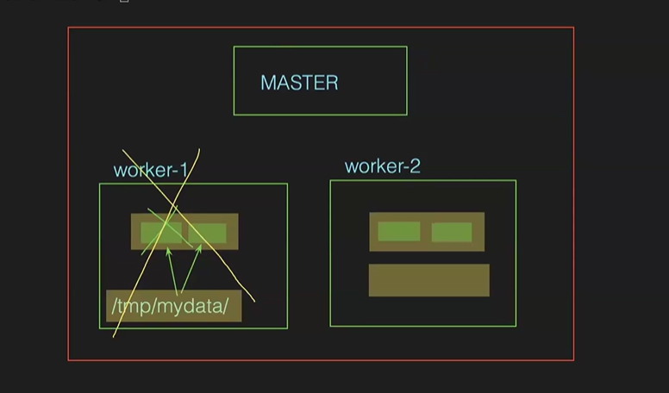
3)PV n PVC
->ikkada vol ni cloud lo create chestamu
->a vol ni mana pods ki attach chestamu(direct ga attach cheyyamu, through pvc we’ll attach)
->cloud lo oka 100gb vol teesukuntamu, a vol nunchi oka 3 pv's create chestamu nd size istamu like
for pv1-30gb, pv2-30gb nd pv3-30gb
->oka pod ki enta mem kavali ani team vallu cheptaru
->oka cont ki direct ga oka pv ni attach cheyyalemu
->mana cont ki enta mem kavalo ani claim chesukuntamu daniney pvc antamu
->jst pvc create chestamu, oka cont ey pv nunchi teesukovali ani manam decide cheyyalemu random ga teesukuntadi
PRACTICAL IMPLEMENTATION OF PV nd PVC
->goto aws>under elastic block store>volumes>in size give 25b>in tags-optional give name >click on create>copy that id
->now goto server write yml file for pv
vim pv.yml
---
apiVersion: v1
kind: PersistentVolume
metadata:
name: pv1
spec:
capacity:
storage: 5Gi
accessModes:
- ReadWriteOnce
awsElasticBlockStore:
VolumeID: that-id
fsType: ext4
->now run pv file
kubectl create -f pv.yml
->chk pv using cmd
kubectl get pv
NOTE - no need to remember this pv file for interview also
PVC manifest file
->to claim pv we need to write yml file pvc
->create a pvc.yml
---
apiVersion: v1
kind: PersistentVolumeClaim
metadata:
name: pvc1
spec:
accessModes:
- ReadWriteOnce
resources:
requests:
storage: 7Gi
->run that pvc file using cmd
kubectl create -f pvc.yml
->chk pvc created or not
kubectl get pvc
->create avutadi but pending state lo untadi, attach ayyaka bound ani vastadi
->chk pv, we observe that pv's are available(that means we are not used our pv's)
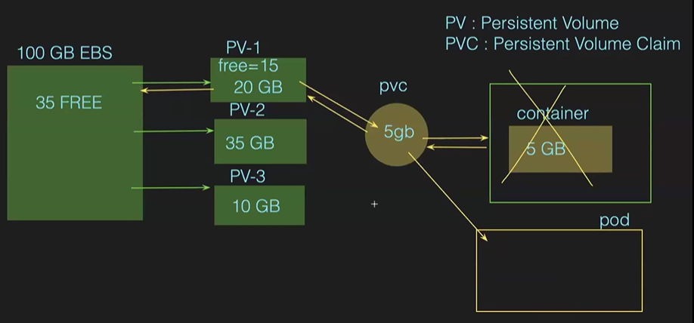
ATTACH PVC TO POD
->jst in deploy file change type to persistentVolumeClaim nd ClaimName" pvc-1
volumes:
- name: devops
persistentVolumeClaim
ClaimName" pvc-1
->now again create a pod
->after creating pods,chk the pvc, it shows bound(got attached to pod)
->now chk pv, it shows bound in status nd claim lo koda kanipistadi
NOTE - ey pv nunchi teesukuntadi ani telidu
CLASS-10 K8S CONFIGMAPS nd SECRETS
->install kops
->pod lopala ki edaina data pass cheyyadaniki ee configmaps, secrets use chestaru
->to pass env var’s nv configurations to pods we use configmaps n secrets
eg – mana dhagra oka db_host=devopsdb, db_host=devopstestdb,db_host=devopsproddb ila env var’s unnai
->generally these env_vars are key-val pairs
->to pass var’s to pod we create a configmap nd we attach this configmap to pod, so that var’s are passed to pod
NOTE – 1 we can attach n no of configmaps to cont/one var frm each configmaps to one cont
2 non-confidential data only stored in configmaps, for confidential we use secrets in k8s
3 in configmaps we can store data upto 1MB, if exceeds we shd use vol’s only
->we can create configmaps in 2 ways
1 imperative 2 declarative
->using imperative we have 3 ways
1 literal 2 file 3 env_file
->to see list of configmaps
Kubectl get cm
->by def cluster create chesinapudu oka configmap vastadi
USING LITERAL
->literal antey oka cmd tho create chestamu nd vals direct ga pass chestamu
Kubectl create cm firstcm –from-literal=env=dev –from-literal=db_port=3306
->chk cm created or not
Kubectl get cm
->to see the vals in those var’s
Kubectl describe cm firstcm
2)USING ENV-FILE
->using ENV file
Vim vars.env
env=test
app_port=5000
cient=tcs
app=uber
->now create cm
Kubectl create cm secondcm –from-env-file=vars.env
->chk cm created or not
->describe chesi chudu
3)USING FILE
->vim file
Welcome to file
This is my file
->now create cm
Kubectl create cm thirdcm –from-file=file
->chk cm created or not
->describe chesi chudu
NOTE- using file if we create cm, then enta data unna oka data ani ey teesukuntadi
USING DECLARATIVE WAY
->vim cm.yml
apiVersion: v1
kind: ConfigMap
metadata:
name: fourthcm
data:
db_port: “3306”
db_host: “devopsdb”
env: “prod”
->create cm
Kubectl create -f cm.yml
NOTE – realtime lo using yml/.env
HOW TO ATTACH CONFIGMAPS TO PODS
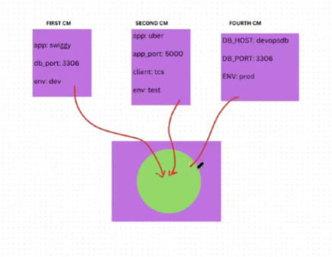
->create a deployment file
vim pod.yml
---
apiVersion: apps/v1
kind: Deployment
metadata:
-name: mydeploy
spec:
replicas: 2
selector:
matchLabels:
app: swiggy
template:
metadata:
Labels:
app: swiggy
spec:
containers:
- name: mycont1
image: nginx
ports:
- containerPort: 80
envFrom:
- configMapRef:
name: firstcm
- configMapRef:
name: secondcm
->now create deployment
Kubectl create -f pod.yml
->chk pods created or not
->goto pod nd chk env var’s available or not
kubectl exec -it mydeploy –bash
printenv
SPECIFIC VAL FROM SPECIFIC CM’S
->create a deployment file
vim pod.yml
---
apiVersion: apps/v1
kind: Deployment
metadata:
-name: mydeploy
spec:
replicas: 2
selector:
matchLabels:
app: swiggy
template:
metadata:
Labels:
app: swiggy
spec:
containers:
- name: mycont1
image: nginx
ports:
- containerPort: 80
env:
- name: myport
valueFrom:
configMapKeyRef:
name: firstcm
key: db_port
- name: myenv
valueFrom:
configMapKeyRef:
name: secondcm
key: env
->now create deployment
Kubectl create -f pod.yml
->chk pods created or not
->goto pod nd chk env var’s available or not
kubectl exec -it mydeploy –bash
printenv
NOTE- cm’s lo unna names teesukovachu/mana own name ivvachu specific ga env ki
SECRETS
->configmaps ela aithey work avutadho same alney secrets wrk avutai but secrets lo data encode avutadi
->chk secrets
Kubectl get secrets
->to create a secret using cmd
Kubectl create secret generic mysecret –from-literal=username=kolla –from-literal=password=admin@123
->chk secrets
Kubectl get secrets
->describe secret
Kubectl describe secret mysecret
NOTE – vals chupinchadu, jst bytes ani chupistadi
->using manifest file
Vim secrets.yml
apiVersion: v1
kind: Secret
metadata:
name: appsecret
data:
user: kolla
pass: admin@123
->now create secret
Kubectl create -f secret.yml
Err vastadi bcz data encrypt cheyyaledu, so file loki velli chudachu ga
->to encode data
echo -n “admin” | base64
->now keep that encoded data in secret file
->now create secret
->it gets created
->create a deployment file
vim pod.yml
---
apiVersion: apps/v1
kind: Deployment
metadata:
-name: mydeploy
spec:
replicas: 2
selector:
matchLabels:
app: swiggy
template:
metadata:
Labels:
app: swiggy
spec:
containers:
- name: mycont1
image: nginx
ports:
- containerPort: 80
envFrom:
- secretRef:
name: appsecret
->pod ni describe chesi chusina data decode ayyeuntadi
NOTE – 1 attach secret to pod like cm
2 we can attach single var from diff secrets
3 pod bayata encode chestadi, lopala decode chestadi
CLASS-11 K8S RBAC
->rbac=rolled based access control
->create a minikube vth 25gb n practice rbac here bcz here only certificates are supporting fr rbac
->minikube ki docker koda kavali so install it
->realtime lo cluster lo chala namespaces untai, a namespace lo pods,svc,deploy,hpa …untai
->realtime lo a namespace lo unnavi anni chudataniki permissions undavu, deniki kavalo daniki ey permisiion istamu
Eg – oka person new ga team loki vachadu, a person ki task deploy cheyyali ani task, so tanaki deploy lo create,view ey istamu nothing but RBAC
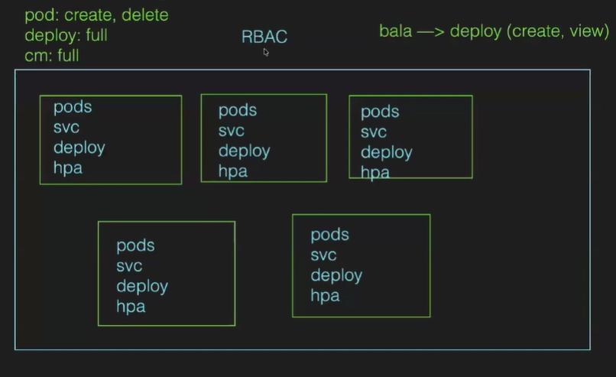
->rbac type
1)user 2)service account
1)user
->oka person basheer kotta ga team loki vacharu tana k8s tasks vachai, so tanaki pods,deploy,svc,statefulset,cm,secrets resources ki permission istamu, deenini user rbac antaru
2)service account
->oka pipeline lo 2 stages unnai stage-1 for code stage-2 fr kubectl apply
->stage-2 lo k8s cmd mana cluster lo execute avvali antey renditiki communication untey ney ga
->so in order to communicate our pipeline vth k8s we will create a service acc rbac(which will allow Jenkins to create objs in cluster)
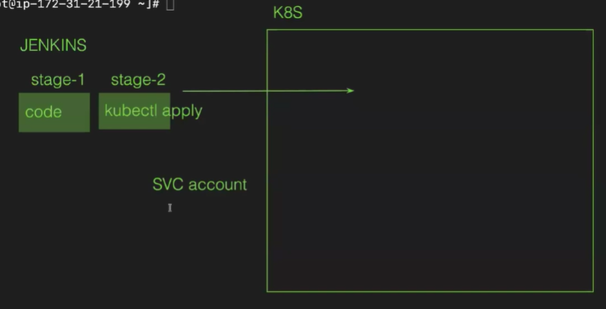

1)role
2)rolebinding
->nen oka role create chestunna vth some permissions like pod(create , del, view), a role ni oka user like krishna ki assign chesthey danini rolebinding antaru
->particular ga oka namespace ki ey istamu
3)clusterrole
4)clusterrolebinding
->nen oka role create chestunna vth some permissions like pod(create , del, view), a role ni oka user like irfan ki assign chesthey danini rolebinding antaru
->cluster lo unna anni namespaces ki permission isthey danini clusterrolebinding antaru

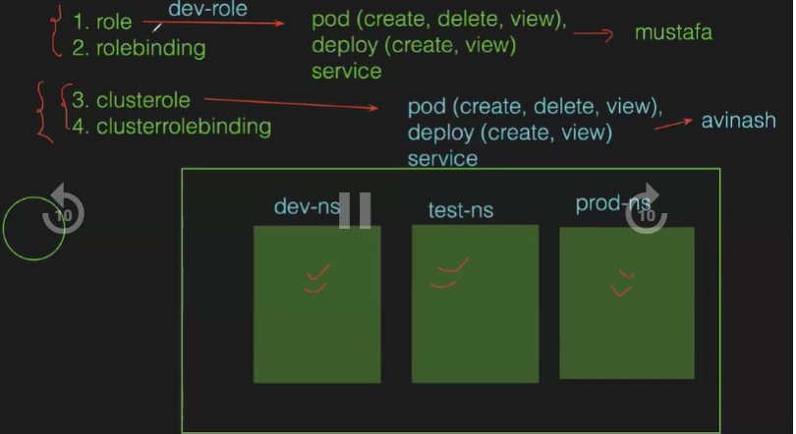
IQ – diff b/w rolebinding n clusterrolebinding
PRACTICAL IMPLEMENTATION OF RBAC
->jst create a folder>go inside of it
->create a key vth below cmd using openssl
openssl genrsa -out mustafa.key 2048
->chk key created or not vth ll
->sign-in access for created user using below cmd
openssl x509 -req -in mustafa.csr -CA ~/.minikube/ca.crt -CAkey ~/.minikube/ca.key -CAcreateserial -out mustafa.crt -days 500
-> chk csr created or not vth ll
->now create a certificate
openssl x509 -req -in mustafa.csr -CA ~/.minikube/ca.crt -CAkey ~/.minikube/ca.key -CAcreateserial -out mustafa.crt -days 500
->now create a user vth below cmd
kubectl config set-credentials mustafa --client-certificate=mustafa.crt --client-key=mustafa.key
NOTE – no need to remember thse cmds
->user ki context add cheyyali(oka user nunchi inko user ki velldaniki ee context use chestamu)
->to see users
Kubectl config view
->present ey user lo unnam
Kubectl config view

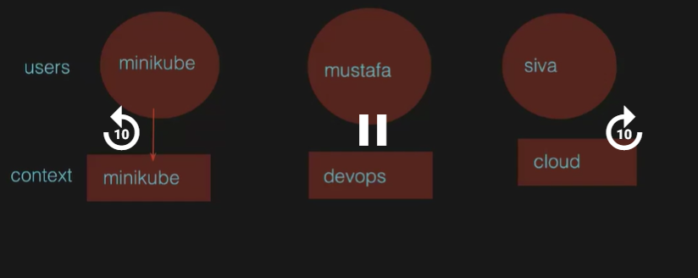
NOTE – oka user nunchi inko user ki vellali antey manam oka user ki context create chestamu
->to create a context for user
kubectl config set-context devops --cluster=minikube --user=mustafa
->to see in which user we are
Kubectl config view
->to switch to user
Kubectl config use-context devops
-> to see in which user we are
Kubectl config view
->now we are in mustafa user
->now try to chk the pods, deployments, svc’s
It’ll show err(bcz ey permissions undav kabati)
->now switch to minikube user and give permissions
Kubectl config use-context minikube
NOTE - minikube admin user kabatti annitiki permissions untai
CREATING A PARTICULAR ROLE
->create a namespace
Kubectl create ns dev
->creating a mustafa role
Vim role.yml
apiVersion: rbac.authorization.k8s.io/v1
kind: Role
metadata:
name: mustafa-role
namespace: dev
rules:
- apiGroups: [“”]
resources: [“pods”, “deployments”]
- apiGroups: [“apps”]
resources: [“pods”, “deployments”]
verbs: [“get”, “watch”, “list” ,”create”, “delete”]
verbs: [“get”, “watch”, “list” ,”create”, “delete”]

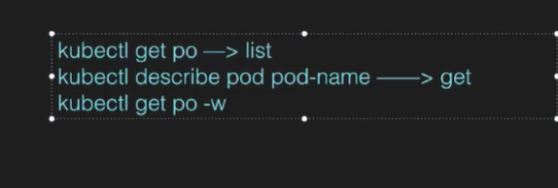
->run the role file
Kubectl create -f role.yml
->chk role created or not
Kubectl get role -n dev
ASSIGNING ROLE TO PARTICULAR USER
->assign role to mustafa user
Vim rolebinding.yml
apiVersion: rbac.authorization.k8s.io/v1
kind: RoleBinding
metadata:
name: mustafa-rb
namespace: dev
subjects:
- kind: User
Name: mustafa
apiGroup: rbac.authorization.k8s.io
roleRef:
kind: Role
name: mustafa-role
apiGroup: rbac.authorization.k8s.io
->create a file using kubectl create -f ym-file
->chk mustfa user ki pods,deployments ki persmisiions unnayo ledo
->to got mustfa user
Kubectl config use-context devops
->switched to mustafa user
->chk pods
->err vastadi, manam mustafa user loney unnam and permissions koda ichamu but enduku ravtala=mustfa user lo def namespace lo unnamu(manam def namespcace ki permission ivvaledu, only dev namespace ki permissions ichamu)
->chk pods in dev namespace
Kubectl get pods -n dev
->ee dev lo resources lev so create a pod
Kubectl run pod-1 –image=niginx -n dev
->now chk pods, it’ll list
NOTE – 1 clusterrole ki yml file same only kind is ClusterRole and namespace koda akkarledu
2 clusterrolebinding ki yml file same only kind is ClusterRoleBinding and namespace koda akkarledu
->konni namespaces manam ey create chedamu
->now goto mustafa context and check has permissions for pods, deployments fr def,dev,prod namespaces
Kubectl auth can-I get po
->anni namespaces lo permissions untai
CLASS-12 RESOURCE QUOTA
->docker lo container create avvali antey manam containers ki resources concept nerchukunnam like intha cpu min nad max intha ani
->same like this in k8s we have resource quota undi
->suppose 2 teams uunai, 1-team is for train ticket booking nd 2-team is for fastag meda wrk avutai
->so ekkuva req’s lu train ticketing ki vastai
->resource quota is nothing but keeping resources limits for conts like 1cpu n ram 1gb, incase mana pod more than 1gb teesukuntey hpa valla new pod create avutadi
->limit pettakapothey oka pod ey consume chestadi, inko pod create avvadu, oka pod lo extra conts create cheyyalemu
->by def in k8s run with no limits on cpu n memory
->scheculder will decide based on resources availability in nodes
->cpu is measured in terms of cores n memory in bytes
->ee resource quota is implemented in namespace level
->nen oka namespace lo oka pod create cheyyali antey k8s admin ni adugutanu nen ee namespace lo pod ni create chestanu antey mem allocate chestadu a namespace ki(ram, cpu)
->saripokapothey k8s admin increase chestadu
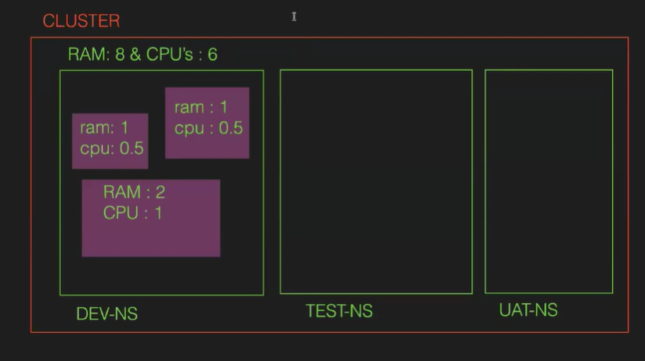
NOTE – oka ns lo resources allocate chesthey, a ns lo create cheesy pod ki koda resources undali
->requests=oka pod create avvali antey min res undali
->limits=pod max res use chesukovachu
PRACTICAL IMPLEMENTATION OF RESOURCE QUOTA
->minikube lo aina practice cheyye
->create a namespace
Kubectl create ns dev
->manifest file fr resource quota for ns dev
Vim rq.yml
apiVersion: v1
kind: ResourceQuota

metadata:
name: dev-rq
namespace: dev
spec:
hard:
limits.cpu: “500m”
requests.cpu: “250m”
limits.memory: “100Mi”
requests.memory: “50Mi”
->oksari ns ni describe cheyye= no resource quota ani vastad
->run that rq file
Kubectl create -f rq.yml
->now describe namespace = ippudu vastadi manam set chesina resources
->now create a pod vth resources
Vim pod.yml
apiVersion: v1
kind: Pod
metadata:
name: mypod
spec:
containers:
- name: mycont
image: shaikmustafa/dm
ports:
- containerPort: 80
resources:
requests:
cpu: “200m”
memory: “5Mi”
limits:
cpu: 500m”
memory: “15Mi”
->now create a pod
->chk pod created in dev nm
Kubectl get pods -n dev
->now describe ns, we’ll see how much resources used
->create another pod by changing pod-name
-> now describe ns, we’ll see how much resources used
->create another pod by changing pod-name, we’ll get err that exceeded quota

RESUME AT 33minsss--------------------------------------------
CLASS-13 HELM CHARTS PART1
->install kops cluster
HELM CHARTS
->suppose oka basic app ki we need to manifest files for deploy,svc,hpa,cm,statefulset, pv nd pvc, rq… adi oka env ki ey
->suppose mana app ki diff env(dev,test,pre-pod,prod) appudu enni manifest files rayali oka 100 of manifest rayali
->ee pbm ni resolve cheyyadaniki helm charts vachindi
->ee helm charts lo values.yml, some templates untai
->manam jst values.yml lo change chesthey chalu
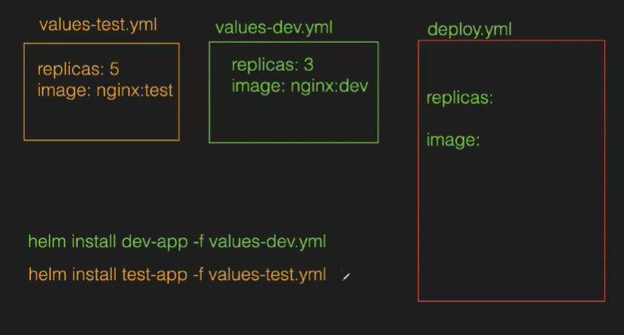
->ey service kavali antey a specific values file run chesthey chalu
->helm=helm is a k8s package manager in which the mul no of yaml files such as the backend, frontend come under one roof(helm) and deploy using helm
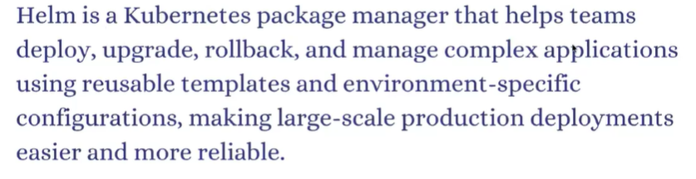
->to install helm
In google> helm installation>helm.sh>copy cmd nd run that in server
->chk installed or not
Helm version
TO CREATE A HELM CHART
->helm create name
Helm create flm
->give ll >we’ll see 2 folders flm n get_helm.sh
->go inside the flm folder>give ll
We’ll see many files, we need values.yml n templates
->ee values.yaml lopala req’s untai
->templates folder lo mana ki kavalisina k8s resources manifest files anni untai
->jst oka deployment files open chesi chudu manam nerchukunna dani lagey untadi
->values.yaml file lo def vals untai
DEPLOYING APP VIA HELM CHART(shaikmustafa/paytym:movie)
->create a helm
->manam use cheesy image version mention cheyyali ga
Vim charts.yml>the 1st line apiVersion is version of helm>last apiversion is image version
->there change the def val to our image tag_name(movie)
Eg :shaikmustafa/paytym:movie
->in values file give repo name as shaikmustafa/paytym
->replicas as u need
->in svc change to loadbalancer nd svc port to 80
->rest all are def
->to install helm
Helm install name .
Helm install paytym_app .
->app got deployed, chk deploys
->chk pods also
->chk svc also
->access app using loadbalancer(takes tym to access)
->to chk list off helms
Helm list
->to del helm
Helm uninstall helm-name
Helm uninstall paytym_app
TO UPGRADE
->values file loki velli cycle ivvu
->to upgrade helm
Helm upgrade helm-name .
Helm upgrade paytym_app .
Revision 2 untadi
->mundu movie undi, now upgraded to movie
->again upgrade to image to dm
TO ROLLBACK
->1st chk helm history to see list of helms
Helm history helm-name
Helm history paytym_app
->to rollback to version1
Helm rollback helm-name 1
Helm rollback paytym_app 1
->now chk helm history
4 vastai(last daniki deployed, reamaing dhi suppressed ani vastadi)
->app koda access chesi chudu
->to list of helm
Helm ls
TO INCREASE PODS
->values file lo replicas inc cheyye
->now upgrade helm file
TO RUN APP IN DIFF ENV’S
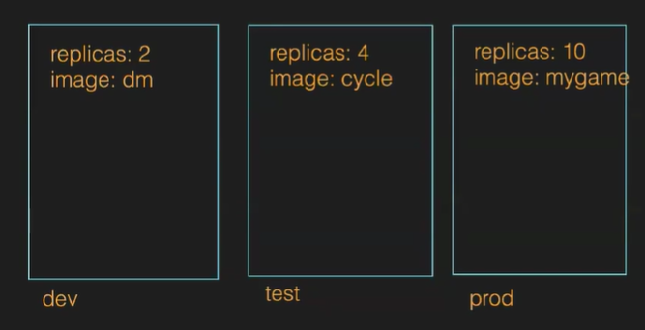
->jst copy values into values_dev
->jst copy values into values_test
->jst copy values into values_prod
->change values in corresponding files based abv req
->create dev namespace
Kubectl create ns dev
->now install helm
Helm install myapp_dev . -f values_dev.yml -n dev
->we see app deployed in dev namespace
->chk pods created in dev ns
Kubectl get pods -n dev
->chk svc in dev
Kubectl get svc -n dev
->now access vth loadbalacer
NOTE – 1 do above steps for test nd prod enc
2 access all env app’s(prathi ns dns teesukoni access cheyye)

CLASS-HELM CHART PART-2(INSTALLING PACKAGES LIKE PROMRTHEOUS,GRAFANA) ND InSTALLING OTHER HELM CHARTS
->create a kops cluster while executing kops cmd master size as m7i flex as , node size as c7i flec large
->using helm we can install prometheous,Grafana, Jenkins, argocd…
->in google search by helm.sh>charts we’ll navigate to artifacthub.io
->suppose Jenkins install cheyyali antey we’ll follow those installation cmds
->a cmds anni dockerfile lo petti image create chesamu
->a image ni teesukoni manifest rasarau like deploy,svc,re, cm n secrets
->ee manifest files anni teesukoni oka helm chart create chesaru
->a helm chart ni teesukoni artifacthub lo pettaru
->a helm chart mana cluster lo install chesukuntey a svc files anni mana cluster loki vastai
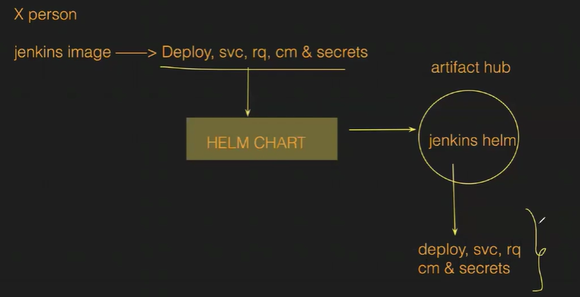
->but realtime lo artifacthub lo pettaru github lo pedataru
->Prometheus=enni no of nodes,cpu,ram n enta use chesukuntunnai(same fr pods,cont)ani monitor chestadi
Ee data anta ela techukuntadi antey manam use cheesy prometheus oka pod install chestadi prathi server lo using daemonset
A data anta raw data la istadi
->Grafana=visuvalization ga data convert chestadi raw data teesukoni
INSTALL PROMETHEUS n GRAFAN IN SERVER
->1st install metrics server
->to chk metrics server installed or not
Kuubectl get pods -n kube-system
->install req softwares using thar ref notes
->1st get the Prometheus repo
->create prometheus namespace and install it
->chk pods,svs… ect in each ns
->Prometheus data anta raw ga istadi vizulaization ki Grafana install cheyye
->create grafana ns and install in int
->chk pods,svc…
->svc nunchi Grafana dns teesukoni access cheyye
->Grafana dashboard ki login avvali antey uname is admin n fr pword goto that path
->to get data frm Prometheus click on data sources
->sel Prometheus>frm notes give url>save n test
->now goto dashboards>new>sel def port>load>sel src as prometheusimport
-> we can see pods,conts,cpu….
->create a pod nd chk in grafana dashboard(ns dhagra def sel cheyye)
->jst pods,cont..ey data ney
->cluster info kosam inko port sel cheyye
CREATING OWN HELMCHARTS nd PUSH TO GITHUB
->create myapp helm chart
->got ovals yml file n change replicas to 2, rep to shaikmustafa/dm, tag to latest, svc to loadbalancer
->to chk helm chart created properly or not
Go back to root> give helm lint myapp
->to pack the helm chart
Helm package myapp
->give ll we’ll see myapp tar file(ee tar file ni manam petted github repo lo)
->to create index file for our helm
Helm repo index .
->give ll nd chk index file created or not
->if we see that index file we see details of our helm
->we keep this index nd tar file in our git repo
->install git
->create empty repo vth readme file frm browser
->copy that empty repo url nd clone it our server
->mv those 2 files to github repo(nothing a folder loki)
->goto folder>track n commit n push to github(fr password create one token)
->chk those 2 files pushed to github or not
->now got pages option of our repo>sel branch as main nd root>save
->url will generate
INSTALL CUSTOM HELM IN OUR CLUSTER
->root lo manaki ey helms lev
Helm list
->add that repo
Helm repo add kolla url
->we’ll see repo got added
Helm repo ls
->if need we can update repo
Helm repo update
->install helm
Helm install release-name index_file_name
Helm install first myapp
->chk pods
Kubectl get pods
->chk deployments n svc
->access file using svc
->if wanna uninstall installed helm
Helm uninstall myapp
CLASS - 14 ARGOCD (gitops methodology)
->create a cluster vth size as matser m7iflex n worker c7i flex
->infra=servers,db,nkts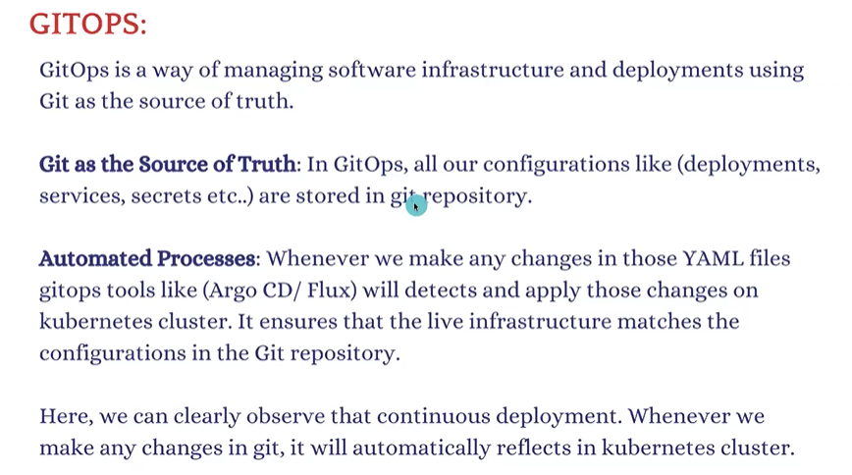
->enduku github lo pettali configuration files=manam jenkins lo webhooks concet nerchukunnam
->like whenever dev pushes code to github automatically triggers job n app is deployed
->likewise manifest files github lo pedithey devops person, automatic ga cluster lo app deploy avutadi
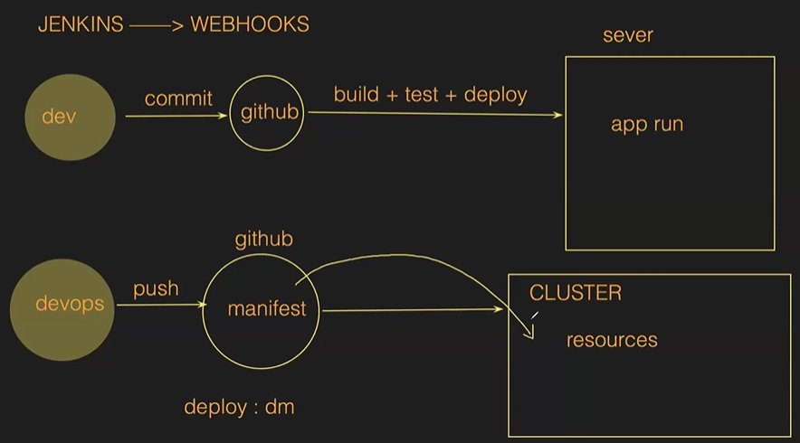
->this method eases devops engineer without running kubectl cmds
->ee process(gitops) chesedi argocd
->argocd=continous deployment
->realtme lo ci jenkins,cd ki argocd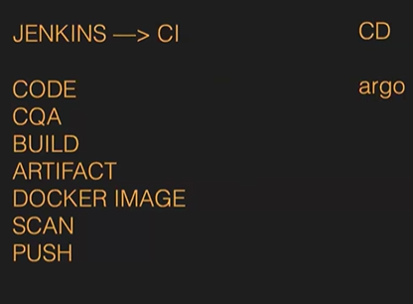
->argocd untey no need of running kubectl cmds n no need of implementing RBAC also
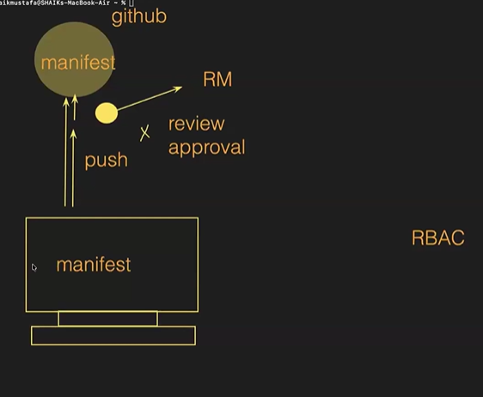
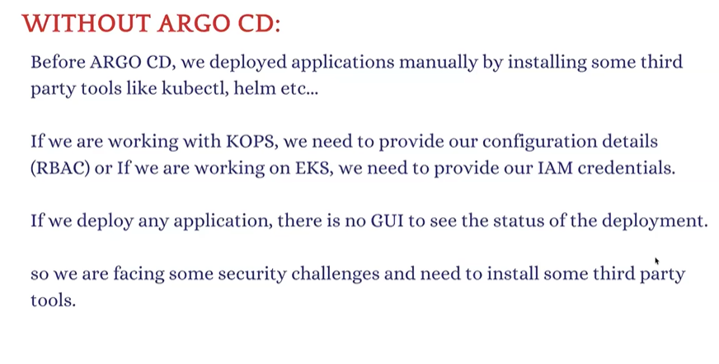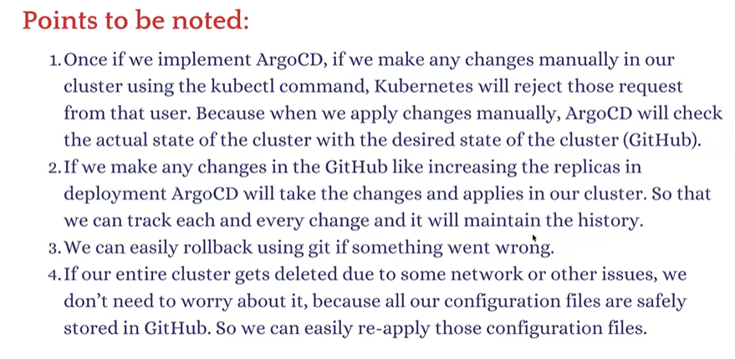->manaki telusu ga ani gitops tho kakunda, cli tho eg pods inc chesthey manaul ga inc chestadi but desired!=actual
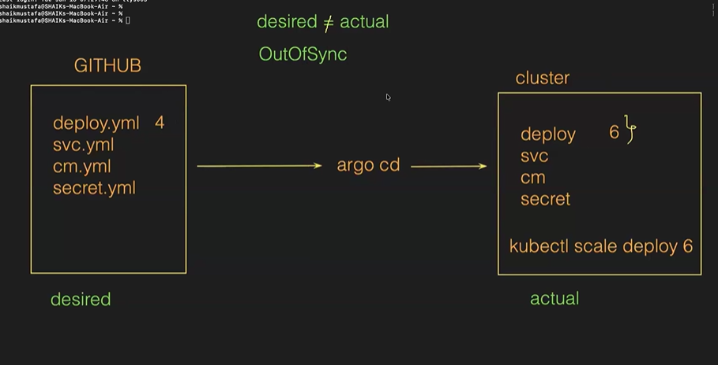->manual ga manifest file change chesi argocd tho cd deploy aithey,mundu chesina changes potai\
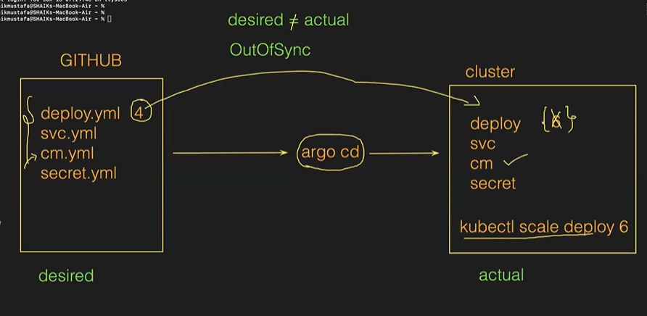->cluster del aina mana files anni github untai kotta cluster chesukoni deploy cheyyachu
ARGOCD INSTALLATION
->INSTALL ARGO CD
kubectl create namespace argocd
kubectl apply -n argocd -f https://raw.githubusercontent.com/argoproj/argo-cd/stable/manifests/install.yaml
kubectl get all -n argocd

EXPOSE ARGOCD SERVER:
kubectl patch svc argocd-server -n argocd -p '{"spec": {"type": "LoadBalancer"}}'
yum install jq -y
export ARGOCD_SERVER='kubectl get svc argocd-server -n argocd -o json | jq --raw-output '.status.loadBalancer.ingress[0].hostname''
echo $ARGOCD_SERVER
kubectl get svc argocd-server -n argocd -o json | jq --raw-output .status.loadBalancer.ingress[0].hostname
The above command will provide load balancer URL to access ARGO CD
TO GET ARGO CD PASSWORD:
login as admin
export ARGO_PWD='kubectl -n argocd get secret argocd-initial-admin-secret -o jsonpath="{.data.password}" | base64 -d'
echo $ARGO_PWD
kubectl -n argocd get secret argocd-initial-admin-secret -o jsonpath="{.data.password}" | base64 -d
The above command to provide password to access argo cd
->update pword
user info>update pword
->login again
DEPLOY APPLICATION
->create app>any name>in pro name give default>in sync policy give automatic>in src give repo url>in revison give main>in path give ./>in cluster url automatic ga vastadi>in ns give default>create
https://github.com/devops0014 /manifest.git
->bcz manam ey ns create cheyyala so giving def
->synced means github tho sync ayyindi, progressing means lopala resources cretae avutunnai, healthy antey create ayyaye
->open it see svc,deploy create ayyaye
->deploy>rs>pod ippudu ardam ayyindha
->access app, jst click on svc we get dns
->oka pod ni describe cheyyali antey, jst click on it
->pod logs koda chudachu,dload chesukovachu
->pod lo edaina pbm vasthey events chk chesukovachu
ROLLBACK
->in manifest file change image to shaikmustafa/mytetrisgame:v1
->deploy ki image ni update chesthey new rs create ayyaye, ee rs related ga 1st oka pod cretae ayye mundu rs lo oka pod del avutadi
->idi manam gui level lo chudachu
->same image ey but rs,pods creation chusamu ga
->again, update image to v2
->ippudu 3rd rs cretae ayye pods deletion,creation chudachu
->ee version koncham ui change chesamu
->to rollback
history & rollback>goto 1st version
->ippudu koda rs lo pods deletion n creation chudachu
NOTE - 1 mana ap out sync ki vellindi bcz not sync vth github bcz manam manual ga version change chesamu
2 helm charts create chesi github lo petti argocd tho deploy cheyye= avvadu
3 fr priv repo goto argocd settings>repo>cont repo> in cnt repo sel http n https>any name>proj default>give github uname n pwords
CLASS – 15 NETWORK PLOCICIES
->minikube is enough vth 25gb
->minikube ni ila start chestamu but network policies ki calico tho start chestamu
minikube start --cni=calico --force
->ade kops ki aithey calico install cheyyali(search in browser for installing calico in kops)
->docker lo nkts ni use chesi ey cont ey cont tho communicate avvali nd ey cont ey cont communicatae avvakodadu ani nkt tho decide chesamu
->in our cluster we have 3 ns's and pods in it, in k8s every pod is communicated irrespective of same ns or not
ss 8 22
->paina img lo fe communicating vth db that not crt so, we have to restrict the comm
->to restrict the comm b/w pods we use nkts in k8s
->ramesh n suresh are frds, ippudu hyd lo koda kalisi undaam ani pakka pakka room lo doors leni room lo oka floor lo untunaru
->but main pbm vallu ey ravtala lopala ki pizza,zepto,zomato delivery boys direct ga vastunaru
->so there is no security fr us,they came up vth we'll keep a door by blocking others nd allows only u
->nkt policies decide wy pod ey pod tho communicate avvachu n avvakodadhu
14 24
->in nkt policies we have ingress n egress
ingress=incoming req
egress=outcoming req
->if pod has no policy allows every req, is there is policy allows specific nd not allows specific
->pod can have mul nkt policies
POD SELECTOR nd NAMESPACE SELECTOR
21 42
PRACTICAL IMPLEMETATION
->creating a pod vth label swiggy
vim po1.yml
apiVersion: v1
kind: Pod
metadata:
name: pod-1
labels:
app: swiggy
spec:
containers:
- name: cont1
image: httpd
ports
- containerPort: 80
->create a pod1
->same create pod2 also by changing pod-2
->comm avutunaya leda antey vati ip kavali
kubectl get pods --o wide
->now goto pod1
kubectl exec -it pod-1 --bash
apt update -y
apt install iputils-ping -y
->now chk pod2 is communicating vth pod1 by ping pod2 ip
->likewise chk pod1 is communicating vth pod2
->to break comm b/w pods create a nkt policy
->create a pod-3 vth label as app zomato nd install ping package
->create a db pod also vth label app db
->manam cretae chesey nkt policy enti antey app:swiggy pods only shd communicate vth db pods
33 58
->lets break comm b/w all pods vth nkt policy
vim deny_all.yml(name can be anything)
apiVersion:networking.k8s.io/v1
kind: NetworkPolicy
metadata: deny_all
spec:
podSelector: {} //all
policyTypes:
- Ingress
- Egress
->create nkt policy
kubectl create -f deny_all.yml
->now chk pod1 pod2 shd not comminicating vth eachother
->now establishing which pod shd comm vth particular pod
->create incoming req for db pod
vim allow-swiggy-to-db.yml
apiVersion: networking.k8s.io/v1
kind: NetworkPolicy
metadata:
name: allow-swiggy
spec:
podSelector:
matchLabels:
app: db
policyTypes:
- Ingress
ingress:
- from:
- podSelector:
matchLabels:
app: swiggy
->create a nkt policy file
kubectl create -f allow-pod.yml
->create outgoing req for db pod
vim allow-swiggy-egress-to-db.yml
apiVersion: networking.k8s.io/v1
kind: NetworkPolicy
metadata:
name: db-rule
spec:
podSelector:
matchLabels:
app: swiggy
policyTypes:
- Egress
egress:
- to:
- podSelector:
matchLabels:
app: db
ports:
- port: 80
->create a nkt policy file
kubectl create -f allow-swiggy-egress-to-db.yml
->ippudu mana requirement enti swiggy pods ey db-pod tho comm avvali,chk cheye
NOTE - 1 manam deny-all nkt policy rasam kabati, manam rasina swiggy nunchi db ki comm avutundi
2 but realtime lo adi use cheyyamu, only ey pod ey pod tho comm avvali ani mention avvali ani nkt policy rastamu
3 paina eg lo 1 way enable chesamu, 2 way cheyyali(like db ki egress n ingrees snd fr swiggy ki koda ingress n egress)
4 5-exp vallaki adugutaru ee nkt plocies
CLASS - 16 PROBES(imp)
->create kops vth 25 n iam role
10:45
->follow the uploaded notes and understand
->project appudu idi cheptaru
->liveness ki implement chestunnaru
vim liveness.yml
apiVersion: v1
kind: Pod
metadata:
name: pod-1
spec:
containers:
- name: cont-1
image: httpd
ports:
- containerPort: 80
command:
- /bin/sh
- -c
- touch /tmp/devops; sleep 1000
livenessProbe:
exec:
command:
- cat /tmp/devops
initialDelaySeconds: 10 //10sec ki start chestadi health chk cheyyadam
periodSeconds: 5 //for every 5 chks
timeoutSeconds: 30 // incase response rakapothey 30secs varaku wait chestadi
->create a livesness probe
kubectl create -f liveness.yml
->describe chesthey telustadi liveness
->wanted ga pod lopala ki velli a file del cheyye,now describe n see that kubelet kills the cont n creates new cont
->kubelet ki liveness probe ey cheptadi restart cheyyamani

